Miss Foley
ESci20: AE2 Healthy Water Aral Sea

Case Study: Aral Sea Crisis
(Designed By Mr. S. Lewchuk)
Background
The Aral Sea is a landlocked, saltwater lake in central Asia bordered by Kazakhstan and Uzbekistan. At one time, it was the fourth largest lake in the world. In the mid-20th century, the former Soviet Union began projects which affected the ecology of the Aral Sea basin region.

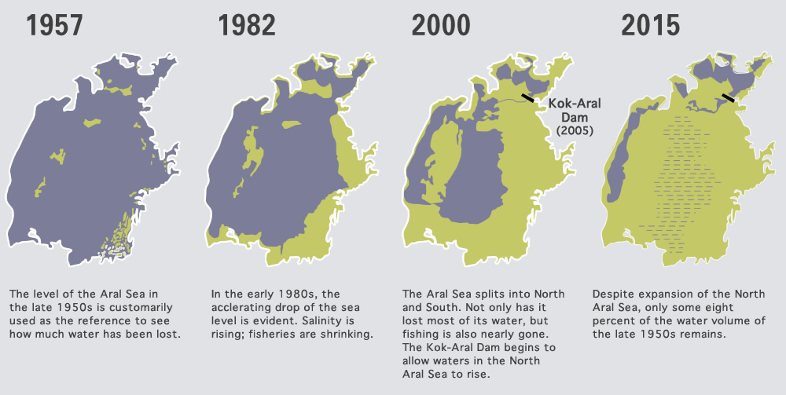

Part One: Investigation
- Find the Aral Sea on a satellite map and explore the area. Google Earth or Google Maps are options.
- Use video links and websites below to gain understanding of this ecological event.
Part Two: Written Summary *Assessed using the included Four Point Writing Assessment.
- Section 1 - Provide a written explanation of the events which resulted in the Aral Sea Crisis. Answer the “who, what, when, where, and why?” as you explain the impact to the environment. Provide details regarding the social, economic, cultural and ethical issues related to the Aral Sea Crisis.
- Section 2 - Write a brief, personal response to the Aral Sea Crisis that clearly states your opinions and/or reflection.
Recommended Websites
http://www.columbia.edu/~tmt2120/introduction.htm
http://news.nationalgeographic.com/news/2014/10/141001-aral-sea-shrinking-drought-water-environment/
http://www.unep.org/dewa/vitalwater/article115.html

Miss Foley
ESci20: AE2 Healthy Water Aral Sea

Recommended Videos
http://rt.com/news/191952-aral-sea-dry-video/
https://www.youtube.com/watch?v=oNDjL_q7kHU
https://www.youtube.com/watch?v=dp_mlKJiwxg

