HANTIS®

HISTORY OF HANTIS (HAND TENNIS)

The game began in 2006 in a media arts classroom at Scott County High School in Georgetown, KY. After completing their class work, the students began playing around with a tennis ball and four tables. For big groups, hantis is played as a rotational activity similar to four square. Hantis is also played as a sport; much like doubles table tennis.

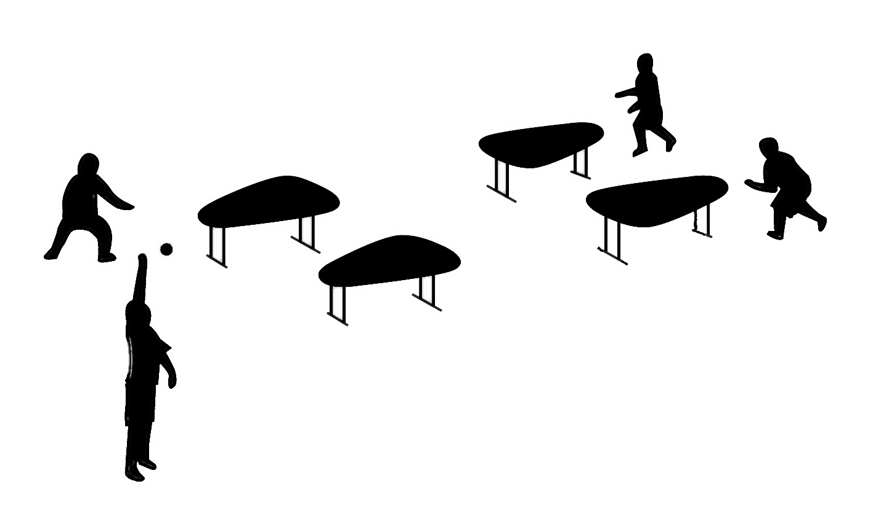
EQUIPMENT & SPACE

- Four tables (wood or plastic)
- Tennis ball (on wood)
- Bouncy/Soft ball (on plastic)
- Gym, hallway, rec room, driveway, outdoors

FREESTYLE PLAY

For large groups, several sets of four tables are set up in a 2x2 pattern. A player enters the game at the first table in rotation. The last table in rotation is the serving table. As mistakes are made, ‘outs’ occur which force players to the back of the line. When an ‘out’ happens, players rotate around the tables to fill in the empty gap made by the person who got ‘out’. Players that are side by side are always teammates, which change rapidly as players rotate through the game. A maximum of 12 students per 4 tables is encouraged.

COMPETITIVE PLAY (view a Hantis match in action!)

During competitive play, games are played to 21 and the winning team must win by 2 points. A match is played as a ‘best of’ 1, 3, 5 or 7 game series. It is recommended to use rock-paper-scissors-SHOOT to determine which team serves first. The serving responsibility switches from team to team every 5 serves and players must alternate serving accordingly until the game point is reached. When a team reaches game point (20 points) the losing team can choose their best server to attempt a tie. On every game point attempt, the serving team is allowed one fault. This allows the underdog to force fast serves on their first attempt without risking a total game loss on a serve. When the game is tied, serving responsibility must switch to the other team. Once a team leads by two points, they have won the game.

BASIC RULES

- Tables are spaced equally in all directions. Recommended spacing is 3 feet for beginners, 4 feet for advanced and 5 feet for professionals.
- The serve is always performed from the serving table. The ball must always hit the server’s table first.
- The offensive team is the team serving the ball. They must not cross the offensive line of scrimmage until the ball is served. This line runs parallel to the line formed by the back edge of their tables.
- The defensive team is the team that receives the ball. They must not cross the defensive line of scrimmage until the ball is served. The defensive line of scrimmage runs parallel to the line formed by the front side of the defenders’ tables. This prevents the defensive players from getting too close to the opposing team before the ball is live.
- Each player is allowed a maximum of two hits per possession. Each team is allowed one hit on each table per possession. Therefore, in one possession, teams of two players can hit the ball four times (twice each) and the ball is allowed to bounce two times (once on each table).
- The contact between the player and the ball is best described as a hit, strike or slap. The ball may not be cupped, grabbed or carried. This results in a point for the other team.
- If two hands are used simultaneously to hit the ball, this counts as two hits.
- Hantis is unique because you can use any part of your body to strike the ball. If a player’s clothing or other part of the body deflects the ball, it can be counted as one hit.

OUTS/POINTS

Player-Ground: After the ball is served, the last person to touch the ball before it hits the ground is out (freestyle); the other team gets a point (competitive).
Table-Ground: After the ball is served, the last table to have the ball bounced on it before it hits the ground is out (freestyle); the other team gets a point (competitive).
Table x 2: After the ball is served, the table where the ball bounces twice without changing possession is out (freestyle); the other team gets a point (competitive).
Player x 3: After the ball is served, the person who strikes the ball three times without changing possession is out (freestyle); the other team gets a point (competitive).
Double Out/Point: A double out happens when one team gets both opposing players out in one play (freestyle) or receives two points in one play (competitive). It can only happen when the ball hits both players’ tables on the same team consecutively before hitting the ground.
Out of Play: When the ball goes out of play, the player/table with the last possession is out (freestyle); the other team receives a point (competitive).

CHANGE OF POSSESSION

Dribbling: Anytime the ball is hit onto a player or table, the possession changes, so the ball can be hit again to bounce it out of the opponents’ reach. Essentially, the ball can be dribbled indefinitely on the opposing team’s tables because it is changing possession after every bounce and hit. Players who are being dribbled on can attempt to intercept the dribble at any time.
Edge Rule: If the ball hits the table’s edge directly, the ball must bounce up to count as a tabletop hit. If the ball bounces down after hitting a table’s edge, the last player or player’s table that touched the ball is at fault.
X-Factors: Any surfaces besides the players, the four tabletops and the ground are called X-Factors and are completely neutral. These may include walls, ceilings, or anything else surrounding the playing area. During the serve and for the remainder of the volley, the ball may bounce off these surfaces with no penalty to the other team. If the ball gets stuck, it is deemed out of play.

