HC1-e: Health Care Philosophies
First Nations Medicine & Healing Practices
Every treatment has a cultural component. Western medicine is founded on science, but we must recognize that this holds no inherent guarantee of quality or efficacy. We teach the importance of evidence-based medicine, but there are many therapies for which we have not yet accumulated evidence of effectiveness, so should you dismiss all therapies that are not yet proven? One suggestion is to proceed with an open but enquiring mind - be sceptical (i.e. question things), but not cynical (i.e. dismiss ideas and find fault with them).
The culture of Western medicine places diagnosis as a central goal, whereas other approaches, including Aboriginal medicine, see it as less central and pay more attention to finding a safe environment in which the patient may recover. For conditions such as mental disorders, this latter approach may prove more effective than struggling to attach a label to the disorder.
Here are some back-ground notes intended to make you aware of some common Aboriginal healing practices that you may hear mentioned by Aboriginal patients you treat. You should at least have a general understanding of what these involve.
- Aboriginal medicine contains innumerable folk remedies based on plants, many of which have formed the basis for pharmaceutical treatments that we use routinely in Western medicine
- Traditional approaches to healing are holistic and consider mind, body and spirit. Medicine is distinguished from healing, which goes beyond mere treatment of sickness. As Donald Warne points out, it is somewhat ironic that modern physicians say they provide health care when they really treat diseases. (Warne D: Traditional perspectives on child and family health. Paediatr Child Health 2005;10:542)
- The healing relationship is based on a series of virtues: respect; humility; compassion; honesty; truth, sharing, hospitality and divine love.
- Traditional Aboriginal care recognizes many more routes to healing than does Western medicine. Seven routes are commonly mentioned: Talking, Crying, Laughing, Dancing, Sweating, Yawning, and Yelling (giving vent to your feelings, not yelling at someone!)
- Much traditional healing centers around group ceremonies, including prayers, the sharing of a meal, the use of traditional medicines and practices such as sweat lodges. Healing also involves feeling part of a shared culture, of being outdoors and in connection with the land and with nature. The Cree of James Bay, for example, emphasize the interconnections of people and animals; hunters feel respect and love for the animals; a feast is a communal way to express this respect. The traditional lifestyle naturally encourages healthy eating and exercise. (The biophylia hypothesis and ecopsychology hold that humans have an instinct to connect emotionally with nature and that dissociation from nature has caused disease and social pathologies). This has led to the idea of land-based healing programs that seek to put people back in touch with nature.

The Medicine Wheel
The medicine wheel symbolizes the interconnection of all life, the various cycles of nature, and how life represents a circular journey. The number four is sacred to the many Aboriginal peoples of North America and can represent many things: the four seasons, the four parts of a person (physical, mental, emotional and spiritual); the four kingdoms (animal, mineral, plant and human); the four sacred medicines (sweetgrass, tobacco, cedar and sage).

Hence, you may see the medicine wheel presented in several different ways:
- The four points of the compass, each with a guiding spirit, symbolize stages in the life journey. The East, direction of the daily birth of the sun, represents a person's birth and early years. The South relates to childhood and intellectual growth. The West symbolizes adulthood and introspection, while the North represents the old age, wisdom and the spiritual aspects of life. The centre of the wheel is symbolic of Mother Earth and the Creator, and their role in the beginning and continuation of life.
- The four points can also represent the balance between spiritual (East), mental (North), physical (West) and emotional (South) aspects of health.
- The wheel can also represent values and decisions. Here, values (drawn in the East, where the sun rises) influence decisions taken in the mental realm (drawn in the North, at the top). Then, decisions are implemented in the physical realm (West), and actions produce reactions in the emotional realm (South). Finally, these reactions provide feedback into the value system, completing the circle of value - action - evaluation.
- The quadrants of the wheel are often colored red, yellow, black, white or green.

For a traditional healer, an imbalance (e.g., the loss of traditional values, perhaps resulting from experiences in residential schools) may affect health decisions (e.g., leading to alcoholism).
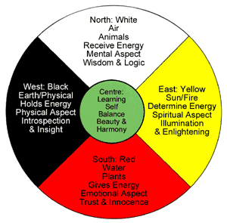
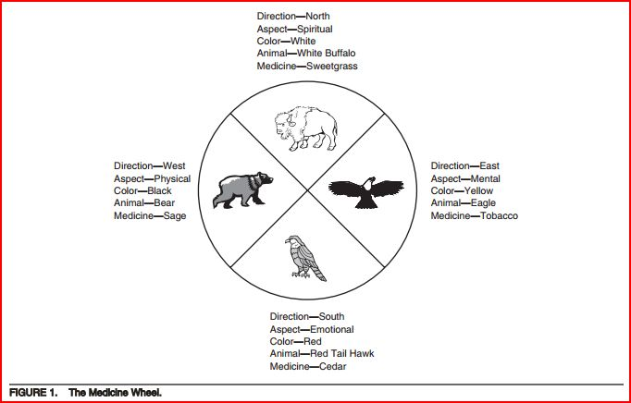

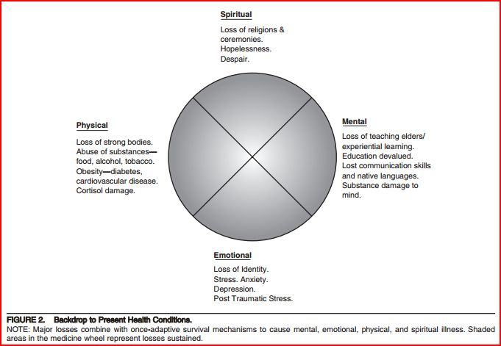
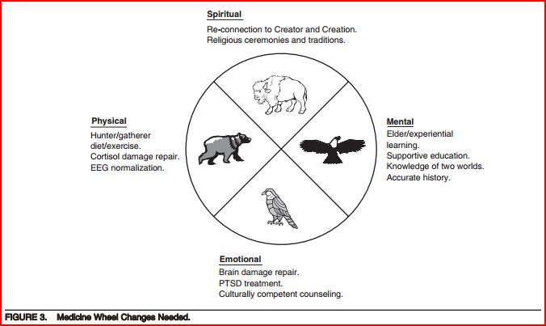

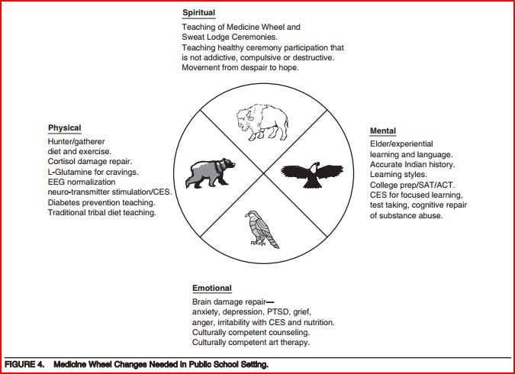

The Four Sacred Medicines
Sweetgrass (the North) is used by almost all Aboriginal peoples in North America for ritual cleansing. When Sweetgrass is walked on, it bends but does not break. Hence, it has been associated with virtue: an injustice can be returned by a kindness, by bending, not breaking.
Tobacco (the East) is held as a scared plant by most First Nations peoples. Tobacco connects us to the spirit world; it absorbs prayers and carries them to the spirit world. If a request is accompanied by an offer of tobacco that is accepted, the promise must be honored. Tobacco can also be used to thank the Creator for his gifts: if you enjoyed good weather, you could leave some tobacco on the ground, and say thank you for the gift. Tobacco is generally not smoked, except on special ceremonial occasions.
Cedar (the South) is used for purification and (taken as a tea) to attract positive energy, feelings, emotions and for balance. Its vitamin C content helped prevent scurvy when fruits and vegetables were unavailable during the winter months.
Sage (the West) is a woman's medicine, conferring strength, wisdom, and clarity of purpose. It is a powerful purifying medicine that drives away negative energies. Sage can be found braided and hung in people’s homes, perhaps tied with a ribbon in one of the colors of the medicine wheel. The threefold braid represents body, mind and spirit.

Rituals & Place-Based Ceremonies
Smudging (a.k.a. a 'smudge') is smoke used for ritual cleansing. Smudging is a ceremony traditionally practiced by some Aboriginal cultures to purify or cleanse negative energy, feelings or thoughts from a place or a person. Sacred medicines such as cedar, sage, sweetgrass or tobacco are burned in an abalone shell. The shell represents water, the first of four elements of life; the medicines represent gifts from mother earth and the burning represents fire, the next two elements. The person puts their hands in the smoke and carries it to their body, especially to areas that need spiritual healing (mind, heart, body). The smoke represents air, the final element. Perhaps the smell of the burning medicines stimulates the brain to produce beta-endorphins and promote healing processes.
Healing Circles are meetings held to heal physical, emotional and spiritual wounds. A symbolic object, often an eagle feather, may be given to a person who wishes to speak, and then it is passed around the circle in sequence to others who wish to speak. Shamans may conduct the ceremony.
Sweat Lodge (a.k.a. Purification Lodge) is a ceremonial sauna used for healing and cleansing. It made of a wooden framework covered by blankets or skins, usually igloo-shaped, about 1.5 meters high and large enough for eight people to sit in a circle on the ground. Hot stones are placed in a shallow hole in the center of the lodge. A medicine man pours water on the stones to produce steam and participants may spend an hour sweating in the lodge. The lodge combines the four elements of fire, water, air and earth. Ceremonies include offerings, prayers, and reverence. At times, excessive exposure to the heat of the lodge may have health effects; also toxins can be released if grasses that have been exposed to pesticides are placed on the rocks.
Sun Dance (a.k.a. Rain Dance, Thirst Dance, Medicine Dance) is a ritual that celebrates the harmony between man and nature, and spiritual dedication. Originally practiced at the summer solstice, the sun dance represents continuity between life, death, and regeneration. The symbolism often involved the buffalo, on which plains Indian groups depended, so deserving reverence, but which they also had to kill. Four days before the ceremony, the dancers prepare by purifying themselves, at times in a sweat lodge, by meditating and collecting ceremonial items of dress to use in the sun dance. The sun dance itself takes another four days, and generally involves drumming, singing, and dancing, but also fasting and, in some cases, self-inflicted pain. This symbolized rebirth and often involved piercing the skin and attaching cords that the person had to tear out. This element led governments to suppress the sun dance around 1880, but it has been re-introduced.
Pipe Ceremony is where the pipe is used individually and in groups for prayer and ceremonial purposes. Participants gather in a circle. A braid of sweetgrass is burned to purify the area and those present, to make a sacred place for the spirits to visit. Tobacco or kinnickkinnick, a traditional mixture of bearberry and wild herbs or red willow shavings, is smoked so that prayers can be made to the Great Spirit or requests made of the spirits. The pipe may also be smoked to open other meetings or ceremonies. When not in use, the bowl and stem are separated and carried by one individual, the pipe holder.
Potlach is a ceremonial feast among northwest Pacific coast Native peoples held to celebrate major family events such as a marriage or birth. The host distributes gifts according to the status of each guest; reinforcing the perceived hierarchical relations between groups. At times the gift-giving became competitive, the host giving away personal possessions in anticipation that others would reciprocate in their turn. Such largesse enhanced the host’s prestige. Missionaries encouraged government to outlaw the potlach around 1885; it is now common.

