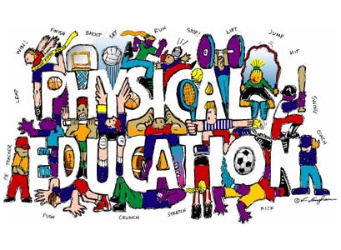
Welcome To Physical Education 6!

The Goals of K-12 Physical Education are:
- Active Living - Enjoy and engage in healthy levels of participation in movement activities to support lifelong active living in the context of self, family and community.
- Skillful Movement - Enhance quality of movement by understanding, developing and transferring movement concepts, skills, tactics and strategies to a wide variety of movement activities
- Relationships - Balance self through safe and respectful personal, social, cultural and environmental interactions in a wide variety of movement activities.
Working to Develop PHYSICALLY LITERATE Individuals who:
- Move with competence in a variety of physical activities that benefit the development of the whole person.
- Consistently develop the motivation and ability to understand, communicate, apply, and analyze different forms of movement.
- Are able to demonstrate a variety of movements confidently, competently, creatively and strategically across a wide range of health-related physical activities.
- Make healthy, active choices that both benefit and respect their whole self, others, and their environment.
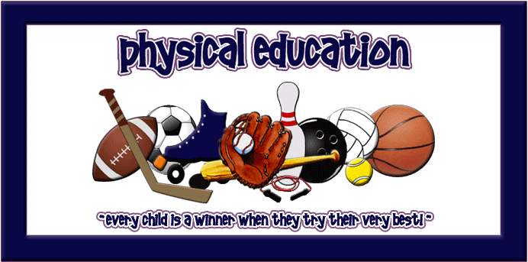
There Are Three Rules To Expect In This Class:
- GIVE THE BEST OF YOURSELF that you have to give today.
- BE RESPECTFUL of yourself, others and the equipment.
- BE SAFE with both yourself and others.
For Class You Will Need:
- A change of clothing that is comfortable for you to move in and respectful to others.
- T-shirts cover belly button with both hands raised overhead; T-shirts preferred over tank tops.
- Tank top straps are at least 2 inches wide with all undergarments covered.
- Shorts are at least mid-thigh length. Light sweats/yoga pants/wind pants are also welcome.
- Athletic footwear, preferably not outside footwear. Flip flops, clogs, flats, cowboy/roper boots, sandals, untied skater shoes are not appropriate footwear.
- Any completed homework required.
- Eye protection (shatter proof goggles/glasses) – option to order through the school at any time.
- Badminton racquet - option to order through the school each spring.
- Seasonal access to backpack, bicycle, skates, swimsuit, winter clothing.
- An open mind, a desire to try new things and the ability to laugh at yourself
Not only are individuals built for and need to move, they also need to appreciate and understand the “how’s, what’s, where’s & why’s” of movement... Welcome to Physical Education!

By The End Of PE 6 You Will Be Able To Say… |  | % of Final Mark
6.1 | Cardiovascular Fitness: I can create & use my own daily fitness plan, using the F.I.T.T. principle, to improve my cardiovascular endurance. | 12 | Active Living  35%
6.2 | Body Composition: I can show my understanding of how inactivity affects body composition while making healthy choices, including physical activity, that effectively and safely affect body composition. | 4
6.3 | Muscle Fitness: I can choose and apply strategies that will safely improve my muscular endurance, flexibility and strength. | 6
6.4 | Skill-Related Fitness: I can show my understanding of how skill-related fitness develops health-related fitness & vice versa while being physically active. | 4
6.10-11, 6.13 | Flexible | 9
6.5 | Complex Skills: I can show that I am working towards control while moving with objects or remaining still during games or sports. | 6 | Skillful Movement  40%
6.6 | Manipulative Skills: I can use performance cues to improve my skills when moving objects. | 2
6.7 | Biomechanics: I can improve my ability to move objects, my travelling & non-travelling skills by using the principles of producing force, resistance, & absorbing force. | 4
6.8 | Movement Concepts: I can analyze and, with help, apply movement concepts to develop skill while playing target and invasion/territorial games. | 4
6.9 | Decision Making: I can make appropriate decisions and choose skills, tactics & strategies that increase my own and my team’s performance in target games, invasion/territorial games and low organizational, inventive & cooperative games. | 8
6.10 | Alternate Environment & Body Management: I can use the appropriate movement skills with control while respecting the environment when participating in a variety of alternate environment & body management activities. | 10
6.3-6.4 | Flexible | 6
6.11 | Volunteerism & Leadership: I can show my ability to carry out a planned class activity focused on including everyone while increasing participation in physical activity. | 5 | Relationships  25%
6.12 | Influences: I can analyze characteristics and limitations of myself & others when making decisions about participating in physical activity and choosing possible careers. | 2
6.13 | Safety & Rules: I can develop an appreciation for the impact of safety & rules on myself and others after analyzing those related to target games, invasion/territorial games and alternate environment activities. | 5
6.14 | Relationship Skills: I can apply my own plan to improve my social skills for personal growth while participating in physical activities. | 5
6.15 | History & Culture: I can look at, critique & appreciate physical activities developed by our World neighbours & how they contribute to my well-being and others. | 5
6.4, 6.8-10 | Flexible | 3

