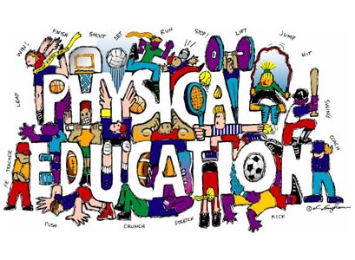
Welcome To Physical Education 8!

The Goals of K-12 Physical Education are:
- Active Living - Enjoy and engage in healthy levels of participation in movement activities to support lifelong active living in the context of self, family and community.
- Skillful Movement - Enhance quality of movement by understanding, developing and transferring movement concepts, skills, tactics and strategies to a wide variety of movement activities
- Relationships - Balance self through safe and respectful personal, social, cultural and environmental interactions in a wide variety of movement activities.
Working to Develop PHYSICALLY LITERATE Individuals who:
- Move with competence in a variety of physical activities that benefit the development of the whole person.
- Consistently develop the motivation and ability to understand, communicate, apply, and analyze different forms of movement.
- Are able to demonstrate a variety of movements confidently, competently, creatively and strategically across a wide range of health-related physical activities.
- Make healthy, active choices that both benefit and respect their whole self, others, and their environment.
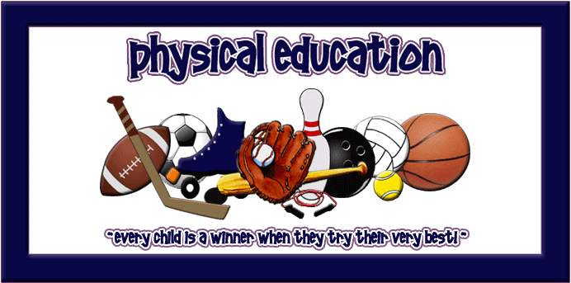
There Are Three Rules To Expect In This Class:
- GIVE THE BEST OF YOURSELF that you have to give today.
- BE RESPECTFUL of yourself, others and the equipment.
- BE SAFE with both yourself and others.
For Class You Will Need:
- A change of clothing that is comfortable for you to move in and respectful to others.
- T-shirts cover belly button with both hands raised overhead; T-shirts preferred over tank tops.
- Tank top straps are at least 2 inches wide with all undergarments covered.
- Shorts are at least mid-thigh length. Light sweats/yoga pants/wind pants are also welcome.
- Athletic footwear, preferably not outside footwear. Flip flops, clogs, flats, cowboy/roper boots, sandals, untied skater shoes are not appropriate footwear.
- Any completed homework required.
- Eye protection (shatter proof goggles/glasses) – option to order through the school at any time.
- Badminton racquet - option to order through the school each spring.
- Seasonal access to backpack, bicycle, skates, swimsuit, winter clothing.
- An open mind, a desire to try new things and the ability to laugh at yourself
Not only are individuals built for and need to move, they also need to appreciate and understand the “how’s, what’s, where’s & why’s” of movement... Welcome to Physical Education!

By The End Of PE 8 You Will Be Able To Say… |  | % of Final Mark
8.1 | Health-Related Fitness: I can create, use and make changes to my own daily fitness plan, using the F.I.T.T. principle, to improve my health-related fitness. | 13 | Active Living  40%
8.2 | Muscular System: I can demonstrate an understanding of the impact of exercise and inactivity on my major muscle groups (biceps, triceps, pectorals, abdominals, quadriceps, hamstrings). | 4
8.3 | Skill-Related Fitness: I can carry out personal action plans to balance out my skill-related fitness (power, agility, speed, reaction time, balance, coordination). | 6
8.8-8.13 | Flexible | 17
8.4 | Complex Skills: I can increase my performance and enjoyment using smooth transitions between various complex movement skills to do an activity. | 4 | Skillful Movement  40%
8.5 | Biomechanics: I can use Newton’s Laws of Motion and the biomechanics of levers and projectiles to increase my motor skills. | 6
8.6 | Concepts, Tactics & Strategies: I can enhance my individual and team performance by planning tactics and strategies for each type of game: target, striking/fielding, net/wall, invasion/territorial & low organizational/inventive games. | 8
8.7 | Decision Making: I can analyze decisions made by myself and others under pressure in game situations and make suggestions for improvement next time. | 4
8.8 | Alternative Environment Activities: I can transfer my skills and strategies to participate in outdoor education opportunities. | 8
8.9 | Movement Sequences: I can create and perform (both leading and following) a smooth routine reflecting various movements alone and with others. | 8
8.2-8.3 | Flexible | 2
8.10 | Volunteerism & Leadership: I can create an action plan to support another individual’s repeated participation in physical activity. | 6 | Relationships  20%
8.11 | Technological Influences: I can demonstrate how technology has impacted fitness, fitness careers and well-being. | 2
8.12 | Basic First Aid: I can demonstrate the skills required to administer first aid for physical activity related injuries. | 4
8.13 | Social Behaviour: I can analyze and assess the impact of environmental influences on social behaviours in physical activity settings. | 4
8.14 | History & Culture: I can investigate the social, cultural and environmental influences on the need for recent physical activity initiatives to support active living and well-being. | 4

