The Reproductive System Anatomy Name: ___________

Female Internal Reproductive Organs
Using the provided word bank, label the following diagram:
Word Bank
Vagina Uterus
Cervix Myometrium
Fallopian Tube x2 Perimetrium
Endometrium Uterine fundus
Ovary x2

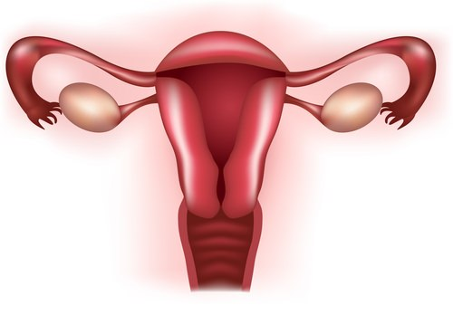

Female External Reproductive Organs
Using the provided word bank, label the following diagram:
Word Bank
Labia Majora Vaginal opening
Labia Minora Anus
Clitoris Perineum
Urethral opening Mons Pubis

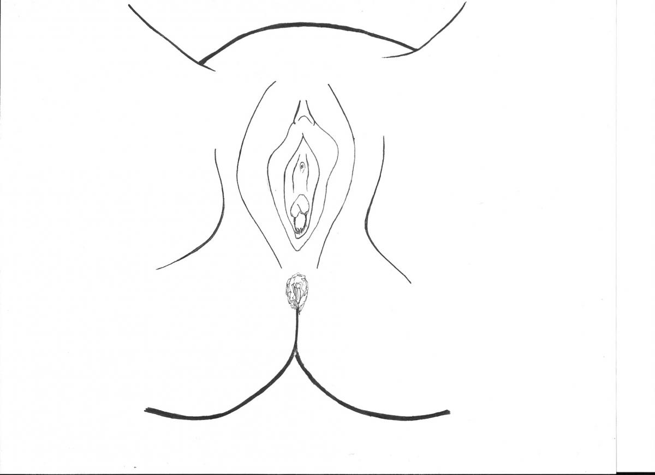

Male Reproductive Organs
Using the provided word bank, label the following diagram:
Word Bank
Pubic bone Seminal Vesicles
Bladder Rectum
Vas Deferens Anus
Urethra Prostate
Testicles Epididymis
Scrotum Penis
Urethra Ejaculatory duct

