Miss Foley
Health 8: USC2 Families Family Structures

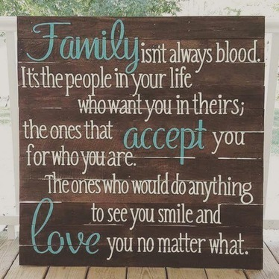
Family Is…
Two or more people who share goals and values, have long-term commitments to one another and usually reside in the same dwelling.

Family comes in all shapes and sizes –
some being genetic/blood ties and some chosen!

Type of Family | School %’s
Nuclear
Single Parent
Blended
Extended
Adoptive
Foster
Other
- Nuclear Family – Mom, Dad, and/or brothers or sisters living under one roof.
- Single Parent Family – Headed by either Mom or Dad.
- Blended Family – Family formed from two previous marriages.
- Extended Family – Grandparents or Aunts/Uncles live under one roof with you.
- Adoptive Family – You are a permanently adopted member of your family.
- Foster Family – You are living with a family that has taken you in temporarily for your best interests.
- Others?

Health 8 Family Structures  School Survey  Please check below which  type of family you live in:  - Nuclear Family – Mom, Dad, and/or brothers or sisters living under one roof.  - Single Parent Family – Headed by either Mom or Dad.  - Blended Family – Family formed from two previous marriages.  - Extended Family – Grandparents or Aunts/Uncles live under one roof with you.  - Adoptive Family – You are a permanently adopted member of your family.  - Foster Family – You are living with a family that has taken you in temporarily for your best interests.  - Others _________________________ | Health 8 Family Structures  School Survey  Please check below which  type of family you live in:  - Nuclear Family – Mom, Dad, and/or brothers or sisters living under one roof.  - Single Parent Family – Headed by either Mom or Dad.  - Blended Family – Family formed from two previous marriages.  - Extended Family – Grandparents or Aunts/Uncles live under one roof with you.  - Adoptive Family – You are a permanently adopted member of your family.  - Foster Family – You are living with a family that has taken you in temporarily for your best interests.  - Others __________________________
Health 8 Family Structures  School Survey  Please check below which  type of family you live in:  - Nuclear Family – Mom, Dad, and/or brothers or sisters living under one roof.  - Single Parent Family – Headed by either Mom or Dad.  - Blended Family – Family formed from two previous marriages.  - Extended Family – Grandparents or Aunts/Uncles live under one roof with you.  - Adoptive Family – You are a permanently adopted member of your family.  - Foster Family – You are living with a family that has taken you in temporarily for your best interests.  - Others __________________________ | Health 8 Family Structures  School Survey  Please check below which  type of family you live in:  - Nuclear Family – Mom, Dad, and/or brothers or sisters living under one roof.  - Single Parent Family – Headed by either Mom or Dad.  - Blended Family – Family formed from two previous marriages.  - Extended Family – Grandparents or Aunts/Uncles live under one roof with you.  - Adoptive Family – You are a permanently adopted member of your family.  - Foster Family – You are living with a family that has taken you in temporarily for your best interests.  - Others __________________________

