Miss Foley
Health 8: USC2 Families Family Life Cycles

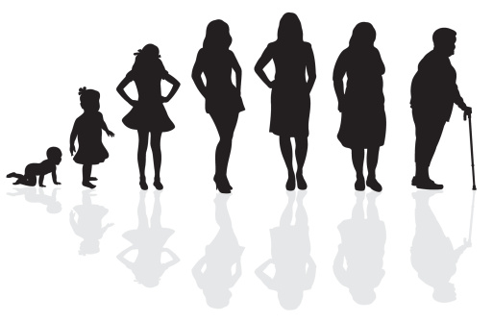
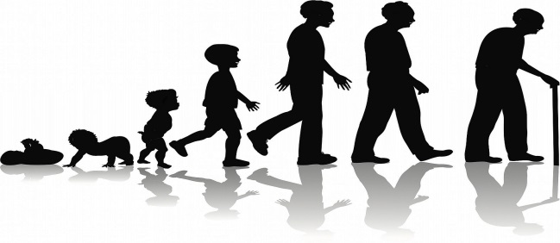
Just As Individuals Have Life Cycles…
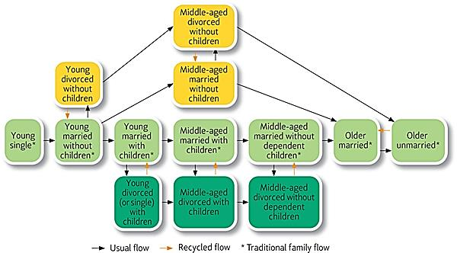
…So Do Families!
The Problem...It’s really hard to represent all kinds
of families within the “standard” family model above.
This creates the following challenges:
- The realities of families aren’t fully represented.
- It doesn’t reflect the realities of blended families, single parent families, couples who can’t marry, families without children, couples who marry at an old age, and couples with great age differences.
- It creates a sense of not being “normal” if family is different than represented in the model which is entirely not true.

Miss Foley
Health 8: USC2 Families My Life Timeline

The line below represents your life from birth to this moment.
Underneath the line jot down where you lived during those times.
On the line, use the following symbols to help as you describe your life events:

Crisis occurred
Recognized for
Achievement

Suffered failure
Faith Experiences
Happy surprises

Times of doubt/sadness
Birth
Death
MY Life Timeline so far…

My FAMILY’S Life Timeline so far…

