Miss Foley
Health 8: USC2 Families Family Protection

United Nations Rights of the Child
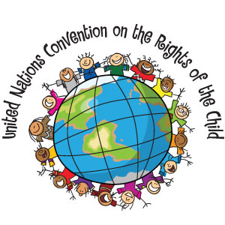
The United Nations Convention on the Rights of the Child changed the world in 1989 by defining basic human rights for young people:
- Security
- Health
- Education
- Human Dignity
- Expression
- Identity
- Protection
- Freedom from cruelty
- The right to make decisions that affect you, guided by parents or other caregivers
Involved Nations are bound to it by international law. Compliance is monitored annually by the UN Committee on the Rights of the Child, which is composed of members from countries around the world.
It applies to everyone under the age of 18. Almost every country, including Canada, has ratified it. This makes it the most widely accepted human rights treaty in the world.
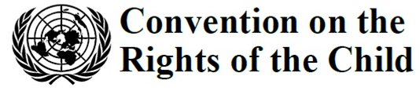

Miss Foley
Health 8: USC2 Families Family Protection

Canadian Charter of Rights & Freedoms
http://laws-lois.justice.gc.ca/eng/Const/page-15.html
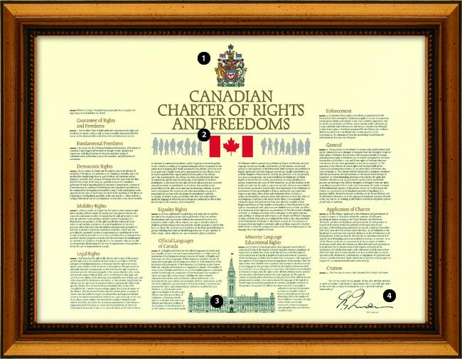
How does this Charter:
- Respect and protect differences in families?

- Ensure that family differences are not to be subject to prejudice, bias, or stereotyping?

- Protect immigrant families coming from other countries where such laws are not in place?

