Miss Foley
Health 8: USC4 Impact of Violence Abuse Defined

Abuse = cruel and/or violent treatment of another human being
Verbal Abuse

- Name-calling
- Placing undue blame
- An overly critical spirit
- Resentment
- Slapping negative labels on personal traits or behaviors
- Responding with ridicule rather than encouragement
- Threatening physical harm
- Starting rumors that degrade reputation
- Angry outbursts
- Manipulation (“If you love me, you’ll do ____”)
- Withholding information
- Limiting access to finances or personal possessions
- Failing to display affection
- Refusing to acknowledge their spouse’s feelings
- Using sarcastic or mocking tones, even if the message itself is positive

Emotional Abuse

- Verbal threats
- Demeaning the partner in front of friends, family or strangers
- Name-calling and use of abusive language
- Constant criticism or humiliation
- Disproportionate anger or yelling to intimidate
- Irrational blaming of the partner
- Withholding affection, approval or appreciation as a punishment
- Obsessive jealousy and accusations of unfaithfulness
- Instilling in the partner the belief that “nothing he does will ever be good enough”
- Use of intimate knowledge (e.g. the partner has herpes) to generate vulnerability
- Abusing or threatening to abuse the partner’s children is included here when the intent is to emotionally harm the partner through the children

- Abusing or threatening to abuse pets is included here, again when the intent is to emotionally harm the partner through the pets
- Being irresponsible with money
- Using insults, sarcasm or sneering
- Laughing at the partner
- The abuser harming or threatening to harm himself/herself
- A special form of emotional abuse is called “crazy making”; examples of this technique are:
  - Lying in order to confuse
  - Blaming the partner for the abuse
  - Telling tales and false stories or playing mind games
  - Telling the partner he doesn’t know what he is talking about
  - Manipulating the partner with words, ideas or lies
  - Denying that statements or promises were made or that behaviors occurred,
  - and telling the partner it’s all in his mind

Miss Foley
Health 8: USC4 Impact of Violence Abuse Defined

Physical Abuse

- Hitting, beating, choking, pushing, slapping, kicking, pulling hair, biting,
punching, backhanding, arm twisting, shoving, kicking or burning
- Holding the partner down or preventing the partner from leaving
- Throwing and/or threatening with objects
- Locking the partner out of the home
- Refusal to get the partner help or medical attention
- Forced use of substances (e.g. alcohol and drugs
- Depriving the partner of medication
- Denying or interfering with the partner meeting his basic physical needs
(e.g. eating and sleeping)
- Smashing, damaging, stealing or selling the partner’s possessions
- Threatening to use or the use of a weapon against the partner (e.g. hammer, knife, gun, etc.)
- Driving recklessly
- Punching walls or doors
- Stalking

Financial Abuse

- Forbidding the partner to work
- Jeopardizing the partner’s employment by such tactics as excessive calls to work; creating conflict with co-workers, supervisor or clients; creating scenes with co-workers; forcing the partner to miss work through threats, injuries or coerced substance use
- Refusing to work, yet contributing to expenses
- Controlling shared resources, including bank accounts and common property
- Demanding the partner sign over paychecks or denying access to liquid assets, like mutual funds
- Demanding the partner account for all the money he spends
- Coercing the partner to pay for all expenses, including rent, food and utilities
- Stealing the partner’s property, such as valuables or assets
- Destroying or threatening to destroy the partner’s property as a means of affecting his financial situation
- Using the partner’s identity to charge expenditures to partner
- Taking credit cards, money or checkbook
- Forging the partner’s signature on financial documents

Sexual Abuse

- Unwanted touching
- Demeaning remarks about the partner’s body or appearance
- Minimization of the partner’s sexual needs
- Berating the partner about his sexual history
- Demeaning remarks about the partner being too femme or butch
- Forcing sex or sexual actions on the partner without consent
- Using force or roughness that is not consensual, including forced sex
(rape)
- Rape with an object
- Refusing to comply with the partner’s request for safe sex
- Coercing the partner into sex with others
- Purposefully and repeatedly crossing the partner’s sexual boundaries
- Violating an agreement for monogamy by having sex with others
- Exposing the partner to sexually transmitted diseases
- Treating the partner as a sex object
- Criticizing sexual performance or desirability
- Withholding sex as a punishment
- Unwanted sadistic sexual acts

Miss Foley
Health 8: USC4 Impact of Violence Cycle of Abuse

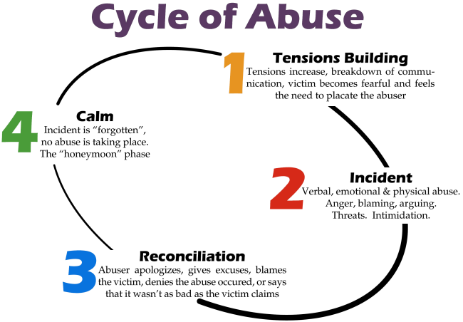
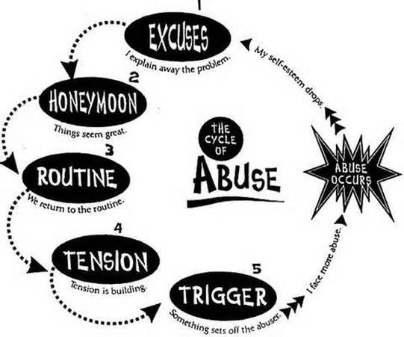
The Cycle of Violence/Abuse

What are similarities and differences between these 3 models?
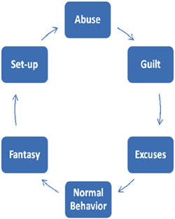
Abuse – Your abusive partner lashes out with aggressive, belittling, or violent behavior. The abuse is a power play designed to show you "who is boss."
Guilt – After abusing you, your partner feels guilt, but not over what he's done. He’s more worried about the possibility of being caught and facing consequences for his or her abusive behavior.
Excuses – Your abuser rationalizes what he or she has done. The person may come up with a string of excuses or blame you for the abusive behavior—anything to avoid taking responsibility.
"Normal" behavior – The abuser does everything he can to regain control and keep the victim in the relationship. He may act as if nothing has happened, or he may turn on the charm. This peaceful honeymoon phase may give the victim hope that the abuser has really changed this time.
Fantasy & Planning – Your abuser begins to fantasize about abusing you again. He spends a lot of time thinking about what you’ve done wrong and how he'll make you pay. Then he makes a plan for turning the fantasy of abuse into reality.
Set-up – Your abuser sets you up and puts his plan in motion, creating a situation where he can justify abusing you.
Example Scenario: A man abuses his partner. After he hits her, he experiences self-directed guilt. He says, "I'm sorry for hurting you." What he does not say is, "Because I might get caught." He then rationalizes his behavior by saying that his partner is having an affair with someone. He tells her, "If you weren't such a worthless whore I wouldn't have to hit you." He then acts contrite, reassuring her that he will not hurt her again. He then fantasizes and reflects on past abuse and how he will hurt her again. He plans on telling her to go to the store to get some groceries. What he withholds from her is that she has a certain amount of time to do the shopping. When she is held up in traffic and is a few minutes late he feels completely justified in assaulting her because "You're having an affair with the store clerk." He has just set her up.

Miss Foley
Health 8: USC4 Impact of Violence Cycle of Abuse

Power & Control Wheel
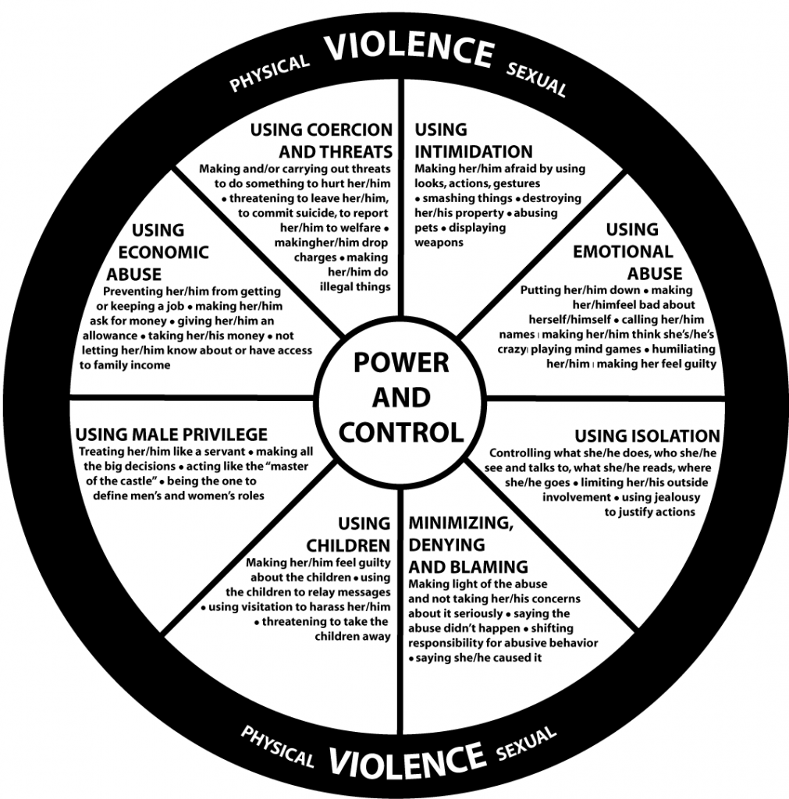
Violence and abuse are used for one purpose and one purpose only:
to gain and maintain total control over you.
An abuser doesn’t “play fair.” Abusers use fear, guilt, shame, and intimidation to wear you down and keep you under his or her thumb. Your abuser may also threaten you, hurt you, or hurt those around you.
Violence and abuse do not discriminate. Abuse happens among heterosexual couples and in same-sex partnerships. It occurs within all age ranges, ethnic backgrounds, and economic levels. And while women are more commonly victimized, men are also abused - especially verbally and emotionally.
The bottom line is that abusive behavior is never acceptable, whether it’s coming from a man, a woman, a teenager, or an older adult. You deserve to feel valued, respected, and safe.

Miss Foley
Health 8: USC4 Impact of Violence Warning Signs

Warning Signs Of Abuse In Others
People who are being abused may:
- Seem afraid or anxious to please their partner
- Go along with everything their partner says and does
- Check in often with their partner to report where they are and what they're doing
- Receive frequent, harassing phone calls from their partner
- Talk about their partner's temper, jealousy, or possessive-ness
Warning signs of physical violence:
- Have frequent injuries, with the excuse of “accidents”
- Frequently miss work, school, or social occasions, without explanation
- Dress in clothing designed to hide bruises or scars (e.g. wearing long sleeves in the summer or sunglasses indoors)
Warning signs of isolation:
- Be restricted from seeing family and friends
- Rarely go out in public without their partner
- Have limited access to money, credit cards, or the car
Psychological warning signs of abuse:
- Have very low self-esteem, even if they used to be confident
- Show major personality changes (e.g. an outgoing person becomes withdrawn)
- Be depressed, anxious, or suicidal
Ways To Support Those Experiencing Abuse or
Living With An Abusive Family Member:
If you suspect that someone you know is being abused, speak up! If you’re hesitating—telling yourself that it’s none of your business, you might be wrong, or the person might not want to talk about it—keep in mind that expressing your concern will let the person know that you care and may even save his or her life.
Talk to the person in private and let him or her know that you’re concerned. Point out the things you’ve noticed that make you worried. Tell the person that you’re there, whenever he or she feels ready to talk. Reassure the person that you’ll keep whatever is said between the two of you, and let him or her know that you’ll help in any way you can.
Remember, abusers are very good at controlling and manipulating their victims. People who have been emotionally abused or battered are depressed, drained, scared, ashamed, and confused. They need help to get out, yet they’ve often been isolated from their family and friends. By picking up on the warning signs and offering support, you can help them escape an abusive situation and begin healing.

Miss Foley
Health 8: USC4 Impact of Violence Supporting Others

Ways To Support Others
Do: | Don't:
Ask if something is wrong | Wait for him or her to come to you
Express concern | Judge or blame
Listen and validate | Pressure him or her
Offer help | Give advice
Support his or her decisions | Place conditions on your support
Why do you think victims of abuse sometimes keep the abuse secret?

Explain the impact of these “secrets” on:
Self –

Family –

Community –

A victim of violence/abuse is NEVER
at fault or to blame for the abuse.

Miss Foley
Health 8: USC4 Impact of Violence Supporting Others

Local Supports Getting Help
- Southwest Sask Connect swsaskconnect.ca/resources
- Southwest Crisis Services www.swcrisis.ca
Crisis Help Line: 1-800-567-3334 24 Hour - Confidential - Toll Free (For Southwest SK)
Safe Shelter: (306) 778-3386
Community Outreach: (306) 778-3386 swcsoutreachmanager@sasktel.net
Southwest Crisis Services is a non-profit community-based organization whose mission is to take action to prevent and alleviate violence and abuse by empowering people to be confident, knowledgeable about healthy relationships, and have the capacity to thrive. Located in Swift Current, Southwest Crisis Services serves the entire southwest corner of Saskatchewan.
Southwest Crisis Services was established in October 1984 as a result of a merger of the Swift Current Sexual Assault Centre and Southwest Action Group for Battered Women. If you have experienced abuse, or know someone who has, we are here to help..... 24 hours every day.
- Crisis Line: (306) 778-3833 and/or Toll Free Crisis Line: 1-800-567-3334
The Crisis Line, answered 24 hours a day 365 days a year, came into service in October 1985 and includes both a local (306-778-3386) and a toll-free number (1-800-567-3334). 24 Hours/Day FREE support for anyone in need of supportive listening, assistance resolving issues, information and referrals to all residents of Southwest Saskatchewan.
- Southwest Safe Shelter: (306) 778-3692
Southwest Safe Shelter was opened in March 1989, followed by the establishment of Genesis House (Second-stage housing) in June 1993. We are a safe place for women and children leaving an abusive situation. Short-term (Four to six weeks) safe, secure, comfortable shelter is available free of charge to women and their children in crisis. Twenty-four hour staff provides support, referrals, and information. Moms may choose to have the child support worker meet with their children during this time.
- Outreach Services: (306) 778-3433
This service provides confidential supportive counselling, advocacy, education, information, assistance, referrals, and support groups for those dealing with interpersonal issues or at risk of abuse. This program is for women, men, children, youth, families, and couples in Southwest SK.
- Supportive Counselling - Someone will assist you in finding healthy, constructive ways to deal with problems. Learn new skills and strategies in how to get through those “tough times”.
- Assistance - Practical assistance is offered in searching for employment, housing, childcare, clothing, food, legal support, cross cultural assistance, transportation, ect.
- Information - Regarding healthy lifestyles, relationships, etc. We believe knowledge is strength. New ideas can help make better life choices.
- Violence Prevention Education - Create, present, and implement publis and school based educational opportunities in regards to boundaries, bullying, conflict resolution, dating violence, friendship, healthy relationships, peer pressure, ect. To help create healthy families and communities, Free2BeGirlz and Free2BeBoyz programs are operated under the violence prevention education.

Miss Foley
Health 8: USC4 Impact of Violence Supporting Others

- Southwest Victim Services
www.saskatchewan.ca/residents/justice-crime-and-the-law/victims-of-crime-and-abuse/help-from-victim-service-units-and-agencies
Phone: 306-778-4898
Victim Services South West comes to the aid of victims of crime and traumatic events through referrals by the RCMP. They provide emotional support, information, crisis intervention, court services, and referrals to professional organizations. They are a police based program supported by the RCMP serving the southwest for the past 21 years. Their mandate is to minimize trauma, prevent further victimization, co-ordinate community and volunteer resources. Police-based Victim Services are currently being expanded province-wide, and new police jurisdictions will be added to this list as services come available.

Police jurisdictions served by the contact number above are:

Assiniboia RCMP
Cabri RCMP
Consul RCMP
Gravelbourg RCMP
Gull Lake RCMP
Kyle RCMP
Leader RCMP
Mankota RCMP
Maple Creek RCMP
Morse RCMP
Ponteix RCMP
Swift Current Municipal RCMP
Swift Current Rural RCMP
Shaunavon RCMP
Val Marie RCMP

- Sheldon Kennedy Child Advocacy Center sheldonkennedycac.ca
Phone: 1 (403) 428-5300
Since the first Child Advocacy Centre (CAC) was launched in the U.S. in 1985, CACs have become recognized internationally as an effective and efficient way to support child and youth victims of sexual and physical assault. CACs increase collaboration, reduce costs and speed up prosecutions. The Sheldon Kennedy Child Advocacy Centre is one of 25 CACs across Canada.

- Little Warriors littlewarriors.ca
Phone: 1-855-922-9010 Email: info@littlewarriors.ca
Little Warriors is a national organization committed to the awareness, prevention and treatment of child sexual abuse. Their mission is to: provide awareness and information about child sexual abuse, provide child sexual abuse prevention strategies to adults through education, provide information about healing and support resources, and provide a treatment facility to help children cope with the devastating effects of child sexual abuse.

- Sexual Assault Services of Saskatchewan sassk.ca
Phone: 1 (306)757-1941 Email: info.sass@sasktel.net

The Sexual Assault Services of Saskatchewan (SASS) is a provincial umbrella organization dedicated to supporting agencies throughout the province that provide services to women and men who have experienced sexual violence in their lifetime.

