Miss Foley
Well10: W1 Wellness Intro In Defense of Food

In Defense of Food: An Eater’s Manifesto
By Michael Pollan (2015)
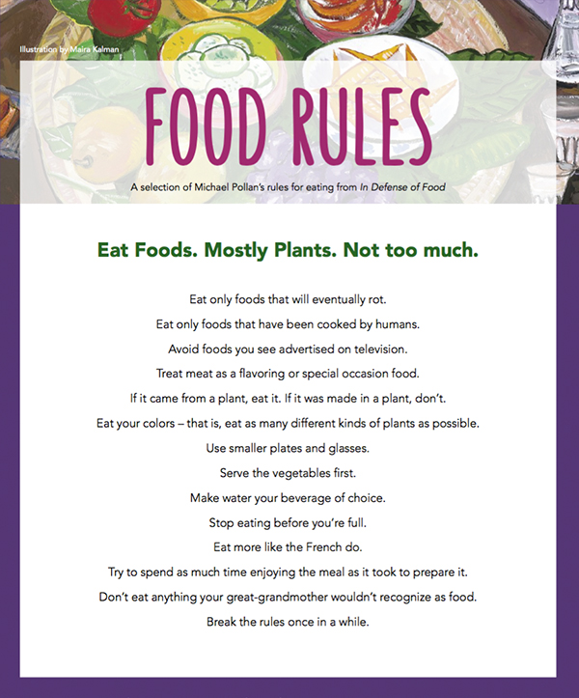

Miss Foley
Well10: W1 Wellness Intro In Defense of Food

All answers must be typed, single spaced, in Times New Roman size 12 font. Please separate your response for each question into a separate paragraph. Question 4 supermarket sketch can be stapled to your answers.

- Early in the film Michael Pollan makes the distinction between “food” and “edible food-substances”. Why is it important to make this distinction? Give three (3) examples of foods from each of these categories.
- Pollan believes that the solution to our dietary woes comes down to seven simple words: Eat food. Mostly plants. Not too much. Provide a brief summary outlining why he makes each of these recommendations.
  - Eat Food.
  - Mostly Plants.
  - Not Too Much.
- Review the list of Pollan’s fourteen “Food Rules”.
- *The completion of this question requires that you set foot in a grocery store.*
Pollan suggests that shopping at the supermarket can be treacherous for those who are trying to eat healthy. After visiting a local supermarket, answer the following questions:
- Describe the layout of products in the store. What types of foods are located in the periphery/outside aisles of the store? What types of foods are located in the center aisles? Include a sketch of the store layout, with the name of the supermarket.
- Look at how products are placed in the center aisles. What types of products are located at “eye level”? Compare them to products located near the bottom of the shelves. What trends do you notice?
- Where is the milk located in respect to the entrance of the store? Why do you think this is so?

