W7 Physical Fitness:
PRE, POST #1, POST #2, POST #3 (Please Circle)
Health-Related Fitness: Strength & Endurance
Lower Body – Squat Thrusts/Standing Burpees _________ # of squat thrusts/burpees
From standing, go down into front plank position, stand back up again. Do as many as you can until you fatigue breaking form by not standing up fully, not going into full plank form or start to noticeably slow your pace.
Upper Body – Medicine Ball Throw
Sit back to the wall with feet extended and slightly apart. Bring medicine ball to chest before pushing out as far as possible and releasing ball. Keep back in contact with wall. Record your best of 3 attempts.
_________ kg ball used _________ cm = throw distance
Upper Body – Push Ups _________ # of push ups
Do as many as you can until you fatigue breaking “head in line with hips in line with knees” form and lowering to “90º in elbows” form.
Core – Partial Curl-Ups _________ # of partial curl ups
Lie on floor with hands touching badminton doubles sideline. Curl up until hands touch badminton singles sideline. Do as many curl ups as you can until your hand(s) lift from the floor, you don’t touch both lines, or your butt shifts too far back that you can’t touch the lines.
Health-Related Fitness: Cardiovascular *Only Complete One Cardio Test*
20m Shuttle Run/Beep Test – How many levels can you stay in the test for? ________ level
1600m Run – How fast can you run 1600m? ________ min _______ sec (23 blue line B-Ball court laps)
Cooper 12 min Run – How many laps can you run in 12 minutes? _________ laps
Health-Related Fitness: Flexibility
Sit & Reach – Sit with feet extended & slightly apart. Place zero end of meter stick in between and directly in line with your knees. Reach forward along meter stick. Record your best of 3 attempts. _________ cm
Shoulder Stretch – arm over shoulder in back-scratch position, other arm reaches behind back to see if your fingers touch from each hand.
Right Side _________ cm or _________ Yes! I Can Touch My Fingers
Left Side _________ cm or _________ Yes! I Can Touch My Fingers
Trunk Lift – Lie on stomach with arms at your sides. Slowly extend upper body off floor. Distance is measured from the floor to the bottom of your chin. Maximum score is 30 cm as hyperextension can be harmful to the back. _________ cm
Health-Related Fitness: Body Composition
Personal body composition not assessed on growing and developing bodies in school settings.
W7 Physical Fitness: Pre-Assessment
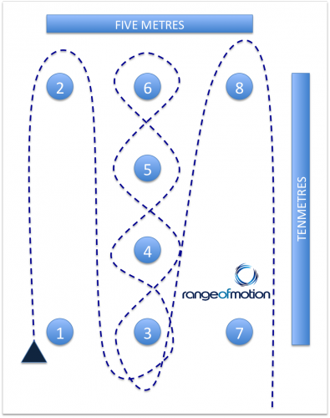
Skill-Related Fitness: Agility *Complete One Agility Test*
Illinois Agility Run _________ sec
- Begin face down on the ground with hands near shoulders.
- On 'go', jump to your feet and follow the directions indicated by the dotted lines.
- Start from cone seven on alternate attempts.
Pro-Agility Shuffle _________ sec
- Start straddling the middle line at cone 1 with one hand touching the ground.
- Sprint to touch the line at cone two.
- Sprint to touch the line at cone three.
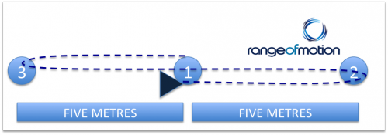
- Sprint back through the start/finish line indicated by cone one.
- Alternate starting direction on alternate attempts.
- Complete 3 attempts. Use your fastest time.
Skill-Related Fitness: Power
Lower Body Power – Vertical Jump _______ cm Vertical Jump
If you don’t have a vertical jump test station available and you have to do it along the wall:
  - Standing sideways (perpendicular) to the wall, how high can you reach with feet planted and making a mark with a marker? _________ cm = Standing Height
  - Step away from the wall. Using your arms and legs, how high can you reach directly above your first mark while jumping and making a mark with a marker?
_________ cm = Jumping Height
  - How high did you jump?
Jumping Height ________ cm – Standing Height ________cm = _______ cm Vertical Jump
Upper Body Power – Clapping Push Ups _________ push ups
Skill-Related Fitness: Balance
Standing Stork Test – Stand on one leg, the other foot resting on the standing leg. Time how long you can stand without putting your foot down.
Right Foot: _________ min _________ sec Left Foot: _________ min _________ sec
Skill-Related Fitness: Speed
30m sprint – How quickly can you sprint 30m? _________ sec
Skill-Related Fitness: Coordination
Tennis Ball Test – How many times can you hit the wall with a tennis ball within 1 minute without losing control? _________ contacts
Bounce Tennis Ball Test - Bounce 2 tennis balls (1 in each hand) as many times as you can without dropping them. _________ bounces
Skill-Related Fitness: Reaction Time
Ruler Drop Test - A ruler is held above the hand with the zero end just above/level with top of the hand. Ruler is then dropped. Person being tested has to quickly respond and catch the ruler. The measurement is then taken at the point where the ruler has been caught. _________ cm

Reflection Questions:
- Which areas of health-related and skill-related fitness would you like to maintain?

- Which areas of health-related and skill-related fitness would you like to improve?

- What might be some possible challenges to you improving these areas?

- What is the F.I.T.T. principle of training?
Rest of document is still DRAFT form….

Illinois Agility Run Standards (Ages 16-19 years)
Rating | Males (seconds) | Females (seconds)
Excellent | < 15.2 | < 17.0
Above Average | 16.1-15.2 | 17.9-17.0
Average | 18.1-16.2 | 21.7-18.0
Below Average | 18.3-18.2 | 23.0-21.8
Poor | > 18.3 | > 23.0

Cooper 12 Minute Run Standards (Ages 15-16 years)
Rating | Males (seconds) | Females (seconds)
Excellent | > 2800 m | > 2100 m
Good | 2500-2800 m | 2000-2100 m
Average | 2300-2499 m | 1700-1999 m
Poor | 2200-2299 m | 1600-1699 m
Very Poor | < 2200 m | < 1600 m

Sit & Reach Standards (Ages 15-16 years) *Using sit & reach box
Rating | Males (seconds) | Females (seconds)
Excellent | > 35 | > 39
Good | 31-34 | 33-38
Average | 27-30 | 29-32
Poor | < 27 | < 29

