Miss Foley
ESci20: AS2 Healthy Water Montreal “Flushgate”

Case Study: Montreal Sewage Dump
(November 2015)
The city of Montreal will begin the week-long dumping of eight billion liters of untreated sewage into the St. Lawrence river on Wednesday morning. Mayor Denis Coderre admitted Tuesday the dump is was “unpopular” but maintained it was done “in a responsible manner.” “It is with no light heart that we proceed with this decision. If we could have avoided this choice we would have done it. If there had been betters options we would have adopted them,” Coderre said. “The reality is this option is based on the lowest impact on the environment.”
So why is Montreal dumping the untreated sewage into the St. Lawrence river?
It comes down to infrastructure repairs. Montreal is dumping the untreated sewage into the St. Lawrence River because intercepting infrastructure that feeds sewage to a treatment facility needs to be repaired. Workers will inspect and clean various sections of the interceptor and they can’t do that while it’s still functioning. Coderre says the city will create a clean-up plan for areas affected by the sewage. “We can’t lose sight that this operation is aimed precisely at limiting the unplanned breakdown of strategic equipment to increase our future capacity to treat wastewater,” Coderre said Tuesday.
How Montreal will dump the sewage?
The city will send 12,000 litres of wastewater per second into the St. Lawrence, via 24 submerged outfall pipes. On Monday, Canada’s Environment Minister Catherine McKenna said she would permit the dump as long as the city implemented several conditions measures to limit the effect of the sewage on the river that included an emergency management plan, video surveillance during and following the discharge and water quality monitoring. The city said it will also have to provide Environment Canada with a report outlining all the events that led to the controversial decision.
What are the environmental risks of dumping the untreated sewage?
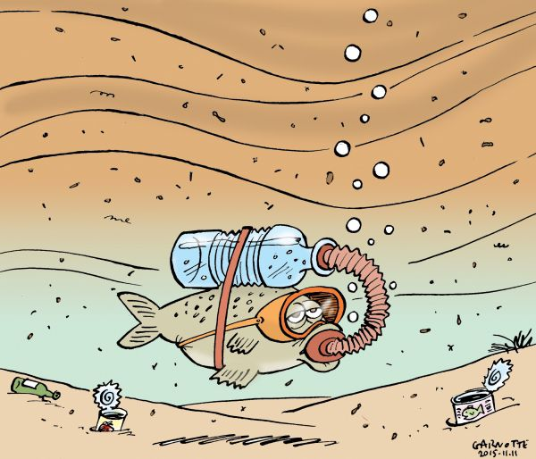
Officials with Environment Canada have said an expert panel hired by the federal government to examine the issue concluded the risks associated with waiting are worse than the city’s current plan. Caroline Blais, a director at the federal agency, told the Canadian Press that there is “little likelihood” it will affect fish production. “The experts’ evaluation is that the risks of not going ahead could result in impacts that are larger than if we didn’t proceed in the way Montreal wants to go,” she said. Coderre urged Montreal residents to remember that everything they flushed and everything that went down a drain for the next week would end up in the

Miss Foley
ESci20: AS2 Healthy Water Montreal “Flushgate”

river. He asked them not to flush diapers, condoms, tampons, medication, or other items for the next week. Lynda Collins, a professor at the University of Ottawa, said the situation highlights the need for increased infrastructure spending. “Hopefully it will confirm the new federal government’s resolve to adequately fund those [infrastructure] initiatives,” she said.
Source: Global News http://globalnews.ca/news/2330913/why-is-montreal-dumping-8-billion-litres-of-sewage-into-the-st-lawrence/
Answer the following questions using full, complete sentences in paragraph form:
- Summarize in your own words the Montreal sewage dump controversy by compiling all the information you find. Compare it to the current situation now.
*Use the website listed above and don’t forget to record any additional resources you have used.
- Analyze how water pollution can affect the following due to the changes of aquatic system conditions:
  - The spread of disease through water
  - Mercury in fish
  - Blue-green algae
  - E coli in drinking water
- Explain and analyze why developing and enforcing the following water quality standards are necessary and apply to our case:
  - Saskatchewan Surface Water Quality Objectives
  - Canadian Water Quality Index
  - Legislation of the Canada Water Act
  - International River Improvements Act
- Examine how individuals and organizations (Watershed Associations, Saskatchewan Water Security Agency, etc.) work to ensure a clean and healthy aquatic system through enforcement of water regulations and the who is in charge of the decision making process of where the water is distributed
- How does indirect pollution (i.e. exhaust from vehicles or boats, oil leakage, etc.) and direct pollution (littering, sewage dumping, oil spill, etc.) affect all life within our ecosystem?
- After all the research you have found, what would you suggest as the solution for this issue? Do you agree or disagree with the decision? What could you do to prevent this from occurring in the future?

