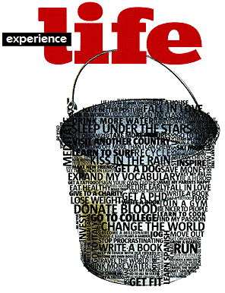A Bucket List That Matters
Remember that you have only one soul; that you have only one death to die; that you have only one life...
If you remember this, there will be many things in this world which you will care nothing about. Saint Teresa
Adventure  Community service  Developing my Gifts & Talents  Family/Friends  Finances | Health  Learning / Education  Things I will teach my kids  Sacrifices I will make  Ways I’ll grow closer to God | To do before I graduate Gr. 12  Things I commit to NEVER doing  Things I will do before I’m 30  Things I will do before I’m 40  Ways I will serve the poor
Somebody should tell us right at the start of our lives that we are dying. Then we might live to the limit, this life we are called to live. Every minute of every day! Do it I say! Do it now!
There are only so many tomorrows. Pope Paul VI

