Miss Foley
HSci20: HC1 Philosophies Historical Evolution

Evolution of Medicine

Medicine was developed to
combat the problem of
disease and wounds

Medicine Through Time
- Prehistoric Medicine – 5000 – 3000 BC - health, herbs, spirits, trephining, aborigines
- Ancient Egypt – 3000 – 1000 BC - gods, mummies, no dissection
- Ancient Greece – 1000 – 500 BC - Asclepios, Hippocrates, Hippocratic oath, Four Humours
- Romans – 500BC – 400 AD - Public health, army, Galen
- Dark Ages – 400 – 1100 – no new learning, faith and superstition, monasteries
- Middle Ages – 1100 – 1400 – medical schools, Four Humours, planets, herbs, Black death, public health
- Renaissance and Reformation – 1500-1700 – new ideas, science, Royal Society, printing, Paracelsus, Great Plague, Vesalius, Pare, Harvey
- Enlightenment - 1800s – Jenner, Nightingale, Germ Theory, Pasteur, Koch, anaesthetics - Simpson, antiseptics - Lister,
- Industrial revolution – Chadwick, cholera, Snow
- Twentieth Century – Penicillin – Fleming, Florey and Chain, blood groups and transfusions, X-rays, transplants
Prehistoric Medicine (5000 – 3000 BC)
Prehistoric people were hunter-gatherers. They lived in small groups and constantly moved around the country seeking out the best conditions for shelter and food supplies. In order to explain the many things in the world they could not otherwise understand, they believed in spirits.
Primitive people were superstitious & believed illness was caused by:
- invasion of evil spirits
- supernatural forces
First physicians were witch doctors who treated illness with ceremonies.
Herbs and plants were used as medicine. For example:
  - Foxglove plants leaves were chewed to strengthen & slow heart
  - Nowadays, it’s given by pills, IV, or injections

Miss Foley
HSci20: HC1 Philosophies Historical Evolution
Trepanation: A hole was cut into the skull to release demons
Trepanning is one of the oldest recorded surgical procedures and has been documented worldwide.
Although trepanning was used over many time periods, the procedure was first used in the Stone Age.
What are some of the possible complications of this treatment?

Ancient Egyptian Medicine (3000 – 1000 BC)
Like prehistoric man, some of the beliefs of the Egyptians were based on myths and legend. However, their knowledge was also based on an increasing knowledge of the human anatomy and plain common sense.
In Ancient Egypt, the treatment of illnesses was no longer carried out only by magicians and medicine men. We have evidence that people existed who were referred to physicians and doctors.
Almost all of our knowledge about Ancient Egyptian medical knowledge comes from the discoveries of papyrus documents. It is from these documents that we know that the Ancient Egyptians still believed that the supernatural caused some disease.
When there was no obvious reason for an illness, many Ancient Egypt doctors and priests believed that disease was caused by spiritual beings. When no-one could explain why someone had a disease, spells and magical potions were used to drive out the spirits.
Embalming/Mummification: is a process in which the skin and flesh of a corpse can be preserved. The process can occur either naturally, or it can be intentional.
The process of embalming a body led to increased understanding of anatomy and diseases. It was done by special priests, not a doctor priest. Gauzes where used to wrap bodies, much like the surgical gauze that is used today. Strong antiseptics kept bodies from decaying
Leeches: Leeches would be used for bloodletting (draining human blood). The process does not hurt because their saliva contains a natural anesthetic. Their saliva also contains a blood thinner, a vasodilator, and an agent that prevents bacteria from infecting the wound.

Miss Foley
HSci20: HC1 Philosophies Historical Evolution

Ancient Greece (1000 – 500 BC)
Ancient Greece played an important part in medical history. Gods dominated the lives of the Greeks. Natural occurrences were explained away by using gods. This, however, did not occur in medicine where Ancient Greek physicians tried to find a natural explanation as to why someone got ill and died.
However, not all Ancient Greeks turned to physicians when ill. Many still turned to the gods. Many turned to the god Asclepios for help. Places called asclepeia were built for those in poor health. These were like temples and here people came to bathe, sleep and meditate. The asclepeias were run by priests. Patients to asclepeias were encouraged to sleep as it was believed that during sleep they would be visited by Asclepios and his two daughters, Panacea and Hygeia. A visit by these three was expected to cure all ailments.
Hippocrates
The most famous of all Ancient Greek doctors was Hippocrates. Hippocrates was a Greek physician born around 460BC. He strongly believed that there had to be a physical cause for all illnesses and rejected ideas that illness was due to superstition or evil spirits. He developed the theory of the four humours to explain illnesses.
Hippocrates spent much time observing the body and was the first physician to accurately describe the symptoms of pneumonia and epilepsy in children. He also noted, through his observations, that some people were able to get over illnesses quicker than others and was the first physician to believe that thoughts, feelings and ideas came from the brain not from the heart.
The Hippocratic Collection is a group of books that were used for centuries. They were written over a period of 150 years. The books contain detailed lists of symptoms and treatments and were used for hundreds of years.
Hippocrates believed in a holistic approach to medicine - that the body should be treated as a whole rather than separate parts and travelled throughout Greece practising his medicine. Later he established a medical school on the island of Cos.
Why is Hippocrates an important figure in medicine?
Hippocrates spent much time thinking about the role of the medical practitioner – what his duties and responsibilities towards his patients should be.

Miss Foley
HSci20: HC1 Philosophies Historical Evolution

Hippocrates believed that those practicing medicine and surgery should be classified separately from philosophers (thinkers) and cosmologists (those who study the universe).
The Hippocratic Oath
The Hippocratic Oath sets out the moral responsibilities of a physician. It is still used today in a modified form. The main points of the oath:
1. The student of medicine and physician will be true to his teacher and his profession.
2. The physician will only practice medicine for the benefit of the sick and not for any criminal or illegal purposes.
3. That the physician will keep secret things that he is told by his patient.
Romans Medicine (500BC – 400 AD)
The Ancient Romans, like the Ancient Greeks and Ancient Egyptians, made a huge input into medicine and health, though their input was mainly concerned with public health schemes. Though the Roman ‘discoveries’ may not have been in the field of pure medicine, poor hygiene by people was a constant source of disease, so any improvement in public health was to have a major impact on society.
The Romans learned a great deal from the Ancient Greeks. They used the ideas of the Greeks but they did not simply copy them. Greek ideas they found impractical they ignored and it seems that the Romans were keener on things that would lead to the direct improvement of the quality of life of the people in their huge empire.
The Romans and Public Health:
The Romans were great believers in a healthy mind equaling a healthy body. There was a belief that if you kept fit, you would be more able to combat an illness. Rather than spend money on a doctor, many Romans spent money on keeping fit.
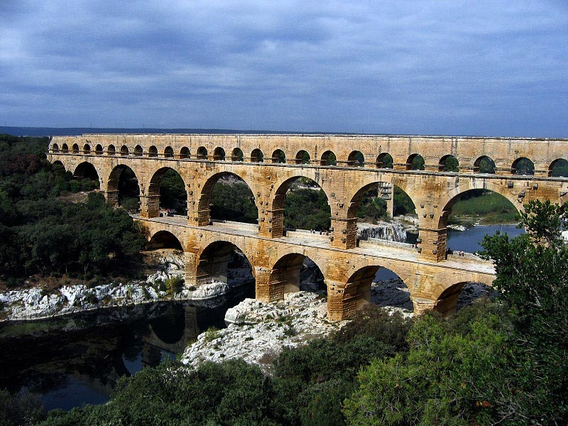
The Romans did believe that illnesses had a natural cause and that bad health could be caused by bad water and sewage, hence their desire to improve the public health system in the Roman Empire so that everyone in their empire benefited – not just the rich. Those who worked for the Romans needed good health as did their soldiers.
In this sense, the Romans were the first civilization to introduce a program of public health for everyone regardless of wealth.
Aqueducts
Romans realized that disease was connected to filth, bad water, and poor sanitation. They built sewers for waste, and aqueducts to deliver clean water. They created laws to keep streets clean and eliminate garbage. The first hospitals were also established.

Miss Foley
HSci20: HC1 Philosophies Historical Evolution

Claudius Galen
Galen was a physician, writer and philosopher who became the most famous doctor in the Roman Empire and whose theories dominated European medicine for 1,500 years.
Galen was the originator of the experimental method in medical investigation, and throughout his life dissected animals in his quest to understand how the body functions. Some of his anatomical and physiological observations were accurate - for example, he proved that urine was formed in the kidney as opposed to the bladder which was common belief. His most important discovery was that arteries carry blood although he did not discover circulation.
Claudius Galen is credited with assigning the terms scoliosis, kyphosis, and lordosis to the disorder. He experimented with chest binders and jackets in an effort to correct curvature of the spine and believed that repeated exercise of the rib cage musculature through such methods as loud singing and respiratory exercises could correct some of the distortion.
Dark Ages (400 – 1100)
Under constant attack from barbarian tribes the Romans had been forced to pull its armies back to defend Rome. The Roman Empire had fallen.
As the Romans left, many of their practices fell into disuse. People returned to a tribal existence and the Romans knowledge of public health was no longer used.

Faith and Superstition
Alcohol and opium were used to numb the senses during operations and for pain relief. Other popular remedies included mandrake and hemlock. Mandrake was used for pain relief, wounds, gout, insomnia and for love potions. Cures using hemlock were problematic because the plant changes according to weather and age and the remedy would often cause more problems including death.
The church taught people that illness and disease was a punishment from God and that they needed to pray to be cured. The soul was considered more important than the body. Medical treatments and bodily cleanliness were of little importance.

Monasteries
St. Benedict, founder of the Benedictine monks believed that the cure of the sick was one of the most important duties of monks. During the dark ages, monasteries were the
only hospitals in Europe. Patients were cared for in the hospitals until they recovered or died. Their fate was God’s will. Prayer and/or pilgrimages to holy shrines were considered the best methods of affecting a cure.
Middle Ages (1100 – 1400)
During the Dark Ages (AD400-1100) there was little progress in medicine in Europe. As Europe moved into the middle ages, however, this began to change.

Miss Foley
HSci20: HC1 Philosophies Historical Evolution

Doctors in the Middle Ages
In 900 the first European medical school in Europe was established. Others followed. The works of Galen and other ancient writers were rediscovered and taught. By the late Middle Ages physicians could only practice medicine if they had trained at one of the medical schools. The church oversaw medical training. The ideas of Galen were encouraged because they fitted in with religious ideas.
Knowledge of anatomy was gained by studying books and through dissection of dead bodies.
Physicians were bound by the Hippocratic Oath.
Women were not allowed to go to university or to become physicians. Women did, however, continue to give day to day care of the sick and continued to act as midwives.

Causes of illness
Many physicians believed that illness was due to common sense reasons (bad smells etc.), imbalance of the four humours, position of the sun and planets, punishment from God, or poisonous fumes.

Treatments
Physicians would often study a patient’s urine and/or use astrology before deciding on a suitable treatment. Due to belief in maintaining the balance of the four humours, bleeding was a very common treatment.
Surgery was not taught at universities, surgeons learnt surgery by watching an established surgeon.
Physicians often worked as army doctors, treating those injured during the many wars of this period.
Herbal concoctions such as hemlock, mandrake, wine or opium were used for pain relief. Herbal remedies were widely used for many everyday illnesses. Preparation of herbs improved due to the improvement in equipment made by scholars interested in alchemy (trying to turn cheap metals into gold).

Hospitals
The Catholic Church taught that it was a religious duty to care for the sick, but it was not until the twelfth century that the church provided medical schools. Of the hospitals that were in existence, only 10% actually provided medical care. They were called hospitals because they provided hospitality (housing, food and clothing) for the needy.
Monks and nuns cared for people in hospitals. Physicians were rarely seen in hospitals, they treated kings, nobles and wealthy merchants, not ordinary people.
Renaissance and Reformation (1500-1700)
The Renaissance was a great period of intellectual growth and artistic development in Europe. As part of that scientists and thinkers began to shake loose from the traditional views that governed medicine in both the east and the west. The focus of treatments

Miss Foley
HSci20: HC1 Philosophies Historical Evolution

was no longer a divinely ordained natural balance. Knowledge advanced through the scientific method—conducting experiments, collecting observations, reaching conclusions. Information was disseminated by means of an important new technology—printing. The roots of scientific medicine were set.
Surgery was practiced mostly by barbers, who used the same tools for both trades. It remained a pretty primitive and extraordinarily painful business in this era. Controversy continued over wound management—was pus good or bad? Cauterization, the burning of a wound to close it, remained the main way to stop bleeding. Most surgeons learned their skills on the battlefield, and the introduction of gunpowder, guns, and cannons made that a much messier place.
The scientific method is applied to medicine.
In 1543, Andreas Vesalius (1514-1564) published an exquisitely illustrated anatomy text. With knowledge based on extensive dissection of human cadavers, he presented the first largely accurate description of the human body.
Ambroise Paré (1510-1590), began to instil some order. He translated some of Vesalius’s work into French to make the new anatomical knowledge available to the battlefield surgeons. With extensive battlefield experience himself, he sewed wounds closed rather than cauterizing them to stop the bleeding during amputations. He replaced the boiling oil used to cauterize gunshot wounds with a salve of egg yolk, oil of roses, and turpentine. His treatments were not only more effective but much more humane than those previously used.
Another major figure of this era was Paracelsus (1493-1541), a Swiss alchemist and physician. He believed that specific diseases resulted from specific outside agents and thus called for specific remedies. He pioneered the use of mineral and chemical remedies, including mercury for the treatment of syphilis.
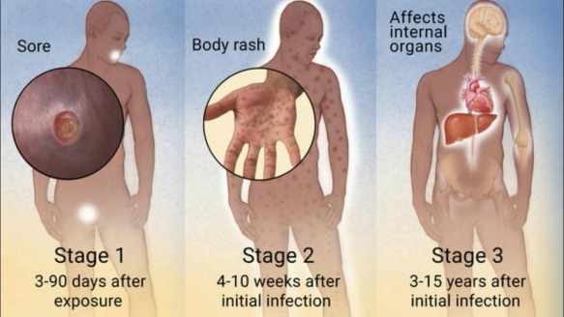
Syphilis: The first written records of an outbreak of syphilis in Europe occurred in 1494 or 1495 in Naples, Italy, during a French invasion.
Characteristics:
- highly contagious disease spread primarily by sexual activity
- Occasionally, the disease can be passed to another person through prolonged kissing or close bodily contact
- Spread from sores, but the vast majority sores go unrecognized.
- Syphilis is caused by the bacteria Treponema pallidum.
Stage 1 - Early or Primary: one or more sores that resemble large round bug bites and are often hard and painless. They occur between 10-90 days (average three weeks) after exposure. Even without treatment they heal without a scar within six weeks.
Stage 2 - Secondary: last one to three months and begins within six weeks to six months after exposure. People with secondary syphilis experience a rosy "copper penny" rash typically on the palms of the hands and soles of the feet. Like primary syphilis, secondary syphilis will resolve without treatment.
Stage 3 - Tertiary: If the infection isn't treated, it may then progress to a stage characterized by severe problems with the heart, brain, and nerves that can result in paralysis, blindness, dementia, deafness, impotence, and even death if it's not treated.

Miss Foley
HSci20: HC1 Philosophies Historical Evolution

William Harvey (1578-1657)
During the 17th and 18th centuries, scientific and medical knowledge advanced at an extraordinary pace. Many of Galen’s misconceptions were finally overturned. The Englishman William Harvey accurately described the circulation of blood in the body, confirming the findings of earlier scholars. He added the critical experimental finding that blood is "pumped" around the body by the heart.
It was Anton van Leeuwenhoek (1632-1723), a Dutch draper and scientist, and one of the pioneers of microscopy who in 1666 became the first man to make and use a real microscope. The invention of the microscope allowed doctors to see disease-causing organisms.
The Great Plague (1665–66) was the last major epidemic of the bubonic plague. Plague is an acute, severe infectious disease caused by the bacterium Yersinia pestis. The bacterium is found in fleas and wild rodents such as rats, squirrels, chipmunks or prairie dogs. Plague is a zoonotic disease, which means it can be transmitted to humans through animals, most often through the bites of fleas or through direct contact with infected animal tissue.
An Enema cleans up the colon and induces bowel movements. The first record mentioning a colon therapy is an Egyptian medical document discovered by Ebers, dated as early as 1500 B.C. The process of enema requires liquid that is forced with a low pressure into the rectum through anus. Enemas have been in practice from ancient time and helped to cure a lot of disorders like constipation, poisoning, acute headache, flu, common cold, meningitis, measles and a lot more.
Enlightenment (1800s)
The 18th century, known as the Age of Enlightenment, was an era of progress in many respects. The desire to find a single an explanation for "life, the universe, and everything" had not disappeared. Some thinkers attributed the workings of the body to newly discovered laws of physics, while others looked to the laws of chemistry.
In the 19th century medical practice finally began to change. At this same time, scientists and physicians made the discoveries that truly revolutionized medicine. Improvements in the microscope made possible more detailed studies of tissues, a field called histology. This led to the new science of cells, called cytology. These studies paved the way for the major theories and practical developments that formed the basis of medicine as we know it today.
Edwin Chadwick (1800-1890) is associated with public health improvements during the era of Queen Victoria. Edwin Chadwick used his position to persuade the government to invest in public health ventures and he must be credited with being Britain’s premier pioneer in public health reform.

Miss Foley
HSci20: HC1 Philosophies Historical Evolution

Cell Theory
Robert Hooke saw and named cells in the early 17th century, when he viewed dead plant cells. In the 19th century the work of three German scientists, Theodore Schwann (1810-82), Matthias Jakob Schleiden (1804-81), and above all, Rudolf Virchow (1821-1902), led to the development of cell theory.
The Cell Theory states:
- all living things are composed of cells
- cells are the basic unit of structure and function in living things
- cells are produced from other cells.
Using cell theory, Virchow was able to explain biological processes such as fertilization and growth. He also demonstrated that changes in cells cause diseases such as cancer. Cell theory is one of the cornerstones of modern medicine.
Germ Theory
The other cornerstone was the development of germ theory. Even in the peak of humoral medicine (using the For Humors Theory), there were healers who recognized that some diseases were spread by contagion.
In general, most scientists believed that disease-causing germs arose from spontaneous generation, just as creatures such as flies, worms, and other small animals appeared to arise spontaneously from decaying matter.
A theory from the Greeks had a very strong influence throughout the 19th century. This theory was based on the idea that diseases such as the plague and cholera were caused by foul-smelling miasmas (air containing particles of rotting matter). The theory that such air was poisonous seemed believable because it associated disease with poor sanitation, and the importance of hygiene was recognized early.
The British nursing pioneer, Florence Nightingale (1820-1910) firmly believed that miasmas caused disease. By then, however, studies were well under way that finally put to rest both these misconceptions. In additional to vastly improving the sanitary conditions of hospitals, Nightingale created a number of patient services that contributed to improving the quality of their hospital stay.
In 1854 the English physician John Snow (1813-1858) traced the source of a cholera outbreak in London to water contaminated by sewage. His detailed study was a key event in the history of both public health and epidemiology.
Louis Pasteur (1822-1895) conducted the experiments that overturned the idea that life could be spontaneously generated. He demonstrated that there are microorganisms everywhere, including in the air. He further demonstrated that they were the source of the chemical process by which milk soured. The process he developed that heats milk (and other liquids) to kill the microbes bears his name: « pasteurization ». When adopted, pasteurization ensured that milk stopped to be a source of tuberculosis and other diseases.
Pasteur believed passionately that microorganisms were responsible for infectious diseases in humans and animals and for their transmission among them. And he

Miss Foley
HSci20: HC1 Philosophies Historical Evolution

developed effective vaccines against anthrax and rabies by harvesting tissue from animals that had died from these diseases.
Joseph Lister (1827-1912) made the link between lack of cleanliness in hospitals and deaths after operations. In 1865, Lister read about the work done by Louis Pasteur on how wine was soured. Lister believed that it was microbes carried in the air that caused diseases to be spread in hospitals. People who had been operated on were especially vulnerable as their bodies were weak and their skin had been cut open so that germs could get into the body with more ease. For this reason, he is known as the “Father of Antiseptic Surgery”.
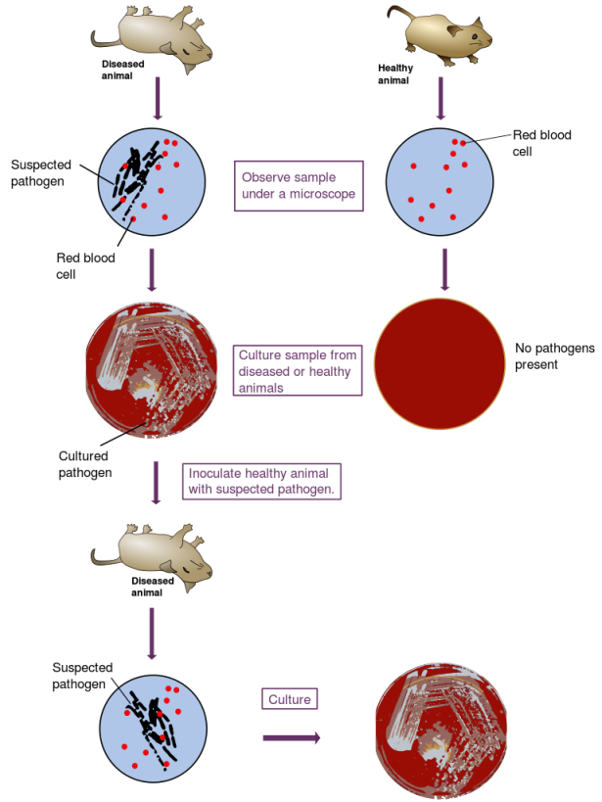
It was the work of a German doctor, Robert Koch (1843-1910), which finally validated the germ theory of disease. He identified the specific bacteria that caused anthrax, tuberculosis, and cholera. He developed a set of rules (Koch’s postulates) for determining whether a microorganism is the source of a disease in a person rather than simply being present. The science of bacteriology was born.
Koch's postulates are:
- The bacteria must be present in every case of the disease.
- The bacteria must be isolated from the host with the disease and grown in pure culture.
- The specific disease must be reproduced when a pure culture of the bacteria is inoculated into a healthy susceptible host.
- The bacteria must be recoverable from the experimentally infected host.
Edward Jenner (1749-1823) is alongside the likes of Joseph Lister, Robert Koch and Louis Pasteur in medical history. Edward Jenner’s great gift to the world was his vaccination for smallpox. This disease was greatly feared at the time as it killed one in three of those who caught it and badly disfigured those who were lucky enough to survive catching it.
Anesthesia and Antiseptics
Before the 19th century operations were horrific procedures, and most patients died from post-operative shock, infection, or loss of blood.
In the middle of the 19th century other discoveries finally made extensive surgery practical. Until then surgical options had been limited by the pain of operating on a person who was awake, and the danger of infection after the operation.
In the 1840s several American dentists pioneered the use first of nitrous oxide and then ether as anesthetics. The latter was soon adopted in Europe for surgical purposes, finally allowing surgeons time to perform long and delicate surgeries.
In 1847 James Simpson (1811-1870) discovered anaesthetic properties of chloroform.

Miss Foley
HSci20: HC1 Philosophies Historical Evolution

Twentieth Century (1900s)
The pace of medical advances quickened in the 20th century. Breakthroughs came in biology, chemistry, physiology, pharmacology, and technology, often in overlapping ways. New understanding of diseases brought new treatments and cures for many of these conditions. However, even as most of the killer epidemic diseases were conquered, new diseases emerged, such as AIDS. During the 20th century, life spans increased in most parts of the world and some diseases that had appeared to have been conquered by drug treatments, such as tuberculosis, developed resistance.
Drugs to treat sicknesses
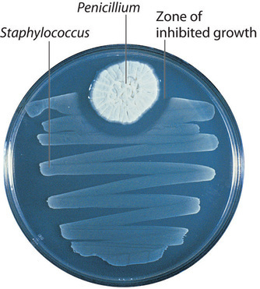
Toward the end of the 19th century the study of herbal, chemical, and mineral remedies transformed into the science of pharmacology. Plant drugs such as opium underwent systematic chemical analysis. Researchers learned how to synthesize these drugs. By the 20th century the pharmaceutical industry marketed laboratory products.
In the 1920s Alexander Fleming (1881-1955) found a mold growing on some bacterial samples in his laboratory. In fact, the mold killed his samples. He discovered the most powerful of all antibiotics: penicillin.
During World War II a team of researchers led by Australian Howard Florey (1898-1968) used Alexander Fleming’s research and tested the new drug on injured soldiers. It proved that penicillin was effective against anthrax, tetanus, and syphilis and was the first drug that worked against pneumonia. Many new drugs followed in the 1950s, including cortisone (steroid hormone that reduced inflammation and suppressed the immune system response).
Viruses were thought to be invisible until the invention of the electron microscope in the 1940s, but they were eventually identified as the cause of a host of diseases. These include not only smallpox, but also influenza, the common cold, chickenpox, polio, and more recently, AIDS. They are also thought to play a major role in cancer.
Although antibiotics did not work against viral diseases, antiviral vaccines did. Two of the most important were the vaccines against smallpox and polio.
Polio, chiefly a disease of childhood, causes paralysis. Two American scientists, Jonas Salk (1914-95) and Albert Sabin (1906-93), developed different versions of a polio vaccine, which were introduced in the mid-1950s. Both were used, with great success. Polio was mostly eradicated by the end of the 20th century.
Other antiviral vaccines include those for measles, chickenpox, and influenza. Vaccines against human papillomavirus (a cause of cervical cancer) and shingles (a relative of chickenpox caused by herpes) became available in 2006. Efforts to develop a vaccine against malaria, ebola and AIDS have so far been unsuccessful.
The first antiviral drug, acyclovir, appeared in the 1970s for use against some forms of herpes. Antiretroviral drugs were developed in the 1980s to combat AIDS. Viruses mutate so quickly, however, that developing antiviral (and antiretroviral) agents has proved very difficult.

Blood groups and transfusions
In 1901, Karl Landsteiner (1868-1943) was awarded the Nobel Prize in Physiology or Medicine in 1930 for discovering human blood groups making blood transfusions safer. Mixing blood from two individuals can lead to blood clumping or agglutination. The clumped red cells can crack and cause toxic reactions. This can have fatal consequences. Karl Landsteiner discovered that blood clumping was an immunological reaction which occurs when the receiver of a blood transfusion has antibodies against the donor blood cells.

Miss Foley
HSci20: HC1 Philosophies Historical Evolution

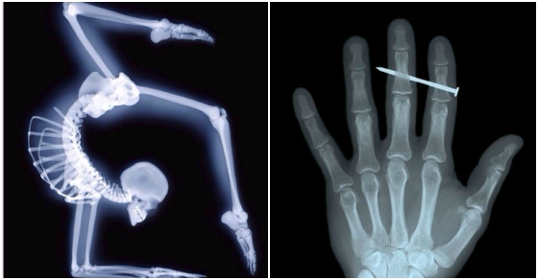
X-Rays
Modern medicine and technology seem inseparable. The discovery of X-rays by German physicist Wilhelm Conrad Roentgen (1845-1923) in 1895 made it possible to look at internal organs of the body. This made it easier to diagnose broken bones, cancer, and other diseases. X-rays, of course, are a form of radiation, which is dangerous to the body. Radiologists learned to use the lowest doses possible in imaging. They also learned to use targeted X-rays and other forms of radiation to destroy unwanted cells. Thus radiation has become a standard treatment for cancer.

Transplants
In 1912, transplant pioneer Alexis Carrell (1873-1944) received the Nobel Prize for his work in the field. He had developed methods for connecting blood vessels and conducted successful kidney transplants on dogs. He later worked with aviator Charles Lindbergh to invent a device for keeping organs viable outside the body, a precursor to the artificial heart.
In 1960, British immunologist Peter Medawar (1915-1987), who had studied immunosuppression’s role in transplant failures, received the Nobel Prize for his discovery of acquired immune tolerance. Soon after, anti-rejection drugs enabled patients to receive organs from non-identical donors.

In the 1960’s the first successful lung, pancreas and liver transplants took place. Also, Christiaan Barnard’s (1922-2001) performed the first open heart transplant. In 2014 such operations are common, but in the late 1960’s operations on the heart were rarely performed because of the risk of death and heart transplants were unheard of.

Other advancements
After WWII, many advances were made in the management of pregnancy and childbirth. This included the ability to induce labour and the use of epidurals to ease difficult pregnancies. The chance of infant survival also improved as medical knowledge developed. The greater use of scans after 1945 also helped to detect problems earlier.
Major advances were also made in birth control. By the 1960’s, the contraceptive pill was widely available, as was the IUD (Intrauterine device).
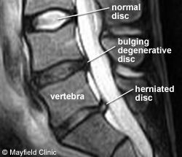
Many very significant medical advances were also made after 1945. One of the most important was the discovery of DNA by Wilkins, Crick and Watson. These three were also helped by the work done by Rosalind Franklin. DNA is the substance that makes life. This has in turn allowed the study of disease caused by defective genes such as in cystic fibrosis and Down’s Syndrome. In recent years, researchers have been able to identify specific genes that are responsible for specific diseases.
The use of ultrasound and magnetic resonance since 1945 has also made it easier to diagnose disease. Ultrasound was developed for looking at unborn babies. Magnetic Resonance Imaging (MRI) can be used to detect diseases without the use of radiation making it less harmful to the patient. Three-dimensional CAT scans can also be used. Less use of radiation the better as some patients can be harmed by exposure to large doses of radiation.

Name: _________________________ Date: ____________
HSci20: HC1 Philosophies Historical Evolution

Historical Timelines

Historical Era | “Healers” | Overall Contributions | Location of Care
Prehistoric Medicine
(5000-3000BC)
Ancient Egypt
(3000-1000BC)
Ancient Greece
(1000-500BC)
Ancient Rome
(500BC-400AD)
Dark Ages
(400-1100)

Name: _________________________ Date: ____________
HSci20: HC1 Philosophies Historical Evolution

Historical Era | “Healers” | Overall Contributions | Location of Care
Middle Ages
(1100-1400)
Renaissance & Reformation
(1500-1700’s)
Industrial Revolution
(1750-1825)
Enlightenment
(1800’s)
20th Century
(1900’s)
Historical Timelines (cont’d)

Miss Foley
HSci20: HC1 Philosophies Medical Technology

Medical Technology Milestones
1668 Microscope - Dr. Antony Van Leeuwenhoek, a Dutch draper and scientist, and one of the pioneers of microscopy who in the late 17th century became the first man to make and use a real microscope.
1798 Vaccination -Edward Jenner invents the world's first vaccine against the deadly disease called smallpox
Dec. 31, 1815 Stethoscope - René Laënnec, a French physician, invented the stethoscope, a trumpet-shaped wooden tube, to examine a woman whose heart he could not hear by pressing his ear to her chest.
Dec. 31, 1841 Anesthesia - Dr. Crawford W. Long performed the first operation using diethyl ether as an anesthetic. He pressed an ether-soaked towel against the patient's face to put him to sleep, then removed one of two tumors from his neck. He billed the patient $2, itemizing the cost of the ether as well as the operation.
1862 Pasteurization - The process is named after Louis Pasteur. He was the first person to learn how to do it successfully. The first pasteurization was done by Louis Pasteur and Claude Bernard on April 20, 1862. It is a process of heating food, which is usually a liquid, to a specific temperature for a predefined length of time and then immediately cooling it after it is removed from the heat. This process slows spoilage caused by microbial growth in the food.
1865 Antiseptic - Joseph Lister was instrumental in developing practical applications of the germ theory of disease with respect to sanitation in medical settings and aseptic surgical techniques—partly through the use of carbolic acid (phenol) as an antiseptic.
1873 Compound Microscope Resolution - Ernst Abbe worked out the solution to the blurry compound microscope problem in the 1870's. He determined the physical laws that govern the collection of light by an objective and maximized this collection by using water and oil immersion lenses. (viewing of pathogens)
Dec. 31, 1874 Brain Waves - Using a galvanometer, the British scientist Richard Caton noted electrical impulses from the brains of animals, laying down the principles that would lead to the development of the electroencephalogram, or EEG.
1895 X-Ray - Wilhelm Conrad Röntgen, a German physicist, discovered the X-ray, an invention so remarkable that many did not believe the first reports of its use. The New York Times referred to it mockingly as Dr. Röntgen's "alleged discovery of how to photograph the invisible."
1903 Electrocardiogram - Dr. Willem Einthoven of the Netherlands invented the first practical electrocardiogram. The original weighed 600 pounds had a water cooling system for its gigantic electromagnets and needed five operators. In 1924 he received the Nobel Prize in Physiology or Medicine for his invention.
1910 Laparoscopy - Dr. Hans Christian Jacobaeus, a Swedish internist, performed the first laparoscopy on a human. He punctured the abdominal walls of 17 patients, using cocaine as a local anesthetic, and removed fluid from their abdomens. After removing the fluid, he examined the cavities with a cytoscope.
1924 Electroencephalogram - Dr. Hans Berger of Germany recorded the first human electroencephalogram, or EEG. His assertion that the brain's electrical impulses could be recorded was generally met with derision, and five years passed before Dr. Berger published his technique for recording the electrical activity of the human brain from the surface of the head.

Miss Foley
HSci20: HC1 Philosophies Medical Technology

1931 Electron Microscope - The invention of the electron microscope by Max Knoll and Ernst Ruska at the Berlin Technische Hochschule in 1931 finally overcame the barrier to higher resolution that had been imposed by the limitations of visible light. The electron microscope allowed us to view viruses, pathogens of many human diseases
1936 Pacemaker - Dr. Albert S. Hyman demonstrated a heart pacemaker. The device was about 10 inches long and weighed less than a pound; it supplied the heart with a current with adjustable voltage. The device, Dr. Hyman said, had been used in seven cases, although the results were good in only two of them.
1943 Dialysis - Willem J. Kolff, a Dutch physician, built the first dialysis machine, working with tin cans and parts from washing machines during the Nazi occupation of the Netherlands. Although his first few attempts were failures, Dr. Kolff did finally develop a useful machine in the 1950s while working with colleagues at the Cleveland Clinic.
1947 Cardiac Defibrillation - A Cleveland cardiovascular surgeon, Claude Beck, successfully defibrillated the heart of a 14-year-old boy during cardiac surgery, bringing an apparently dead person back to life. Although the principle of defibrillation had been known for decades, this was probably its first successful clinical application.
1952 Mechanical Heart - Henry Opitek, 41, was operated on using an artificial heart, the Dodrill GMR heart machine, manufactured by General Motors and generally considered the first mechanical heart. The surgeon, Dr. Forest Dewey Dodrill, successfully repaired the patient's mitral valve, and Mr. Opitek lived until 1981.
1952 Magnetic Resonance - The Nobel Prize in Physics was awarded to Felix Bloch and Edward Mills Purcell for their work in developing nuclear magnetic resonance, the principle behind M.R.I. machines.
1953 Heart-Lung Bypass - Dr. John Heysham Gibbon used his new invention, the heart-lung bypass machine, for the first time in open-heart surgery, supporting a patient's heart and lung functions for about half the time of the surgery. It was the culmination of his decades of work in developing the machine.
1954 Kidney Transplant - In the first successful kidney transplant, after at least nine failures, a team of surgeons at Peter Bent Brigham Hospital in Boston transplanted a kidney from a 24-year-old man to his twin brother. The recipient lived 11 years more, and in 1990 the lead surgeon, Dr. Joseph E. Murray, won the Nobel Prize in Medicine or Physiology.
1958 Pacemaker - Dr. Seymour Furman, a cardiologist at Montefiore Hospital in the Bronx, succeeded in extending a patient's life by more than two months using a cardiac pacemaker, a large machine to which the patient was attached by a 50-foot extension cord. By the next year, portable versions of the machine were in use.
Fetal Ultrasound - Dr. Edward Hon of Yale reported using a Doppler monitor on a woman's abdomen to detect fetal heartbeat. Ultrasound's principles had been known for more than a century (a Swedish physicist, Christian Andreas Doppler, gave his name to the phenomenon in 1842), but this was its first use in prenatal care.
1961 Minimally Invasive Surgery - Dr. Thomas J. Fogarty came up with the idea for the balloon embolectomy catheter for removing blood clots, and used it on a patient six weeks later. It was the first minimally invasive surgery technique.
1963 Artificial Heart - Paul Winchell, the ventriloquist and inventor, patented the first artificial heart, developed in collaboration with Dr. Henry J. Heimlich, later famous for the Heimlich maneuver.
Liver Transplant - The first human liver transplant was performed by Dr. Thomas E. Starzl. The patient, a 3-year-old child, rapidly bled to death.

Miss Foley
HSci20: HC1 Philosophies Medical Technology

1965 Portable Defibrillator - Dr. Frank Pantridge installed the first portable defibrillator in an ambulance in Belfast, Northern Ireland. It weighed 150 pounds and was powered by car batteries.
Commercial Ultrasound - Walter Erich Krause of the Siemens Corporation filed a patent for the first practical commercial ultrasound machine. According to the patent, his machine could be "used for practical ultra-sonic-optical examination to achieve a lifelike reproduction of the body part under examination."
1967 Heart Transplant - Dr. Christiaan Barnard, performed first human heart transplant. The patient, a 53-year-old man, died 18 days later.
1971 CT Scanner - The first commercial CT scanner, developed by Dr. Godfrey Hounsfield, was used on a patient in London. Dr. Hounsfield shared the 1979 Nobel Prize in Physiology or Medicine for his invention.
1973 Insulin Pump - An inventor and entrepreneur, Dean L. Kamen, patented the first insulin pump. He became perhaps even better known for a later invention, the Segway transporter.
1978 M.R.I. - Dr. Raymond V. Damadian announced that he had patented a technique using nuclear magnetic resonance to distinguish between normal and cancerous tissue. In 2003, two other researchers won a Nobel Prize for further discoveries.
1989 Synthetic Blood - The first synthetic blood, Fluosol-DA, was approved for human use. It was withdrawn from the market in 1994. The search for a blood substitute goes on, and there is none in use in clinical practice.
1992 DNA Sequencing - Dr. Leroy E. Hood patents his invention of the automated DNA sequencing technique. The patent is owned by the California Institute of Technology.
Imaging Thought - A paper in the journal Magnetic Resonance Medicine by a group of researchers at the Medical College of Wisconsin announced the first use of functional magnetic resonance imaging to detect brain blood flow in conjunction with a human mental activity.
2000 Human Genome - The first draft of the human genome was announced. Three years later, it was declared complete three years later.
2004 Adaptive Artificial Knee - The Rheo knee, a plastic prosthetic joint that adapts to a user's walking style and changes in terrain, was produced by the Ossur Corporation.
2006 Artificial Liver - Mr. Colin McGucklin and Dr. Nico Forraz of Newcastle University developed a liver grown from stem cells. The size of a small coin, it was not an organ that could be implanted in a human.
Where to from here? (Check out the link)
- Augmented reality
- Google brain
- Recreational cyborgs
- Medical 3D printing
- Gamifying behavior change
- New emergent diseases
- Real time diagnostics & data
- Holographic data input
- Digestible & wearable sensors
- Multi-functional radiology machines
- Genomics
- Patient empowerment
And even more here! (Check out the link)

Miss Foley
HSci20: HC1 Philosophies Cultural Lens

Cultural Perspectives
Culture | Health Concepts | Cause of Illness | Traditional Healers | Methods of Treatment | Response to Pain
South African | - Maintain harmony of body, spirit and mind  - Harmony with nature  - Illness can be prevented by diet, rest and cleanliness | - Supernatural cause  - Spiritual and demons  - Punishment from God  - Conflict or disharmony in life | - Root Doctor  - Folk Practitioner(commonly known as “mother” healer, spiritualist) | - Restore harmony  - Prayer or meditation  - Herbs, roots, poultices and oils  - Religious rituals  - Charms, talismans and amulets | - Tolerating pain is a sign of strength  - Some may express pain
Asian | - Health is a state of physical and spiritual harmony with nature  - Balance of two energy forces: yin(cold) and yang (hot) | - Imbalance between yin and yang  *Supernatural forces such as God, evil spirits or ancestral spirits  - Unhealthy environment | - Herbalist  - Physician  - Shaman healer (physician-priest) | - Cold remedies if yang is overpowering and hot remedies if yin is overpowering  - Herbal remedies  - Acupuncture and acupressure  - Energy to restore balance between yin and yang | - Pain must be accepted and endured silently  - Displaying pain in public brings disgrace  - May refuse pain medication
European | - Health can maintained by diet, rest and exercise  - Immunizations and preventive practices help maintain health  - Good health is a personal responsibility | - Outside sources such as germs, pollutants or contaminants  - Punishment for sins  - Lack of cleanliness  - Self-abuse (drugs, alcohol, tobacco) | - Physician  - Nurse | - Medications and surgery  - Diet and exercise  - Home remedies and self-care for mild illnesses  - Prayer and religious rituals | - Some express pain loudly and emotionally  - Others value self-control in response to pain  - Pain can be helped by medications

Miss Foley
HSci20: HC1 Philosophies Cultural Lens

Cultural Perspectives (cont’d)
Culture | Health Concepts | Cause of Illness | Traditional Healers | Methods of Treatment | Response to Pain
Hispanic | - Health is a reward from God  - Health is good luck  - Balance between “hot” and “cold” forces | - Punishment from God for sins  - Susto (fright), malojo (evil eye), or envidia (envy)  - Imbalance between hot and cold | - Native healers (Curandero, Espiritualista, Yerbero, or herbalist, Brujo) | - Hot and cold remedies to restore balance  - Prayers, medals, candles and religious rituals  - Herbal remedies, especially teas  - Massage  - Anointing with oil  - Wearing an Azabache (black stone) to ward off the evil eye | - Many will express pain verbally and accept treatment  - Other feel pain is a part of life and must be endured
Middle Eastern | - Health is caused by spiritual causes  - Cleanliness essential for health  - Male individuals dominate and make decisions on health care | - Spiritual causes  - Punishment for sins  - Evil spirits or evil “eye” | - Traditional healers  - Physician | - Meditation  - Charms and amulets  - Medications and surgery  - Male health professionals prohibited from touching or examining female patients | - Tolerating pain is a sign of strength  - Self-inflicted pain is used as a sign of grief
First Nations | - Health is harmony between man and nature  - Balance among body, mind and spirit  - Spiritual powers control body’s harmony | - Supernatural forces and evil spirits  - Violation of a taboo  - Imbalance between man and nature | - Medicine Man  - Shaman | - Rituals, charms and masks  - Prayer and meditation to restore harmony and nature  - Plants and herbs  - Medicine bag or bundle filled with herbs and blessed by medicine man | - Pain is a normal part of life and tolerance of pain signifies strength and power

Miss Foley
HSci20: HC1 Philosophies Holistic Health Care

Health Care Approaches Defined
Complementary Medicine is alternative medicine used together with conventional medical treatment, in a belief not confirmed using the scientific method that it "complements" (improves the efficacy of) the treatment. CAM is the abbreviation for complementary and alternative medicine. Integrative medicine (or integrative health) is the combination of the practices and methods of alternative medicine with conventional medicine.
Traditional Medicine (also known as indigenous medicine) comprises knowledge systems that developed over generations within various societies before the era of modern medicine. The World Health Organization (WHO) defines traditional medicine as:
"Traditional medicine is the sum total of the knowledge, skills, and practices based on the theories, beliefs, and experiences indigenous to different cultures, whether explicable or not, used in the maintenance of health as well as in the prevention, diagnosis, improvement or treatment of physical and mental illness."
In some Asian and African countries, up to 80% of the population relies on traditional medicine for their primary health care needs. When adopted outside of its traditional culture, traditional medicine is often called complementary and alternative (CAM) medicine.
The WHO also notes, though, that "inappropriate use of traditional medicines or practices can have negative or dangerous effects" and that "further research is needed to ascertain the efficacy and safety" of several of the practices and medicinal plants used by traditional medicine systems. Core disciplines which study traditional medicine include herbalism, ethno medicine, ethno botany, and medical anthropology.
Traditional medicine may include formalized aspects of folk medicine, i.e. longstanding remedies passed on and practiced by lay people. Practices known as traditional medicines include Ayurveda, Siddha medicine, Unani, ancient Iranian medicine, Irani, Islamic medicine, traditional Vietnamese medicine, traditional Chinese medicine, traditional Korean medicine, acupuncture, Muti, Ifá, traditional African medicine, and many other forms of healing practices.
Alternative medicine is any practice that is put forward as having the healing effects of medicine, but does not originate from evidence gathered using the scientific method, is not part of biomedicine or is contradicted by scientific evidence or established science. It consists of a wide range of health care practices, products and therapies, ranging from known or experienced effective and biologically plausible but not well tested, to being directly contradicted by evidence and science, or even harmful or toxic. Examples include new and traditional medicine practices such as homeopathy, naturopathy, chiropractic, energy medicine, various forms of acupuncture, traditional Chinese medicine, Ayurvedic medicine, and Christian faith healing. The treatments are those that are not part of the science-based healthcare system, and are not clearly backed by scientific evidence.
Alternative medical diagnoses and treatments are not included as science-based treatments that are taught in western medical schools, and are not used in medical practice where treatments are based on what is established using the scientific method. Regulation and licensing of alternative medicine and health care providers varies from country to country, and state to state.
Western Medicine is a term sometimes used to describe evidence-based medicine, which, for various historical reasons, emerged from "Western" civilization (i.e. countries originally populated by or settled by Europeans), though it is now practiced throughout the world. It involves the use of pharmacologically active agents or physical interventions to treat or suppress symptoms or pathophysiologic processes of diseases or conditions. Additionally the epistemological virtues of particular aspects of clinical trial methodology have been examined, mostly notably the special place that is given to randomization, the notion of a blind experiment and the use of a placebo control.
Limitations of western medicine include dealing with: fiber myalgia, chronic pain, lower back pain, cancer, who gets an organ transplant, long waiting lists, creating superbugs, less strengthening of natural immunity, and potential awful side effects.

Miss Foley
HSci20: HC1 Philosophies Holistic Health Care

Health Care Approaches Summary
Health Perspective | Definition | Strengths | Challenges
Complementary Medicine
Traditional Medicine
Alternative Medicine
Western Medicine

Miss Foley
HSci20: HC1 Philosophies CAMedicine

CAM = Complementary and Alternative Medicine
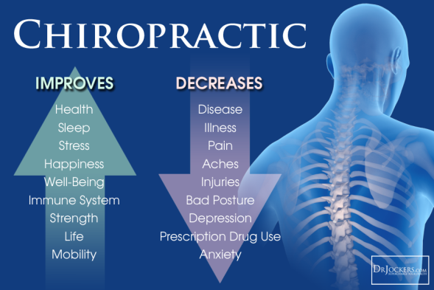
Chiropractic is a form of alternative medicine that emphasizes diagnosis, treatment and prevention of mechanical disorders of the musculoskeletal system, especially the spine, under the belief that these disorders affect general health via the nervous system. Many chiropractors reject being characterized as complementary and alternative medicine (CAM). It is a healthcare profession, and although chiropractors have many similarities to primary care providers, they are more similar to a medical specialty like dentistry or podiatry. The main chiropractic treatment technique involves manual therapy, especially manipulation of the spine, other joints, and soft tissues; treatment may also include exercises and health and lifestyle counseling. Traditional chiropractic assumes that a vertebral subluxation or spinal joint dysfunction interferes with the body's function and its innate intelligence.
Chiropractic is well established in the U.S., Canada and Australia. It overlaps with other manual-therapy professions, including massage therapy, osteopathy, and physical therapy. Back and neck pain are the specialties of chiropractic but many chiropractors treat ailments other than musculoskeletal issues. Most who seek chiropractic care do so for low back pain.
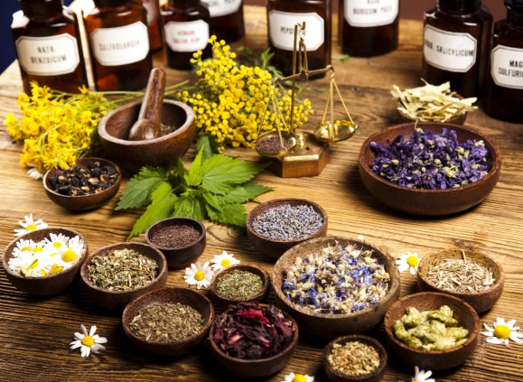
Herbalism ("herbology" or "herbal medicine") is use of plants for medicinal purposes, and the study of such use. Plants have been the basis for medical treatments through much of human history, and such traditional medicine is still widely practiced today. Modern medicine recognizes herbalism as a form of alternative medicine, as the practice of herbalism is not strictly based on evidence gathered using the scientific method. Modern medicine does, however, make use of many plant-derived compounds as the basis for evidence-tested pharmaceutical drugs, and phytotherapy works to apply modern standards of effectiveness testing to herbs and medicines that are derived from natural sources. The scope of herbal medicine is sometimes extended to include fungal and bee products, as well as minerals, shells and certain animal parts. The World Health Organization (WHO) estimates that 80 percent of the population of Asian and African countries presently use herbal medicine for some aspect of primary health care. Pharmaceuticals are prohibitively expensive for most of the world's population, half of which lives on less than $2 U.S. per day. In comparison, herbal medicines can be grown from seed or gathered from nature for little or no cost.
Many of the pharmaceuticals currently available to physicians have a long history of use as herbal remedies, including opium, aspirin, digitalis, and quinine. According to the World Health Organization, approximately 25% of modern drugs used in the United States have been derived from plants. At least 7,000 medical compounds in the modern pharmacopoeia are derived from plants. Among the 120 active compounds currently isolated from the higher plants and widely used in modern medicine today, 80 percent show a positive correlation between their modern therapeutic use and the traditional use of the plants from which they are derived.

Miss Foley
HSci20: HC1 Philosophies CAMedicine

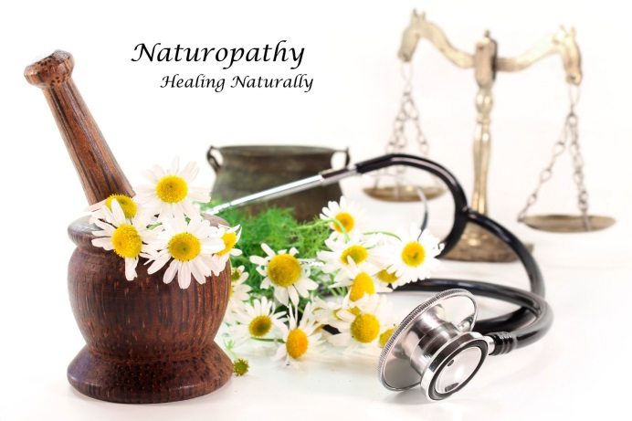
Naturopathy, or naturopathic medicine, is a form of alternative medicine based on a belief in vitalism, which posits that a special energy called "vital energy" or "vital force" guides bodily processes such as metabolism, reproduction, growth, and adaptation. Naturopathy favors a holistic approach with non-invasive treatment and generally avoids the use of surgery and drugs. Practitioners of naturopathy often prefer methods of treatment that are not compatible with evidence-based medicine, and in doing so sometimes reject the tenets of biomedicine and modern science.
The term "naturopathy" is derived from Latin and Greek, and literally translates as "nature disease". Modern naturopathy grew out of the Natural Cure movement of Europe. The term was coined in 1895 by John Scheel and popularized by Benedict Lust, the "father of U.S. naturopathy". Beginning in the 1970s, there was a revival of interest in the United States and Canada, in conjunction with the holistic health movement. Today, naturopathy is primarily practiced in the United States and Canada. Naturopathy comprises many different treatment modalities, including nutritional and herbal medicine, lifestyle advice, counseling, flower essence, homeopathy and remedial massage.
Naturopaths aim to prevent illness through stress reduction and changes to diet and lifestyle, often rejecting the methods of evidence based medicine. Naturopaths do not generally recommend vaccines and antibiotics, based in part on the early views that shaped the profession, and they may provide alternative remedies even in cases where evidence-based medicine has been shown effective.
Homeopathy is a system of alternative medicine created in 1796 by Samuel Hahnemann based on his doctrine of “like cures like”: a substance that prevents the symptoms of a disease in healthy people will cure similar symptoms in sick people. Homeopathy is considered a pseudoscience, and its remedies have been found to be no more effective than placebos.
Diseases have spiritual, as well as physical causes. Hahnemann believed the underlying causes of disease were phenomena that he termed miasms, and that homeopathic remedies addressed these. Medicines may cure symptoms, but the underlying imputed miasm still remains, and deep-seated ailments can be corrected only by removing the deeper disturbance of the vital force. The remedies are prepared by repeatedly diluting a chosen substance in alcohol or distilled water, Claims: dilution increases potency.
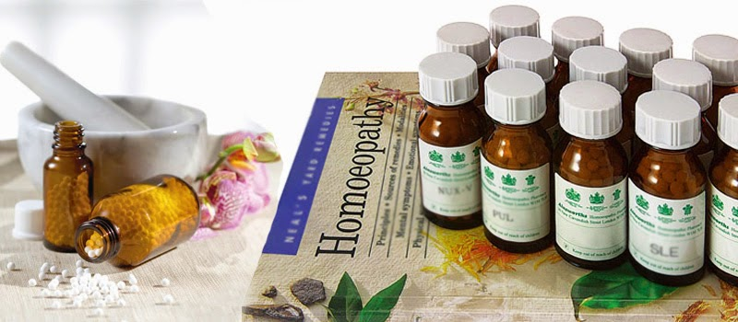
The postulated mechanisms of action of homeopathic remedies are both scientifically implausible and not physically possible. Although some clinical trials produce positive results, systematic reviews reveal that this is because of chance, flawed research methods, and reporting bias. Continued homeopathic practice, despite the evidence that it does not work, has been criticized as unethical because it increases the suffering of patients by discouraging the use of real medicine, with the World Health Organization warning against using homeopathy to try to treat severe diseases such as HIV and malaria. The continued practice, despite a lack of evidence of efficacy, has led to homeopathy being characterized within the scientific and medical communities as nonsense, quackery, or a sham.

Miss Foley
HSci20: HC1 Philosophies CAMedicine

Acupuncture is the stimulation of specific acupoints along the skin of the body involving various methods such as penetration by thin needles or the application of heat, pressure, or laser light. Traditional acupuncture involves needle insertion, moxibustion, and cupping therapy. It is a form of complementary and alternative medicine and a key component of traditional Chinese medicine (TCM). According to TCM, stimulating specific acupuncture points corrects imbalances in the flow of qi through channels known as meridians. Acupuncture aims to treat a range of conditions, though is most commonly used for pain relief.
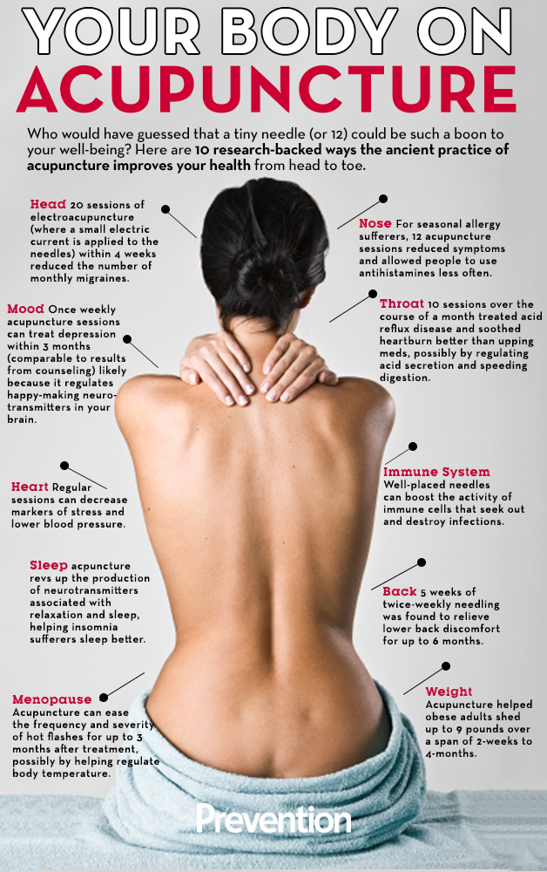
Acupuncture has been the subject of active scientific research, both in regard to its basis and therapeutic effectiveness, since the late 20th century. Any evidence on the effectiveness of acupuncture is "variable and inconsistent" for all conditions. Some of the research results suggest acupuncture can alleviate pain but others consistently suggest that acupuncture's effects are mainly due to placebo. A systematic review of systematic reviews highlighted recent high-quality randomized controlled trials which found that for reducing pain, real acupuncture was no better than sham acupuncture. It remains unclear whether acupuncture reduces pain independent of a psychological impact of the needling ritual.
Acupuncture is generally safe when done using clean technique and single use needles. When properly delivered, it has a low rate of mostly minor adverse effects. However since serious adverse events continue to be reported, it is recommended that acupuncturists be trained sufficiently to reduce the risk.
Acupuncture is currently used widely throughout China and many other countries, including the United States & Canada.

Miss Foley
HSci20: HC1 Philosophies CAMedicine

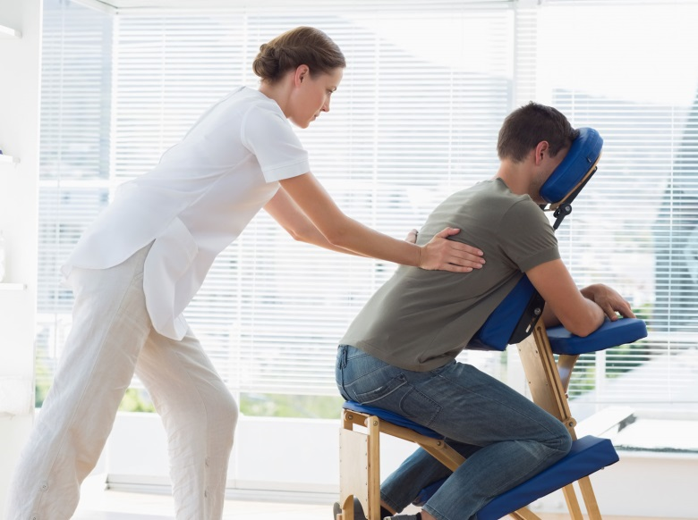
Massage Therapy is the manipulation of superficial and deeper layers of muscle and connective tissue using various techniques, to enhance function, aid in the healing process, decrease muscle reflex activity, inhibit motor-neuron excitability, promote relaxation and well-being. Massage involves working and acting on the body with pressure – structured, unstructured, stationary, or moving – tension, motion, or vibration, done manually or with mechanical aids. Target tissues may include muscles, tendons, ligaments, fascia, skin, joints, or other connective tissue, as well as lymphatic vessels, or organs of the gastrointestinal system. Massage can be applied with the hands, fingers, elbows, knees, forearm, or feet.
The main professionals that provide therapeutic massage are massage therapists, athletic trainers, physical therapists and practitioners of many traditional Chinese and other eastern medicines. Massage practitioners work in a variety of medical settings and may travel to private residences or businesses. Contraindications to massage include deep vein thrombosis, bleeding disorders or taking blood thinners such as Warfarin, damaged blood vessels, weakened bones from cancer, osteoporosis, or fractures, bruising, and fever. Anyone suffering from these conditions should not use massage therapy.
Aromatherapy is a form of alternative medicine that uses volatile plant materials, known as essential oils, and other aromatic compounds for the purpose of altering a person's mind, mood, cognitive function or health. Other stated uses include pain and anxiety reduction, enhancement of energy and short-term memory, relaxation, hair loss prevention, and reduction of eczema-induced itching.
Two basic mechanisms are offered to explain the purported effects. One is the influence of aroma on the brain, especially the limbic system through the olfactory system. The other is the direct pharmacological effects of the essential oils. While precise knowledge of the synergy between the body and aromatic oils is often claimed by aromatherapists, the efficacy of aromatherapy remains unproven. However, some preliminary clinical studies of aromatherapy in combination with other techniques show positive effects. Aromatherapy does not cure conditions, but it is suggested that it helps the body to find a natural way to cure itself and improve immune response.
Some essential oils such as tea tree have demonstrated anti-microbial effects, but there is still a lack of clinical evidence demonstrating efficacy against bacterial, fungal, or viral infections. Evidence for the efficacy of aromatherapy in treating medical conditions remains poor, with a particular lack of studies employing rigorous methodology, but some evidence exists that essential oils may have great therapeutic potential.

Miss Foley
HSci20: HC1 Philosophies CAMedicine

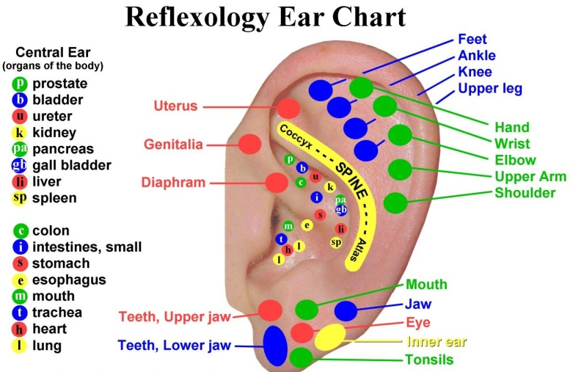
Reflexology, or zone therapy, is an alternative medicine involving the physical act of applying pressure to the feet, hands, or ears with specific thumb, finger, and hand techniques without the use of oil or lotion. It is based on what reflexologists claim to be a system of zones and reflex areas that they say reflect an image of the body on the feet and hands, with the premise that such work affects a physical change to the body.
Through application of pressure on these reflexes without the use of tools, crèmes or lotions, the feet being the primary area of application, reflexology relieves tension, improves circulation and helps promote the natural function of the related areas of the body.
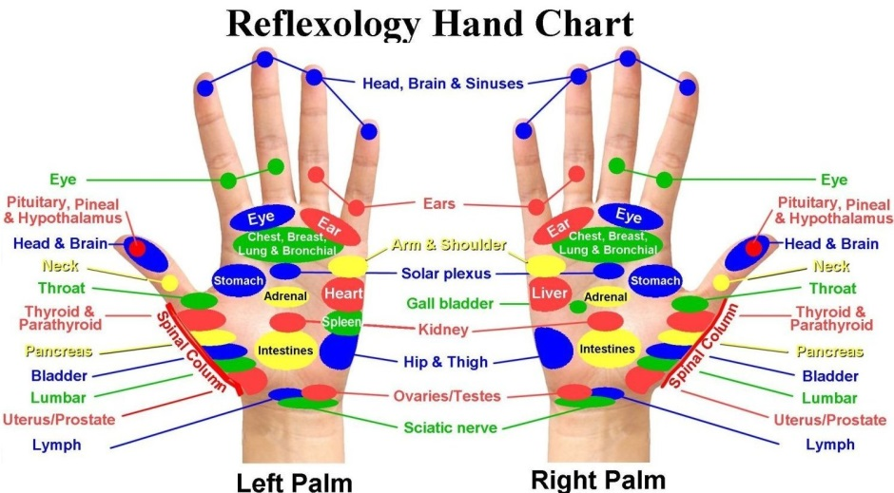
Reflexologists position that the blockage of an energy field, invisible life force, or Qi, can prevent healing. Another tenet of reflexology is the belief that practitioners can relieve stress and pain in other parts of the body through the manipulation of the feet. One claimed explanation is that the pressure received in the feet may send signals that 'balance' the nervous system or release chemicals such as endorphins that reduce stress and pain.
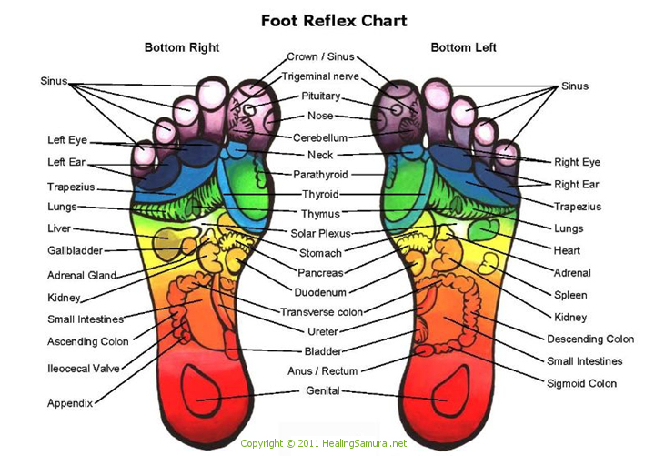
Reflexology's claim to manipulate energy (Qi) has been highly controversial, as there is no scientific evidence for the existence of life energy (Qi), 'energy balance', 'crystalline structures,' or 'pathways' in the body. There is no consensus among reflexologists on how reflexology is supposed to work; a unifying theme is the idea that areas on the foot correspond to areas of the body, and that by manipulating these one can improve health through one's Qi. Reflexologists divide the body into ten equal vertical zones, five on the right and five on the left. Concerns have been raised by medical professionals that treating potentially serious illnesses with reflexology, which has no proven efficacy, could delay the seeking of appropriate medical treatment.

Miss Foley
HSci20: HC1 Philosophies CAMedicine

Iridology (also known as iridodiagnosis or iridiagnosis) is an alternative medicine technique whose proponents claim that patterns, colors, and other characteristics of the iris can be examined to determine information about a patient's systemic health. Practitioners match their observations to iris charts, which divide the iris into zones that correspond to specific parts of the human body. Iridologists see the eyes as "windows" into the body's state of health.
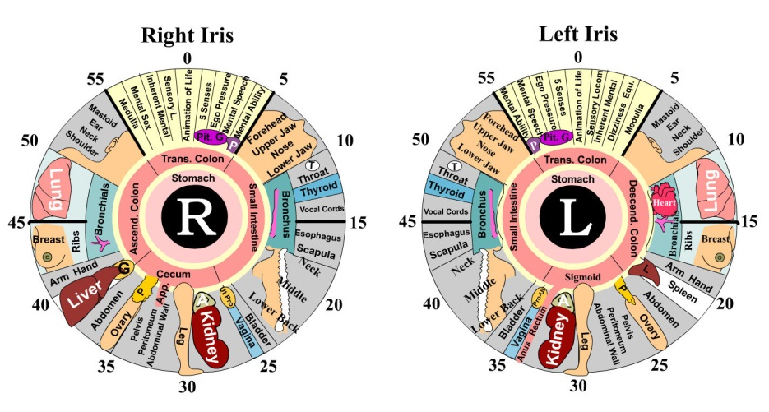
Iridologists believe they can use the charts to distinguish between healthy systems and organs in the body and those that are overactive, inflamed, or distressed. Iridologists believe this information demonstrates a patient's susceptibility towards certain illnesses, reflects past medical problems, or predicts later health problems.
As opposed to evidence-based medicine, Iridology is not supported by quality research studies and is widely considered pseudoscience. Iris texture is a phenotype feature which develops during gestation and remains without significant change after birth. The stability of iris structures is the foundation of the biometric technology which uses iris recognition for identification purposes.
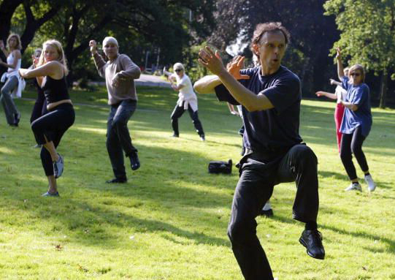
T'ai chi or tai chi in English is an internal Chinese martial art practiced for both its defense training and its health benefits. It is also typically practiced for a variety of other personal reasons: its hard and soft martial art technique, demonstration competitions, and longevity. T'ai chi's health training and meditation techniques concentrate on relieving the physical effects of stress on the body and mind.
A comprehensive overview of all the existing systematic reviews of t'ai chi ch'uan's health effects, found that as of 2011, "the evidence is conclusively or tentatively positive for fall prevention, general healthcare in older people, improving balance and enhancing psychological health"; the overview's authors thus recommended t'ai chi ch'uan to older people for its various physical and psychological benefits. There was no conclusive evidence of benefit for any of the other conditions researched, including Parkinson's disease, diabetes, cancer and arthritis.
Yoga as exercise or alternative medicine is a modern phenomenon which has been influenced by the ancient Indian practice of hatha yoga. It involves holding stretches as a kind of low-impact physical exercise, and is often used for therapeutic purposes. Yoga in this sense often occurs in a class and may involve meditation, imagery, breath work and music.
Both the meditative and the exercise components of hatha yoga have been researched for both specific and non-specific health benefits. Hatha yoga has been studied as an intervention for many conditions, including back pain, stress, and depression. In general, it can help improve quality of life, but does not treat disease.

Miss Foley
HSci20: HC1 Philosophies CAMedicine

A dietary supplement is intended to provide nutrients that may otherwise not be consumed in sufficient quantities. Supplements as generally understood include vitamins, minerals, fiber, fatty acids, or amino acids, among other substances. U.S. authorities define dietary supplements as foods, while elsewhere they may be classified as drugs or other products.
There are more than 50,000 dietary supplements available. More than half of the Canadian adult population (53% - 55%) consumes dietary supplements with most common ones being multivitamins. These products are not intended to prevent or treat any disease and in some circumstances are dangerous when not taken properly. For those who fail to consume a balanced diet, certain supplements "may have value."
Most supplements should be avoided, and usually people should not eat micronutrients except people with clearly shown deficiency because many are a waste of money with many popular vitamins having high levels of fillers and being composed of insoluble forms of the vitamins and minerals. Some vitamins are fat soluble so they are not absorbed unless eaten with lipids. Most excess vitamins are eliminated by the body, making expensive urine. People should first consult a doctor before taking supplements. An exception is vitamin D, which is recommended in northern hemisphere countries due to weak sunlight.
Placebo-controlled studies are a way of testing a medical therapy in which, in addition to a group of subjects that receives the treatment to be evaluated, a separate control group receives a sham "placebo" treatment which is specifically designed to have no real effect. Placebos are most commonly used in blinded trials, where subjects do not know whether they are receiving real or placebo treatment. Often, there is also a further "natural history" group that does not receive any treatment at all.
The purpose of the placebo group is to account for the placebo effect, that is, effects from treatment that do not depend on the treatment itself. Such factors include knowing one is receiving a treatment, attention from health care professionals, and the expectations of a treatment's effectiveness by those running the research study. Without a placebo group to compare against, it is not possible to know whether the treatment itself had any effect.
Patients frequently show improvement even when given a sham or "fake" treatment. Such intentionally inert placebo treatments can take many forms, such as a pill containing only sugar, a surgery where nothing efficacious is actually done (just an incision and sometimes some minor touching or handling of the underlying structures), or a medical device (such as an ultrasound machine) that is not actually turned on. Also, due to the body's natural healing ability and statistical effects such as regression to the mean, many patients will get better even when given no treatment at all. Thus, the relevant question when assessing a treatment is not "does the treatment work?" but "does the treatment work better than a placebo treatment or no treatment at all?" As one early clinical trial researcher wrote, "the first object of a therapeutic trial is to discover whether the patients who receive the treatment under investigation are cured more rapidly, more completely or more frequently, than they would have been without it." More broadly, the aim of a clinical trial is to determine what treatments, delivered in what circumstances, to which patients, in what conditions, are the most effective.
Therefore, the use of placebos is a standard control component of most clinical trials, which attempt to make some sort of quantitative assessment of the efficacy of medicinal drugs or treatments. Such a test or clinical trial is called a placebo-controlled study, and its control is of the negative type. A study, whose control is a previously tested treatment, rather than no treatment, is called a positive-control study, because its control is of the positive type.
Government regulatory agencies approve new drugs only after tests establish not only that patients respond to them, but also that their effect is greater than that of a placebo (by way of affecting more patients, by affecting responders more strongly, or both). As a result, "placebo-controlled studies often are designed in such a way that disadvantages the placebo condition".

Miss Foley
HSci20: HC1 Philosophies CAMedicine

Home birthing in developed countries is attended or an unattended childbirth in a non-clinical setting, typically using natural childbirth methods, that takes place in a residence rather than in a hospital or a birth center, and usually attended by a midwife or lay attendant with experience in managing home births. Home birth was, until the advent of modern medicine, the de facto method of delivery. Since the beginning of the 20th century, home birth rates have drastically fallen in most developed countries, generally to less than 1% of all births. Infant and mother mortality rates have also dropped drastically over the same time period.
Women with access to high-quality medical care may choose home birth because they prefer the intimacy of a home and family-centered experience or desire to avoid a medically-centered experience typical of a hospital. Professionals attending home births can be obstetricians, certified or uncertified midwives, and doulas. In developing countries, where women may not be able to afford medical care or it may not be accessible to them, a home birth may be the only option available, and the woman may or may not be assisted by a professional attendant of any kind.
Multiple studies have been performed concerning the safety of home births for both the child and the mother; as standard practices, licensing requirements, and access to emergency hospital care differs between regions it can be difficult to compare studies across national borders. A 2014 US survey of medical studies found that perinatal mortality rates were triple that of hospital births, and a US nation-wide study over 13 million births on a 3-year span (2007-2010) found that births at home were roughly 10 times as likely to be stillborn (14 times in first-born babies) and almost four times as likely to have neonatal seizures or serious neurological dysfunction when compared to babies born in hospitals, while a 2007 UK survey found that perinatal mortality rates were only slightly higher in that country than planned hospital births for low-risk pregnancies. Both baby's and mother's higher mortalities are associated with the inability to timely assist mothers with emergency procedures in case of complications during labor.
Blood transfusion is generally the process of receiving blood products into one's circulation intravenously. Transfusions are used for various medical conditions to replace lost components of the blood. Early transfusions used whole blood, but modern medical practice commonly uses only components of the blood, such as red blood cells, white blood cells, plasma, clotting factors, and platelets.
Units of packed red blood cells are typically only recommended when either a patient's hemoglobin level falls below 10 g/dL or hematocrit falls below 30%; recently, this 'trigger' level has been decreased to 7-8 g/dL, as a more restrictive strategy has been shown to have better patient outcomes. This is in part due to the increasing evidence that there are cases where patients have worse outcomes when transfused. One may consider transfusion for people with symptoms of cardiovascular disease such as chest pain or shortness of breath. Globally around 85 million units of red blood cells are transfused in a given year
Objections to blood transfusions may arise for personal, medical, or religious reasons. For example, Jehovah's Witnesses object to blood transfusion primarily on religious grounds—they believe that blood is sacred, as the Bible says "abstain from blood" (Acts 15:28,29). They have also highlighted complications associated with transfusion.
Organ donation is the donation of biological tissue or an organ of the human body, from a living or dead person to a living recipient in need of a transplantation. Transplantable organs and tissues are removed in a surgical procedure following a determination, based on the donor's medical and social history, of which are suitable for transplantation. While views of organ donation are positive there is a large gap between the numbers of registered donors compared to those awaiting organ donations on a global level.

Miss Foley
HSci20: HC1 Philosophies CAMedicine

Certain groups, like the Roma (gypsies), oppose organ donation on religious grounds, but most of the world's religions support donation as a charitable act of great benefit to the community. Issues surrounding patient autonomy, living wills, and guardianship make it nearly impossible for involuntary organ donation to occur.
Further, cloning is still a controversial topic, especially considering the possibility for an entire person to be brought into being with the express purpose of being destroyed for organ procurement. While the benefit of such a cloned organ would be a zero-percent chance of transplant rejection, the ethical issues involved with creating and killing a clone may outweigh these benefits. However, it may be possible in the future to use cloned stem-cells to grow a new organ without creating a new human being.
A relatively new field of transplantation has reinvigorated the debate. Xenotransplantation, or the transfer of animal (usually pig) organs into human bodies, promises to eliminate many of the ethical issues, while creating many of its own. While xenotransplantation promises to increase the supply of organs considerably, the threat of organ transplant rejection and the risk of xenozoonosis (animal diseases becoming human diseases), coupled with general anathema to the idea, decreases the functionality of the technique. Some animal rights groups oppose the sacrifice of an animal for organ donation and have launched campaigns to ban them.
While most first-world nations have a legal system of oversight for organ transplantation, the fact remains that demand far outstrips supply. Consequently, there has arisen a black market trend often referred to as transplant tourism. The issues are weighty and controversial. On the one hand are those who contend that those who can afford to buy organs are exploiting those who are desperate enough to sell their organs. Many suggest this can result in a growing inequality of status between the rich and the poor. On the other hand are those who contend that the desperate should be allowed to sell their organs and that preventing them from doing so is merely contributing to their status as being impoverished.
An autopsy — also known as a post-mortem examination, necropsy (particularly as to non-human bodies), autopsia cadaverum, or obduction — is a highly specialized surgical procedure that consists of a thorough examination of a corpse to determine the cause and manner of death and to evaluate any disease or injury that may be present. It is usually performed by a specialized medical doctor called a pathologist.
Some religions including Judaism and Islam usually discourage the performing of autopsies on their adherents. They outright object, because bodily intrusion violates beliefs about the sanctity of keeping the human body complete. Organizations such as Zaka in Israel and Misaskim in the USA generally guide families how to ensure that an unnecessary autopsy is not made.
Refusal of medical assistance is the term for when a patient refuses any or all parts of medical treatment. Informed refusal is linked to the informed consent process, as a patient has a right to consent, but also may choose to refuse.
The individual needs to be in possession of the relevant facts as well as of his reasoning faculties, such as not being intellectually disabled or mentally ill and without an impairment of judgment at the time of refusing. Such impairments might include illness, intoxication, drunkenness, using drugs, insufficient sleep, and other health problems. In cases where an individual is considered unable to give informed refusal, another person (guardian) may be authorized to give consent on their behalf. The pregnant patient represents a specific dilemma in the field of informed refusal as her action may result in harm or death to the fetus. Ethicists disagree on how to handle this situation.
Christian Science is a set of beliefs and practices that include sickness is an illusion that can be corrected by prayer alone, believing that reality is purely spiritual and the material world an illusion. This includes the view that disease is a mental rather than physical disorder, that there is

Miss Foley
HSci20: HC1 Philosophies CAMedicine

no death, and that the sick should be treated, not by medicine, but by a form of prayer that seeks to correct the beliefs responsible for the illusion of ill health.
The church does not require that Christian Scientists avoid all medicine – adherents use dentists, optometrists, obstetricians, physicians for broken bones, and vaccination when required by law – but maintains that Christian Science prayer is most effective when not combined with medical care. The avoidance of medical treatment was blamed for the deaths of several adherents and their children; parents and others were prosecuted for manslaughter or neglect and in a few cases convicted.
Euthanasia refers to the practice of intentionally ending a life in order to relieve pain and suffering. In some countries there is a divisive public controversy over the moral, ethical, and legal issues of euthanasia. Those who are against euthanasia may argue for the sanctity of life, while proponents of euthanasia rights emphasize alleviating suffering, bodily integrity, self-determination, and personal autonomy. Jurisdictions where euthanasia or assisted suicide is legal include the Netherlands, Belgium, Luxembourg, Switzerland, Estonia, Albania, the US states of Washington, Oregon and Montana, and, starting in 2015, the Canadian Province of Quebec.
The difficulty of justifying euthanasia when faced with the notion of the subject's "right to life". Euthanasia may be classified according to whether a person gives informed consent into three types: voluntary, non-voluntary and involuntary.
There is a debate within the medical and bioethics literature about whether or not the non-voluntary (and by extension, involuntary) killing of patients can be regarded as euthanasia, irrespective of intent or the patient's circumstances. However, others see consent as essential: Euthanasia has to be voluntary, and that "involuntary euthanasia is, as such, a great wrong".
When the patient brings about his or her own death with the assistance of a physician, the term assisted suicide is often used instead. Assisted suicide is legal in Switzerland and the U.S. states of Oregon, Washington and Montana. The "right to die" is often understood to mean that a person with a terminal illness should be allowed to commit suicide or assisted suicide or to decline life-prolonging treatment, where a disease would otherwise prolong their suffering to an identical result. The question of who, if anyone, should be empowered to make these decisions is often central to debate. The right to die is sometimes associated with the idea that one's body and one's life are one's own, to dispose of as one sees fit. However, a legitimate state interest in preventing irrational suicides is sometimes argued. A debate exists within bioethics over whether the right to die is universal, only applies under certain circumstances—such as terminal illness, or if it exists at all.
Hinduism accepts the right to die for those who are tormented by terminal diseases or those who have no desire, ambition or no responsibilities remaining; and allows death through the non-violent practice of fasting to the point of starvation (Prayopavesa). Jainism has a similar practice named Santhara. Other religious views on suicide vary in their tolerance, and include denial of the right as well as condemnation of the act. In the Catholic faith, suicide is considered a grave sin. Japanese health insurance will even pay out to families of suicides because it is a traditionally honorable way to die.
Withholding or withdrawing life-sustaining treatments with patient consent (voluntary) is almost unanimously considered, at least in the United States, to be legal. The use of pain medication in order to relieve suffering, even if it hastens death, has been held as legal in several court decisions.
Some governments around the world have legalized voluntary euthanasia but generally it remains as a criminal homicide. In the Netherlands and Belgium, where euthanasia has been legalized, it still remains homicide although it is not prosecuted and not punishable if the perpetrator (the doctor) meets certain legal exceptions.

Name: _________________________ Date: ____________
HSci20: HC1 Philosophies CAMedicine

CAM Summary Chart
Health Perspective | Definition | Strengths | Challenges
Chiropractic
Naturopathy
Homeopathy
Dietary supplements
Acupuncture
Massage Therapy
Aromatherapy
Reflexology
Iridology

Name: _________________________ Date: ____________
HSci20: HC1 Philosophies CAMedicine

CAM Summary Chart (cont’d)

Health Perspective | Definition | Strengths | Challenges
Tai Chi
Yoga
Placebo Studies
Home Birthing
Blood Transfusions
Organ Donations
Autopsies
Refusal of Treatment
Euthanasia

Miss Foley
HSci20: HC1 Philosophies Traditional Medicine

First Nations Medicine and
Healing Practices
Sources: University of Ottawa Medicine http://www.med.uottawa.ca/sim/data/Aboriginal_Medicine_e.htm
Journal of Transcultural Nursing, Vol. 17 No. 3, July 2006 251-260
Every treatment has a cultural component. Western medicine is founded on science, but we must recognize that this holds no inherent guarantee of quality or efficacy. We teach the importance of evidence-based medicine, but there are many therapies for which we have not yet accumulated evidence of effectiveness, so should you dismiss all therapies that are not yet proven? One suggestion is to proceed with an open but enquiring mind - be sceptical (i.e. question things), but not cynical (i.e. dismiss ideas and find fault with them).
The culture of Western medicine places diagnosis as a central goal, whereas other approaches, including Aboriginal medicine, see it as less central and pay more attention to finding a safe environment in which the patient may recover. For conditions such as mental disorders, this latter approach may prove more effective than struggling to attach a label to the disorder.
Here are some back-ground notes intended to make you aware of some common Aboriginal healing practices that you may hear mentioned by Aboriginal patients you treat. You should at least have a general understanding of what these involve.
- Aboriginal medicine contains innumerable folk remedies based on plants, many of which have formed the basis for pharmaceutical treatments that we use routinely in Western medicine
- Traditional approaches to healing are holistic and consider mind, body and spirit. Medicine is distinguished from healing, which goes beyond mere treatment of sickness. As Donald Warne points out, it is somewhat ironic that modern physicians say they provide health care when they really treat diseases. (Warne D: Traditional perspectives on child and family health. Paediatric Child Health 2005;10:542)
- The healing relationship is based on a series of virtues: respect; humility; compassion; honesty; truth, sharing, hospitality and divine love.
- Traditional Aboriginal care recognizes many more routes to healing than does Western medicine. Seven routes are commonly mentioned: Talking, Crying, Laughing, Dancing, Sweating, Yawning, and Yelling (giving vent to your feelings, not yelling at someone!)
- Much traditional healing centers around group ceremonies, including prayers, the sharing of a meal, the use of traditional medicines and practices such as sweat lodges. Healing also involves feeling part of a shared culture, of being outdoors and in connection with the land and with nature. The Cree of James Bay, for example, emphasize the interconnections of people and animals; hunters feel respect and love for the animals; a feast is a communal way to express this respect. The traditional lifestyle naturally encourages healthy eating and exercise. (The biophylia hypothesis and ecopsychology hold that humans have an instinct to connect emotionally with nature and that dissociation from nature has caused disease and social pathologies). This has led to the idea of land-based healing programs that seek to put people back in touch with nature.

Miss Foley
HSci20: HC1 Philosophies Traditional Medicine

The Medicine Wheel
The medicine wheel symbolizes the interconnection of all life, the various cycles of nature, and how life represents a circular journey. The number four is sacred to the many Aboriginal peoples of North America and can represent many things: the four seasons, the four parts of a person (physical, mental, emotional and spiritual); the four kingdoms (animal, mineral, plant and human); the four sacred medicines (sweetgrass, tobacco, cedar and sage).

Hence, you may see the medicine wheel presented in several different ways:
- The four points of the compass, each with a guiding spirit, symbolize stages in the life journey. The East, direction of the daily birth of the sun, represents a person's birth and early years. The South relates to childhood and intellectual growth. The West symbolizes adulthood and introspection, while the North represents the old age, wisdom and the spiritual aspects of life. The centre of the wheel is symbolic of Mother Earth and the Creator, and their role in the beginning and continuation of life.
- The four points can also represent the balance between spiritual (East), mental (North), physical (West) and emotional (South) aspects of health.
- The wheel can also represent values and decisions. Here, values (drawn in the East, where the sun rises) influence decisions taken in the mental realm (drawn in the North, at the top). Then, decisions are implemented in the physical realm (West), and actions produce reactions in the emotional realm (South). Finally, these reactions provide feedback into the value system, completing the circle of value - action - evaluation.
- The quadrants of the wheel are often colored red, yellow, black, white or green.

For a traditional healer, an imbalance (e.g., the loss of traditional values, perhaps resulting from experiences in residential schools) may affect health decisions (e.g., leading to alcoholism).
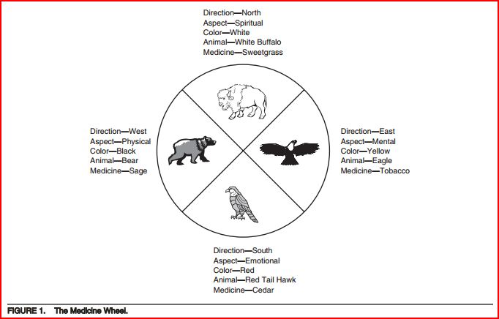

Miss Foley
HSci20: HC1 Philosophies Traditional Medicine

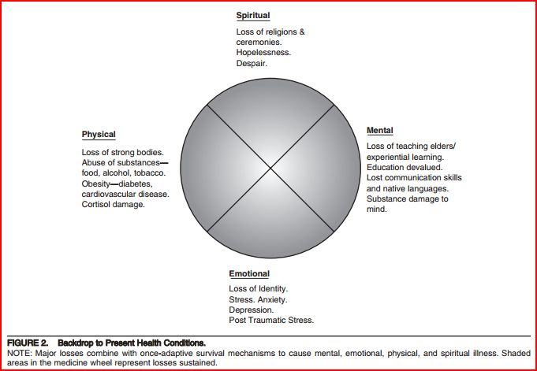

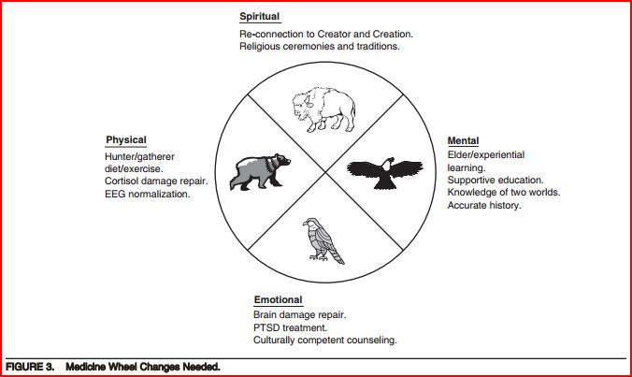

Miss Foley
HSci20: HC1 Philosophies Traditional Medicine

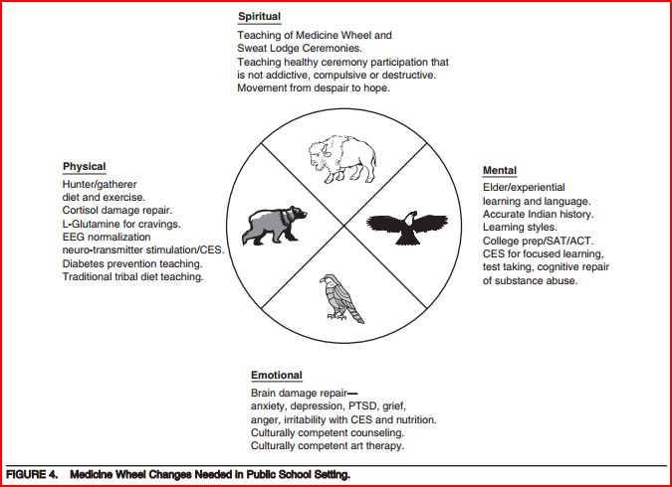
The Four Sacred Medicines
Sweetgrass (the North) is used by almost all Aboriginal peoples in North America for ritual cleansing. When Sweetgrass is walked on, it bends but does not break. Hence, it has been associated with virtue: an injustice can be returned by a kindness, by bending, not breaking.
Tobacco (the East) is held as a scared plant by most First Nations peoples. Tobacco connects us to the spirit world; it absorbs prayers and carries them to the spirit world. If a request is accompanied by an offer of tobacco that is accepted, the promise must be honored. Tobacco can also be used to thank the Creator for his gifts: if you enjoyed good weather, you could leave some tobacco on the ground, and say thank you for the gift. Tobacco is generally not smoked, except on special ceremonial occasions.
Cedar (the South) is used for purification and (taken as a tea) to attract positive energy, feelings, emotions and for balance. Its vitamin C content helped prevent scurvy when fruits and vegetables were unavailable during the winter months.
Sage (the West) is a woman's medicine, conferring strength, wisdom, and clarity of purpose. It is a powerful purifying medicine that drives away negative energies. Sage can be found braided and hung in people’s homes, perhaps tied with a ribbon in one of the colors of the medicine wheel. The threefold braid represents body, mind and spirit.

Miss Foley
HSci20: HC1 Philosophies Traditional Medicine

Rituals & Place-Based Ceremonies
Smudging (a.k.a. a 'smudge') is smoke used for ritual cleansing. Smudging is a ceremony traditionally practiced by some Aboriginal cultures to purify or cleanse negative energy, feelings or thoughts from a place or a person. Sacred medicines such as cedar, sage, sweetgrass or tobacco are burned in an abalone shell. The shell represents water, the first of four elements of life; the medicines represent gifts from mother earth and the burning represents fire, the next two elements. The person puts their hands in the smoke and carries it to their body, especially to areas that need spiritual healing (mind, heart, body). The smoke represents air, the final element. Perhaps the smell of the burning medicines stimulates the brain to produce beta-endorphins and promote healing processes.
Healing Circles are meetings held to heal physical, emotional and spiritual wounds. A symbolic object, often an eagle feather, may be given to a person who wishes to speak, and then it is passed around the circle in sequence to others who wish to speak. Shamans may conduct the ceremony.
Sweat Lodge (a.k.a. Purification Lodge) is a ceremonial sauna used for healing and cleansing. It made of a wooden framework covered by blankets or skins, usually igloo-shaped, about 1.5 meters high and large enough for eight people to sit in a circle on the ground. Hot stones are placed in a shallow hole in the center of the lodge. A medicine man pours water on the stones to produce steam and participants may spend an hour sweating in the lodge. The lodge combines the four elements of fire, water, air and earth. Ceremonies include offerings, prayers, and reverence. At times, excessive exposure to the heat of the lodge may have health effects; also toxins can be released if grasses that have been exposed to pesticides are placed on the rocks.
Sun Dance (a.k.a. Rain Dance, Thirst Dance, Medicine Dance) is a ritual that celebrates the harmony between man and nature, and spiritual dedication. Originally practiced at the summer solstice, the sun dance represents continuity between life, death, and regeneration. The symbolism often involved the buffalo, on which Plains Indian groups depended, so deserving reverence, but which they also had to kill. Four days before the ceremony, the dancers prepare by purifying themselves, at times in a sweat lodge, by meditating and collecting ceremonial items of dress to use in the sun dance. The sun dance itself takes another four days, and generally involves drumming, singing, and dancing, but also fasting and, in some cases, self-inflicted pain. This symbolized rebirth and often involved piercing the skin and attaching cords that the person had to tear out. This element led governments to suppress the sun dance around 1880, but it has been re-introduced.
Pipe Ceremony is where the pipe is used individually and in groups for prayer and ceremonial purposes. Participants gather in a circle. A braid of sweetgrass is burned to purify the area and those present, to make a sacred place for the spirits to visit. Tobacco or kinnickkinnick, a traditional mixture of bearberry and wild herbs or red willow shavings, is smoked so that prayers can be made to the Great Spirit or requests made of the spirits. The pipe may also be smoked to open other meetings or ceremonies. When not in use, the bowl and stem are separated and carried by one individual, the pipe holder.
Potlach is a ceremonial feast among northwest Pacific coast Native peoples held to celebrate major family events such as a marriage or birth. The host distributes gifts according to the status of each guest; reinforcing the perceived hierarchical relations between groups. At times the gift-giving became competitive, the host giving away personal possessions in anticipation that others would reciprocate in their turn. Such largesse enhanced the host’s prestige. Missionaries encouraged government to outlaw the potlach around 1885; it is now common.

Name: _________________________ Date: ____________
HSci20: HC1 Philosophies Investigation

Investigation:
CAM and Traditional Medicine

Choose to investigate one of the following Contemporary and Alternative Medicines (CAM) or Traditional Medicine listed below:

Natural Products
Herbs
Vitamins
Minerals
Probiotics
Essential Oils
Others?

Mind-Body Practices
Acupuncture
Massage Therapies
Yoga
Reiki
Spinal Manipulation
Relaxation Techniques
Meditation
Movement Therapies
Others?

Traditional Medicine
Medicine Wheel
Sweetgrass
Tobacco
Cedar
Sage
Traditional Medicinal Plants
Smudging
Healing Circles
Sweat lodges
Sun Dance
Pipe Ceremony
Potlach
Others?
Investigate the following:
- Intended Results & Health Benefits -

- Education/Training required -

- Cost associated -

- Accessibility in our community and in the province -

Miss Foley
HSci20: HC1 Philosophies Western Medicine

Clinical-Based Studies

Randomized Studies

Blind Studies

Double-Blind Studies

Placebo-controlled studies are a way of testing a medical therapy in which, in addition to a group of subjects that receives the treatment to be evaluated, a separate control group receives a sham "placebo" treatment which is specifically designed to have no real effect. Placebos are most commonly used in blinded trials, where subjects do not know whether they are receiving real or placebo treatment. Often, there is also a further "natural history" group that does not receive any treatment at all.
The purpose of the placebo group is to account for the placebo effect, that is, effects from treatment that do not depend on the treatment itself. Such factors include knowing one is receiving a treatment, attention from health care professionals, and the expectations of a treatment's effectiveness by those running the research study. Without a placebo group to compare against, it is not possible to know whether the treatment itself had any effect.
Patients frequently show improvement even when given a sham or "fake" treatment. Such intentionally inert placebo treatments can take many forms, such as a pill containing only sugar, a surgery where nothing efficacious is actually done (just an incision and sometimes some minor touching or handling of the underlying structures), or a medical device (such as an ultrasound machine) that is not actually turned on. Also, due to the body's natural healing ability and statistical effects such as regression to the mean, many patients will get better even when given no treatment at all. Thus, the relevant question when assessing a treatment is not "does the treatment work?" but "does the treatment work better than a placebo treatment or no treatment at all?" As one early clinical trial researcher wrote, "the first object of a therapeutic trial is to discover whether the patients who receive the treatment under investigation are cured more rapidly, more completely or more frequently, than they would have been without it." More broadly, the aim of a clinical trial is to determine what treatments, delivered in what circumstances, to which patients, in what conditions, are the most effective.
Therefore, the use of placebos is a standard control component of most clinical trials, which attempt to make some sort of quantitative assessment of the efficacy of medicinal drugs or treatments. Such a test or clinical trial is called a placebo-controlled study, and its control is of the negative type. A study, whose control is a previously tested treatment, rather than no treatment, is called a positive-control study, because its control is of the positive type.
Government regulatory agencies approve new drugs only after tests establish not only that patients respond to them, but also that their effect is greater than that of a placebo (by way of affecting more patients, by affecting responders more strongly, or both). As a result, "placebo-controlled studies often are designed in such a way that disadvantages the placebo condition".

