Health Science 20
Course Outline

Instructor: Miss Jennifer Foley
Phone: 297-2733 Ext. 241 E-mail: jfoley@chinooksd.ca
Remind Texts: text @hsci20fun to (306)992-6966
Website: www.liveitup4life.com
Course Mark Categories
Exams & Major Assignments will be worth twice as much as Assignments & Quizzes.

This course will challenge students to look at the health science field from holistic and analytic perspectives to provide a basis for making sound personal health choices. Students will examine the range of philosophies that guide health care and consider ethical decision within those contexts. Understanding the basic anatomy and physiology of various body systems and functioning metabolism. Lastly, students will examine diagnostic tools and procedures and how they are used to inform treatment. Students will also investigate the range of health science careers and post-secondary programs available in Saskatchewan.

Prerequisite: Science 10 or 11

Health Care Philosophies and Ethics
HC1 Analyze how Western, Indigenous, traditional, complementary and alternative approaches to health care contribute to a holistic perspective (e.g., mental, emotional, physical and spiritual) of health.
HC2 Examine how personal and societal beliefs impact ethical decisions regarding health care.

Human Body
HB1 Analyze the anatomy and physiology of a healthy human.
HB2 Investigate various pathologies and ailments and their effects on cells, tissues, organs, and systems of a healthy human.

Nutrition
NU1 Assess the importance of micro and macromolecules in maintaining a healthy human.
NU2 Analyze dietary choices based on personal and cultural beliefs and scientific understanding of nutrition.

Diagnostics and Treatment
DT1 Evaluate the tools and procedures used to diagnose and monitor medical conditions
DT2 Recognize the importance of interpreting diagnostic findings to support treatment options.

Career Exploration
CE1 Analyze and explore health-science related career paths in Saskatchewan, Canada and the world.

Student-Directed Study
SDS1 Create and carry out a plan to explore one or more topics of personal interest relevant to
Health Science 20 in depth.
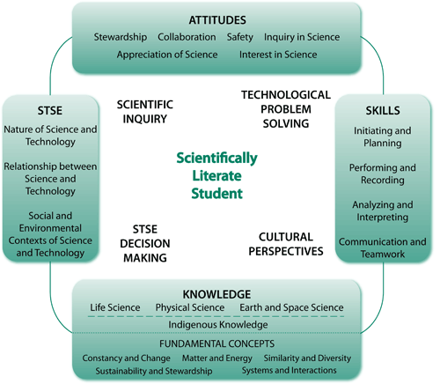

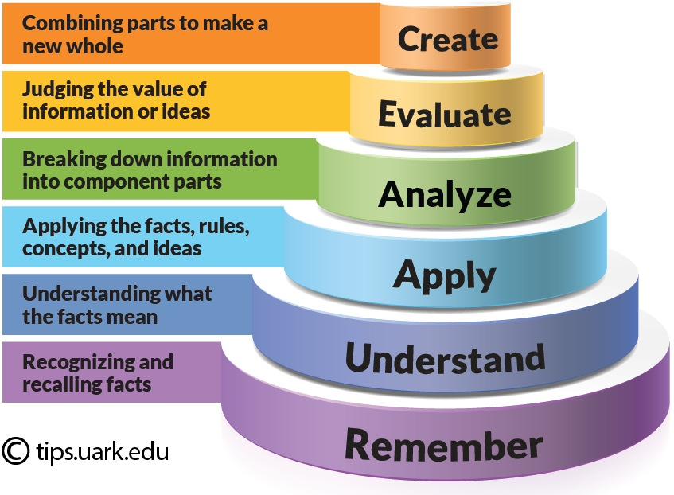

Health Science 20: Outcomes & Indicators

Health Care Philosophies and Ethics (HC)

HC1: Analyze how Western, Indigenous, traditional, complementary and alternative approaches to health care contribute to a holistic perspective (e.g., mental, emotional, physical and spiritual) of health.

a. Identify how humanity’s beliefs about health, wellness, illness, disease, and treatment have changed over time.

b. Discuss the importance of and difficulties in defining terms such as Western, Indigenous, traditional, complementary, and alternative approaches to health care within a current global context.

c. Assess how health, wellness, illness, disease, and treatment (e.g., Circle of Life disharmony of body energies, being symptom free, and healthy lifestyle choices) are addressed in Western, Indigenous, traditional, complementary, and alternative approaches to health care.

d. Investigate the intended results of using natural products (e.g., herbs, vitamins, minerals, probiotics, and essential oils) and mind and body practices (e.g., acupuncture, various massage therapies, yoga, spinal manipulation, relaxation techniques, meditation, and movement therapies) and other complementary and/or alternative approaches to health care.

e. Examine the significance of rituals, place based ceremonies, plants, and traditional herbs in Indigenous and traditional approaches to health care.

f. Describe the role of clinical based studies (e.g., randomized, blind, double-blind, and placebo) in understanding Western approaches to health care.

g. Provide examples of ways in which one or more of the approaches to health care might be implemented together to support the health and wellbeing of an individual.

HC2: Examine how personal and societal beliefs impact ethical decisions regarding health care.

Pose questions about ethical dilemmas within health care.

Understand the core ethical questions to be considered when making health care decisions:

What can be done for the patient? (intervention technologies)

Does the patient understand the options? (informed consent)

What does the patient want? (autonomy)

What are the benefits? (beneficence)

Will it harm the patient? (non-maleficence)

Are the patient’s requests fair and able to be satisfied? (justice)

Are the costs involved fair to society? (economic consequences)

Analyze a health care issue (e.g., case study, interview and current events) with respect to the core ethical questions.

Contrast how procedures to prevent illness, such as immunizations, vitamin supplements, physical activity, nutrition and prayer, might be viewed from the perspective of Western, Indigenous, traditional, complementary, and alternative approaches to health care.

Examine ethical considerations related to various treatments (e.g., chemotherapy, radiation, acupuncture, sweat lodge, blood transfusions, and hirudotherapy) that might be prescribed in Western, Indigenous, traditional, complementary, and alternative approaches to health care.

Examine individual, community and cultural beliefs regarding issues related to life and death such as home birthing, blood transfusions, contraception, abortions, organ donation, autopsies, euthanasia, cremation and burials.

Discuss ethical considerations and perspectives related to issues such as the use of cadavers in professional studies, dissection and raising animals for the purpose of dissection, and public exhibits of plastinated organs and bodies, all of which could provide increased scientific understanding of human anatomy.

Understand a patient’s rights in Saskatchewan and in Canada with regards to health care decisions such as developing an advance care directive, refusal of treatment, informed consent, and the role of a proxy or substitute decision-maker.

Discuss ethical considerations (e.g., personal beliefs, informed consent, the roles of institutional review boards and regulatory agencies) of why an individual may choose to participate in a clinical study of a new biomedical intervention (e.g., vaccine, drug, treatment, device, or process).

Debate a decision related to ethics in health care from the viewpoint of individuals who hold different belief systems.

Health Science 20: Outcomes & Indicators

Human Body (HB)

HB1: Analyze the anatomy and physiology of a healthy human.

a. Examine First Nations, Métis, and other holistic perspectives of the human body.

b. Describe the anatomy (structure) and physiology (function) of all human body systems (i.e., cardiovascular, endocrine, lymphatic, digestive, urinary, muscular, nervous, respiratory, reproductive, integumentary, and skeletal).

c. Identify the normal value or range for the common vital signs (e.g., heart rate, blood pressure, temperature, O2 saturation and respiratory rate).

d. Demonstrate the scientific use of anatomical terminology, including directional terms, body planes, body regions, and body cavities, to locate anatomical features.

e. Investigate the anatomical locations of organs in mammals such as pigs, rats, or cats through dissection or virtual simulation.

f. Design and carry out an investigation to examine baseline values used for assessing health such as heart rate, O2 saturation, blood pressure, temperature, and respiratory rate.

g. Discuss the interrelationships between the ABO and Rh blood group systems, an individual’s blood type, and blood donor compatibilities.

h. Investigate benefits of normal flora in the body (e.g., swab skin and examine results).

i. Research advances in scientific understanding of the anatomy and physiology of humans.

HB2: Investigate various pathologies and ailments and their effects on cells, tissues, organs, and systems of a healthy human.
- Differentiate among the ways in which medical practitioners and the public describe pathologies using terms such as disease, illness, ailment,

disorder, infection, medical condition, syndrome, and abnormal condition.
b. Examine how the interrelationship between a person’s lifestyle and the human immune system affect how the body responds to pathogens (e.g., risky behaviors, poor hygiene, auto-immune, immunocompromised, innate, and adaptive immunity).
c. Research the symptoms, possible causes, stages, scope (e.g., cells, tissues, organs and/or systems) and prevention of a pathology that affects one or more body systems.
d. Create a representation (e.g., illness narrative, journal, timeline, story, video, or diorama) of the progression of pathology from the perspective of a real or hypothetical individual, including impacts on their lifestyle.
e. Outline the history of a disease or illness and its causes, including societal and cultural perspectives.
f. Compare prepared slides or digital images of healthy and diseased tissues to identify how pathologies affect cells.
g. Compare how bacteria (e.g., Salmonella, Streptococcus, and Escherichia coli) and viruses (e.g., common cold, influenza, and herpes) differ in how they are transmitted, their impact on the human body, and how each is treated.

Health Science 20: Outcomes & Indicators

Nutrition (NU)

NU1 Assess the importance of micro and macromolecules in maintaining a healthy human.

a. Examine the role of carbohydrates (e.g., monosaccharaides, disaccharides and polysaccharides) as being the main source of short term energy.

b. Establish the critical role of lipids (e.g., saturated, unsaturated, trans fats) in processes such as long term energy storage, supporting vitamin absorption, creating cell membranes, synthesizing hormones and HDL vs. LDL.

c. Describe the role of protein in the production of antibodies, hemoglobin and insulin, structural support, building and maintaining muscle.

d. Examine the role of enzymes (e.g., amylase, pepsin, bile, lipase, protease) as catalysts in chemical digestion.

e. Recognize issues (e.g., hypo/hyperglycemia, high/low cholesterol, denaturation of proteins) that may arise when macromolecules are disrupt homeostasis.

f. Establish the relationships between dehydration synthesis and decomposition reactions in relation to the macronutrients. (e.g., glucose + fructose = sucrose)

g. Identify which macronutrients and micronutrients are found in common food groups (i.e., Grains, Milk and Alternatives, Meat and Alternatives, Vegetables and Fruits, and Fats and Oils).

h. Explain how micronutrients (e.g., Vitamins A, B, D, C, E, K, and iron, calcium, phosphorous) are necessary for health.

i. Investigate the contributions of people (e.g., Justus von Liebig, Antoine-Laurent Lavoisier, Claude Bernard, and Emil Fischer) in advancing scientific understanding of nutrition.

NU2: Analyze dietary choices based on personal and cultural beliefs and scientific understanding of nutrition.
- Pose questions about the role of nutrition in supporting healthy eating practices.
b. Determine factors (e.g., activity levels, age, weight, height) that affect personal energy requirements.
c. Calculate personal energy requirements and record personal caloric and macronutrient intake.
d. Analyze results of individual macronutrient intake and compare to recommended daily intake values.
e. Explain how analysis of excrement and urine (e.g., Bristol Stool Chart, urine analysis by color, clarity, odor, pH, nitrites, protein and glucose, piddle chart, tinkle testing, and Pee-O-Meter) serve as indicators of healthy functioning.
f. Design an appropriate diet representation based on personal lifestyle choices.
g. Critique various indicators of health (e.g., food labels, body mass index [BMI], skinfold calipers, Bodpod, Eating Well with Canada’s Food Guide, Eating Well with Canada’s Food Guide – First Nations, Inuit and Métis, and food guides from other countries).
h. Investigate the effects of processed foods, nutrition supplements, growth hormones, genetically modified organisms, and food additives (e.g., caffeine, aspartame, food coloring, and monosodium glutamate [MSG]) on human health.
i. Evaluate physiological and psychological effects of nutritional disorders such as anorexia, bulimia and obesity and their connection to body image.
j. Analyze eating practices such as carbohydrate loading, fad diets, vegetarianism, veganism, fast food, energy drinks, 100-mile diet, and fasting to determine if they provide sufficient nutrition to support healthy functioning.
k. Examine a variety historical and contemporary eating practices that are based upon cultural and religious beliefs. (e.g., pre-contact First Nations and Métis, Ramadan, Kosher, Lent).

Health Science 20: Outcomes & Indicators

Diagnostics & Treatment (DT)

DT1: Evaluate the tools and procedures used to diagnose and monitor medical conditions.

a. Pose questions about the importance of diagnosis.

b. Assess the significance of monitoring vital signs in health care, including accurate medical history and patient perception of pain.

c. Identify examples of tools and procedures (e.g., stethoscope, octoscope, sphygmomanometer, and visual inspection) used for non-invasive observations in health care.

d. Perform observations and record vital signs (e.g., heart rate, breathing rate, temperature, blood type and blood pressure) of self and/or other students.

e. Explain the procedures and relevance of common laboratory tests (e.g., blood testing, blood glucose testing, culture swabs, urinalysis, biopsy, and microscopy) in medical diagnosis.

f. Research the operation, risks, benefits, and imaging modalities (e.g., sound, light, radiation, and nuclear medicine) of medical imaging tools, including X-ray, magnetic resonance imaging [MRI], computerized tomography [CT], ultrasound, positron emission tomography [PET]).

g. Describe technological advances in diagnostic tools (e.g., X-ray, ultrasound, computerized tomography and magnetic resonance imaging).

h. Provide examples of how technologies are used to provide information about certain symptoms to support a diagnosis including the differences between physiological and anatomical imaging (e.g., PET compared to CT, MRI compared to a Functional MRI and Ultrasound compared to an X-Ray).

i. Discuss the factors (e.g., severity of illness, dose received, cost, and availability) that influence the use of a diagnostic tool or procedure.

j. Explain why medical practitioners often use multiple tools and procedures to establish a medical diagnosis.

k. Discuss the responsibility, including preparation and expectations, of the patient in diagnostic and imaging procedures.

l. Identify differences in tools and procedures used in diagnosing illness from the perspectives of Western, Indigenous, traditional, complementary, and alternative approaches.
DT2: Recognize the importance of interpreting diagnostic findings to support treatment options.
- Suggest explanations based on interpretation of data from diagnostic assessment tools. (e.g. identifying a broken bone in an x-ray, ultrasound of a pregnancy to determine number of fetuses and identifying high blood pressure based on given values)
b. Describe how treatment options (e.g., dialysis, radiation therapy, surgery, and organ transplants) have been developed to address specific health care issues.
c. Identify tools and procedures used to assist health care providers in monitoring the progression of a specific pathology and the treatment options available at each stage.
d. Interpret diagnostic results and choose an appropriate course of action (e.g., role-play, simulation and case study).
e. Discuss personal and societal implications of incorrect interpretation of diagnostic findings (e.g., incorrect diagnosis, improper treatment, and psychological effect on patient).
f. Describe various treatments that might be prescribed in Western, traditional, and complementary and alternative approaches to health care with respect to a specific pathology.

Health Science 20: Outcomes & Indicators

Student-Directed Study (SDS)

SDS1: Create and carry out a plan to explore one or more topics of personal interest relevant to Health Science 20.

a. Write a proposal for a scientific investigation related to a topic of study in Health Science 20 and submit to a peer review panel.

b. Design and conduct an experiment following established scientific protocols.

c. Share the results of student directed research through a display, presentation, performance, demonstration, song, game, commercial, fine art representation or research paper.

d. Debate a current health science related issue by developing materials to support the arguments for and arguments against a position.

e. Develop a case study which exemplifies ethical decision making in health care.

f. Develop a case study of the progression and/or treatment of a specific pathology from the perspective of a Western, traditional, complementary, and/or alternative approach to health care.

Health Science 20: Outcomes & Indicators

Career Exploration (CE)

CE1 Analyze and explore health science related career paths in Saskatchewan, Canada and the world.

a. Identify relevant and/or undersubscribed health science related career options locally, regionally, and/or nationally.

b. Analyze a chosen career in terms of personal suitability, using criteria such as:

i. the training program

ii. the work that graduates of this program are trained to do

iii. the types of facilities in which graduates of this program are

employed

iv. hours/shifts worked

v. current wages received in Saskatchewan

vi. physical and mental stresses experienced

vii. workplace hazards and safety considerations

viii. other professionals they interact with

ix. Continuing Education requirements – post diplomas

x. Professional and/or licensing requirements in Canada and

Saskatchewan

c. Examine the qualifications and skills of health care practitioners (e.g. traditional healer, medical doctor, massage therapist, and acupuncturist).

d. Participate in health science based vocational experiences and communicate experiences with peers.

e. Communicate research findings related to health science careers through a display, video, presentation software, website or orally.

f. Interview or connect with others (e.g., elders and knowledge keepers, experts in various disciplines) to discuss relevant health science careers.

g. Attend a science related career fair, and analyze career choices based on information gathered.

