Miss Foley
LifeTrans20: Orientation Mod 1.1 Journal Responses

Journal Writing Response Assessment Rubric
There will Journal Prompts and Journal Reponses throughout this course.
Journal Prompts are intended to inspire quick, informal reflection.
Journal Responses are intended to inspire deep, formal reflection and will be assessed using the following rubric throughout the course.
Rating | Content of work/  responses to questions | Personal reflection | Self-assessment
4 | · My response is thorough.  · I make meaningful connections to important ideas from the lesson.  · I draw upon previous knowledge and/or connect my response to larger issues.  · I support my responses with relevant details and accurate facts. | · My reflections are thoughtful and complete. · I reveal personal feelings about the topic.  · I reflect on personal experiences related to the topic.  · I use humour, questioning, and other techniques that probe for deeper meaning. | · I describe how my understanding has changed using specific, meaningful examples.  · I make comparisons between what I understood before and what I understand now.  · I raise important questions for further exploration, or describe new topics I'd like to learn.
3 | · My response is adequate but could be more thorough.  · I make some connections to ideas from the lesson.  · I support my responses with some details and facts, but they are not completely accurate. | · My reflections are adequate, but could be more thoughtful.  · I reveal some personal feelings about the topic.  · I mention personal experiences but don't reflect on them.  · I use some humour or questioning in my writing. | · I describe how my understanding has changed and give some examples.  · I make comparisons between what I understood before and what I understand now.  · I briefly mention new questions or topics for exploration.
2 | · My responses is incomplete.  · The connections I make to other ideas or information are weak. · I provide only weak or incomplete supporting evidence. | · My reflections are brief.  · I reveal very little about my personal feelings or experiences.  · There is little reflection or questioning; it sounds as if I'm not really interested in the topic. | · I provide some information about how my understanding has changed. I don't include any examples.  · I provide only limited comparison between what I understood before and what I understand now.
1 | · My response is random or unrelated to the question.  · My writing is disorganized and unconnected to any important ideas. | · My reflection is limited or superficial.  · I don't reveal any personal feelings or ideas. | · I don't reveal anything about how my understanding of the issue has changed.
Your score/ notes:

Miss Foley
LifeTrans20: Orientation Mod 1.1 Journal Responses

Name: ________________________________ Date: _____________
LifeTrans20: Orientation Mod 1.1 Intro

Assignment: Modality Preferences
- Complete the Modality Preferences survey using the Modality Test handout.
- Once you have totalled all of your categories to discover which type of learner you are, research online the type of learner that you are. If you only have a difference of one, research both styles.
- Open this document in a word processor and complete the following:
  - “In your own words define your learning style(s).
  - List five examples of academic assignments that use your strength(s) or five examples of jobs that use your learning strength(s).
My Learning Style Is…

Miss Foley
LifeTrans20: Orientation Mod 1.2 Transitions

Transition =
a positive/negative change in someone’s life
that has an effect on their future
Video: 3 Tips to Help with Transition - How to Deal with Change (3:53)
Think about your life right now, what major transitions have you already been through?
- __________________________________________________________________________
- __________________________________________________________________________
- __________________________________________________________________________
- __________________________________________________________________________
- __________________________________________________________________________
How have these transitions affected who you are?

Video: Christine Hong: The Art of Managing Life's Transitions (9:16)
The 3 R’s of Managing Change Are:

Assignment: Personal Transitions
Create a timeline of the major transitions in your life so far. You must include a min of 15 important transitions in your life and predict 5 future transitions you may face. Be sure to describe how these transitions have affected and/or could affect your life.
You may create a power point presentation, speech, pictures, a written account or any other method you would like as long as you have it approved by the teacher.
Assessment:
Correct number of Transitions: 15 experienced + 5 predicted /20
Appropriate Descriptions: Written component /20
Mechanics: /10
Miss Foley
LifeTrans20: Orientation Mod 1.3 Decision Making

Decision Making Styles
There are a variety of decision-making strategies. Here are some of the most common:

Agonizing: People using this style search for so much information that the decision gets very
complex. They are in danger of becoming "lost" in the confusion.
Compliant: People using this style prefer to let someone else decide. "Whatever you say, sir."
Delaying: People using this style cannot make up their minds. I’ll do it later."
Fatalistic: People using this style believe that it does not matter what their decision is because the outcome is pre­ determined by fate.
Impulsive: People using this style decide and then think about the decision later. This is
perfectly acceptable in many situations, such as where to park on a busy street.
Intuitive: People using this style use more feeling than thinking. "It feels right inside so I think I'll do it." We are encouraged to "trust our feelings". Some argue that intuitive decision making is a higher order of decision making than the logical or rational style.
Paralysis: People using this style know they must decide but are so overwhelmed by the choices that they are unable to make any decision at all.
Planning: People who use this style are organized decision makers who consider alternatives before deciding. They follow a definite strategy.
Decision-Making Process: Example
Step 1: Problem or Situation - I didn’t study for a test and I don’t want to go to school.
Step 2: Choices - I can stay home or go to school.
Step 3: Advantages or Good Results - If I stay home I can sleep late, relax and watch TV. I can do what I want. If I go to school, I can take the test, get my work done, see friends.
Step 4: Disadvantages or Bad Results - If I stay home I will get behind in class, I could get caught and have an unexcused absence. If I go to school, I will have to get up early, get my homework done and take a test.
Step 5: Best Choice - Which decision is best?
Step 6: Final Decision - Make a final decision.
Step 7: What Did You Learn? - Think about the decision. Did I make the right decision? What did I learn from this decision?
Miss Foley
LifeTrans20: Orientation Mod 1.3 Decision Making

This Decision-making Notes section has been adapted from The Transitions Curriculum © Used by permission of the James Stanfield Company Santa Barbara. CA 93103 and the Life Transitions 20/30 Curriculum 1996.

Miss Foley
LifeTrans20: Orientation Mod 1.3 Decision Making

Decision Making Styles & Steps
Every day we make decisions, some are good and some are not good. Everyone makes decisions differently. When we make decisions, we need to take many things into account, such is good and bad about the decision, how it will affect others, and is it the best decision for me. There are a number of different decision-making styles.
- Survey: Complete the survey below. What kind of decision maker are you?
__________________________________________________________________________________________
Read the words and mark those that are most like you.

Quiet or Loud
Calm or Tense
Afraid or Brave
Shy or Confident
Slow or Fast
Thoughtful or Impulsive
Cautious or Daring
Careful or Carefree

If you marked the words in the left-hand column, you may tend to avoid decisions. If you marked the words in the right-hand column you may tend to make decisions too quickly. There are no right or wrong answers. One way is not better than another. It is important that you understand your decision-making style and use it wisely.
Reflection: Applying Personal Standards to Career Tracking – highlight/circle your answer.

1. A person who enjoys adventure and excitement might consider a career as:
a) a cashier
b) a foreign ambassador
c) a florist
2. Knowledge and continued learning might be most important to a:
a) university professor
b) an autobody shop employee
c) a receptionist
d) all of the above
3. A person who values power and authority might want a degree in:
a) philosophy
b) business administration
c) French
4. A person who values and enjoys companionship might be suited to:
a) small appliance repairs
b) a tour-guide
c) cosmetology
5. A person with a need for some creativity might be happiest as:
a) a waitress
b) a chef
c) a pharmacist
6. A person who likes helping others might get the most satisfaction from being a
a) a car sales person
b) editing videos
c) driving an ambulance
7. A person who values independence might consider a career as
a) a loan-officer
b) a freelance writer
c) a pilot
- Because I value _______________________, I might consider a career as:

Miss Foley
LifeTrans20: Orientation Mod 1.3 Decision Making

- Remember the 8 different decision-making styles. Think about an example for each of the decision-making styles.
Agonizing –

Compliant –

Delaying –

Fatalistic –

Impulsive –

Intuitive –

Paralysis –

Planning –

- Reflect on the steps to the decision-making process in your notes. Demonstrate your understanding by choosing a problem or situation and completing the following:
Step 1: Problem or Situation –
Step 2: Choices –
Step 3: Advantages or Good Results -
Step 4: Disadvantages or Bad Results -
Step 5: Best Choice -
Step 6: Final Decision -
Step 7: What Did You Learn? -
Miss Foley
LifeTrans20: Orientation Mod 1.3 Decision Making

- Read the following write ups about Tina and Adam. Complete the decision-making chart to outline the decision-making steps. (7 marks/decision = 14 marks)

Tina’s Dilemma
Is it a good idea for teenagers to work after school? It depends on the teenager and the reasons for working. Over fifty percent of all teenagers’ work. Working means earning extra money and learning a new skill. It also means having less time for friends, school work, and sports.
Tina feels that she needs to get a job. Her dad was laid off 5 months ago and is still looking for a job. Money is very tight at home right now. She feels she needs to help the family and herself.
Her classes are hard and her grades have been low this year It is her senior year; and Tina needs to keep her grades up. She wants to get into the business program at the local community college next year. She would like to work in a business office in the future.
Tina is also on the volleyball team. The team is in season for the next two months. They have a chance to make it to the finals this year and she really wants to stay on the team.
During lunch Tina stopped to talk to Mrs. Casey, the work experience teacher. She asked Mrs. Casey if there were any job leads. Mrs. Casey gave her three job leads: Burger King, Clothestime and Smith's Insurance.
After school the next day, Tina went to each place and filled out applications. Two of the places called her; Burger King and Smith’s Insurance. Burger King offered her 25 hours a week at $4.75 an hour She would have to work evenings and weekends.
Smith’s Insurance offered her 10 to 15 hours a week at $5.50 an hour. She would work after school until 5:00 RM. and some Saturday mornings.
Volleyball practice was three days a week from 3:30 RM. to 6:00 RM. Games were usually on Saturdays. Burger King would work around her Volleyball Schedule but Smith's couldn't. Tina really didn’t want to work at a fast food place. She liked the idea of working as a receptionist at Smith’s.
Studying was a priority this year. She needed to have time to study. Working 25 hours a week at Burger King would leave very little time for her homework.

Adam Needs Help
Adam is having problems with his grades. He needs to pass his American History class or he will not be able to play baseball. If his grade average falls below 3.0, he will not be able to use his parent’s car He needs the car to get to work and to baseball practice.

This is his junior year at South High School. Adam has played baseball each season. He has improved his batting average and has a good chance of making the varsity team. Adam has been playing baseball since he was 5 years old. If he doesn't make the team, he and his dad will be very disappointed.
Right now, Adam is working four nights a week at Lucky Pizza. He likes his job. Adam needs the money but his job has caused his grades to slip.
Once baseball season starts, he probably will have to quit his job. But that’s two months away. He needs to save money to pay his car insurance while he’s playing ball.
Adam talked to Mr. Atwood, his history teacher Mr. Atwood told him that he had to pass the next test or he would flunk the class. If he flunks, he cannot play baseball. Mr. Atwood told him to check into the school’s tutoring program. The program is available after school, three times a week. If he uses the tutoring program, he will have only 30 minutes to get to work afterward.
Adam needs to find a solution to his grade and money problems. He wants to keep his job and his can and play on the baseball team. To do this, he needs to bring up his history grade. He also will need to keep it up after the baseball season starts. This will be difficult because, with working and baseball, he won't have much time to study.

Name: ________________________________ Date: _____________
LifeTrans20: Orientation Mod 1.3 Decision Making

Decision Making Process Chart

Decision Making Steps | Tina | Adam
Step 1: Problem or Situation

Step 2: Choices

Step 3: Advantages or Good Results

Step 4: Disadvantages or Bad Results

Step 5: Best Choice

Step 6: Final Decision

Step 7: What Did You Learn?

Name: ________________________________ Date: _____________
LifeTrans20: Orientation Mod 1.4 Decision Making

Assignment: Your Personal Decision Making
In an average day, we make several different decisions (what clothes to wear, what we want to eat, whether or not we want to wake up on time for school, etc.) Today, it is your job to examine some of the decisions you have made in your life.
Using the Decision-making process notes you received yesterday, pick five (5) of the styles listed, and write about a time you were this kind of decision maker.
Write a short paragraph (3-4 sentences) describing:
- The event (1 mark)
- What kind of decision maker you were (1 mark)
- If that was the right way to approach the decision (could you have handled the event differently) (1 mark)
- There will be one mark/per paragraph on mechanics, so make sure you are using spell check!

Assessment: 4 marks/ paragraph x 5 paragraphs= /20

Name: ________________________________ Date: _____________
LifeTrans20: Orientation Mod 1.4 Decision Making

Name: ________________________________ Date: _____________
LifeTrans20: Orientation Mod 1.4 Decision Making

Assignment: Your Personal Decision Making
In an average day, we make several different decisions (what clothes to wear, what we want to eat, whether or not we want to wake up on time for school, etc.) Today, it is your job to examine some of the decisions you have made in your life.
Using the Decision-making process notes you received yesterday, pick five (5) of the styles listed, and write about a time you were this kind of decision maker.
Write a short paragraph (3-4 sentences) describing:
- The event (1 mark)
- What kind of decision maker you were (1 mark)
- If that was the right way to approach the decision (could you have handled the event differently) (1 mark)
- There will be one mark/per paragraph on mechanics, so make sure you are using spell check!

Assessment: 4 marks/ paragraph x 5 paragraphs= /20

Name: ________________________________ Date: _____________
LifeTrans20: Orientation Mod 1.4 Decision Making

Miss Foley
LifeTrans20: Orientation Mod 1.5 Values & Goals

What Will The Future Bring?
Answer each of the following questions about your future.
What Do You Want to Achieve FIVE (5) Years from Now?
High school diploma? __________
Part-time job? __________ Doing what? __________________________________________
Full-time job? __________ Doing what? __________________________________________
Have your own apartment? __________ Where? ________________________________________
Own a used vehicle? __________ Paying for a new car? __________________________
Accepted into college? __________ College choice? _______________________________
A one-week vacation in ____________________________________________________________________
A longer trip to _____________________________________________________________________________
Other? _____________________________________________________________________________________
What Do You Want to Achieve FIFTEEN (15) Years from Now?
College degree? __________ From __________________________ Major ____________________
Master’s degree? __________ From __________________________ Major ____________________
Full-time job? __________ Occupation _______________________________________________
Own your own home? ______________________________________________________________________
Salary Range:
$10,000 - $20,000 ___________ Married? ___________
$21,000 - $40,000 ___________ Children? ___________
$50,000 - $75,000 ___________ How Many? ___________
Other: $ ___________
Two-week vacation each year? ___________ One-month trip to (location) ___________________
Own new car (no payments) ___________
Help in the community? ___________ How? ________________________________________
*Adapted from Baylor University’s Community Mentoring for Adolescent Development.
Miss Foley
LifeTrans20: Orientation Mod 1.5 Values & Goals

SMART Goal Setting Tips
Specific
Measurable
Attainable
Realistic
Timely
SMART is an acronym for the following characteristics that should be present when creating goals for yourself:
SMART goals are specific. Specific goals are much more likely to be accomplished than vague ones! A specific goal can be determined by asking the following questions:
WHO is involved? Smart goals don’t depend on the involvement of too many people - remember, the only person you can control is yourself, so the achievement of your goal should depend on you.
WHAT do you want to accomplish? Define your aim, so you will have a clear idea of what you are aiming for. A vague ‘I want to be a better person’ is not specific enough!
WHERE will you work on your goal? Identify a location or locations where most of the work towards your goal will be carried out. If your home is the main base, you may need to revamp a few things.
WHEN do you hope to accomplish your goal? Set a time frame and specific deadline for completion. Having a specific end date will keep you from procrastinating.
WHICH factors will affect the success of your goal? What requirements do you have, and what limitations will you have to deal with? Being prepared for obstacles makes them easier to surmount.
WHY do you want to reach this goal? The reasons behind your choice of a goal are just as important as the goal itself. Looking at those reasons can often tell you quite a bit about yourself!
SMART goals are measurable. You should be able to see the progress you are making. This allows you to feel the thrill of each milestone reached, and keeps you on track for completion of your goal. The way you find out if your goal is truly measurable is to ask another set of questions:
How much (weight do I want to lose)? How many (laps do I want to swim)? How will I know when the goal is reached?
Charts are a great way for you to track your progress and measure how much of your goal you have achieved.
SMART goals are attainable & action-orientated. Not easy, but attainable. They aren’t based on a premise that you will suddenly become superhuman, and they don’t follow a plan of action that could be hazardous. They simply are representative of what you know you are capable of if you just put some effort into it.
Each goal you reach makes the next one more attainable, so as you grow so can your goals! As you stretch to reach the goals you set for yourself, you find out you are capable of more than you ever thought possible. You set goals higher each time as you grow more confident.
SMART goals are realistic. They not only consider what you are capable of, but what you are willing to do and what your circumstances permit. A goal can be high and still be realistic. At the same time, what might seem like an easy goal to some might be difficult for you because of factors below the surface.
Setting a high goal brings a sense of greater motivation, because you can see what a great difference it will make in your life. At the same time, it can be overwhelming - so break the larger goal down into a series of smaller ones. Your goal will be easier to accomplish if it seems realistic to you, and small goals are approached with greater confidence of success.
SMART goals are timely. If you don’t have a time frame for the reaching of your goal, you have no real impetus. ‘Someday’ is not an acceptable deadline. Setting a date for the completion of your goal puts you in motion mentally and sets the pace for a steady race to the finish.Smart goal setting considers all of the guidelines above, and helps you develop a right state of mind and a game plan for getting things done. Is your goal a SMART one?
Miss Foley
LifeTrans20: Orientation Mod 1.5 Values & Goals

Choices & Values: What’s Important to Me?
Take a few minutes to think about the meaning of the items listed below. Indicate with a check mark the items that are important to you.

- _____ A physical appearance to be proud of
- _____ To graduate with honors
- _____ Being an honest person
- _____ To have political power
- _____ Being known as a “real” person
- _____ A meaningful relationship
- _____ Self-confidence & personal growth
- _____ Enjoyment of nature and beauty
- _____ A life with meaning, purpose, and
fulfillment
- _____ Continuing to learn and gain
knowledge
- _____ A chance to help the sick and
disadvantaged
- _____ To be attractive to others
- _____ Some honest and close friends
- _____ A long and healthy life
- _____ A meaningful relationship with God
- _____ A good marriage
- _____ Satisfaction/success in career choice
- _____ An equal opportunity for all people
- _____ Freedom to live life as you want
- _____ A financially comfortable life
- _____ Accomplishment of something
worthwhile
- _____ A secure and positive family life
- _____ An enjoyable, leisurely life
- _____ Unlimited travel, fine foods,
entertainment, recreational, and
cultural opportunities
- _____ Getting things changed for the better
- _____ A beautiful home in the setting of your
choice
- _____ A chance to develop creativity/
potential in any area
- _____ Owning a possession of great value
- _____ To speak up for my personal beliefs
- _____ To have better feelings about myself
- _____ To be needed & to be important
- _____ To become a good parent
- _____To have better relationship with parents
- _____ To be sexy
- _____ To persevere in what I’m doing
- _____ Time for prayer
- _____To give of myself freely in helping others
- _____A safe and secure environment
- _____ To be loved by a special few
- _____ To be trusted by others

List below the number of the four or five items that are most important to you:
A. ____________ B. ____________ C. ____________ D. ____________ E. ____________
When you have listed the 4 – 5 items that are the most important to you, refer to the “Value Characteristics” handout and write the appropriate characteristics related to those numbers.
*Adapted from Character Plus, www.characterplus.org, originally from License to Lead ©1996, National Association of Secondary School Principals.
Miss Foley
LifeTrans20: Orientation Mod 1.5 Values & Goals

Choices & Values: Value Characteristics
Number | Characteristic
5 | Sincerity
3, 40 | Honesty, Integrity
7, 30 | Emotional well-being, Stability
8 | Artistic appreciation
2, 10 | Education, Intelligence, Wisdom
11, 37, 18 | (Altruism) Compassion, Fairness, Justice
1, 12, 34 | Appearance, Beauty, Approval
6, 13, 31, 39 | Love, Friendship, Personal closeness
14, 38 | Health, Personal safety, Security
15, 36 | Religion, Spirituality
16, 22, 32, 33 | Family, Love, Emotional Security
9, 17, 21, 27 | Fulfillment, Intellectual & Vocational achievement
19 | Personal freedom, Independence
20, 26, 28 | Financial security, Money, Status
23, 24 | Pleasure, Travel, Material Satisfaction
4, 25 | Power, Achievement
29 | Courage
35 | Perseverance
Write the characteristic that corresponds to the numbers you selected on the checklist.
- ______________________________________________________________________________________
- ______________________________________________________________________________________
- ______________________________________________________________________________________
- ______________________________________________________________________________________
- ______________________________________________________________________________________
Miss Foley
LifeTrans20: Orientation Mod 1.5 Values & Goals

Short-Term Goal = a goal that can be realized in a shorter period of time such as a day, week or month
These would be goals such as: improving test scores, writing better study notes, read more books, participate in
something that's important to you.
Long-Term Goal = a goal that requires a longer period of time
(greater than a couple of months) to achieve
These would be goals such as: becoming fitter,
saving money, develop better friendships.
Both goals require you to act to be able to realize them.
Write 2 short term goals that would be important to you:

What action would you need to take to realize your short-term goals?

Write 2 Iona term goals that would be important to you:

What action would you need to take to realize your long-term goals?
Miss Foley
LifeTrans20: Orientation Mod 1.5 Values & Goals

Name: ________________________________ Date: _____________
LifeTrans20: Orientation Mod 1.5 Values & Goals

Assignment: Your Values & Goals
Journal Response: Reflect on your Choices & Values personal inventory results. Complete a journal entry - minimum half page response - that provides examples and specifically answers the following: Do these values actually represent who you are? Explain. Be specific.
SMART Goal Setting: Reflect on the Smart Goal Setting Tips handout. Reflecting on the What Will the Future Bring and Short & Long Term Goals handouts, think about yours goals for 5 and 15 years from now. Thinking about where you want to be in 5 & 15 years from now, write two SMART goals that you would like to achieve. Remember to use the SMART goal writing steps.
Assessment: Journal Response: (See attached rubric) /12
SMART Goal Setting: /12
You must have two goals, one for 5 years from now & one for 15 years from now. Please ensure that you have included each of the SMART criteria in each goal. One mark for each SMART goal criteria per goal.
Journal Writing Response Assessment Rubric
Rating | Content of work/  responses to questions | Personal reflection | Self-assessment
4 | · My response is thorough.  · I make meaningful connections to important ideas from the lesson.  · I draw upon previous knowledge and/or connect my response to larger issues.  · I support my responses with relevant details and accurate facts. | · My reflections are thoughtful and complete. · I reveal personal feelings about the topic.  · I reflect on personal experiences related to the topic.  · I use humour, questioning, and other techniques that probe for deeper meaning. | · I describe how my understanding has changed using specific, meaningful examples.  · I make comparisons between what I understood before and what I understand now.  · I raise important questions for further exploration, or describe new topics I'd like to learn.
3 | · My response is adequate but could be more thorough.  · I make some connections to ideas from the lesson.  · I support my responses with some details and facts, but they are not completely accurate. | · My reflections are adequate, but could be more thoughtful.  · I reveal some personal feelings about the topic.  · I mention personal experiences but don't reflect on them.  · I use some humour or questioning in my writing. | · I describe how my understanding has changed and give some examples.  · I make comparisons between what I understood before and what I understand now.  · I briefly mention new questions or topics for exploration.
2 | · My responses is incomplete.  · The connections I make to other ideas or information are weak. · I provide only weak or incomplete supporting evidence. | · My reflections are brief.  · I reveal very little about my personal feelings or experiences.  · There is little reflection or questioning; it sounds as if I'm not really interested in the topic. | · I provide some information about how my understanding has changed. I don't include any examples.  · I provide only limited comparison between what I understood before and what I understand now.
1 | · My response is random or unrelated to the question.  · My writing is disorganized and unconnected to any important ideas. | · My reflection is limited or superficial.  · I don't reveal any personal feelings or ideas. | · I don't reveal anything about how my understanding of the issue has changed.
Your Mark/
Notes
Name: ________________________________ Date: _____________
LifeTrans20: Orientation Mod 1.5 Values & Goals

Choices & Values Journal Response

Name: ________________________________ Date: _____________
LifeTrans20: Orientation Mod 1.5 Values & Goals

S.M.A.R.T. Goal Setting: 5 Years from Now

__________________________________________________
S
Specific

__________________________________________________
__________________________________________________
__________________________________________________
M
Measurable

__________________________________________________
__________________________________________________
__________________________________________________
A
Attainable

__________________________________________________
__________________________________________________
__________________________________________________
R
Realistic

__________________________________________________
__________________________________________________
__________________________________________________
T
Timely

__________________________________________________
__________________________________________________

Goal: __________________________________________________________________
__________________________________________________________________
__________________________________________________________________
__________________________________________________________________
__________________________________________________________________
__________________________________________________________________
__________________________________________________________________
Name: ________________________________ Date: _____________
LifeTrans20: Orientation Mod 1.5 Values & Goals

S.M.A.R.T. Goal Setting: 15 Years from Now

__________________________________________________
S
Specific

__________________________________________________
__________________________________________________
__________________________________________________
M
Measurable

__________________________________________________
__________________________________________________
__________________________________________________
A
Attainable

__________________________________________________
__________________________________________________
__________________________________________________
R
Realistic

__________________________________________________
__________________________________________________
__________________________________________________
T
Timely

__________________________________________________
__________________________________________________

Goal: __________________________________________________________________
__________________________________________________________________
__________________________________________________________________
__________________________________________________________________
__________________________________________________________________
__________________________________________________________________
__________________________________________________________________
Name: ________________________________ Date: _____________
LifeTrans20: Orientation Mod 1.6 Values & Goals

Assignment: Breaking Up Your SMART Goals
You Will Need: A ball, basketball hoop, stopwatch
Your (SMART) Goal: In 3 minutes, I will make three of my 6 shots in the basket from 5 m away.
Process: Set up standing 5m away from the hoop you will be shooting at. Time yourself shooting the ball in to the basket using a stop watch. Make sure that you mark down the success of your shots on the attached SMART goals activity worksheet. After you have finished this, reflect on whether or not you achieved the goal set out for you.
Answer the following questions:
- Did you achieve the goal? How do you know?
- What could you have done to make the goal easier? More challenging?
Journal Response: Look at your 5 year and 15 year goals from last class. In paragraph form, explain how you could break those goals up to be more attainable. This may involve you changing the time frame, the specifics of the goal, or the form of measurement that you have selected. Ultimately, you will be responding to the question, “How can I break up my 5 year and 15 year goals to make them more attainable (easier to reach)?”
Assessment: Question 1 and 2: /4
Journal Response: (See attached rubric) /12
Journal Writing Response Assessment Rubric
Rating | Content of work/  responses to questions | Personal reflection | Self-assessment
4 | · My response is thorough.  · I make meaningful connections to important ideas from the lesson.  · I draw upon previous knowledge and/or connect my response to larger issues.  · I support my responses with relevant details and accurate facts. | · My reflections are thoughtful and complete. · I reveal personal feelings about the topic.  · I reflect on personal experiences related to the topic.  · I use humour, questioning, and other techniques that probe for deeper meaning. | · I describe how my understanding has changed using specific, meaningful examples.  · I make comparisons between what I understood before and what I understand now.  · I raise important questions for further exploration, or describe new topics I'd like to learn.
3 | · My response is adequate but could be more thorough.  · I make some connections to ideas from the lesson.  · I support my responses with some details and facts, but they are not completely accurate. | · My reflections are adequate, but could be more thoughtful.  · I reveal some personal feelings about the topic.  · I mention personal experiences but don't reflect on them.  · I use some humour or questioning in my writing. | · I describe how my understanding has changed and give some examples.  · I make comparisons between what I understood before and what I understand now.  · I briefly mention new questions or topics for exploration.
2 | · My responses is incomplete.  · The connections I make to other ideas or information are weak. · I provide only weak or incomplete supporting evidence. | · My reflections are brief.  · I reveal very little about my personal feelings or experiences.  · There is little reflection or questioning; it sounds as if I'm not really interested in the topic. | · I provide some information about how my understanding has changed. I don't include any examples.  · I provide only limited comparison between what I understood before and what I understand now.
1 | · My response is random or unrelated to the question.  · My writing is disorganized and unconnected to any important ideas. | · My reflection is limited or superficial.  · I don't reveal any personal feelings or ideas. | · I don't reveal anything about how my understanding of the issue has changed.
Your Mark/
Notes
Name: ________________________________ Date: _____________
LifeTrans20: Orientation Mod 1.6 Values & Goals

Name: ________________________________ Date: _____________
LifeTrans20: Self Knowledge Mod 2.1 Profiles

Personality Profiles
- Go online and complete the following personality profile test: www.16personalities.com
Please be honest and put some thought into your answers. This will help with the accuracy of your results.
- Find at least one (1) other personality profile test to complete online.
- Journal Response: Once you have completed the tests read over your results. Write a minimum half page journal response stating whether or not you believe that this is an accurate representation of your personality.
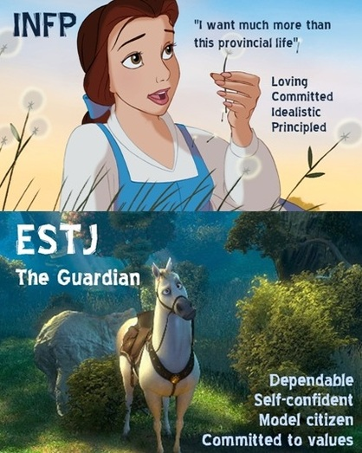
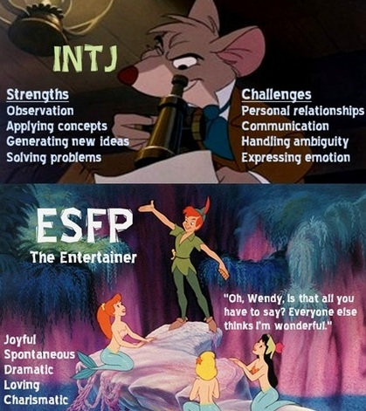
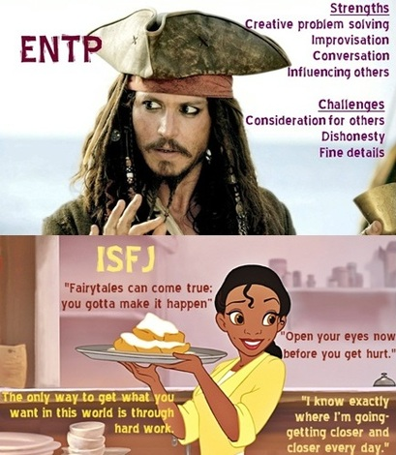
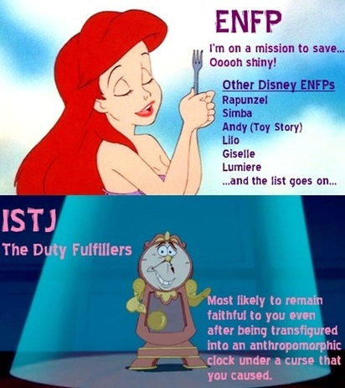
Name: ________________________________ Date: _____________
LifeTrans20: Self Knowledge Mod 2.1 Profiles

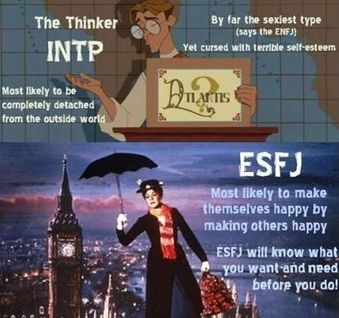
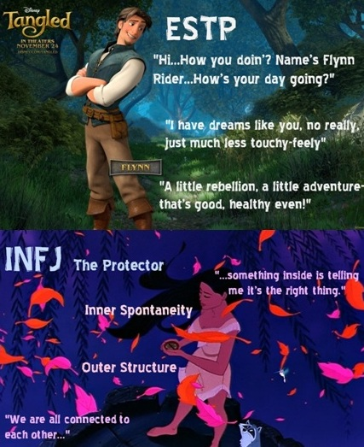
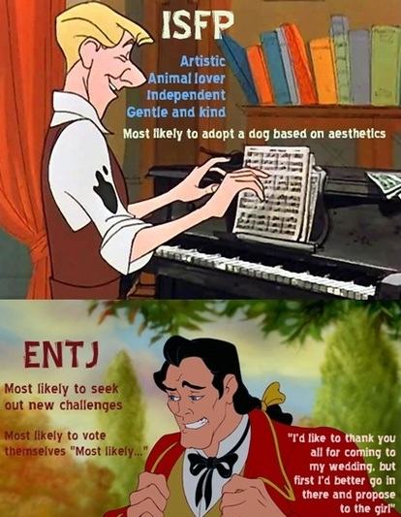
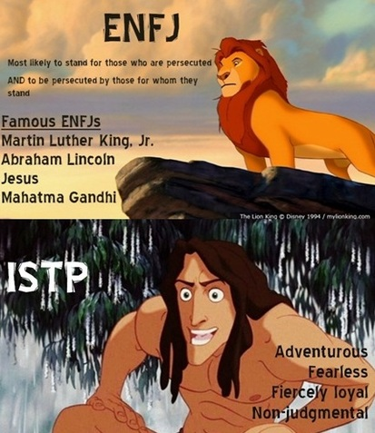
Name: ________________________________ Date: _____________
LifeTrans20: Self Knowledge Mod 2.1 Profiles

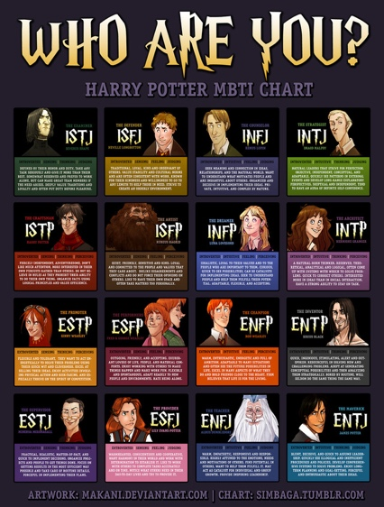
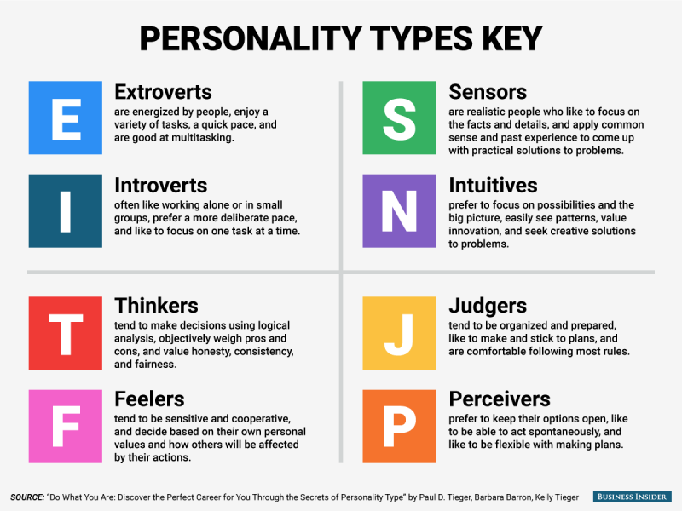
Name: ________________________________ Date: _____________
LifeTrans20: Self Knowledge Mod 2.1 Profiles

Miss Foley
LifeTrans20: Self Knowledge Mod 2.2 Personality

Complexities of Personality
In groups of 2 or 3, you will be assigned one of the following founders of the most accepted theories and models of human development and personality. A good website to use would be Simply Psychology.

      - Freud
      - Erikson
      - Maslow
      - Piaget
      - Kohlberg
      - Myers-Briggs

You will be creating class notes on your assigned person, please include a brief biography (when they studied and where), a brief summary of their theory and the impact they had on the study of human development and personality.

Theories and Models of
Human Development and Personality
Name:
Summary of Theory:
Impact they had:
Other interesting facts:
Miss Foley
LifeTrans20: Self Knowledge Mod 2.2 Personality

Theories and Models of
Human Development and Personality (cont’d)
Name:
Summary of Theory:
Impact they had:
Other interesting facts:
Miss Foley
LifeTrans20: Self Knowledge Mod 2.2 Personality

Theories and Models of
Human Development and Personality (cont’d)
Name:
Summary of Theory:
Impact they had:
Other interesting facts:
Miss Foley
LifeTrans20: Self Knowledge Mod 2.2 Personality

Theories and Models of
Human Development and Personality (cont’d)
Name:
Summary of Theory:
Impact they had:
Other interesting facts:
Miss Foley
LifeTrans20: Self Knowledge Mod 2.2 Personality

Theories and Models of
Human Development and Personality (cont’d)
Name:
Summary of Theory:
Impact they had:
Other interesting facts:
Miss Foley
LifeTrans20: Self Knowledge Mod 2.2 Personality

Theories and Models of
Human Development and Personality (cont’d)
Name:
Summary of Theory:
Impact they had:
Other interesting facts:
Name: ________________________________ Date: _____________
LifeTrans20: Self Knowledge Mod 2.3 Appreciation

Appreciating Similarities & Differences
Between People
Journal Prompt: I am different from others in these ways . . .

Are We All Different? Are You More Like This or That?
Read each pair of words. Choose the one most like you. Mark an X on the line on either side of the middle marker to show your choice. Be prepared to talk about your choice.

- Red _______________ | _______________ Blue Why?_______________________
- Winter _______________ | _______________ Summer Why?_______________________
- Jeans _______________ | _______________ Dress-up Why?_______________________
- Funny _______________ | _______________ Serious Why?_______________________
- Dress Shoes______________ | _______________ Tennis Shoes Why?_______________________
- Truck _______________ | _______________ Car Why?_______________________
- Candy _______________ | _______________ Hamburger Why?_______________________
- Piano _______________ | _______________ Guitar Why?_______________________
- Open Door______________ | _______________ Closed Door Why?_______________________
© Used by permission of the James Stanfield Company.Santa Barbara. CA 9310 THE TRANSITIONS CURRICULUM
Name: ________________________________ Date: _____________
LifeTrans20: Self Knowledge Mod 2.3 Appreciation

Journal Prompt: I like being different or similar (choose one) because . . .

Miss Foley
LifeTrans20: Self Knowledge Mod 2.4 Human Needs

Journal Prompt: One thing I need to have in my life is . . .

Basic Human Needs
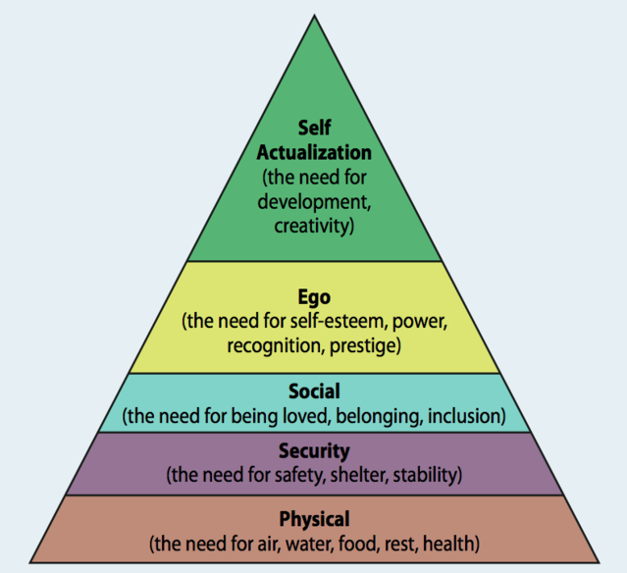
Self-Actualization =
Knowing yourself
Self-Esteem =
How you feel about yourself
Affiliation =
Connection to other people
Safety =
Feeling secure
Physiological =
Basic physical needs

The first need is PHYSIOLOGICAL This is your need to stay alive. What do you need to stay alive? Air, water, food, sleep, and exercise. These are important for you to stay healthy and ready to be your personal best.
SAFETY is the second need. This is the need to feel safe and secure. You need to feel safe in your home and the places you spend most of your time. You also need to know the rules and what is expected of you.
The third basic need is AFFILIATION. This is the need to be connected and cared for by other people such as family, friends, church, and neighbors. This need includes: being a good listener; communicating clearly with others; caring about others; and having friends who care about you.
The fourth level is SELF-ESTEEM. This is your need to feel good about yourself. Self-Esteem includes: knowing what you do well; believing in yourself; looking for the positive instead of the negative; feeling needed and important; and setting the dreams and goals you want to accomplish.
The last and highest need is called SELF-ACTUALIZATION, This is becoming the best you can be. At this level, you develop your talents more each day by working toward your goals without giving up and without being told to do so. You are independent and want to do things to help other people and make the world a better place.
We all work on these needs every day. None of us can meet all of these 100% of the time but we all become better at meeting our needs. This personal growth continues throughout our lives, not just while we’re in school. All of us take care of the first two needs automatically. Sometimes even meeting these two basic needs may be difficult when there has been a big change in our lives.
Miss Foley
LifeTrans20: Self Knowledge Mod 2.4 Human Needs

Read through the following situations and respond how your five needs would be affected by each situation.
Example: “Everything is disorganized so there is only junk food to eat. You are not sure what to
expect and you don’t feel secure.”
Because you are feeling insecure, you are worried and not sleeping well. You do not feel like making new friends. You feel bad about yourself. You feel like you will have to fit into a new situation and maybe lose part of yourself.

- “You’ve just moved to a new city.”

- “There are bullies in the neighbourhood and at school and you feel threatened when they are around.”

- “Your best friend just moved and you don’t have anyone with whom you can talk.”

- “You feel like you’re not very smart or good looking.”

- “You don’t know who you are anymore.”

Name: ________________________________ Date: _____________
LifeTrans20: Self Knowledge Mod 2.4 Human Needs

Human Needs Collage
Make a collage, using pictures cut out of a magazine or found on the computer that represents all five of the basic human needs. This needs to be about you. Please use both sides of this assignment page for your collage, if needed. Make sure to label each area in your collage.
( /10 marks)

Name: ________________________________ Date: _____________
LifeTrans20: Self Knowledge Mod 2.4 Human Needs

Miss Foley
LifeTrans20: Self Knowledge Mod 2.5 Human Needs

Meeting Human Needs
Journal Prompt: An important human need for me is . . .

Basic Human Needs Checklist
Circle number 3 if you did what the statements says in the last 24 hours. Circle number 2 if you almost completed the statement & circle number 1 if you did not complete the statement.
In The Last 24 Hours… | Met | Almost Met | Not At All
- I ate healthy food. | 3 | 2 | 1
- I slept 6-8 hours. | 3 | 2 | 1
- I drank plenty of water, milk, and juice. | 3 | 2 | 1
- I exercised for at least 20 minutes. | 3 | 2 | 1
- I felt safe and secure at home and at school. | 3 | 2 | 1
- I knew what to expect at home and school. (predictable – no surprises) | 3 | 2 | 1
- I was treated the same way with which I am familiar. (consistency) | 3 | 2 | 1
- I felt comfortable in my surroundings. (warm, cool, safe) | 3 | 2 | 1
- I listened to others who were speaking. | 3 | 2 | 1
- I showed that I understood what another person needed or was saying. | 3 | 2 | 1
- I expressed my feelings appropriately. | 3 | 2 | 1
- I showed that I cared about those who need me and who I love. | 3 | 2 | 1
- I talked about the things I can do well with my friends or family. | 3 | 2 | 1
- I felt confident about what I was doing in my life at home, school, or work. | 3 | 2 | 1
- I had a positive attitude. | 3 | 2 | 1
- I felt needed by others at home, in school, or in other activities. | 3 | 2 | 1
- I thought about my goals and what I want for myself in the future. | 3 | 2 | 1
- I learned something new that will help me in the future. | 3 | 2 | 1
- I concentrated and did a good job on my school work and chores. | 3 | 2 | 1
- I worked on a chore or task until it was finished. | 3 | 2 | 1
- I started working without being told. | 3 | 2 | 1
- I helped a friend or family member with something. | 3 | 2 | 1
TOTAL SCORE: | ____________________________
© Used by permission of the James Stanfield Company, Santa Barbara, CA 93103 THE TRANSIT1ONS CURRICULUM
Miss Foley
LifeTrans20: Self Knowledge Mod 2.5 Human Needs

Miss Foley
LifeTrans20: Self Knowledge Mod 2.6 Self-Esteem

Self-Esteem = a person’s overall
sense of their value or worth
We all know that self-esteem sometimes referred to as self-worth or self-respect, can be an important part of success. Too little self-esteem can leave people feeling defeated or depressed. It can also lead people to make bad choices, fall into destructive relationships, or fail to live up to their full potential. A grandiose sense of self-esteem, as exhibited in narcissistic personality disorder, can certainly be off-putting to others and can even damage personal relationships.
Self-esteem levels at the extreme high and low ends of the spectrum can be harmful, so ideally, it's best to strike a balance somewhere in the middle. A realistic yet positive view of yourself is generally considered the ideal. But what exactly is self-esteem? Where does it come from and what influence does it really have on our lives?
What Is Self-Esteem?
In psychology, the term self-esteem is used to describe a person's overall sense of self-worth or personal value. In other words, how much you appreciate and like yourself.
• Self-esteem is often seen as a personality trait, which means that it tends to be stable and enduring.
• Self-esteem can involve a variety of beliefs about yourself, such as the appraisal of your own appearance, beliefs, emotions, and behaviors.
Why Self-Esteem Is Important
Self-esteem can play a significant role in your motivation and success throughout your life. Low self-esteem may hold you back from succeeding at school or work because you don't believe yourself to be capable of success.
By contrast, having a healthy self-esteem can help you achieve because you navigate life with a positive, assertive attitude and believe you can accomplish your goals.
Self-Esteem Theories
Many theorists have written on the dynamics involved in self-esteem. The need for self-esteem plays an important role in psychologist Abraham Maslow's hierarchy of needs, which depicts self-esteem as one of the basic human motivations. Maslow suggested that people need both esteem from other people as well as inner self-respect. Both of these needs must be fulfilled in order for an individual to grow as a person and achieve self-actualization.
It is important to note that self-esteem is a concept distinct from self-efficacy, which involves how well you believe you'll handle future actions, performance, or abilities.
Miss Foley
LifeTrans20: Self Knowledge Mod 2.6 Self-Esteem

Factors That Influence Self-Esteem
As you might imagine, there are different factors that can influence self-esteem. Genetic factors that help shape overall personality can play a role, but it is often our experiences that form the basis for overall self-esteem. Those who consistently receive overly critical or negative assessments from caregivers, family members, and friends, for example, will likely experience problems with low self-esteem.
Additionally, your inner thinking, age, any potential illnesses, disabilities, or physical limitations, and your job can affect your self-esteem.
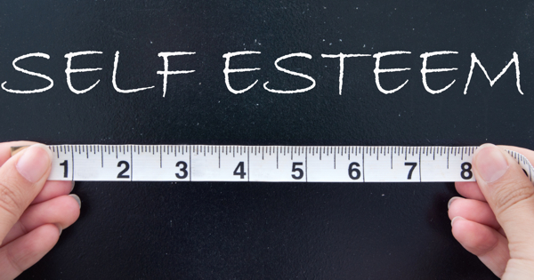

Signs of Healthy Self-Esteem
You probably have a good sense of who you are if you exhibit the following signs:
- Confidence
- Ability to say no
- Positive outlook
- Ability to see overall strengths and weaknesses and accept them
- Negative experiences don't impact overall perspective
- Ability to express your needs
Signs of Low Self-Esteem
You may need to work on how you perceive yourself if you exhibit any of these signs of poor self-esteem:
- Negative outlook
- Lack of confidence
- Inability to express your needs
- Focus on your weaknesses
- Excessive feelings of shame, depression, or anxiety
- Belief that others are better than you
- Trouble accepting positive feedback
- Intense fear of failure

Miss Foley
LifeTrans20: Self Knowledge Mod 2.6 Self-Esteem

The Self-Esteem Circle
Our self-esteem affects our behaviour. The way we feel about ourselves affects the way we see ourselves, which in turn affects our behaviour. Our behaviour then affects the way we feel about ourselves.

How You Feel About Yourself
How You Act
Or Behave
How You Think About Yourself

Point to the appropriate place on the circle as you read and discuss the following examples with your group.

- You didn't finish the homework that was due today and you thought you were really stupid. You said:, "The class and teacher are stupid and so is the assignment." You felt embarrassed, unprepared, and dumb. You acted tough and said you didn't care. You got into an argument with someone to take the attention off of your unfinished homework.
- You brought your homework into class on time. You thought you were really smart to get it completed the day before. You felt calm and prepared. You felt sorry for the kids who didn't get their work finished. You acted like a good student by paying attention and listening.
- You were late for work. You thought about how stupid you were to be late as you drove to work. You felt embarrassed and afraid of what the boss would say. You acted sneaky and tried to check in without anyone seeing you .You ignored a friend who saw you clock in late.
You were early for work and had time to enjoy a soft drink before you started your shift. You thought about how good you are at your job. You felt proud and secure. You acted friendly and joked around with a co-worker who works near you.
Miss Foley
LifeTrans20: Self Knowledge Mod 2.6 Self-Esteem

How Self –Esteem Is Different Than…
Self-Esteem vs. Self-Image
Another similar term with a different meaning is self-image; self-image is similar to self-concept in that it is all about how you see yourself (McLeod, 2008). Instead of being based on reality, however, it can be based on false and inaccurate thoughts about ourselves. Our self-image may be close to reality or far from it, but it is generally not completely in line with objective reality or with the way others perceive us.
Self-Esteem vs. Self-Worth
Self-esteem is a similar concept to self-worth but with a small (although important) difference: self-esteem is what we think, feel, and believe about ourselves, while self-worth is the more global recognition that we are valuable human beings worthy of love (Hibbert, 2013).
Self-Esteem vs. Self-Confidence
Self-esteem is not self-confidence; self-confidence is about your trust in yourself and your ability to deal with challenges, solve problems, and engage successfully with the world (Burton, 2015). As you probably noted from this description, self-confidence is based more on external measures of success and value than the internal measures that contribute to self-esteem. One can have high self-confidence, particularly in a certain area or field, but still lack a healthy sense of overall value or self-esteem.
Self-Esteem vs. Self-Efficacy
Similar to self-confidence, self-efficacy is also related to self-esteem but not a proxy for it. Self-efficacy refers to the belief in one’s ability to succeed at certain tasks (Neil, 2005). You could have high self-efficacy when it comes to playing basketball, but low self-efficacy when it comes to succeeding in math class. Unlike self-esteem, self-efficacy is more specific rather than global, and it is based on external success rather than internal worth.
Self-Esteem vs. Self-Compassion
Finally, self-esteem is also not self-compassion. Self-compassion centers on how we relate to ourselves rather than how we judge or perceive ourselves (Neff, n.d.). Being self-compassionate means we are kind and forgiving to ourselves, and that we avoid being harsh or overly critical of ourselves. Self-compassion can lead us to a healthy sense of self-esteem, but it is not in and of itself self-esteem.

Name: ________________________________ Date: _____________
LifeTrans20: Self Knowledge Mod 2.6 Self-Esteem

Angelica
Read the following story and apply it to the circle of self-esteem by pointing to the areas of the circle that illustrate the story.
Angelica has been working at Miller’s Clothing store. She likes her job, but doesn’t like the assistant manager She feels that the assistant manager picks on her and makes her do the boring jobs. The assistant told her she was too slow to work at the front counter checking customers. Angelica is beginning to think she is slow at the front counter checking customers. The more she thinks she is slow, the worse she feels.
Which part of the diagram illustrates her self-esteem at this point?
Now she feels so bad that she is getting slower The assistant manager yelled at her in front of a customer because she didn't find a shirt fast enough. She is so upset, her work is slow and she is making mistakes. Looking at the diagram, find where her self-esteem is now. Angelica feels so bad she wants to cry.
How has her self-esteem been affected? Find this on the Self-Esteem Circle.
Now she can hardly work at all and is slower than ever.
How does the Self-Esteem Circle illustrate Angelica's self-esteem at this point?
Questions:
- What would it take for Angelica to get faster?
- Is her self-esteem high or low? How can you tell?
- Is her self-esteem affecting her success? Why?
- What would you do in her place?

Name: ________________________________ Date: _____________
LifeTrans20: Self Knowledge Mod 2.6 Self-Esteem

Miss Foley
LifeTrans20: Self Knowledge Mod 2.7 Self-Empower

Building a Self-Empowering Vocabulary
Journal Prompt: I feel good about myself when . . .

Self-esteem defines how we value our own self-worth based on our character. To have high self-esteem, we must see ourselves as worthy of high regard. To be empowered is to give ourselves power and authority over our lives. The most successful adults are those who can combine high self-esteem and self-empowerment. As our self-esteem becomes stronger we become more empowered to take positive control over our choices and decisions.
Personal Empowerment Key Words
Using the computer find definitions for these words and put them into YOUR OWN WORDS. You cannot use the root word of the word in the definitions. You will have an assessment on these words.
- Self-esteem -

- Worth -

- Talent -

- Attitude -

- Integrity -

- Respect -

Miss Foley
LifeTrans20: Self Knowledge Mod 2.7 Self-Empower

- Character -

- Regard -

- Choice -

- Responsibility -

- Honesty -

- Strength -

Used by permission of the James Stanfield Company. Santa Barbara. CA 93103 THE TRANSITIONS CURRICULUM
Journal Prompt: Having high self-esteem means . . .

Miss Foley
LifeTrans20: Self Knowledge Mod 2.8 Self-Empower

Assessing Your Self-Esteem & Empowerment
Journal Prompt: I am most powerful when . . .

Personal Power Self-Assessment
Read each statement and mark yes, sometimes, or no. Be honest This information will only be used by you to assess yourself and choose your personal growth goals.
WORTH | YES | Sometimes | NO
- You worry about what someone will think of you. | 1 | 2 | 3
- You think you are a good person. | 3 | 2 | 1
- You're embarrassed to raise your hand in class. | 1 | 2 | 3
- You feel comfortable speaking in class. | 3 | 2 | 1
- You often feel bad about yourself. | 1 | 2 | 3
- When someone compliments you, you say thank you and feel good about it. | 3 | 2 | 1
Add the numbers next to the boxes you checked & write the total on the line. TOTAL: | __________________

TALENTS | YES | Sometimes | NO
- You don't like to be around people who don't agree with you. | 1 | 2 | 3
- You don't worry about winning the game. | 3 | 2 | 1
- You wish you could be more like other people. | 1 | 2 | 3
- You can name three things you do well. | 3 | 2 | 1
- You want to be better than the next person. | 1 | 2 | 3
- You play to have fun, and feel that it’s OK not to win. | 3 | 2 | 1
Add the numbers next to the boxes you checked & write the total on the line. TOTAL: | __________________

ATTITUDE | YES | Sometimes | NO
- When someone gives a wrong answer you say, "He’s brain-less!" | 1 | 2 | 3
- If a classmate dropped their books, you would help them. | 3 | 2 | 1
- You are sarcastic and hard on someone who makes a  mistake. | 1 | 2 | 3
- You compliment others when they do something well. | 3 | 2 | 1
- You often put yourself down. | 1 | 2 | 3
- You usually tell yourself you did the best you could. | 3 | 2 | 1
Add the numbers next to the boxes you checked & write the total on the line. TOTAL: | __________________
Miss Foley
LifeTrans20: Self Knowledge Mod 2.8 Self-Empower

INTEGRITY | YES | Sometimes | NO
- You usually don't feel like finishing things you start. | 1 | 2 | 3
- You are serious about homework and do your best. | 3 | 2 | 1
- You don’t always get your chores and homework done. | 1 | 2 | 3
- You always do what you say you will do. | 3 | 2 | 1
- You often tell stories to sound better than they really were. | 1 | 2 | 3
- You do not exaggerate when you talk about yourself. | 3 | 2 | 1
Add the numbers next to the boxes you checked & write the total on the line. TOTAL: | __________________

RESPECT | YES | Sometimes | NO
- You always think of ways to do things better the next time. | 1 | 2 | 3
- When something goes wrong, you blame it on someone else. | 3 | 2 | 1
- When someone hurts your feelings, you talk and get over it. | 1 | 2 | 3
- Someone who hurts you will not get another chance. | 3 | 2 | 1
- If you did something silly in class, you would laugh at  yourself. | 1 | 2 | 3
- You get mad and put yourself down after making a mistake. | 3 | 2 | 1
Add the numbers next to the boxes you checked & write the total on the line. TOTAL: | __________________

SECTION TOTALS:
In each section, add the numbers next to the boxes you checked. Write your total score for each section on the lines below. Add the section totals together and write this total on the line for a grand total.
WORTH ________ ATTITUDE ________ INTEGRITY ________ TALENTS ________ RESPECT ________
A score of 14 or above in any section indicate strength in that area of Personal Power.
A score between 11 & 13 in any section indicates some skill and is an area to target for growth.
A score of 10 or below in any section indicates weakness and is an area to target for growth.
GRAND TOTAL: _____________________
A total score of 70 or above indicates strong Personal Power.
A score between 51 and 69 indicates some skill with a need for continual growth.
A score of 50 or below indicates growth is needed to develop your Personal Power.
Used by permission of the James Stanfield Company. Santa Barbara. CA 93103 THE TRANSITIONS CURRICULUM
Miss Foley
LifeTrans20: Self Knowledge Mod 2.8 Self-Empower

The Road to Personal Power
Journal Prompt: I am most powerful when . . .

The Road to Personal Power
Refer to the Assessing Your Self-Esteem & Empowerment handout. For each self-esteem characteristic with a score of more than 14, draw a star or symbol on that section of the road to indicate an area of strength.
Start
Winner
Worth
Talent
Attitude
Integrity
Respect

Journal Prompt: My strongest area(s) of personal power is/are . . .

Miss Foley
LifeTrans20: Self Knowledge Mod 2.8 Self-Empower

Name: ________________________________ Date: _____________
LifeTrans20: Self Knowledge Mod 2.9 Self-Empower

Assignment: Self-Esteem Behaviors
Journal Prompt: High self-esteem is important because. . .

The Road to Personal Power: Refer back to the Road to Personal Power handout. Look at each of the areas you marked as high on the handout. People with low self-esteem often let others people control them while those with high self-esteem are in control of their lives. What is the difference between high and low self-esteem?

Choosing Personal Power: Where do you fit in each category? Highlight or circle the side of each section that corresponds with where you fit.
Low Self-Esteem High Self-Esteem
(Others are in control) (You are in control)
YOUR WORTH
The way you look is most important.  You value what others think of you.  How others treat you is important. | Your inner person is most important.  You value what you think of yourself.  How you treat yourself is important.

YOUR TALENT
You do not know your talents & gifts.  You compare yourself with others.  You have a Win/Lose attitude. | You know your talents & gifts.  You do not compare yourself with others.  You have a Win/Win attitude.

Name: ________________________________ Date: _____________
LifeTrans20: Self Knowledge Mod 2.9 Self-Empower

Low Self-Esteem (Cont’d) High Self-Esteem
YOUR ATTITUDE
You put yourself down.  You are critical of others.  You use put-downs & sarcasm. | You say positive things about yourself.  You are positive about others.  You are kind and thoughtful.
(Others are in control) (You are in control)

YOUR INTEGRITY
You do not keep your word.  You do not do your best.  You are dishonest with others & yourself. | You always keep your word.  You do your best every time.  You are honest with others & yourself.

YOUR RESPECT
You blame others.  You hold grudges.  You do not want to grow. | You accept your own mistakes.  You are forgiving.  You work on personal growth.

Used by permission of the James Stanfield Company. Santa Barbara. CA 93103 THE TRANSITIONS CURRICULUM

Journal Prompt: A high self-esteem characteristic I have is . . .

Miss Foley
LifeTrans20: Self Knowledge Mod 2.10 I Messages

Getting Your Messages Across Respectfully
We have all done it. Lost our cool in the heat of the moment and said something that we later regretted. The tool to overcome this is l-messages. It gets the message across about how you feel and what behaviour made you feel that way. All this without blaming and rarely does it makes things worse, l-messages is a simple way to communicate in any situation. But do not confuse simple with easy. It takes skill and practice.
l-Messages
l-messages provide a way feedback can be safely offered, as it avoids putdowns, judgement or assigning blame. There are three types of information when providing effective feedback to someone about their behaviour. These are:
- describing the behaviour,
- the feeling the behaviour creates &
- the effect that the behaviour has.
A description of the behaviour is necessary to inform the person what the problem behaviour is. This should always be included in the message otherwise they will not know what behaviour to change. Including either of the other two types (how it makes you feel and what the effect is) will normally be sufficient to communicate the problem effectively.
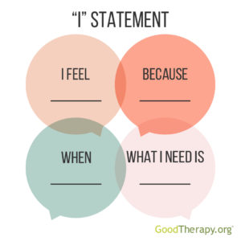
An l-message states the behaviour and describes the speaker’s feelings (numbers 1 and 2 above). The speaker owns their feelings without coming across as judging the person. It promotes a willingness to exchange information, find a solution and to seek a constructive change in the situation. Rarely does this make matters worse.
l-messages are delivered by saying: ‘I feel... (name the feeling) when ... (describe the behaviour)’. For example, you might say, ‘I feel angry when I am expecting a ride home and am forgotten.’
Some other examples of l-messages are:
- I feel angry when people call me names.
- I feel hurt when no one asks what I want to do.
- I feel suspicious when someone tells me one thing, then I find out they are doing
another.
You-Messages
In You-messages, the message contains either you or you’re in it. For example, ‘You make me so angry because you forgot to give me a ride home.’ Using You-messages blames the person for the situation and judges them. It can also hold others responsible for the feelings of the speaker as well as include putdowns. It causes feelings in the receiver that can make them defensive or start making excuses. All of this can make the situation worse.
The examples of the l-messages above have been turned into You-message to show this:
- I feel angry when you call me names.
- I feel hurt when you don’t ask what I want to do.
- I get suspicious when you’re telling me one thing then I find out you’re doing
another.
Miss Foley
LifeTrans20: Self Knowledge Mod 2.10 I Messages

l-Messages and You-Messages
An effective l-message does not contain a ‘you’ reference in it. It is common for those new to l-messages to use the form, I feel ...(feeling) when you ... (behaviour) such as ‘I feel upset when you ignore me.’ It could be classed as both an l-message and a You-message.
However, the ‘you’ in the statement still blames the other person, making them less likely to cooperate. Therefore, the I feel... when you ... message needs to be treated as a You-message and avoided. Everything said before the ‘you’ is generally ignored by the person receiving the message.
As soon as they hear the ‘you’, most people immediately concentrate on the personal attack that follows. It is similar to using ‘but’ in an argument. This is generally interpreted to mean that you may now disregard everything I have said prior to the ‘but’. For example, ‘I agree with you, but...’ is normally followed by listing all the reasons why you do not agree with them.
Always avoid using the ‘you’ word when giving constructive feedback as it will be heard as a personal attack. Instead replace it with a generic term, like ‘people’, ‘someone’ or ‘anybody’. By using a generic term with an l-message, others are more likely to listen to your entire message and willingly change their behaviour.
You will normally feel the same no matter who is using that specific behaviour. So you do not have to single them out. When you don’t accuse directly, it enables them to save face and their reaction to you is more open-minded and receptive. It provides an opportunity to start a conversation and work towards a solution.
It is worth noting that l-messages can be used negatively in order to try and manipulate someone. For example, ‘I feel worthless when we are not together’, or ‘I feel angry when people go off and talk to somebody else without me. ’This use is calculated to manipulate the other person into behaving in the manner the user wants. Like any tool it can be used for good and bad.

Alternative Ways of Delivering an l-Message
The simplified version, I feel... when ... is the best starting point when teaching or learning to use l-messages. It is less complex and gets the most important information out first - the behaviour and the feeling about the behaviour.
A danger in using a template such as this is that it can become predictable or sound false and manufactured. This comes down to what the actual content is and how the message is delivered, o offset this there are a number of additional options.
Below are 20 additional variations to consider. They use the three types of information feelings, behaviour and effect in various combinations.

The basic l-Message Includes the Feeling and the Behaviour
I feel... (feeling) when... (behaviour)
- I feel worried when it’s well after home time and there is no phone call or message.
- I feel angry when I get told off for things when others don’t.
Miss Foley
LifeTrans20: Self Knowledge Mod 2.10 I Messages

Possible other words to replace feel are: get and become
- I get concerned when I hear stories about the dangerous pranks that are played on people.
- I become frustrated and annoyed when people say they will do something for me
and then they don’t.
Or you can reverse the order:
When... (behaviour) I feel... (feeling)
- When people talk about me as if I am not even there, I feel powerless and useless.
- When I am picked on by others, I feel this rage in my gut and just want to rip something to pieces.
Possible other words to replace when are: because, as, whenever, after, and due to.
- I feel hurt because no one asked me what I thought.
- I feel frightened because of all the yelling and pushing.
- I feel disappointed because this mess has not been cleaned up.
- I feel humiliated as shouting at me in front of others shows a lack of respect.
- I feel offended whenever someone uses racist language.
- I feel suspicious after finding out that people have not told me everything.
- I feel anxious due to the risks involved in riding a motorbike in the city.
The Basic Behaviour and Effect Messages
I want... (behaviour) because... (effect)
- I want everyone to stay away from the edge because they could fall and get seriously hurt.
- I want everybody to be on time because we need to have this finished tomorrow.
I need... (behaviour) because... (effect)
- I need everyone to turn up on time because we cannot serve our customers well without all our staff.
I expect... (behaviour) because... (effect)
- I expect everyone to treat each other with basic respect because that will make it enjoyable for everyone.
It was my understanding that... (behaviour) because... (effect)
- It was my understanding that everyone agreed not to use putdowns because it can make people feel angry or hurt.
The Complex Behaviour and Effect Message
I think... (behaviour + judgement) because... (effect)
- I think telling stories that are not true about someone is unfair because others will believe the stories and not like the person for the wrong reasons.
Miss Foley
LifeTrans20: Self Knowledge Mod 2.10 I Messages

The Complex Feeling, Behaviour and Effect Messages
I would... (feeling) it if... (behaviour) because... (effect)
- I would appreciate it if everyone would ring when they are late because then I can plan to have enough staff stay back and cover till they arrive.
I would... (feeling) it very much (or variation) if... (behaviour) because... (effect)
- I would like it much better if only one person at a time spoke because then we can all get to hear what each other has to say.
(behaviour and effect)... and then I feel... (feeling)
- Leaving the sports gear outside all the time means it gets ruined and then I feel angry about having to spend money to replace it.
The final option is to use a feeling and effect message.
Just be aware that, when using this type of message, the actual behaviour that is causing the problem is not included in the message. Only its effect is, so you might need a follow¬ up message to outline the behaviour to change.
I feel... (feeling) because... (effect)
- I feel hurt because I didn’t get to make a choice.
- I feel frightened because the situation is dangerous.
Possible other words to replace because are: as and due to
- I feel sad as it hurt my feelings.
- I feel horrified due to the animals being left to go hungry.

Courtesy of www.encouraging-appropriate-behaviour.com

Name: ________________________________ Date: _____________
LifeTrans20: Self Knowledge Mod 2.10 Messages

"YOU' MESSAGES TO "I" MESSAGES
"YOU"-messages create barriers to communication (provoke anger, hurt, embarrass, create feeling of worthlessness in teens) messages share feelings and concerns (build trust and respect for feeling, allows us to accept responsibility for our own feelings, and allows us to focus on the actions not the person).
“I”-messages share feelings and concerns (build trust and respect for feeling, allows us to accept responsibility for our own feelings, and allows us to focus on the actions not the person).
Turn the following “YOU”-messages into “I”-messages:
Example: [ I feel ___ ] {how ___ emotion} [why __________reason]

            - "I can't believe you. Where is the jacket I let you borrow?"

    - "You idiot, don't cut in front of me! Watch where you are going or don't drive at all!"

    - "When will you get it through your thick skull that when you are done with things, put them away where they go!"

    - "Hey stupid, next time I see your ski crossing my skis, I am going to crack your stupid head open! I do not want my skis to get scratched by someone as careless as you. "

    - "How in the heck do you expect to graduate with grades like this?"

Name: ________________________________ Date: _____________
LifeTrans20: Self Knowledge Mod 2.10 Messages

    - "Why bother, I can never count on you to be on time for anything?

    - "You just used me. One day you act like I am your best friend and the next day, you ignore me!"

    - "Get out of my way; can't you see that I am trying to get some work done?"

    - "You are so lazy, all you ever do is bum around and beg for money."

    - "You are always late for our dates. You have a watch, call me when you know how to use it."

    - "Stop tapping on your desk!"

    - "Listen to me; I am trying to help you!"

    - "You are so dumb, you can't do anything right!"

Name: ________________________________ Date: _____________
LifeTrans20: Self Knowledge Mod 2.11 Mental Health

Mental Health
Research: Using the internet, complete a 1 page research assignment in your own words which includes the following:
- A definition for mental health.
- A minimum of 10 mental health illness and/or disorders. Be sure to provide a brief description in your own words.
- Research the supports currently available in the Cypress Health Region for mental health.
Assessment Criteria: 2 marks for the definition
1 mark for each disorder
3 marks for the services in Cypress Health Region
( _________ / 15)

Name: ________________________________ Date: _____________
LifeTrans20: Self Knowledge Mod 2.11 Mental Health

Name: ________________________________ Date: _____________
LifeTrans20: Self Knowledge Mod 2.12 Defenses

Mental Health Defense Mechanisms
Please reference the attached PowerPoint, research one of the defense mechanism outlined in the PowerPoint presentation & create a journal response that responds to the information below.

Journal Response: Using the defence mechanism that you researched, please outline a time that you, or someone that you know, used that mechanism. Was it successful? What did you learn from the experience?

Assessment Criteria: The response should at least be half a page, and will be marked based on the
Journal Response Rubric for this course. ( _______ / 12)

Name: ________________________________ Date: _____________
LifeTrans20: Self Knowledge Mod 2.12 Defenses

