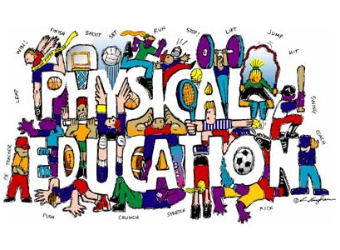
Welcome To Physical Education 7!

The Goals of K-12 Physical Education are:
- Active Living - Enjoy and engage in healthy levels of participation in movement activities to support lifelong active living in the context of self, family and community.
- Skillful Movement - Enhance quality of movement by understanding, developing and transferring movement concepts, skills, tactics and strategies to a wide variety of movement activities
- Relationships - Balance self through safe and respectful personal, social, cultural and environmental interactions in a wide variety of movement activities.
Working to Develop PHYSICALLY LITERATE Individuals who:
- Move with competence in a variety of physical activities that benefit the development of the whole person.
- Consistently develop the motivation and ability to understand, communicate, apply, and analyze different forms of movement.
- Are able to demonstrate a variety of movements confidently, competently, creatively and strategically across a wide range of health-related physical activities.
- Make healthy, active choices that both benefit and respect their whole self, others, and their environment.
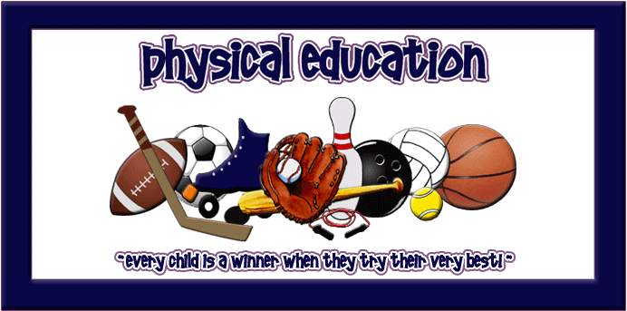
There Are Three Rules To Expect In This Class:
- GIVE THE BEST OF YOURSELF that you have to give today.
- BE RESPECTFUL of yourself, others and the equipment.
- BE SAFE with both yourself and others.
For Class You Will Need:
- A change of clothing that is comfortable for you to move in and respectful to others.
- T-shirts cover belly button with both hands raised overhead; T-shirts preferred over tank tops.
- Tank top straps are at least 2 inches wide with all undergarments covered.
- Shorts are at least mid-thigh length. Light sweats/yoga pants/wind pants are also welcome.
- Athletic footwear, preferably not outside footwear. Flip flops, clogs, flats, cowboy/roper boots, sandals, untied skater shoes are not appropriate footwear.
- Any completed homework required.
- Eye protection (shatter proof goggles/glasses) – option to order through the school at any time.
- Badminton racquet - option to order through the school each spring.
- Seasonal access to backpack, bicycle, skates, swimsuit, winter clothing.
- An open mind, a desire to try new things and the ability to laugh at yourself
Not only are individuals built for and need to move, they also need to appreciate and understand the “how’s, what’s, where’s & why’s” of movement... Welcome to Physical Education!

By The End Of PE 7 You Will Be Able To Say… |  | % of Final Mark
7.1 | Health-related Fitness: I can create & carry out my own daily fitness plan, using the F.I.T.T. principle, to improve my cardiovascular endurance, flexibility and cardiovascular endurance. | 14 | Active Living  35%
7.2 | Body Composition: I can explain how my eating and drinking habits will affect participation in various activities and how they could affect a healthy body weight and body composition. | 4
7.3 | Skeletal System: I can explain the effect that exercise and lack of it have on my skeleton and on the skeletal system while I’m moving. | 3
7.4 | Cross-training: I can demonstrate how cross training improves fitness and skill across a variety of activities. | 5
7.10-7.13 | Flexible | 9
7.5 | Complex Skills: I can demonstrate control, with smooth transitions, while moving with objects or remaining still during games or sports. | 7 | Skillful Movement  40%
7.6 | Biomechanics: I can improve my ability to move objects, my travelling and non-travelling skills using principles of balance, stability, spin and rotation. | 5
7.7 | Movement Concepts: I can analyze and, with help, apply movement concepts while playing net/wall games & striking/fielding games. | 5
7.8 | Decision Making: I can make appropriate decisions and choose skills, tactics & strategies that increase my own and my team’s performance in the following types of games: net/wall, striking/fielding and low organizational, inventive & cooperative. | 8
7.9 | Alternate Environment & Body Management: I can use the appropriate movement skills and in combination to participate in a variety of alternate environment & body management activities. | 10
7.4 | Flexible | 5
7.10 | Volunteerism & Leadership: I can plan, organize, lead & evaluate an interactive movement activity for younger students. | 6 | Relationships  25%
7.11 | Influences: I can identify what might affect opportunities for people to participate in physical activity and develop physical skills. | 2
7.12 | Safety & Rules: I can develop an appreciation for the impact of safety & rules on myself and others after analyzing those related to net/wall games, striking/fielding games, low organizational & inventive games, alternate environment & body management activities. | 5
7.13 | Relationship Skills: I can show responsible and caring behaviours for personal growth while participating in activities. | 4
7.14 | History & Culture: I can look at, critique and appreciate various physical activities developed by Canada’s Northern people & how they contribute to my well-being and others. | 4
7.8-7.9 | Flexible | 4

