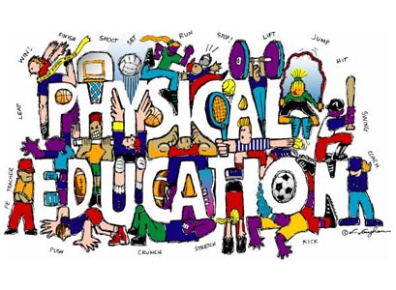
Welcome To Physical Education 9!

The Goals of K-12 Physical Education are:
- Active Living - Enjoy and engage in healthy levels of participation in movement activities to support lifelong active living in the context of self, family and community.
- Skillful Movement - Enhance quality of movement by understanding, developing and transferring movement concepts, skills, tactics and strategies to a wide variety of movement activities
- Relationships - Balance self through safe and respectful personal, social, cultural and environmental interactions in a wide variety of movement activities.
Working to Develop PHYSICALLY LITERATE Individuals who:
- Move with competence in a variety of physical activities that benefit the development of the whole person.
- Consistently develop the motivation and ability to understand, communicate, apply, and analyze different forms of movement.
- Are able to demonstrate a variety of movements confidently, competently, creatively and strategically across a wide range of health-related physical activities.
- Make healthy, active choices that both benefit and respect their whole self, others, and their environment.
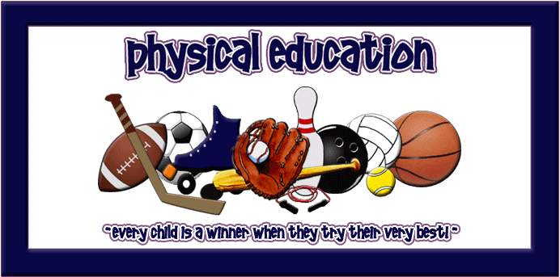
There Are Three Rules To Expect In This Class:
- GIVE THE BEST OF YOURSELF that you have to give today.
- BE RESPECTFUL of yourself, others and the equipment.
- BE SAFE with both yourself and others.
For Class You Will Need:
- A change of clothing that is comfortable for you to move in and respectful to others.
- T-shirts cover belly button with both hands raised overhead; T-shirts preferred over tank tops.
- Tank top straps are at least 2 inches wide with all undergarments covered.
- Shorts are at least mid-thigh length. Light sweats/yoga pants/wind pants are also welcome.
- Athletic footwear, preferably not outside footwear. Flip flops, clogs, flats, cowboy/roper boots, sandals, untied skater shoes are not appropriate footwear.
- Any completed homework required.
- Eye protection (shatter proof goggles/glasses) – option to order through the school at any time.
- Badminton racquet - option to order through the school each spring.
- Seasonal access to backpack, bicycle, skates, swimsuit, winter clothing.
- An open mind, a desire to try new things and the ability to laugh at yourself
Not only are individuals built for and need to move, they also need to appreciate and understand the “how’s, what’s, where’s & why’s” of movement... Welcome to Physical Education!
By The End Of PE 9 You Will Be Able To Say… |  | % of Final Mark
9.1 | Health-Related Fitness: I can carry out a daily action plan using the principles of training to improve/maintain my health-related fitness. | 14 | Active Living  40%
9.2 | Body Composition: I can determine safe and credible options for managing body composition and weight while analyzing the influence of media on body image. | 6
9.3 | Core Strength: I can investigate strategies and effectively develop strength in my core and joint muscles safely. | 8
9.4 | Skill-related Fitness: I can, using a sport/activity of my choice, carry out a personal action plan to improve a component of skill-related fitness of my choice. | 5
9.7-9 & 9.11-12 | Flexible | 10
9.5 | Complex Skills: I can become proficient in four chosen skills from four of the following: target games, invasion/territorial games, net/wall games, alternate environment activities & body management activities. | 3 | Skillful Movement  40%
9.6 | Games, Tactics & Strategies: I can, with others, design and carry out plans that use effective tactics and strategies to increase my performance and enjoyment, along with others, for each type of game: target, striking/fielding, net/wall, invasion/territorial & low organizational/inventive/cooperative games. | 12
9.7 | Alternate Environment: I can, with others, design and carry out plans that use effective tactics & strategies to increase my performance and enjoyment, along with others, in alternate environment activities while respecting the environment. | 12
9.8 | Body Management: I can share my experience of doing body management activities and explain how it contributes to participation in recreational and leisure activities for my holistic well-being. | 6
9.7-9.8 | Flexible | 4
9.9 | Volunteerism & Leadership: I can use my leadership skills to plan and lead a movement activity event within my class, school or community. | 5 | Relationships  20%
9.10 | Influences: I can analyze how mass media & advertising influences and promotes active living. | 2
9.11 | Prevention & Care: I can apply my understanding of how to prevent and care for activity related injuries. | 3
9.12 | Respectful Behaviour: I can identify positive & negative influences of sport & mass media before showing positive behaviours as a spectator and participant in movement activities. | 3
9.13 | Contemporary Culture: I can investigate opportunities and challenges that influence my ability to become a skillful mover and live a balanced active lifestyle while developing & maintaining safe and respectful relationships. | 3
9.6-9.8 | Flexible | 4

