Miss Foley

Psych20: Unit 1 Title Page

Unit I: What Is Social Psychology?
  - What is social psychology?
- What is social psychology?
- Who are social psychologists and what do they do?
- How can social psychology make a positive difference in our lives?
- What is your metaphor for life?
  - What influences human social action and interaction?
- What is the biological basis for our behaviour?
- What are the various systems of support that influence our behaviour?
- In what ways do heredity, experience and/or the systems of support influence how we think, feel and behave?
- How does gender influence our thoughts, feelings and behaviours?
  - What are the different perspectives on human social action & interaction?
- What are the contemporary perspectives that try to explain human social behaviour?
- What is the Aboriginal perspective on social psychology?
  - How do we make sense of our behaviour?
- How do we make sense of our behaviour?
- What are the positive and negative aspects of each of the ways of

conducting research?
- Given a research question, what research method is most appropriate?
- What are the methodological issues in research?
- What are some of the ethical issues in research?
  - Action research in social psychology
- Should parents be legally permitted to spank their children?
- Should the government be launching a national daycare program paid for by taxpayers?
- Should parents be held accountable in some way for the behaviour of their children?
- Should we abolish the military and use the money to fund social programs such as health and education?
- What, or who, are the primary influences on you?
- Should animals be used for scientific research purposes?
- What are the qualities you most admire in a friend?
- Should the legal age to drive a car be raised to 18?
- Should the legal age to consume alcohol be raised to 21?
- Do you agree with euthanasia (mercy killing)?
- Do you think we should reinstate capital punishment?
- Do you believe in fate?
- What is the most important human value?
- What is the most important quality in a parent?
- If you could swap genders, would you? Why?

Miss Foley

Psych20: Unit 1 Title Page (cont’d)

- Moral dilemmas:
- Is it right to steal life-saving medicines that you cannot afford?
- Should you tell the police if your best friend committed a crime?
- If you found a large sum of money in an unmarked envelope, should you keep it?
- What are the play behaviours of young children?
- How prevalent is violence in television programming?
- What are the social norms in a variety of contexts (e.g., cafeteria, malls, hallways, sporting events)?
- How do group behaviours change in varying social situations (e.g., single gender, mixed gender, different age groups)?
- What is a day in the life of ......... like?
- In what situations does the presence of others influence behaviour?
- How do different seating arrangements affect conversation?
- Lives lived. Conduct a case study of a senior or Elder in your family or community and construct presentation or report on his/her life.
- Who was B.F. Skinner and what role did he play in social psychology?
- Who was Ivan Pavlov and what role did he play in social psychology?
- Who was Jean Piaget and what role did he play in social psychology?
- Who was Albert Bandura and what role did he play in social psychology?
- Who was Abraham Maslow and what role did he play in social psychology?
- Who was Lev Vygotsky and what role did he play in social psychology?
- Research one of the following topics:
- gender development
- personality
- aboriginal spirituality
  - cultural Industries (fashion, music, beauty)
  - advertising
- Ask an Elder or senior citizen: How has society changed since you were a teenager?
- Ask an Elder or senior citizen: What have you learned about the basic values and goals in life?
- Ask your parents: What are the major sources of stress in your lives?
- Ask a person in a position of leadership: What qualities are important in a leader?
- Ask your parents or family members: What qualities are important in a relationship?
- Ask your parents or family members: What are the human values you respect or aspire to the most?

Miss Foley
Psych20: 1.1 Intro Believe It Or Not!

Believe It Or Not!

_________________________ was born in another country.

_________________________ has more than 5 siblings.

To become a doctor is the career goal of _____________________.

____________________ and _____________________ are related.

____________________ can play a musical instrument other than a guitar, piano or drums.

____________________ has relatives that live on another continent.

____________________ has more than 5 body piercings.

____________________ has represented Saskatchewan at a national event.

____________________, ___________________ and ________________ still live in the same house in which they were born.

___________________ has lived in more than 2 provinces.

___________________ has a relative older than 90 years of age.

___________________ can roll his/her tongue.

___________________ has dual citizenship, Canada and _________________.

When ________________ graduates, his/her plan is to travel to ______________.

___________________’s parents went to school with one of ________________'s parents.

___________________ is an aunt or an uncle.

___________________ has twins in his/her family.

___________________ thinks the Maple Leafs are the greatest hockey team in the world!

Miss Foley
Psych 20: 1.1 Intro Psych Defined

Psychology =
the science of human thought and behavior
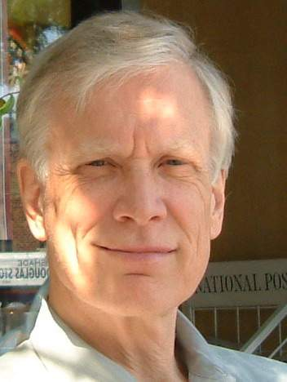
Social Psychology =
James Alcock, prominent Canadian Psychologist, author & professor at York University in Toronto, ON
The study of human beings in
relationship to each other
OR
the study of how the thoughts, feelings
and behaviours of individuals are
influenced by the actual, imagined, or
implied presence of others (Alcock et al., 1998, p. 11)
Social psychology deals with human interaction – the way people relate to one another and the way people influence one another. How can we understand human relations and social influence? By studying the way people feel and the way people think – in short, by studying the heart and the mind (Aronson et al., 1994, p. 5).
Social psychologists have worked to understand such phenomena as economic depression, attitude formation, racial prejudice, adaptation and acculturation of immigrants, friendships and relationships, the effects of the Canadian multiculturalism policy, social norms of behaviour, group dynamics, propaganda and conformity, the development of racial identity among native children, conflict resolution, cognitive processes such as memory, attention and problem solving, environmental issues, marital conflicts, addiction and aggression (Alcock et al., 1998, p. 9).

What was the point of the “Believe It or Not” Handout?
Psychology is the science of human thought and behaviour - all of the statements included in the “Believe It or Not” handout are questions of interest to social psychologists.
Activity: “Metaphors for Life”
On the television show Ally McBeal the characters have theme songs. The songs are supposed to reflect how they live their lives, or maybe how they would like to live their lives. Most of us don't have theme songs, but we often have metaphors for our lives that either help us or hinder us.
Some people see life as a battle. Every encounter is a struggle, and if they don’t win, they feel like they have lost. Others view life as an adventure. A new day brings new opportunities to explore. If something goes badly today, there’s always tomorrow.
How do these metaphors develop? As children we begin to understand and organize the world. If we think of the brain as a filing cabinet, then childhood is when we open the files and label them. We often spend the rest of our lives putting new material in these old files. If childhood was healthy, then we may have a pretty good filing system. If it was a struggle, then we often see struggles for the rest of our life.
Miss Foley
Psych 20: 1.1 Intro Psych Defined

Metaphors for Life Examples

Battle – Everything is a competition or a struggle. We are always either winning or losing.
A garden – Relationships are cultivated like flowers or vegetables. We see things as growing, flowering or producing.
A mission – We believe that we have the truth and we need to convince others that our point of view is right.
A journey or an adventure – We travel from place to place meeting new people and exploring.
A building – Starting with a solid foundation, then adding floors and rooms.
A roller coaster –Life consists of ups and downs, and we are along for the ride.
A stained glass window – Full of light and colours.
A mountain climb – Life consists of hierarchies. We are always climbing the various ladders of life.
A race – Always finding the fastest route, “keeping up with the Joneses”.
A courtroom – Everything in life should be fair.
Stepping stones – We barely get comfortable where we are before we are looking for a better job or a bigger house.
A prison – Feeling like we do not have choices, like others have all the power.
A classroom – There are always new lessons to learn.
A battery – Every encounter seems to drain energy. We need the weekends to recharge
What are YOUR metaphors?
Miss Foley
Psych 20: 1.1 Intro Role of Psychologists

Pig Personality Profile Test

FINISH!!!!!!!!!!!!!

Group Dynamics: Choose a Color

FINISH!!!!!!!!!!!!!

Miss Foley
Psych 20: 1.1 Intro Roles of Psychologists
Psychologists = receive training in graduate schools that offer masters or doctoral programs

* Can NOT prescribe medications

Psychiatrists = physicians with a medical degree that specialize in the treatment of mental disorders

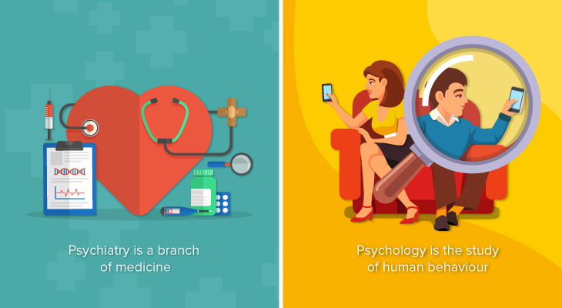
Psychiatry is a branch of medicine while psychology is the study of human behaviour.

Psychiatry is a “branch of medicine that deals with the diagnosis, management and prevention of mental, emotional or behavioural disorders”. Psychiatrists are doctors who look at the biology and neurochemistry of human beings to determine how they influence our behaviour and emotions.

On the other hand, psychology is a multifaceted discipline that studies how human beings think, behave and interact with one another. Depending on your level of study, you may be exposed to scientific research and conduct experiments, case studies, observations and brain imaging to investigate why we behave the way we do.

Psychiatrists have a Medical Degree while psychologists have a postgraduate Psychology Degree.

Since psychiatrists are qualified doctors, a career in psychiatry begins with a Medical Degree, which typically takes 5 years to complete.

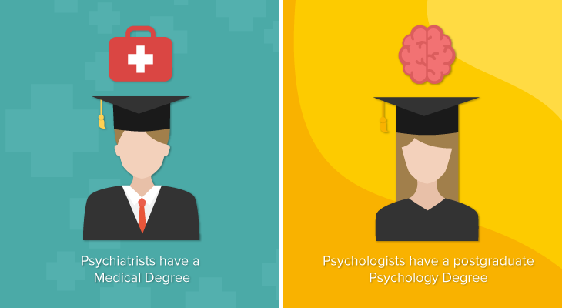
Once you are a registered doctor, you will then need to study for a Masters in Psychiatry.

To qualify as a psychologist, you will first need to complete a Degree in Psychology, which takes 3 years to complete, before taking your masters or PhD in a specialised field, such as clinical psychology, neuropsychology or forensic psychology. This may take approximately 2 to 3 years.
Miss Foley
Psych 20: 1.1 Intro Role of Psychologists

Psychiatrists can prescribe medication but psychologists can’t.
Both psychiatrists and psychologists are trained to solve mental health problems but their approach to finding a solution may be different.
A psychiatrist is a qualified medical doctor who specialises in treating mental illnesses.
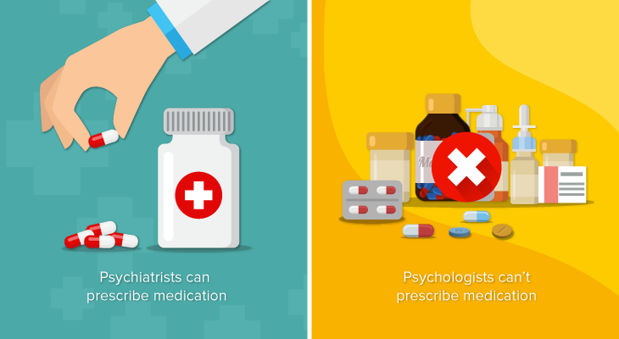
They diagnose a variety of mental health disorders, from anxiety and depression to schizophrenia, and use their knowledge of human behaviour and genetics to develop a treatment plan for their patients.
As they are registered medical practitioners, psychiatrists can prescribe medication to their patients in combination with psychotherapy as part of their treatment.
Mental disorders, such as anxiety, bipolar disorder and attention deficit hyperactivity disorder (ADHD) can be treated effectively with the help of medication.
A psychologist, on the other hand, is an expert in human behaviour. They conduct laboratory and psychological tests, conduct interviews to assess the behaviour of individuals and help their patients cope with life problems and mental health disorders.
Unlike psychiatrists, psychologists cannot prescribe medication. Instead, they use various methods, such as counselling and psychotherapy, to treat their patients.
Psychiatrists primarily work in the medical field while psychologists can work in a wider range of fields.

While psychiatrists can work in various settings, such as hospitals, universities, private practice or nursing homes, their careers primarily revolve around the medical field due to their background as medical practitioners.

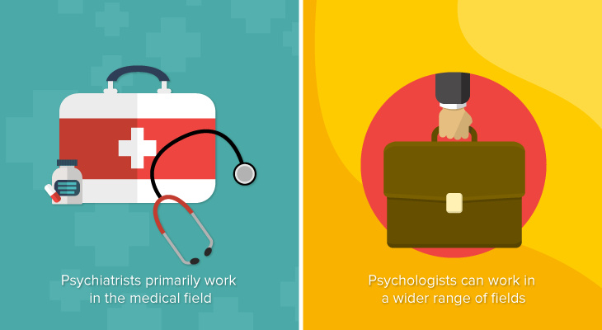
In contrast, psychologists can specialise in a variety of fields, giving them a wider range of career opportunities. Aside from clinical psychology that focuses on mental health disorders, other specialisations include sports psychology (helping athletes enhance their performance), industrial and organisational psychology (improving efficiency and employee well-being in the workplace) and cognitive psychology (exploring how people process information).
A psychologist can also become a certified counsellor by obtaining a license from the Malaysian Board of Counsellors and registering with the Malaysian Association of Counsellors. A counsellor utilises his or her counseling skills and techniques to provide help to people with mental health problems and others who need emotional and psychological support.
Miss Foley
Psych 20: 1.1 Intro Role of Psychologists

There are many specialties. Each specialty has a particular focus. Psychologists study many different forms of behaviours and perform their work in many different settings. Below are some common sub-fields of psychology.

Specialization | Focus
Clinical Psychology | diagnosis, causes, and treatment of mental disorders
Cognitive Psychology | all aspects of cognition-memory, thinking, reasoning, language, decision making, etc.
Counselling Psychology | individual’s personal problems that do not involve psychological disorders
Developmental Psychology | how people change physically, cognitively, and socially over their entire life span
Educational Psychology | all aspects of the education process
Experimental Psychology | all basic psychological processes, including perception, learning, and motivation
Industrial/Organizational Psychology | all aspects of behavior in the work setting
Psychobiology | the biological bases of behavior
Social Psychology | all aspects of social behavior and social thought – how we think about and interact with others
Sports Psychology | all aspects of behavior in the sports setting

Nearly half of all psychologists are clinical or counselling psychologists who conduct therapy and help people with problems. Many social psychologists are employed by universities, colleges, hospitals, and mental health institutions to teach and to conduct either basic research (designed to increase understanding) or applied research (focuses on finding solutions to practical problems).

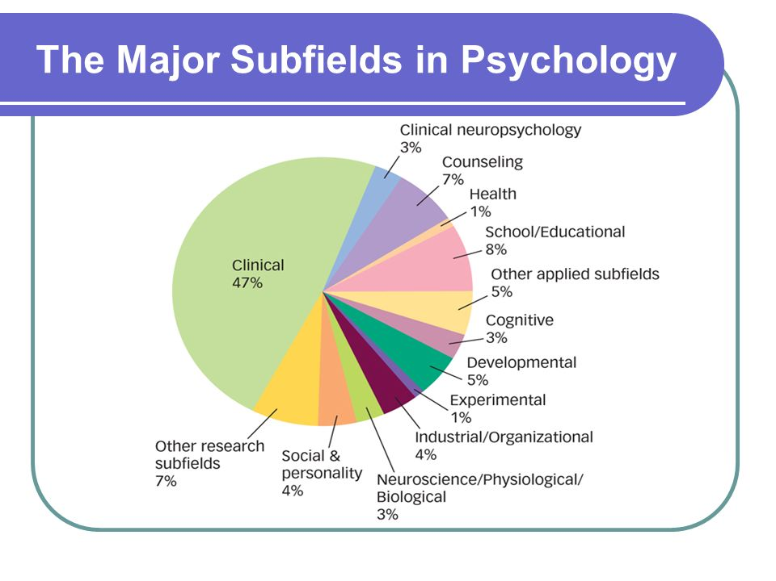
Social psychology has always been concerned with the real-life problems of people and the societies which they live. In the business sector, psychologists may advise companies on issues dealing with the following:
- Hiring and firing practices
- Introducing and dealing with change
- Stress management
- Effective management and leadership styles
- Creating a collaborative work environment
- Resolving workplace conflict
- Addiction counselling
- Marketing and advertising strategies
- Customer service
- Motivating employees

Name: ____________________ Date: ___________
Psych 20: 1.1 Intro Psychologist Profile

Psychologist Profile
Select one of the following psychologists for your research paper. Your research should include the following:

- Some personal background on the psychologist
- Birth/Death
- Family
- Up-bringing
- Education

- The particular field in which his/her main research was/is being done. Describe how the new ideas were or how the y challenged previous thinking. Was it controversial?

- What are some theories attributed to this person?

- What are some examples of the work done by this person? For example, some famous experiments, famous books, etc.

- What contributions has this made to society today?

The paper should be 500-700 words long, typed single spaced, Times New Roman size 12 font. You should have an opening and closing paragraph. A bibliography with endnotes/footnotes should be provided. Your research should come from at least TWO SOURCES and you MUST HAVE a MINIMUM of 2 DIRECT QUOTES.

Your paper is out of 100 marks with the following breakdown:

Research 60%
Grammar & Spelling 20%
Bibliography & 20%
Endnotes/Footnotes

Select from the following Psychologists:

Sigmund Freud
Abraham Maslow
Ivan Pavlov
Carl Rogers
Albert Bandura
Erik Erikson
Alfred Adler
Eleanor Gibson
Carl Jung
Lawrence Kohleberg
Eleanor Macoby
B.F. Skinner
Jean Piaget
Leon Festinger
William James
Others?

Teacher Information/Options:
- Ecological Model of Human Behaviour Handout
- Nature/Nurture and Human Behaviour Handout
- Activity/Discussion: Biology or environment?
  - Ask a female and a male student to stand up and hold hands. Note the relative position of the male student’s hands. Invariably, the male student’s hand will be on top, and the female student’s hand will be on the bottom. Repeat several times to establish a pattern.

  - Discuss possible reasons or explanations as to why this occurs. A biological interpretation (nature) will explain it in terms of the mechanics of holding hands, in other words, the taller person (usually the male) will find it more comfortable to place his hand on top. A psychological (social environment or nurture) explanation might include the relative “dominance” of males versus the “submissiveness” of females, as illustrated in the unconscious act of placing the female hand on the bottom.

  - Read Interactions p.10-12 – Ecological Model of Human Behaviour. What are the primary sources of influence on our behavior? Making Connections #1

Miss Foley
Psych 20: 1.2 Influences Human (Inter)action

Influences on Human
Social Action and Interaction

Discussion: What are the primary sources of influence on our behaviour?
Student Responses:

Possible Answers: Music Industry Television Fashion Industry
Family Movies Beauty Industry
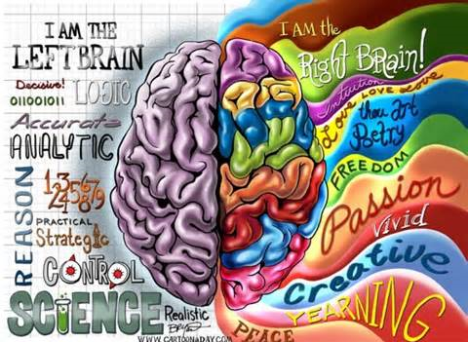
What is the biological basis for our behaviour?
How is it that human beings have dreams, make plans, feel joy or hunger, fall in love, read and understand this page, or remember events that took place ages ago? This question is about the relationship between biology, brain, and behaviour and the answer is at once most simple and most complex. The simple answer is this. All of our thoughts, feelings and behaviours originate from basic biological processes – more specifically from the brain (Baron et al., 1998, p. 42).
What are the various systems of support that influence our behaviour?
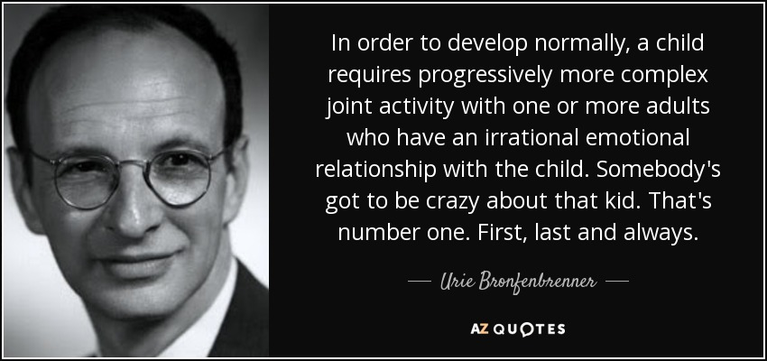
In his Ecological Model, Urie Bronfenbrenner (1979) described three levels of influence that affect an individual through various processes. According to Bronfenbrenner, each person is significantly affected by interactions among a number of overlapping ecosystems. At the center of the model is the individual. Microsystems are the systems that intimately and immediately shape human development. Interactions among the microsystems, as when parents and teachers coordinate their efforts to educate the child, take place through the mesosystem. Surrounding the microsystems is the exosystem, which includes all the external networks, such as community structures and local educational, medical, employment, and communications systems, that influence the microsystems. Influencing all other systems is the macrosystem, which includes cultural values, political philosophies, economic patterns, and social conditions. Together, these systems are termed the social context of human development (Bronfenbrenner, 1977, as quoted in Berger, 2000, p. 7).

Miss Foley
Psych 20: 1.2 Influences Human (Inter)action

The Ecological Model
of Human Behavior
Urie Bronfenbrenner (1979)
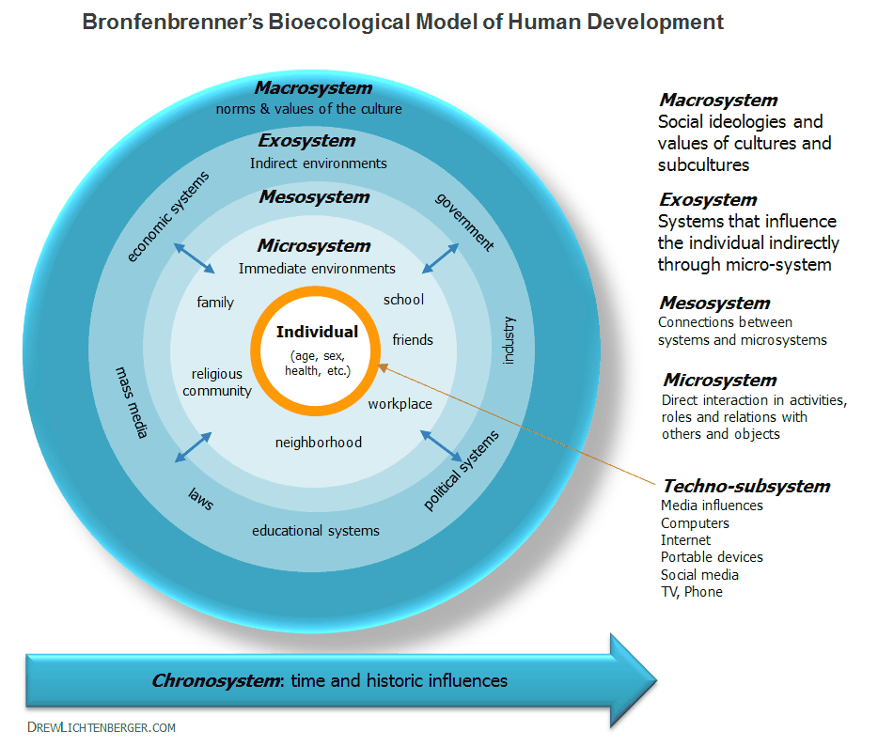

Name: ____________________ Date: ___________
Psych 20: 1.2 Influences Human (Inter)action

Ecological Model of Human
Behavior: Personalized
Upon reflecting on your own life, discuss the following levels of Urie Bronfenbrenner’s Ecological Model of Human Behavior as they relate to your current life:
Individual: (Age, Sex, Health, personality characteristics, etc.)
Techno-subsystem: (not in original 1979 model – media influence, computers, Internet, portable devices, social media, TV, phone, etc.)
Microsystem: (family, school, friends, religious community, workplace, neighborhood, etc.)
Exosystem: (economy, government, industry, politics, education systems, laws, mass media, etc.)
Macrosystem: (norms and values of culture)

Name: ____________________ Date: ___________
Psych 20: 1.2 Influences Human (Inter)action

Miss Foley
Psych 20: 1.2 Influences Human (Inter)action

NATURE =
genetics
NURTURE = interaction with the environment

VS

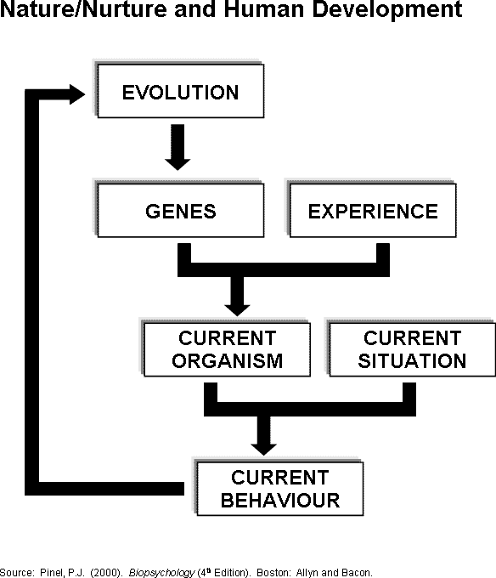
Miss Fole
Psych 20: 1.2 Influences Human (Inter)action

In what ways do heredity, experience and/or the systems of support influence how we think, feel and behave?
Psychologists and biologists have long debated whether interaction with the environment—a person’s family and culture, for instance—is more important than genes in shaping disease, character, and behaviour.
It is becoming more obvious that environment and genes have different degrees of influence, depending on the trait. Some traits such as eye colour appear to depend on only a genetic component with little or no environmental input. However, others such as muscle strength or musical achievement seem to require contributions from both genes and the environment. If a person is born with the alleles for great athletic or musical potential, for example, those talents will not develop without practice. A child may be born with the alleles for potentially high academic intelligence, but lack of stimulation and limited exposure to new experiences in early childhood may keep the child from realizing that potential. Lack of nutrition during childhood can turn a person with the potential to be six feet tall into someone who barely clears five feet.
Current research indicates that expression of alleles in certain individuals may also depend on their unique internal environment – their nervous system, hormone balance, or other aspects of their biochemistry (Berger, 2000, p. 82).

Examples of factors that influence human behavior:
Nature –

Nurture -

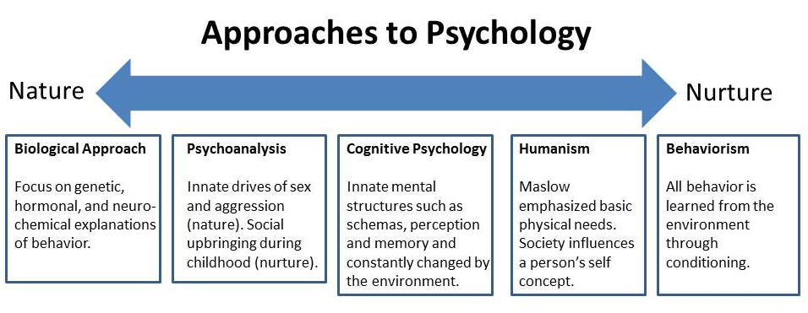

Miss Foley
Psych 20: 1.2 Influences Human (Inter)action

Gender =
how we classify oneself and
others as man or woman

How does gender influence our thoughts, feelings and behaviours?
Biological Sex refers to the physical sex characteristics an individual is born with and develops, including genitalia, body shape, voice pitch, body hair, hormones, etc. All of these genetic traits are dependent on their combination of chromosomes.
i.e. XX = female, XY = male, XXY or XYY = transsexual.
Gender identity refers to the classification of oneself and others as man/boy or woman/girl, depending on age.
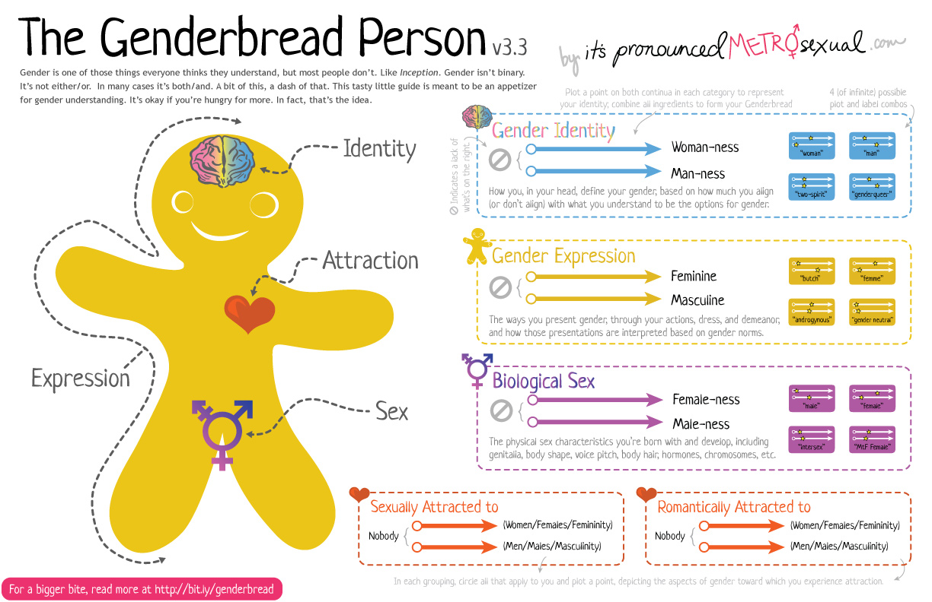
Gender roles/expression refers to the actions, attitudes, behaviors, beliefs, dress, demeanor, etc. that a particular society either expects from, or considers appropriate to males and females on the basis of their biological sex. To be masculine or feminine, therefore, requires males and females to conform to their respective gender roles (Gross and McIlveen, 1998, p. 393).

Miss Foley
Psych 20: 1.3 Perspectives Human (Inter)action

Perspectives of Social Psychology
What are the contemporary perspectives that try to explain human social behaviour?
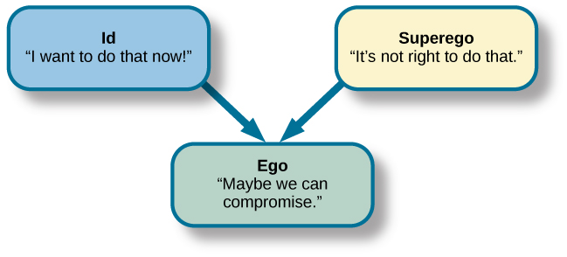
Psychodynamic Perspective:
Advocates of the psychodynamic perspective believe that behaviour is motivated by inner forces, memories and conflicts that are generally beyond people’s awareness and control.
Sigmund Freud’s psychoanalytic theory suggests that unconscious forces act to determine personality and behaviour. To Freud, the unconscious is a part of the personality about which a person is unaware. It contains infantile wishes, desires, demands and needs that are hidden, because of their disturbing nature, from conscious awareness. Freud suggested that the unconscious is responsible for a good part of our everyday behaviour. According to Freud, one’s personality has three aspects: the id, the ego and the superego.
The id is the raw, unorganized, inborn part of personality that is present at birth. It represents primitive drives related to hunger, sex, aggression and irrational impulses. The id operates according to the “pleasure principle”, in which the goal is to maximize satisfaction and reduce tension.
The ego is the part of the personality that is rational and reasonable. While providing a reality check for the demands of the id, the ego acts as a buffer between the outside world and the primitive id. The ego operates on the “reality principle”, in which instincts are restrained in order to maintain the safety of the individual and help integrate the individual into society.
Finally, Freud proposed that the superego represents a person’s conscience, incorporating distinctions between right and wrong. It develops around age five or six and is learned from an individual’s parents, teachers and other significant figures (Feldman, 2000, p. 15).
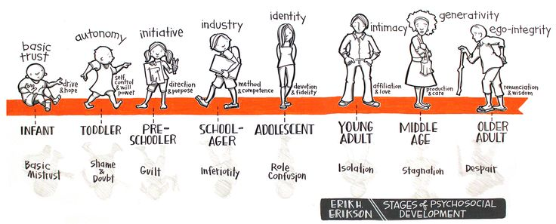
Erikson’s psychosocial theory suggests that developmental change occurs throughout our lives in eight distinct stages. The stages emerge in a fixed pattern and are similar for all people. Erikson argues that each stage presents a crisis or conflict that the individual must resolve. Although no crisis is ever fully resolved, making life increasingly complicated, the individual must at least address the crisis of each stage sufficiently to deal with demands made during the next stage of development (Feldman, 2000, p. 17).

Miss Foley
Psych 20: 1.3 Perspectives Human (Inter)action

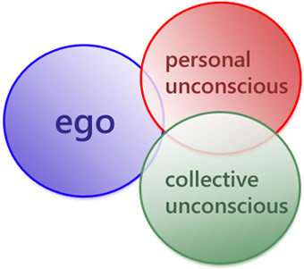
Carl Jung was originally one of Freud’s closest friends, but by 1914 he had left Freud’s inner circle. In addition to the individual’s own unconscious, said Jung (1969), there is a collective unconscious shared by all human beings, containing universal memories, symbols and images that are the legacy of human history. In his studies of myths, art and folklore in cultures all over the world, Jung identified a number of these common themes, which he called archetypes. Psychologists have found that some basic archetypes such as the Hero, the Nurturing Mother, the Powerful Father, the Wicked Witch and the Earth Mother do appear in the stories and images of virtually every society. Two of the most important archetypes, in Jung’s view, are those of Men and Women themselves. Jung recognized that “masculine” and “feminine” qualities exist in both sexes. Problems can arise, however, if a person tries to repress his or her internal, opposite archetype – that is, if a man totally denies his softer “feminine” side or if a woman denies her “masculine” aspects. People also create problems in relationsh ips when they expect the partner to behave like the ideal archetypal man or woman, instead of a real human being who has both sides (Tavris and Wade, 2000, p. 481).
The Behavioural Perspective:
The behavioural perspective suggests that the keys to understanding development are observable behaviour and outside stimuli in the environment. If we know the stimuli we can predict the behaviour. Behavioural theories reject the notion that individuals universally pass through a series of stages. Instead, people are assumed to be affected by the environmental stimuli to which they happen to be exposed. Developmental patterns, then, are personal, reflecting a particular set of environmental stimuli, and development is the result of continuing exposure to specific factors in the environment (Feldman, 2000, p. 18).
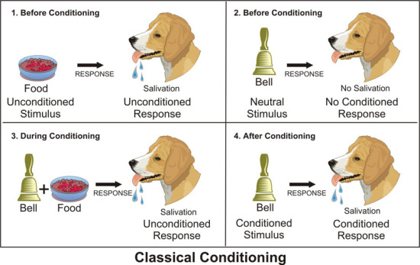
John B. Watson and B.F. Skinner’s theories of classical and operant conditioning hold that all behaviour is learned as a response to external stimuli. Classical conditioning occurs when an organism learns to respond in a particular way to a neutral stimulus that normally does not evoke that type of response. For example, Russian psychologist Ivan Pavlov found that if a dog is repeatedly exposed to the pairing of two stimuli, such as the sound of a bell and the presentation of meat, it may learn to react to the sound of the bell alone in the same way it reacts to the presentation of meat. In operant conditioning, Skinner demonstrated that individuals learn to act deliberately on their environments in order to bring about desired consequences. In a sense, then, people operate on their environment in order to bring about a desired state of affairs. Reinforcement is the process by which a stimulus is provided that increases the probability that a preceding behaviour will be repeated. In addition, punishment will decrease the probability that the preceding behaviour will occur in the future (Feldman, 2000, p. 18).
According to social-cognitive learning theorist Albert Bandura, when we see the behaviour of a model being rewarded, we are likely to imitate that behaviour. Behaviour is learned through observation and imitation, not conditioning through reinforcement or punishment (Feldman, 2000, p. 18).

Miss Foley
Psych 20: 1.3 Perspectives Human (Inter)action

The Cognitive Perspective:
The cognitive perspective focuses on the processes that allow people to know, understand and think about the world. The cognitive perspective emphasizes how people internally represent and think about the world. By using this perspective, developmental psychologists hope to understand how children and adults process information, and how their ways of thinking and understanding affect their behaviour (Feldman, 2000, p. 20).
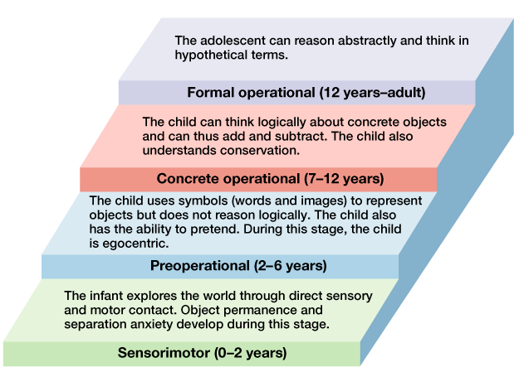
No single person has had a greater impact on the study of cognitive development than Jean Piaget who proposed that all people pass in a fixed sequence through a series of universal stages of cognitive development. In each stage, he suggested that not only did the quantity of information increase, but so did the quality of knowledge and understanding. Piaget suggests that the growth in children’s understanding of the world can be explained by two basic principles. Assimilation is the process in which people understand an experience in terms of their current state of cognitive development and way of thinking. In contrast, accommodation refers to changes in existing ways of thinking in response to encounters with new stimuli or events (Feldman, 2000, p. 20).
Russian psychologist Lev Vygotsky’s sociocultural theory proposes that a full understanding of development is impossible without taking into account the culture in which children develop. Sociocultural theory proposes that children’s understanding of the world is acquired through their problem-solving interactions with adults and other children. As children play and cooperate with others, they learn what is important in their society, and at the same time, advance cognitively in their understanding of the world (Feldman, 2000, p. 21).
The Humanistic Perspective:
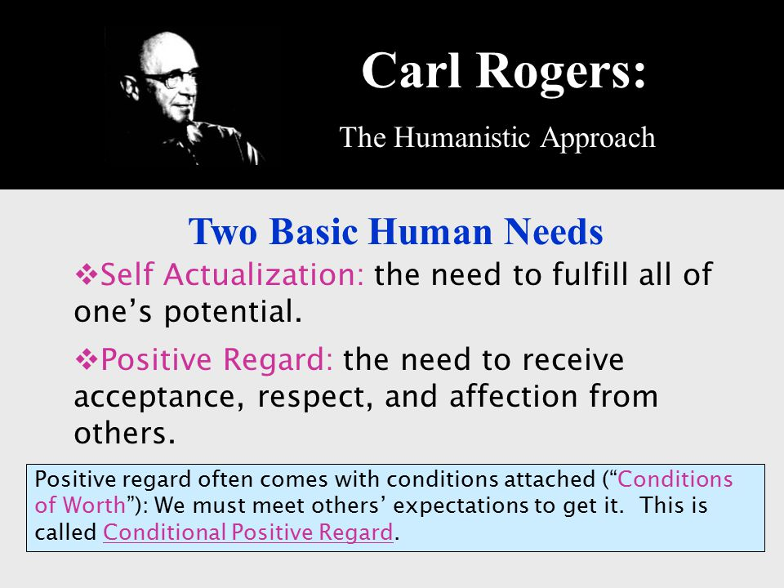
The humanistic perspective contends that people have a natural tendency to make decisions about their lives and control their behaviour. The humanistic perspective emphasizes free will, the ability of humans to make choices and come to decisions about their lives (Feldman, 2000, p. 22).
Carl Rogers suggested that all people have a need for positive regard that results from an underlying wish to be loved and respected. Because it is other people who provide this positive regard, we become dependent on them. Consequently, our view of ourselves and our self-worth is a reflection of how we think others view us (Feldman, 2000, p. 22).

Miss Foley
Psych 20: 1.3 Perspectives Human (Inter)action

The Humanistic Perspective (cont’d)
Abraham Maslow suggests that self-actualization is a primary goal in life. Self-actualization is a state of self-fulfillment in which people achieve their highest potential in their own unique way. (Feldman,2000, p. 22). Self-actualization can only be achieved if foundational needs are fulfilled.
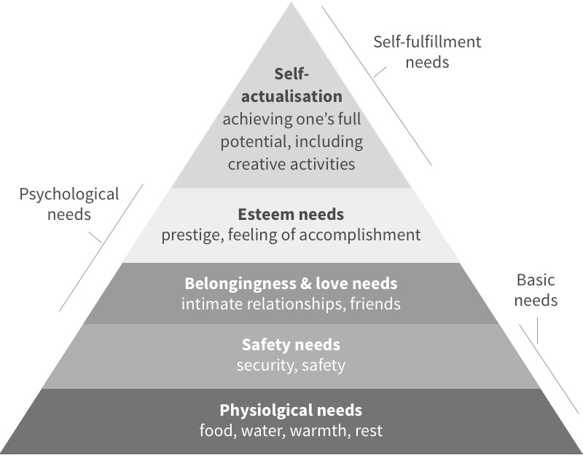
The Evolutionary Perspective:
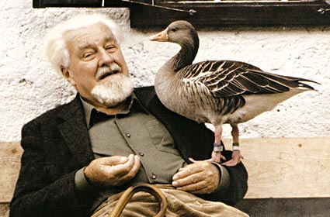
According to evolutionary theories, behaviour is strongly influenced by biology, is tied to evolution, and is characterized by critical or sensitive periods. Evolutionary approaches grow out of the ground breaking work of Charles Darwin (Feldman, 2000, p. 22).
Konrad Lorenz discovered that newborn geese are genetically preprogrammed to become attached to the first moving object they see after birth. His work, which demonstrated the importance of biological determinants in influencing behaviour patterns, ultimately led developmentalists to consider the ways in which human behaviour might reflect inborn genetic patterns (Feldman, 2000, p. 23).
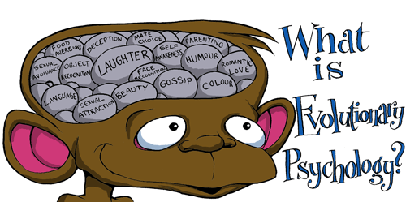
The evolutionary perspective encompasses one of the fastest growing areas within the field of lifespan development, behavioural genetics. Behavioural genetics studies the effects of heredity and genetics on behaviour. As technology improves, and researchers continue to map the human genome, there is an increasing understanding of the role and function of the genetic codes and their influence on development (Feldman, 2000, p. 23).

Miss Foley
Psych 20: 1.3 Perspectives Human (Inter)action

The Sociocultural Perspective:
The Ecological model, the major proponent of which is Urie Bronfenbrenner, seeks to explain individual knowledge, development, and competencies in terms of the guidance, support, and structure provided by society and to explain social change over time in terms of the cumulative effect of individual choices (Berger, 2000, p. 8).
According to Urie Bronfenbrenner, each person is significantly affected by interactions among a number of overlapping ecosystems. At the center of the model is the individual. Microsystems are the systems that intimately and immediately shape human development. The primary microsystems for children include the family, peer group, classroom, neighbourhood, and sometimes a church, temple, or mosque as well. Surrounding the microsystems is the exosystem, which includes all the external networks, such as community structures and local educational, medical, employment, and communications systems, that influence the microsystems. And influencing all other systems is the macrosystem, which includes cultural values, political philosophies, economic patterns, and social conditions. Together, these systems are termed the social context of human development (Bronfenbrenner, 1977, quoted in Berger, 2000, p. 7).

Miss Foley
Psych 20: 1.3 Perspectives Human (Inter)action

An Aboriginal Perspective – A Code of Ethics:
In addition to the sacred teachings concerning the nature of things, the teachings of the Sacred Tree include a code of ethics to which all should conform their lives if they wish to find happiness and well-being. This code describes what wisdom means in the relationship between individuals, in family life, and in the life of the community. These are the sparkling gems of experience practised by Native peoples everywhere:
- Each morning before rising, and each evening before sleeping, give thanks for the life within you and for all life, for the good things the Creator has given you and others and for the opportunity to grow a little more each day. Consider your thoughts and actions of the past day and seek for the courage and strength to be a better person. Seek for the things that will benefit everyone.
- Be truthful at all times, and under all conditions.
- Always treat your guests with honor and consideration. Give of your best food, your best blankets, the best part of your house, and your best service to your guests.
- The hurt of one is the hurt of all, the honor of one is the honor of all.
- Receive strangers and outsiders with a loving heart and as members of the human family.
- Observe moderation and balance in all things.
- All the races and tribes in the world are like the different coloured flowers of one meadow. All are beautiful. As children of the Creator they must all be respected.
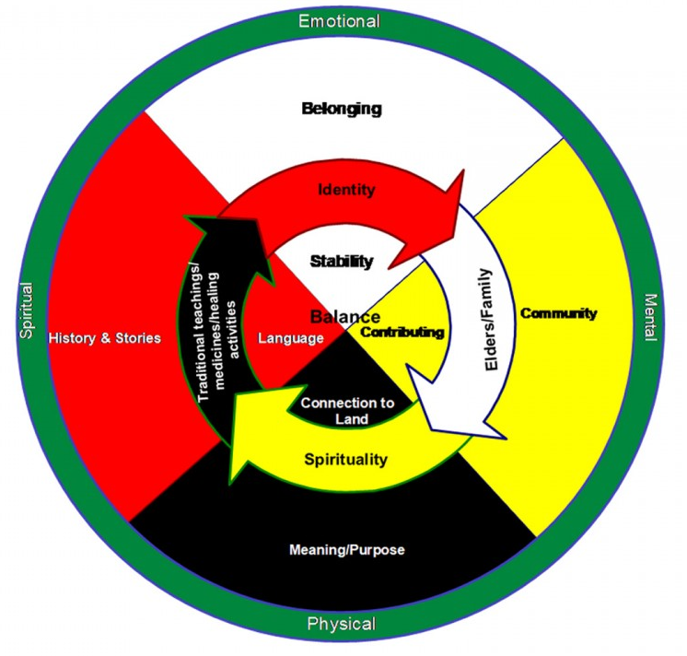
- To serve others, to be of use to family, community, nation or the world is one of the main purposes for which human beings have been created. Do not fill yourself with your own affairs and forget your most important task. True happiness comes only to those who dedicate their lives to the service of others.
- Know those things that lead to your well-being, and those things that lead to your destruction.
- Respect the wisdom of the people in council. Once you give an idea to a council or a meeting it no longer belongs to you. It belongs to the people. Respect demands that you listen intently to the ideas of others in council and that you do not insist that your idea prevail. Indeed you should freely support the ideas of others if they are true or good, even if those ideas are quite different from the ones you have contributed. The clash of ideas brings forth the spark of truth. Once a council has decided something in unity, respect demands that no one speak secretly against what has been decided. If the council has made an error, that error will become apparent to everyone in its own time.

Miss Foley
Psych 20: 1.3 Perspectives Human (Inter)action

An Aboriginal Perspective – A Code of Ethics (cont’d)
- Respect. Respect means “to feel or show honor or esteem for someone or something; to consider the well-being of, or to treat someone or something with deference or courtesy”. Showing respect is a basic law of life.

  - Treat every person, from the tiniest child to the oldest elder with respect at all times.
  - Special respect should be given to elders, parents, teachers, and community members.
  - No person should be made to feel “put down” by you; avoid hurting other hearts as you would avoid a deadly poison.
  - Touch nothing that belongs to someone else without permission, or an understanding between you.
  - Respect the privacy of every person. Never intrude on a person’s quiet moments or personal space.
  - Never walk between people that are conversing.
  - Never interrupt people that are conversing.
  - Speak in a soft voice, especially when you are in the presence of elders, strangers, or others to whom special respect is due.
  - Do not speak unless invited to do so at gatherings where elders are present.
  - Never speak about others in a negative way, whether they are present or not.
  - Treat the earth and all of her aspects as your mother. Show deep respect for the mineral world, the plant world, and the animal world. Do nothing to pollute the air or the soil. If others would destroy our mother, rise up with wisdom to defend her.
  - Show deep respect for the beliefs and religions of others.
  - Listen with courtesy to what others say, even if you feel that what they are saying is worthless.
  - Listen with your heart.

Miss Foley
Psych 20: 1.3 Perspectives Human (Inter)action

An Aboriginal Perspective – The Tipi
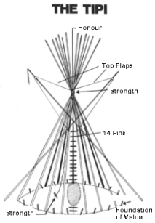
The Tipi of the Plains was a portable structure. It was covered with well-made buffalo hides sewn together with sinew. This conical shaped dwelling probably evolved from the dome shaped dwelling that was made by bending willows into an arch shape, like a sweat lodge, but bigger, and then putting a cover over it. The Tipi was practical for buffalo hunters on the prairies who moved from place to place. The Tipi was easy to dismantle and the poles became part of the travois. When the horse was introduced the tipis became larger and more elaborate, and the number of foundation poles was more consistently patterned.

Source: The Great Plains Moccasin Factory Inc.
#8 - 401 - 45th Street West
Saskatoon, Saskatchewan, Canada S7L 5Z9
Phone: (306) 665-1913 Fax: (306) 665-1913
Used by permission

The Fifteen poles represent the following values:
- Obedience: We learn by listening to traditional stories; by listening to our parents or guardians, our fellow students and our teachers.
- Respect: We learn by listening to traditional stories; by listening to our parents or guardians, our fellow students and our teachers.
- Humility: We learn by listening to traditional stories; by listening to our parents or guardians, our fellow students and our teachers.
- Happiness: We learn by listening to traditional stories; by listening to our parents or guardians, our fellow students and our teachers.
- Love: We learn by listening to traditional stories; by listening to our parents or guardians, our fellow students and our teachers.
- Faith: We learn by listening to traditional stories; by listening to our parents or guardians, our fellow students and our teachers.
- Kinship: We learn by listening to traditional stories; by listening to our parents or guardians, our fellow students and our teachers.
- Cleanliness: We learn by listening to traditional stories; by listening to our parents or guardians, our fellow students and our teachers.
- Thankfulness: We learn by listening to traditional stories; by listening to our parents or guardians, our fellow students and our teachers.
- Sharing: We learn by listening to traditional stories; by listening to our parents or guardians, our fellow students and our teachers.
- Strength: We learn by listening to traditional stories; by listening to our parents or guardians, our fellow students and our teachers.
- Good Child Rearing: We learn by listening to traditional stories; by listening to our parents or guardians, our fellow students and our teachers.
- Hope: We learn by listening to traditional stories; by listening to our parents or guardians, our fellow students and our teachers.
- Ultimate Protection: We learn by listening to traditional stories; by listening to our parents or guardians, our fellow students and our teachers.
- Control Flaps: We learn by listening to traditional stories; by listening to our parents or guardians, our fellow students and our teachers.

Miss Foley
Psych 20: 1.3 Perspectives Case Study
The Wild Boy of Aveyron: A Case Study
Before dawn on January 9, 1800, a remarkable creature came out of the woods near the village of Saint-Sernin in southern France. No one expected him. No one recognized him. He was human in bodily form and walked erect. Everything else about him suggested an animal. He was naked except for the tatters of a shirt and showed no modesty, no awareness of himself as a human person related in any way to the people who had captured him. He could not speak and made only weird, meaningless cries. Though very short, he appeared to be a boy of about eleven or twelve, with a round face under dark, matted hair. During the night he had approached the lower part of the village, where the Rance River leaves a narrow wooded valley and sweeps under a stone bridge. The boy had entered the terraced garden of a tanner and begun digging for vegetables. There the tanner caught him.
In an official report of the local commissioner written three weeks after the capture, we have our first eyewitness account:
The whole neighbor-hood learned about it quickly and everyone turned out to see the child. People referred to him as a wild savage. I hurried down there myself to make my own decision about how far to believe the stories. I found him sitting by a warm fire, which he seemed to enjoy, but showing signs of uneasiness from time to time, probably because of the great crowd of people around him. For a while I watched him without saying anything. When I spoke to him it didn’t take long to discover that he was mute. Soon after that, when I noticed that he made no response to various questions I put to him, in both a loud and a soft voice, I decided that he must be deaf.
When I took him affectionately by the hand to lead him to my house, he resisted strenuously. But a series of caresses and particularly two hugs I gave him, with a friendly smile, changed his mind, and after that he seemed to trust me.
When we reached my house, I decided he must be hungry. To find out what he liked, I had my servant offer him on a big earthenware platter raw and cooked meat, rye and wheat bread, apples, pears, grapes, nuts, chestnuts, acorns, potatoes, parsnips and an orange. He picked up the potatoes confidently and tossed them into the fire to cook them. One at a time he seized the other items, smelled them and rejected them. With his right hand he picked the potatoes right out of the live coals and ate them roasting hot. There was no way to persuade him to let them cool off a little. He made sharp, inarticulate, yet scarcely complaining sounds that indicated the hot food was burning him. When he got thirsty, he glanced around the room. Noticing the pitcher, he placed my hand in his without any other sign and led me to the pitcher, which he tapped with his left hand as a means of asking for a drink. Some wine was brought, but he scorned it and showed impatience at my delay in giving him water to drink.
He relieved himself wherever and whenever he felt like it, squatting to urinate, defecating while standing.
Several days later, the “savage” was taken to an orphanage, or hospice in the town of Saint-Affrique. He was kept there for a month. During this time, reports were kept on his behaviour:
Accustomed to all the hardships of winter in the open air and at a high altitude, the boy would not tolerate any kind of clothing. He pulled his clothes off as soon as he had been dressed, or tore them up if he couldn’t get them off. When he arrived at the home, he showed a great aversion to sleeping in a bed. However, he gradually got used to doing so, and later on showed his pleasure whenever his sheets were changed.
Following a brief stay at the orphanage, the boy was taken to Paris under the protection of a local priest and naturalist named Bonaterre. The descriptions and accounts continued:

Miss Foley
Psych 20: 1.3 Perspectives Case Study
Outwardly, this boy is no different from other boys. He stands four feet one inch tall; he appears to be about twelve or thirteen years old. He has delicate white skin, a round face, long eyelashes, a long, slightly pointed nose, an average-sized mouth, a rounded chin, generally agreeable features, and an engaging smile. When he raises his head, one can see at the upper end of the tracheal artery, right across the glottis, a healed over wound about an inch and a half long. It looks like the scar left by a sharp instrument.

When he is sitting down, and even when he is eating, he makes a guttural sound, a low murmur; and he rocks his body from right to left or backwards and forwards, with his head and chin up, his mouth closed, and his eyes staring at nothing. In this position he sometimes has spasms, convulsive movements that may indicate that his nervous system has been affected.

There is nothing wrong with the boy’s five senses, but their order of importance seemed to be modified. He relies first on smell, then on taste; his sense of touch comes last. His sight is sharp; his hearing seems to shut out many sounds people around him pay close attention to. Nothing interests him but food and sleep.

His constant need for food multiplies his connections with the objects around him and develops a certain degree of intelligence in him. During his stay at the orphanage, his sole occupation consisted of shelling beans, and he performed that job as efficiently as an experienced person. Since he knew that the beans were a regular part of his ration, as soon as he saw a bunch if dried beanstalks he went to get a pot. He set up his workspace in the middle of the room, laying out the different articles as conveniently as possible. As he emptied the pods, he set them down next to him in a symmetrical pile. When he had finished, he picked up the pot, put water in it, set it on the fire, which he built up by adding the dry pods. If the fire had gone out, he picked up the shovel and gave it to the worker, making signs that they should go find some live coals in the neighbor-hood. As soon as the pot began to boil, he demonstrated his desire to eat. And there was no alternative but to pour the half-cooked beans into his plate. He ate them eagerly.

When it is time to go to bed, nothing can stop him. He picks up a candlestick, points at the key to his room, and goes into a rage if he is not obeyed.

After several months of careful observation and experimentation, Bonaterre concluded:

All these little details and many others we could add prove that this child is not totally without intelligence, reflection, and reasoning power. However, we are obliged to say that, in every case not concerned with his natural needs or satisfying his appetite, one can perceive in him only animal behaviour. If he has sensations, they give birth to no idea. He cannot even compare them with one another. One would think that there is no connection between his soul or mind and his body, and that he cannot reflect on anything. As a result he has no discernment, no real mind, no memory. This condition of imbecility shows itself in his eyes, which he never keeps on any one object, and in the sounds of his voice which are inarticulate, and discordant. One can see it even in his gait – always a trot or a gallop – and in his actions, which have no purpose or explanation.

Shattuck, R. (1980). The Forbidden Experiment: The Story of the Wild Boy of Aveyron. New York: Quartet Books
Name: ____________________ Date: ___________
Psych 20: 1.3 Perspectives Human (Inter)action

Wild Boy of Aveyron: A Case Study
Using available resources (Interactions article p.13-15 and notes) for the six following perspectives of psychology, discuss using examples how each of them would explain how Victor of Aveyron acquired his knowledge and behaviour:
- Behavioural:

- Cognitive:

- Humanistic:

- Evolutionary:

- Psychodynamic:

- Sociocultural:

Name: ____________________ Date: ___________
Psych 20: 1.3 Perspectives Human (Inter)action

Miss Foley
Psych 20: 1.4 Making Sense Research Methods

Making Sense of Our Behaviour
Science is fundamentally a rational process. In its simplest form, the rational model consists of these steps:
- Formulating a theoretical problem
- Translate problem into testable hypotheses
- Selecting the appropriate research method
- Designing and carrying out the study
- Analyzing and interpreting the results
- Using the results to confirm, deny or modify the theory (Alcock et al., 1998, p. 17).

The Scientific Method
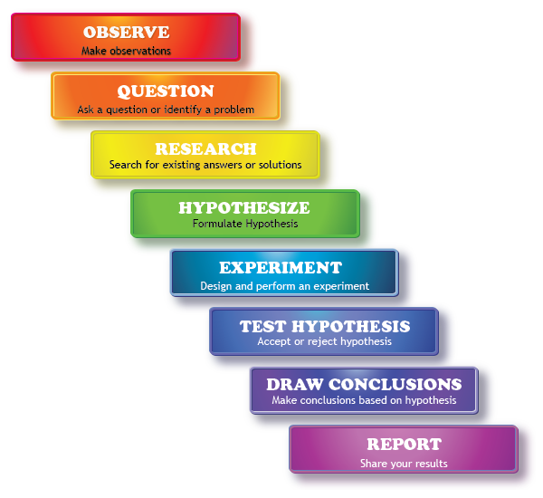

Miss Foley
Psych 20: 1.4 Making Sense Research Methods

Methods of Research in Social Psychology
Experimental Methods:
- Came into being because of the need to draw causal inferences about how variables influence one another.
- Using the experimental method, the researcher deliberately assigns subjects randomly to two or more groups and applies an independent variable to one group and not the other. Then the researcher measures the effect of the treatment by comparing the two groups (Alcock et al., 1998, p. 23).
Interview:
- Typically, a face-to-face meeting in which a researcher (interviewer) asks an individual a series of questions.
- The interviewer usually tape records or writes down the participant’s responses (Lefton et al., 2000, p. 14).
Observation:
- Involves direct observation of the spontaneous behaviour of an individual, or group of people in a natural setting. –
- The observer may remain aloof and simply observe, or become a participant-observer (Alcock et al., 1998, p. 19).
Case Study:
- A case study is an intensive study of one individual. Typically, the case study is based on interviews with the subject regarding his :or her background, present thinking or actions; it may also utilize interviews of others who know the individual.
- Additional case-study material may be obtained through observation, experiments and standardized tests, such as personality inventories and intelligence tests.
- Case studies can provide a wealth of detail, which makes them rich in possible insights. Many developmentalists prefer case studies precisely for that reason: the complexity of a human life is easier to understand through the rich qualitative, or descriptive, information of a case study than through a study involving sheer numbers, even though statistical significance depends on such quantitative or numerical data.
- The interpretation of case-study information reflects the biases as well as the wisdom of the researcher; and, even when a case-study is carefully interpreted, the conclusions apply with certainty to only one person.
- Nevertheless, the case-study has three important uses: to provide a provocative starting point for other research; to understand a particular individual very well; and to illustrate general truths.
- Remember, that no confident conclusions about people in general can be drawn from a sample size of one, or even 10 or 20, no matter how deep and detailed the study is (Berger, 2000, p. 28).
Topical:
- A topical research study involves the acquisition, synthesis, organization and presentation of information. Typically, the topical research study will involve both paper-based as well as web-based resources. Additional information may be gained through the other research methods and strategies.
Survey:
- Involves going out and asking, or sending out, questions about the phenomenon of interest.
- The survey method is especially useful for collecting data from a large number or people and is often the only way of obtaining data about thoughts, feelings, and private behaviour not open to direct observation.
- Survey methods do not provide cause-effect relationship data, and can be unreliable because of poorly constructed questions, interviewer bias, inaccurate reporting from respondents, and a poorly defined sample (Alcock et al., 1998, p. 21).

Miss Foley
Psych 20: 1.4 Making Sense Research Methods

Research Method Description | Pros | Cons

Naturalistic Observation:

Participant Observation:

Structured Observation:

Field Experiments:

Research Methods Comparison
The Interactions: Research Methodologies in Social Psychology article outlines how we answer psychological questions. Rather than focusing exclusively on the answers themselves, this article focuses on the ways answers are discovered. Using this article, complete the chart below:

Miss Foley
Psych 20: 1.4 Making Sense Research Methods
Research Method Description | Pros | Cons

Correlation Studies:

Experiments:

Interview:

Research with Animals:

Survey or Questionnaire:

Miss Foley
Psych 20: 1.4 Making Sense Research Issues

Methodological Issues in Research
Reliability
- Reliability refers to the extent to which the research yields the same results each time they are applied to the same issue (Baron et al., 1998, p. 459).
- For instance, if we were conducting an observational study of the play behaviours of children during recess, and our findings at the end of one study indicated that the boys were more aggressive than girls, but when we repeated our study at a different school and we found the opposite, that the girls were more aggressive than the boys, then we could not claim that our study was reliable.
Validity
- Validity refers to the extent to which a research methodology measures what it is supposed to measure (Baron et al., 1998, p. 460).
- Continuing with our example of the play behaviours of young children, is the observational approach a valid means of studying the topic?
- Let’s say that we had chosen to do an interview, and we interviewed the children and asked them questions about what happened at recess time. Would this method be considered valid as a way to gain information from which we could draw a conclusion? Probably not, or not as valid as directly observing them.
Ethical Issues in Research
Confidentiality
- This is the right of privacy for subjects concerning their participation in research. All steps must be taken to assure that subjects’ participation is confidential.
- If any possibility exists that someone other than the researcher may have access to the data, the subject must be informed of this possibility before they provide their informed consent to participate (Buskist et al., 2002, p. 42).
Informed Consent
- This requires that potential subjects understand exactly what is expected of them during the course of the research and that the investigator protects participants from physical and psychological discomfort, harm and danger (Buskist et al., 2002, p. 42).
Debriefing
- This requires that research participants be given full information about all aspects of the study after they have participated in it, thus assuring that they leave with a full understanding of its purpose, and receive a full disclosure of the information gathered (Baron et al., 1998, p. 31).
Biases
- Researchers must be careful to avoid subtle biases that influence results, such as gender (male or female), ethnicity (people’s common traits, background, and allegiances which are often cultural, religious, or language based), and cultural (a person’s racial and ethnic background, religious and social values, artistic and musical tastes, and scholarly interests) bias (Lefton et al., 2000, p. 15).

Miss Foley
Psych 20: 1.4 Making Sense Research Issues

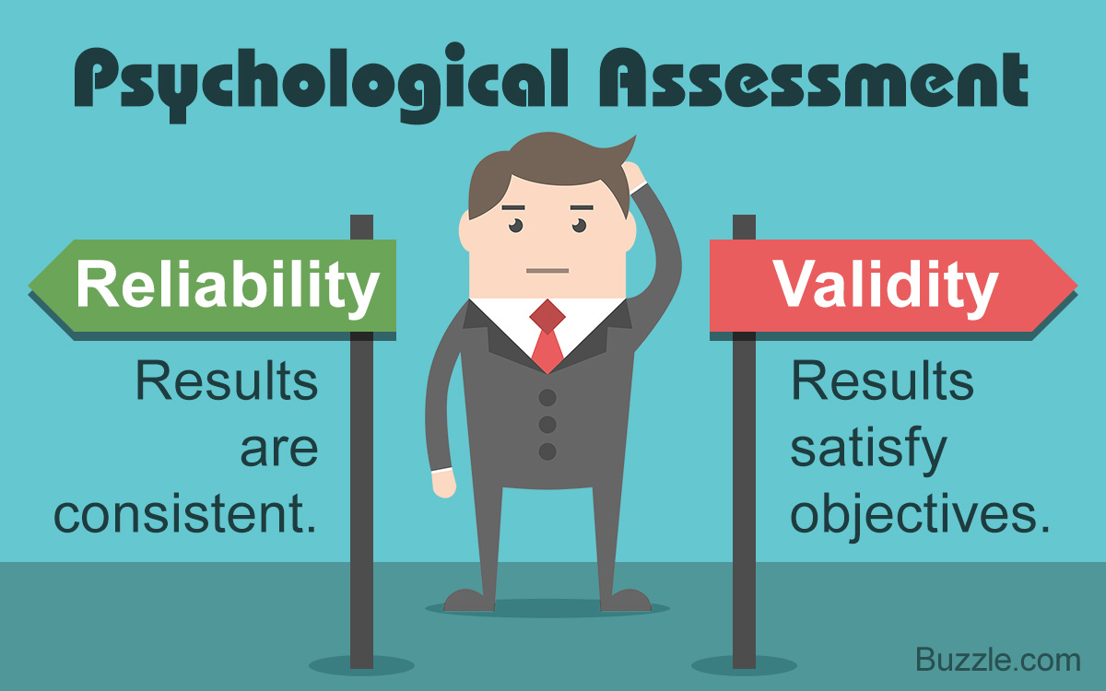
Making Research More Valid & Reliable
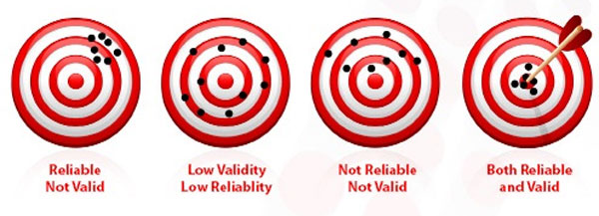
Scientific investigation includes the possibility that researchers’ procedures and/or biases may compromise the validity of their findings. Researchers can, however, use a number of techniques to increase the validity of their research:
Sample Size
To make statements about people in general, scientists study groups of individuals chosen from populations. Each such group, called a sample, must be large enough to ensure that a few extreme cases within the sample do not distort the picture it gives of the population.
Representative Sample
Data collected from one group of individuals may not be valid for other people who are different in significant ways, such as in gender or ethnic background. Thus it is important that every sample be a representative sample, that is, consist of people who are typical of the general population the researchers wish to learn about.
“Blind Experimenters”
When experimenters have specific expectations about their research findings, those expectations can affect the research results. As much as possible, therefore, the people who actually gather the data should be “blind”, that is, unaware of the purpose of the research.
Operational Definitions
When planning a study, researchers must establish operational definitions of whatever phenomena they will be examining. That is, they must define each variable in terms of specific, observable behaviour that can be measured with precision.
Experimental and Control Groups
To test a hypothesis accurately in an experiment, researchers must gather data on two samples that are similar in every important way except one. They must compare an experimental group - which receives some special experimental treatment, and a control group, which does not receive the experimental treatment.
Statistical Significance
Whenever researchers find a difference between two groups, they have to consider the possibility that the differences occurred purely by chance. Determining the statistical significance is a mathematical measure of the likelihood that a particular research result occurred by chance (Berger, 2000, p. 23).
Miss Foley
Psych 20: 1.4 Making Sense Animal Research

From Both Perspectives…

Topic: Animals should be used for research purposes.
Reasons why I agree… | Reasons why I disagree…

Miss Foley
Psych 20: 1.4 Making Sense Debate Format

Classroom Debate
“Those who do not know their opponent’s arguments do not completely understand their own.” ~ Anonymous ~
The classroom debates are exercises designed to allow you to strengthen your skills in the areas of leadership, interpersonal influence, teambuilding, group problem solving, and oral presentation.

Debate Format
(Time Required: 40-45 minutes)
6 minute Position Presentation - PRO  6 minute Position Presentation - CON | Position – What position/plan of action do you take or propose?  Inherency – Why do you think it isn’t already this way?  Harms – What are the problems with the current situation or opposition’s position?  Solvency – What are reasons why you could solve it or what are advantages to your position being right?
5 minute Work Period
4 minute Rebuttal – PRO 4 minute Rebuttal - CON | Address any issues presented by the opposition  Present predicted counter arguments  Prove opposition’s position brings more problems that solutions
3 minute Work Period
2 minute Response – PRO 2 minute Response - CON | Explain again (extend) why your position is a better idea  Respond to all negative arguments as to why it is a bad idea  Overview: “If you only remember three things…the most important three things are…”
1 minute Work Period
2 minute Position Summary – PRO or CON  2 minute Position Summary – PRO or CON | What is your position or plan?  Why is it a good idea?  Why is the world better off aligning with your position?  Refute any negative statements presented in the rebuttal
5 minute Tallying of Ballots/Announcement of Winner

Miss Foley
Psych 20: 1.4 Making Sense Debate Ballot

DEBATE BALLOT
Debate ______________________________________________ Class ________________

Name of Evaluator ____________________________________ Date _________________
1 2 3 4 5
Poor Fair Average Good Excellent
PRO CON

6 Minute Position Presentation
Rating = ____ Comments: | Rating = ____ Comments:
***** 5 Minute Work Period *****
4 Minute Rebuttal
Rating = ____ Comments: | Rating = ____ Comments:
***** 3 Minute Work Period *****
Continued on Reverse ---------->

Miss Foley
Psych 20: 1.4 Making Sense Debate Ballot

2 Minute Response
Rating = ____ Comments: | Rating = ____ Comments:
***** 1 Minute Work Period *****

2 Minute Position Summary
Rating = ____ Comments: | Rating = ____ Comments:

[ ] Total Points [ ] Total Points

Circle Winner Below:
PRO CON

General Comments:

Signature of Evaluator:

________________________________

Miss Foley
Psych 20: 1.5 Action Research ??????

Action Research in Social Psychology
- Should parents be legally permitted to spank their children?
- Should the government be launching a national daycare program paid for by taxpayers?
- Should parents be held accountable in some way for the behaviour of their children?
- Should we abolish the military and use the money to fund social programs such as health and education?
- What, or who, are the primary influences on you?
- Should animals be used for scientific research purposes?
- What are the qualities you most admire in a friend?
- Should the legal age to drive a car be raised to 18?
- Should the legal age to consume alcohol be raised to 21?
- Do you agree with euthanasia (mercy killing)?
- Do you think we should reinstate capital punishment?
- Do you believe in fate?
- What is the most important human value?
- What is the most important quality in a parent?
- If you could swap genders, would you? Why?
- Moral dilemmas:
- Is it right to steal life-saving medicines that you cannot afford?
- Should you tell the police if your best friend committed a crime?
- If you found a large sum of money in an unmarked envelope, should you keep it?
- What are the play behaviours of young children?
- How prevalent is violence in television programming?
- What are the social norms in a variety of contexts (e.g., cafeteria, malls, hallways, sporting events)?
- How do group behaviours change in varying social situations (e.g., single gender, mixed gender, different age groups)?
- What is a day in the life of ......... like?
- In what situations does the presence of others influence behaviour?
- How do different seating arrangements affect conversation?
- Lives lived. Conduct a case study of a senior or Elder in your family or community and construct presentation or report on his/her life.
- Who was B.F. Skinner and what role did he play in social psychology?
- Who was Ivan Pavlov and what role did he play in social psychology?
- Who was Jean Piaget and what role did he play in social psychology?
- Who was Albert Bandura and what role did he play in social psychology?
- Who was Abraham Maslow and what role did he play in social psychology?
- Who was Lev Vygotsky and what role did he play in social psychology?
- Research one of the following topics:
- gender development
- personality
- aboriginal spirituality
  - cultural Industries (fashion, music, beauty)
  - advertising
- Ask an Elder or senior citizen: How has society changed since you were a teenager?
- Ask an Elder or senior citizen: What have you learned about the basic values and goals in life?
- Ask your parents: What are the major sources of stress in your lives?
- Ask a person in a position of leadership: What qualities are important in a leader?
- Ask your parents or family members: What qualities are important in a relationship?
- Ask your parents or family members: What are the human values you respect or aspire to the most?

Miss Foley
Psych 20: Unit 1 Review Study Guide
What Is Social Psychology?
“Starting Point” Study Guide
- Define Social Psychology.
- Define nature and nurture. Using examples, explain how nature and nurture interact to affect human behavior.
- Define biological sex, gender, and gender roles/expression.
- Explain Urie Bronfenbrenner’s Ecological Model of human behavior.
- How does the Psychodynamic Perspective of Human Development explain human social behavior?
- How does the Behavioural Perspective of Human Development explain human social behavior?
- How does the Cognitive Perspective of Human Development explain human social behavior?
- How does the Humanistic Perspective of Human Development explain human social behavior?
- How does the Evolutionary Perspective of Human Development explain human social behavior?
- How does the Sociocultural Perspective of Human Development explain human social behavior?
- List the 6 methods of research in social psychology. Please provide a detailed explanation for each. Be able to explain 1 advantage and 1 disadvantage for each method.
- What are two methodological issues associated with research in social psychology? Explain.
- What are four ethical issues associated with research in social psychology? Explain.
- What are 3 ways that research can be made more valid and reliable? Explain.
- Explain the steps of the Scientific Method.
What Is Social Psychology?
1.1 Introduction To Social Psychology
1.3 Contemporary Perspectives in Psychology
1.2 Primary Sources of Influence on Behaviour
Who Are
Psychologists
& What Do
They Do?
1.4 Making Sense of Our Behaviour
1.4 How Do
We Conduct Research?
1.4 Issues In
Research

Miss Foley

Psych20: Unit 2 Title Page

Unit 2: Who Am I?
  - Unit Overview: Who am I?
- What are the four aspects of our Being?
- What influence does biology have on thoughts, feelings and behaviour?
- What affects how we feel about the world?
- What affects how we think about the world?
- Are our thoughts and emotions independent of each other?
- What is spirituality, and what role does it play in our lives?
- How do the key issues and questions in developmental psychology relate to self-understanding?
  - Physical Aspects: How do we receive, process and act upon information from our

interaction with the world?
- How do we receive information from the world?
- How do we process information from the world?
- How do we act upon the processed information?
- How are traits and characteristics passed from generation to generation?
- What are the sociocultural influences on our physical development?
    - The Human Sensory System

• What is the difference between sensation and perception?

• What is subliminal perception?

• What does extra-sensory information (E.S.P.) mean?

• Is E.S.P. real?
    - The Nervous System

• How does the body transmit sensory information?

• How does the brain process sensory information?

• What areas of the brain control what functions?

• How is experience represented in the brain?

• Does the brain grow and develop, or is it stable and unchanging?

• Are there gender differences in brain function?
    - Endocrine System

• What is the endocrine system?

• What is the role and function of the endocrine system?

• What are hormones?

• What do hormones do?
    - Heredity/Genetics

• What is heredity and genetics?

• How are traits passed from one generation to the next?

• What is genetic engineering?

• What are some ethical and moral issues involved in genetic engineering?
  - Emotional Aspects: What affects how we feel about the world?
- What affects how we feel about the world?
- In what ways are our emotions biologically based?
- What are the sociocultural influences on our feelings and behaviours?

Miss Foley

Psych20: Unit 2 Title Page (cont’d)

    - Motivation

• What is motivation?

• Why is motivation important?

• Is motivation innate or learned?

• Why do some people persevere, and others give up?

• What are the intrinsic and external motives that affect our thoughts and behaviour?

• What motivates you?
    - Emotions

• What is an emotion?

• How is an emotion different than a feeling?

• Are emotions innate or learned?

• What are the social and cultural influences on emotional expression?

• What is anger, and how can it be controlled or managed?

• How can we manage our emotions?

• How can we minimize the effects of debilitating emotions?
    - Attitudes

• What are attitudes?

• How do we form attitudes?

• Why do we have attitudes?

• How do attitudes change?

• How are attitudes related to values and beliefs?

• How can you resist peer pressure?
    - Social Perception

• What is social perception?

• How are social perceptions formed and changed?

• What are some problems and issues in forming impressions of people and

situations?

• What is the relationship between attribution, stereotypes, prejudice and

discrimination?

• Who are some prominent social rights activists, and what did they

achieve?
  - Mental Aspects: What affects how we think about the world?
- What does it mean to think?
- What affects how we think about the world?
- What is the mind?
- What are the sociocultural influences on our thoughts and behaviours?
    - Social Cognition

• How do we make sense of the behaviour of other people?

• What processes do we use to make sense of other people?

• How is our understanding of other people's behaviour represented in our

minds?

• What factors affect our judgement?

Miss Foley

Psych20: Unit 2 Title Page (cont’d)

    - Learning

• What does it mean to learn?

• How do people learn?

• What are the biological bases for learning?

• Are there gender differences in learning?

• How can you improve your ability to learn?
    - Memory

• What role and function does memory serve?

• How is experience stored and retrieved in the brain?

• How can memory be improved?
    - Intelligence

• What is intelligence?

• What are the different types of intelligence?

• To what extent is intelligence culturally or biologically based?

• Is intelligence inherited?
  - Spiritual Aspects: Defining our relationship to a Higher Power
- What is spirituality?
- What is the soul?
- What are the sociocultural influences on our spirituality?
- What is an Aboriginal perspective on spirituality?
    - Worldview

• What is a worldview?

• How does a worldview influence our behaviour?

• How does a worldview develop?

• What is your worldview?

• How do the worldviews of different faith systems compare?
    - Values

• What are values?

• How are beliefs and values related?

• What are your values?

• What is your credo?
    - Morality and Ethics

• What are morals and ethics?

• How is moral and ethical behaviour developed?

• How do we know if our decisions or actions are moral?

• What are the cultural perspectives on moral and ethical behaviour?
  - Personality: Who I am?
- What does it mean to have a personality?
- How do personalities develop?
- Is there a biological basis for what role do they play in social personality?
- What kind of personality do you have?
- What are the types of personality disorders?

Miss Foley

Psych20: Unit 2 Title Page (cont’d)

  - Action research in social psychology
- What is the most important value in your life?
- What qualities do you most admire in a friend?
- Do you believe in a Creator or Higher Power?
- Do you attend church regularly?
- Do you believe in E.S.P.?
- Do you support the cloning of human genetic material?
- What is your primary motivator?
- What is your favourite colour?
- Have you experienced prejudice, and if so, what form or type (age, gender, culture, race)?
- Are there basic personality types?
- How do personalities develop?
- How prevalent are nutritional drugs supplements?
- Who was Jesus ? What influence has he had on social actions and interactions?
- Who was Buddha and what influence has he had on social actions and interactions?
- Who was Mohammed & what influence has he had on social actions and interactions?
- Who are social rights activists, and what influence have they had on society?
- How do people deal with stress?
- What would a day in the life of…be like?
- Ask your parents and friends: What are your earliest recollections?
- Ask your parents: What are some memorable stories or anecdotes about you as a child?
- Ask your parents or grandparents: Have societal values changed? In what ways?
- What are stereotypical attitudes towards:
- Female police officers
- Female truck drivers/bus drivers
- Female entrepreneurs
- Male nurses
- How reliable is eyewitness testimony?
- How much can you remember?
- What are multiple intelligences, and what role do they play in social behavior?
- What is beautiful?
- Are there gender differences in impression formation and making judgements?
  - Research one of the following:

• Moral dilemmas

• Sensory system

• Nervous system

• Endocrine system

• Genetics and heredity

• Origins of names

• Machiavelli

• The Canadian Charter of Rights and Freedoms

• Artificial intelligence

• Amnesia

• Alzheimer’s disease

• Hypnosis

• Anger management

• Eating disorders

• Parenting styles

• Abuse

• Addiction

• Drugs

• Toys

• Acupuncture

• Personality disorders

Miss Foley

Psych 20: 2.1 Overview Who Am I?

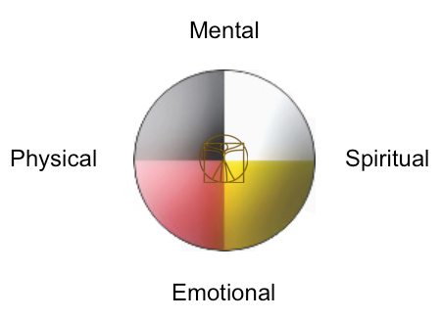
Four Aspects To Our Being

Physical aspects include all the growth and change that occur in a person’s body, and in the genetic, nutritional, and health factors that affect that growth and change. Motor skills – everything from grasping a rattle to driving a car – are also part of the biosocial domain. Social and cultural factors that affect these areas, such as duration of breast feeding, education of children with special needs, and attitudes about ideal body shape, are also part of biosocial development (Berger, 2000, p. 3).

Are you physically healthy and active? Do you like and feel comfortable in your body? Do you enjoy your sexuality? Are you comfortable in the material world? Are you practical, down to earth, financially stable, independent?

Mental/Cognitive aspects include all the mental processes that are used to obtain knowledge or to become aware of the environment. Cognition encompasses perception, imagination, judgement, memory, and language – the processes people use to think, decide, and learn. Education included within the formal curriculum within schools, informal tutoring by family and friends, and the results of individual curiosity and creativity, is also part of this domain (Berger, 2000, p. 3).

Are you satisfied with your intellect? Can you think and express yourself clearly? Do you have a belief system that supports you and works for you? Are you open to new ideas without being overly impressionable?

Emotional aspects include development of emotions, temperament, and social skills. The influences of family, friends, the community, the culture, and the larger society are particularly central to the psychosocial domain. Thus cultural differences in the value accorded children, or in ideas about “appropriate” sex roles, or in what is regarded as the ideal family structure are considered part of this domain (Berger, 2000, p. 3).

Are you in touch with your feelings and able to express them appropriately? Do you allow yourself to feel the full range of emotions - fear, sadness, anger, as well as love and joy - or do you find that certain emotions make you uncomfortable? Are you able to set appropriate boundaries with people? Can you relate to others in a close, intimate way?

Spiritual aspects mean the experiences that appeal to the human spirit and our connection to God or some spiritual power outside ourselves. Through this spiritual dimension, we try to supply meaning to our lives. We also try to understand the profound sense of awe and mystery at the core of our Beings. It is also our spiritual nature that fuels our drive to express ourselves in painting, music, drama, poetry, architecture, sculpture and other art forms (Badley, 1996, p. 142).

Do you feel a sense of connection to your spiritual source? Are you able to spend time quiet and alone, just "being"? Do you have a relationship with your own inner wisdom or intuitive guidance? Do you have moments when you feel at one with everything or part of something greater?

Name: _________________________ Date: ____________

Psych 20: 2.1 Overview Who Am I?

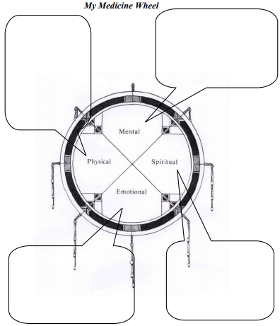
My Medicine Wheel

Mental
Physical
Spiritual
Emotional

Miss Foley

Psych 20: 2.1 Overview Who Am I?

What influence does biology have on my thoughts, feelings and behaviour?

Everything we do, from blinking reflexively to falling in love, has a biological basis. Why and how we behave and think is, in large part, a function of how the brain and body work (Bernstein and Nash, 1999, p. 40).

What affects how we feel about the world?

Motivation is the internal state of an organism that drives it to behave in a certain way. There are three aspects: Drives (hunger, thirst, temperature regulation, sex), Learned and Needs (Cardwell, 1998, p. 148).

Emotions are responses to an interaction between the subjectivity of feelings and an objective experience. Emotions, as opposed to feelings and sentiments are more momentary than prolonged, an intense state characterized by behavioural disorganization, reflect survival strategies, non-habitual, and reactive to certain situations (Cardwell, 1998, p. 84).

Social Perception is the process by which someone infers other people’s motives and intentions from observing their behaviour and deciding whether the causes of the behaviour are internal or situational (Aronson et al., 1994, p. 158).

Attitudes are long lasting patterns of feelings and beliefs about other people, ideas, or objects that are based in people’s experiences and shape their future behaviour (Lefton et al., 2000, p. 448).

What affects how we think about the world?

Social cognition refers to the thought process of making sense of events, people, oneself, and the world in general through analyzing and interpreting them. It focuses on social information in memory, which affects judgements, choices, evaluations, and ultimately, behaviour (Lefton et al., 2000, p. 457).

Learning is an adaptive process in which the tendency to perform a particular behaviour is changed by experience. Learning cannot be observed directly; it can only be inferred from changes in behaviour. Learning takes place within the nervous system. Experience alters the structure and chemistry of the brain, and these changes affect the individual's subsequent behaviour (Buskist et al., 2002, p. 131).

Current research suggests that memories are encoded as they are stored, in forms dictated by people’s assumptions, attention, and schema. Remembering is an active or “constructive” process in which these assumptions and schema influence the memory that is retrieved. A memory of a person will include both memories of specific things that the person has said or done, and more abstract memories of “what the person is like” such as personality traits, physical characteristics and dispositions. Our memory of past events can be influenced by our expectation or “theory” about what should have happened (Lefton et al., 2000, p. 225).

Intelligence is the overall capacity of the individual to act purposefully, to think rationally, and to deal effectively with the environment (Lefton et al., 2000, p. 264).

Miss Foley

Psych 20: 2.1 Overview Who Am I?

Are your thoughts and emotions independent of each other?

It was a miracle Phineas Gage did not die. On September 13, 1848, while he was blasting rock on a Vermont railroad line, exploding gunpowder drove a tamping iron into his face under his left eye. The force of the explosion drove the rod up through his brain and out through his shattered skull at about the place where hair and forehead meet. Astonishingly, Gage made a complete physical recovery and lived for another dozen years. Psychologically, however, he was a changed man. Once emotionally well-balanced, he became obstinate, capricious, impatient of anything that went against his wishes, and given to outbursts of profanity.

It was the frontal lobes of Gage’s brain that were destroyed, a part of the brain about which neuroscientists had previously known very little. The Gage case gave brain specialists the first clear evidence that thoughts and emotions are closely related, and that they are so because of actual physical connections between the limbic system (the principal emotional centre in the brain) and other brain structures.

From this case and later studies, it now appears that the frontal lobes enable us to control our emotions. Damage to the lobes and destruction of their links to the limbic system bring about chemical and electrical changes in many parts of the brain, and thus alter the way people express their emotions (Guinness, 1989, p. 68).

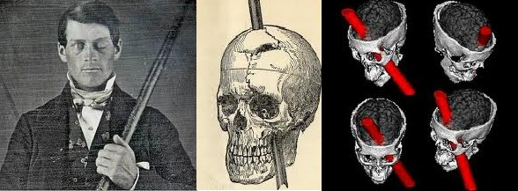
How do the key issues and questions in developmental psychology relate to self-understanding?

From the time of its establishment, several key issues and questions have dominated the field of developmental psychology. Among the issues are the nature of developmental change, the importance of critical periods, life span approaches versus the more focused approaches, and the nature/nurture issue.
- Continuous change versus discontinuous change: In continuous change, developmental change is gradual, with achievements at one level building on those of previous levels. In contrast, discontinuous change occurs in distinct stages or steps. Each stage brings about behaviour that is assumed to be qualitatively different from behaviour at earlier stages.

Miss Foley

Psych 20: 2.1 Overview Who Am I?

- A critical period is a specific time during development when a particular event has its greatest consequences. Critical periods occur when the presence of certain kinds of environmental stimuli are necessary for development to proceed normally.
- Life span approaches versus a focus on a particular period: Developmentalists now believe the entire life span is important, for several reasons. One is the discovery that developmental growth and change continue during every part of life. Furthermore, to understand fully the social influences on people of a given age, we need to understand the people who are in large measure providing those influences. For instance, to understand development in infants, we need to unravel the effects of their parents’ ages on the social environment.
- Nature versus Nurture: One of the enduring questions of development involves how much of people’s behaviour is due to their genetically determined nature and how much is due to nurture, the physical and social environment in which a child is raised. In this context, nature refers to traits, abilities, and capacities that are inherited from one’s parents. It encompasses any factor that is produced by the predetermined unfolding of genetic information, a process known as maturation. These genetic inherited influences are at work as we move from the one cell organism that is created at the moment of conception to the billions of cells that make up a fully formed human being. In contrast nurture refers to the environmental influences that shape behaviour. Some of these influences may be biological, such as the impact of a pregnant mother’s substance abuse on the fetus, or the amount and kind of food available to children. Other environmental influences are more social, such as the ways parent’s discipline their children and the effects of peer pressure on adolescents (Feldman, 2000, p. 10).

Miss Foley

Psych 20: 2.2.1 Sensory Systems Receiving Info

How We Receive, Process &

Act on Information in Our World

How do we receive information from the world?

In humans and other animals, this is the role of the sensory organs, which then transmit impulses to the brain via a nerve or nerves. Aristotle classified five senses: hearing, sight, smell, taste and touch, the last of which has a multiplicity of subdivisions, including the senses of pressure, heat, cold, contact and pain. Your senses gather information about the world by detecting forms of energy, such as sound, light, heat and physical pressure. Specifically, your eyes detect light energy, your ears detect the energy of sound, and your skin detects the energy of heat and pressure. These have continued to be regarded as the classical five senses, although scientists have determined the existence of as many as 15 additional senses. Sense organs buried deep in the tissues of muscles, tendons and joints, for example, give rise to sensations of weight, position of the body and amount of bending of the various joints; these organs are called proprioceptors. Within the semicircular canal of the ear is the organ of equilibrium, concerned with the sense of balance. General senses, which produce information concerning bodily needs (hunger, thirst, fatigue, and pain), are also recognized. Humans depend primarily on vision, hearing and the skin senses to gain information about the world. All of these senses must detect stimuli, encode them into neural activity, and transfer this coded information to the brain (Bernstein and Nash, 1999, p. 73).

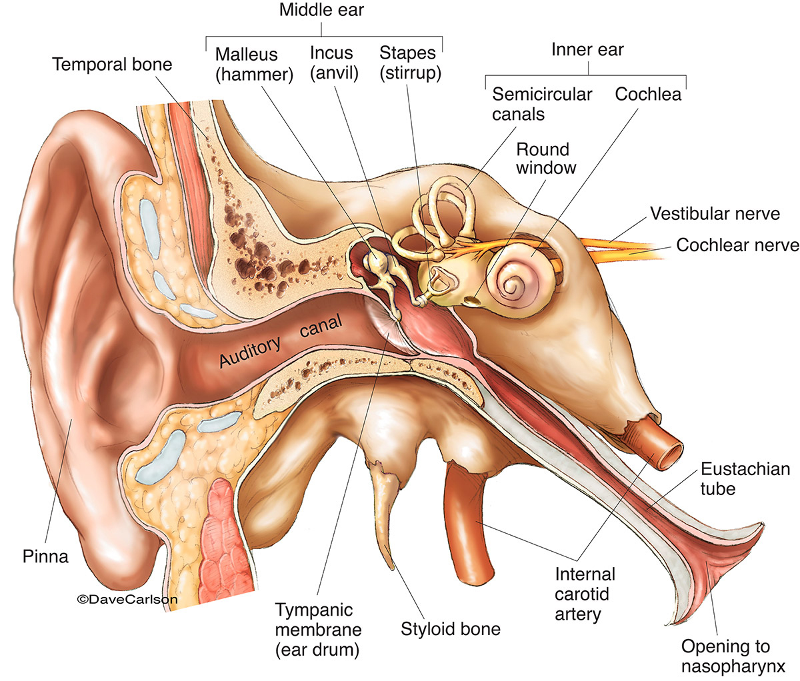
How does each of the senses work?

The human ear consists of three sections: the outer ear, the middle ear, and the inner ear. The outer ear includes the auricle (pinna), the visible part of the ear that is attached to the side of the head, and the waxy, dirt-trapping auditory canal. The tympanic membrane (eardrum) separates the external ear from the middle ear, an air-filled cavity. Bridging this cavity are three small bones—the malleus (hammer), the incus (anvil), and the stapes (stirrup). The cochlea and semicircular canals make up the inner ear.

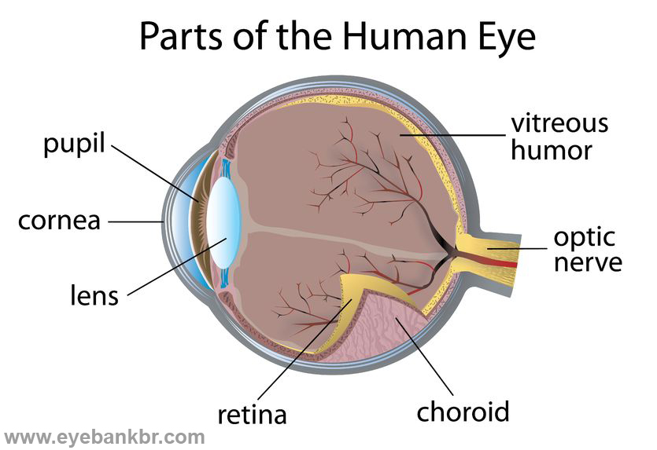
The amount of light entering the human eye is controlled by the pupil, which dilates and contracts accordingly. The cornea and lens, whose shape is adjusted by the ciliary body, focus the light on the retina, where receptors convert it into nerve signals that pass to the brain. A mesh of blood vessels, the choroid, supply the retina with oxygen and sugar. Lacrimal glands secrete tears that wash foreign bodies out of the eye and keep the cornea from drying out. Blinking compresses and releases the lacrimal sac, creating a suction that pulls excess moisture from the eye's surface.

Miss Foley

Psych 20: 2.2.1 Sensory Systems Receiving Info
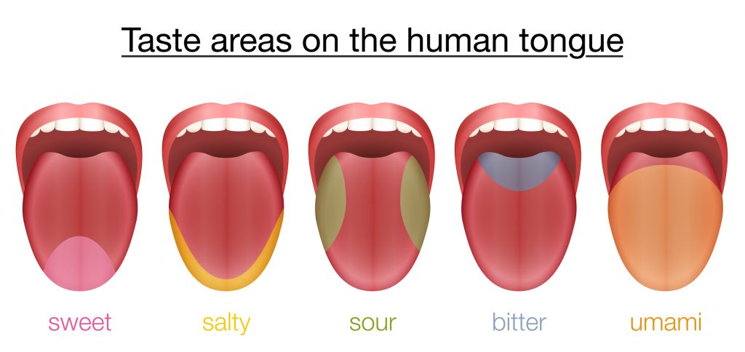

The human tongue is covered with approximately 10,000 taste buds, grouped in areas sensitive to sweet, sour, salty and bitter flavors. Chemicals from the food we eat stimulate receptors in each of these areas, and nerves transmit this input to the brain. The sense of smell adds information to give us a wide range of taste.

Human touch is accomplished by nerve endings in the skin that convey sensations to the brain via nerve fibers. Nerves end in or between the cells of the epidermis, the outer layer of the skin, in all parts of the body. In one complex form of nerve ending, the terminals form tiny swellings, or end bulbs; characteristic of this form are the Pacinian corpuscles found in the sensitive pad of each finger. Touch is the least specialized of the senses, but acuteness can be sharpened by use; for example, people who are blind exhibit a remarkable delicacy of the tactile sense in their ability to read the fine, raised letters of the Braille system. The skin consists of an outer, protective layer (epidermis) and an inner, living layer (dermis). The top layer of the epidermis is composed of dead cells containing keratin, that also makes up hair and nails.

Is Spelling Important?

I cdnuolt blveiee taht I aulaclty uesdnatnrd waht I was rdgnieg The phaonmneal pweor of the hmuan mnid Aoccdrnig to a rscheearch at Cmabrigde Uinervtisy, it deosn’t mttaer in waht oredr the ltteers in a wrod are, the olny iprmoatnt tihng is taht the frist and lsat ltteer be in the rghit pclae. The rset can be a taotl mses and you can sitll raed it wouthit a porblem. Tihs is bcuseae the huamn mnid deos not raed ervey lteter by istlef, but the wrod as a wlohe. Amzanig huh? Yaeh and I awlyas thuohgt slpeling was ipmorantt.

What is the difference between sensation and perception?

To understand how sensory systems help us create reality, we need basic information about the senses. A sense is a system that translates outside information into activity in the nervous system. Sensations are messages from the senses. Perception is the process of using information and your understanding of the world, so that sensations become meaningful experiences. By shaping experience, perceptions influence thoughts, feelings and actions. But before something can be perceived, it must be sensed (Bernstein and Nash, 1999, p. 72).

What is subliminal perception?

People often know more than they know they know. In fact, non-conscious processing appears to occur not only in perception, but also in memory, thinking and decision making. However, the real-world implications of subliminal perception are not as dramatic as you might think. Even in the laboratory, where researchers have considerable control, the phenomenon is hard to demonstrate. The strongest evidence comes from studies using simple stimuli (faces or single words, like “bread”), rather than complex stimuli such as sentences (Tavris and Wade, 2000, p. 216).

Miss Foley

Psych 20: 2.2.1 Sensory Systems Receiving Info

What does extra-sensory perception (E.S.P.) mean?

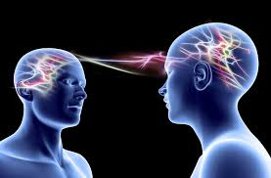
E.S.P. includes telepathy, clairvoyance, precognition and psychokinesis. Telepathy is the transfer of thought from one person to another. Clairvoyance is the ability to recognize objects or events, such as the contents of a message in a sealed envelope that are not present to normal sensory receptors. Precognition is unexplained knowledge about future events, such as knowing when the phone is about to ring. Psychokinesis is the ability to move objects by using one’s mental powers (Lefton et al., 2000, p. 110).

Is E.S.P. real?

Experimental support for the existence of E.S.P. is generally weak, and results have not been repeated often (refer to the scientific method as described in Unit One, particularly the aspects of reliability and validity). Moreover, E.S.P. phenomena such as “reading people’s minds” or bending spoons through mental power cannot be verified by experimental manipulations in the way that other perceptual events can be. None of these criticisms means that E.S.P. does not exist (Lefton et al., 2000, p. 110).

Challenge: Sensory & Perception Stories

The Wealthy Man: Author Unknown

I heard a story about a father, a very wealthy man, who decided to send his son off to understand and appreciate how fortunate he was. So he decided to send him to what the father considered to be a poor family out in the countryside. When the son returned three days later, the father said, “Well son, did you see how poor people can live?” “Yes father, I did,” said the son. “Tell me what you saw?” said the father. “Well, I saw that we have expensive lamps imported from Europe, and they have stars. I saw that we have one dog, and they have four dogs. I saw that we have a swimming pool in our garden, and they have a creek that never ends. Thank you, father for showing me how poor we are.”

- Do you believe money can buy happiness?
- Community Service: Explain a time when you went on a mission or help others less fortunate. Explain how this experience may have changed your perception. What did you learn about yourself and others?

Miss Foley

Psych 20: 2.2.1 Sensory Systems Receiving Info

The Starfish

An old man was walking along the beach, when he came upon a part of the sand where thousands of starfish had washed ashore. A little further down the beach he saw a young woman, who was picking up the starfish one at a time and tossing them back into the ocean. “Oh you silly girl,” he exclaimed. “You can’t possibly save all of these starfish. There’s too many.” The woman smiled and said, “I know. But I can save this one, ” and she tossed another into the ocean, “and this one”, she tossed another one into the ocean, “and this one…” (This story was adapted from a poem written by Randy Poole called The Difference He Made)

- Describe a time when you feel you made a difference in a person’s life.
- Describe a person who has made a difference in your life.

Nail In The Fence

There once was a little boy who had a bad temper. His father gave him a bag of nails and told him that every time he lost his temper, he must hammer a nail into the back of the fence. The first day the boy had driven 37 nails into the fence. Over the next few weeks, as he learned to control his anger, the number of nails hammered daily gradually dwindled down. He discovered it was easier to hold his temper than to drive those nails into the fence.

Finally the day came when the boy didn’t lose his temper at all. He told his father about it and the father suggested that the boy now pull out one nail for each day that he was able to hold his temper. The days passed and the young boy was finally able to tell his father that all the nails were gone.

The father took his son by the hand and led him to the fence. He said, “You have done well, my son, but look at the holes in the fence. The fence will never be the same. When you say things in anger, they leave a scar just like this one. You can put a knife in a man and draw it out. It won’t matter how many times you say I’m sorry, the wound is still there.

A verbal wound is as bad as a physical one. Friends are very rare jewels, indeed. They make you smile and encourage you to succeed. They lend an ear, they share words of praise, and they always want to open their hearts to us.”

- Comment on the following phrase: “A verbal wound is as bad as a physical one.”
- Describe a verbal wound that you received or inflicted. (You will not have to share this with the class.)

The Mountain Story

A son and his father were walking on the mountains.

Suddenly, his son falls, hurts himself and screams: “AAAhhhhhhhhhhh!!!”

To his surprise, he hears the voice repeating, somewhere in the mountain:

“AAAhhhhhhhhhhh!!!”

Curious, he yells: “Who are you?”

He receives the answer: “Who are you?”

Angered at the response, he screams: “Coward!”

He receives the answer: “Coward!”

Miss Foley

Psych 20: 2.2.1 Sensory Systems Receiving Info

He looks to his father and asks: “What’s going on?”

The father smiles and says: “My son, pay attention.”

And then he screams to the mountain: “I admire you!”

The voice answers: “I admire you!”

Again the man screams: “You are a champion!”

The voice answers: “You are a champion!”

The boy is surprised, but does not understand.

Then the father explains: “People call this ECHO, but really this is LIFE.

It gives you back everything you say or do.

Our life is simply a reflection of our actions.

If you want more love in the world, create more love in your heart.

If you want more competence in your team, improve your competence.

This relationship applies to everything, in all aspects of life;

Life will give you back everything you have given to it.”

YOUR LIFE IS NOT A COINCIDENCE. IT’S A REFLECTION OF YOU!

- How we look at life is largely determines our attitudes and actions. We spend a great deal of time in our lives communicating with ourselves in our head. Explain the conversations you have in your head. Are they positive / negative? Could you try to change your thoughts to create better results?
- “This relationship applies to everything, in all aspects of life; Life will give you back everything you have given to it.” Explain a time when you have given “everything” to a cause, relationship, extracurricular activity.

Build Quality into Your Life

An elderly carpenter was ready to retire. He told his employer-contractor of his plans to leave the house- building business and live a more leisurely life with his wife enjoying his extended family. He would miss the paycheck, but he needed to retire. They could get by.

The contractor was sorry to see his good worker go and asked if he could build just one more house as a personal favor. The carpenter said yes, but in time it was easy to see that his heart was not in his work. He resorted to shoddy workmanship and used inferior materials. It was an unfortunate way to end his career. When the carpenter finished his work and the builder came to inspect the house, the contractor handed the front-door key to the carpenter. “This is your house,” he said, “my gift to you.” What a shock! What a shame! If he had only known he was building his own house, he would have done it all so differently. Now he had to live in the home he had built none too well.

So it is with us. We build our lives in a distracted way, reacting rather than acting, willing to put up with less than the best. At important points we do not give the job our best effort.

Then with a shock we look at the situation we have created.

Think of yourself as the carpenter. Think of your life as the house. Each day you hammer a nail, place a board or erect a wall, build wisely. It is the only life you will ever build. Even if you live it for only one day more, that day deserves to be lived graciously and with dignity.

The plaque on the wall says, “Life is a do-it-yourself project, do it to the best of your ability.”
- Describe a time when you gave everything you had to a project. Describe what it was and what you received in return.

Name: _________________________ Date: ____________

Psych 20: 2.2.2 Nervous System Teenage Brain

PBS Inside The Teenage Brain (54:00)

Video Questions

- What are characteristics of a teenage brain?

- How do the characteristics above affect learning?

- How would these characteristics affect decisions as a parent?

Miss Foley

Psych 20: 2.2.2 Nervous System Processing Info

How does the body transmit sensory information?

This is the role of the nervous system, those elements within us that are concerned with the reception of stimuli, the transmission of nerve impulses, or the activation of muscle mechanisms. The reception of stimuli is the function of special sensory cells. The conducting elements of the nervous system are cells called neurons; these may be capable of only slow and generalized activity, or they may be highly efficient and rapidly conducting units. The specific response of the neuron - the nerve impulse - and the capacity of the cell to be stimulated make this cell a receiving and transmitting unit capable of transferring information from one part of the body to another.

Neurons are made up of:

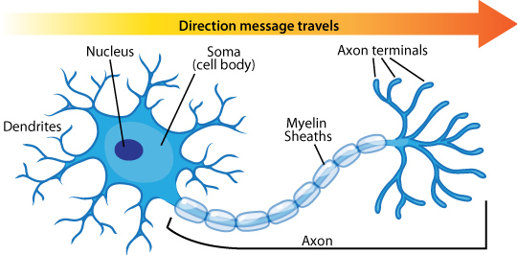
Cell Body – contains the nucleus & other organelles. Materials needed for the maintenance of the neuron are made here

Dendrites – a short, highly branched fibers that receive impulses conducting impulses towards the cell body

Axon – a long, thin fiber extending away carrying impulses away from the cell body sending them to other neurons.

Myelin Sheaths – protective, insulating covering on the axon that prevent shorting of the electrical impulses.

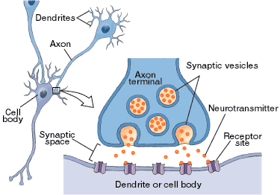
The transmission of nerve impulses is a chemical process. The end of an axon is called the synaptic knob. Within the synaptic knob there are many small sacs called synaptic vesicles that contain special chemicals called neurotransmitters.

When the impulse reaches the synaptic knob neurotransmitters are released into the synaptic gap. The diffusion of these chemicals across the gap allows the electrical impulse to be carried to the neighboring nerve cell by changing the permeability of its membrane. Usually, only the ends of axons release neurotransmitters. Therefore, impulses only travel in one direction across the synapse…from axons towards dendrites!

Common Neurotransmitters:

Adrenaline – Fight or Flight Gaba – Calming

Noradrenaline - Concentration Acetylcholine – Learning

Serotonin – Mood Control Glutamate – Memory

Dopamine – Reward/Pleasure Oxytocin - Bonding

Endorphins – Natural Painkillers/Euphoria

Miss Foley

Psych 20: 2.2.2 Nervous System Processing Info

How do we process information from the world?

The spinal cord, contained within the spinal column, receives signals from the sensory organs, muscles and glands and relays these signals to the brain, which is the control center.

The cerebrum is responsible for intelligence and reasoning.

The thalamus acts primarily as a relay station for sensory information conducting electrical impulses travelling to and from the cerebral cortex.

The hypothalamus plays a crucial role in regulating the body's internal environment by maintaining body temperature and blood sugar levels; it regulates the endocrine system, and affects specific behaviours such as eating, drinking and sexual arousal.

The limbic system is an interconnected group of structures involved in emotions, memory, social behaviour and brain disorders such as epilepsy.

The corpus callosum is a thick band of 200 million nerve fibres that provide cross-hemisphere connections that conveys information between the cerebral hemispheres; damage to it results in essentially two separate brains within one skull.

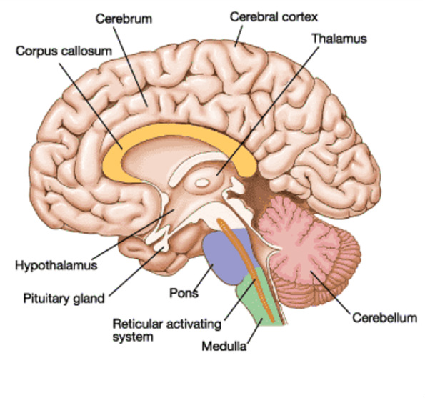
The cortex is the exterior covering of the brain, a 1.5 square feet system that plays a special role in behaviour because it is intimately involved in thought and reason. The cortex is divided into areas, or lobes, each with characteristic structures and functions.

The midbrain located between the forebrain and the hindbrain, consists of several major structures, as well as a number of smaller but important collections of cell bodies. The reticular formation extends from the hindbrain into the midbrain. Like the hindbrain, the midbrain interprets signals and either relays the information to a more complex part of the brain or causes the body to act at once.

The hindbrain/reptilian brain contains the oldest parts of the brain in terms of evolution. It receives signals from other parts of the brain and from the spinal cord; they interpret the signals and either relay the information to more complex parts of the brain or immediately cause the body to act.

The medulla is a dense, elongated bundle of nerve fibers that is involved in maintaining involuntary functions such as controlling heart rate, blood pressure and breathing.

The reticular formation controls the awareness of sensory information, muscle tone, cardiac and circulatory reflexes, and attention.

The pons affects sleep, dreaming and respiration.

The cerebellum, a large structure attached to the back surface of the brain stem, influences balance, posture, coordination, movement and single joint actions such as the flex of an elbow or knee. It allows you to do things accurately such as walk in a straight line, shoot a puck or coordinate dance movements. The cerebellum is also involved in a number of thinking operations including learning.

Miss Foley

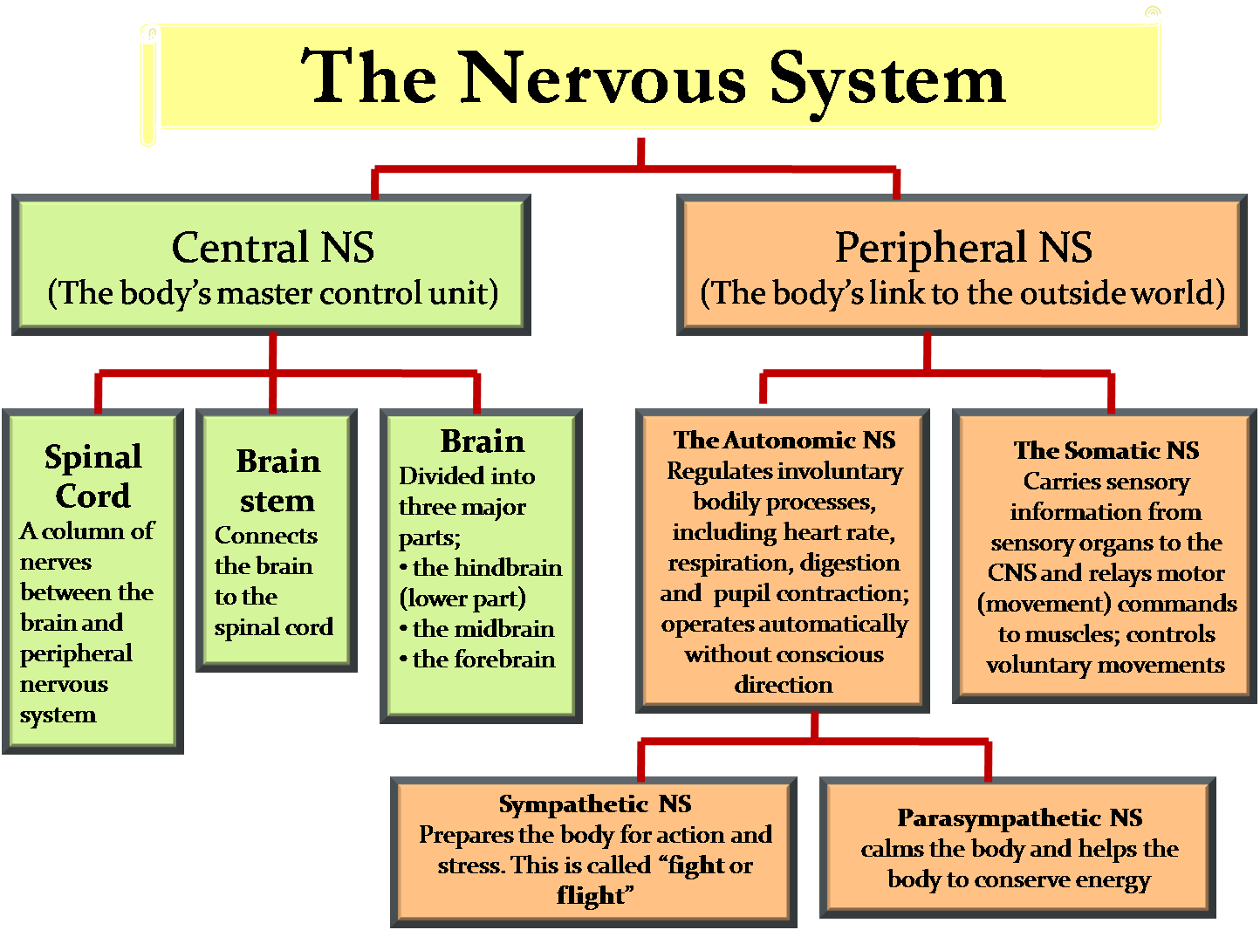
Psych 20: 2.2.2 Nervous System Processing Info

How is experience represented in the brain?

Research into the physiological and behavioral bases for memory has attempted to describe mechanisms for encoding information (transforming it into a storable state), as well as decoding and retrieving it. One avenue of study has sought to identify a neurochemical code which may be responsible for creating a memory trace in the nervous system. All memory traces are thought to consist of clusters of attributes -- e.g., "cat," "Siamese," "blue eyes," -- any of which may serve as clues in decoding and retrieving. The more closely the circumstances in which something was learned are duplicated, the more likely it is to be recalled. Any attribute or association may be used to encode information, although some are more likely to be used than others.

Mental representations take the form of cognitive maps (mental representations of familiar parts of one’s world), images, concept schemas (categories of objects, events, or ideas with common properties), event scripts (schemas about familiar sequences of events or activities), and mental models (clusters of relationships between objects or processes). (Bernstein & Nash, 1999)

We develop schemata that represent our knowledge about ourselves, others and our roles within the social world. These schemata, once formed, bias our judgements about ourselves and others. Schemata become more complex and organized over time, and also harder to change. (Cardwell)

Name: _________________________ Date: ____________

Psych 20: 2.2.2 Nervous System Processing Info

Brain Parts & Function Review

_______ Thalamus

_______ Hypothalamus

_______ Limbic System

_______ Corpus Callosum

_______ Cortex

_______ Midbrain

_______ Hindbrain

_______ Medulla

_______ Reticular Formation

_______ Pons

_______ Cerebellum

_______ Spinal Cord
- Affects sleep, dreaming and respiration.
- Exterior covering of the brain; intimately involved in thought and reason.
- Acts primarily as a relay station for sensory information.
- Dense, bundle of fibers that controls heart rate, blood pressure and breathing.
- Thick band of 200 million nerve fibers that convey information between cerebral hemispheres.
- Contained within spinal column; receives signals from sensory organs, muscles/glands and relays it to the brain.
- Interconnected group of structures involved in emotions, memory, social behavior and brain disorders.
- Controls awareness of sensory information, muscle tone, cardiac and circulatory reflexes and attention.
- Crucial in regulating the body’s homeostasis; maintaining body temperature, blood sugar levels, regulating endocrine system and affects behaviors such as eating, drinking and sexual arousal.
- Oldest parts of the brain; regulates needs for survival; receive signals from spinal cord and relay them to other parts of the brain.
- Large structure attached to back of brain stem; influences balance, coordination, movement and thinking/learning.
- Located between the forebrain and hindbrain; interprets signals to send to other parts of the brain or causes the body to act.

Name: _________________________ Date: ____________

Psych 20: 2.2.2 Nervous System Processing Info

- Draw and label the parts of a neuron.

- Explain how nerve impulses are transmitted between neurons for the brain to process & transmit sensory information.

- List & define the two (2) main parts of the Peripheral Nervous System.

- a) What is role/function does the Sympathetic Nervous system play?

b) What role/function does the Parasympathetic Nervous system play?

Miss Foley

Psych 20: 2.2.2 Nervous System Processing Info

Does the brain grow and develop or is it stable and unchanging?

In the first three years of life, the human brain is a veritable factory of neural development. Trillions of synaptic circuits that will last a lifetime are being formed. Just to grow the brain, young children use twice as much energy in their heads as adults, who carry about all the cares of the world. But scientists are now discovering that the brain can grow and reorganize itself, within limits, past puberty and possibly well into adulthood, depending on the demands put on it. A British study released in March, 2000 showed that the brains of cab drivers ranging in age from 32 to 62 had experienced a “relative distribution of grey matter” in the memory-focusing hippocampus. The researchers attributed the change to having to learn to navigate the labyrinth of streets in London.

“Simply put, the brain is a riot of functional changes,” says Alan Evans of the Montreal Neurological Institute. What’s more, the maturing brain, awash in different stages of chemical and hormonal development, is like nature’s wild garden: the grey matter grows more synapses than it needs, then spends part of its development “pruning” or leaving aside areas that are not put to use.

Between six and fifteen are peak language years when the left (language) hemisphere fills out. Some scientists believe the window shuts at about 11 or 12, at the onset of puberty, when learning new languages becomes much more difficult. Studies of children with damaged left hemispheres show that their language skills can be reorganized, within limits, on the right side before puberty; after that the right hemisphere has pretty well settled into a different way of ordering its world.

The brains of teenagers are definitely a work in progress. Hormones push the limbic system, where raw emotion is seated, into overdrive. At the same time, the frontal cortex, where cool-headed decision-making takes place, is still trying to get its act together. This back and forth may help to explain why teenagers can’t seem to choose between talking on the phone or doing their homework when a term paper looms; and why social situations and insults become so important: they are still sorting out the social signals. One study showed adults and teenagers images of faces contorted in fear. All the adults recognized the emotion; many teens did not. Scans also showed the adults and teens used different areas of their brains during the experiment (Sheppard, 2000, p. 47).

Are there gender differences in brain function?

Over the years, with a large body of animal studies and studies of humans that include psychological tests, anatomical studies and, increasingly, brain scans, researchers are constantly finding that the brains of the two sexes are subtly but significantly different:
- Researchers who conducted a study into processing of nonsense words and whether they rhymed, reported that the subjects did equally well at the task, but the men and women used different areas of their brains. The men used just a small area of the left side of their brain, next to Broca’s area, while the women used the same area but on the right side of their brain.
- For the most part, researchers have found that the brains of men and women while “at rest” were virtually indistinguishable from one another, but there was one difference found in a brain structure called the limbic system that regulates emotions. Men, on average, had more activity in the area of the limbic system that was involved with action, while women had more activity in the areas that were involved in symbolic actions. Women have a larger corpus callosum, the tangle of fibers that run down the center of the brain and enable the two hemispheres to communicate.
- Men have larger brains than women, but women have about 11 percent more neurons (Wade, 1998, p. 64).

Miss Foley

Psych 20: 2.2.2 Nervous System Processing Info

The Big Picture: Processing Information

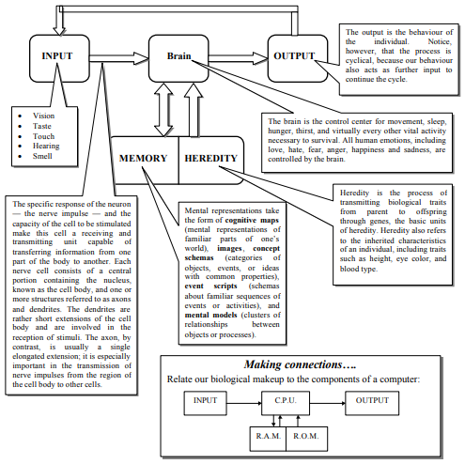

Miss Foley

Psych 20: 2.2.2 Nervous System Processing Info

The Neurobiology of Grace Under Pressure:

8 habits that stimulate your vagus nerve and

keep you calm, cool, and collected

When was the last time that you had to perform gracefully in a high-pressure situation? How did you handle it? Did you choke or did you have grace under pressure? Researchers continue to confirm that daily habits of mindset and behavior can create a positive snowball effect through a feedback loop linked to stimulating your vagus nerve. In this entry I will show you 8 habits that stimulate healthy ‘vagal tone’ and allow you to harness the power of your vagus nerve to help you stay calm, cool, and collected in any storm.

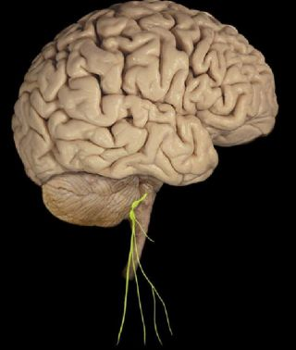
Healthy vagal tone is indicated by a slight increase of heart rate when you inhale, and a decrease of heart rate when you exhale. Deep diaphragmatic breathing—with a long, slow exhale—is key to stimulating the vagus nerve and slowing heart rate and blood pressure, especially in times of performance anxiety. A higher vagal tone index is linked to physical and psychological well-being. A low vagal tone index is linked to inflammation, negative moods, loneliness, and heart attacks.

Heart disease is the number one killer in America. One way to improve your heart health is to focus on the vagus-friendy lifestyle habits I explore below. Well-conditioned athletes have higher vagal tone because aerobic breathing creates healthy vagal tone, which results in a lower resting heart rate. Healthy cardiac function is directly linked to stimulating the vagus nerve.

In 1921, a German physiologist named Otto Loewi discovered that stimulating the vagus nerve caused a reduction in heart rate by triggering the release of a substance he coined Vagusstoff (German: “Vagus Substance”). The “vagus substance” was later identified as acetylcholine and became the first neurotransmitter identified by scientists.

Vagusstuff is literally a tranquilizer that you can self-administer simply by taking a few deep breaths with long exhales. You can consciously tap the power of your vagus nerve to create inner-calm on demand. This knowledge alone should be enough to reduce the fear-of-fear-itself and give you grace under pressure next time you need it.

What exactly is the vagus nerve?

The word vagus means "wandering" in Latin. The words vagabond, vague, and vagrant come from the same root. The vagus nerve is known as the wandering nerve because it has multiple branches that diverge from two thick stems rooted in the cerebellum and brainstem that wander to the lowest viscera of your abdomen touching your heart and most major organs along the way.

The vagus nerve is constantly sending sensory information about the state of the body's organs "upstream" to your brain. In fact, 80-90% of the nerve fibers in the vagus nerve are dedicated to communicating the state of your viscera up to your brain. When people say “trust your gut” they are in many ways saying, “trust your vagus nerve.” Visceral feelings and gut-instincts are literally emotional intuitions transferred up to your brain via the vagus nerve.

As with any mind-body feedback loop, messages also travel "downstream" from your conscious mind through the vagus nerve signaling your organs to create an inner-calm so you can “rest-and-digest” during times of safety or to prepare your body for “fight-or-flight” in dangerous situations.

Your vagus nerve is the commander-in-chief when it comes to having grace under pressure. The autonomic nervous system is comprised of two polar opposite systems that create a complementary tug-of-war which allows your body to maintain homeostasis (inner-stability).

Miss Foley

Psych 20: 2.2.2 Nervous System Processing Info

The sympathetic nervous system is geared to rev you up like the gas pedal in an automobile – it thrives on adrenaline and cortisol and is part of the fight-or-flight response. The parasympathetic nervous system is the polar opposite. The vagus nerve is command central for the function of your parasympathetic nervous system. It is geared to slow you down like the brakes on your car and uses neurotransmitters like acetylcholine and GABA to literally lower heart rate, blood pressure, and help your heart and organs slow down.

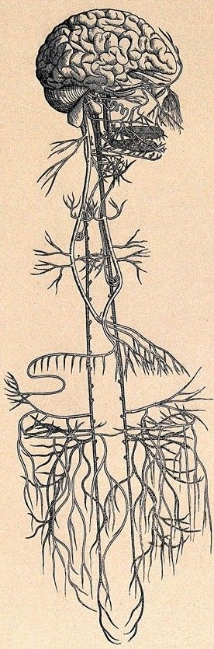
Unfortunately, the vagus nerve’s reflexive responses can backfire and turn it from comrade into saboteur. Anytime you psyche yourself out before an important event, feel intimidated, or insecure your vagus nerve interprets that you are in real danger which exacerbates these negative responses.

All of the physical symptoms of performance anxiety—racing heart, sweaty palms, dry mouth, upset stomach, shakiness—are the result of your vagus nerve disengaging. Luckily, you have the power to harness your vagus nerve and keep it engaged to create grace under pressure. By understanding the incredible power of your vagus nerve you can begin practicing ways to flex its inhibitory strength to keep you mellow in times of distress.

8 habits that will stimulate your vagus nerve

and give you grace under pressure:

1. Visualize the Vagus Nerve. Visualizing the vagus nerve as a wellspring of neurobiological ingredients that create mental and physical calmness will create a self-fulfilling prophecy. This is not just the placebo effect in action. Remember, anytime you take a deep breath and exhale you are triggering a biological release of vagusstuff that will lower heart rate and blood pressure.

In addition to visualizing my vagus nerve I literally talk to it in the third person like it is a separate entity. You can try this too the next time you have the butterflies or are shaky before a big presentation or challenge. I will literally say to my vagus nerve things like, "I thought we were in this together. I need you to work with me here. Come on! Don't let me down." Somehow this helps take my ego out of the situation, puts me at ease, and makes me feel like I have a loyal comrade on deck. Try this trick the next time you need grace under pressure and see if it works for you.

I include this narrow anatomical drawing to help you visualize what the vagus nerve actually looks like in your body and to illustrate how long it is from top to bottom.

2. Practice, Practice, Practice. In a Psychology Today blog entry called No. 1 Reason Practice Makes Perfect, I wrote about the power of your cerebellum to store muscle memory and allow you to perform gracefully under pressure. Without extensive practice we are forced to rely too much on the ‘executive function’ of our prefrontal cortex. Anytime you 'over-think' your performance you are more likely to choke, fumble and drop the ball. Arthur Ashe called this “paralysis by analysis." Once the cerebellum is running the show your vagus nerve engages which helps create fluidity in your thoughts and actions.

Miss Foley

Psych 20: 2.2.2 Nervous System Processing Info

3. Create Flow by balancing skill and challenge. The key to being in the ‘zone’ or creating a state of ‘flow’ is to find the sweet spot where your skill level perfectly matches the challenge. Get in the habit of continually nudging against your limits. By increasing the challenge gradually you become more skilled and comfortable with more difficult tasks.

Seek challenges that keep you nestled between anxiety and boredom. The key to peak performance is to have a heightened state of arousal but an inner sense of calm reflected in a perfect dynamic tension within the yin-yang of your autonomic nervous system. Although it is tempting to bite-off-more-than you can chew, your vagus nerve can betray you if it feels you're in uncharted territory. By consistently increasing your skills you will feel at ease as you take on bigger challenges. That said, if you ever do have the opportunity to leap frog to a high-stakes challenge, use other techniques here to harness the vagus nerve and use it as an ally to get you through.

4. Reframe Priorites and Values. I strongly believe that friends, family, good health, and generosity of spirit matter more than any achievements that requires grace under pressure. In 2006, Geoffrey Cohen, a professor at the Stanford University School of Education, conducted a series of experiments designed to reduce test-taking pressures. In the experiment he asked students to write a paragraph about a topic unrelated to the exam such as: “relationships with friends and family,” “religious values,” “athletic ability,” and “being good at art” before being tested. This brief writing assignment significantly improved the grades of students.

Before you face any challenge or test that fills you with performance anxiety get in the habit of reframing the importance of the event by putting it in a broader perspective of other things that you're good at and what matters most to you. Even when the stakes are high, remember that every hurdle is an opportunity to learn. Mastery is a process. Overblown performance anxiety jacks up cortisol and andrenaline levels and makes you less likely to succeed.

5. Use neuroplasticity to re-wire habits of positive thinking. By generating positive emotions and a learned optimism you will ‘fire-and-wire’ together neural networks associated with a mindset that will give you grace under pressure. The vagus nerve picks up on signals coming from the 'top-down' and from the 'bottom-up' and uses these signals to re-wire your mind through neuroplasticity.

On January 28, 2013 researchers at the University of Glasgow in Scotland announced that they are hoping to help victims of stroke to overcome physical disabilities by helping their brains to 'rewire' themselves using a Vagal Nerve Stimulator (VNS). Lead researcher Dr Jesse Dawson, a stroke consultant and clinical senior lecturer in medicine, described the vagus nerve by saying, "That nerve is one of the major nerves that goes to the brain. By stimulating the nerves, you can cause upstream changes in the brain without having to go into the brain."

It is hoped that the device will stimulate release of the brain's own chemicals and help the brain form new neural connections which might improve participants' arm mobility. In 2005, the FDA approved the use of VNS for treatment-resistant depression, although it’s use remains controversial... VNS is also used to treat epilepsy and tinnitus.

Dr Dawson added: "Evidence from animal studies suggests that vagus nerve stimulation could cause the release of neurotransmitters which help facilitate neural plasticity and help people re-learn how to use their arms after stroke, particularly if stimulation is paired with specific tasks.” The link between vagus nerve stimulation and neuroplasticity is strong. By focusing on

creating healthy vagal tone you can trigger similar neuroplastic changes from the bottom-up. Creating a mindset of grace under pressure are reinforced through powerful mind-body connection of the vagus nerve.

6. Seek Daily Physicality. Cardio-respiratory activity, strength training and yoga stimulate vagal tone and harmonize hormones and neurotransmitters linked to grace under pressure. Aerobic activity stimulates healthy vagal tone due to the inherent diaphragmatic breathing of rhythmic cardio-respiratory exercise. Strength training with an emphasis on a robust exhale as you push the weight will stimulate vagal tone.

Yoga increases vagal tone, too. In a 2012 article published in Medical Hypotheses, researchers from Boston University School of Medicine (BUSM), New York Medical College (NYMC), and the Columbia College of Physicians and Surgeons (CCPS) presented evidence that yoga may be effective in
Miss Foley

Psych 20: 2.2.2 Nervous System Processing Info

treating patients with stress-related psychological and medical conditions such as depression, anxiety, high blood pressure and cardiac disease.

The researchers hypothesize that stress causes an imbalance in the autonomic nervous system (parasympathetic under-activity and sympathetic over-activity) as well as under-activity of the inhibitory neurotransmitter GABA. According to the researchers, low GABA activity occurs in anxiety disorders, post-traumatic stress disorder, depression, epilepsy, and chronic pain. The hypothesis advanced in this paper could explain why vagal nerve stimulation (VNS) works to decrease both seizure frequency and the symptoms of depression.

"Western and Eastern medicine complement one another. Yoga is known to improve stress-related nervous system imbalances," said Chris Streeter, MD, associate professor of psychiatry at BUSM and Boston Medical Center, who is the study's lead author. Streeter believes that "This paper provides a theory, based on neurophysiology and neuroanatomy, to understand how yoga helps patients feel better by relieving symptoms in many common disorders."
7. Anxiety is contagious: Avoid anxious people. As a neurosurgeon, my father needed to have grace under pressure. He understood how delicate the sensors of his own vagus nerve were and would ask anyone in the operating room to leave if he or she was emitting an uptight vibe.

I’ve learned to do the same in life—especially before an important event. Because anxiety is catching, I will remove myself from the vicinity of anyone who is negative, cynical or doubtful of my ability to hit-it-out-of-the-park in a high stakes situation. The vagus nerve picks up on people’s vibe. Of course, none of us like to be around high strung people, but it is particularly important when you need to have grace under pressure.

If you are unable to remove yourself from anxious or nervous people (like in a waiting room for an audition or near the starting line of a race) I recommend using headphones with music that creates an appropriate mood and blocks the ability of others' anxiety to affect your vagal tone. You can also close your eyes and do mindfulness or meditation maneuvers to distance your vagal nerve from picking up the nervous vibe of people in your vicinity. Obviously, people who emit easy-going, warm, upbeat emotions are much better for your health, longevity, and ability to perform with grace under pressure. Seek these people out!
8. Foster Loving & Kindness. In order to maintain healthy vagal tone it’s important to foster diverse and rewarding social connections. In a 2010 study published in Psychological Science, Barbara Frederickson and Bethany Kok of the University of North Carolina at Chapel Hill focused their attention on the vagus nerve.

Their article was titled: How Positive Emotions Build Physical Health: Perceived Positive Social Connections Account for the Upward Spiral Between Positive Emotions and Vagal Tone.They discovered that a high vagal tone index was part of a feedback loop between positive emotions, physical health and positive social connections.

Their research results suggests that positive emotions, positive social connections, and physical health influence one another in a self-sustaining upward spiral dynamic that scientists are just beginning to understand. Kok states that: “We propose here that people’s ability to translate their own positive emotions into positive social connections with others may hold one of the keys to solving this mystery.”

In the experiment Frederickson and Kok used a Loving-Kindness Meditation technique to help participants become better at self-generating positive emotions. However, they also found that simply reflecting on positive social connections and working to improve them also caused improvements in vagal tone.

Name: _________________________ Date: ____________

Psych 20: 2.2.2 Nervous System Processing Info

Experience and the Developing Brain:

Children’s Toys Investigation

Research:

Use the provided class time to investigate different types of children’s toys. Things to consider investigating:
- Read the linked articles below
- Your top 5 favorite toys from childhood
- Toys from different cultures
- “Top 10” reviewed toy lists – for education, for creativity, for gender neutral, etc.
- Active toys vs non-active toys
- The intended purpose of toys
- The impact on cognitive development
- The impact on emotional development
- The impact on gender identity roles

Psychology Today: The Toy Your Child Really Needs

MIT Technology Review: Toy Psychology

Psychological and Educational Evaluation of Toys in Moscow Center of Play and Toys

What the Research Says: Impact of Specific Toys on Play

Reporting:

Choose one (1) toy that illustrates your research well. Create a one (1) page visual impact poster, to be shared publicly, that shares the information found from your research of #6-9 above.
- The intended purpose of toys
- In what ways are the toys that children play with influencing their cognitive development?
- In what ways are the toys that children play with influencing their emotional development?
- In what ways are the toys that children play with influencing their gender identity roles?

Miss Foley

Psych 20: 2.2.3 Processing Info Endocrine System

Endocrine System Regulates:
- Metabolism 3. Growth
- Homeostasis 4. Reproduction
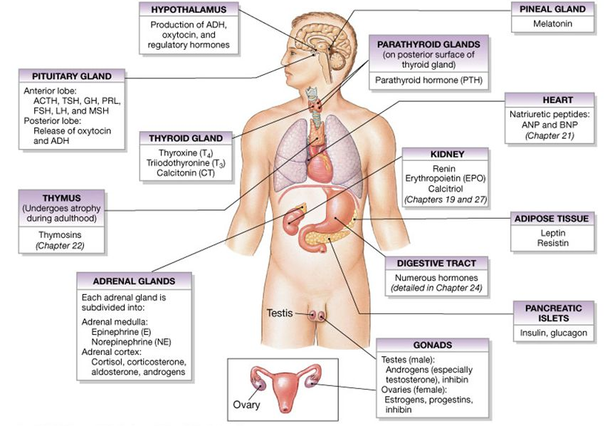

The endocrine system employs chemical messengers called hormones, which move through the blood stream, and can reach every cell in the body. Their effect can be rapid or delayed (Guinness, 1989, p. 74). Hormones help maintain homeostasis (a constant environment inside the body), adjusting the amount of salt and water in your tissues, sugar in your blood, and salt in your sweat to suit the particular conditions around you. Hormones produce both long-term changes, such as a child’s growth and sexual maturation, and rhythmic ones, such as the menstrual cycle. They trigger swift, dramatic responses in the body whenever illness or injury strikes or your brain perceives danger. They have a lot to do with such powerful emotions as anger and fear, joy and despair (Guinness, 1989, p. 74)

Homeostasis - The ability to keep the internal environment of your body constant despite changes in the external environment.

Glands - Organs that secrete hormones.

Hormones - Chemical substances secreted into the blood that influence growth, development and behavior of other cells.

Two (2) types of hormones:
- Protein – Can NOT pass through membranes Example: Insulin
- Steroid – Can pass through membranes Example: Estrogen

Miss Foley

Psych 20: 2.2.3 Processing Info Endocrine System

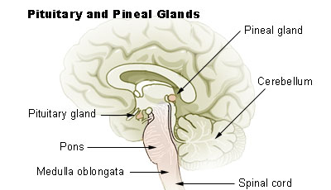
Pituitary Gland:
The “Master Commander”

The Pituitary gland is controlled by the hypothalamus

in the brain.

Anterior Pituitary: Secretes hormones controlling other glands

Thyroid Stimulating Hormone (TSH): stimulates the production and release of thyroxine from the thyroid gland

Adrenocorticotropic Hormone (ACTH): stimulates the production & release of hormones from the cortex layer of the adrenal glands

Growth Hormone (GH): controls growth

Follicle Stimulating Hormone (FSH): stimulates the development of egg cells in the ovaries in females; in males, it controls the production of sperm cells in testes

Lutenizing Hormone (LH): releases the egg cells from the ovaries in females

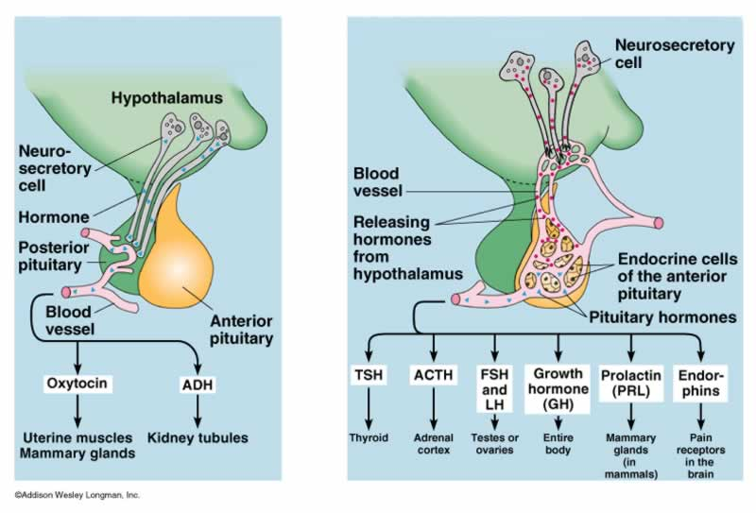
Prolactin: stimulates the secretion of milk by the mammary glands of the female after she gives birth

Posterior Pituitary:

Oxytocin: controls contractions of uterus during childbirth

Vasopressin: (A.K.A. ADH) controls the re-absorption of water by the nephrons of the kidneys.

Miss Foley

Psych 20: 2.2.3 Processing Info Endocrine System

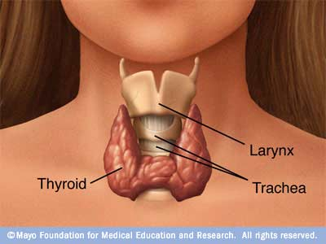
Thyroid Gland

Thyroxin: regulates the metabolism of protein, fats &

carbohydrates and cellular respiration rates; contains iodine

Calcitonin: regulates blood calcium levels
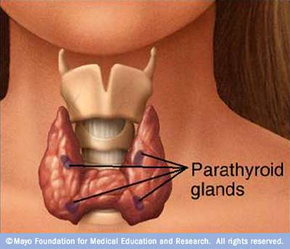

Parathyroid Glands

Parathyroid: regulates the metabolism of calcium (growth, bones/teeth, clotting, nerve function & muscle contractions) and phosphate (bones, ATP, DNA & RNA)

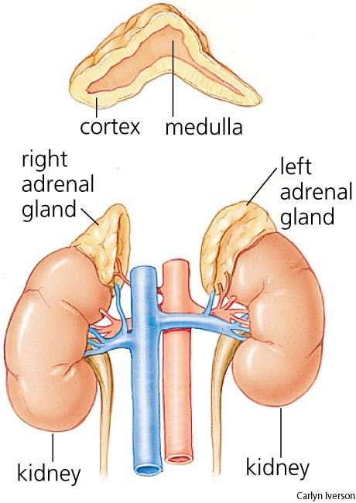
Adrenal Glands

Medulla (inner layer) deals with sudden stress

Norepinephrine & Epinephrine:

(A.K.A Adrenalin)

Secreted to produce our emergency fight-or-flight response during sudden stress such as fear, anger, pain or physical exertion

Cortex (outer layer) deals with chronic Stress

Cortisol (A.K.A. Hydrocortisone): regulates metabolism of carbohydrates, proteins & fats

Aldosterone: maintains normal blood mineral balance

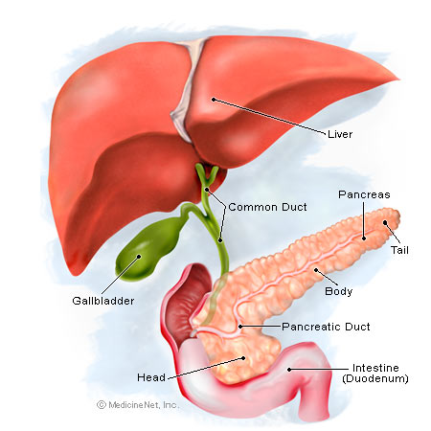

Pancreas

Islets of Langerhans secrete glucagon and insulin.

Glucagon: pulls sugar from the cells back into the blood.

Insulin: releases sugar from the blood into the cells.

When insulin fails or isn’t present, glucose can’t leave the blood and enter the cells. As a result, the sugar punches holes in the blood vessels causing damage needing constant repair. This results in blindness or limb amputations when the body can’t keep up with recovery. The kidneys must excrete the sugar in the urine = DIABETES = death if untreated.

Miss Foley

Psych 20: 2.2.3 Processing Info Endocrine System
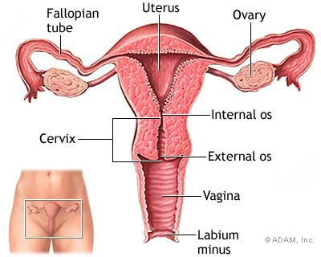

Female Gonads: Ovaries

“A.K.A. Female Sex Glands”

Estrogen: stimulates the development of the female reproductive system; promotes the development of secondary sex characteristics such as broadening hips and development of breasts; regulates menstrual cycle.

Progesterone: works with estrogen to regulate the menstrual cycle.

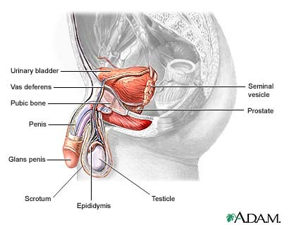
Male Gonads: Testes

“A.K.A. Male Sex Glands”

Testosterone: stimulates the development of the male reproductive system; promotes the development of secondary sex characteristics such as deepening of the voice, beard, body hair and the male body form

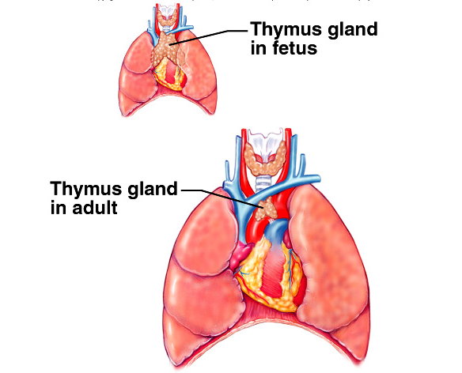
The Thymus

Thymosin: stimulates the development of T- lymphocytes which help defend the body against infection as children.

It APPEARS not to serve any function in adults.
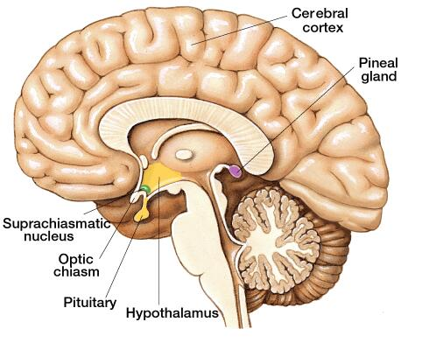

The Pineal Gland

Melatonin: regulates the sleep/wake pattern; causing drowsiness & lowering body temperature; needed to trigger quality sleep patterns; may inhibit sexual development

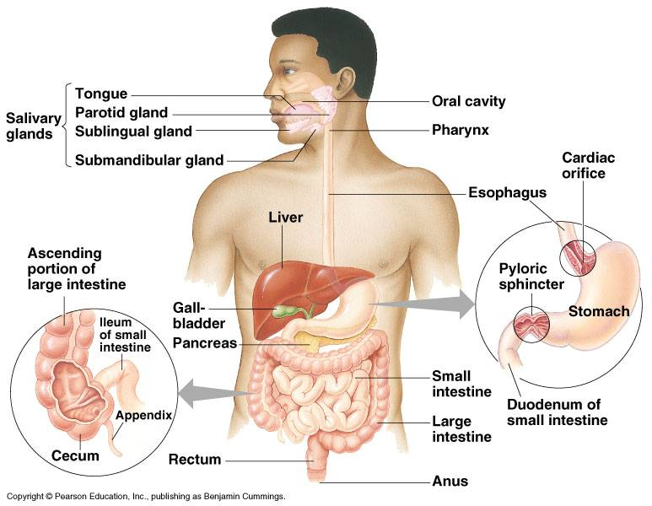
The Digestive Glands

Saliva: stimulates the flow of saliva & the enzyme amylase to break down starches

Gastrin: stimulates the flow of gastric juices in the stomach

Secretin: stimulates the flow of pancreatic juices in the small intestines

Miss Foley

Psych 20: 2.2.4 Heredity/Genetics Gattaca

Gattaca (1997) Movie: Synopsis

In "the not-too-distant" future, where genetic engineering of humans is common and DNA plays the primary role in determining social class, Vincent (Ethan Hawke) is conceived and born without the aid of this technology. Suffering from the nearly eradicated physical dysfunctions of myopia and a congenital heart defect, as well as being given a life expectancy of 30.2 years, Vincent faces extreme genetic discrimination and prejudice. The only way he can achieve his life-long dream of becoming an astronaut is to break the law and impersonate a "valid", a person with appropriate genetic advantage.
He assumes the identity of Jerome Eugene Morrow (Jude Law), a former swimming star who, despite a genetic profile "second to none", won only a silver medal in a high-profile competition. He then attempted to commit suicide by jumping in front of a car, but again fell short of his goal in that he only succeeded in paralyzing himself from the waist down. However, as the incident occurred outside the country, no one knows of his newly acquired disability. Thus, Vincent can "buy" his identity with no one the wiser. Though he requires orthopedic surgery to increase his height, persistent practice to favor his right hand instead of his left, and contact lenses to replace his glasses while matching Jerome's eyes, he can use his "valid" DNA in blood, tissue and urine samples to pass any genetic test - as long as he takes extreme measures to leave no traces of his identity as an "in-valid". But, where he was once an object of scorn and pity, he is now a perpetrator of an unspeakable fraud. Legally, exposure would only subject him to fines, but socially the consequences would be far more extreme - he is now a heretic against the new order of genetic determinism. Vincent is now a "borrowed ladder" (a reference to the ladder structure of an un-coiled DNA strand) or in harsher language, a de-gene-erate.
With Jerome's impressive genetic profile he easily gains access to the Gattaca Aerospace Corporation (his interview consists entirely of a urine test), the most prestigious space-flight conglomerate of the day. With his own equally impressive determination, he quickly becomes the company's ace celestial navigator. But a week before Vincent is scheduled to leave for Saturn's moon Titan, the mission director is murdered, and evidence of Vincent's own "in-valid" DNA is found in the building in the form of an eyelash. The presence of this unexpected DNA attracts the attention of the police, and Vincent must evade ever-increasing security as his mission launch date approaches and he pursues a relationship with his co-worker Irene Cassini (Uma Thurman).
After numerous close calls, the investigation eventually comes to a close as Director Josef (Adam S. Gottbetter) is arrested for the murder by the lead detective covering the investigation (Alan Arkin). The Director reveals that he murdered the mission director in order to buy time for the mission to launch, because the window of opportunity for the launch is only open once every seventy years, and that it is now too late to stop the launch. However, just as Vincent appears to be in the clear, he is confronted by one of the detectives, who are revealed as Vincent's estranged brother, Anton (Loren Dean). Anton tries to convince Vincent to go with him for protection before Vincent is found out. However, it soon becomes apparent that Anton is acting

Miss Foley

Psych 20: 2.2.4 Heredity/Genetics Gattaca

more out of insecurity and is more concerned with how Vincent had managed to get the better of him, despite his supposed genetic superiority. Vincent and Anton settle their competition as they did when they were children, by seeing who could swim out into the ocean farthest. As he did once before when they were young, Vincent manages to beat his brother, and, once again, saves him from drowning. This is simply because he refused to save any strength to swim back - he is willing to risk everything to succeed. Conversely his brother worried about preserving enough strength to swim out and return again, and these fears kept him from testing his true limits.
Anton: "Vincent! How are you doing this, Vincent? How have you done any of this? We have to go back!"
Vincent: "It's too late for that; we're closer to the other side."
Anton: "What other side? Do you want to drown us both"
Vincent: "You want to know how I did it? This is how I did it, Anton. I never saved anything for the swim back."
As the day of the launch finally arrives, Jerome bids Vincent farewell and says that he intends to travel too. He reveals that he has stored enough genetic samples to last Vincent two lifetimes. Overwhelmed and grateful, Vincent thanks Jerome for "lending" him the identity that has allowed his success at Gattaca. Jerome replies, however, that it is he who should be grateful, since Vincent lent Jerome his dreams. As Vincent moves through the Gattaca complex to the launch site, he is stopped for an unexpected DNA test. Vincent reluctantly agrees to take the test, even though he has none of Jerome's genetic material to hide his identity. The test result uncovers Vincent's "in-valid" status, and the doctor, Lamar (Adam S. Gottbetter), reveals that he has known Vincent's true identity all along, saying: "For future reference, right-handed men don't hold it with their left. Just one of those things". Lamar then alters the test result to allow him to proceed regardless, confessing that his son admires Vincent, and wants to be an astronaut just like him, despite an unforeseen genetic defect that would already rule him out. As the shuttle lifts off, Jerome is shown committing suicide inside his home incinerator, wearing his silver medal, which turns gold in the flames.
The story centers on the irony of the perfect Jerome failing to succeed despite being given every advantage while the imperfect Vincent transcends his deficiencies through force of will and spirit. A milder version of the disorder that afflicts Vincent prevents Irene from taking part in space flight. This dichotomy shows how the eugenic policy in Gattaca and the world in which it is set adversely affect the humanity of both Vincent and Jerome, as well as the "invalid" and "valid" humans they represent. A coda, cut from the final film, lists various people who have succeeded despite genetic deficiencies (and would be excluded in the modern society of Gattaca), such as Albert Einstein and Abraham Lincoln.

Name: _________________________ Date: ____________

Psych 20: 2.2.4 Processing Info Gattaca

Gattaca Movie:

Curriculum Connection Questions

Answer each of the following questions using specific examples from the movie Gattaca (1997):
- Illustrate how humans receive, process and act on information in our world.
- Explain the difference between sensation and perception.
- How are traits passed from one generation to the next in the movie?
- What influence did genetic engineering have on the lives of the characters?
- Give examples of ethical/moral issues that arose from genetic engineering in the movie.
- Why is motivation important?
- Is motivation innate or learned?
- Why do some people persevere and others give up?
- What are the intrinsic and external motives that affect our thoughts and behaviour?
- Which character did you most identify with and why?

Name: _________________________ Date: ____________

Psych 20: 2.2.4 Processing Info Gattaca

Miss Foley

Psych 20: 2.2.4 Processing Info Heredity & Genetics

Heredity =

process of transmitting biological traits through genes

Behaviour is the product of complex biological processes. Heredity refers to those biologically determined characteristics that, through the filter of our experience and environmental factors, influence behaviour.

Every cell of the body contains a set of biological blueprints that enables it to perform its essential functions. This information is contained in chromosomes, strand-like structures found in the nuclei of all cells. Chromosomes contain thousands of genes-segments of DNA that serve as basic units of heredity. Our genes, working in complex combinations with each other, with our environment, and with our experiences, ultimately determine our biological make-up (Baron et al., 1998, p. 74).

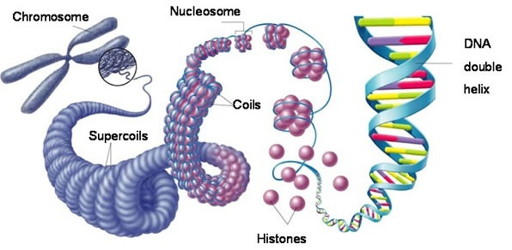
How are traits and characteristics passed from generation to generation?

Humans have 23 pairs of chromosomes. In each pair, one chromosome comes from the mother and the other from the father. Twenty-two of the pairs are the same in both men and women, and these are called autosomes. The twenty-third pair consists of the sex chromosomes, so called because they are the primary factor in determining the gender of a child. The sex chromosomes are known as the X and Y chromosomes (Berger, 2000, p. 69).

What is the role of heredity and what influence does it have on our thoughts, feelings and behaviors?

Heredity is the process of transmitting biological traits from parent to offspring through genes, the basic units of heredity. Heredity also refers to the inherited characteristics of an individual, including traits such as height, eye color and blood type. Genetics is the study of how heredity works and, in particular, of genes. A gene is a section of a long deoxyribonucleic acid (DNA) molecule, and it carries information for the construction of a protein or part of a protein. Through the diversity of proteins they code for, genes influence or determine such traits as eye color, the ability of a bacterium to eat a certain sugar, or the number of peas in a pod. A virus has as few as a dozen genes. A simple roundworm has 5000 to 8000 genes, while a corn plant has 60,000. The construction of a human requires an estimated 50,000 genes. If the DNA in a single human cell could be unraveled, it would form a single thread about five feet long and about 50 trillionths of an inch thick.

Miss Foley

Psych 20: 2.2.4 Processing Info Heredity & Genetics

What is genetic engineering?

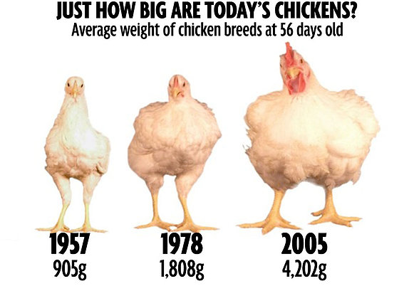
Genetic engineering is the alteration of an organism's genetic instructions through the insertion of additional genes. In humans, genetic engineering involves adding normal genes, either directly via a blood transfusion or bone marrow transplant or directly into a cluster of cells, thereby enabling the body to replace ailing cells with healthy ones. The technique is being used experimentally for hemophilia, cystic fibrosis, rheumatoid arthritis, several types of cancer, and dozens of rare diseases (Berger, 2000, p. 95).

What are the ethical and moral issues involved in genetic engineering?

Gene mapping and genetic engineering create some dilemmas. Do people want to know about their genetic defects even though they cannot be corrected? When the issues are genetic screening and abortion, ethical values often clash with practicality and parental rights. Do parents want to bring to term a child that will have a severe disorder? One country has already instituted a policy about such disorders. In 1993, China established a program of abortions, forced sterilization, and marriage bans to avoid new births of “inferior quality” infants and raise the standards of their country. Worries abound that the information housed in people's genes will be used to their detriment. A drop of blood or a lock of hair contains all of the genetic information a potential employer or insurer would need to determine whether someone is at risk of contracting any of a long list of debilitating diseases (Santrock, 1999, p. 74). Ethical dilemmas have increased as scientists on the Human Genome Project have now completed mapping out human genes.
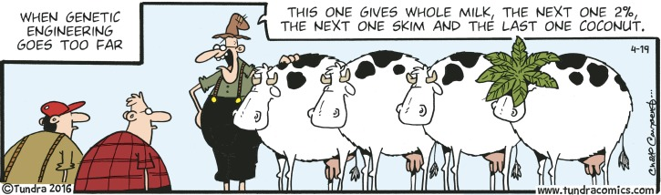

Miss Foley

Psych 20: 2.2 Physical Aspects Acting On Info

What are the socio-cultural influences on our physical development?

Our systems of support have a profound influence on the physical development and nurturance of the individual.
- Microsystems - nutrition, poverty and high or low economic status of the family have as great importance with regards to physical development. Peer groups can influence our development (e.g., body image), and groups such as sport teams can influence our physical development.
- Exosystem – Schools and communities play a very important role in promoting healthy development through facilities (e.g. hockey rinks, skateboard parks) and programs (Health care programs, homecare, seminars for parents, single moms, teen moms).
- Macrosystem - What are the influences of the economic climate (e.g., slums, ghettos, underdeveloped nations), the political climate (e.g., political systems and their perspectives on amateur sport), and cultural values (e.g., competitiveness, individuality, and achievement)?

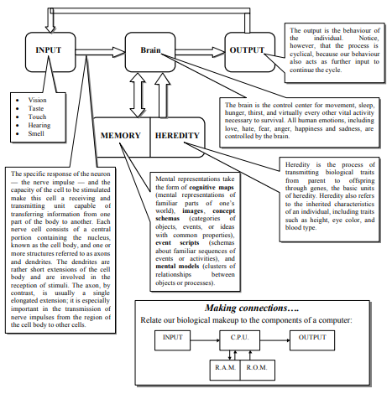
The final aspect to the reception, processing and acting upon the information we receive from the world is, of course, our behaviour. However, once we have processed the information and then responded in some way, this behaviour in turn becomes information which is then received, processed and acted upon, and so the cycle is repeated. How many times have you said, “I’ll never do that again!” Well, this is an example of the way in which your behaviors as a response to a situation became more input for future responses! The following graphic describes this process through a model which is very similar to ones used by computer technologists.

Miss Foley

Psych 20: 2.3 Emotional Aspects Overview

Test Yourself:
Life Event | Mean Value
- Death of a spouse | 100
- Divorce | 73
- Marital Separation | 65
- Jail term | 63
- Death of a close family member | 63
- Personal injury or illness | 53
- Marriage | 50
- Fired at work | 47
- Marital reconciliation | 45
- Retirement | 45
- Change in health of family member | 44
- Pregnancy | 40
- Sex difficulties | 39
- Gain of a new family member | 39
- Business readjustment | 39
- Change in financial state | 38
- Death of a close friend | 37
- Change to different line of work | 36
- Change in number of arguments with spouse | 35
- Mortgage over $10,000* | 31
- Foreclosure of mortgage or loan | 30
- Change in responsibilities at work | 29
- Son or daughter leaving home | 29
- Trouble with in-laws | 29
- Outstanding personal achievement | 28
- Spouse begins or stops work | 26
- Begin or end school | 26
- Change in living conditions | 25
- Revision of personal habits | 24
- Trouble with boss | 23
- Change in work hours or conditions | 20
- Change in residence | 20
- Change in schools | 20
- Change in recreation | 19
- Change in church activities | 19
- Change in social activities | 18
- Mortgage or loan less than $10,000 | 17
- Change in sleeping habits | 16
- Change in number of family get-togethers | 15
- Change in eating habits | 15
- Vacation | 13
- Christmas | 12
- Minor violations of the law | 11
*1967 figure; today this figure would be much higher

The Social Adjustment Rating Scale

The Social Readjustment Rating Scale lists events in life that require us to cope with and adjust to change. Both positive and negative events cause some degree of stress.

The life events are listed in the left column. The numbers in the right-handed column assign a value to the event, based on the responses of a large sample of people.

To test yourself, add up all the events that you have experienced in the last year.

According to experts, if you score over 300 points, your chances of becoming physically ill from stress rises to about 90%. Remember that you have a good measure of control over many life events.

Source:
Adapted from T.H. Holmes and
R.H. Rahe, The Social
Readjustment Rating Scale,
Journal of Psychosomatic
Research, vol. 11 (1967), pp.213-
218; “Stress”, Blue Print for Health,
Blue Cross Association (Chicago),
vol. 25, no.1.
Miss Foley

Psych 20: 2.3 Emotional Aspects Overview

What affects how we feel about the world?

Motivation is the internal state of an organism that drives it to behave in a certain way. There are three aspects: Drives such as hunger, thirst, temperature regulation and sex; learned motives; and needs, such as achievement, affiliation, status and power.

An emotion is a temporary experience with negative or positive qualities that is felt with some intensity as happening to the self, is generated in part by a mental assessment of a situation, and is accompanied by both learned and innate physical responses (Bernstein and Nash, 1999, p. 310).

Attitude is a state of readiness, based on past experiences, which guides, biases, or otherwise influences our behaviour. There are three components: Cognitive, or what we believe; Affective which include our feelings; and Behavioural, or learned associations.

Attitudes serve a number of motivational functions:

ego-defensive

value-expressive

instrumental: gain social acceptance or avoid disapproval

knowledge: organize social world (e.g., what I like or don’t like) and make predictions (Aronson et al., 1994, p. 287).

Social perception is the process by which people come to know and evaluate one another. Researchers in social perception study how we form impressions of each other, how we explain the causes of our own and other people’s behaviour, and how we form stereotypes and prejudices toward social groups (Aronson et al., 1994, p. 158).

In what ways are our emotions biologically based?

All emotional responses contain three components: behavioural, autonomic and hormonal. The behavioural component consists of muscular movements that are appropriate to the situation that elicits them. For example, a dog defending its territory against an intruder first adopts an aggressive posture, growls, and shows its teeth. If the intruder does not leave, the defender runs towards it and attacks. Autonomic responses – that is, changes in the activity of the autonomic nervous system facilitate these behaviours and provide quick mobilization of energy for vigorous movement. As a consequence, the dog’s heart rate increases, and changes in the size of blood vessels shunt the circulation of blood away from the digestive organs toward the muscles. Hormonal responses reinforce the autonomic responses. The hormones secreted by the adrenal glands further increase heart rate and blood flow to the muscles, and also make more glucose available to them (Buskist et al., 2002, p. 433).

What are the socio-cultural influences on our feelings and behaviors?

Using the Ecological model as a conceptual organizer, discuss how each level of the model contributes to the formation, maintenance and change of our emotional states, most particularly our attitudes including biases and prejudice.

Miss Foley

Psych 20: 2.3.1 Emotional Aspects Motivations

Motivation =
Factors influencing the initiation, direction, intensity, and persistence of behaviour
Currently MY personal motivating factors are:
_____ Power | _____ Achievement | _____ Dominance | _____ Thrill Seeking
_____ Status | _____ Social Justice | _____ Food/Water | _____ Satisfaction
_____ Prestige | _____ Obligation | _____ Self-respect | _____ Creativity
_____ Control | _____ Spirituality | _____ Social Recognition | _____ Empathy
_____ Pleasure | _____ Belonging | _____ Mastery | _____ Altruism
_____ Money | _____ Self-Interest | _____ Wisdom | _____ Inclusion
_____ Morality/  Ethics | _____ Manipulation | _____ Self-Actualization | _____ Rescue
_____ Friendship | _____ Needing | _____ Self-esteem | _____ Liking
_____Happiness | _____Material Goods | _____Greed | _____Sympathy
_____Order | _____Shelter | _____ Fear | Other: ______________

Four Categories of Motivations: (Bernstein and Nash, 1999, p. 287).

Biological factors –

Emotional factors –

Cognitive factors –

Social factors –

When we want to emphasize the needs, desires, and mental calculations that lead to goal-directed behaviour, we use the word “drive” or “motivation” (Kasschau, 1995, p. 314).

Miss Foley

Psych 20: 2.3.1 Emotional Aspects Motivations

Why is motivation important?

The two major sources of construals the need to maintain a positive view of ourselves (the self-esteem approach) and the need to view the world accurately (the social cognition approach)are the most important of our social motives, but they are certainly not the only motives influencing people’s thoughts and behaviours. We humans are complex organisms, and there are a variety of motives that, under various conditions, influence what we think, feel and do. Biological drives such as hunger and thirst, of course, can be powerful motivators, especially when we are under extreme deprivation. At a more psychological level, we can be motivated by fear or by the promise of love, favours, and other rewards involving social exchange. Still another important motive is the need for control; research has shown that people need to feel that they exert some control over their environment (Aronson et al., 1994, p. 230).

Are motivations innate or learned?

Which of your motives is the most purely physiological or inherited? You might say hunger or thirst. Both are inherited, present at birth, and appear without any evidence of a need to practice how to respond to them. Physiological motives are inherited needs satisfied only by specific goals, food for hunger and water for thirst. Yet, we quickly develop “tastes” for certain foods and dislikes for others. So, what is the role of learning and the environment in our motives? In the middle of the continuum, then, we could list such motives as pain avoidance, sex, and the need for stimulation. Here, physiology clearly plays a role, yet learning is crucial to our effective response to such “mixed” motives. Finally motives such as achievement and social approval certainly are most subject to the ultimate effects of experience. For these learned or social motives, the satisfying goals are much more diverse (Kasschau, 1995, p. 325).

Why do some people persevere, and others give up?

Many human behaviours are reinforced on intermittent schedules that require the performance of long sequences of behaviours over long intervals of time. Intermittent reinforcement leads to perseverance, even when the behaviour is no longer being reinforced. A person’s previous experience with various schedules of reinforcement probably affects how long and how hard the person will work between occasions of reinforcement. If all attempts at a particular task are reinforced (or if none are), the person is unlikely to pursue a long and difficult project (Buskist et al., 2002, p. 420).

What are the intrinsic and external motives that affect our thoughts and behaviours?

Psychologists talk about intrinsic and extrinsic motivation whether things are done for fun or for rewards. Extrinsic motivation is supplied in the form of rewards that come from the external environment. Praise, a high grade, and money are extrinsic rewards. In contrast, behaviours engaged in for no apparent reward except the pleasure and satisfaction of the activity itself arise from intrinsic motivation (Lefton et al., 2000, p. 299).

Name: _________________________ Date: ____________

Psych 20: 2.3.1 Emotional Aspects Motivations

Given the list of motivations, list your “Top Ten Motivations”.

Compare your ranking of the ten most important motivations with a partner. How do they differ? How are they the same? Compare your most important motivation with that of your partner. Do you agree? If not, why? Be prepared to defend your choice for the most important motivation in life.

Generally, what is the most important human motivation?

What motivates you?

What is the most important intrinsic (internal) motivation in your life?

What is the most important extrinsic (external) motivation in your life?

Miss Foley

Psych 20: 2.3.2 Emotional Aspects Emotions

Emotion =

A temporary, personal experience with negative or positive qualities felt with intensity

Emotions are generated in part by a mental assessment of a situation, and are accompanied by both learned and innate physical responses (Bernstein and Nash, 1999, p. 310). Emotions are rather like colours: Some are simple, whereas others are blends. For example, jealousy can be viewed as a combination of several different emotions: distress, anger, disgust, contempt, fear and even shame.

Robert Plutchik has described eight primary emotions:

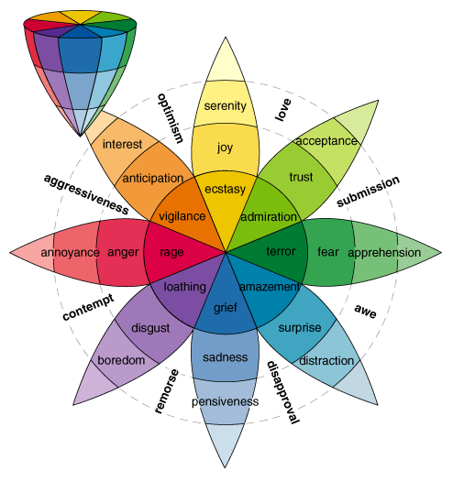
Anger 4. Disgust 7. Sadness

Fear 5. Acceptance 8. Joy

Surprise 6. Anticipation

He suggests that these primary emotions can combine to form other, mixed emotions such as:

Optimism -

Love-

Submission -

Awe -

Disappointment -

Remorse -

Contempt -

Aggressiveness -

Other ways emotions are like colours will be in their intensity. It is as if there is a vertical slice so that emotions might range from pensiveness to sadness to grief, or distraction to surprise to amazement (Adler et al., 2001, p. 135).

How is an emotion different than a feeling?

Emotions, as opposed to feelings and sentiments, are:

more momentary than prolonged

an intense state

characterized by behavioural disorganization

reflect survival strategies

non-habitual, reactive to certain situations (Cardwell, 1998, p. 85).

Miss Foley

Psych 20: 2.3.2 Emotional Aspects Emotions

Are emotions innate or learned?

In humans, voice tones, bodily movements, and, mainly, facial movements and expressions are involved in communicating emotions. Some facial expressions do appear to be innate, and certain facial movements are universally associated with certain emotions. Other emotional expressions are learned, and even innate expressions are modified by learning and social contexts. As children grow, they learn an emotion culture, the rules of emotional expression appropriate to their culture. Accordingly, the same emotion may be communicated by different facial expressions in different cultures. Especially in ambiguous situations, other people’s emotional expressions may serve as a guide about what to do or what not to do, a phenomenon called social referencing (Bernstein and Nash, 1999, p. 322).

What are the social and cultural influences on emotional expression?

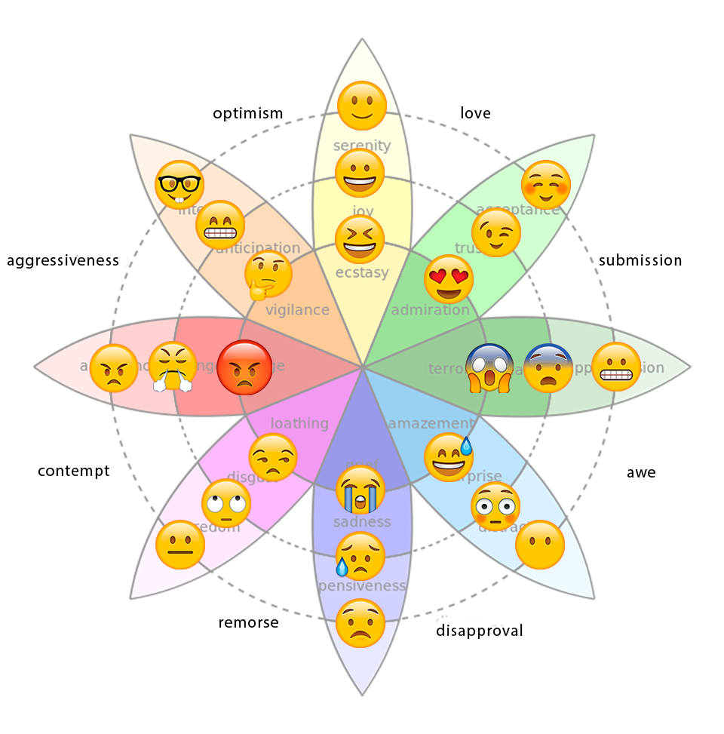
Whereas some basic emotional expressions are innate, many others are neither innate nor universal. For example, facial expressions become more intense and change more frequently while people are imagining social scenes as opposed to solitary scenes. Similarly, facial expressions in response to odors tend to become more intense when others are watching than when people are alone. Further, although a core of emotional responses is recognized by all cultures, there is a certain degree of cultural variation in recognizing some emotions. In one study, for example, Japanese and North American people agreed about which facial expressions signaled happiness, surprise, and sadness, but they frequently disagreed about which faces showed anger, disgust and fear. In addition, there are variations in the ways that cultures interpret emotions expressed by tone of voice. An example is provided by a study showing that Taiwanese participants were best at recognizing a sad tone of voice whereas Dutch participants were best at recognizing happy tones (Bernstein and Nash, 1999, p. 320).

What is anger, and how can it be controlled or managed?

Anger is a feeling; a normal emotion caused by stress; a signal that something is wrong. It is a secondary emotion whose function is to protect the self and others. Anger is based in initial feelings of hurt, disappointment, and/or frustration. The “fight or flight” responses vary from individual to individual, are changeable, but the first step toward managing anger is recognizing its warning signs.

Miss Foley

Psych 20: 2.3.2 Emotional Aspects Emotions

Techniques for preventing anger and violence may include:

Understanding behaviour

the ABC’s of behaviour (antecedent, behaviour, consequences)

developing an internal locus of control

developing positive belief systems

understanding basic needs (e.g., Maslow’s hierarchy)

Dealing with feelings

Alternatives to aggression

Dealing with stress

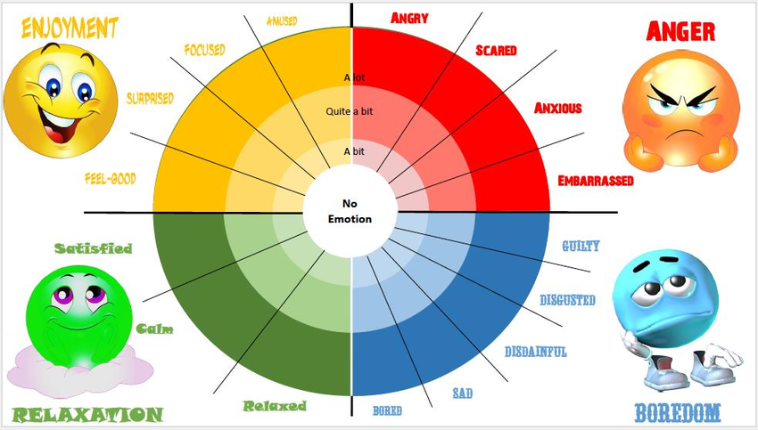
Problem solving/decision making skills

How can we minimize the effect of debilitating emotions?

Monitor your emotional reactions, be aware and self-reflective about your emotional state.

Note the activating event or series of events that has triggered your response.

Record your self-talk and begin to analyze the thoughts that are the link between the activating event and the emotions and feelings. Putting your thoughts on paper will help you see whether they actually make any sense.

Dispute your irrational beliefs by listing each belief and labeling it as either rational or irrational. Next, explain why the belief does or does not make sense. Finally, if the belief is irrational, write down an alternative response that will lead to better feelings as a response to the trigger (Adler et al., 2001, p. 161).

Miss Foley

Psych 20: 2.3.2 Emotional Aspects Emotions

How can we manage our emotions?

Focusing on the self-talk that we use is key to understanding how to manage emotional response. Many debilitative feelings come from accepting a number of irrational thoughts and/or fallacies which lead to illogical conclusions and, in turn to debilitating emotions.

The Fallacy of Perfection asserts that people should be able to handle every situation with complete confidence and skill. Subscribing to the myth of perfection not only can keep others from liking you, but also can act as a force to diminish your own self-esteem.

The Fallacy of Approval is the mistaken belief that it is not just desirable but vital to get the approval of virtually every person. In addition to the obvious discomfort that arises from denying your own principles and needs to gain acceptance and approval from others, the myth of approval is irrational because it implies that others will respect and like you more if you go out of your way to please them. Striving for universal acceptance is irrational because it is simply not possible.

The Fallacy of Should’s is the inability to distinguish between what is and what should be. Becoming obsessed with shoulds has three troublesome consequences. First, it leads to unnecessary unhappiness, for people who are constantly dreaming about the ideal are seldom satisfied with what they have or who they are. A second drawback is that merely complaining without acting can keep you from doing anything to change unsatisfying conditions. A third problem with shoulds that you impose on others is that this sort of complaining can build a defensive climate with others, who will resent being nagged.

The Fallacy of Overgeneralization comprises two types. The first occurs when we base a belief on a limited amount of evidence and use overgeneralizations.

The Fallacy of Causation is based on the irrational belief that emotions are caused by others rather than by one’s own self-talk. This fallacy causes trouble in two ways. The first plagues people who become overly cautious about relating because they don’t want to “cause” any pain or inconvenience for others. The second is when we believe that others cause our emotions. It’s our thinking, not the actions of others, that determines how we feel.

The Fallacy of Helplessness suggests that satisfaction in life is determined by forces beyond your control, that we are only helpless victims. Our emotions, thoughts and actions are either a matter of choice, or an area that calls for further action.

The Fallacy of Catastrophic Expectations operates on the assumption that if something bad can possibly happen, it will. Once we start expecting terrible consequences, a self-fulfilling prophecy can build (Adler et al., 2001, p. 154).

Miss Foley

Psych 20: 2.3.3 Emotional Aspects Attitudes

Attitudes =
A state of readiness, based on past experiences, which guides, biases, and/or influences behaviour
Attitudes are usually evaluative and have cognitive, emotional and behavioural dimensions, each of which serves a function. Attitudes are formed early in life through learning processes. Social psychologists can assess people’s attitudes, but whether those attitudes predict behaviour depends on a number of variables, including attitude strength, vested interest, specificity of attitudes, and accessibility of attitudes (Lefton et al., 2000, p. 448).
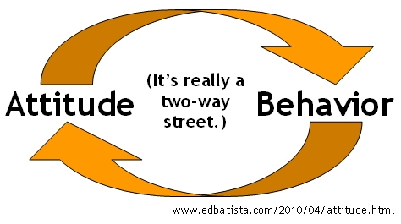
An attitude implies an internal state which, given the occurrence of certain stimulus events, will ultimately result in some sort of response or behaviour. The definition also implies that an attitude is learned and that our actions are related to it. This latter characteristic is important because it gives us the basis for deciding whether or not a given attitude exists, that is, whether a label can be attached to an individual. It is important to note that attitudes are hypothetical constructs. You can never actually observe people's attitudes; you can only infer or guess the existence of an attitude from what people say or do (Alcock et al., 1998, p. 96).
How do we form attitudes?
There are three types of attitudes which we can develop:
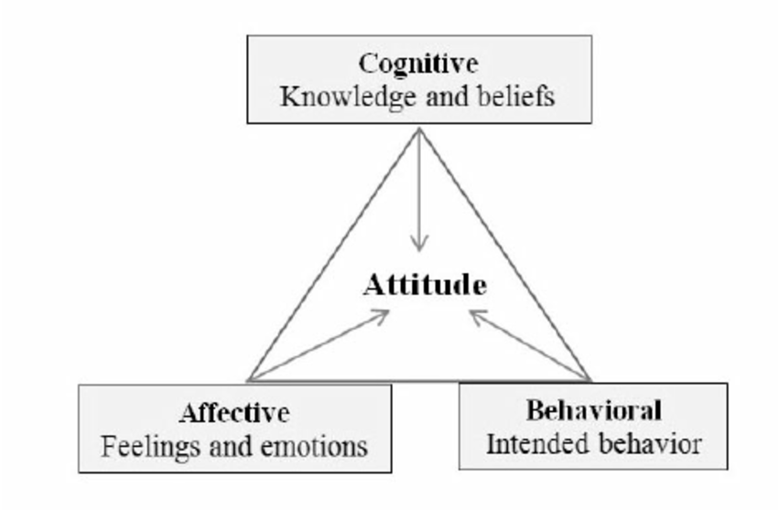
- Cognitively based attitudes are based primarily about people’s beliefs about the rewards and punishments they can provide, about the pluses and minuses of an object, the head over the heart.
- Affectively based attitudes are based more on people’s feelings and values than on beliefs about the nature of the attitude object, the heart over the head. Affectively based attitudes come from a variety of sources: basic religious and moral beliefs, sensory reactions (e.g., chocolate), or conditioning through the linking of a stimulus and a response.
- Behaviourally based attitudes are based more on self-perception, how you feel about something is based on performance or activity (Aronson et al., 1994, p. 287).

Miss Foley

Psych 20: 2.3.3 Emotional Aspects Attitudes

Why do we have attitudes?
Attitudes are functional in the sense that they satisfy important needs:
- Utilitarian or instrumental function leading to greater rewards and fewer costs.
- Social function by gaining approval and acceptance from others.
- Knowledge function, enabling us to make sense of our world, to cope with everyday decisions, and to feel that we do understand.
- Ego-defensive function, protecting people from becoming aware of harsh, uncomfortable truths about themselves or their world
- Value-expressive function demonstrating our uniqueness and what is important to us (Alcock et al., 1998, p. 101).
How do attitudes change?
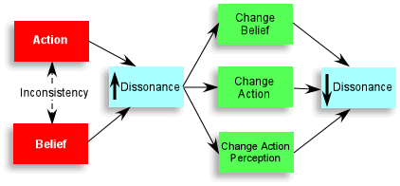
Festinger’s (1957) Theory of Cognitive Dissonance suggests reasons for interactions between attitudes and behaviour. It proposes that discrepancies between attitudes and behaviour, between behaviour and self-image, or between one attitude and another lead to the unpleasant state of cognitive dissonance (Buskist et al., 2002, p. 497).
Cognitive dissonance is a state of psychological tension, the uncomfortable feeling people get when they become aware of inconsistencies in their thoughts. For example, in the case of “Smoking is dangerous” versus “I smoke”, there are five possible outcomes:
- Change behaviour: I'll quit smoking.
- Modify dissonant cognition: It’s only a statistical danger.
- See cognition as irrelevant: It’s not dangerous to me.
- Bolster with consonance: Smoking keeps my weight down.
- Downgrade importance: Dangerous? They’ll come up with a cure (Alcock et al., 1998, p. 113).
Explicit attempts at changing attitudes often involve persuasion. We tend to be persuaded by arguments that have a credible source, such as an expert on a particular topic, or an attractive source, such as a handsome or beautiful model. Aspects of the message being delivered in a persuasive appeal are also important. If you know little about an issue or hold a strong opinion about it, then you are likely to be persuaded by a one-sided appeal. However, if you are already well informed about the issue, then you are likely to find a two-sided appeal more persuasive. Scare tactics appear to work best when they include information that is instructive as well as emotional (Buskist et al., 2002, p. 496).

Miss Foley

Psych 20: 2.3.3 Emotional Aspects Attitudes

Bem’s (1972) alternative to cognitive dissonance – self-perception theory suggests that many of our attitudes are based on self-perception. When our motives are unclear, we look to the situation for the stimuli and probable reinforcers and punishers that cause us to act (Buskist et al., 2002, p. 499).
Our attitudes are influenced constantly by other people. Sometimes people persuade us to change our minds using reasoned argument; sometimes they use subtle manipulation; and sometimes outright coercion.
- Friendly persuasion is the drip, drip, drip of a repeated idea. Another effective technique for influencing people's attitudes is to have arguments presented by someone who is considered admirable, knowledgeable or beautiful. Persuaders may also try to link their message with a good feeling.
- Persuasion techniques become coercive when they suppress an individual's ability to reason, think critically, and make choices in his or her own best interests. Studies of religious, political, and other cults have identified some of the key processes of coercive persuasion:
  - The person is put under physical or emotional distress.
  - The person’s problems are reduced to one simple explanation, which is repeatedly emphasized.
  - The leader offers unconditional love, acceptance and attention.
  - A new identity based on the group is created.
  - The person is subjected to entrapment.
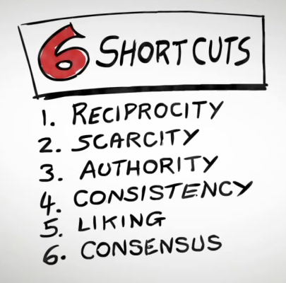
  - The person’s access to information is severely controlled (Tavris and Wade, 2000, p. 277).
In most cases, efforts at persuasion involve a source directing some type of message to a target audience. The most important research findings on persuasion include:
- Messages that do not appear to be designed to change our attitudes are often more successful in this respect than ones that seem intended to reach this goal. In other words, we generally don’t trust and generally refuse to be influenced by persons who deliberately set out to persuade us.
- Experts are more persuasive than non-experts.
- Attractive sources are more effective in changing attitudes than unattractive ones.
- People are sometimes more susceptible to persuasion when they are distracted by some extraneous event than when they are paying full attention to what is being said.

Miss Foley

Psych 20: 2.3.3 Emotional Aspects Attitudes

- When an audience holds views contrary to those of the would be persuader, it is often much more effective for the communicator to adopt a two-sided approach in which both sides of the argument are presented, rather than a one-sided approach.
- People who speak rapidly are often more persuasive than those who speak more slowly.
- Persuasion can be enhanced by messages that arouse strong emotions (especially fear) in the audience, particularly when the message provides specific recommendations about how a change in attitude or behaviour will prevent the negative consequences described in the fear-provoking message (Baron et al., 1998, p. 669).
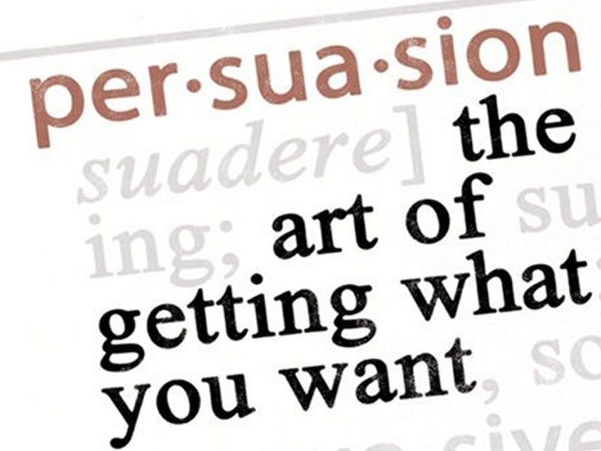
- In the 1950s, Carl Hovland was one of the first social psychologists to identify key components of attitude change: the communicator, the communication, the medium and the audience.
- To be persuasive, the communicator, the person trying to effect attitude change must project integrity, credibility and trustworthiness. If people don’t respect, believe or trust the communicator, they are unlikely to change their attitudes. Researchers have also found that the perceived power, prestige, celebrity, prominence, modesty and attractiveness of the communicator are extremely important.
- A clear, convincing and logical argument is the most effective tool for changing attitudes especially attitudes with emotional content. Communications that arouse fear are effective in motivating attitude change, especially when health issues are concerned and the communicator does not overdo the fear appeal. Researchers have also found that if people hear a persuasive message often enough, they begin to believe it, regardless of its validity.
- The medium the way in which the communication is presented influences people's receptiveness to attitude change.
- The audience; openness to attitude change is in part age and education-related. People are most susceptible to attitude change in their early adult years. People of high intelligence are less likely to have their opinions changed, and people with high self-esteem tend to be similarly unyielding. However, when a friend tries to change a person's attitude attitude change is far more likely (Lefton et al., 2000, p. 450).

Miss Foley

Psych 20: 2.3.3 Emotional Aspects Attitudes

How are attitudes related to values and beliefs?
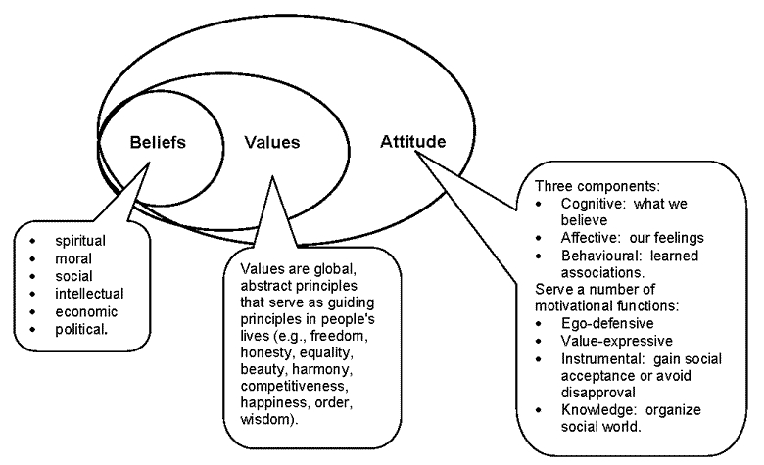
How can you resist peer pressure?
- Realize that you are being manipulated. Others are deliberately trying to get you to change your mind.
- If you are the only holdout, you are more likely to give in. Try to get just one other person on your side, and you will feel much stronger about your position.
- People want their behaviour and attitudes to be in harmony. Consequently, even if they know of some negative effects of what they are doing, they probably won’t own up to them, because to do so would cause cognitive dissonance. Thus, you should be aware that you are probably not getting the whole story from the group.
- For all age groups, peers are more persuasive than other people are. The more prestige particular peers have, the greater their influence. Use this tendency to your advantage by finding peers who have had a bad experience with whatever you are being urged to do and listen to what they have to say.
- Minority opinions can have an effect on the majority. One way to increase this effect is to give consistent and repeated statements of your position. Often, this technique has a private effect on others - one that is not publicly expressed.
- If all the members of a group are on one side, doesn’t that mean that they are more likely to be right than a single, lone individual? Actually, a group’s decision-making is usually not as accurate as an individual’s, particularly if the individual is well-informed and highly rational.
- When attempting to persuade someone, group members often try to make that person feel embarrassed for not going along. Embarrassing people is an age-old tool for making them conform. If you know that ahead of time, perhaps it will have less impact on you.
- One of the best ways to resist conformity is to be exposed to all the arguments in favour of some risky behaviour and then learn to refute these arguments, one by one (McMahon and Romano, 2000, p. 616).

Miss Foley

Psych 20: 2.3.4 Emotional Aspects Social Perception

Social Perception =
The process of someone inferring other people’s motives and intentions from observing their behaviour and deciding whether the causes of behaviour are internal or situational
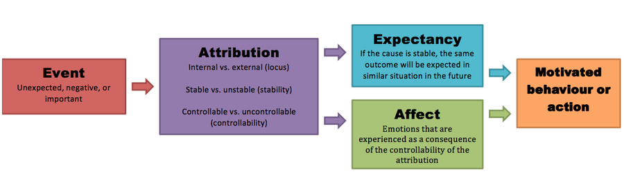
Social perception helps people make sense of the world, organize their thoughts quickly, and maintain a sense of control over the environment. It helps people feel competent and masterful, maintain a sense of balance, because it helps them predict similar events in the future (Lefton et al., 2000, p. 457).
How are social perceptions formed and changed?
Research has shown that people form impressions of each other in two ways. Sometimes people make quick and effortless judgements based on others’ physical appearance, facial expressions, or body language. Studies have shown, for example, that people who are physically attractive are perceived to be happy, warm, friendly, successful, confident, and well-adjusted. At other times, however, people form impressions based on a careful observation of a person’s behaviour. According to this latter view, people act like amateur scientists, gathering and analyzing behavioural evidence before evaluating others. The explanations for behaviour that people come up with are called attributions, and the theory that describes the process is called attribution theory (Aronson et al., 1994, p. 192).

What are some problems and issues in forming impressions of people and situations?
Over the years, research into attribution has shown that when we explain the behaviour of others, we tend to overestimate the role of personal factors and underestimate the influence of situations. This bias is so universal that it has been called the fundamental attribution error. In one demonstration of the fundamental attribution error, experimenters randomly assigned subjects to participate in a quiz show in the role of either questioner or contestant. Then in front of the contestant and an observer, the experimenters told the questioner to devise a set of difficult questions to ask the contestant. Not surprisingly, many of the questions—created from the questioner’s own

Miss Foley

Psych 20: 2.3.4 Emotional Aspects Social Perception

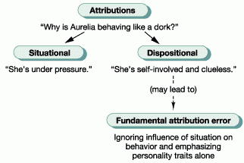
store of esoteric knowledge—stumped the contestant. Yet when asked to rate the general knowledge of both participants, observers consistently saw the questioners as more knowledgeable than the contestants. The observers failed to take the situational roles into account and attributed the behaviour they witnessed to each person’s level of knowledge.
In forming impressions of others, people are subject to other biases as well. For example, a great deal of research shows that people are often slow to revise their first impressions of others even when those views are not supported by the evidence. Part of the problem is that once we form an impression of someone, we tend to interpret that person’s later behaviour in ways that seem to fit our impression. Another problem is that our first impression of someone may shape the way we treat that person — which, in turn, may influence his or her actual behaviour. This process is known as a self-fulfilling prophecy. In a classic illustration of this phenomenon, in 1968 American psychologists Robert Rosenthal and Lenore Jacobson told a group of elementary school teachers that certain students were on the verge of an intellectual growth spurt (in fact, these students were randomly chosen from their classes). By the end of the school year, these designated students—who had received more positive attention from the teachers—actually had higher average test scores than their peers (Aronson et al., 1994, p. 197).
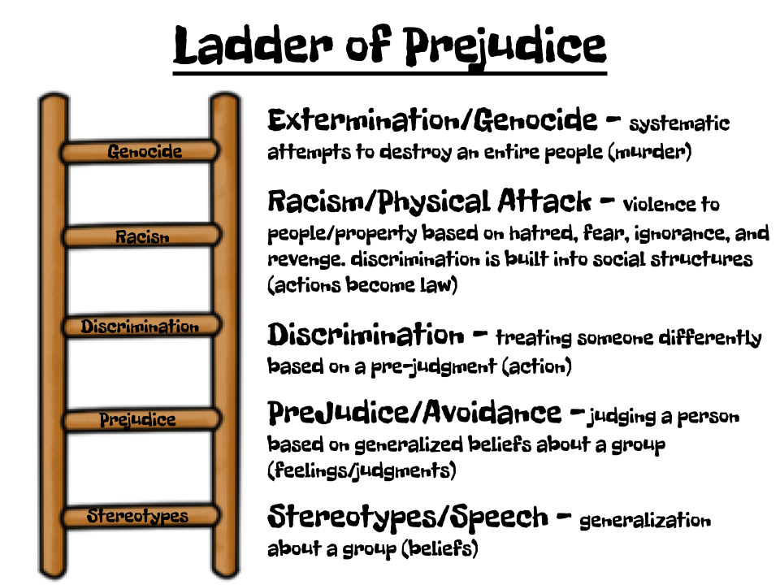
What is the relationship between attribution, stereotypes, prejudice and discrimination?
Prejudice is a negative evaluation (attitude) of an entire group of people that is typically based on unfavourable (and often incorrect) ideas or stereotypes about the group. It is usually based on a small sample of experience with an individual from the group being evaluated, or even on no direct experience. Stereotypes are fixed, overly simple, often incorrect, and often negative ideas about traits, attitudes and behaviours attributed to groups of people. When prejudice is translated into behaviour, it is called discrimination (Lefton et al., 2000, p. 464).

Name: _________________________ Date: ____________

Psych 20: 2.3.4 Emotional Aspects Social Perception

Social Media Person Profile

Social perception helps people make sense of the world, organize their thoughts quickly, and maintain a sense of control over the environment. It helps people feel competent and masterful, maintain a sense of balance, because it helps them predict similar events in the future.

Task: Create a 1 page “personal profile” of someone who currently is or has challenged social perception. Your 1 page must include the following:

1. A Photo of the Person

2. A Catchy Tagline - If you were asked to describe your profiled person in one sentence, what would you say? Think about your answer. Was it unique? Could I identify them by your tagline alone? There are three components to a tagline or your “CUE” statement. CUE stands for Catchy, Unique and Engaging. It should be short enough to tweet and long enough to answer three questions: Who are they? How are they different? and Why should we be interested in them? The tricky part is fitting all of this into one sentence but with some practice it can be done.

3. An Interesting Biography - Now you’re not writing a novel here, so take it easy, but you certainly want to cover more ground than what is in your tagline. The goal is to expand upon the three questions posed above. Describe who they are, what they do or did do, how are they different and why people should care. Be sure to include answering the following questions within the biography:

Biography Questions/Thoughts To Cover:

1. What do you attribute – a.k.a. the explanations for behaviour that people come up with - your profiled person’s general behavior to?

2. How did/do people overestimate the role of personal factors/biases and underestimate the influence of the situation – a.k.a. fundamental attribution error – regarding your profiled person?

3. We are often slow to revise first impressions of others and they may shape the way we treat that person — which, in turn, may influence his or her actual behaviour. How is this process – a.k.a. self-fulfilling prophecy – evident in the life of your profiled person?

4. How did/does your profiled person overcome prejudice – a.k.a. a negative evaluation (attitude) of an entire group of people that is typically based on unfavourable (and often incorrect) ideas or stereotypes about the group?

5. How did or does your profiled person break or challenge stereotypes – a.k.a. fixed, overly simple, often incorrect, and often negative ideas about traits, attitudes and behaviours attributed to groups of people?

6. Has your profiled person had to overcome discrimination – a.k.a. prejudice that is translated into behaviour?

Possible People:

Rosa Parks Nelson Mandel Malala Yousafzai

Martin Luther King Jr. Mahatma Gandhi Mother Theresa

Friend/Family Member Current Role Model Fictional Character

Others?

Name: _________________________ Date: ____________

Psych 20: 2.4 Mental Aspects Overview

Mental Aspects: Investigations

Who was Sigmund Freud and what was the significance of his work regarding the id, ego, and super ego? How did his research impact social psychology?

Who was Abraham Maslow and what was the significance of his work regarding the hierarchy of needs? How did his research affect social psychology?

Who was Howard Gardner and what was the significance of his work regarding different types of intelligences? How did his research impact social psychology?

Miss Foley

Psych 20: 2.4 Mental Aspects Overview

What affects how we think about the world?

Discussion:

What affects how we think about the world?

What role does media and technology have? In what ways do the media portray people and situations, and what influences doesthe media have on our social cognition, particularly as we are entering the “global village”?

What role does propaganda play? What can happen when manipulation goes to the extreme?

Thinking =

the manipulation of mental representations by a process that receives, represents, transforms, and acts on incoming stimuli

Core functions of thought are to:

Describe

Elaborate

Decide

Plan

Guide action

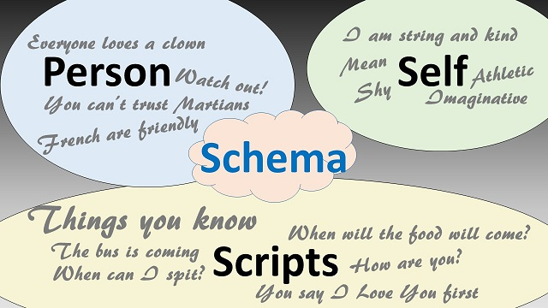
Mental representations take the following forms:

Cognitive Maps - mental representations of familiar parts of one's world

Images

Concept Schema - categories of objects, events, or ideas with common properties

Scripts - schema about familiar sequences of events or activities (Bernstein and Nash, 1999, p. 221)

What is the mind?

According to Freudian psychoanalysis, the mind is comprised of the id, the ego and the superego. “Mind, in essence, is all the things the brain does,” according to neurologist Richard Restak. Most but not all neuroscientists now share this view. On the other hand, neurobiologist David Hubel says that the word mind is so “fuzzy at the edges” that it falls outside the realm of science. That is, “mind” suggests something too elusive and ethereal to be pinned down, and some issues, including the mind-brain question, are really philosophical rather than scientific (Guinness, 1989, p. 46).

What are the socio-cultural influences on our thoughts and behaviours?

Based on the Ecological Model, discuss how the various levels of support influence our thoughts and behaviours about the world.

How is social cognition influenced by your family, peers, cultural background?

How is learning and schooling influenced by family expectations, peer group influences, educational systems and the political environment (e.g., Nazism and communism and their control of education)?

What “intelligences” are necessary to be successful in our contemporary Canadian society? How have these changed in the last century? With the increasing technologization of our world, what intelligences will be required in the future?

Miss Foley

Psych 20: 2.4.1 Mental Aspects Social Cognition

Social Cognition =

how our thoughts are affected by the immediate social context and how our thoughts affect social behaviour

Images of Landscapes – Describe country or city

Role play: Social cognition

Invite small groups of students to create a mime illustrating various judgement forming situations (e.g., romantic, intimidation, arrogance, argumentative, stubbornness, danger, fear, worry, cooperative, competitive, power, intimate, friendship).

The other students should be able to guess what the situation is through the actions and body language of the actors.

Elevator Activity: Social cognition

Tape a rectangle on the floor to represent an elevator. Clearly mark the elevator entrance. Invite a student to enter the elevator and go the second floor. Invite other students to enter the elevator and move to the fifth floor. Observe their behaviours. Coach one student to face the back of the elevator.

Discuss the mental scripts that the students followed. How did the students learn those social behaviours? What are social norms? How did the students react to the student who faced the back of the elevator? Why? What other social norms do we have for behaviour?

How do we make sense of the behaviour of other people?

Social cognition focuses on the way in which our thoughts are affected by the immediate social context, and in turn how our thoughts affect social behaviour. The approach can be summarized as follows:

People have a limited capacity to process information about the social world and will take cognitive shortcuts (such as stereotyping) in order to minimize the load.

We develop schema that represent our knowledge about ourselves, others, and our roles within the social world. These schema, once formed, bias our judgements about ourselves and others.

Schema become more complex and organized over time, and also harder to change (Cardwell, 1996, p. 218).

What processes do we use to make sense of other people?

Often, to save time, people use mental short cuts to make sense of the world, developing rules of thumb. Some of these rules of thumb include:

Representativeness - individuals or events that appear to be representative of other members of a group are quickly classified as such

Availability - ease of association with existing knowledge

False Consensus Effect - people tend to believe that others agree with them

Framing - the way in which information is organized and presented helps determine whether it is will be accepted, rejected or ignored (Lefton et al., 2000, p. 458)

Miss Foley

Psych 20: 2.4.1 Mental Aspects Social Cognition

What factors affect our judgement?

In addition to schema, people use judgemental heuristics to help us deal with the large amount of social information with which we are faced. Heuristics are rules of thumb people follow in order to make judgements quickly and efficiently. The availability heuristic refers to the ease with which we can think of something, which has a strong effect on how we view the world. The representative heuristic helps us decide how similar one thing is to another; we use it to classify people or situations on the basis of their similarity to a typical case. When using this heuristic we have a tendency to ignore base rate information that is, the prior probability that someone or something belongs in that classification. People also rely on the anchoring/adjustment heuristic, wherein an initial piece of information acts as an anchor, or starting point, for subsequent thoughts on the subject (Aronson et al., 1994, p. 136).

What role does culture play in how we come to make sense of others?

Collectivist societies, which include most traditional pre-industrial societies and, to a large extent, the predominantly Catholic countries of Southern Europe and Latin America, as well as most Asian and African cultures, are characterized by an emphasis on family and community-based relations and values. The members of one's primary “in-group” that is, one's kin, one's immediate neighbourhood community, and in the case of modern industrial societies, one's work group are the primary sources of demands and rewards, and the primary arbiters of what is desirable, what is permissible and what is unthinkable. In short, in collectivist societies it is in-group norms and role relations that provide both the motivating force that drives the individual and the compass from which the person takes direction.

Individualistic cultures, which, not coincidentally, predominate in the nations of Western Europe that gave rise to the Protestant Reformation, as well as North America, show opposite orientations. They are characterized by an emphasis on personal goals, interests, and preferences. Social relationships are dictated by commonality of interests and aspirations and are therefore subject to change as those interests and aspirations shift over time. In such societies the individual's choices, whether of dress, diet, friends, occupation, or spouse, are relatively free of the dictates of family, neighbours or others to whom one might be linked in traditional role relations (Nisbett and Ross, 1991, p. 181).

Discussion:

What affect do you think tribalism (behavior and attitudes stemming from strong loyalty to one's own tribe or social group) is having on our local communities? Nationally? Internationally?

The Psychology of Tribalism (6:32)

Name: _________________________ Date: ____________

Psych 20: 2.4.1 Mental Aspects Social Cognition

Social Cognition Application Questions
- Define social cognition.

- Give an example of a schema.

- Define heuristics.

- Give an example of a representativeness mental short cut.

- Give an example of an availability mental short cut.

- Give an example of a false consensus effect mental short cut.

- Give an example of a framing mental short cut.

- Give an example of an anchoring/adjustment heuristic.

- How does one identify a collective culture?

- How does one identify an individualistic culture?

Miss Foley

Psych 20: 2.4.2 Mental Aspects Learning

Learning =
adaptive process where behaviors are
changed by experience

Discussion: Learning Styles/Preferences
- Do your students have a preferred learning modality (e.g., visual, auditory, kinesthetic)?
- Review how students study. What is their learning environment like?
- How could you improve your learning based on your preferred modality?
Drama: The world’s greatest expert
- Students will write, or improvise, a short presentation in which they are the world’s recognized expert on the topic of ________________.

What does it mean to learn?
Learning is an adaptive process in which the tendency to perform a particular behaviour is changed by experience. Learning cannot be observed directly; it can only be inferred from changes in behaviour. Learning takes place within the nervous system. Experience alters the structure and chemistry of the brain, and these changes affect the individual's subsequent behaviour (Buskist et al., 2002, p. 131).
How do people learn?
For centuries, education in Western cultures was guided by the principle of formal discipline. According to this principle, the mind has certain elemental abilities that improve through practice, and struggling with difficult concepts enhances mental abilities. Edward Thorndike (1914) was among the first to challenge the value of formal discipline. Thorndike saw education as a “transfer of training” problem. He claimed that what is learned in the classroom is valuable only to the degree that it can be transferred to, and used in, the student’s life, termed the identical elements approach. Educational psychologists are still debating the degree to which school curricula should be based on formal or identical elements (Bernstein and Nash, 1999, p. 176).
What are the biological bases for learning?
Ernst Mayr (1974), an American biologist, argues that the type of genetic program, the specific set of genetic instructions an organism inherits at birth, determines the extent to which an organism’s behaviour may be changed by environmental factors, or how much it may be capable of learning. Across species, the capacity to learn varies across a continuum. At one end are species having closed genetic programs and at the other end are species having open genetic programs. Species having closed genetic programs such as insects and some amphibians and reptiles, generally have short life spans, mature quickly, and receive little or no care from their parents. At birth, these animals are genetically predisposed to respond in certain ways to particular situations. Species having open genetic programs, which include many mammals and birds, generally have longer life spans and extended periods of immaturity and parental care. Learning is the means by which organisms having open genetic programs adapt to their environments (Buskist et al., 2002, p. 150).

Miss Foley

Psych 20: 2.4.2 Mental Aspects Learning

Are there gender differences in learning?
Educators are recognizing that women students work better in groups, in cooperative efforts that stimulate connections among their ideas and emphasizes critical thinking which focuses on integrating ideas rather than memorizing information. As boys and girls, children are taught different behaviours on the playground and in the home, and these behaviours affect the way they learn at least according to some experts. In general, psychologists argue that boys are more independent and aggressive than girls, and that girls are more cooperative than boys. In general, boys are taught to win, whereas girls are encouraged to enjoy the game and the process of playing and to maintain their relationships with their playmates (Lefton et al., 2000, p. 182).
How can you improve your ability to learn?
McKeachie, Pintrich, and Lin (1985) have argued that there are general cognitive techniques that span topics, which students can use to learn better. Among them are:
• Elaboration: translating concepts into one’s own language and actively trying to relate new ideas to old ones.
• Attention: focusing one’s concentrative abilities and staying on task.
• Organization: developing skills that allow one to perform the tasks of learning and concept formation in an orderly manner.
• Scheduling: developing routine times for studying.
• Managing anxiety: learning to focus anxiety on getting a task done, rather than becoming paralyzed with fear.
• Expecting success: developing an expectation of success rather than failure.
• Note taking: acquiring the skills necessary to take notes will be a worthwhile learning tool.
• Learning in groups: developing good cooperative learning styles that make the most of interactions with other students (Lefton et al., 2000, p. 184).
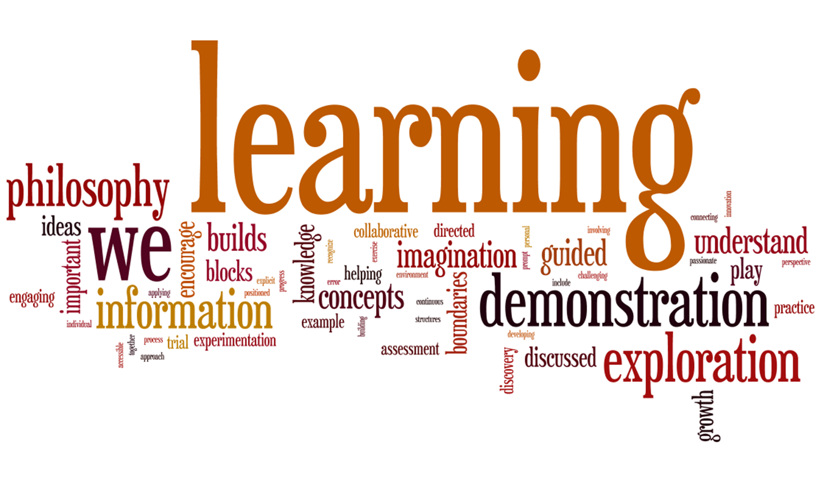

Miss Foley

Psych 20: 2.4.2 Mental Aspects Learning

Self-Regulated Learning Inventory

Highlight or Star the statements that apply to you.

Planning Strategies - Planning is what you do when you figure out what your assignment is, when it is due, and what specific steps you need to take in order to be successful.

To prepare for class, I make enough time for reading and making notes on the assigned material.

I organize my time according to how difficult or easy each assigned task is likely to be.

Organizing Strategies - Organizing is what you do when you are arranging the things you have to do for an assignment in such a way that the job gets done successfully.

I use a calendar to keep track of when tests are scheduled.

I break down my assignments according to how much time I think they will take.

Goal Setting Strategies - Goal-setting is what you do when you decide what you want to accomplish, both in the immediate and the distant future.

I set goals that I want to accomplish both in the immediate and the long-term future.

In my classes, I set my goals according to what I need to do to make an “A: or a “B”.

Keeping Records Strategies - Keeping records is what you do when you keep track of your progress toward your goals.

I keep my assignments, class notes, and old tests in one place so that I can review them when necessary.

I make sure my class notes are dated and organized.

Environmental Structuring Strategies - Environmental Structuring is what you do to make your surroundings conducive to achieving your goals.

Before I start to study, I organize my study area and make sure that I’ll be free from distractions.

When I study, I make time to organize my study time into times for intensive study and times for short breaks.

Memorizing Strategies - Memorizing is what you do when you want to remember the material for class.

I memorize by practice and repetition.

When I study, I try to understand and apply the information instead of just memorizing enough to “get by”.

Seeking Information Strategies - Seeking Information is what you do when you figure out which information is important, where it is located, and to whom you will go for that information or for help.

I make sure that my class notes are cross-referenced to my textbook.

I find out what my teachers think is important and make sure that I study that material.

Miss Foley

Psych 20: 2.4.2 Mental Aspects Learning

Rehearsing Strategies - Rehearsing is what you do when you practice learning or remembering the material.

When studying the material, I ask myself lots of questions and make sure that I can answer them.

I apply what I am learning to something I already understand or have experienced.

I study with another person so that I can learn the material by talking and listening.

Transforming Strategies - Transforming is when you deal with what you have learned by putting it into another form.

When I study, I put the material into a more simple form, such as an outline or a concept map.

I summarize and rewrite my notes and use them to prepare for tests.

I apply what I am learning in school to my “everyday” world outside of school.

Self-Evaluation Strategies - Self-Evaluation is what you do when you analyze the quality of your work by using a personal set of evaluation standards.

After I have studied from the textbook, I make up some test questions about the material. Then I check my answers in the book to see how much I learned.

Before I turn in a written assignment, I compare it with previously graded assignments.

I compare my grade to the amount of time I spent doing the assignment.

Monitoring Strategies - Monitoring is what you do when you figure out how successful you are in your goals, and change your strategies if you need to.

I keep up my grades in each class, if one seems to be sliding I’ll stress studying more in that class.

I find out what the teacher expects and keep track of how well I am doing.

I know how well I am doing by keeping track of my grades.

I am aware of how well I understand my assignments and my reading materials.

Self-Consequences Strategies - Self-Consequences are what you do to reward or “punch” yourself for the quality of your work.

If I have problems with an assignment or a test, I study harder instead of ignoring my problems.

When I’ve done well on an assignment or a test, I reward myself in some way.

If I make a bad grade, I deny myself something that I enjoy.

Source: University of Maine http://www.umpi.edu/files/prospective-students/upward-bound/inventory/self-regulated_inventory_pdf.pdf

Name: _________________________ Date: ____________

Psych 20: 2.4.2 Mental Aspects Learning

Learning Strategies Investigation

Planning Strategies - Planning is what you do when you figure out what your assignment is, when it is due, and what specific steps you need to take in order to be successful.

Organizing Strategies - Organizing is what you do when you are arranging the things you have to do for an assignment in such a way that the job gets done successfully.

Goal Setting Strategies - Goal-setting is what you do when you decide what you want to accomplish, both in the immediate and the distant future.

Keeping Records Strategies - Keeping records is what you do when you keep track of your progress toward your goals.

Environmental Structuring Strategies - Environmental Structuring is what you do to make your surroundings conducive to achieving your goals.

Memorizing Strategies - Memorizing is what you do when you want to remember the material for class.

Name: _________________________ Date: ____________

Psych 20: 2.4.2 Mental Aspects Learning

Seeking Information Strategies - Seeking Information is what you do when you figure out which information is important, where it is located, and to whom you will go for that information or for help.

Rehearsing Strategies - Rehearsing is what you do when you practice learning or remembering the material.

Transforming Strategies - Transforming is when you deal with what you have learned by putting it into another form.

Self-Evaluation Strategies - Self-Evaluation is what you do when you analyze the quality of your work by using a personal set of evaluation standards.

Monitoring Strategies - Monitoring is what you do when you figure out how successful you are in your goals, and change your strategies if you need to.

Self-Consequences Strategies - Self-Consequences are what you do to reward or “punch” yourself for the quality of your work.

Miss Foley

Psych 20: 2.4.3 Mental Aspects Memory

Memory =

how the mind stores & remembers information

Discussion: I Remember When…

Ask the students to write down humorous or memorable experiences, and then share in the whole class setting.

Research: Childhood Memories

Interview family members about what they remember from their childhood. What are the funniest, scariest, most ridiculous or surprising incidents that they can remember?

What is your, or your parent’s, earliest memory?

Research: Memory

Present 10 items arranged on a tray. Allow the students to view the items for 30 seconds. Ask the students to list the items.

How many items could the students remember? What criteria did the students use (shape, colour, arrangement, usage, etc.)? Is there any relationship between how the students memorized the items and their preferred learning style?

What role and function does memory serve?

Current research suggests that memories are encoded as they are stored, in forms dictated by people's assumptions, attention, and schema. Remembering is an active or “constructive” process in which these assumptions and schema influence the memory that is retrieved. A memory of a person will include both memories of specific things that the person has said or done, and more abstract memories of “what the person is like” such as personality traits, physical characteristics and dispositions. Our memory of past events can be influenced by our expectation or “theory” about what should have happened (Lefton et al., 2000, p. 225).

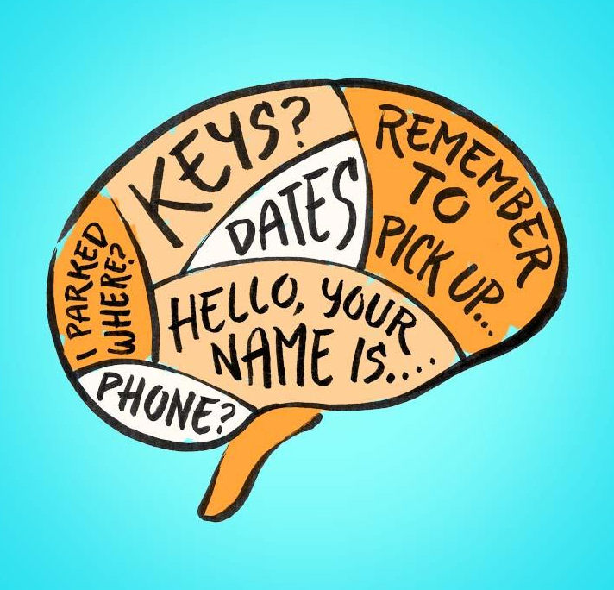
How can memory be improved?

Remembering lists of items:

use mnemonics

look for meaningful acronyms

Remembering textbook material:

follow the SQ3R system (survey, question, read, recite, review),

allocate your time to allow for distributed practice,

read actively not passively.

Taking lecture notes:

Take notes, but record all the main points, think about the overall organization of the material, review your notes as soon after the lecture as possible to fill in the missing points.

Studying for exams:

Write a detailed outline of your lecture notes, rather than passively reading them (Bernstein and Nash, 1999, p. 213).

Name: _________________________ Date: ____________

Psych 20: 2.4.3 Mental Aspects Memory

Family Member “Memories” Interview

What is your earliest memory?

What is one of your funniest memories from childhood?

What is one of your scariest memories from childhood?

What is one of your most ridiculous or surprising memories from childhood?

What other memories do you have from childhood that you would like to share with me?

Miss Foley

Psych 20: 2.4.3 Mental Aspects Memory

Short-Term Memory Test: TEACHER PREP

The following activity is awesome to illustrate the limitations of short term memory. Some facts about short term memory:

It can store 7 items (+ or – 2)

It last for 20 seconds

This test below is a simple memory exercise. Letters are show with each trial and the students are asked to remember each set of letter correctly. There are 6 trials. Students can complete the activity in their note or you can type up a worksheet.

Simply click on the link below to complete the activity. (Be careful. The last slide shows the answers immediately.) http://faculty.washington.edu/chudler/stm0.html

Spoiler Alert…The Answers:

Trial #1 UM

Trial #2 TZLD

Trial #3 KXCEJO

Trial #4 AVCYISEH

Trial #5 LBFQRPMAUX

Trial #6 ZQECTBUMONRV

Ask the students who do the best, how they remembered the letters so well. Very often they use chunking which is also a concept covered in memory and thought.

Miss Foley

Psych 20: 2.4.3 Mental Aspects Memory

Short-Term Memory Test

The following activity is awesome to illustrate the limitations of short term memory. Some facts about short term memory:

It can store 7 items (+ or – 2)

It last for 20 seconds

This test below is a simple memory exercise. Letters are show with each trial and the students are asked to remember each set of letter correctly. There are 6 trials.

Simply click on the link below to complete the activity.

http://faculty.washington.edu/chudler/stm0.html

Data Chart:
Trial # | Total #  of Letters  in the Set | Characters Remembered | Total #  of Letters  You Remembered | %  You  Remembered
1 | 2
2 | 4
3 | 6
4 | 8
5 | 10
6 | 12

For those that did well, how did they remember the letters so well? Very often they use chunking which is also a concept covered in memory and thought.

Possible Strategies Used:

Comparison Challenge: Pictures vs Letters

http://faculty.washington.edu/chudler/puzmatch.html

Name: _________________________ Date: ____________

Psych 20: 2.4.3 Mental Aspects Memory

“Telephone” Short-term Memory Worksheet

Telephone sentences – Copy the final sentence, underline the words that are correct, record the percentage correct.

Word % / Chunks

1.

2.

3.

4.

5.

6.

Why did you mess up soooooo bad?

Short-term memory can only store 7 items easily (+/- 2) and each sentence has more than 7 words in them.

Short-term memory only lasts for 20 seconds and it often took more than 20 seconds between hearing the sentence and repeating the sentence.

Selective Attention or the “Cocktail Party Effect”. There are some many discussions going on in the room as this activity is completed that it may be difficult to focus on the person telling you the sentence. Many times, it often took more than 20 seconds between hearing the sentence and repeating the sentence.

The last sentence was much easier to remember because of chunking – the process of grouping pieces of information for easier handling.

Miss Foley

Psych 20: 2.4.3 Mental Aspects Memory

Short-Term Memory & Telephone Sentences

The telephone sentence activity is great to use with a memory unit in psychology. This lesson can also be used in the same class as the “I am going on a picnic” activity. The worksheet is used to help evaluate the accuracy of final sentences and to identify the number of chunks. The worksheet helps to reinforce the concepts and it aids the students in better understanding the material.

This clip from Madagascar is a great introduction to the telephone sentence activity. Instruct the students to do the best they can to remembering the sentence accurately. Despite your best efforts, the sentences will be drastically different and often times very funny. Tell you students “PLEASE do not make any changes on your own. Just do your best.”

Objectives:

To introduce/reinforce the concept of chunking.

To provide concrete examples of the limitations of short-term memory.

Method:

Give the first student the typed sentence. Allow the student 1-2 minutes to study the words, then take the sentence back.

The student will then begin the telephone chain by sharing the sentence with the next student.

Each student will pass on the sentence to the next student.

The last student will write their sentence on the board.

Students copy the sentence from the board onto the worksheet.

Analyze the sentence to see where the breakdowns occurred. Go back the chain to see where the sentence changed.

List the % of correct words and the number of chunks in the final sentence.

In larger classes, you can share the same sentence and divide the class into 2 groups to encourage a little friendly competition.

Word % – The number of correct words from the original sentence divided by the total words in the sentence.

# of Chunks – When looking at the final sentence, we try to determine how many “chunks” are within the sentence.

For example:

With the sentence, “Mr. Margarit teaches supply and demand using gadgets and widgets in economics.” (12 words)

Girl final sentence: (Mr. Martin) (uses wedge hammers) (to teach economics.) 1 word correct out of 0.083% correct words / 3 chunks

Miss Foley

Psych 20: 2.4.3 Mental Aspects Memory

Telephone Sentences

“Community service is like peeing your pants in a dark suit. It leaves a warm feeling inside and no one knows.”

(19 words)

“Mr. Margarit teaches supply and demand using gadgets and widgets in economics.”

(12 words)

“Mr. Plummer lies on a bed of nails while Doc smashes him with a hammer to illustrate a lesson in physics.”

(21 words)

“When Yogi and Boo Boo steal a pic i nic basket, Ranger Smith becomes very angry and yells.”

(16 words / 18 words with pic i nic) Video Clip of Yogi

“Poor old Charlie Brown gets rained on, baseballs hit at him, and the footballs pulled away from him. Rats.”

(19 word) Video Clip of Charlie Brown

“Fred and Barney are members of the Water Buffalo club. They bowl on Wednesdays.”

(14 words) Video Clip of the Water Buffalo Club Convention (3:02)

Miss Foley

Psych 20: 2.4.4 Mental Aspects Intelligence

Intelligence =

overall capacity to act purposefully,

to think rationally, and to deal effectively

with the environment

What are the different types of intelligence?

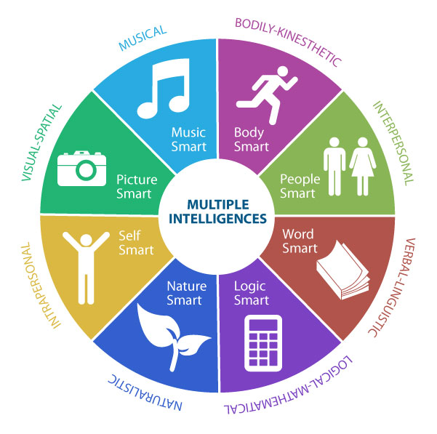
Cases of remarkable ability in specific areas are part of the evidence that led Howard Gardner to propose his theory of multiple intelligences (Gardner, 1983). Gardner focused on how people learn and use symbol systems like language, mathematics and music. According to Gardner, all people possess a number of intellectual potentials, or “intelligences,” each of which involves a different set of skills. The specific intelligences that Gardner proposes are:

Linguistic Intelligence - proficient vocabulary and reading comprehension

Logical-Mathematical Intelligence - skill at arithmetic and certain kinds of reasoning

Spatial Intelligence - reflected in understanding of relationships between objects

Musical Intelligence - reflected in abilities involving rhythm, tempo and sound

Body-Kinesthetic Intelligence - reflected in skill at dancing, athletics and eye-hand coordination

Interpersonal Intelligence - reflected in self-awareness and social skills (Bernstein and Nash, 1999, p. 257)

To what extent is intelligence culturally or biologically based?

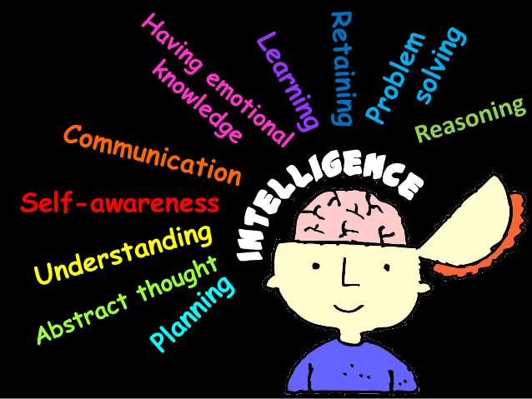
The concept of intelligence is determined by culture. Most Western societies include academic skills such as verbal ability and formal reasoning in their definitions of intelligence and regard non-academic abilities as talents. People in pre-industrial societies are less likely to approach a logical problem abstractly. Instead, they tend to base their conclusions on what they know to be true – and not on the hypothetical situations proposed by the person questioning them (Buskist et al., 2002, p. 352).

Environmental influences on intelligence show up in studies that compare children’s IQ scores before and after environmental changes such as adoption. Children from relatively impoverished backgrounds who were adopted into homes with more enriching intellectual environments with interesting materials and experiences, as well as a supportive and responsive adult show modest increases in their IQ scores (Bernstein and Nash, 1999, p. 267).

Miss Foley

Psych 20: 2.5 Spiritual Aspects Overview

Spiritual Aspects

Discussion: Spirituality and the Ecological Model

How is our spirituality influenced by the various levels of the Ecological Model?

Are any of the levels more or less influential than the others?

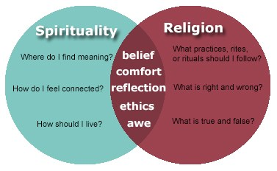
What is the most influential source of spirituality in your life?

Discussion: Questions of life

Why am I here?

What is the meaning of life?

Where am I heading?

What do I believe in?

What is spirituality?

By spirituality we mean the experiences that appeal to the human spirit and our connection to God or some spiritual power outside ourselves. Through this spiritual dimension, we try to supply meaning to our lives. We also try to understand the profound sense of awe and mystery at the core of our Beings. It is also our spiritual nature that fuels our drive to express ourselves in painting, music, drama, poetry, architecture, sculpture and other art forms (Badley, 1996, p. 142).

It’s the whole world to an Aboriginal person. Spirituality is central to our way of Being. In our tradition, we celebrate life, give thanks every day. I remember a story when I was in Navajo country in the United States, and a small cactus was pointed out to me. I was reminded that this small plant was absolutely critical to my survival, because if I had nothing else, that the milk of this cactus would provide enough nutrition to survive in the desert. That's what I mean about giving thanks, and appreciating the gifts of Creation (Asikinak, 2001).

Read: The Tipi from Interactions Unit 1

What is your credo?

A credo is a statement of personal beliefs and values. Create your own credo that illustrates and describes your worldview. You can create your credo using whatever medium feels most comfortable to you. Remember, a worldview is a fundamental belief about how you treat and value yourself, as well as how you treat and value the environment, the natural world, and the people who live on this planet.

Quotations for Discussion

Do not overestimate the decency of the human race (H.L. Mencken).

Do not speak harshly to any one; those who are spoken to will answer thee in the same way. Angry speech is painful: blows for blows will touch thee (Buddha, The Dhammapada (c. B.C. 300).

Win any way as long as you can get away with it. Nice guys finish last (Leo Durocher).

Keep your eyes on the stars, and your feet on the ground (Theodore Roosevelt).

You must grow like a tree, not like a mushroom (Janet Erskine Stuart).

Miss Foley

Psych 20: 2.5.1 Spiritual Aspects Worldview

Worldview = a description of reality generally accepted by members of a cultural group

Do not overestimate the decency of the human race (H.L. Mencken).

Keep your eyes on the stars, and your feet on the ground (Theodore Roosevelt).

You must grow like a tree, not like a mushroom (Janet Erskine Stuart).

Do not speak harshly to any one; those who are spoken to will answer thee in the same way. Angry speech is painful: blows for blows will touch thee (Buddha, The Dhammapada (c. B.C. 300).

Win any way as long as you can get away with it. Nice guys finish last (Leo Durocher).

What is a worldview?

The Aboriginal worldview accepts that survival depends on cooperation and coexistence with the forces of nature rather than expecting to manipulate and control them. Social relations are also dependent on harmony and coexistence with strict social codes and mores to dictate relationships. People see themselves as part of the social order, with deep respect for the environment, because of their dependence on the land and its resources. The affinity with the land is referred to as “mother” (Hewitt, 2000, p. 112).

Worldview is a description of reality providing “natural and believable” knowledge which is generally accepted by the members of a cultural group, because it meets their needs, creates order and coherence, and provides a basis for predictions. A worldview acts as a template providing people with a set of beliefs about dealing with the reality in which they find themselves:

• Spiritual beliefs defining the meaning and purpose of existence

• Moral beliefs about people’s rights and obligations

• Social beliefs about the organization of individuals into a society

• Intellectual beliefs about determining truth and beauty

• Economic beliefs about creating and distributing wealth

• Political beliefs about making and enforcing decisions within society

How does a worldview influence our behaviour?

The worldview of a group of people underlies every aspect of their life their language, social system, religious beliefs, even the way they go about their daily life. Worldview can be defined as a set of concepts that relate individuals within any culture to the natural universe and to other humans who comprise their social reality (Hewitt, 2000, p. 111).

Read: Interactions Unit 2 – “Worldview: Our Relationship to Nature” p.30-31 - Complete the “My Worldview…” section.

Miss Foley

Psych 20: 2.5.2 Spiritual Aspects Values

Values =

global, abstract principles that serve as

guiding principles in people's lives

_____ A comfortable life _____ An exciting life _____ A world of peace
_____ A world of beauty _____ Equality _____ Family security

_____ Freedom _____ Happiness _____ Inner harmony

_____ Mature love _____ National Security _____ Pleasure
_____ Salvation _____ Self-Respect _____ Social Recognition
_____True Friendship _____ Wisdom _____ Other: ______________
_____A sense of accomplishment _____ Other: ______________
Think/Pair/Share: Human values
- In pairs, have the students share and discuss their ranking of the values above.
- After pair discussion, combine pairs to make groups of four, and ask the students to arrive at a group ranking of the values.
- In the final stage of the discussion, have students report, and average, the values ranked by each of the groups.
- Is there a general consensus? Can you arrive at a collective agreement regarding the ranking of those values? Are there gender differences?
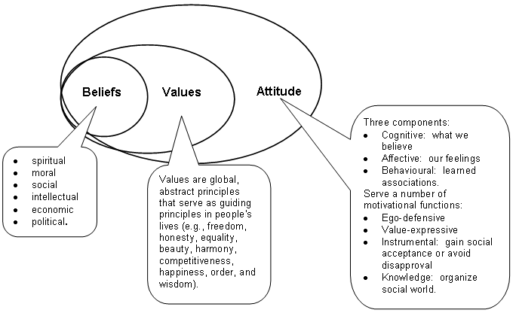
- How are beliefs, values and attitudes related?

Miss Foley

Psych 20: 2.5.3 Spiritual Aspects Morality & Ethics

Topic 2.5.3 – What does it mean to act in a moral and ethical way?

Discussion: Moral decision making

Ask the students to reflect on several recent situations where they had to make a choice or decision concerning a moral or ethical issue, a question of whether their actions were “right” or “wrong”. For each situation, ask the students to describe the situation they faced, the questions they asked and addressed in making a decision, and the decision at which they arrived. Based on the moral-testing process, have the students apply their issues to each of the three moral-test cases.

Miss Foley

Psych 20: 2.5.3 Spiritual Aspects Morality & Ethics

Morality Play – Online GAME http://www.philosophyexperiments.com/moralityplay/

Harvard: Moral Sense Test

http://www.moralsensetest.com/

“Big Three” Morality Test

https://www.idrlabs.com/morality/3/test.php

Your Morals

https://www.yourmorals.org/explore.php

Moral DNA

https://moraldna.org/

Out of Service Morality Test

http://www.outofservice.com/morality/

Miss Foley

Psych 20: 2.6 Personality: Who Am I? Overview

Personality =

sum of all your psychological, behavioural

and biological processes

Reflection: Personality traits

Ask each student to answer this question: Are you basically a happy person? Why or why not? How would you describe your personality?

This exercise guides students to consider their basic personality traits, which leads into a discussion of the basic theories of personality.

What does it mean to have a personality?

Your personality represents the sum of all your psychological, behavioural and biological processes. It reflects the consistent patterns of thinking, feeling and behaving that make you different from and, in some ways, similar to others (Bernstein and Nash, 1999, p. 406).

How do personalities develop?

Psychodynamic Approach Freud, on the basis of his work in treating “neurotic disorders,” came to believe that personality and behaviour are determined more by psychological factors than by biological conditions or current events. He proposed that people may not know why they think, feel or act the way they do because they are partly controlled by the unconscious portion of the personality, of which people are normally unaware (Bernstein and Nash, 1999, p. 408).

The trait approach to personality makes three main assumptions:

Personality traits remain relatively stable and therefore predictable over time.

Personality traits remain relatively stable across diverse situations, and they can explain why people act in predictable ways in many different settings.

People differ with regard to how much of a particular personality trait they possess; no two people are exactly alike on all traits. The result is an endless variety of unique personalities (Bernstein and Nash, 1999, p. 413).

Discussion: Personality trait theory

In what ways are your personality characteristics similar to those of your parents or other family members?

In what ways are your personality traits similar to those of your friends?

Why do some people take more risks than others?

Cognitive-behavioural Approach: views personality as a set of behaviours that people acquire through learning, then display in particular situations. It defines personality as the sum total of the behaviours and cognitive habits that develop as people learn through experience in the social world (Bernstein and Nash, 1999, p. 421).

Humanistic Approach: maintains that the primary human motivator is an innate drive toward personal growth that prompts people to fulfil their unique and natural potential. Like the planted seed that naturally becomes a flower, people are inclined towards goodness, creativity, love and joy. Proponents of this theory emphasize that each individual perceives reality somewhat differently and that these differences, rather than traits, instincts or learning experiences, are central to creating personality differences (Bernstein and Nash, 1999, p. 424).

Miss Foley

Psych 20: 2.6 Personality: Who Am I? Overview

Is there a biological basis for personality?

Every individual is born with a distinct, genetically based set of psychological tendencies, or dispositions. These tendencies, which together are called temperament, affect and shape virtually every aspect of the person’s developing personality. Temperament, and therefore personality, is epigenetic, not merely genetic: it begins in the multitude of genetic instructions that guide the development of the brain, then is affected by the prenatal environment (Berger, 2000, p. 219).

What are the types of personality disorders?

People with personality disorders are divided into three broad clusters: those whose behaviour appears: odd or eccentric; dramatic, emotional and erratic; fearful or anxious. There are essentially six basic personality disorders:

Paranoid personality disorder involves unwarranted feelings of persecution and those who display these feelings mistrust almost everyone. They are hypersensitive to criticism and have a restricted range of emotional responses. They have strong fears of being exploited, and of losing control and independence. Sometimes they appear cold, humourless and even scheming.

Borderline personality disorder is characterized by difficulty with relationships; it shows a pattern of instability with interpersonal relationships, self-image and affect. In addition, it is often impulsive. Easily bored and distracted, such individuals fear abandonment.

Histrionic personality disordered individuals seek attention by exaggerating situations in their lives. They have stormy personal relationships, are excessively emotional, and demand constant reassurance and praise.

Narcissistic personality disorder is closely related to histrionic, because people with this disorder have an extremely exaggerated sense of self-importance, expect favours, and need constant attention and admiration. They show a lack of caring for others, and they react to criticism with shame, rage or humiliation.

Antisocial personality disorder is characterized by egocentricity, behaviour that is irresponsible and that violates the rights of other people (e.g., lying, theft, delinquency), a lack of guilt feelings, an inability to understand other people’s feelings and a lack of fear of punishment. Antisocial people consistently blame others for their behaviour. The disorder occurs six times more in men than in women. As many as three percent of all individuals may be diagnosed with antisocial personality disorder.

Dependent personality disorder involves acting fearful or anxious, submissive or clinging and letting other people make all of the important decisions in life. People with this disorder try to appear pleasant and agreeable at all times. They act meek, humble and affectionate in order to keep their protectors. Overprotective, authoritarian parenting seems to be a major initiating cause of dependency (Lefton et al., 2000, p. 538).

Discussion/Reflection: Who I am

Using the template supplied in the Interactions article, have students reflect on the basic values and attitudes that define them. (Page 35, 36 Interactions Unit 2)

Miss Foley

Psych 20: Unit 2 Review Study Guide

Who Am I? “Starting Point” Study Guide

2.1 What are the four aspects to our Being?

What affects how we feel about the world?

2.2 How do we process information from the world? Function of the cerebrum, cerebellum, medulla, thalamus.

What are the socio-cultural influences on our physical development?

Example: The role of the microsystem, exosystem, macrosystem.

2.2.1 What is the difference between sensation and perception?

What is subliminal perception?

What does extra sensory information mean?

2.2.2 How does the body transmit sensory information? What are axons?

What are dendrites?

What areas of the brain control what functions?

2.2.3 What is the endocrine system?

What is the role and function of the different parts of the endocrine system?

What are hormones? What do hormones do?

2.2.4 What is heredity and genetics?

What is genetic engineering?

What are the ethical and moral issues involved in genetic engineering?

2.3 What is motivation? What are 3 aspects of motivation? What is emotion?

What are Attitudes?

2.3.1 What are the intrinsic and external motives that affect our thoughts and behaviour?

2.3.2 What is an emotion?

How is an emotion different than a feeling?

What are 7 fallacies that lead to debilitating emotions?

2.3.3 What are attitudes?

How do we form attitudes?

Why do we have attitudes?

What is the theory of cognitive dissonance? What are 5 ways that a person could deal with cognitive dissonance?

2.3.4 What is social perception?

How are social perceptions formed and changed? (2 ways)

What is fundamental attribution error?

What is the self-fulfilling prophecy?

What is the relationship between attribution, stereotypes, prejudice and discrimination?

Miss Foley

Psych 20: Unit 2- Who Am I? Study Guide (cont’d)

2.4 Mental Aspects: What affects how we think about the world? What does it mean to think? What is the mind?

2.4.1 What is social cognition?

2.4.2 What does it mean to learn?

What are the biological bases for learning?

Are there gender differences in learning?

How can you improve your ability to learn?

2.4.3 What role and function does memory serve?

How is experience stored and retrieved in the brain?

How can memory be improved?

2.4.4 What are the different types of intelligence? (6)

2.5 Spiritual Aspects: Defining our relationship to a Higher Power. What is spirituality?

2.5.1 What is a worldview?

What is your worldview?

2.5.2 What are values?

What are your values?

2.5.3 What influences our moral and ethical decision making?

Moral testing – be able to describe the New Cases test, the role exchange test and the universal consequences test.

With regards to Kohlberg’s Stages of Moral development, be able to describe the pre-conventional, Conventional and post conventional stages.

2.6 Personality: Who I am?

What does it mean to have a personality?

How do personalities develop? (3 theories)

What kind of personality do you have?

What are the types of personality disorders?

Who Am I?
2.6 Personality
2.3 Emotional
Physical
2.4 Mental
2.5 Spiritual
Attitudes
Motivation
Emotions
Endocrine System
The Brain
Heredity/
Genetics
Sensory System
Morality/
Ethics
Worldview
Values
Learning
Intelligence
Memory

Miss Foley

Psych20: Unit 3 Title Page

Unit III: Making Sense of Our World
  - How do we make sense of our world?
- What processes do we use to understand the world?
- How do we understand others?
- How do we come to understand ourselves?
- How do key issues and questions in developmental psychology relate to making sense of our world?
  - Social cognition: Overview
- How do we make sense of the behaviour of other people?
- What factors affect our judgement?
    - Social Schema

• How is experience represented in the brain?

• In what ways do we interpret our schema?

• How are schema revised or changed?

• In what ways do we create our own schema?
    - Biological basis for social cognition

• How does our biology influence social cognition?

• What biological processes are involved in social cognition?

• What is autobiographical memory, and how does it influence cognition?
    - Judgements and impression formation

• How do we form impressions about people?

• What are some biases on how we form impressions of other people?

• How do we make judgements and decisions about other people?
    - Prejudice

• What is prejudice?

• How do people develop prejudicial attitudes?

• How do we reduce prejudice?

• Why does enhanced contact reduce prejudice and discrimination?

• What is racism?

• How is racism related to prejudice?

• How do racist attitudes develop?
  - How do we come to understand other people?
- What is social perception?
- How are social perceptions formed and changed?
- How do we select information about others?

- How do we organize the information received in social situations?
- What processes do we use to interpret social information?
- What are some problems and issues in forming impressions of people and situations?
- What is the relationship between attribution, stereotypes, prejudice and discrimination?
- Who are some prominent social rights activists, and what did they achieve?
    - Communication

• What is communication?

• What are the basic principles of communication?

• What are the purposes of communication?

• What are the different means of communication?

• What are some communication misconceptions?

• What are the characteristics of effective communicators?
    - Influences on perception

• What are the physiological influences on our perceptions?

• In what ways does culture influence the accuracy of our perceptions?

• How does gender influence perception?

• What influence does self-esteem have on our social perceptions?
    - Attributions: Asking the why?

• What processes do we use in trying to understand why a person acted in a particular way?

• What processes do we use in trying to understand our own feelings and behaviours?

• What are some biases in our causal explanations of the behaviour of others?
  - Self-understanding: How do you develop a sense of yourself in the world?
- What is self-concept?
- How do we develop a self-concept?
- What are the cultural influences on self-concept?
- How does gender influence self-concept?

3.4.1 Development of self-concept

• What are the characteristics of a self-concept?

• What influences the development of a self-concept?

• How important is your self-concept?

• What do we do when our self-concept is threatened?
    - Culture and the Self

• What does culture mean?

• Does your cultural background influence your general health and outlook on life?

    - Gender and the Self

• What does gender mean?

• How does a gender identity develop?

• What are the differences between the genders?

• What are the sociocultural influences on gender development?
    - Self-schema and Identity

• How do we represent knowledge about ourselves?

• How does self-identity develop?

• What influences does the family have on identity?

• How does gender influence identity development?
    - Identity Management

• How does our behaviour change in social situations?

• In what ways does our behaviour change in social situations?

• What processes of identity management do we use in social situations?

• How do we act differently in private versus public situations?

• How, and why, do we disclose private and personal information about ourselves to others?
    - Mass Media

• What defines the mass media?

• What influence does media have on our thoughts, feelings and behaviours?

• What influence does media have on developing aggression and violence, especially in children?

• What influence does the Internet have on social relations and behaviour?

• What influence does media have on society and our culture?

• What is the relationship between cultural values, the media and censorship?
  - Action research in social psychology
- What are stereotypical attitudes towards…
- Should cosmetic surgery be free?
- How would you define beauty?
- Media:
- How many hours of television do you watch in a week?
- How many times do you go to the movies in a month?
- How many videos do you rent in a month?
- Do you think television values are replacing family values?
- Are the movie and television rating systems appropriate? Effective?
- Social cognition
- Emotional expressions
- Business woman
- Internet usage

- Love at first sight?
- Gender differences
- Sleep behaviours
- Non-verbal communication
- A day in the life of…
- Proxemics:
- Intimate distance
- Personal space
- Social distance
- Television violence
- Gender differences
- Television usage
- Gender differences
- Circadian rhy1hms
- Sleep
- Dreams
- Sexism
- Sign language
- Advertising techniques
- Women's suffrage
- Gender differences
- Internet usage
- Martin Luther King
- Rosa Parks
- Mhatma Ghandi
- Terry Fox
- Mother Theresa
- Nelson Mandela
- Helen Keller
- Autobiographical memory
- Schema
- Prejudice and discrimination
- Dreams and dream interpretation
- Changing role of women in society

Miss Foley

Psych20: Unit 4 Title Page

Unit IV: Acting and Interacting

In a Social World

4.1 How do we act and interact in social situations?
- How do families influence us?
- How do we act and interact in interpersonal relationships?
- How do groups influence our social actions and interactions?
- How do we act and interact in social situations?
- How do people develop dysfunctional thoughts, feelings and behaviours?
- How do the key issues and questions in developmental psychology relate to social actions and interactions?
  - What influence does the family have on our social development?
- How do we define a family?
- What are the functions of families?
- What are the characteristics of strong and healthy families?
- What are the different parenting styles?
- What is the national census data on Canadian families and children's living arrangements?
- What are the effects of maltreatment by families of children?
- Are mistreated children likely to be become mistreating parents?
- How vulnerable are families to crisis and mistreatment of children?
- What is the influence of culture on families?
  - How and why do we act and interact in interpersonal relationships?
- How do we define interpersonal relationships?
- Why do we establish interpersonal relationships?
- How do we establish and maintain relationships?
- Why do people remain in unsatisfying relationships?
- What influence does culture have on social relationships and interactions?
    - Attraction and Intimacy

• Why are we attracted to people?

• What is intimacy in a relationship?

• What is the relationship between gender and intimacy?

• What influence does culture have on intimacy?
    - Love

• What is love?

• What are the different types of love?

• How is liking someone different than loving someone?

• Can passionate love be a misattribution?

• What influence does culture have on our notions of love?

• What makes a good marriage?
    - Honesty and Dishonesty

• How important is honesty in relationships?

• How important is honesty in terms of basic human values?

• In what ways are people dishonest?

• Why do people lie?
  - How do groups act and interact?
- What are collective behaviours?
- What are some examples of collective behaviours?
- What are the theoretical approaches to collective behaviour?
- What is "groupthink", and how does it influence group behaviours?
- How does culture influence group behaviours?
    - Crowds and mobs

• What is the difference between a crowd and a mob?

• Why do groups of people become crowds?

• Why do crowds become mobs?
    - Gangs

• What is the definition of a gang?

• Why do people join gangs?

• What is the relationship between risk-taking behaviours and gang involvement?

• Are there gender differences in terms of gangs and gang activity?
    - Cults
- What is a cult?
- How are cults different from sects and denominations?
- What are the warning signs of cult activity?
- Why do people join cults?
    - Social movements

• What are social movements?

• What are the various types of social movements?

• What is the life of a social movement?

• Why do social movements develop?

• What are some examples of social movements?
    - Political parties

• Why do we have political systems and parties?

• What are the contemporary Canadian political ideologies?
  - How do we act and interact in social situations?
- What are the various social influences on our behaviour?
- How do we explain our social behaviour?
    - Cooperation versus Competition

• How do we promote cooperation?

• Difference in willingness to cooperate between individual/group situations?
    - Humour and Laughter

• Why do people laugh?

• Are there gender differences in humour and laughter?

• Is laughter a factor in meeting, matching and mating?

• Is laughter contagious?

• Are there health benefits to humour and laughter?
    - Pro-social behaviours

• What does it mean, to act in a pro-social manner?

• What are the bases for pro-social behaviours?

• What influence does culture have on pro-social behaviour?

• How does gender influence pro-social behaviour?

• What influence does religious belief have on pro-social behaviour?

• How do we define heroism?

• What are the general characteristics of heroic people?
    - Leadership

• How do people assume leadership roles?

• What are the different leadership styles?

• How do leaders rise to positions of power and influence?
    - Conflict and conflict resolution

• What does it mean to be in conflict?

• What are the different models of conflict?

• What are the different types of conflict?

• What are some personal conflict styles?

• How can partners in a relationship manage conflict?

• How does gender influence conflict styles?

• How does culture influence conflict styles?

• What are some methods of conflict resolution?
    - Aggression and Violence

• How do social psychologists define aggression?

• What are the various perspectives on aggression and violent behaviour?

• What influence does gender have on aggression?

• What are the contemporary theories of aggression?

• What are the cultural influences on aggression?

• Is aggression in the genes?

• What influence do hormones have on aggression?

• How do we reduce violent behaviour?

• What are the characteristics of peaceful societies?
    - Social Inaction

• To help or not to help, is that the question?

• What is the "Bystander Phenomenon"?

• What are some situational and individual differences in bystander behaviour?

• What is the relationship between impulsive helping & pro-social behaviours?

• Does the bystander phenomenon mean that we are essentially selfish?
    - Problem Solving/Decision Making

• What are the steps involved in problem solving?

• What are some methods for problem solving?

• What are the problem-solving approaches to resolving conflicts?

• How do groups make decisions?
    - Power

• What is power?

• What are the three conditions of power?

• What are the various sources, or types of power?
    - Games

• What is a game?

• What are the different types of games?

• Can human action and interaction be described in terms of a game?
    - Compliance, Conformity and Obedience

• What is the difference between compliance, conformity and obedience?

• Why do people comply with the wishes of others?

• How do we gain compliance from others?

• Why do people conform?

• Why do people obey?

• Why do people obey when it is not in their interests, or when obedience requires them to ignore their own values or even commit a crime?
    - Stress, Coping Skills and Resiliency

• What is stress?

• How does stress develop?

• What can we do to minimize the effects of stress?

• What are some successful ways of dealing with stress?

• What are the factors that increase the risk of illness from stress?

• What is resiliency?

• How do you promote resiliency?
    - Social Justice

• What does the term social justice mean?

• What social issues and concerns are monitored by social justice activists?

• What influence does culture have on the concept of justice?

• When do people experience a sense of unfairness or injustice?
  - Dysfunctional Behaviour
- What do we mean by abnormality?
- How common is abnormal behaviour?
- What are the models, or theories, of abnormality?
- What are the types of abnormal behaviours?
    - Mood Disorders

• What are the types of mood disorders?

• What is depression?

• How can you tell if you or a friend might be depressed?

• Why do people get depressed?

• What can you do if you are depressed?

• What is the relationship between depression and suicide?
    - Anxiety, Somatoform and Dissociative Disorders

• What does it mean to be anxious?

• What are the types of anxiety disorders?

• What are somatoform disorders?

• What are dissociative disorders?
    - Eating Disorders

• What are the two main types of eating disorders?

• What roles do genetics and the environment play in eating disorders?
    - Schizophrenia
- What is schizophrenia?
- How are people with schizophrenia diagnosed?
- What are the types of schizophrenia?
- How does schizophrenia develop?
- How do current psychological theories explain schizophrenia?
- What is the relationship between nature, nurture and schizophrenia?
    - Criminal Behaviour
- What do we mean by criminal behaviour?
- What are the perspectives in criminology?
- What are the origins of criminal behaviour?
- What is juvenile delinquency?
- What are the factors in the development of delinquency?
    - Addiction
- How do we define substance abuse and addiction?
- What are the defining characteristics of a substance abuser?
- Are some people more likely than others to become alcoholics?
- Why do people become addicted?
- Under what conditions are people likely to become addicted?
- Why is alcoholism a disease?
- What are the myths and models of alcoholism?
- What are some risks for prolonged alcohol abuse?
- How prevalent is the problem of alcohol abuse in Canada?
- Why do people smoke?
- What happens, physically, when smokers quit?

  - Action Research in Social Psychology
- How would you define a family? What are the characteristics of healthy and strong families? Is any family better than no family at all? What are the greatest challenges and issues facing families today?
- What rights do children have? Should parental rights supercede children's rights?
- What do you consider to be the most important qualities in a friend? Spouse? Parent? Leader?
- What is the most important reason why we establish friendships?
- What does intimacy mean to you?
- Why are we attracted to people?
- What are the characteristics of beautiful males/females?
- What does it mean to love someone?
- How is liking someone different from loving someone?
- What makes a good marriage?
- Do you need to love someone to have a different successful marriage?
- Is honesty always the best policy?
- In what situations is lying acceptable?
- Are the Olympic games worth the financial investment?
- Should we hold people legally responsible for their actions even though they were "just following orders"?
- Do we have the right to pursue political, military and terrorist leaders for their actions regardless of the country of their location?
- How would you define "normal" behaviour?
- Eating patterns and habits
- Attitudes towards various aspects of criminal behaviour and the justice system
- Beliefs in smoking
- Television moms and dads: Compare the various images of parents on television. How have these images changed over the past five decades?
- What are some examples of confirming behaviours in friendships?
- How is love portrayed in the media?
- Examples of collective behaviours (panic, fad, fashion, craze, propaganda, public opinion, social movement, revolution)
- Similarities and differences in crowd behaviours at sporting events, social events and political events.
- Gang behaviours
- Influences on social behaviour (social norms, imitation, social facilitation, social loafing, reciprocity, commitment, attractiveness, authority)
- Gender differences in social interactions
- Competition/cooperation and gender differences
- Playground behaviours of children
- Laughter in social situations
- Gender differences in humour and laughter
- Aggression in social behaviours
- Divorce and its effects on family members
- The relationship between beauty and influence of the cultural industries on body image
- Machiavellian political philosophy
- Social policies of the federal and provincial political parties
- UNESCO
- Greenpeace
- Social justice
- Biker gangs
- Sexism and sports
- Relative importance of humour in relationships
- Heroes
- The United Nations
- Wars of the 20lh century
- Aggression
- International terrorism
- Sexual harassment
- Learned helplessness
- Social justice
- Powerful historical figures
- The Nuremberg Trials
- Learned helplessness
- Phobias
- Gender differences in eating disorders
- Neurotransmitters
- Young Criminal's Justice Act
- Gambling addiction
- Myths of alcoholism
- Olympic athletes
- Politician
- Leaders
- Powerful historical leaders
- War criminals
- Interview a senior citizen: What have you learned in life? What is most important lesson in life? How have social behaviours changed since you were a teenager? What social situations do you remember where there were clear expectations of certain kinds of behaviour?
- Interview your grandparents: Family history
- Interview your parents: what are the greatest challenges and issues facing families today? What rules do you have for different types of relationships? What makes a good marriage? Do you need to love someone to have a successful marriage?
- Leadership skills and attributes
- What are the stressors in your life? What resiliency skills have you developed?
- Viral infections

Miss Foley
Psych 20: 3.2 Social Cognition Ladder of Prejudice

"Never doubt that a small group of thoughtful, committed citizens
can change the world; indeed, it is the only thing that ever has."
~ Margaret Mead ~
Post-It-Note “Park It” Activity:
Write something that has happened in the school or community that could be placed somewhere on the ladder. Park it on the correct ladder rung. Discuss how stereotypes and prejudices are learned attitudes & behaviours.
The Million Dollar Question:
What keeps individuals and communities from reaching extermination/genocide level?
First Rung: Stereotypes/Spoken Abuse - This often takes the form of talking or joking about a group as if all members of that group were one personality or had one set of features. Spoken abuse includes all of the following:

• Degrading names
• Verbal attack
• Stereotyping
• Music/songs that are degrading
• Jokes
• Rumors
• Ascribing evil motives and behaviors to a whole group/class of people

Miss Foley
Psych 20: 3.2 Social Cognition Ladder of Prejudice

Second Rung: Prejudice/Avoidance - people seek to avoid the group which has been stereotyped. Like speech, this seems harmless in the beginning. One has the right to choose one’s friends, and choosing not to be friends with a particular group of people does not seem so awful. The trouble is that lack of contact and friendship with a group breeds fear and increases negative feelings leading to ignorance about them. Ignorance, in turn, leads to stereotyping, fear, and prejudice. Avoidance includes:
- Avoiding homes, schools, and churches
- Avoiding businesses and recreation areas/activities
- Boycotting - a group refusal to have dealings with a certain person, store, organization, race, etc. in order to express disapproval or to force acceptance of certain conditions.
Third Rung: Discrimination - the unwanted group is now kept out of some neighborhoods, shopping areas, social clubs, schools, churches, gathering places, and public centers. Laws are enacted to sometimes enforce this discrimination making it legal for society to discriminate. Institutional Racism is legalizing prejudice, which includes the following:
- Treating others as legally inferior
- Segregation laws
- All types of institutional racism, sexism, age-ism, etc.
- Making legal distinctions that deny rights to others
Fourth Rung: Racism/Physical Attack - may be a mob’s expression of anger or resentment. It may take the form of gang warfare resulting from prejudice, or it may take the form of defacing buildings or places of worship. Physical attack includes all violence to people or property based on hatred, fear, ignorance, and revenge.
• Such groups as the KKK and the neo-Nazis use forms of physical attack to frighten and intimidate their victims, such as burning crosses, painting swastikas on synagogues, inciting riots, gay bashing, etc.
• On the ladder of prejudice, the steps may be short between speaking against a group and attacking it physically.
Rung Five: Extermination/Genocide - the final step escalates from murder to genocide and includes lynching, massacre, mass murder, and attempting to annihilate members of an unwanted group. Genocide is the systematic attempt to destroy an entire people. Examples of genocide in history include the following:
• The Nazi extermination of the Jews and other enemies of the state (11 million)
• Cambodia in the late 1970s—the Khmer Rouge under the leadership of Pol Pot murdered 3 million people (one-third of the population)
• White settlers/Native Americans
• KKK & white supremacists/ non-whites
• Ethnic cleansing in Y ugoslavia
• The anarchy and violence in Rwanda and Somalia

Miss Foley
Psych 20: 3.2 Social Cognition Pyramid of Hate

Pyramid of Hate Anti-Defamation League (2005)
Similarities and/or differences between the
Ladder of Prejudice and the Pyramid of Hate?
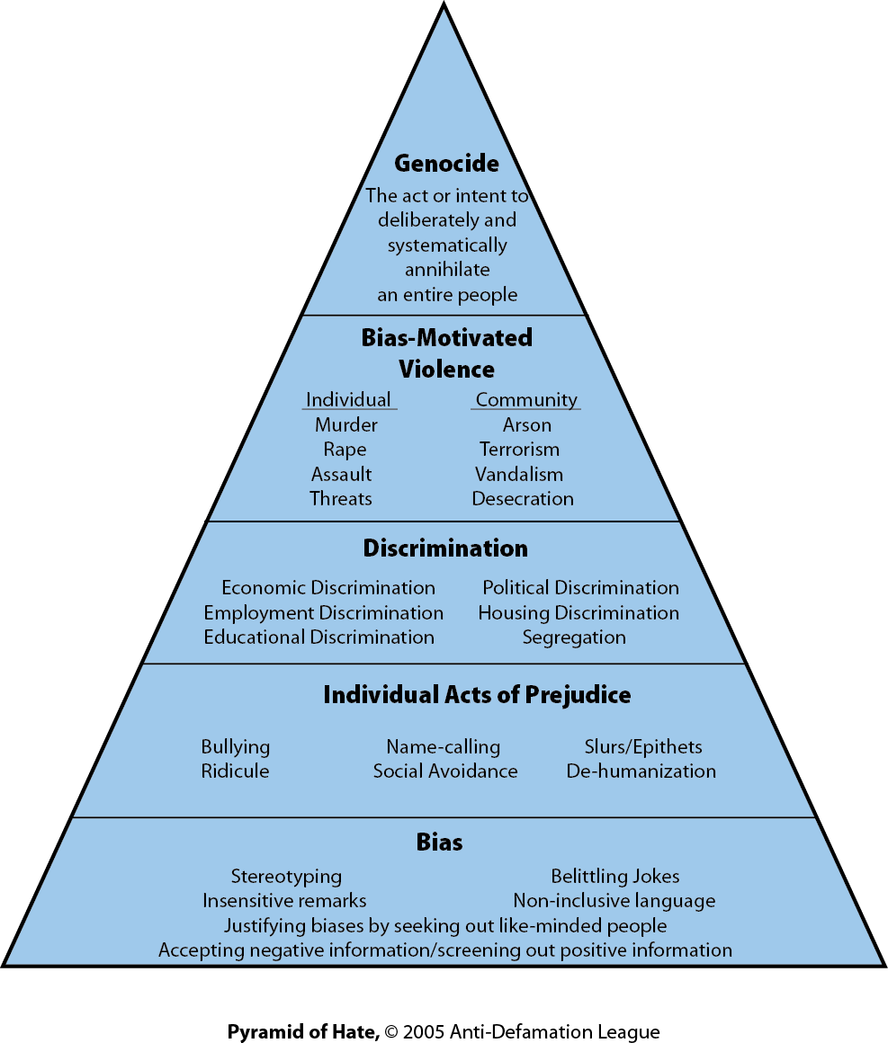

Comparisons/Similarities –

Contrasts/Differences -

Miss Foley
Psych 20: 3.2 Social Cognition TRC

Truth & Reconciliation Council

©2003, David M. Leuser, Ph.D. Plymouth State University. All rights reserved.

