Miss Foley
Sci10: Chemical Reactions Outcomes & Indicators

Chemical Reactions (CR)
CR1: Explore the properties of chemical reactions, including the role of energy changes, and applications of acids and bases.
- Create a representation about the prevalence of chemistry in our lives.
- Research the ways in which people, including First Nations and Métis, from various times and cultures have applied their understanding of the transformation of materials to produce new substances.
- Observe and describe a variety of chemical reactions, including synthesis, decomposition, combustion, single replacement and double replacement.
- Demonstrate knowledge of Workplace Hazardous Materials Information System (WHMIS 1998 and WHMIS 2015) standards by selecting and applying proper techniques for handling and disposing of lab materials and interpreting Materials Safety Data Sheets (MSDS) and Safety Data Sheets (SDS).
- Explain why it can be difficult to classify changes as physical or chemical, including reference to the reversibility of the reaction.
- Differentiate between reactants and products in chemical reactions.
- Investigate the properties of endothermic and exothermic chemical reactions, including identifying where or how energy is absorbed or released in the reaction and identifying potential benefits and consequences of the reaction.
- Research practical examples of chemical reactions involving acids and bases, including neutralization reactions such as those involved in chemical spills, soda-acid fire extinguishers and antacids.
- Provide examples of the importance of pH measurements in areas such as biology, chemistry, food science, environmental science and water treatment.
- Research the operation of technologies designed to monitor and manage pH in various applications such as swimming pools, consumer products, agriculture and horticulture.
CR2: Name and write formulas for common ionic and molecular chemical compounds, including acids and bases.
- Examine the relationship between an element’s position on the periodic table, the number of its valence electrons and its chemical properties.
- Discuss the importance of valence electrons, and whether they are shared or transferred, in determining bond type in chemical compounds.
- Name and write formulas for common ionic compounds, including compounds involving polyatomic ions, using the periodic table and a list of common ions.
- Analyze the relationship between the structure of ionic compounds, their chemical formulas and their common names.
- Classify substances as ionic or molecular, based on their properties and the results of student conducted tests (e.g., melting/boiling point, electrical conductivity and solubility).
- Relate the properties (e.g., solubility, conductivity in solution or gaseous form, high melting point and brittleness) of ionic compounds to their uses.
- Name and write formulas for common molecular and organic compounds (e.g., methane, propane, butane, octane, methanol, ethanol and glucose), using the periodic table and a list of numerical Greek prefixes.
- Design and carry out investigations to determine the properties of acids and bases, including selecting and using appropriate instruments for safely collecting evidence.
- Classify substances as acids, bases or salts, based on observable properties, name and chemical formula.
- Investigate how certain substances, including those traditional to First Nations and Métis cultures, can serve as acid-base indicators.
- Describe how the pH scale is used to classify substances as acidic, basic or neutral.
Miss Foley
Sci10: Chemical Reactions Outcomes & Indicators

(CR2 cont’d)
- Name and write formulas for common acids and bases, using the periodic table, a list of ions and rules for naming acids and bases.
- Explain the importance of scientific nomenclature systems such as the International Union of Pure and Applied Chemistry (IUPAC) naming conventions in communicating information about chemical compounds.
CR3: Represent chemical reactions and conservation of mass symbolically using models, word and skeleton equations and balanced chemical equations.
- Design and safely carry out an experiment to confirm the law of conservation of mass, identifying and controlling major variables.
- Explain the importance of the concept of conservation of mass in understanding, interpreting and predicting results of chemical reactions.
- Represent chemical reactions, organic compounds and conservation of mass using models and word equations.
- Represent chemical reactions and conservation of mass using skeleton equations and balanced equations.
- Translate word equations to balanced chemical equations and balanced chemical equations to word equations.
- Differentiate between the use of subscripts and coefficients in representing the numbers of atoms and molecules present in chemical reactions.
- Categorize chemical reactions as synthesis, decomposition, combustion, single replacement and double replacement, including acid base neutralization.
- Verify whether a chemical equation is correctly balanced, and correct any errors.
- Discuss the value of representing chemical reactions using models, word and skeleton equations and balanced chemical equations.
CR4: Investigate the rates of chemical reactions, including factors that affect the rate.
- Provide examples of chemical reactions that occur over a range of time scales.
- Predict how factors such as temperature of the reactant(s), concentration of the reactant(s), surface area of the reactant(s) and the presence or absence of catalysts or inhibitors might affect the rate of a chemical reaction.
- Formulate scientific questions about the rates of chemical reactions and the factors that affect rates of chemical reactions.
- Design and perform an experiment to determine how various factors affect chemical reaction rates, including identifying and controlling major variables.
- Compile and organize data, using appropriate formats and data treatments to facilitate interpretation of data related to rates of chemical reactions.
- Interpret patterns and trends in data, and infer or calculate linear and nonlinear relationships among variables related to chemical reaction rates.
- Reflect upon data collection and analysis procedures, and suggest improvements to increase precision and accuracy.
- Use the collision model to explain differences in chemical reaction rates.
- Value the processes for drawing conclusions in science.
- Research how the rates of chemical reactions are controlled in everyday situations as well as in agricultural and industrial applications.
- Work co-operatively with team members to develop and carry out a plan, and troubleshoot problems as they arise when investigating rates of reactions.
Name: ____________________ Date: _________
Sci10: Chemical Reactions Definitions

PRE-Assessment: Definitions _____ /?? = _____%
FINISH!!!!!

Miss Foley
Sci10: Chemical Reactions OLD Key Concept Notes

*Definitions words are bold & italicized.
Unit Overview
- A chemical reaction involves the rearrangement of atoms to produce different substances.
- Chemical reactions either release or consume energy. Some reactions such as the burning of fossil fuels release large amounts of energy in the form of heat and light. Light can initiate many chemical reactions such as photosynthesis and the evolution of urban smog.
- A large number of important chemical reactions involve the transfer of hydrogen ions (acid/base reactions) between reacting ions, molecules, or atoms.
- Chemical reactions can take place in intervals ranging from femtoseconds (10⁻¹⁵ seconds) to geologic time scales of billions of years. Reaction rates depend on how often the reacting atoms and molecules encounter one another, on the temperature of the reactants, and on certain physical properties - including shape - of the reacting substances.
- Catalysts are substances that increase the rate of a chemical reaction without being consumed in the reaction. Chemical reactions in living systems are catalyzed by protein molecules called enzymes.
- The Law of Conservation of Mass states that in a chemical reaction the total mass of reactants is equal to the total mass of the products.
CR 1: Observe common chemical reactions in your world
- A chemical reaction is a process that involves the formation of new substances with new properties.
- Reactants are substances that undergo change in a chemical reaction.
- Products are substances that form in a chemical reaction.
- Indicators that provide evidence that a chemical reaction might have taken place include: a colour change, an odour change, the formation of a new substance (precipitate), the emission of a gas, and the release or absorption of heat or light.
- Energy is lost (released) or gained (absorbed) in every chemical reaction.
- In an exothermic chemical reaction, energy is released to the surroundings.
- In an endothermic chemical reaction, energy is absorbed from the surroundings.
- Observing and describing, using our senses, are basic processes of science.
- Inferring is explaining an observation in terms of previous experience.
- Scientific knowledge is generated by, and used for, asking questions concerning the natural world.
CR 2: Represent chemical reactions symbolically using models, word equations, and balanced chemical equations
- An ion is an atom that has become charged by gaining or losing one or more electrons.
- An anion is a negatively charged ion, the result of gaining one or more electrons.
- A cation is a positively charged ion, the result of losing one or more electrons.
- A covalent bond is the bond formed by two or more atoms sharing one or more pairs of electrons.
Miss Foley
Sci10: Chemical Reactions OLD Key Concept Notes

- A molecular compound is a neutral compound composed of two or more non-metallic elements held together by covalent bonds.
- A polyatomic ion is composed of two or more non-metallic atoms bonded together covalently.
- An ionic bond is the bond formed by the transfer of electrons from one atom (usually a metal) to another (usually a non-metal).
- An ionic compound is a neutral compound that consists of positive and negative ions held together by an ionic bond.
- A binary compound contains two different elements.
- A diatomic molecule contains two identical elements.
- A valence electron is an electron(s) of an atom located in the outermost shell (valence shell) of the atom. Valence electrons can be transferred to or shared with another atom.
- A word equation identifies the reactants and products in a chemical reaction using only the names of the elements and compounds.
- A chemical equation represents the reactants and products in a chemical reaction using their symbols or formulas.
- The Law of Conservation of Mass states that in a chemical reaction the total mass of reactants is equal to the total mass of the products.
- A balanced chemical equation represents the identities and relative amounts of reactants and products in a chemical reaction. The total number of each type of atom remains the same.
- Designing experiments involves planning a series of data-gathering operations that will provide a basis for testing a hypothesis or answering a question.
- A scientific law is a statement that summarizes an observed pattern in nature.
CR3: Identify characteristics of chemical reactions involving organic compounds
- Organic compounds are molecular substances that contain carbon, excluding carbonates and oxides.
- Hydrocarbons are organic compounds composed solely of hydrogen and carbon atoms.
- Combustion is the reaction of a substance with oxygen to produce oxides, light and heat. Most combustion reactions involve organic compounds.
- Incomplete combustion occurs when there is not enough oxygen available for a combustion reaction which leads to the production of carbon monoxide instead of or in addition to carbon dioxide, when burning a hydrocarbon.
- Scientific and technological developments have real and direct effects on every person's life. Some effects are desirable; some are not.
- Scientific thought and knowledge can be used to support different positions. Scientists may disagree even though they may invoke the same scientific theories and data.
- Science is based on evidence, developed privately by individuals or groups, and is shared publicly with others. This enables others to attempt to establish the validity and reliability of the evidence.
- All branches of science are interrelated.
- Applications of scientific knowledge and of technological products and practices are ultimately determined by society. Scientists and technologists have a responsibility to inform the public of the possible consequences of such applications.
Miss Foley
Sci10: Chemical Reactions OLD Key Concept Notes

CR 4: Identify factors that affect the rates of chemical reactions
- The rate of a chemical reaction is a measure of how quickly or slowly the reaction occurs.
- Measuring the rate of a chemical reaction involves measuring how much product(s) forms or how much reactant(s) is used up in a time interval.
- Factors that influence the rate of chemical reactions include: nature of the reactant(s), temperature of the reactant(s), concentration of the reactant(s), surface area of the reactant(s), and the presence or absence of a catalyst or inhibitor.
- Increasing the temperature of the reactants generally increases the rate of a chemical reaction.
- Increasing the concentration of one or more reactants generally increases the rate of a chemical reaction.
- Increasing the surface area of one or more reactants generally increases the rate of a chemical reaction.
- A catalyst is a substance that changes the rate of a chemical reaction but is not changed in the reaction.
- The collision model states that the number of effective collisions (above activation energy) of reactant molecules affects the rate of a chemical reaction.
- Scientific knowledge is based on experimentation and observation.
- Science is based on evidence that could be obtained by other people working in a different place and at a different time under similar conditions.
- Controlling variables in an experiment is done to isolate factors that may influence a situation or event.
- Hypothesizing is stating a tentative generalization which may be used to explain a relatively large number of events. Hypotheses are subject to testing by experiments.
- Interpreting data is based on finding a pattern in a collection of data that then leads to generalizations.
CR 5: Investigate chemical reactions involving acids and bases
- Acids are substances with a pH less than 7 that produce hydrogen ions ( H⁺ ) when dissolved in water. Acids are sour-tasting, good conductors of electricity, turn blue litmus paper red, and react with bases to form salts and water.
- Bases are substances with a pH greater than 7 that produce hydroxide ions ( OH ⁻ ) when dissolved in water. Bases are bitter tasting, good conductors of electricity, feel slippery, turn red litmus paper blue and react with acids to form salts and water.
- Indicators are substances that change colour at specific pH levels.
- The pH scale indicates the acidity or alkalinity of a solution. It is a logarithmic scale in which a change in pH of 1 indicates a ten-fold change in the acidity or alkalinity.
- A neutral substance has a pH of 7 and is neither acidic nor basic.
- Neutralization is the reaction between an acid and a base that produces a salt and water.
- A salt is an ionic compound that is composed of a cation from a base and an anion from an acid.
- Numbers can be used to convey important scientific information such as the relative strengths of acids and bases.
- Science and technology can be used to monitor the impact of acids and bases on the environment.
Miss Foley
Sci10: CR1 Variety of Reactions Scientific Method

Scientific Method =
A method of research gathering knowledge
through observation, the experimental testing of
hypotheses, obtaining and analyzing empirical
evidence to support the reasoning process
Data is information that DOES NOT differ from person to person.
Value judgements are information that DOES differ from person to person.
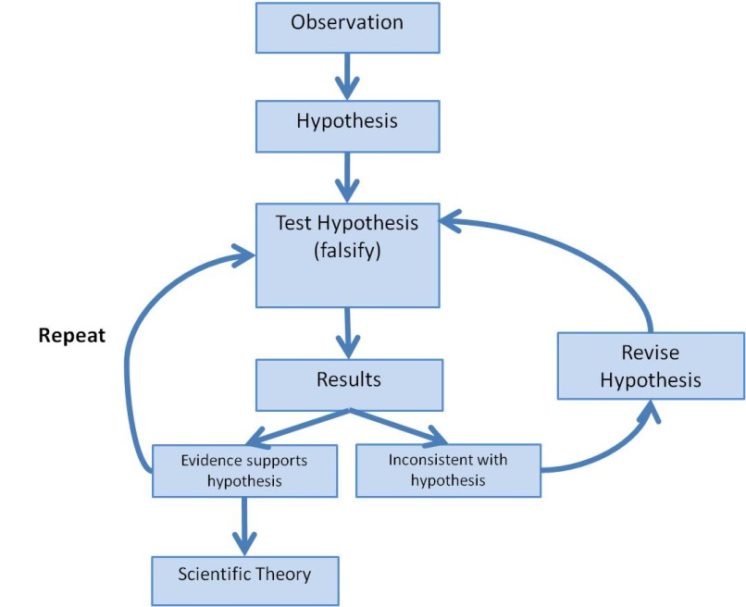
Science deals with data not value judgements.

Miss Foley
Sci10: CR1 Variety of Reactions Scientific Method

Part A: True or False
_______ A reliable experiment can have 2 or 3 independent variables.
_______ Scientists MUST follow the scientific method to ensure valid results in an experiment.
_______ An independent variable is a change that occurs as a result of the 1st change. This change usually
takes place at the end of an experiment.
_______ In the Scientific Method step known as “Statement of the Problem,” the problem should always be
written in question form.
_______ Research must always be conducted prior to forming a hypothesis.
Part B: Understanding Experiments
Mr. Higgenbottom wants to know the effect of different colors of light on the height of rose bushes. He believes that rose bushes can grow taller when exposed to green light. He buys 5 rose bushes of the same species, which are all approximately the same age and height. He places one in white light, one in blue light, one in green light, one in red light and one in a dark box. All of the rose bushes are planted in the same soil and given 300 mL of water once a day for 3 weeks. After the three weeks, Mr. Higgenbottom observes the rose bushes and makes measurements.
- Which of the following would BEST describe the “Statement of the Problem?”
  - Does the color of light affect the height of a rose bush?
  - The color of light does affect the growth of a rose bush.
  - How can plants best survive different temperatures?
  - Does Miracle Grow affect the height of a rose bush?
- Which of the following BEST describes Mr. Higgenbottom’s hypothesis?
  - Plants survive best in red light.
  - Plants survive best in blue light.
  - Plants survive best in green light.
  - Plants survive best in the dark.
- Which of the following is NOT considered to be a constant in the experiment?
  - Plant type
  - Soil
  - Light
  - Amount of water
- Which of the following is the independent variable in the experiment?
  - Soil
Plant/Light | Plant Height
White | 7 inches
Blue | 10 inches
Green | 12.5 inches
Red | 8 inches
No Light | No growth
  - Amount of water
  - Temperature
  - Color of light
- Which rose bush is considered the “control” group?
  - The roses given blue light.
  - The roses given red light.
  - The roses given white light.
  - The roses placed in the dark box.
- The following table shows the results from the experiment.
Which of the following would be a valid conclusion for this experiment?
- Rose bushes grow tallest in Blue light.
- Rose bushes grow tallest in White light.
- Rose bushes grow tallest in No light.
- Rose bushes grow tallest in Green light.

Miss Foley
Sci10: CR1 Variety of Reactions Lab Reports

Lab Reports document findings from the scientific method.
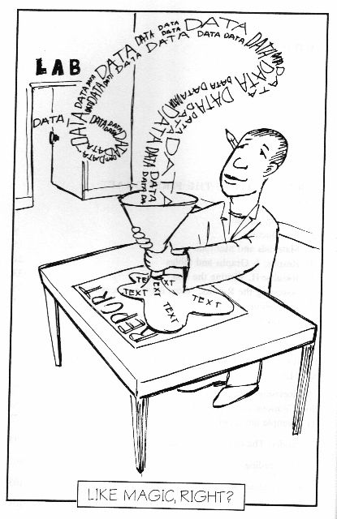
The lab write-up should be done as outlined below. The Purpose (objective), Hypothesis, and Procedure should be completed before the lab period. When conducting an experiment using the scientific procedure, some data may be collected in rough form. You may need to transfer this data to a proper data chart in your final write up.

Title

Purpose: This is the problem you are evaluating. Make a brief statement about what you are trying to discover or find out.

Hypothesis: This is a statement of what you think will happen based on your experiences. This should be a tentative answer to the problem posed in the purpose, and will either be proved or disproved by the results of the activity. No marks will be deducted for stating a hypothesis that does not agree with what you will discover in the activity, but they must be statements that make sense.

Materials: List of all materials used during the lab.

Procedure: This is a description of the steps to be followed to complete the activity. Diagrams of the experimental apparatus (if required) may be included here. If you are given a handout of the procedure, or if the procedure is in the textbook, you may indicate this by writing “see handout” or “see textbook” instead of writing out the procedure.

Data / Observations: If measurements or any other kind of quantitative information has been collected, these will be listed here. They are usually in the form of chart or table. Use a ruler to make your tables. If qualitative observations are made, these will also be included under this heading. A single sample calculation must be included for each calculation type when calculations are done, but you do not need to show all work for all values.
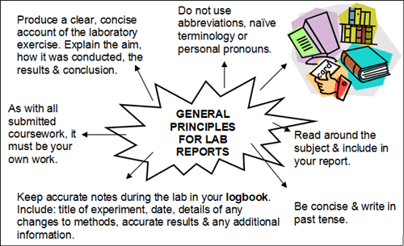
Discussion: In this section, you interpret your results in terms of what you know or what is in the text or other references. In most cases this will take the form of answering questions in the lab material.

Conclusion: This is a statement indicating if your hypothesis is correct or incorrect. If your hypothesis is well written, you should have no difficulty in writing a meaningful conclusion. A list of experimental errors is often included in this section.
Name: ____________________ Date: _________
Sci10: CR1 Variety of Reactions Observing vs Inferring

Observing =
Describing WHAT is happening using your five senses
*Used in data collection
Inferring =
Explaining the WHY behind an observation
based on past knowledge and experiences
*Used in conclusions

Candle Observations:
Before Burning –

During Burning –

After Burning -

Name: ____________________ Date: _________
Sci10: CR1 Variety of Reactions Observing vs Inferring

Animation Inferences:
Partly Cloudy

One Man Band

Name: ____________________ Date: _________
Sci10: CR1 Variety of Reactions Observing vs Inferring

Animation Inferences:
Partly Cloudy
0:25 Why are storks carrying babies?

1:35 Why is the cloud grey?

2:38 Why does the stork not look like the other storks?

4:20 Why does the cloud have that response?

5:19 Why does the stork come back?

One Man Band
1:45 What happened and why?

4:15 What happened and why?

Miss Foley
Sci10: CR1 Variety of Reactions Lab Safety

Safety in the Science Classroom
1. Never begin an experiment or lab without your teacher’s permission.
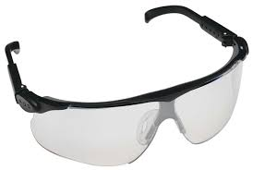
2. Read and study the procedure from start to finish before beginning any experiment. If you have any questions, ask your teacher. Make sure you understand any safety symbols on materials you will be using, and the hazards they represent. Follow the procedure exactly as specified.
3. Always wear safety goggles throughout a lab that requires chemicals. Keep the goggles on for as long as there are any chemicals being used by anyone in the lab. Do not take your goggles off or move them from your eyes (for example, to write down observations) at any time during the lab. Wear other safety equipment, such as aprons, gloves, lab coats, as required.
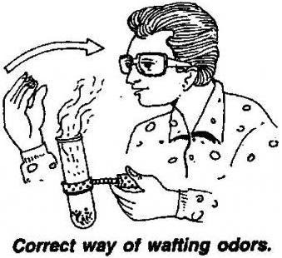
4. Never eat or drink anything in the lab. Do not chew gum during labs.
5. Never inhale chemicals. Use the “wafting” technique if you need to smell a chemical. Do not taste any substances or draw any material into a tube with your mouth.
6. If you are taking chemicals from one container and putting them into smaller containers, make sure you label all the containers.
7. When pouring liquids hold the containers away from your face. Put test tubes in a test tube rack before pouring liquids into them.
8. Use only Pyrex or Kimax glass containers when heating. Never use chipped or cracked glass wear. Never allow a container to boil dry.
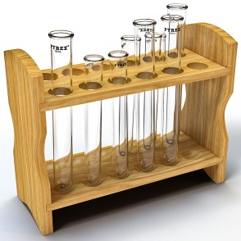
9. Report all chemical spills to your teacher. All chemical spills must be cleaned up completely and immediately. Wipe up any splashes or spills of water immediately.
10. Use test tube holder and always slant test tubes away from yourself and others when heating them. Keep materials away from flames. Follow all instructions for using Bunsen burners carefully.
11. Take caution with hotplates -- you can’t tell by looking if they are hot, but they can remain hot for up to one hour after being turned off. To see if one is still hot, don’t touch it! Instead, carefully put a drop of water on its’ surface. If the water bubbles or boils, the hot plate is too hot to touch!
Miss Foley
Sci10: CR1 Variety of Reactions Lab Safety

12. Make sure your hands are dry when using electrical equipment. Unplug electrical cords by pulling on the plug, not the cord. Don’t use equipment with frayed wires or cords. Be sure to report any defective equipment or outlets to your teacher.
13. When cutting materials, follow the following guidelines:
- Do not cut anything with a scalpel or razor blade by holding it in one hand while cutting it with the other. Always put the item down (for example, into a dissecting tray) on a flat surface. Hold it down with pins or clamps, not your fingers.
- Always cut away from yourself and away from others when using a scalpel.
- When walking with or handling over a scalpel or sharp or pointed object, keep sharp or pointed surfaces facing the floor away from others when using a scalpel.
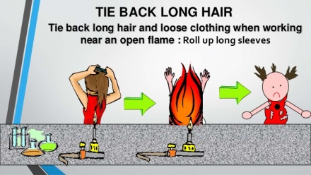
14. Tie back long hair and loose clothing.
15. When holding a bottle from which you are going to pour chemicals, keep the label against the palm of your hand. If everyone does this, any drips will only touch the opposite side of the bottle, and not get on your hand.
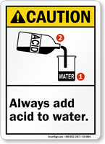
16. When diluting acid, always add small amounts of acid to large amounts of water. Never vice versa.
17. Know the location and proper use of the fire extinguisher, safety shower, fire blanket, first aid kit, and fire alarm.
18. If your clothing catches on fire, smother it with the fire blanket or a coat. “Stop, Drop, and Roll” NEVER RUN.
19. Report any accident or injury, no matter how small, to your teacher.
20. When cleaning up, be sure to:
- Turn off gas if it was used.
- Disconnect electrical apparatus.
- Return all materials to their proper places.
- Do not return unused chemicals to the original containers. Your teacher will tell you what to do with the unused chemicals and how to dispose of any other materials. Never pour unused chemicals down the drain without permission from your teacher.
- Place any broken glass in the container(s) reserved for broken glass. Do not put broken glass in the regular garbage.
- Clean and dry your work area. Do not leave water on the counter or floor
- The last thing you should do after a lab is wash your hands with soap and water.
Name: ____________________ Date: _________
Sci10: CR1 Variety of Reactions What-Not-To-Do-Lab

Review each numbered spot in the What-Not-To-Do-Lab.
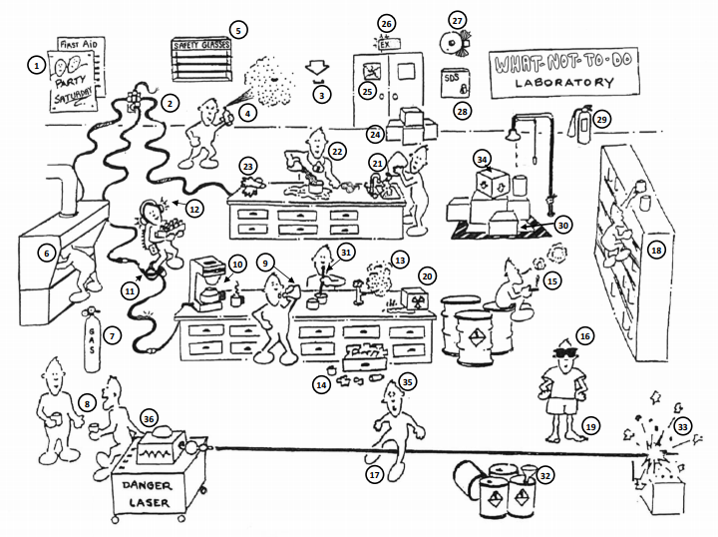
In the table below, record how each numbered incident is unsafe.

1 |  | 6
2 |  | 7
3 |  | 8
4 |  | 9
5 |  | 10
Name: ____________________ Date: _________
Sci10: CR1 Variety of Reactions What-Not-To-Do-Lab

11 |  | 24
12 |  | 25
13 |  | 26
14 |  | 27
15 |  | 28
16 |  | 29
17 |  | 30
18 |  | 31
19 |  | 32
20 |  | 33
21 |  | 34
22 |  | 35
23 |  | 36
Miss Foley
Sci10: CR1 Variety of Reactions Chemical Safety

International Hazard System
• Not all products are controlled by the WHMIS legislation, and so they may not have WHMIS labels or use the exact same symbols as WHMIS. You’ll see these other symbols on products you commonly find around the house and garden, including cosmetics (like hairsprays), pesticides, and some consumer and household products (like oven cleaners). These products use the International Hazard Symbols you see below.
• For your safety, you should be able to recognize these symbols and understand what hazards they represent.
• The following warning symbols used on labels are not controlled by WHMIS legislation:
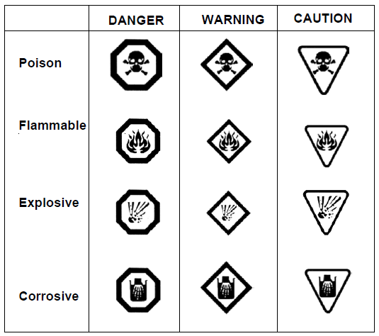

Note: The border that surrounds each symbol signifies the danger level of the hazard.
• An octagon (same shape as a stop sign) indicates “DANGER” and represents the most dangerous hazard.
• A four-sided diamond, indicates “WARNING” and represents a moderate or medium hazard level. A warning diamond does not pose as extreme a risk as the danger octagon.
• The upside-down triangle indicates “CAUTION” and represents the slightest or least hazard of the three borders. This does not make it hazardless! Use these products with caution.
Miss Foley
Sci10: CR1 Variety of Reactions Chemical Safety

Material Safety Data Sheets (MSDS)

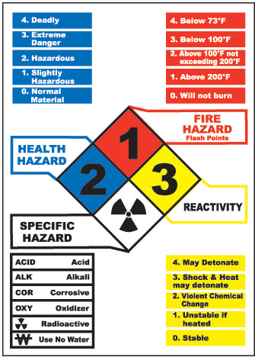
An MSDS is a sheet that gives more detailed technical information about the product. It is broken up into nine sections:
• Product information - description of the chemical
• Hazardous ingredients in the product
• Physical data (chemical properties of the ingredients
• Fire and explosive hazard - how easily it catches on fire or explodes.
• Reactivity data - describes how it reacts with other chemicals
• Toxicological properties - describes how it affects human health
• Preventive measures to be taken
• First aid measures to be taken if exposed
• When it was made and who to contact for more information

Employers must keep the MSDS up to date (no older than three years) and on file at the worksite,
and must allow employees to read them and make copies of them.
The employer must educate workers about important information on the sheet for each chemical.

MATERIAL SAFETY DATA SHEET SAMPLES
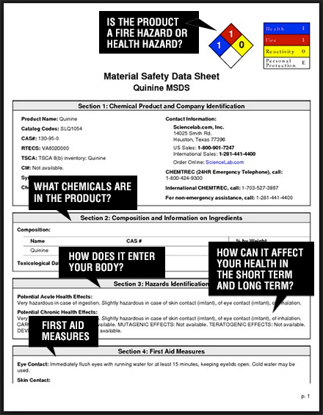
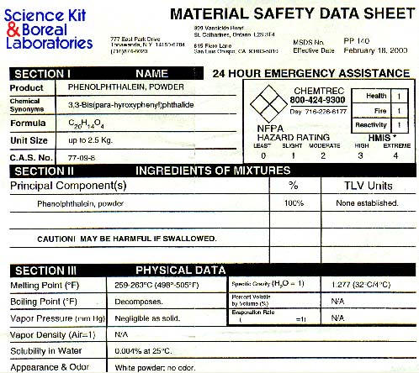
Miss Foley
Sci10: CR1 Variety of Reactions Chemical Safety

Workplace Hazardous Materials
Information System (WHMIS) 2015

  - WHMIS stands for Workplace Hazardous Materials Information System.
  - It is an information system implemented in 1988, and since updated in 2015, designed to help students know more about safety and health hazards of materials that they use in the workplace.
  - WHMIS gives workers and employers key safety and handling information in the form of special labels, symbols, and Material Safety Data Sheets (MSDS) on potentially dangerous chemicals that are used on the job.
  - You will come across controlled products that fall under the WHMIS legislation at school (for example, the chemicals used in your science and shop class), and at any workplace where chemicals are used.
WHMIS Labels
All controlled products at school or the workplace must have WHMIS labels.
The purpose of a WHMIS label is to identify the product as controlled and alert workers or handlers to the hazards and safe handling procedures of the product. Employers are responsible for making sure that hazardous products that come into the workplace are labelled and to prepare and apply a workplace label when appropriate.
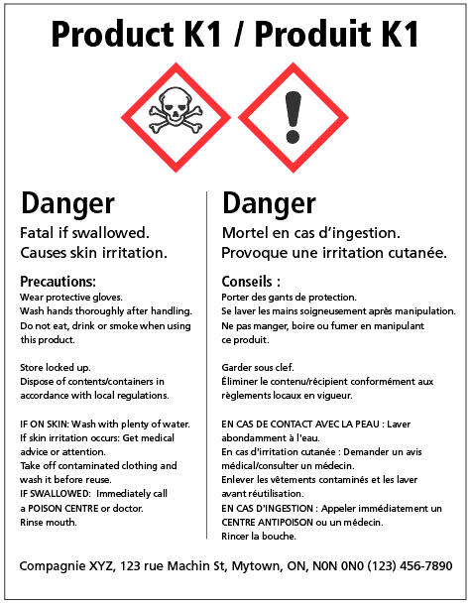
A WHMIS label is just a first alert, as the amount of information in it is limited by its size. The MSDS provides more detailed information. It is important that you read the whole label before using a product for the first time. The label will give a brief summary of the most important things to know about the chemical.
This includes:
WHMIS LABEL SAMPLE

- Product identifier – the brand name, chemical name, common name, generic name or trade name of the hazardous product.
- Initial supplier identifier – the name, address and telephone number of either the Canadian manufacturer or the Canadian importer.
- Pictogram(s) – hazard symbol within a red "square set on one of its points".
- Signal word – a word used to alert the reader to a potential hazard and to indicate the severity of the hazard.
- Hazard statement(s) – standardized phrases which describe the nature of the hazard posed by a hazardous product.
- Precautionary statement(s) – standardized phrases that describe measures to be taken to minimize or prevent adverse effects resulting from exposure to a hazardous product or resulting from improper handling or storage of a hazardous product.
- Supplemental label information – some supplemental label information is required based on the classification of the product. Labels may also include supplementary information about precautionary actions, hazards not yet included in the GHS, physical state, or route of exposure. This information must not contradict or detract from the standardized information.
Miss Foley
Sci10: CR1 Variety of Reactions Chemical Safety

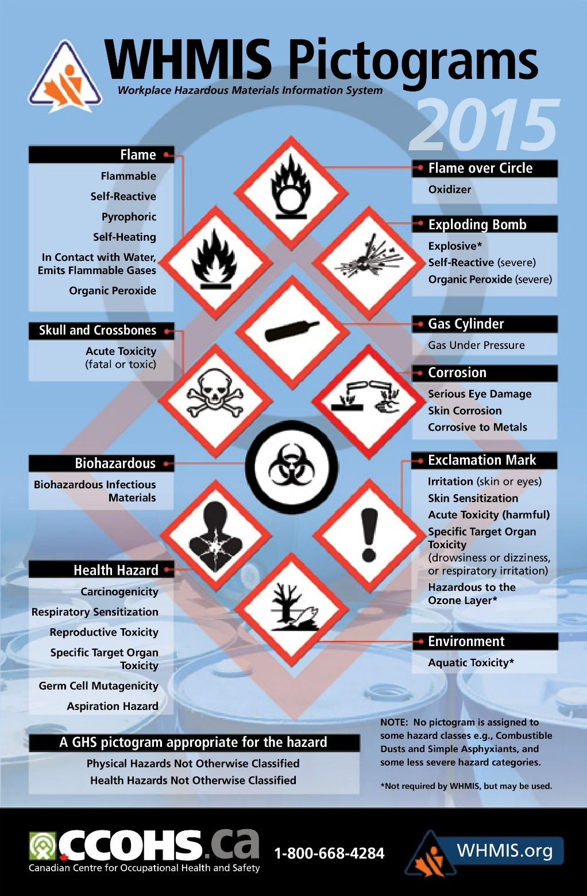

Miss Foley
Sci10: CR1 Variety of Reactions Chemical Safety

WHMIS: PHYSICAL Hazard Classes
Hazard Class | General Description | Example(s)
Flammable gases  Flammable aerosols  Flammable liquids  Flammable solids | These four classes cover products that have the ability to ignite (catch fire) easily and the main hazards are fire or explosion.
Oxidizing gases  Oxidizing liquids  Oxidizing solids | These three classes cover oxidizers, which may cause or intensify a fire or cause a fire or explosion.
Gases under pressure | This class includes compressed gases, liquefied gases, dissolved gases and refrigerated liquefied gases.  Compressed gases, liquefied gases and dissolved gases are hazardous because of the high pressure inside the cylinder or container. The cylinder or container may explode if heated. Refrigerated liquefied gases are very cold and can cause severe cold (cryogenic) burns or injury.
Self-reactive substances and mixtures | These products may react on their own to cause a fire or explosion, or may cause a fire or explosion if heated.
Pyrophoric liquids  Pyrophoric solids  Pyrophoric gases | These products can catch fire very quickly (spontaneously) if exposed to air.
Self-heating substances and mixtures | These products may catch fire if exposed to air. These products differ from pyrophoric liquids or solids in that they will ignite only after a longer period of time or when in large amounts.
Substances and mixtures which, in contact with water, emit flammable gases | As the class name suggests, these products react with water to release flammable gases. In some cases, the flammable gases may ignite very quickly (spontaneously).
Organic peroxides | These products may cause a fire or explosion if heated.
Corrosive to metals | These products may be corrosive (chemically damage or destroy) to metals.
Combustible dust | This class is used to warn of products that are finely divided solid particles. If dispersed in air, the particles may catch fire or explode if ignited.
Simple asphyxiants | These products are gases that may displace oxygen in air and cause rapid suffocation.
Physical hazards not otherwise classified | This class is meant to cover any physical hazards that are not covered in any other physical hazard class. These hazards must have the characteristic of occurring by chemical reaction and result in the serious injury or death of a person at the time the reaction occurs. If a product is classified in this class, the hazard statement on the label and SDS will describe the nature of the hazard.
Miss Foley
Sci10: CR1 Variety of Reactions Chemical Safety

WHMIS: HEALTH Hazard Classes
Hazard Class | General Description | Example(s)
Acute toxicity | These products are fatal, toxic or harmful if inhaled, following skin contact, or if swallowed.  Acute toxicity refers to effects occurring following skin contact or ingestion exposure to a single dose, or multiple doses given within 24 hours, or an inhalation exposure of 4 hours.  Acute toxicity could result from exposure to the product itself, or to a product that, upon contact with water, releases a gaseous substance that is able to cause acute toxicity.
Skin corrosion/ irritation | This class covers products that cause severe skin burns (i.e., corrosion) and products that cause skin irritation.
Serious eye damage/eye irritation | This class covers products that cause serious eye damage (i.e., corrosion) and products that eye irritation.
Respiratory or skin sensitization | A respiratory sensitizer is a product that may cause allergy or asthma symptoms or breathing difficulties if inhaled. Skin sensitizer is a product that may cause an allergic skin reaction.
Germ cell mutagenicity | This hazard class includes products that may cause or are suspected of causing genetic defects (permanent changes (mutations) to body cells that can be passed on to future generations).
Carcinogenicity | This hazard class includes products that may cause or are suspected of causing cancer.
Reproductive toxicity | This hazard class includes products that may damage or are suspected of damaging fertility or the unborn child (baby).  Note: There is an additional category which includes products that may cause harm to breast-fed children.
Specific target organ toxicity – single exposure | This hazard class covers products that cause or may cause damage to organs (e.g., liver, kidneys, or blood) following a single exposure.  This class also includes a category for products that cause respiratory irritation or drowsiness or dizziness.
Specific target organ toxicity – repeated exposure | This hazard class covers products that cause or may cause damage to organs (e.g., liver, kidneys, or blood) following prolonged or repeated exposure.
Aspiration hazard | This hazard class is for products that may be fatal if they are swallowed and enter the airways.
Biohazardous infectious materials | These materials are microorganisms, nucleic acids or proteins that cause or is a probably cause of infection, with or without toxicity, in humans or animals.
Health hazards not otherwise classified | This class covers products that are not included in any other health hazard class. These hazards have the characteristic of occurring following acute or repeated exposure and have an adverse effect on the health of a person exposed to it - including an injury or resulting in the death of that person. If a product is classified in this class, the hazard statement will describe the nature of the hazard.
Name: ____________________ Date: _________
Sci10: CR1 Variety of Reactions WHMIS

- What does MSDS stand for? (1 mark)
- What does WHMIS stand for? (1 mark)
- What information would you find on a WHMIS label? (6 marks)

- Explain why all products and chemicals don’t have WHMIS labels. (2 marks)

- What kind of information would be found on a MSDS Sheet? (9 marks)

- Complete the following chart. (24 marks)
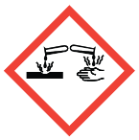
_{A} _{B} _{C} _{D} _{E} _{F} _{G} _{H} _{I} _{J}
Symbol | Symbol Name | Hazard | Example
A
B
C
D
E
F
G
H
I
J
Name: ____________________ Date: _________
Sci10: CR1 Variety of Reactions WHMIS

Miss Foley
Sci10: CR1 Variety of Reactions Classifying Matter

Matter =
Everything that has mass and takes up space
Complete using Nelson Science 10 - pages 172-175
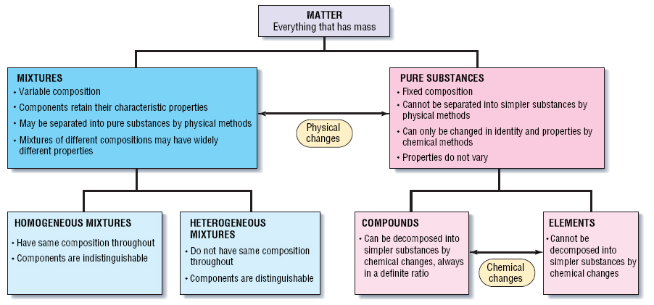
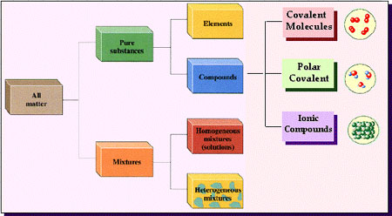

Miss Foley
Sci10: CR1 Variety of Reactions Classifying Matter

Mixture –

Pure Substance –

Element –

Compound -

Physical Change –

Chemical Change –

Indicators of Chemical Change:

The hallmark of a chemical reaction is that new material or materials are made, along with the disappearance of the mass that changed to make the new. This does not mean that new elements have been made.

A chemical equation is a way to describe what goes on in a chemical reaction, the actual change in a material. Chemical equations are written with the symbols of materials to include elements, ionic or covalent compounds, aqueous solutions, ions, or particles. There is an arrow pointing to the right that indicates the action of the reaction. The materials to the left of the arrow are the reactants, or materials that are going to react. The materials to the right of the arrow are the products, or materials that have been produced by the reaction.

The Law of Conservation of Mass states that in a chemical reaction no mass is lost or gained. The Law of Conservation of Mass applies to individual types of atom. One could say that for any element, there is no loss or gain of that element in a chemical reaction. There are such things as reversible reactions, reactions in which the products reassemble to become the original products. Reversible reactions are symbolized in chemical equations by a double-headed arrow, but the standard remains to call the materials on the left the reactants and the materials on the right the products.
Miss Foley
Sci10: CR1 Variety of Reactions Classifying Matter

Mixture – contain two or more pure substances

Pure Substance – substance where all of the particles making up the substance are
identical

Element – pure substances that cannot be broken down into simpler substances

Compound – pure substances that contain two or more different elements in a fixed
proportion.

Physical Change – a change (i.e. dissolving, melting, condensing) in the size or form of
a substance which does NOT change the chemical properties of the substance

Chemical Change – a change in the chemical properties of the substance creating a
new substance

Indicators of Chemical Change:

- Color change (excluding dissolving)
- Temperature change
- Odour/gas produced (i.e. bubbles)
- Heat/light produced
- Precipitate (solid) forms

The hallmark of a chemical reaction is that new material or materials are made, along with the disappearance of the mass that changed to make the new. This does not mean that new elements have been made.
A chemical equation is a way to describe what goes on in a chemical reaction, the actual change in a material. Chemical equations are written with the symbols of materials to include elements, ionic or covalent compounds, aqueous solutions, ions, or particles. There is an arrow pointing to the right that indicates the action of the reaction. The materials to the left of the arrow are the reactants, or materials that are going to react. The materials to the right of the arrow are the products, or materials that have been produced by the reaction.
The Law of Conservation of Mass states that in a chemical reaction no mass is lost or gained. The Law of Conservation of Mass applies to individual types of atom. One could say that for any element, there is no loss or gain of that element in a chemical reaction. There are such things as reversible reactions, reactions in which the products reassemble to become the original products. Reversible reactions are symbolized in chemical equations by a double-headed arrow, but the standard remains to call the materials on the left the reactants and the materials on the right the products.
Miss Foley
Sci10: CR1 Variety of Reactions Chemical Change

Physical vs Chemical Change
Identify the following as a chemical (C) or physical property (P):

PHYSICAL PROPERTY CHEMICAL PROPERTY
1. observed with senses 1. indicates how a substance reacts with another
2. determined without destroying matter 2. matter will be changed into a new substance after the reaction

______1. blue color ______8. melting point
______2. density ______9. reacts with water
______3. flammability (burns) ______10. hardness
______4. solubility (dissolves) ______11. boiling point
______5. reacts with acid ______12. luster
______6. supports combustion ______13. odor
______7. sour taste ______14. reacts with air

PHYSICAL CHANGE CHEMICAL CHANGE
1. a change in size, shape, or state 1. a change in the physical & chemical properties
2. no new substance is formed 2. a new substance is formed

Identify the following as physical (P) or chemical (C) changes.
_____1. NaCl (Table Salt) dissolves in water. ______9. Milk sours.
_____2. Ag (Silver) tarnishes. ______10. Sugar dissolves in water.
_____3. An apple is cut. ______11. Wood rots.
_____4. Heat changes H₂O to steam. ______12. Pancakes cook.
_____5. Baking soda reacts to vinger. ______13. Grass grows.
_____6. Fe (Iron) rusts. ______14. A tire is inflated.
_____7. Alcohol evaporates . ______15. Food is digested.
_____8. Ice melts. ______16. Paper towel absorbs water.

Part A
Can you recognize the chemical and physical changes that happen all around us? If you change the way something looks, but haven’t made a new substance, a physical change (P) has occurred. If the substance has been changes into another substance, a chemical change (C) has occurred.

1. |  | An ice cube is placed in the sun. Later there is a puddle of water. Later still the puddle is gone.
2. |  | Two chemical are mixed together and a gas is produce.
3. |  | A bicycle changes color as it rusts.
4. |  | A solid is crushed to a powder.
Miss Foley
Sci10: CR1 Variety of Reactions Chemical Change

5. |  | Two substances are mixed and light is produced.
6. |  | A piece of ice melts and reacts with sodium.
7. |  | Mixing salt and pepper.
8. |  | Chocolate syrup is dissolved in milk.
9. |  | A marshmallow is toasted over a campfire.
10. |  | A marshmallow is cut in half.

Part B
Read each scenario. Decide whether a physical or chemical change has occurred and give evidence for your decision. The first one has been done for you to use as an example.

 | Scenario | Physical or Chemical Change? | Evidence…
1. | Umm! A student removes a loaf of bread hot from the oven. The student cuts a slice off the loaf and spreads butter on it. | Physical | No change in substances.  No unexpected color change, temperature change or gas given off.
2. | Your friend decides to toast a piece of bread, but leaves it in the toaster too long. The bread is black and the kitchen if full of smoke.
3. | You forgot to dry the bread knife when you washed it and reddish brown spots appeared on it.
4. | You blow dry your wet hair.
5. | In baking biscuits and other quick breads, the baking powder reacts to release carbon dioxide bubbles. The carbon dioxide bubbles cause the dough to rise.

Miss Foley
Sci10: CR1 Variety of Reactions Chemical Change

6. | You take out your best silver spoons and notice that they are very dull and have some black spots.
7. | A straight piece of wire is coiled to form a spring.
8. | Food color is dropped into water to give it color.
9. | Chewing food to break it down into smaller particles represents a _________ change, but the changing of starch into sugars by enzymes in the digestive system represents a ___________change.
10. | In a fireworks show, the fireworks explode giving off heat and light.

Part C: True (T) or False (F)

1. |  | Changing the size and shapes of pieces of wood would be a chemical change.
2. |  | In a physical change, the makeup of matter is changed.
3. |  | Evaporation occurs when liquid water changes into a gas.
4. |  | Evaporation is a physical change.
5. |  | Burning wood is a physical change.
6. |  | Combining hydrogen and oxygen to make water is a physical change.
7. |  | Breaking up concrete is a physical change.
8. |  | Sand being washed out to sea from the beach is a chemical change.
9. |  | When ice cream melts, a chemical change occurs.
10. |  | Acid rain damaging a marble statue is a physical change.
Miss Foley
Sci10: CR1 Variety of Reactions Heat Transfer

Endothermic vs Exothermic Processes
Every chemical reaction involves the transfer of energy in the form of heat, light or even electricity. However, every transfer of energy is not always a chemical reaction. When trying to classify a process as exothermic or endothermic, watch how the temperature of the surroundings changes. An exothermic process releases heat, and causes the temperature of the immediate surroundings to rise. An endothermic process absorbs heat and cools the surroundings. Can you think of a way to test the classification of each of these processes?

Exothermic processes | Endothermic processes
making ice cubes | melting ice cubes
formation of snow in clouds | conversion of frost to water vapor
condensation of rain from water vapor | evaporation of water
a candle flame | forming a cation from an atom in the gas phase
mixing sodium sulfite and bleach | baking bread
rusting iron | cooking an egg
burning sugar | producing sugar by photosynthesis
forming ion pairs | separating ion pairs
Combining atoms to make a molecule in the gas phase | splitting a gas molecule apart
mixing water and strong acids | mixing water and ammonium nitrate
mixing water with an anhydrous salt | making an anhydrous salt from a hydrate
crystallizing liquid salts (as in sodium acetate in chemical hand warmers) | melting solid salts
nuclear fission | reaction of barium hydroxide octahydrate crystals with dry ammonium chloride
mixing water with calcium chloride | reaction of thionyl chloride (SOCl₂) with cobalt(II) sulfate heptahydrate

Miss Foley
Sci10: CR1 Variety of Reactions Heat Transfer
Chemistry Applied: Hand Warmers
4Fe_{(s)} + 30_{2(g)} 2Fe₂0_{3(s)} + heat
Hand warmers work their magic through the power of rust. Yes, the same thing that destroys your car in the winter heats your hands up as you drive – an exothermic reaction. Small pieces of iron are dispersed in heat packs, isolated by the wrapping on the pack from any oxygen. When the wrapping comes off, the permeable membrane of the pack lets oxygen in and makes it "oxidize" the iron. Oxidation is what causes a lot of the heat on earth. When a tree burns down, the carbon in the tree is oxidizing, too. Both iron and carbon give off heat when they oxidize. And yet the iron around us isn't constantly sizzling. The iron in the heat packs is surrounded by a chemical that allows the reaction to go much faster. It's ordinary salt, and it's why a lot of important iron things get eaten through in the winter, when salt is regularly thrown on streets and sideways to de-ice them, and is then kicked up on to cars and buildings, getting a good rust started on them unless they're well protected. Also in the heat pack…carbon which spreads the heat around, and vermiculite which keeps the heat from escaping too fast. The slushy feel of the pack is due to water and polypropylene, a polymer with high heat resistance that keeps the water from evaporating. Eventually, all of the iron oxidizes and the heat dissipates. But the rust... the rust will last forever.
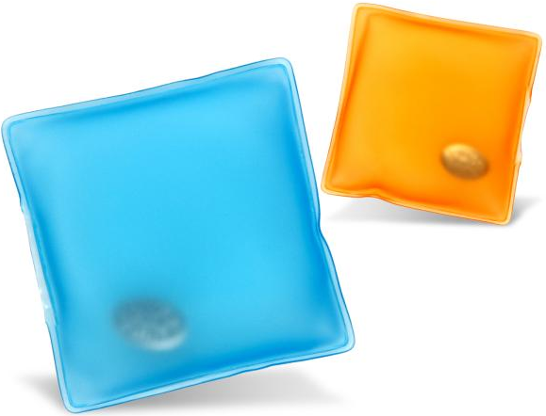
Chemistry Applied:
Click Hand Warmers
On cold days, a hand warmer can offer comfort to the chilly-fingered. Yet the science behind them is surprisingly straightforward. A hand warmer contains sodium acetate, dissolved in water. The solution is ‘super-saturated’, which means it has been heated to dissolve more sodium acetate. The solution crystallises readily. When the internal metal strip is bent, tiny bits of metal are released, which offer ‘nucleation sites’ for crystals to form. As the crystals spread, the stored heat energy of the solution is released, heating the hand warmer up to 54°C – an exothermic reaction. If you look closely, the solution begins to solidify radially outwards from the metal disk. There are slits in the metal disk which trap solid particles of sodium acetate when the hand warmer is being “recharged” (melting from solid back to liquid state). These stored particles are “seed crystals” or “starter particles” that initiate the solution to solidify. When the metal disk is bent, the seed crystals trigger the solidification process and the solution starts to harden. But this also means the hand-warmer would stop working if no seed crystals get stored in the metal disk during the recharging step. The hand warmer can be reset by boiling it in a pan of water to liquefy the crystals.
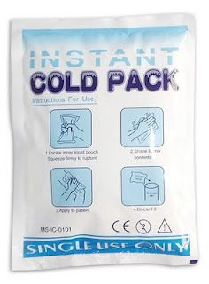
Chemistry Applied: Instant Icepacks
NH₄Cl_{(s)} + H₂O_{(l)} + heat NH₄⁺_{(aq)} + Cl⁻_{(aq)}
The water and ammonium chloride reactants are kept separate inside the ice pack during storage. The cold pack is activated by breaking the barrier separating the water and ammonium chloride, allowing them to mix. When ammonium nitrate is dissolved in water, heat is required to break apart the forces holding the ammonium nitrate together as a crystal. The process is an endothermic reaction.
Miss Foley
Sci10: CR1 Variety of Reactions Agriculture

Agricultural Chemistry
Modern agriculture depends quite heavily on the advances that have been made in science and chemistry in particular, to maximize the yield of crops and animal products. Fertilizers, pesticides, and antibiotics play ever increasing roles in this field.
Fertilizers are perhaps the most widely used form of chemical in agriculture. Fertilizers are added to the soil in which crops are growing to provide nutrients required by the plants. Fertilizers can be divided into two categories: organic and inorganic. Organic fertilizers are derived from living systems and include animal manure, guano (bird or bat excrement), fish and bone meal, and compost. These organic fertilizers are decomposed by microorganisms in the soil to release their nutrients. These nutrients are then taken up by the plants. Inorganic or chemical fertilizers are less chemically complex and usually more highly concentrated. They can be formulated to provide the correct balance of nutrients for the specific crop that is being grown. Both organic and inorganic fertilizers supply the nutrients required for maximum growth of the crop. Inorganic fertilizers contain higher concentrations of chemicals that may be in short supply in the soil. The major or macro- nutrients in inorganic fertilizers are nitrogen, phosphorous, and potassium. These fertilizers also may provide other nutrients in much smaller quantities (micro-nutrients).
With the expansion of cities due to increases in population, there has been a loss of agricultural land. Appropriate use of fertilizers to increase crop yield has in part counterbalanced this loss of land. The use of fertilizers is not without controversy, however. There are concerns that adding supplements of nitrogen, particularly in the form of inorganic fertilizers, can be detrimental. It is thought that adding additional nitrogen to the soil can disrupt the action of nitrogen-fixing bacteria, an important part of the nitrogen cycle. If these nitrogen-fixing bacteria in the soil are killed, then less nitrogen is added naturally. As a consequence, more and more fertilizer must be applied. Inorganic nitrogen fertilizers are relatively cheap and they are often added to arable land in excessive amounts. The crop does not assimilate all of this extra nitrogen, but instead the nitrogen can run off the land and enter the water supply. High levels of nitrogen in water can lead to eutrophication which can trigger algal and bacterial blooms. These organisms remove oxygen from the water faster than it is replaced by diffusion and photosynthesis, causing some other aquatic animals to die from oxygen deprivation. High levels of nitrate in drinking water, which can be due to agricultural runoff, have been implicated in human health problems, such as blue baby syndrome (methemoglobinemia).
Pesticides are another important group of agricultural chemicals. They are used to kill any undesired organism interfering with agricultural production. Pesticides can be divided into fungicides, herbicides, and insecticides. Fungicides are used to control infestations of fungi, and they are generally made from sulfur compounds or heavy metal compounds. Fungicides are used primarily to control the growth of fungi on seeds. They are also used on mature crops, although fungal infestation are harder to control at this later stage.
Herbicides are weed killers that are used to destroy unwanted plants. Generally herbicides are very selective, since they would be useless for most applications if they were not. A general non-selective herbicide can be used to clear all plants from a particular area. However, appropriate treatment must be carried out to remove the herbicide or render it ineffective if that area is to be used for subsequent plant growth. Herbicides can be used to kill weeds that grow among crops and reduce the value of the harvest. They can also be used to kill plants that grow in fields used for grazing by animals, since some plants can be poisonous to livestock or can add unpleasant flavors to the meat or milk obtained from the livestock. Breeding and genetic manipulation are used to introduce herbicide resistance to crops, allowing the use of more broad-spectrum herbicides that can kill more weed species with a single application. Herbicides include a wide range of compounds, such as

Miss Foley
Sci10: CR1 Variety of Reactions Agriculture (cont’d)

common salt, sulfates, and ammonium and potassium salts. In the 1940s 2,4-D (2,4 trichlorophenoxyacetic acid) was developed and this herbicide is still widely used today. The use of a related compound, 2,4,5-T (2,4,5 trichlorophenoxyacetic acid), is now controlled because of its potentially harmful effects. 2,4,5-T was a constituent of Agent Orange, a defoliant used during the Vietnam War.
Insecticides are chemicals that are used to kill insect pests. Insects can spread livestock diseases, can eat stored grain, and can feed on growing crops. Not all insects are harmful, and certain species of insects are needed to pollinate plants to ensure that they set seed. Many insecticides are non-selective and kill all insects, beneficial as well as harmful. Some insecticides, which are very effective at killing insects, have other problems associated with them. For example, DDT (dichlorodiphenyltrichloroethane) persists in the environment and is concentrated in the food chain. With high levels of exposure, DDT can directly kill fish and birds by paralyzing their nerve centers. In lower concentrations, it can weaken bird's egg shells and cause sharp declines in reproductive rates. Insecticides work in a number of ways. Some are direct poisons (chrysanthemic acids, contact poisons, systemic poisons), while others are attractants or repellents that move the insects to a different location (fumigation acrylonitrile). Some insecticides will only attack a particular stage of an insect's life cycle and this can make them more specific.
Antibiotics and growth hormones are routinely used as feed supplements for a number of animals. These additives are supplied to keep the animals free from disease and to help them grow to a marketable size as quickly as possible. However, the indiscriminate use of antibiotics can cause problems, since this can lead to the development of resistant strains of microorganisms or sensitization to the antibiotic among people who eat these animal products. The effects on humans of eating the meat of animals treated with growth hormones are poorly understood at the present time.
Agricultural chemistry has provided us with more and cheaper food than ever before. It has also allowed food to be produced in areas that previously were unsuitable for agriculture. The application of chemicals to farming has been one of the chemical success stories of the twentieth century. This is not to say that there have not been problems, the most famous being DDT. In the 1980s and 1990s there has been a backlash against the application of chemicals to foodstuffs in the western world. This has led to the production of organic and green products that are produced without artificial application of chemicals. These products are often more expensive to produce and this increased price is passed on to the consumer. However, there is much research to suggest that appropriate organic techniques can be competitive in cost with typical chemical agriculture and that Third World countries would benefit greatly from many organic practices.
In addition to the applications outlined above, chemicals also have other agricultural uses. For example, sulfur dioxide can be used to keep grain fresh and useable for a longer period of time than untreated grain. Other chemicals can be added to promote the ripening of fruits or the germination of seeds. It is difficult to estimate the monetary value of agricultural chemicals, but many multi- national corporations are involved in their manufacture and use. Agricultural chemistry has increased the diversity of the human diet and has led to a greater overall availability of food, both animal and plant.
Source: http://www.bookrags.com/printfriendly/?p=gale&u=agricultural-chemistry-woc

Miss Foley
Sci10: CR1 Variety of Reactions Agriculture (cont’d)

Check For Understanding:
Agricultural Chemistry

Summarize the impact of the following common chemical reactions that take place in Saskatchewan agriculture and industry (Use the back of the page when you run out of room with your explanation):

Fertilizers –

Pesticides –

Antibiotics -

Miss Foley
Sci10: CR1 Variety of Reactions

Miss Foley
Sci10: CR2 Chemical Symbols Counting Atoms

How to Count Atoms

- The symbol of an element represents one atom of that element.

e.g. Ca =

- A subscript is a number written at the lower right corner behind the symbol of an element. If there is more than one atom of the element in the molecule, then a subscript is used to indicate the number of atoms.

e.g. N₂ =

- A subscript outside of a bracket multiples all of the elements inside the brackets.

e.g. Ba(PO₄₎₂ =

- a) A coefficient is a number written in front of a chemical symbol and indicates the number of atoms of that element.

e.g. 3C =

OR

b) A coefficient is a number written in front of a chemical formula and indicates the number of molecules of that compound.

Note: A coefficient multiples the number of atoms of each element in the formula.

e.g. 2H₂O =

3FeSO₄ =

4Cu(NO₃)₂ =

Miss Foley
Sci10: CR2 Chemical Symbols Counting Atoms

Na₂CO₃ |  |  |  |  | Ca₃(PO₄)₂
Type of Atom |  | # of Atoms |  |  | Type of Atom | # of Atoms
Total |  |  |  |  | Total
K₂CrO₄ |  |  |  |  | 3BaCl₂
Type of Atom | # of Atoms |  |  |  | Type of Atom | # of Atoms
 |  |  |  |  | Total
Total
NH₄C₂H₃O₂ |  |  |  |  | 2(NH₄)₂Cr₂O₇
Type of Atom | # of Atoms |  |  |  | Type of Atom | # of Atoms
Total |  |  |  |  | Total
Pb(NO₃)₂ |  |  |  |  | 4Al₂(CO₃)₃
Type of Atom | # of Atoms |  |  |  | Type of Atom | # of Atoms
Total |  |  |  |  | Total

Miss Foley
Sci10: CR2 Chemical Symbols Molecular Mass

Molecule =
A particle that has two or more atoms bonded together
Examples: O₂, C₆H₁₂O₆, N₂, H₂O, Br₂, etc.

Compound =
A molecule that has more than one kind
of atom bonded together
Examples: C₆H₁₂O₆, H₂O, CaCO₃, etc.

The periodic table of elements lists the atomic mass of each element underneath the chemical symbol. The molecular mass (a.k.a. formula mass) of each molecule is determined by adding up the individual atomic masses of each atom that form the molecule.

The unit used for molecular mass is amu = atomic mass units.

Molecule | # of atoms | Atomic mass | Sub-Totals
C₆H₁₂O₆  (glucose) | C – 6  H – 12  O - 6 | 6 x 12.01 amu  12 x 1.01 amu  6 x 16.00 amu | 72.06 amu  12.12 amu  96.00 amu
 |  | Molecular Mass | 180.18 amu

Molecule | # of atoms | Atomic mass | Sub-Totals
NH₄OH  (ammonium hydroxide) | N – 1  H – 5  O - 1 | 1 x 14.01 amu  5 x 1.01 amu  1 x 16.00 amu | 14.01 amu  5.05 amu  16.00 amu
 |  | Molecular Mass | 35.06 amu

Miss Foley
Sci10: CR2 Chemical Symbols Molecular Mass

Miss Foley
Sci10: CR2 Chemical Symbols Molecular Mass

To determine the formula mass or mass of the molecule of a specific compound, you must find the atomic mass of each atom in the molecule, multiply it by the number of each atom and add all of the masses together.
Molecule | # of atoms | Atomic Masses | Total Atomic Masses
HCl  hydrochloric acid | hydrogen - 1  chlorine -1 | 1 x 1.01=  1 x 35.47= | 1.01  35.47
 |  | Molecular mass | 36.48 amu
NH₄OH
ammonium hydroxide
 |  | Molecular mass
MgSO₄
Epsom salt

 |  | Molecular mass
CaCO₃
chalk (limestone)

 |  | Molecular mass
H₂SO₄
sulfuric acid

 |  | Molecular mass
C₆H₁₂O₆
Glucose

 |  | Molecular mass
H₂CO₃
carbonic acid
(soda pop)
 |  | Molecular mass
Miss Foley
Sci10: CR2 Chemical Symbols Molecular Mass

Molecule | # of atoms | Atomic Masses | Total Atomic Masses
H₂O₂
hydrogen peroxide
 |  | Molecular mass
NaHCO₃
sodium bicarbonate (baking soda)
 |  | Molecular mass
C₉H₈O₄
aspirin

 |  | Molecular mass
C₇H₅(NO₂)₃
TNT

 |  | Molecular mass
H₄Mg₃Si₂O₉
Asbestos

 |  | Molecular mass
C₄H₁₀
butane (lighter fluid)
 |  | Molecular mass
C₆H₄Cl₂
mothballs
 |  | Molecular mass
HOCH₂CH₂OH
antifreeze
 |  | Molecular mass
Miss Foley
Sci10: CR2 Chemical Symbols Types of Compounds

Ionic Compound =
Molecular/Covalent Compound =
Diatomic =
Binary =

Compound | Ionic/Molecular | Binary/Diatomic/Neither
1. PCl₃
2. NaOH (lye)
3. CH₄ (methane gas)
4. K₂CO₃ (potash)
5. MgI₂
6. C₂H₄O₂ (vinegar)
7. NaCl (table salt)
8. Cl₂ (gas)
9. MgCO₃
10. Na₂CO₃
11. hydrogen sulfide (H₂S)
12. nitrogen dioxide (NO₂)
13. zinc oxide (ZnO)
14. lithium oxide (Li₂O)
15. potassium sulfide (K₂S)
16. sodium carbonate (NaCO₃)
17. potassium fluoride (KF)
18. carbon dioxide (CO₂)
19. carbon tetrachloride (CCl₄)
20. oxygen gas (O₂)

Miss Foley
Sci10: CR2 Chemical Symbols Atomic Theories

Development of Atomic Theories

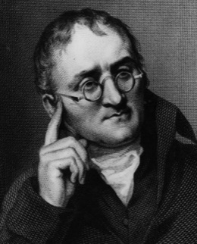
John Dalton (1808)
- Matter is made up of small particles called atoms.
- Atoms cannot be created, destroyed or divided.
- All atoms of an element are identical but different from other elements.
- Compounds are formed when atoms of elements combine in fixed proportions.
- Chemical reactions change the way atoms are grouped, but not the atoms themselves.
- To summarize, atoms are viewed as spheres that combined in different ways to form matter.
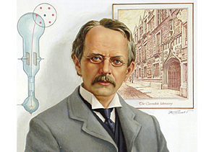
J.J. Thomson (1894)
- Matter is made up of small particles called atoms.
- Atoms cannot be created, destroyed or divided.
- All atoms of an element are identical but different from other elements.
- Compounds are formed when atoms of elements combine in fixed proportions.

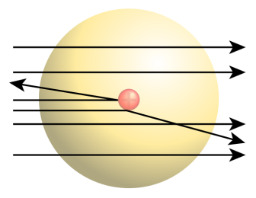
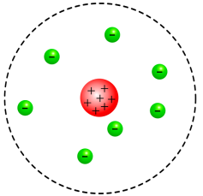
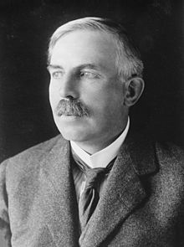
Rutherford (1909)
- Shot alpha particles at gold foil and found that some of these particles bounced back from a collision.
- He reasoned that atoms must have a compact positive core, the nucleus.
- Electrons are orbiting nucleus like planets around the sun (solar system model).
- Matter is composed primarily of empty space.
- Compared atomic mass of hydrogen and helium; reasoned that there must be a third type of subatomic particle called the neutron.
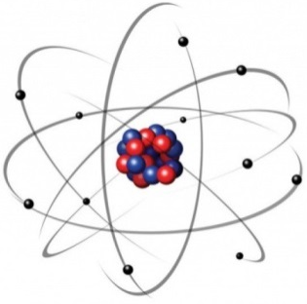
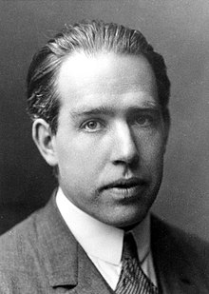
Niels Bohr (1913)
- Reasoned that atoms must have different energy levels that electro ns can occupy.
- Electrons can move between energy levels by emitting or absorbing energy.
- Electrons could not exist in between energy levels.
- Also found that these energy levels can only support/hold a certain number of electrons.
Current Working Model: Protons and neutrons are together in nucleus to form a positive central core. Electrons occupy space around nucleus in orbitals.
Particle Short Hand Symbols: Proton = p⁺ Neutron = nº Electron = e⁻
Miss Foley
Sci10: CR2 Chemical Symbols Atomic Theories

Electron Orbital Levels
  - Electrons always occupy the lowest possible energy level.
  - There is a maximum number of electrons for each energy level, given by 2n2, where n is the unknown energy level (principal quantum number).
  - The outermost occupied energy level always has a maximum of 8 electrons, regardless of what level or sub-level it is. These outside electrons are known as and referred to as valence electrons.
- Sub-levels: s level holds 2 electrons d level holds 10 electrons
p level holds 6 electrons f level holds 14 electrons
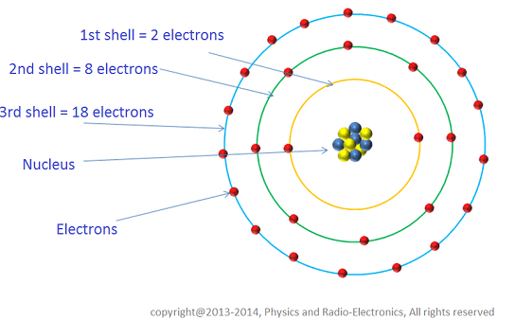
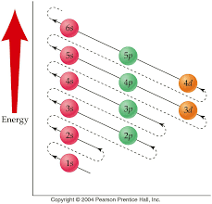
4th Energy Shell Sub-Levels:
4s – 2 electrons
4p – 6 electrons
4d – 10 electrons
4f – 14 electrons
3rd Energy Shell Sub-Levels:
3s – 2 electrons
3p – 6 electrons
3d – 10 electrons
2nd Energy Shell Sub-Levels:
2s – 2 electrons
2p – 6 electrons
1st Energy Shell Sub-Levels:
1s – 2 electrons
Miss Foley
Sci10: CR2 Chemical Symbols Atomic Theories

Bohr Model Template

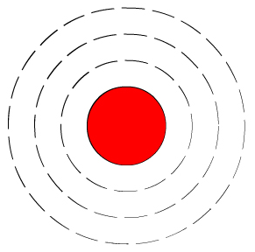
4f¹⁴
4d¹⁰
4p⁶²
4s²
3p⁶
3d¹⁰⁰
3s²
2s²
2p⁶
1s²

Name: ____________________ Date: _________
Sci10: CR2 Chemical Symbols Atomic Theories

Ionic Charges & Chemical Families
ALKALI METALS
Element Name |  | Element Symbol |  | Bohr Diagram of Atom | # Valence Electrons | Bohr Diagram of Stable Ion | Ionic Charge
ALKALINE EARTH METALS
Element Name | Element Symbol |  | Bohr Diagram of Atom |  | # Valence Electrons | Bohr Diagram of Stable Ion | Ionic Charge
Name: ____________________ Date: _________
Sci10: CR2 Chemical Symbols Atomic Theories

Ionic Charges & Chemical Families
HALOGENS
Element Name | Element Symbol |  | Bohr Diagram of Atom |  | # Valence Electrons | Bohr Diagram of Stable Ion |  |  | Ionic Charge
NOBLE/INERT GASES
Element Name |  | Element Symbol |  | Bohr Diagram of Atom |  |  | # Valence Electrons | Will Atom Form An Ion?

Name: ____________________ Date: _________
Sci10: CR2 Chemical Symbols Atomic Theories

Ionic Charges & Chemical Families
METALLIC ELEMENTS
Element Name |  | Element Symbol |  | Bohr Diagram of Atom | # Valence Electrons | Tendency To Gain or Lose Electrons | Ionic Symbol
sodium

magnesium

aluminum

NONMETALLIC ELEMENTS
Element Name | Element Symbol |  | Bohr Diagram of Atom |  | # Valence Electrons | Tendency to Gain or Lose Electrons | Ionic Symbol
nitrogen

oxygen

fluorine

Name: ____________________ Date: _________
Sci10: CR2 Chemical Symbols Atomic Theories

Miss Foley
Sci10: CR2 Chemical Symbols Sign My Petition?

Ban dihydrogen monoxide! The Invisible Killer
Dihydrogen monoxide is colorless, odorless, tasteless, and kills uncounted thousands of people every year. Most of these deaths are caused by accidental inhalation of DHMO, but the dangers of dihydrogen monoxide do not end there. Prolonged exposure to its solid form causes severe tissue damage. Symptoms of DHMO ingestion can include excessive sweating and urination, and possibly a bloated feeling, nausea, vomiting and body electrolyte imbalance. For those who have become dependent, DHMO withdrawal means certain death.

Dihydrogen monoxide:
- is also known as hydric acid and is a major component of acid rain.
- contributes to the “greenhouse effect”.
- contributes to the erosion of our natural landscape.
- accelerates corrosion and rusting of many metals.
- may cause electrical failures and decreased effectiveness of automobile brakes.
- has been found in excised tumors of terminal caner patients.

CONTAMINATION IS REACHING EPIDEMIC PROPORTIONS!

Quantities of dihydrogen monoxide have been found in almost every stream, lake, and reservoir in America today. The pollution is global, and the contaminant has even been found in Antarctic ice. In the Midwest alone DHMO has caused millions of dollars of property damage.

Despite the danger, dihydrogen monoxide is often used:
- as an industrial solvent and coolant.
- in nuclear power plants.
- in the production of Styrofoam.
- as a fire retardant.
- in many forms of cruel animal research.
- in the distribution of pesticides. Even after washing, produce remains contaminated by this chemical.
- as an additive in certain “junk-foods” and other food products.

Companies dump waste DHMO into rivers and the ocean, and nothing can be done to stop them because this practice is still legal. The impact of wildlife is extreme, and we cannot afford to ignore it any longer!

IT’S NOT TOO LATE!

Act NOW to prevent further contamination. Find out more about this dangerous chemical. What you don’t know can hurt you and others throughout the world.

- Read the above article completely. It would be very costly to “clean up” this substance. Do you feel that the expense is justified? Support your answer.

Miss Foley
Sci10: CR2 Chemical Symbols Naming & Formulas

Binary Covalent Compounds
Atoms can become more stable by sharing electrons (rather than fully gaining or losing them like ionic compounds) thus forming covalent bonds. Covalent bonds are more common than ionic bonds in the molecules of living organisms.
For instance, covalent bonds are key to the structure of carbon-based organic molecules like our DNA and proteins. Covalent bonds are also found in smaller inorganic molecules, such as H_{2​}O, O₂, and CO₂​. One, two, or three pairs of electrons may be shared between atoms, resulting in single, double, or triple bonds, respectively. The more electrons that are shared between two atoms, the stronger their bond will be.
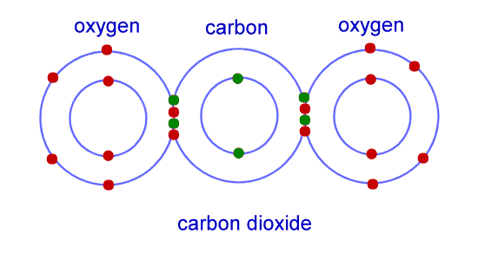
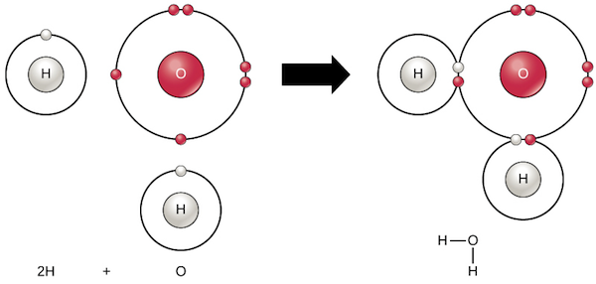
A single water molecule, H₂O, consists of two hydrogen atoms bonded to one oxygen atom. Each hydrogen atom shares an electron with oxygen, and oxygen shares one of its electrons with each hydrogen atom:

The shared electrons split their time between the valence shells of the hydrogen and oxygen atoms, giving each atom something resembling a complete valence shell (two electrons for H, eight for O). This makes a water molecule much more stable than its component atoms would have been left on their own.
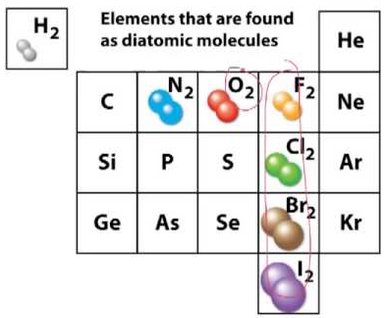
Diatomic Elements =
2 identical elements
that are more stable
bonded together
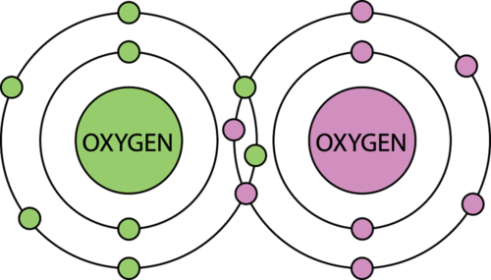

Miss Foley
Sci10: CR2 Chemical Symbols Naming & Formulas

Naming Covalent Compounds
Common
COVALENT
“Exceptions to the Rule”:
ammonia
NH₃
hydrogen peroxide
H₂O₂
methane
CH_{4( aq)}
water
H₂O
  - The order of the name is in increasing order of the group number (except for hydrogen) – this means the element farthest to the left or bottom of the periodic table goes first in the chemical name.
  - Write the entire name of the first element. Write the name of the second element making sure to change the ending of the second element to “-ide”.
  - Use a prefix to indicate the number of each type of atom in the molecule. If only one atom is present, you can use the pre-fix “mono” or leave it blank.
Reminder: All chemical compounds names are written in lower case!
Writing Covalent Formulas
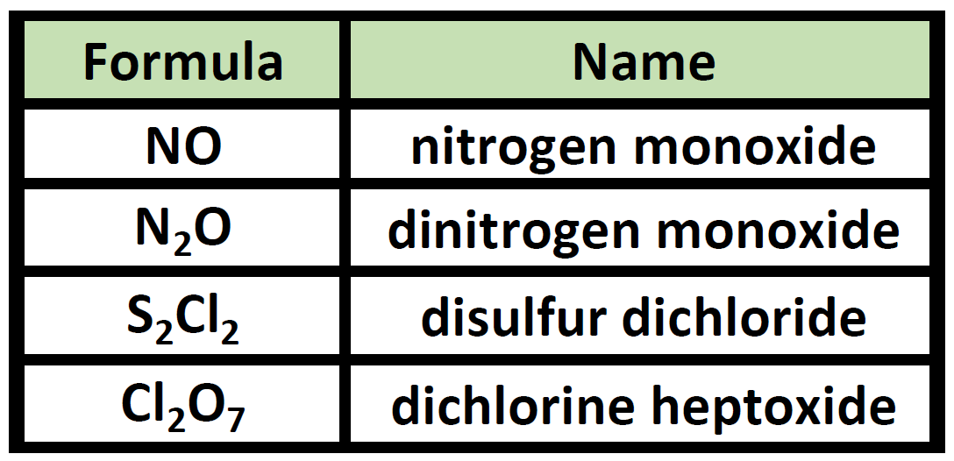
- Write symbols for the elements in the same order as they appear in the name.
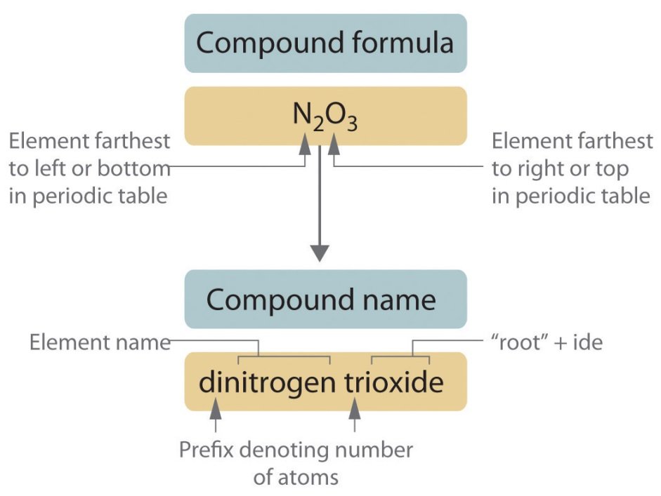
- Indicate the number of each type of atom in the formula using subscripts after the atomic symbol. The numbers of atoms are represented by the Greek pre-fixes used in the chemical name. Omit the subscript when only one atom is present.
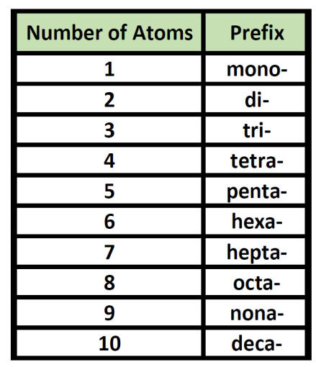
Miss Foley
Sci10: CR2 Chemical Symbols Naming & Formulas

Miss Foley
Sci10: CR2 Chemical Symbols Naming & Formulas

Naming Compounds: Covalent

Compound | Chemical Name
1. CO
2. SO₃
3. P₂O₅
4. NO₂
5. BCl₃
6. CS₂
7. N₂O₃
8. P₄S₁₀
9. SCl₂
10. CCl₄
11. SiO₂
12. N₂F₄
13. IF₇
14. SCl₄
15. P₂O₅
16. BrF₅
17. CSe₂
18. S₂Cl₂
19. NCl₃
20. SF₆

Miss Foley
Sci10: CR2 Chemical Symbols Naming & Formulas

Writing Formulas: Covalent

Chemical Name | Compound
- diphosphorous pentachloride
2. silicon decacarbide
3. octasulfur trioxide
4. boron tribromide
5. dinitrogen oxide
6. hexacarbon monoxide
7. phosphorous tetrahydride
8. water
9. dibromine tetraiodide
10. dinitrogen heptachloride
11. ammonia
12. carbon tetrachloride
13. trihydrogen monophosphide
14. pentaphosphorous octafluoride
15. hydrogen peroxide
16. bromine hexachloride
17. decacarbon diselenide
18. sulfur trichloride
19. methane
20. oxygen pentabromide

Miss Foley
Sci10: CR2 Chemical Symbols Naming & Formulas

Binary Ionic Compounds
Atoms can become more stable by gaining or losing an electron(s) - rather than sharing them like covalent compounds - thus forming ionic bonds. When they do so, atoms form ions (charged particles). Electron gain or loss can give an atom a filled outermost electron shell and make it energetically more stable.
Cation = positively (+) charged ion Anion = negatively (-) charged ion
Ionic compounds occur when a metal (+ ion) and a non-metal (- ion) are attracted to each other (opposite charges attract) forming a new molecule. Metals have a tendency to lose electrons and non-metals have a tendency to gain electrons when forming ionic bonds leaving both elements stable with full outer electron structures.
When one atom loses an electron and another atom gains that electron, the process is called electron transfer. Sodium and chlorine atoms provide a good example of electron transfer. Sodium (Na) only has one electron in its outer electron shell, so it is easier (more energetically favorable) for sodium to donate that one electron than to find seven more electrons to fill the outer shell. Because of this, sodium tends to lose its one electron, forming Na+. Chlorine (Cl), on the other hand, has seven electrons in its outer shell. In this case, it is easier for chlorine to gain one electron than to lose seven, so it tends to take on an electron and become Cl−.
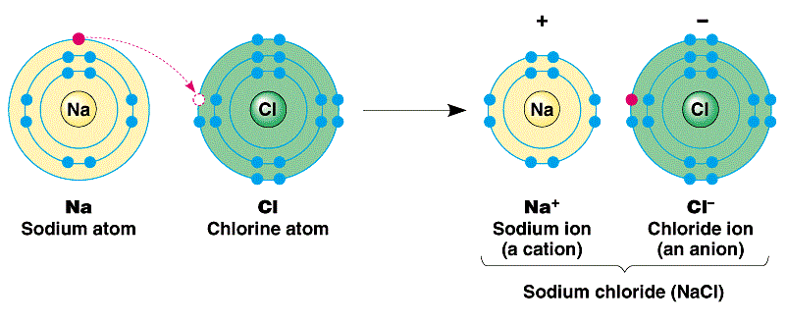
Sodium transfers one of its valence electrons to chlorine, resulting in formation of a sodium ion (with no electrons in its 3n shell, meaning a full 2n shell) and a chloride ion (with eight electrons in its 3n shell, giving it a stable outer shell). When sodium and chlorine are combined, sodium will donate its one electron to empty its shell, and chlorine will accept that electron to fill its shell. Both ions now satisfy the octet rule – “rule of 8 valence electrons” - and have complete outermost shells. Because the number of electrons is no longer equal to the number of protons, each atom is now an ion and has a +1 (Na+) or –1 (Cl−) charge.
Miss Foley
Sci10: CR2 Chemical Symbols Naming & Formulas

Naming Ionic Compounds
- Is the compound ionic? If yes…continue to #2.
- Write the cation name first – then write the anion name. Monoatomic anions (one element) use the suffix “-ide”. Polyatomic anions (more than one element) often use suffixes “-ate” or “-ite”. Names of polyatomic anions (more than one element) can be found in the Charges of Common Ions Table found on the back of your periodic table. When there is more than one of a polyatomic ion in the formula we use parenthesis. Example: Mg(NO₃)₂
- If the cation is a transition metal that has various charge options, write the charge using parenthesis and Roman numerals after the metal name. Example: Cu⁺² is written as copper (II).
Reminder: All chemical compounds names are written in lower case!
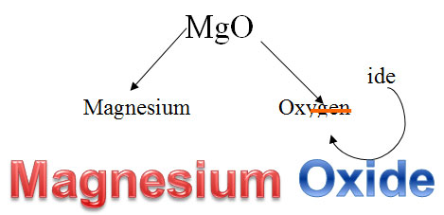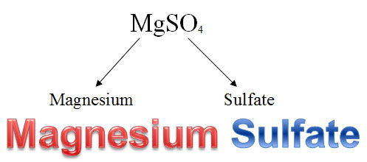
Monoatomic Anion
Polyatomic Anion

Examples: Fe₂(SO₄)₃ chemical name is iron(III) sulfate
NaCl chemical name is sodium chloride
Cu(OH)₂ chemical name is copper(II) hydroxide

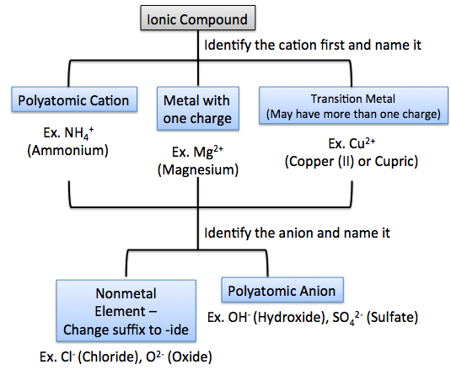
Common
IONIC
“Exceptions to the Rule”:
nitric acid
HNO_{3 (aq)}
carbonic acid
H₂CO_{3( aq)}
sulfuric acid
H₂SO_{4( aq)}
phosphoric acid
H₃PO_{4( aq)}

Miss Foley
Sci10: CR2 Chemical Symbols Naming & Formulas

Writing Ionic Formulas

- Write the symbol/formula of the cation in the compound’s name – then write the symbol/formula of the anion in the compound’s name.
- Balance the ion charges within the compound. Do this by indicating the ratio of each ion in the compound using subscripts after each ion. Always represent the ratio of ions using the lowest ratio.
- Remember when using polyatomic ions to use the overall polyatomic charge.
Example: aluminum (III) sulfide
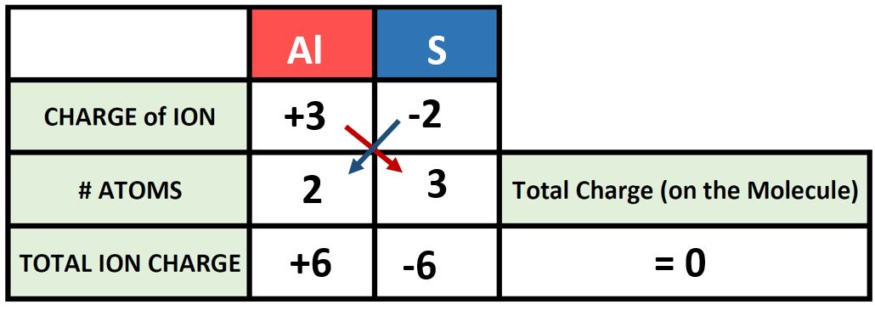
Answer:
Al₂S₃

Example: sodium phosphate
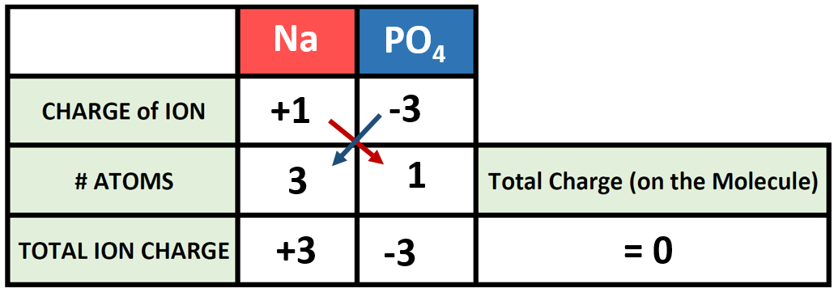
Answer:
Na₃PO₄

Example: iron (III) sulfate
Answer:
____________
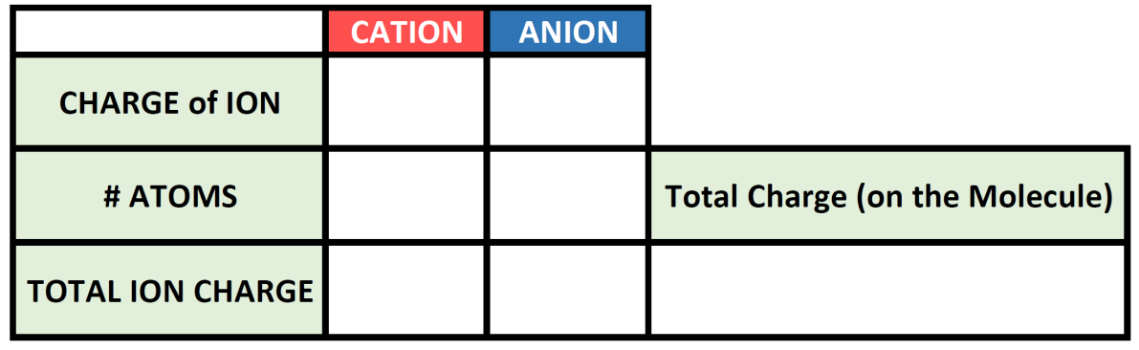

Miss Foley
Sci10: CR2 Chemical Symbols

Miss Foley
Sci10: CR2 Chemical Symbols Naming & Formulas

Naming Compounds: Ionic
Compound |  | Chemical Name | Compound |  | Chemical Name
1. | NaOH |  | 20. | K₂O
2. | K₂SO₄ |  | 21. | NH₄OH
3. | PbSO₄ |  | 22. | AlF₃
4. | KBr |  | 23. | Ag₂S
5. | SnCl₂ |  | 24. | Na₄F
6. | LiNO₃ |  | 25. | CaBr₂
7. | MgCl₂ |  | 26. | Na₃P
8. | CaCrO₄ |  | 27. | Li₂CO₃
9. | CuI |  | 28. | Ni₃(PO₄)₂
10. | NH₄NO₃ |  | 29. | FeCl₃
11. | Na₂O |  | 30. | MnSO₄
12. | Ba(OH)₂ |  | 31. | CaSO₄
13. | SnO₂ |  | 32. | K₃N
14. | FeSO₃ |  | 33. | NH₄Cl
15. | NaCl |  | 34. | KF
16. | Cu₃N₂ |  | 35. | Cr(ClO₃)₂
17. | BeCl₃ |  | 36. | Na₃P
18. | FeF₃ |  | 37. | B(NO₃)₃
19. | CaS |  | 38. | AlI₃
Miss Foley
Sci10: CR2 Chemical Symbols Naming & Formulas

Writing Formulas: Ionic
Chemical Name | Cation | Anion | Chemical Formula
1. ferrous nitrate
2. magnesium chloride
3. calcium oxide
4. lead (IV) sulfide
6. sodium sulfate
8. potassium chloride
9. manganese (IV) sulfide
10. lithium fluoride
11. magnesium bromide
12. tin (II) hydroxide
13. aluminum nitride
15. zinc oxide
17. sodium bromide
18. cupric carbonate
19. barium sulfide
20. sodium hydroxide
Name: ____________________ Date: _________
Sci10: CR2 Chemical Symbols Ionic/Covalent Compounds

Challenge: Formulas & Naming _____ /38 = ______%
Compound |  | Chemical Name | Compound |  | Chemical Name
1. | MgO |  | 20. |  | iron(III) chloride
2. |  | aluminum chloride | 21. |  | sodium bicarbonate
3. | BeF |  | 22. | I₂
4. | CO₂ |  | 23. |  | sodium chlorate
5. |  | calcium bromide | 24. |  | hydrogen
6. |  | hydrogen peroxide | 25. | PbF₄
7. | Fe₃(PO₄)₂ |  | 26. | NO
8. |  | oxygen | 27. |  | beryllium sulfate
9. | Mg₃N₂ |  | 28. | NH₃
10. | PCl₅ |  | 29. |  | dinitrogen pentachloride
11. |  | sulfuric acid | 30. | FeO
12. | H₂O |  | 31. |  | chlorine
13. | CF₄ |  | 32. | P₂O₅
14. |  | aluminum sulfide | 33. | NaOH
15. | SiC |  | 34. |  | calcium nitride
16. | N₂O₄ |  | 35. | Pb(NO₃)₃
17. |  | arsenic tribromide | 36. |  | methane
18. | CuBr₂ |  | 37. | Al(NO₃)₃
19. |  | silicon dioxide | 38. |  | copper nitrate
Name: ____________________ Date: _________
Sci10: CR2 Chemical Symbols Ionic/Covalent Compounds

Miss Foley
Sci10: CR2 Chemical Equations Balancing Equations

Word Equations =
chemical reactions represented with words
that include states of matter using subscripts
Solid = _{(s)} Liquid = _{(l)} Gas = _{(g)} Aqueous = _{(aq)} (a.k.a. solute dissolved in water = solution)
Example: Iron reacts with oxygen in the air to form rust (iron oxide)
iron_{(s)} + oxygen_{(g)} → iron oxide_{(s)}

1. When zinc metal and sulfur powder are heated, they form solid zinc sulfide.

2. When octane is burned in an excess of oxygen, carbon dioxide and water vapor produced.

3. When a solution of table salt and a solution of silver nitrate are mixed together, white particles of silver chloride are formed in a solution of sodium nitrate.

4. Zinc metal plus oxygen gas produces solid zinc oxide.

5. When sodium metal is placed in a beaker of water, hydrogen gas and sodium hydroxide solution are formed.

6. When zinc metal is placed in a solution of hydrochloric acid, hydrogen gas and a zinc chloride solution are formed.

7. Methane combines with oxygen to produce water and carbon dioxide.

8. Hydrochloric acid is poured over some marble chips (calcium carbonate) producing bubbling carbon dioxide gas and water.

9. A solution of hydrochloric acid reacts with a solid calcium carbonate to produce water, carbon dioxide and calcium chloride.

10. Calcium metal reacts with water to form calcium hydroxide and hydrogen gas.
Miss Foley
Sci10: CR2 Chemical Equations Balancing Equations

Miss Foley
Sci10: CR2 Chemical Equations Balancing Equations
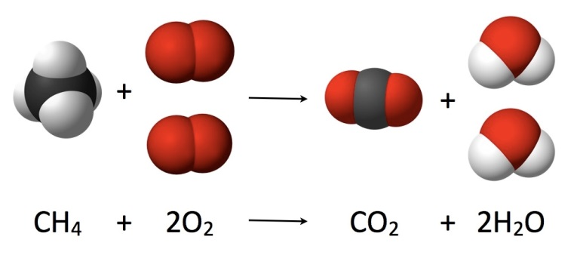
Law of Conservation
of Mass =
total mass of reactants equals total mass of products

Matter cannot be created or destroyed, only recycled. Therefore, mass must ALWAYS be conserved in any physical or chemical change. Since all matter has mass the mass of the reactants must equal the mass of the products. This is why we balance equations - to ensure that this law is visually represented in how we represent chemical reactions on paper.
Reactant
Products
Formula
Coefficient
Subscript
States of Matter

2HgO_{(s)} 2Hg_{(l)} + O_{2(g)}

Reminder:
Coefficients – represents how many molecules are present
Formulas - represents the chemical structure of bonded atoms
Subscript Numbers – represents how many atoms are present in one molecule
Subscript Letters – represents physical state of matter
Addition Sign – represent reacting atoms/molecules and separate products
Arrow – represents chemical reaction has taken place; catalysts are listed above the arrow
Molecules Left of Arrow – reactants going INTO the chemical reaction
Molecules Right of Arrow – products coming OUT of the chemical reaction

Balancing Chemical Equations
- Write correct chemical formula for each reactant & product, including the state of matter.
- Identify & count individual atoms involved in the reaction on both the reactant and product side.
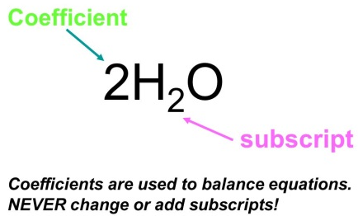
- Using coefficients ONLY start balancing atoms present in the greatest number to get equal numbers of atoms on both sides.
NOTE: Leave hydrogen atoms & oxygen atoms to the end. They often occur alone, or in water, so it is easier to adjust them at the end without affecting other compounds.
- Repeat step 3 balancing remaining unbalanced atoms.
- Be sure that the coefficients are represented in their lowest form and can’t be reduced by a common divisor.
Miss Foley
Sci10: CR2 Chemical Equations Balancing Equations

Balancing Chemical Equations: Example
Iron metal is added to chlorine gas to form iron chloride metal.
- Write correct chemical formula for each reactant & product, including the state of matter.
Fe_{(s)} + Cl_{2(g)} FeCl_{3(s)}
- Identify & count individual atoms involved in the reaction on both the reactant and product side.
Fe - 1 Fe – 1
Cl - 2 Cl - 3
- Using coefficients ONLY start balancing atoms present in the greatest number to get equal numbers of atoms on both sides. NOTE: Leave hydrogen atoms & oxygen atoms to the end. They often occur alone, or in water, so it is easier to adjust them at the end without affecting other compounds.
Fe_{(s)} + 3Cl_{2(g)} 2FeCl_{3(s)}
Fe - 1 Fe – 2
Cl – 2 6 Cl – 3 6
- Repeat step 3 balancing remaining unbalanced atoms.
2Fe_{(s)} + 3Cl_{2(g)} 2FeCl_{3(s)}
Fe – 1 2 Fe – 2
Cl – 2 6 Cl – 3 6
- Be sure that the coefficients are represented in their lowest form and can’t be reduced by a common divisor.

There are no common divisors - they are in their lowest form.

Therefore, the balanced equation is:

2Fe_{(s)} + 3Cl_{2(g)} 2FeCl_{3(s)}
Miss Foley
Sci10: CR2 Chemical Equations Balancing Equations

Balancing Equations: Worksheet #1

FINISH!!!!!!!!!

Miss Foley
Sci10: CR2 Chemical Equations Balancing Equations

Balancing Equations: Worksheet #2

FINISH!!!!!!!!!!!!!!!

Name: ____________________ Date: _________
Sci10: CR2 Chemical Equations Balancing Equations

Challenge: Balancing Equations _____ /10 = _____%
Part A: Write a word equation for each of the following.
- When zinc metal is placed in a solution of hydrochloric acid, hydrogen gas and a zinc chloride solution are formed.

- Calcium metal reacts with water to form a solution of calcium hydroxide and hydrogen gas.

Part B: Balance the following equations.
- Al + Br₂ AlBr₃
- Li + S Li₂S
- Mg + N₂ Mg₃N₂
- Na + H₂O NaOH + H₂
- Na + HCl H₂ + NaCl
Part C: Write and balance the following word equations.
- iron + oxygen iron(III) oxide
______________________________________________________________________________________________
- nitrogen + hydrogen ammonia (NH₃)
______________________________________________________________________________________________
- barium chloride + magnesium sulfate barium sulfate + magnesium chloride
______________________________________________________________________________________________
Name: ____________________ Date: _________
Sci10: CR2 Chemical Equations Balancing Equations

Name: ____________________ Date: _________
Sci10: CR2 Chemical Equations Investigation

Conservation of Mass Lab _____ /36 = _____%
In this investigation you compare the total mass of the products formed in a chemical reaction with the total mass of the reactants.

Materials:
Balance/Digital Scale
Erlenmeyer flask and stopper
Small test tube
Solutions of each of the following: lead nitrate, potassium iodide, copper sulfate, sodium hydroxide, barium chloride, sodium sulfate

Procedure:
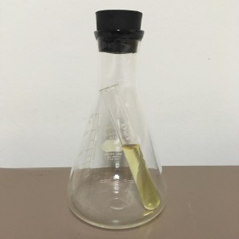
- Use the table below to record your results. The procedures for all three reactions are the same. Your teacher will tell you which reaction(s) to do.
- Half-fill the small test tube with one of the solutions.
- Pour 10mL of the other solution into the Erlenmeyer flask.
- Carefully slide the small test tube and contents into the flask (see figure).
- Put the stopper in the flask. Record a description of the reactants.
CAUTION: Avoid contact of solutions with eyes, skin and clothing.
Rinse thoroughly with water if an accident does happen.
- Find the mass of the entire assembly. Record the mass in the “Mass of Reactants” column.
- Remove the assembly from the balance or digital scale. Do not adjust the balance if using a balance scale. Invert the assembly and swirl the contents to mix the solutions.
- Return the assembly to the balance/digital scale and find its mass.
- Record a description of the reaction and the products. Note the mass and record it in the “Mass of Products” column.

Table: Conservation of Mass (12 marks)
Reaction # | Names of Reactants | Description of  Reactants | Mass of Reactants (g) | Description of  Reaction & Products | Mass of Products (g)
1 | lead nitrate (aq)  potassium iodide (aq)
2 | copper sulfate (aq)  sodium hydroxide (aq)
3 | barium chloride (aq)  sodium sulfate (aq)
Name: ____________________ Date: _________
Sci10: CR2 Chemical Equations Investigation

Discussion Questions:
- For each reaction explain how you know that a chemical change was involved. (3 marks)
Reaction #1 –

Reaction #2 –

Reaction #3 –

- Make ONE (1) generalized statement that reflects your results for all three reactions. Do your results support the Law of Conservation of Mass? (2 marks)

- Predict the mass of sulfur trioxide produced when 100g of sulfur reacts with 150g of oxygen.
Write the word equation for the reaction. (2 marks)

- When 80g of sulfur trioxide reacts with water, 98g of sulfuric acid is formed. What mass of water is required? Write the word equation for the reaction. (2 marks)

- Represent each of the reactions correctly as chemical equations: (5 marks each)
  - Reaction #1 - A solution of lead nitrate is mixed with a solution of potassium iodide, making a lead iodide precipitate and a solution of potassium nitrate.

  - Reaction #2 - A solution of copper sulfate is combined with a solution of sodium hydroxide which makes solid copper hydroxide and a solution of sodium sulfate.

  - Reaction #3 - A solution of barium chloride combines with a solution of sodium sulfate to make a solution of sodium chloride and barium sulfate precipitate.

Miss Foley
Sci10: CR2 Chemical Equations Investigation

Conservation of Mass Lab:
Mixing Chemicals Teacher Prep
Chemical | Pb  Atomic Mass | 2N  Atomic Mass | 6O  Atomic Mass | g/mol/L | divide by 10 = g/0.1mol/L
lead nitrate_{(aq)}  Pb(NO₃)₂ | 207.19 amu | 2(14.01)=28.02 amu | 6(16.00)=96.00 amu | 331.21 | 33.12

Chemical | K  Atomic Mass | I  Atomic Mass | g/mol/L | divide by 10 = g/0.1mol/L
potassium iodide_{(aq)}  KI | 39.10 amu | 126.90 amu | 166.00 | 16.60

Chemical | Cu  Atomic Mass | S  Atomic Mass | 4O  Atomic Mass | g/mol/L | divide by 10 = g/0.1mol/L
copper sulfate_{(aq)}  CuSO₄ | 63.55 amu | 32.06 amu | 4(16.00)=64.00 amu | 159.61 | 15.96

Chemical | Na  Atomic Mass | O  Atomic Mass | H  Atomic Mass | g/mol/L | divide by 10 = g/0.1mol/L
sodium hydroxide_{(aq)}  NaOH | 22.99 amu | 16.00 amu | 1.01 amu | 40.00 | 4.00

Chemical | Ba  Atomic Mass | 2Cl  Atomic Mass | g/mol/L | divide by 10 = g/0.1mol/L
barium chloride_{(aq)}  BaCl₂ | 137.33 amu | 2(35.45) = 70.90 amu | 208.23 | 20.80

Compound | 2Na  Atomic Mass | S  Atomic Mass | 4O  Atomic Mass | g/mol/L | divide by 10 = g/0.1mol/L
sodium sulfate_{(aq)}  Na₂SO₄ | 2(22.99)=45.98 amu | 32.06 amu | 4(16.00)=64.00 amu | 142.04 | 14.20

Miss Foley
Sci10: CR2 Chemical Equations Investigation

Miss Foley
Sci10: CR3 Organic Compounds Hydrocarbons

Organic Compounds =
molecular substances that contain carbon atoms
The simplest organic compound is methane (CH₄) and there are literally tens of thousands different organic compounds. Carbon is contained in more compounds than all of the other elements put together due to its capacity to either gain 4 electrons OR lose 4 electrons when bonding with other elements to fill its valence electron structure. Carbon easily combines with other non-metals, especially hydrogen, oxygen, and nitrogen to form very stable compounds. Plants build the following organic molecules through photosynthesis:
Carbohydrates – contain C, H, O elements
Starches – contain C, H, O elements
Fats – contain C, H, O (less oxygen) elements
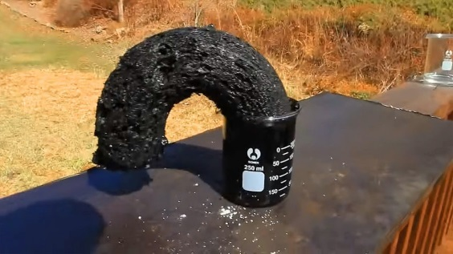
Proteins – contain C, H, O, N elements
How to Create "Black Snakes" Through Chemistry
Basically, put ordinary table sugar (C₆H₁₂O₁₁) in a glass beaker and stir in some concentrated sulfuric acid (H₂SO₄). The sulfuric acid removes water from the sugar in a highly exothermic reaction, releasing heat, steam, and sulfur oxide fumes. Aside from the sulfurous odor, the reaction smells a lot like caramel. The white sugar turns into a black carbonized tube that pushes itself out of the beaker.
How the Black Snakes Are Formed
Sugar is a carbohydrate, so when you r emove the water from the molecule, you're basically left with elemental carbon. Carbon, of course, is black. The dehydration reaction is a type of elimination reaction.
sugar_{(s)} + sulfuric acid_{(l)} → carbon_{(s)} + water(l) + sulfur dioxide
C₁₂H₂₂O₁₁ + H₂SO₄ → 12C + 11H₂O + SO₂ + energy
Although the sugar is dehydrated, the water isn't 'lost' in the reaction. Some of it remains as a liquid in the acid. Since the reaction is exothermic (heat-generating), much of the water is boiled off as steam.
Safety Precautions
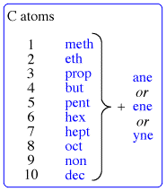
If you do this demonstration, use proper safety precautions. Whenever you deal with concentrated sulfuric acid, you should wear gloves, eye protection, and a lab coat. Avoid standing over the beaker during the experiment or inhaling the steam generated. After the beaker has cooled, you can pull out the carbon and remove the residue from the glassware with acetone. It's preferable to perform the demonstration inside of a fume hood.
Hydrocarbons =
compounds of hydrogen and carbon
found in many combinations
These mixtures of organic molecules were produced over millions of years as once-living plants and animals decayed and were changed by heat and pressure under the surface of the Earth. These substances are also called fossil fuels because of their origin in living matter. Examples of hydrocarbons include: methane (CH₄), propane (C₃H₈), butane (C₄H₁₀), petroleum, natural gas, crude oil, etc.
Miss Foley
Sci10: CR3 Organic Compounds Combustion

Combustion =
the rapid reaction of a substance with oxygen
to produce oxides and energy
(a.k.a. burning)

Most hydrocarbons originate from fossil fuels. The combustion of hydrocarbons powers cars/buses, warms homes, generates electricity, and even lights up candles on birthday cakes. The products of hydrocarbon combustion depends on the availability of oxygen.
Complete Combustion = uses ALL available oxygen
If oxygen is plentiful, hydrocarbons burn completely to release the energy they contain. This decomposition reaction always produces carbon dioxide and water. A strong, blue flame is often indicative of complete combustion. During complete combustion, fuels burn cleanly with NO sooty residue.
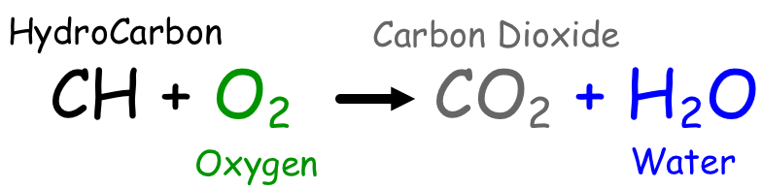
The complete combustion of hydrocarbons can be represented by the general equation:
C_{x}H_{y} + O₂ CO₂ + H₂O + energy
Methane Example: CH₄ + O₂ CO₂ + H₂O + energy
Propane Example: C₃H₈ + O₂ CO₂ + H₂O + energy
Incomplete Combustion = occurs when oxygen is limited
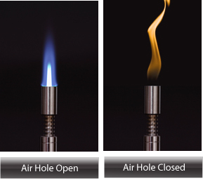
If the oxygen supply is limited, incomplete combustion may occur releasing carbon monoxide gas and carbon (soot) in addition to carbon dioxide and water. An orange, flickering flame and the presence of smoke is often indicative of incomplete combustion.
Carbon monoxide is an odourless, colourless gas that is highly toxic. Symptoms of carbon monoxide poisoning include headache, dizziness, nausea, and respiratory problems. Many people have died from inhaling carbon monoxide. It is often produced as a result of incomplete combustion of fuels in a confined space. Common examples are homes with a poorly ventilated furnace or in a closed garage with a running vehicle.
Soot is made up of particle of carbon and is evidence of incomplete combustion causing pollution and waste energy. Soot is common in older vehicles with poorly maintained engines. Forest fires also produce huge quantities of soot that can travel far downwind.
Miss Foley
Sci10: CR4 Reaction Rates Rates of Reaction

Indicators of Chemical Change
(a.k.a. A Chemical Reaction)

- Colour Change
- Odour/Gas Produced
- Temperature Change
- Heat/Light Produced
- Precipitate Formed
*Often Difficult to Reverse

Collision Model –
the rate of reaction is affected by the # of collisions between reactant molecules.

Two Ways To Increase Reactions:
- Increase the # of collisions
- Increase the fraction of collisions that are effective

Rates of Reaction
↑ Temperature = ↑ Reaction Rate
↑ Catalyst = ↑ Reaction Rate
↑ Concentration = ↑ Reaction Rate
↑ Pressure = ↑ Reaction Rate
↑ Surface Area = ↑ Reaction Rate
Miss Foley
Sci10: CR4 Reaction Rates Rates of Reaction

Indicators of Chemical Change
(a.k.a. A Chemical Reaction)

*Often Difficult to Reverse

Collision Model –

Two Ways To Increase Reactions:
- Increase the # of collisions
- Increase the fraction of collisions that are effective

Rates of Reaction
_____ Temperature = _____ Reaction Rate
_____ Catalyst = _____ Reaction Rate
_____ Concentration = _____ Reaction Rate
_____ Pressure = _____ Reaction Rate
_____ Surface Area = _____ Reaction Rate
Miss Foley
Sci10: CR5 Acids & Bases Acids & Bases

Acid - a compound that dissolves in water to form a solution with a pH lower than 7
Base - a compound that dissolves in water to form a solution with a pH greater than 7
Indicator - chemicals used to determine if a solution is an acid or a base
- litmus paper-derived from the lichens (symbiotic relationship between algae & fungus)
-turns red in acid -turns blue in a base
Universal Indicator - mixture of several indicators that change color as the acidity changes
Neutralization – acids and bases reacting (losing their properties) to produce water and a salt
Neutralization = Acid + Base → Water + Salt
Acids | Bases (a.k.a. alkaline)
Sour tasting  Water soluble  Highly reactive  Good conductors of electricity  Chemical formulas begin with hydrogen (H)  Corrodes metals  Red Litmus Test Result  pH <7 | Bitter tasting  Water soluble  Feel slippery when aqueous  Good conductors of electricity  Chemical formulas generally contain hydroxide (OH)  No reaction with metals  Blue Litmus Test Result  pH >7
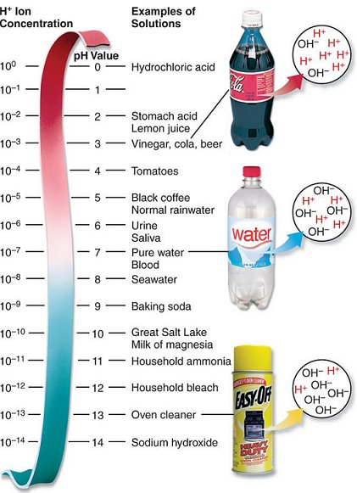

pH Scale
- Represents how acidic or basic a solution is.
- Measures the “Presence of Hydrogen Ions” = concentration of hydrogen ions in a solution.
- Very acidic has < 7 pH value = higher H⁺ ions and lower OH⁻ ions
- Very basic has > 7 pH value = lower H⁺ ions and higher OH⁻ ions
- Neutral has pH value = 7 on a scale of 0 -14.
- Every step on the scale represents a 10 times difference (increase/decrease).
Miss Foley
Sci10: CR5 Acids & Bases Acids & Bases

Miss Foley
Sci10: CR5 Acids & Bases Acids & Bases

pH & Human Nutrition
The closer the pH is to 7.35 - 7.45, the higher you’re level of health and well-being and your ability to resist states of disease will be.
Deviations above or below a 7.35 -7.45 pH range in the blood can signal potentially serious and dangerous symptoms or states of disease. When the body can no longer effectively neutralize and eliminate the acids it relocates them within the body’s extra-cellular fluids and connective tissue cells directly compromising the integrity of your cells.
Indeed the entire metabolic process depends on a balanced pH. As more acid wastes back up, and the body slowly stews in its poisonous wastes, a chronically over acidic body pH corrodes body tissue, slowly eating into the 60,000 miles of our veins and arteries like acid eating into marble. This is what science calls hemorrhage. If left unchecked, it will interrupt all cellular activities and functions from the beating of your heart to the neuro firing of your brain.
Over acidification interferes with life itself, leading to all sickness and “dis-ease.” Fundamentally, all regulatory mechanisms, including breathing, ingestion, circulation, hormone production, neurotransmitter release, etc., serve the purpose of balancing pH by removing cells. When you eat food, it ferments, just the way a banana on your counter ferments from a green, to yellow, to brown, to black. The banana rots from the inside out, not from the outside in. That is why humans can look healthy from the outside but are rotting and decaying from the inside. This is what the medical community refers to as degenerative disease.
Ways My Body Fights To Maintain pH
All metabolic processes, including immunity, depend on a delicately balanced pH around 7.35 -7.45. These seven responses fight to maintain the homeostasis of this pH balance:
1) Using high pH bodily fluids such as water as a solvent to neutralize acid residues.
2) Pulling bicarbonate from the pancreas into the blood (an alkalizing agent). Bicarbonate ions are generated into the blood cells from carbon dioxide and diffuse into the plasma.
3) Protein buffers (glutathione, methionine, cystine, taurine to name a few) act as buffers inside cells to bind or neutralize acids during cellular chaos.
4.) Electrolyte buffers of sodium, calcium and potassium work in the blood, lymph, and extra-cellular and intracellular fluids to bind acids, which are then removed through the urine.
5.) Pulling stored calcium and magnesium from skeletal bones and teeth to neutralize blood acids. (The major reason why drinking pop decreases bone mass, especially when laying down the calcium for the rest of your life during puberty.)
6.) Filtration and elimination of acidic residues through the skin, urinary tract and respiration.
7.) Pushing blood acid residues and accumulated toxins into outer extremities as a storage bin away from vital organs. The wrist, joints, fingers, toes and skin are the major target areas to keep the toxins from saturating internal vital organs like the heart and lungs.
When all seven-protection phases are overwhelmed, the end result is accumulated acid residues at the cellular level, which drown out oxygen. With this acidic, low oxygen terrain, fungus, molds and parasites, cancer cells, etc., seek the diseased acid terrain as food.
Miss Foley
Sci10: CR5 Acids & Bases Acids & Bases

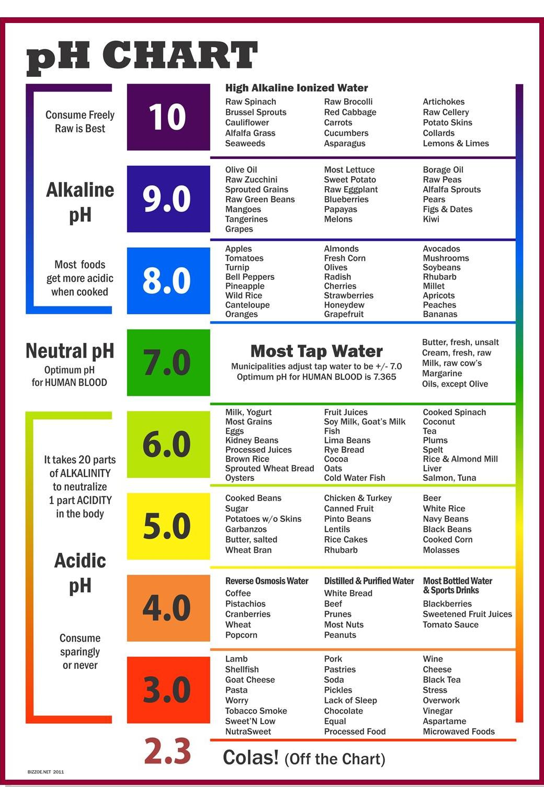
Miss Foley
Sci10: Chemical Reactions Study Guide

Chemical Reactions Unit Exam
STUDY GUIDE
- Define all italicized definitions found on Key Concepts Notes.
- WHMIS & Safety
  - what is it, its purpose, symbols, MSDS’s
  - classroom safety rules
  - household product’s symbols
- Define Physical vs. Chemical Change, identify and provide examples
- Define and compare Exothermic and Endothermic Reactions, identify examples
- Indicators of Chemical Change
- Factors that affect the Rate of Chemical Reactions
- The Periodic Table and how it is organized: Atomic number, families, periods, metals, non-metals, transition metals, how to find ionic charges, diatomic elements
- How many electrons, protons, neutrons are in each element
remember the relationship to the atomic number and atomic mass
- Counting atoms in compounds
  - remember if there are brackets, you multiply by the # outside by the one inside
- Determining Molecular Mass of compounds
- the # of atoms X atomic mass of the element
- add up the totals of each element
- do not forget the units (g/mol)
- Identifying Ionic and Molecular Compounds
- the difference between them, define and be able to pick out what type of compound it is based on the name or formula
Miss Foley
Sci10: Chemical Reactions Study Guide

- Naming Ionic Compounds
- Transition Metals need the extra step- you have to find the charge then place it in brackets in roman numerals
- Naming Molecular Compounds
- use Greek prefixes (must have these memorized)
- Writing Chemical Formulas of Ionic and Molecular Compounds
- find charge of metal and non-metal making balanced formula
- using Greek prefixes
- know which rules to use for which type of compound

- Balancing Chemical Equations
- know the Law of Conservation of Mass
- create word equations and change word equations into chemical equations
- using coefficients to balance reactions (remember the coefficient multiplies the # of original atoms)
- Show your work!
- Organic Compounds & Hydrocarbons
- define organic compounds
- define hydrocarbons
- define combustion by using general chemical equation
- compare and contrast complete and incomplete combustion
- Acids and Bases
- their properties and identifying them
- indicators
- pH scale, draw & label, what does it measure, how do you use it
- Neutralization
- Chemical equation for neutralization, reactants and products
- effect on pH

Miss Foley
Sci10: Force & Motion Outcomes & Indicators

Force and Motion in Our World (FM)
FM1: Explore the development of motion-related technologies and their impacts on self and society.
- Create a representation of different types of motion and motion-related technologies from various cultures, including First Nations and Métis.
- Describe how motion that may appear imperceptible to humans (e.g., continental drift, subatomic particles, light, blood circulating and galaxies) can be measured using appropriate technologies.
- Evaluate the historical development of a motion-related technology, including the role of continued testing in the development and improvement of the technology.
- Design, construct and evaluate a prototype of an object that meets a student-identified need related to motion.
- Evaluate the design and function of a motion-related technology using student-identified criteria such as safety, cost, availability and impact on everyday life and the environment.
- Describe examples of Canadian contributions to science and technology in motion-related fields such as transportation, sport science or space science.
FM2: Investigate and represent the motion of objects that travel at a constant speed in a straight line.
- Provide examples of objects that exhibit, or appear to exhibit, uniform motion.
- Discuss the concept of ‘frame of reference’ in determining whether an object is in motion and in constructing representations of an object’s motion.
- Construct scale diagrams of displacement vectors (i.e., collinear, non-collinear [perpendicular], and non-collinear [non-perpendicular]) to represent changes in an object’s position.
- Design and carry out experiments to determine the properties of uniform motion, using technologies such as photogates, motion detectors, ticker timers and stopwatches to collect distance and time data effectively and accurately.
- Discuss the importance of distinguishing between scalar (e.g., distance, speed and time) and vector (e.g., position, displacement, velocity and acceleration) quantities when studying motion.
- Construct and analyze graphs (i.e., distance-time, position-time, speed-time and velocity-time) using student-collected data obtained from objects undergoing uniform motion or through computer simulations.
- Describe quantitatively the relationship among distance, time and speed for everyday objects that undergo uniform motion.
- Derive the relationship between speed, distance and time (i.e., 𝑣 = ∆𝑑/∆𝑡) and between velocity, displacement and time (i.e., 𝑣⃗ = ∆𝑑⃗/∆𝑡 ) using student-collected data from objects undergoing uniform motion.
- Solve problems related to the motion of objects that travel at a constant speed in a straight line.
Miss Foley
Sci10: Force & Motion Outcomes & Indicators

FM3: Investigate and represent the motion of objects that undergo acceleration.
- Develop and carry out experiments to determine the properties of accelerated motion, including identifying variables to be tested, developing appropriate sampling procedures for data collection, collecting and recording data and analyzing data to generate conclusions.
- Evaluate the relevance, reliability and adequacy of data and data collection methods, including identifying and explaining sources of error and uncertainty in measurements.
- Apply the concept of ‘rate of change’ to operationally define speed, velocity and acceleration.
- Demonstrate the importance of converting measurements to the same units when solving motion problems.
- Differentiate between the concepts of instantaneous and average as they relate to speed and velocity.
- Construct and analyze graphs (i.e., distance-time, position-time, speed-time and velocity-time) that represent the motion of objects that undergo acceleration.
- Solve problems related to acceleration using the equations of motion (e.g., 𝑎⃗ =∆𝑣⃗/∆𝑡, ∆𝑑⃗= 𝑣⃗t + ½ 𝑎⃗∆𝑡²).
- Value the role and contribution of science and technology in understanding phenomena that are directly observable and those that are not.
FM4: Explore the relationship between force and motion for objects moving in one and two dimensions.
- Pose and refine scientific questions about the ways in which forces cause objects to move or change their motion.
- Investigate the effects of applying constant forces to objects at rest and to objects moving at a constant velocity in a straight line.
- Add force vectors in one and two dimensions (i.e., collinear, non-collinear [perpendicular] and non-collinear [non-perpendicular]) using vector diagrams to determine the net force acting on an object.
- Demonstrate the role of friction in changing the position and/or motion of an object.
- Provide examples of technologies that have been developed to increase or decrease frictional forces between two or more surfaces.
- Analyze student-collected data to verify the relationship between the acceleration of an object and the net force acting on it.
- Describe and provide examples of Newton’s three laws of motion in practical situations such as sports, flight and transportation.

Name: ____________________ Date: _________
Sci10: Force & Motion Definitions

PRE-Assessment: Definitions _____ /20 = _____%

_____ Uniform Motion
_____ Frame of Reference
_____ Rate of Change
_____ Position
_____ Distance
_____ Speed
_____ Instantaneous Speed
_____ Average Speed
_____ Acceleration
_____ Slope of a Distance –Time Graph
_____ Slope of a Speed-Time Graph
_____ Area under a Speed-Time Graph
_____ Uniformly Accelerated Motion
_____ Non-Uniform Motion
_____ Ticker Tape Timer
_____ Slope
_____ Velocity
_____ Position-Time Graph
_____ Uniform Acceleration Equation
_____ Equation for Uniform Motion

1. An object’s location relative to a reference point
2. The rate of change of distance of an object
3. What the observer measures motion to
4. Motion without a constant speed; the direction or speed changes
5. How fast the position of an object changes
6. Calculation of change in distance over a time interval for a moving object
7. Represents the speed of an object
8. Represents the change in distance of the object
9. A timing device which makes a series of dots on paper tape as it is pulled through a timer
10. On a distance-time graph it represents the speed on an object; on a speed-time graph it
represents the acceleration of an object
11. A graph that shows position on the vertical or y-axis and time on the horizontal or x-axis
12. Velocity equals change in distance over change in time
13. Motion at a constant speed in a straight line
14. Rate of change of an object’s speed; change in magnitude or change in direction of speed
15. Measures how fast a quantity changes per unit time
16. Length of path travelled between 2 points
17. The actual speed of an object at a particular instant in time
18. Represents the acceleration of the object
19. Increasing velocity at a constant rate
20. Acceleration equals change in velocity over change in time
Name: ____________________ Date: _________
Sci10: Force & Motion Definitions

Miss Foley
Sci10: Force & Motion OLD Key Concept Notes

*Definitions words are bold & italicized.
Unit Overview
- The motion of any object can be described by its position, direction of motion, and speed.
- That motion can be measured and represented on a graph or by the use of mathematical equations.
- All motion is relative to whatever reference point the observer chooses. Since everything in the universe is moving, there is no fixed reference point in space from which to measure all movement.
MW1: Explore motion-related technologies
- There is a distinction between science and technology, although they often overlap and depend on each other.
- Science deals with the generating and ordering of conceptual knowledge.
- Technology deals with the design, development, and application of scientific or technical knowledge, often in response to social and human needs.
- Some types of questions can lead to further understanding through scientific inquiry.
- Scientific knowledge is based on evidence, developed privately by individuals or groups, and is shared publicly with others.
- Scientific knowledge is tentative, and subject to change. It is not an absolute truth for all time.
- Scientific knowledge is a product of human creativity, critical thinking, and imagination.
MW2: Observe and describe the motion of everyday objects
- Motion at a constant speed in a straight line is called uniform motion.
- All motion is measured relative to some frame of reference chosen by the observer.
- Scientific knowledge is based on observation.
- An operational definition in the physical sciences explains how to measure the quantity being defined.
MW3: Investigate the relationship among distance, time, and speed for
objects that undergo uniform motion
- Rate of change is a measure of how fast a quantity changes per unit time.
- Position is an object's location relative to a reference point.
- Distance is the length of path traveled between two points.
- Speed is the rate of change of distance of an object.
- Instantaneous speed refers to the actual speed of an object at a particular instant in time.
- Average speed refers to a calculation of change in distance over a time interval for a moving object.
- All measurements are subject to uncertainty based on the limits of the measuring device.
- Designing scientific experiments involves planning a series of data-gathering operations that will provide a basis for testing a hypothesis or answering a question.
- Variables are controlled in scientific experiments in order to determine the effect of changing one variable on another variable.
- Interpreting data is a process based on finding patterns in a collection of data that leads to generalizations.
- Scientific results are reproducible if all other conditions are identical.
Miss Foley
Sci10: Force & Motion OLD Key Concept Notes

MW4: Investigate the relationship among speed, time, and acceleration
for objects that undergo uniformly accelerated motion
- Acceleration is the rate of change of an object's speed, which may be a change in magnitude of the speed or a change of direction of the speed. (The former is a topic of study in this unit; the latter is not.)
- The acceleration of an object may be in a direction that is different from the direction of its motion.
- Models (physical, mathematical, or conceptual) are simplified representations of real phenomena that facilitate a better understanding of some scientific concepts or principles.
- Hypothesizing is stating a tentative generalization that may explain a large number of events and that may be tested experimentally.
MW5: Analyze graphically and mathematically the relationship among
distance, speed, time, and acceleration for objects that undergo
simple linear motion or uniformly accelerated motion
- Uniform motion appears as a straight, sloped line on a distance-time graph and as a horizontal line on a speed-time graph.
- The slope of a distance-time graph represents the speed of the object.
- A useful equation for uniform motion is v = Δd/Δt
- Uniformly accelerated motion appears as a parabola on a distance-time graph and as a straight, sloped line on a speed-time graph.
- The slope of a speed-time graph represents the acceleration of the object.
- The area under a speed-time graph represents the change in distance of the object.
- Some useful equations for uniformly accelerated motion are:
a = Δv/Δt
Δd = v_{i} t + 1/2aΔt₂
- Numbers can convey important information in science and may be used to express physical relationships in an abstract format.

Miss Foley
Sci10: Force & Motion Measurement & Graphing

Distance
What are some units used to measure distance?

- Imperial (U.S.A.)

- Metric

What do you notice about all of the metric units?

- All of the units contain the __________________________________________________
- This is because the metric system ____________________________________________
- All of the other units are derived from _______________________________________________

- International System of Units (SI): a.k.a. the official name for the metric system includes:
Length – meter (m) Volume – liter (L) Mass – kilogram (kg)
Temperature – Kelvin (K) Time – seconds (s)
- Customary to SI Conversions:

Metric Unit Conversions for Distance
- We will ALWAYS use the metric system when we measure distance
- When using the metric system, it is very easy to convert between units
- Observe the image below to help you with metric conversions:

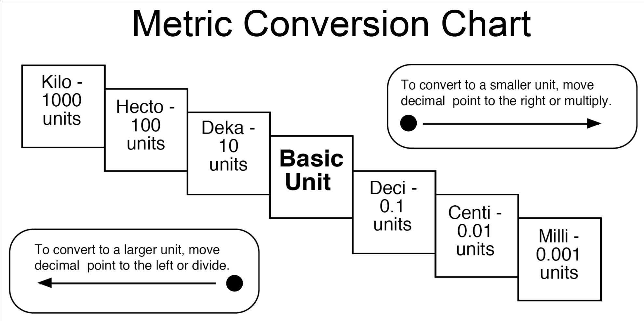

Miss Foley
Sci10: Force & Motion Measurement & Graphing

Metric Unit Conversions for Distance – Example 1

Convert 5123cm to km

- Step 1: Always write down the number you start with and its unit

- Step 2: Set up a multiplication with a fraction. Put the unit you want to get to on top and the unit you want to get rid of on the bottom.

- Step 3: Place a 1 beside the larger unit

- Step 4: Place the number of times the smaller unit can go into the larger unit beside the smaller unit (you can find that out from the “metric conversion chart:

- Step 5: Do the multiplication (top times top, bottom times bottom). Since there is cm on the top and bottom, they cancel out and you are left with your answer in the correct units

Metric Unit Conversions for Distance – Example 2

Convert 51 km to millimeters (mm)

Miss Foley
Sci10: Force & Motion Measurement & Graphing

Time
What are some units used to measure time?

- Large

- Medium

- Small

Conversions for Units of Time

- Unlike distance, time measurements do not follow the metric system

- Luckily, our life experience and common sense should help us:

  - 1 year = _________ days
  - 1 year = _________ months
  - 1 year = _________ weeks
  - 1 week = _________ days
  - 1 day = _________ hours
  - 1 hour = _________minutes
  - 1 minute = ________ seconds

Time Conversion Examples
Follow along with the examples. We will follow the same five steps that we used with the distance examples.

Convert 81 seconds into hours

Convert 365 days into seconds

Miss Foley
Sci10: Force & Motion Measurement & Graphing

Distance & Time Practice Questions
Distance:

- Convert the following distances to kilometers (km):

a) 105 m b) 82 mm

c) 1125 cm d) 0.0382 m

- Convert the following distances to meters (m):

a) 4307 mm b) 291 cm

c) 21 km d) 0.227 km

- Convert the following distances to centimeters (cm):

a) 0.12 mm b) 182 km

c) 45 m d) 0.27 km

Time:

- Convert the following times to hours (hr):

a) 108 seconds b) 5 days

c) 4 years d) 2 weeks

- Convert the following times to seconds (s):

a) 0.5 hours b) 5 days

c) 4 years d) 2 weeks
Miss Foley
Sci10: Force & Motion Measurement & Graphing

Measurement & Significant Digits
When you are communicating in science you should express how certain you are about your measurements. This is called the degree of certainty or uncertainty. Every measurement has uncertainty, so scientists have come up with ways to express their degree of certainty when stating their results. The certainty of a measurement is determined by how many certain digits (plus one) are obtained by the measuring instrument. Certainty is measured by the number of significant digits. These “certain plus one” digits are referred to as significant digits. Exact values (i.e. counting) and defined values (known ratios) are both considered to contain an infinite number of significant digits. Therefore when counting (6 students) or using a defined value (100 km/hr) these are exact values not measurements, hence significant digits not being applicable.
There is an international agreement about the correct way to record measurements:
record all those digits that are certain plus one uncertain digit, and no more.
* Always measure to and from center of dots when graphing plot points.
1 2 3 4
● ● ● ●
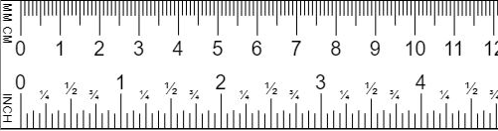

Certain Digits - Digits measured that ARE 100% accurate.
Uncertain Digits - Digits measured NOT 100% accurate. (i.e. estimated/possibly rounded)
Measurement #1: _____0.05 cm_____ Certain Digit(s): ___0.0____ Uncertain Digit(s): ____5_____
Measurement #1: _____0.7 mm_____ Certain Digit(s): ___0____ Uncertain Digit(s): ____7_____
Measurement #2: _____1.00 cm_____ Certain Digit(s): ___1.0____ Uncertain Digit(s): ____0_____
Measurement #3: _____3.15 cm_____ Certain Digit(s): ____3.1____ Uncertain Digit(s): ____5_____
Measurement #4: _____9.05 cm_____ Certain Digit(s): ___9.0____ Uncertain Digit(s): ____5_____
Significant Digits – all digits included in a stated value
(*excluding leading zeroes = zeroes following decimal before another number)
- Rounding Rule: If the digit after the digit to be retained as significant is 5 or more, round up. If the digit after the last significant digit is 4 or less, leave it as it is.
- Adding & Subtracting: When adding and/or subtracting measured values of known precision, the answer has the same number of decimal places as the measured value with the fewest decimal places.
- Multiplying & Dividing: When multiplying and/or dividing measured values of known precision, the answer has the same number of significant digits as the measurement with the fewest number of significant digits.
Miss Foley
Sci10: Force & Motion Measurement & Graphing

Measurements & Calculations

Example: What is the total distance travelled by a car when the following distances are recorded by
different individuals using a variety of instruments? (∆d = change in distance)
∆d₁ = 104.2 km ∆d₂ = 11 km ∆d₃ = 0.67 km
∆d_{t} = ∆d₁ + ∆d₂ + ∆d₃
= 104.2 km + 11 km + 0.67 km
= 115.87 km *Calculator based answer.
= 116 km *Proper significant digit based answer. The least precise
measurement is 11 km, since it has the fewest decimal places.

Example: Calculate the answer to the following question and state the answer with the correct certainty and units.
Using the equation $A=\frac{1}{2}bh$, and given b and h, find A.
b = 6.21 cm h = 8.0 cm
$A=\frac{1}{2} x 6.21 cm x 8.0 cm$
= 24.84 cm² * Calculator based answer.
= 25 cm² * Proper significant digit based answer. The measurement with the fewest
number of significant digits in the question was 8.0 cm.

Example: Calculate how long it takes for an intergalactic car to travel a round-trip route with times recorded by astronauts using a variety of instruments?
t₁ = 0.04216 s t₂ = 0.0041348 s
t_{total} = t₁ + t₂
t_{total} = 0.04216 s + 0.0004134 s
= 0.0462948 s * Calculator based answer.
= 0.04263 s *Proper significant digit based answer. The least precise measurement is 0.04216 s, since it has the fewest decimal places.

Complete on Loose-Leaf Paper & Hand In…
Name: ____________________ Date: _________
Nelson 10 (Frog) Textbook: Understanding Concepts p. 349 #1-9

Name: ____________________ Date: _________
Sci10: Force & Motion Measurement & Graphing

Conversions & Significant Digits _____ /28 = _____%
Show ALL of your work and represent your answers using the correct significant digits.

- The SI units used to measure the following are: (4 marks)
a) Time -
b) Distance -
c) Volume -
d) Mass -

- Convert the following distances: (8 marks)
a) 105 m = ? km
b) 0.0382 cm = ? km
c) 0.12 mm = ? cm
d) 291 cm = ? m

- Convert the following times: (8 marks)
a) 108 s = ? hr
b) 4 yr = ? hr
c) 5 days = ? s
d) 2 wk = ? hr

4. Calculate/solve the following: (8 marks)

a) 465 km = b) 72.5 min x 1h =
5.21 h 60 min

c) 32.1 m + 960 m + 20.02 m = d) D = m v=?
v

Name: ____________________ Date: _________
Sci10: Force & Motion ANSWER KEY Measurement & Graphing

Miss Foley
Sci10: Force & Motion Measurement & Graphing

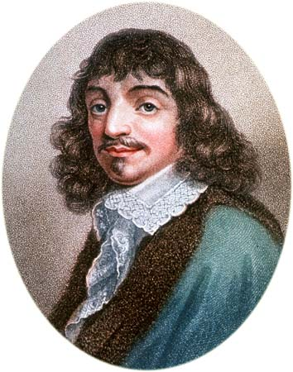
General Graphing Information
René Descartes discovered that graphs are a great tool for analyzing numerical data for three reasons:
- Patterns in the data are often shown more clearly on a graph
- Graph lines average human errors made during observation, so that a graph is more accurate than the individual measurements used to produce the information
- Simpler calculations of useful information are possible, e.g. slope of a line, area enclosed under a line.
Graphs describing motion use the straight line of best fit or a smooth curve between data points to accommodate physicist's assumptions that position and time change smoothly. The line will likely not go through all points. If it did, the experiment would have very little error. A graph where the velocity of a vehicle is recorded is often not a straight line because the vehicle slows down, stops, speeds up and so on. Graphs, like hills and mountains, can be described by their slope which, in mathematics, is calculated as slope = rise/run. The graph of a positive slope rises as it moves to the right. The graph of a negative slope falls as it moves to the right. To find average velocity, which is more important when traveling a distance or calculating gas mileage, calculate the slope of the line on the graph. If instantaneous velocity is desired, such as when the police use radar to check the speed a vehicle is traveling, the slope of a tangent line (a straight line that touches the curve at one point) indicates the estimate of the instantaneous velocity.
Vocabulary
Average Velocity – the displacement divided by the total time from start to finish, the overall rate of change of position
Dependent Variable – a variable affected by another variable (independent variable) or by a certain event
Extrapolation – an estimate of values outside what is shown on a graph
Independent Variable – a variable whose value determines the value of other variables
Instantaneous Velocity – refers to the actual velocity (speed and direction) of an object at a particular instant in time
Interpolation – to estimate a value between two known points on a graph
Line of Best Fit – a line plotted on a scatter plot of data which is 'closest to most points' of the plot, a best approximation of a summary of all the points on a scatter plot
Perpendicular – horizontal rows of elements in the periodic table
Position – is an object's location relative to a reference point
Rise – on a graph, the change in y, up or down, the number of units up or down on a graph from a given point to a point on a line
Run – on a graph, the change in x, left or right, the number of units left or right on a graph from a given point to a point on a line
Slope – slope of a distance-time graph represents the speed of the object; slope of a speed-time graph represents the acceleration of the object; area under a speed-time graph represents the change in distance of the object
Tangent – a straight line that just touches the curve of a graph, the slope of this line is the steepness of the curve at that point
Time – duration between two events (Standard Unit is seconds)
Miss Foley
Sci10: Force & Motion Measurement & Graphing

General Graphing Information

- All graphs should be completed using a pencil and ruler.
- Graphs should be titled with the title describing what the graph is showing. The title is usually written including the data recorded on the y-axis versus the data recorded on the x-axis (e.g. Distance vs Time Traveled).
- Each graph should include an independent variable. This is the variable that is intentionally changed and plotted on the x-axis (the horizontal axis). (e.g. Time may be the independent variable since its intervals are often chosen by the experimenter).
- A dependent variable, plotted on the y-axis, changes according to the intervals set by the independent variable. (e.g. as a vehicle travels its speed is recorded every 30 seconds (independent variable) and the distance it travels (dependent variable) changes depending on the length of time.
- Each axis should be labeled with a name, symbol (if appropriate) and the unit the variable is representing (e.g. The x-axis could be labeled: Time t(s) and the y-axis could be labeled: Distance d(m)).
- A scale that represents the data appropriately and clearly should be chosen. A graph should be a half page in size and each division on the axis should be equal and represent a whole number (e.g. x-axis: 1 block = 1 second; y-axis: 1 block = 5 meters).
- Each point should be plotted with a small closed dot. Drawing a small circle around the dot helps locate the dot when a line of best fit is drawn and reminds us that measured points have some error.
- When each of the points is plotted, draw a line of best fit. This line attempts to put most of the dots on the line or as close to the line as possible. The dots that don't fit directly on the line should be evenly distributed above and below the line.
Extrapolation – outside the original graph, extend the line of best fit

Distance vs Time Traveled
Distance d(m) | 20  18  16  14  12  10  8  6  4  2
 |  |  |  | Interpolation – inside the original graph
 |  |  |  |  |  |  |  |  |  |  |  |  |  |  |  |  |  |  |  | Line of best fit
 | 0 2 4 6 8 10
 | Time t(s)

Miss Foley
Sci10: Force & Motion Measurement & Graphing

Reading a Graph
Interpolation
- Graphs can be interpreted using interpolation which involves constructing new data points using information provided from an existing graph or line of best fit. This is not always accurate since it involves making the assumption that the point chosen as the new data point was in fact part of collected data and not just a result of points on the graph being connected by a line (e.g. line of best fit).
- To find a point using interpolation, draw a line perpendicular to the x-axis from a desired point (x-coordinate) until it crosses the line of best fit (e.g. if distance traveled in 5 seconds is the information sought, locate 5 seconds on the graph and draw a perpendicular line to the line of best fit).
- Draw a line from this point to the y-axis. The point where your perpendicular line intersects the y-axis provides the y-coordinate of the point.
Extrapolation
- Extrapolation is used to find a value before or after a set of measured numbers. In other words, values that are not shown on the graph. By extending the line of best fit of a graph, additional information can be found. The accuracy of the information outside the graph should be questioned since it assumes that the trend shown in the measured points on the graph will continue. This information is subject to greater uncertainty than information using interpolation.
- Extend the line of best fit. Draw a perpendicular line from the desired point on the y-axis until it crosses the line of best fit (e.g. if the information desired is the how long it took to travel 10 m, find 10 on the y-axis (y-coordinate) and draw a perpendicular line to the line of best fit).
- From this point draw a perpendicular line to the x-axis. The point where this line intersects the x-axis is the x-coordinate of the point.
Slope
- Slope can be defined as rise over run and determined using the following formula:
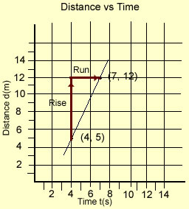
Slope = _Rise m = y₂ – y₁
Run x₂ – x₁
A point on a graph is labeled by its x-coordinate then its y-coordinate, (x, y). The x-coordinate represents the position on the graph when moving horizontally along the x-axis and the y-coordinate represents the position on the graph when moving vertically along the y-axis. In the example graph, the point labeled (4, 5) is substituted into the slope formula in the (x₁, y₁) positions. The point (7, 12) is substituted for (x₂, y₂). These can be interchanged and will result in the same answer.
m = 5 – 12 = -7 = 7 = 2.3 m/s or m = 12 – 5 = 7 = 2.3 m/s
4 – 7 -3 3 7 – 3 3
To find slope, the co-ordinates of two points on the graph are needed. (e.g. (4, 5) and (7, 12)). The first number in each co-ordinate pair is the x-value and the second number is the y-value. In the formula above, the subtracted y-values are divided by the subtracted x-values, the result is the slope of the line - rise/run. In the example shown, the slope of the graph is 7 units up and 3 units across. When calculated to one unit, as velocity and speed are, it is 2.3 m/s.
- Draw a straight line of best fit on your graph. Pick two convenient points (ones that are exactly where two lines of the grid cross will provide more accurate data) and use these points to determine the slope using the above formula.
- For a distance-time graph, slope describes the average speed of the object. For a velocity-time graph, slope describes acceleration of the object. Remember to include the units (e.g. m/s or km/hr²).
Miss Foley
Sci10: Force & Motion Measurement & Graphing

Name: ____________________ Date: _________
Sci10: Force & Motion Measurement & Graphing

Challenge: Graphing Canadian Provinces & Territories
_____ /10 = _____%
Use the following information to create graphs using the correct format. If using graph paper the graphs should be a half page in length.
Listed below are the Canadian provinces-territories, along with their populations according to the 2006 Census, (http://www.citypopulation.de/Canada-Metro.html#Stadt-alpha). Create a line graph following correct graphing practice using this data. Answer the following questions using information from the graph.
  - What scale did you use to represent population on the graph?

  - What type of graph is best suited for this information? Line graph, bar graph, pie graph, scatter plot, etc.

  - Which province-territory has the greatest population?

  - Which province-territory has the smallest population?

  - Which provinces-territories have more than a million people living there?

  - Which provinces-territories have less than 100000 people living there?

Canadian Provinces and their Population, 2006
Province | Population
Alberta | 3290250
British Columbia | 4113587
Manitoba | 1148401
New Brunswick | 729997
Newfoundland-Labrador | 505469
Northwest Territories | 41464
Nova Scotia | 913462
Nunavut | 29474
Ontario | 12160282
Prince Edward Island | 135851
Quebec | 7546131
Saskatchewan | 968157
Yukon | 30372

Name: ____________________ Date: _________
Sci10: Force & Motion Measurement & Graphing

Challenge: Graphing Canadian Provinces & Territories
_____ /10 = _____%
Use the following information to plot a line graph using the correct format. If using graph paper the graphs should be a half page in length. Place a line of best fit on the completed graph.
A list of cities in Canada that have a population of more than one hundred fifty thousand according to the 2006 Census are listed below, (http://www.citypopulation.de/Canada-Metro.html#Stadt-alpha). Plot the population on a graph showing the city name and province-territory before answering the following:

Cities in Canada with Populations of More than 150000, 2006
City, Province | Population
Abbotsford, BC | 159020
Barrie, ON | 177061
Calgary, AB | 1079310
Halifax, NS | 372858
Kelowna, BC | 162276
Kingston, ON | 152358
Kitchener, ON | 451235
London, ON | 457720
Montreal, PQ | 3635571
Oshawa, ON | 330594
Ottawa, ON | 1130761
Quebec City, PQ | 715515
Regina, SK | 194971
Saguenay, PQ | 151643
Saskatoon, SK | 233923
Sherbrooke, PQ | 186952
St. Catherines, ON | 390317
St. John’s, NL | 181113
Sudbury, ON | 158258
Toronto, ON | 5113149
Vancouver, BC | 2116581
Victoria, BC | 330088
Windsor, ON | 323242
Winnipeg, MB | 694668
- Which province-territory has the most cities in this population range?

- Of the represented provinces-territories, which province-territory has the least cities in this population range?

- Are there provinces-territories that do not have a city with a population of over 150000 and are not represented on the graph? Which one(s)?

- What scale did you use to represent population on this graph?

Miss Foley
Sci10: MW1 Technologies Technologies

Motion-Related Technology
Scientists have developed the theory of motion to help us understand, predict and describe the motion of objects. This theory has provided information for the design and construction of many useful devices that enable us to move objects efficiently and safely. Early inventions were developed through trial and error, such as the Wright Brothers' airplane, that was built, test flown and rebuilt in a new design if it crashed. Current practice is to create a computer generated simulation before testing a product. This enables producers to determine areas of difficulty before the product is tested at the cost of many dollars.
Canada's landscape, population and climate have created many obstacles for technologists and developers to overcome. The climate varies greatly and includes periods of heavy snow, extreme cold and high winds. The population is spread over a large area, sometimes with large expanses of unpopulated land between communities. Canada's landscape varies from flat prairies, to lake lands, to high mountains. All of these contribute to the difficult task of traveling and transporting goods across the country. Canadian Scientists have risen to the challenge that Canada presents and have developed many innovative technologies to overcome those challenges.
Pedal Bikes: The Pedaling History Bicycle Museum provides a time-line depicting the development of the pedal bicycle. Other sites include the Bicycle History page and Bicycle History and Human Powered Vehicle History.
In-line Skates: Information about the history of in-line skates can be found at Roller Sport History,
The History in In-Line Skating, and The Invention of the Wheel.
Wheel Chairs: A historical look at the Wheel Chair can be located at Wheel Chair History.
The History of the Automobile provides a beginning look at steam, electric and gas automobiles. Another site, History of the Automobile, discusses the development of the automobile from the 1890's to the present. Many others can be found by googling automobile history.
Jolly Jumpers: The history of the jolly jumper can be investigated at Jolly Jumper History.

Canadian Contributions To Motion Science Technologies
Electric Wheelchair: George Klein
Wikipedia National Research Council Canadian Science and Technology Museum Veteran's Affairs Canada
Wind Tunnel and Variable Pitch Propeller: Wallace Turnbull
National Defense Site The Canadian Encyclopedia Wikipedia The Canadian Science and Technology Museum
Jolly Jumper: Olivia Poole
Wikipedia Famous Canadians Jolly Jumper History
Fuel Cell Technology: Ballard Power Systems
Ballard Home Page Wikipedia History
Electrical Engineer, Aviation and Transportation, Skis, De-icing Equipment: Elsie McGill
Veterans Affairs Wikipedia Library and Archives Canada
Jetliner and Jetfighter: AVRO
Arrow Recovery Canada Historical Minutes Wikipedia
Miss Foley
Sci10: MW1 Technologies Technologies

Bush Planes
Hyack Air Wikipedia De Havilland Canada
G-suit: Mr. W.R. Franks
Wikipedia Canadian Info G-Suit Wikipedia
Revolving Snow Shovel: J.W. Elliot
Collections Canada Rotary Snowplow List The Road Scholar The Canadian Encyclopedia
Cutting Wheels to Improve J.W. Elliot's Snow Shovel: Orange Jewel
Collections Canada Rotary Snowplow List The Canadian Encyclopedia
Ice Skates - "Spring Skates": John Forbes
Birthplace of Hockey The Greatest Canadian Inventions Collections Canada
Rock Picker: manufactured at Vonda, SK
http://www.highlinemfg.com

Ice Skates - "Long Reachers": James Whelpley
Collections Canada Kings County GenWeb
Snowmobile, Ski-Doo, Light Rail Transport Systems: Armand Bombardier
The Greatest Canadian Inventions Bombardier Site Wikipedia
Canadian Science and Technology Museum Great Names of the French Canadian Community
Sanivan Garbage Truck: Rinaldo Boissonault & Sicard, Inc
Classic Refuse Trucks Business Library
Nodwell Carrier Off-road Cargo Vehicle: Bruce Nodwell
Alberta Inventors and Inventions Alberta Inventors and Inventions Nodwell 110 Wikipedia DOB Magazine
Self-propelled Combine: Thomas Carroll
Australian History of Biography Wikipedia Combine Harvester

Miss Foley
Sci10: MW1 Technologies Technologies

Motion Related Technology: Research Projects
Everyday activities of humans have resulted in many changes to motion related technologies such as personal transportation devices, recreational conveyances and scientific equipment. The use of these technologies has led to improvements and further exploration into the science of motion, as well as the technologies related to motion. In order to develop a better understanding of motion and the development of technologies to solve motion related problems, it is necessary to understand the relationships between motion, acceleration, velocity, distance, displacement, and speed, as well as research and testing.

Topic Options:
- Research a specific motion-related technology such as a bicycle, snowmobile, skateboard, skates or wheelchair. Determine its historical development and the involvement of science and technology in its development. Consider the ethical, social, ecological, economic and political influence that directed its development. Include how the performance of these technologies has improved (e.g. speed, safety, fuel economy, braking systems) and the impact that these improvements have had on society.
- Research the role of Canadians or Canadian companies and their contributions to science and technology in motion-related fields. A focus could be on contributions of women, First Nations people, or minorities. Some examples of Canadian contributions are the kayak, self-propelled combine, electric wheelchair, and jolly jumper.
- Research the ways in which athletes and high performance trainers use the science of motion (kinematics) and motion analysis software to improve athletic performance. Include a discussion about the impact of technology on improved athletic performance, and the ethical, social and legal implications that may be involved.
- Research a career that is related to the study of motion (sports science, biomechanics, mechanical engineering, aerodynamics, etc.) Be sure to determine the relationship the career has to motion and/or motion-related technologies, educational requirements and job availability. Include a historical perspective of the career, outlining job responsibilities in the past and the present, and the development of motion-related technologies or knowledge that have influenced changes in these job responsibilities or duties.

The end result of your research will be to present your findings, including photographs, timelines, tables and graphs of data in a report. Some suggested formats include essay format, PowerPoint presentation, posters, video or web page.

Miss Foley
Sci10: MW1 Technologies Technologies

Motion Related Technology: Cost Benefit Analysis
As new technology emerges, people debate the benefits and the costs of each new innovation. What is the impact of the new technology on the environment? Who is responsible if something goes wrong? Who should pay for it? Many other questions arise. A cost-benefit analysis is a process used to determine the answers to these questions before the technology is released for public use. The perspective of each category listed below is researched and a list of pros and cons are developed to help better understand the impact of the new technology.
Perspectives
Ethical
- According to accepted beliefs and values, is the change or new technology right or wrong?
- How will the change affect the people's quality of life?
- Do we have the right to impose this change on the world?
- Examples: Is motorized transportation a benefit, convenience, or an improvement in the quality of life and are these more important than the pollution, dangers of accidents, etc.?
Legal
- According to current laws, who is responsible for the effects of the product and fair treatment of all parties affected by it?
- What laws and regulations apply to the new product or change, and do they need revision?
- How will the people affected be compensated?
Ecological
- How will this change or technology impact the natural environment?
- Are the effects reversible?
- What effect will the change have on the relationship between living things and the environment?
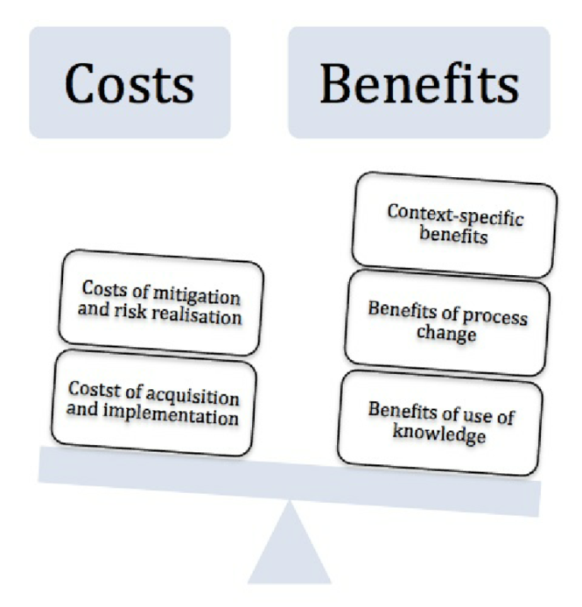
Technological
- How will this be manufactured or processed?
- What machinery will be required for the change or technology?
- Can the efficiency or performance be improved? How?
Political
- What is the role of the government?
- Should public funds be used for the project?
- Is the new technology popular with voters?
Economic
- How much will it cost?
- Who will pay for it?
Scientific
- What could be the outcome of the change?
- What problems may arise from it?
- Does this technology lead to other innovations?
- Are current planning practices effective, or do they need to be revised to reflect the needs of the change?
Name: ____________________ Date: _________
Sci10: MW1 Technologies Technologies

Motion Related Technology: Cost Benefit Analysis
Objective: Use the Cost Benefit Analysis process to determine the benefits and costs of current new technologies.
Materials: A chart to record brainstorm ideas. A model is detailed below.
Procedure:
- As a class, discuss current innovations. Examples: high speed transportation, creating a new highway, uranium processing plants, open pit mining, fish finders, radar detectors, etc.
- Decide on one of the issues to explore and work through at least four of the steps in the Cost Benefit Analysis Process.
- Record the benefits and costs in a chart such as the one below.
- Assign one perspective per pair/group of students. One student/group should develop an argument for the innovation (benefit) and the other student/group should develop an argument against the innovation (costs).
- Perspectives should be supported by personal experience anecdotes and logical arguments.
- Each person should be prepared to present their arguments to the class in a succinct summarization, utilizing visuals (overheads, diagrams) if appropriate.
- As each student listens to the summaries, record which perspective s/he agree with and why.
- Total the class votes for each summary and total votes for or against the change or new technology.
Analysis and Observations:
- Which perspectives were most popular with the class?

- Did your personal perspective match the majority or minority?

- How did presenting your perspective to the class make you feel?

- Give an example of when you took a public stand or wanted to take a public stand to oppose or favor a proposed change. (Example: written a letter, called a member of a political party, telephoned a radio station, went to a teacher or principal, etc.) Tell what happened, what the change was, what your stand was regarding the change and why you took had the opinion that you had.

Name: ____________________ Date: _________
Sci10: MW1 Technologies Technologies

Technology Example: _______________________________________________
Perspective | Benefits | Costs | Vote Following Presentation
Ethical |  |  | FOR  AGAINST
Legal |  |  | FOR  AGAINST
Ecological |  |  | FOR  AGAINST
Techno-logical |  |  | FOR  AGAINST
Political |  |  | FOR  AGAINST
Economic |  |  | FOR  AGAINST
Scientific |  |  | FOR  AGAINST
Personal Reaction, Thoughts, Comments:
Vote FOR this technology: (Please print your name as your FINAL vote)

Vote AGAINST for this technology:
Miss Foley
Sci10: MW2 Everyday Motion Everyday Motion

Motion Is Relative!
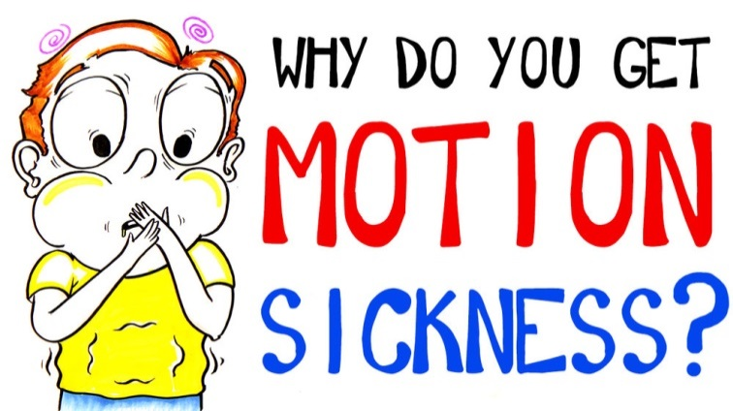
Frames of reference and relative motion is actually the reason that people get car sick. Your brain is getting two different sets of information about your body's motion that might not exactly agree with each other; information from your eyes, and information from your inner ear. Some people are more sensitive to these differences, which causes them to feel car sick as they watch the road "whiz" by. If you are prone to getting car sickness, try to look forward at a point far in the distance and stay focused on that.
Frame of Reference =
the point or object of comparison when deciding
if an object is in motion
A frame of reference can be thought of as any spot you’re doing your measurement from as long as it is not accelerating. This is called an inertial frame of reference.
Relative motion is just a way of saying that sometimes different people will say different things about the motion of the same object.
- This is not because one of them is wrong, but because they are using different frames of reference.
- The best way to see how this is possible is to look at some examples. In all of the following examples, ignore air resistance.
Example 1: Let’s say I am standing on the back of a pickup truck (that is motionless), and I am
throwing apples forwards. I know that I can throw an apple exactly 15m/s every time.
- If a person were standing on the sidewalk, how fast would she say the apples are moving?
  - Since she will see them exactly the same way as me (we're both in the same reference frame), she will say 15m/s.
- Now the truck starts to move forwards at 20m/s. I am still throwing apples forwards, exactly the same as I was throwing them before, at 15m/s.
  - If I am really not paying attention to what’s going on around me (like the fact that I am standing in the back of a moving truck), how fast would I say the apples are moving?
  - Still 15m/s! Relative to me, I can only make an apple move away from me at 15m/s, so that’s how fast I measure the apple moving away from me.
- How fast does my friend on the sidewalk say the apple is moving?
  - Well, even before I throw it, she’ll say that the apple is moving at 20m/s (the speed of everything on the truck).
  - When I have thrown the apple forward, adding more velocity to it, she will say it is going at (20m/s + 15m/s) 35m/s!
Miss Foley
Sci10: MW2 Everyday Motion Everyday Motion

- Now I turn around and start throwing the apples from the rear of the truck, backwards!
  - I will still say that my apples are moving at 15m/s, because from my way of looking at it, that’s how fast the apple is moving. The only thing I might say that is different is that it is -15m/s, since even I should be able to notice they are going in the opposite direction now.
  - My friend on the sidewalk will say that the apple is moving at (20m/s + -15m/s) 5m/s!
In each of the above examples, we are really talking about two different people having two different frames of reference while measuring the relative velocity of one object.
Frame of Reference: When you are standing on the ground - that is your frame of reference. Anything that you see, watch, or measure will be compared to the reference point of the ground. If I am standing in the back of a moving truck, the truck is now my frame of reference and everything will be measured compared to it.
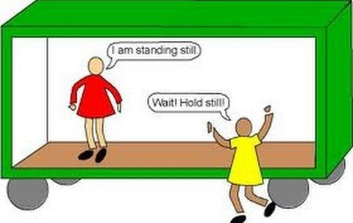
Relative Velocity: In the above examples, each person was measuring the velocity of the apples relative to (compared to) the frame of reference that they were standing in. Relative to a person standing on the sidewalk, the apple may be moving at 10m/s, while for a person in the frame of reference of the truck, the apple is moving at 15m/s relative to him.
Example 2: Sitting at your desk, how fast are you moving?
- Relative to the ground: Zero. You’re not moving relative to the frame of reference of the ground.
- Relative to the sun: 2.97e4 m/s! That’s a pretty big difference, but since the Earth is orbiting the sun at this speed, an observer standing on the sun (ouch!) would say that you are moving at 2.97e4 m/s.
- Both of these answers are correct in their own frame of reference.
Example 3: You might have even noticed relative velocity while sitting at a red light…
- Have you ever been sitting at a red light with a bus stopped next to you?
- You’re kind of daydreaming, looking out the window at the side of the bus, when all of a sudden it feels like your car is rolling backwards!
- Then you realize that it was just the bus moving forwards.
  - Your brain knows that the bus was just sitting there on the road… it became part of the frame of reference of the ground.
  - When your brain saw the bus moving forwards, it had already “decided” that the bus won’t move. The only option remaining is that you must be moving backwards.
Miss Foley
Sci10: MW2 Everyday Motion Everyday Motion

Uniform Motion =
motion with NO change in speed or direction
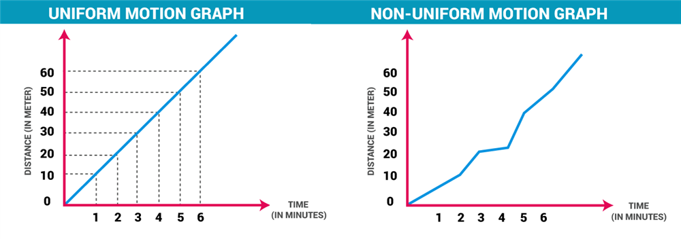
If uniform motion was possible, it would be very easy to analyze. For analysis or observation, objects at an almost constant speed, moving in a straight line, are used to represent uniform motion. Objects with uniform motion have a constant velocity - neither speed nor direction change. The direction must be linear (in a straight line) - forward, backward, or up or down.
Three Types of Uniform Motion:
- NO motion (the object is stationary)
- Uniform motion UP, FORWARD or to the RIGHT
- Uniform motion DOWN, BACKWARD or to the LEFT
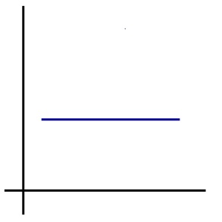 | 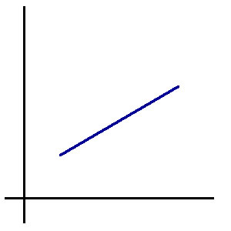 | 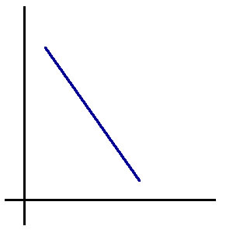
No motion = the object  is stationary | Uniform motion, up, right, accelerating or forward | Uniform motion, down, left, decelerating, or backward

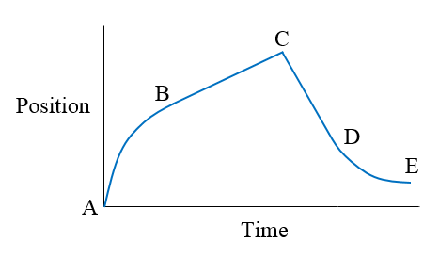
Reading Position Time Graphs: The straight line portion of the graph does not always start at the origin. If it does start at the origin, the object was initially not moving when observations began. If the object starts at a standstill, the initial motion is not uniform as it accelerates so this may not be graphed or is a curved graph. If the object's speed or direction changes during the experiment, the graph can have a number of straight line segments that are not necessarily joined together. On distance-time and velocity-time graphs the movement from left to right indicates the passage of time. Identify types of motion on the following sections on the graph to the right:
A-B: _____________________ B-C: _____________________
C-D: _____________________ D-E: _____________________
Miss Foley
Sci10: MW2 Everyday Motion Everyday Motion

Challenge: Graphing Position-Time Motion
Sketch position-time graphs for each object listed below.
Describe the slope as positive or negative, and as constant, increasing or decreasing.

- a runner moving steadily to the right
- a parked car
- a child on a tricycle moving to the left and slowing down
- a hang-glider drifting down at a steady speed
- an egg falling from a nest with increasing speed
- a fireworks rocket moving up at an increasing speed
- an airplane taking off at a steady speed
- a horse moving to the right begins walking and changes to a gallop
- a log rolling down a hill with increasing speed
- a boat moving to the right across the lake at a steady speed

- 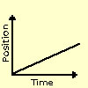

- 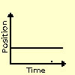

- 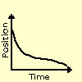

- 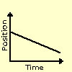
- 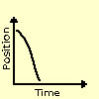

- 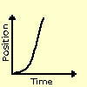

- 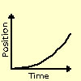
- 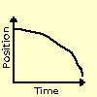

- 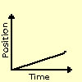

Name: ____________________ Date: _________
Sci10: MW5 Graphing Everyday Motion Motion Scenarios

Acting Out & Graphing Motion Scenarios Lab
  - Students will work in groups.
  - The teacher will identify a space to allow students to move freely forward and back along a numbered line placed on the floor. (This could be a line on a tiled floor.)
  - Before starting, students should make predictions, explaining what they think will happen, how they will move, and why.
  - One student will then “Act Out” the scenario motion on the marked floor. Students should rotate jobs, allowing each student to ‘feel’ the motion.
  - Another member of the group is the time keeper, snapping the cadence at 1 second intervals of time.
  - The rest of the students should graph each motion scenario as Distance vs. Time on the provided graphs.
Scenario #1 | Scenario #2 | Scenario #3 | Scenario #4
From 0, walk forward  with a steady pace for 7 seconds. | From 10, walk  backward with a  steady pace for  5 seconds. | From 0, walk steadily  forward for 3 seconds,  stop for 3 seconds,  and walk forward very  quickly for 3 seconds. | From 0, move at an  increasing rate of  speed away from  the origin for  8 seconds.
Answers:
- Make predictions explaining how you will move in each scenario.
Scenario 1 –
Scenario 2 –
Scenario 3 –
Scenario 4 –

- Draw a time/distance table for each scenario.

Name: ____________________ Date: _________
Sci10: MW5 Graphing Everyday Motion Motion Scenarios

- Graph a distance vs. time data table for each scenario. Graph the scenarios in the following grids.

Graph Scenario #_______ Graph Scenario #_________

Graph Scenario #_______ Graph Scenario #_________

Miss Foley
Sci10: MW2 Distance, Time & Speed Velocity

Quantity Symbols
d = distance/position
d₂ = present distance d₁ = past distance
d_{f} = final distance d_{i} = initial distance
t = time
t₂ = present time t₁ = past time
t_{f} = final time t_{i} = initial time
v = instantaneous velocity v_{av} = average velocity
a = acceleration a_{av} = average acceleration
∆ = delta/“change in…”
∆ = Present – Past = Final – Initial
Example: ∆d = d₂ – d₁ OR ∆d = d_{f} - d_{i}

V = Instantaneous Velocity = d/t
the speed at which an object is travelling
at a particular instant
V_{av} = Average Velocity = ∆d/∆t
the total distance travelled compared to the change in time
Constant Speed (a.k.a. Uniform Motion) =
the speed of an object remaining the same
over a period of time
Miss Foley
Sci10: MW2 Distance, Time & Speed Velocity

Average Velocity/Speed =
the total distance travelled compared to the change in time
V_{av} = ∆d = d₂ – d₁
∆t t₂ – t₁
Example:
Kira is trying to predict the time required to ride her bike to the nearby beach. The distance is 45 km. She knows from other trips that she can usually average about 20 km/h, including slowing down for climbing hills. Predict how long the trip will take.
Strategy 2: Rearranging Formula First
V_{av} ● t₂ – t₁ = d₂ – d₁ ● t₂ – t₁
t₂ – t₁
V_{av} ● t₂ – t₁ = d₂ – d₁
V_{av} V_{av}
t₂ – t₁ + t₁ = d₂ – d₁ + t₁
V_{av}
t₂ = d₂ – d₁ + t₁
V_{av}
t₂ = 45 km – 0 km + 0 h
20 km/h
t₂ = 45 = 2.25 h = 2.3 h
20 h

20 km/h = 45 km – 0 km
t₂ – 0 s
t₂ ● 20 km/h = 45 km ● t₂
t₂
t₂ ● 20 km/h = 45 km
20 km/h 20 km/h
t₂ = 45 = 2.25 h = 2.3 h
20 h

Strategy 1: Using Formula As Is
V_{av} = ∆d = d₂ – d₁
∆t t₂ – t₁
20 km/h = 45 km – 0 km
t₂ – 0 h
t₂ ● 20 km/h = 45 km ● t₂
t₂
t₂ ● 20 km/h = 45 km
20 km/h 20 km/h
t₂ = 45 = 2.25 h = 2.3 h
20 h

d₂ = 45 km
d₁ = 0 km
V_{av} = 20 km/h
t₂ = ?
t₁ = 0 h

There is an easy method of converting between km/h and m/s:
1 m/s = 3.6 km/h
Exactly because all of the conversion factors used were exact values, by definition.
1 m x 1 km x 3600 s = 3.6 km/h
s 1000 m 1 h
Marking Criteria For ALL Calculation Problems (5 marks/question)
1 mark – Did you identify info given in the question correctly in order to know what you
are trying to find?
1 mark – Did you show that you are using the correct formula?
1 mark – Did you substitute the correct info into the correct spot in the equation?
1 mark – Did you do the math correctly?
1 mark – Did you get the correct answer including using the correct units?
Miss Foley
Sci10: MW2 Distance, Time & Speed Velocity

Distance-Time Graphs for Velocity
FINISH!!!!!!!!!!!!!!!
Miss Foley
Sci10: MW2 Distance, Time & Speed Velocity

Distance-Time Graphs for Velocity
FINISH!!!!!!!!!!!!!!!
Miss Foley
Sci10: MW2 Distance, Time & Speed Velocity

Throwing Velocity Motion Lab Worksheet
Trial 1 | Average Velocity
d₂ =
d₁ =
t₂ =
t₁ =
Trial 2 | Average Velocity
d₂ =
d₁ =
t₂ =
t₁ =
Trial 3 | Average Velocity
d₂ =
d₁ =
t₂ =
t₁ =
Trial 4 | Average Velocity
d₂ =
d₁ =
t₂ =
t₁ =
Trial 5 | Average Velocity
d₂ =
d₁ =
t₂ =
t₁ =
Miss Foley
Sci10: MW2 Distance, Time & Speed Velocity

Name: ____________________ Date: _________
Sci10: MW2 Distance, Time & Speed Velocity

Challenge: Average Speed #1 ____ /40 = ____%
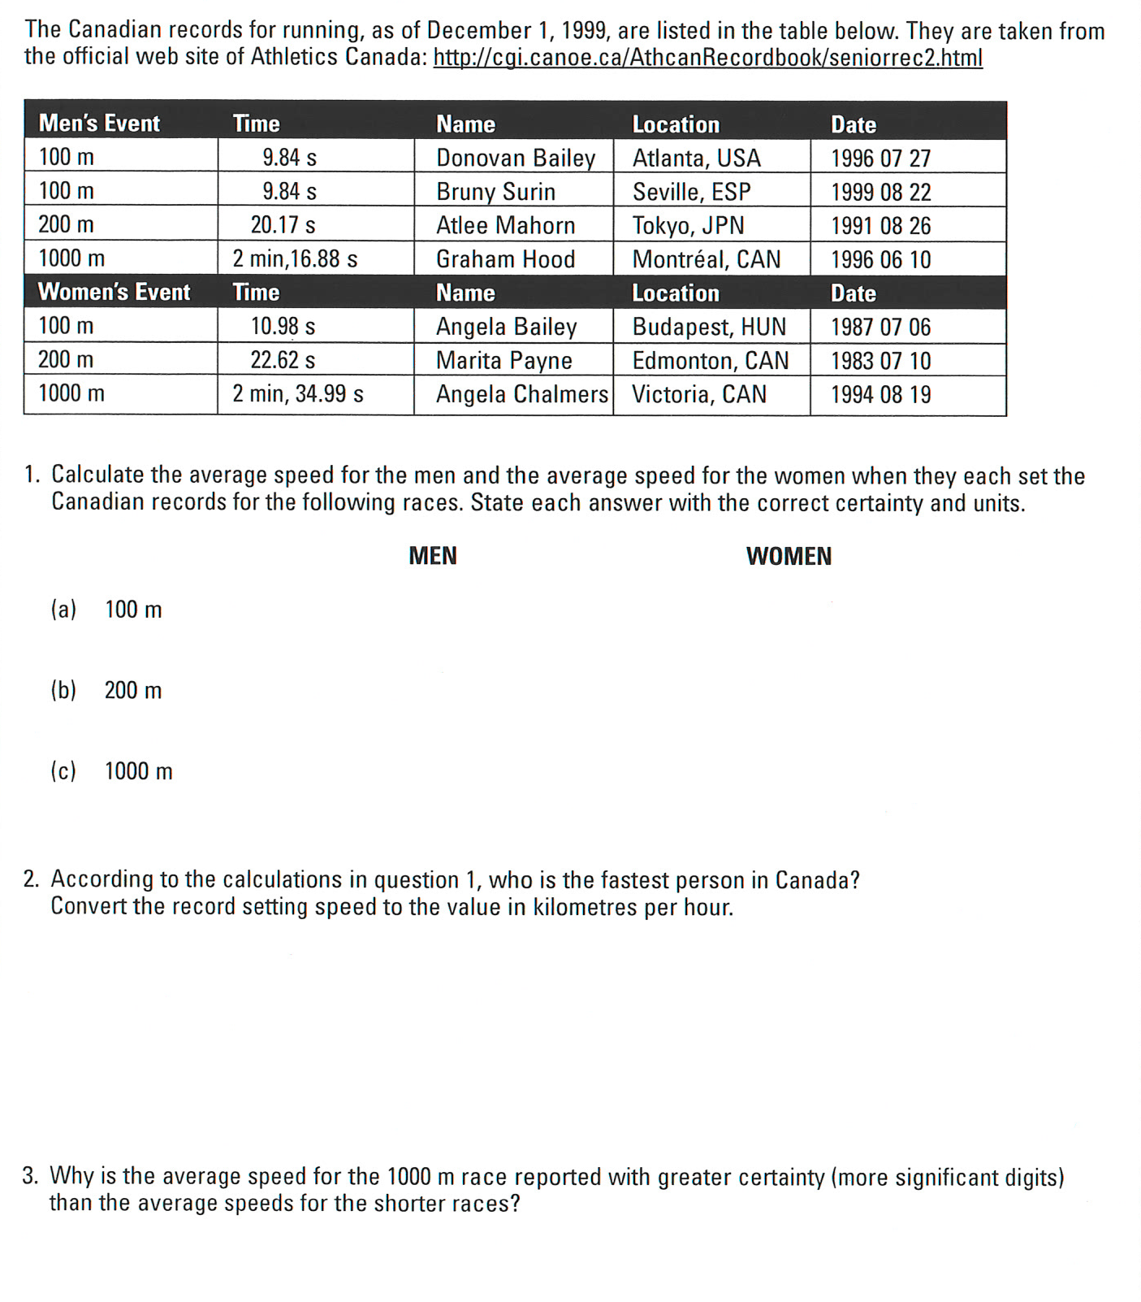

Name: ____________________ Date: _________
Sci10: MW2 Distance, Time & Speed Velocity

Challenge: Average Speed #2 ____ /35 = ____%

Name: ____________________ Date: _________
Sci10: MW2 Distance, Time & Speed Velocity

Challenge: Uniform Motion Formula Activity
_____ /40 = _____%

Solve the following problems using the uniform motion formula.
V_{av} = ∆d = d_{f} – d_{i}
∆t t_{f} - t_{i}
- Use the given formula to complete the table below.
∆t | ∆d | V_{av}
3.0 s | +12 m | +4.0 m/s
 | +28 m | +4.0 m/s
15.1 s |  | +2.00 m/s
1.5 h |  | +50 km/h
1.7 h | +84 km
 | +120 km | 15 km/h
- A girl rides a scooter along a straight path for 30.0 s. She travels 254 m away from her home. Find her average velocity.

- A transport is moving east at 90 km/h along a straight highway. Find the displacement of the transport after 1.2 h.

Name: ____________________ Date: _________
Sci10: MW2 Distance, Time & Speed Velocity

- A man walks west at 4.2 m/s. How long before he will be 110 m west?

- A motorcycle starts at a position of 18 m at a time of 7.2 s. He is traveling at a velocity of 17 m/s. Find the position of the motorcycle at the time of 9.8 s.

- A youth is walking with a constant velocity on a straight sidewalk. At a time of 1.4 s, his position is 30.4 m. Later, at a time of 6.1 s, his position is 92.6 m.
  - At what velocity is the youth traveling?

  - At 4.4 s, what is his position?

  - When will the youth be at the position of 120.0 m?

Name: ____________________ Date: _________
Sci10: MW5 Distance, Time & Speed Velocity

Slope of an Object’s Motion Lab _____ /34 = _____%
Objective: To obtain useful information from the slope of a line on a position-time graph.
Materials: Paper – lined Paper – graph Rulers Pencils Calculator
Procedure:
- The bunny hop is a dance that involves a line of people that right kick twice, left kick twice, hop forward once, backwards once and then forward three times. This sequence is then repeated until the end of the song.
- Assume that each hop, forward and backward is 30 cm and that each hop takes 0.1 second to complete.
- Complete a position-time table like the example below for two complete cycles (forward 1 hop cycling through all the way to pause twice). Add a title to the table.
Interval | Time (s) | Position (m) | Movement
 | 0.0 | 0.00 | ---
1 | 0.1 | +0.3 | Forward 1 hop
2 | 0.2 | 0.00 | Backward 1 hop
3 | 0.3 | +0.9 | Forward 3 hops
4 | 0.4 | +0.9 | Pause
5 | 0.5 | +1.2 | Forward 1 hop
6 | 0.6 |  | Backward 1 hop
7 | 0.7 |  | Forward 3 hops
8 | 0.8 |  | Pause
- Use the information from the table to draw a position-time graph. Remember to title your graph and label the y-axis as position, x-axis as time. Determine an appropriate scale for each axis.

Name: ____________________ Date: _________
Sci10: MW5 Distance, Time & Speed Velocity

- Find the slope of the line where the dancers hop three times.
  - Pick two points on the line and use them to draw a slope triangle. It's easiest if the two points have whole number values.
  - Label the points (x₁, y₁) and (x₂, y₂) with x being time and y being distance hopped or (t₁, d₁) and (t₂, d₂).
  - Find the number values that correspond with the lettered points above.

  - Calculate the slope using the two-point slope formula learned in math class.
Slope = Rise = d_{f} - d_{i}
Run t_{f} - t_{i}

- Now write the above information using the scientific method and notation showing the rise as a change in the distance and the run as a change in the time. (Example, Δd and Δt)

- On the graph, label each section as either positive slope or negative slope.
- What standard unit of measure is the position or numerator part of the expression measured in?

- What standard unit of measure is the time or the denominator part of the expression measured in?

- Together these two measures give the slope. What units of measure are representing this slope?

- Compare this information with the standard units for velocity. What do you discover?

- Find the slope at a different place on the line or on the line that represents the next set of three hops.

- How does it compare to the slope found earlier? Why might the answers be different?

- Draw a third slope triangle from the beginning to the very end of your graph. Calculate the slope of this line to determine the average velocity of the dancers over the whole time interval you graphed.

- How does this slope compare to the other two velocities calculated in this investigation? Is it the same? Why or why not?
Miss Foley
Sci10: MW2 Distance, Time & Speed Velocity

Velocity: Check for Understanding
- Complete the table below. In the right-hand column, circle the correct word assuming that up is positive and right is positive in describing the motion.

t_{i} (s) | t_{f} (s) | ∆t (s) | d_{i} (m) | d_{f} (m) | ∆d (m) | ∆v (m/s) | Direction of motion
4.0 | 6.5 |  | 12 | 25 |  |  | Up/down
 | 9.1 | 4.7 |  | -3.8 | 12.7 |  | Left/right

- Match the correct terms to the definitions.
  - Distance e) Average speed
  - Speed f) Instantaneous speed
  - Uniform motion g) Slope
  - Non-uniform motion

______ Motion with no change in direction or speed
______ The rise of a graph over its run
______ Rate of change in distance of an object
______ A calculation of change in distance over a time interval for a moving object.
______ The length of path traveled between objects
______ The actual speed of an object at a particular moment in time.
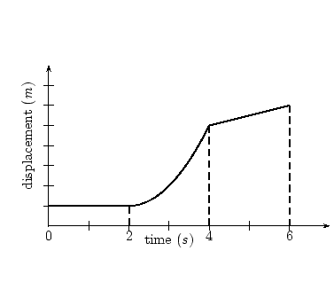
______ Motion with change in direction or speed.

- Describe the motion represented on the following d- t graph.

- Describe what you know about a quantity if its slope (rate of change) on a position-time graph is:

  - Positive:

  - Negative

  - Zero

Miss Foley
Sci10: MW2 Distance, Time & Speed Velocity

- Construct a rise over run triangle on the position–time graph below. Use this triangle to calculate the following quantities. Show Your Work
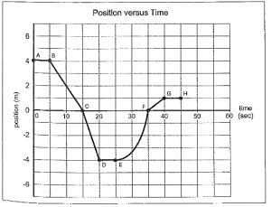

  - The average velocity from t = 0 s to t = 20 s

  - The instantaneous velocity at t= 30s

Miss Foley
Sci10: MW2 Distance, Time & Speed Velocity

Calculation Problems Criteria:
- Did you identify info in the question correctly in order to know what you are trying to find?
- Did you show that you are using the correct formula?
- Did you substitute the correct info into the correct spot in the equation?
- Did you do the math correctly?
- Did you get the correct answer including using the correct units?

- A car travels 73 km along a straight highway in 0.80 h. Find the average velocity of the car in km/hr.

- How long will it take a runner to travel 1500 m at an average velocity of 6.9 m/s?

- A cat starts at a position of 12 m from its home. It runs away from it’s home, at 6.0 m/s, for 3.0s. It waits for 6.5s and then returns home at a speed of 1.5m/s.
  - Find the total distance the cat travels.

  - Draw a distance- time graph of the cat’s motion. Show any calculations that you need to make.

Miss Foley
Sci10: MW2 Distance, Time & Speed Velocity

Miss Foley
Sci10: MW2 Distance, Time & Speed Ticker Tapes

Ticker Tape Machine Measures Motion
Ticker Tape Diagram #1
Uniform Velocity/Speed =
A uniform distance between dots indicates no changing velocity
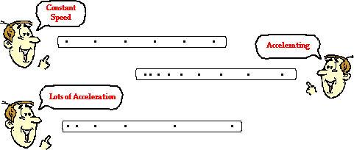
Ticker Tape Diagram #2
Acceleration/Deceleration =
A changing distance between dots indicates changing velocity
Review Time…
What Motion Do These Ticker Tapes Represent?
Miss Foley
Sci10: MW2 Distance, Time & Speed Ticker Tapes

Ticker Tape Machine Set Up
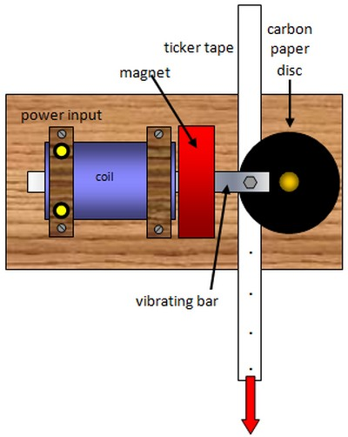

Miss Foley
Sci10: MW3 Speed, Time & Acceleration Acceleration

Acceleration =
the rate of change in an object’s speed
a = ∆v = v₂ – v₁
∆t t₂ – t₁
Example:
Jack rides his motorcycle through an intersection after completing a full stop at a stop sign. Jack’s speed going through the intersection was 9.0 m/s. It takes Jack 2.0 s to completely pass through the intersection. What was Eli’s acceleration with his motorcycle going through the intersection?
a = ∆v = v₂ – v₁
∆t t₂ – t₁
a = 9.0 m/s – 0 m/s
2.0 s – 0 s
a = 9.0 m/s
2.0 s
a = 4.5 m/s²

v₂ = 9.0 m /s
v₁ = 0 m/s
t₂ = 2.0 s
t₁ = 0 s
a = ?

Common units for acceleration are:
a = ∆v = m/s = m/s²
∆t s
Other units occasionally used can be:
a = ∆v = km/h = (km/h)/s
∆t s

Marking Criteria For ALL Calculation Problems (5 marks/question)
1 mark – Did you identify info given in the question correctly in order to know what you
are trying to find?
1 mark – Did you show that you are using the correct formula?
1 mark – Did you substitute the correct info into the correct spot in the equation?
1 mark – Did you do the math correctly?
1 mark – Did you get the correct answer including using the correct units and significant digits?

Miss Foley
Sci10: MW3 Speed, Time & Acceleration Acceleration

Example:

Example:

Miss Foley
Sci10: MW3 Speed, Time & Acceleration Acceleration

Speed-Time (V-t) Graphs for Acceleration
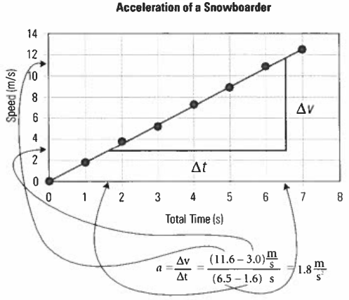
Acceleration =
change in speed over time
As you know, the slope of a line on a graph indicates the rate of change in one variable (∆y) compared to a second variable (∆x).
If the variables are speed (a.k.a. velocity) (on the y-axis) and time (on the x-axis), then the slope (∆y/∆x) corresponds to the mathematical definition of acceleration (∆v/∆t). In summary, the slope of the line on a v-t graph provides acceleration.
The units of the slope of a speed-time graph are the units of speed divided by the units of time with standard units being m/s².
Slope = rise = ∆y = y₂ – y₁
run ∆x x₂ – x₁
Relationship between Slope & Acceleration
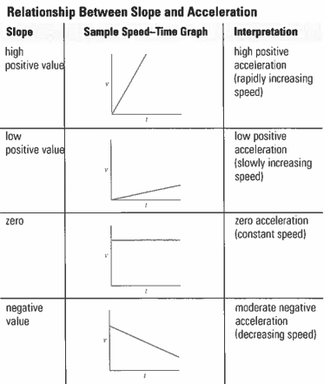
Miss Foley
Sci10: MW3 Speed, Time & Acceleration Acceleration

Finding Distance from Speed-Time Graphs

∆d = ∆V x ∆t = area under the slope = 1/2bh = 1/2∆t x ∆V = ∆d *Triangles
∆d = ∆V x ∆t = area under the slope = bh = ∆t x ∆V = ∆d *Squares/Rectangles

Total area under the slope of speed-time graphs =
distance object travels
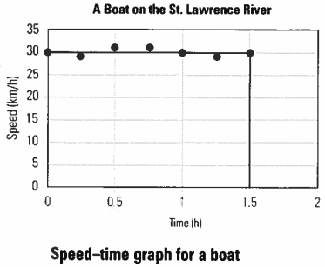
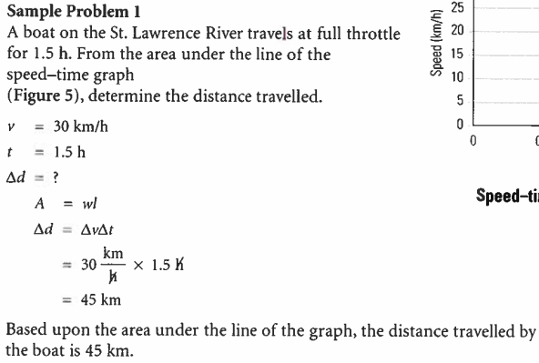

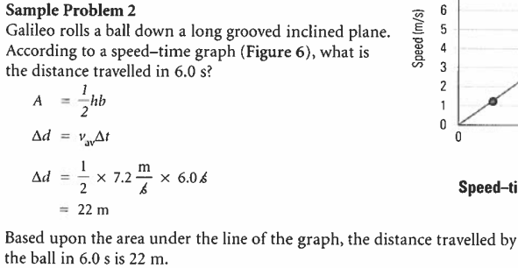
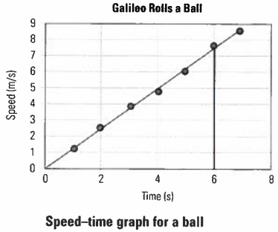

Name: ____________________ Date: _________
Sci10: MW3 Speed, Time & Acceleration Acceleration

Challenge: Acceleration ______ /35 = _______%
During spring break, Kristen and Brad ride their bikes on a bike path that runs from Kristen’s neighborhood to the university. (5 marks each)
- The bike path passes over a small bridge designed to carry a cyclist over a busy street. At the bottom of the ramp leading up to the bridge, Kirsten is riding at 5.6 m/s. When she reaches the top of the ramp, she is travelling at 1.8 m/s. If it takes her 28 s to ride up the ramp, what is her acceleration?

- Brad starts down the ramp on the other side of the bridge, travelling at a speed of 2.8 m/s, and then accelerates at 0.25 m/s² for 18 s. What is her speed at the bottom of the ramp?

- At the bottom of the ramp, Brad hits a patch of loose gravel and wipes out. Kirsten applies her brakes quickly to avoid hitting him. She is travelling at 6.5 m/s when she applies the brakes and she accelerates at -2.6 m/s². How long (time) does it take her to stop?

- Kirsten and Brad coast down a long hill that leads into the river valley. They accelerate at 0.12 m/s² for 85 s and are travelling at 12.5 m/s at the bottom of the hill. What was their initial speed?

Name: ____________________ Date: _________
Sci10: MW3 Speed, Time & Acceleration Acceleration

Challenge: Acceleration (cont’d)
- What feature of a velocity/speed-time graph communicates: (2 marks)
  - The acceleration?
  - The distance travelled?

- Two runners, Cathryn and Keir, take part in a fundraising marathon. The graph below shows how their speeds change for the first 100 s from the start of the marathon.
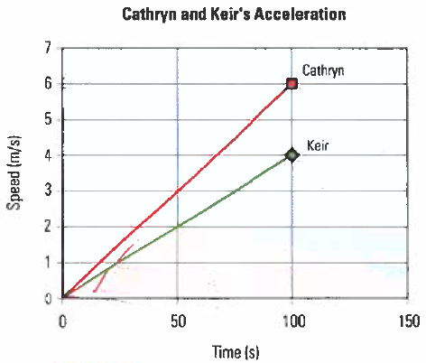
  - Which runner has the greater acceleration? (1 mark)

  - Which runner is ahead after 100s? Calculate and compare the distance travelled by each. (3 marks)

- Clayton sets out on his motorcycle. His speed at different times is shown on the graph below.
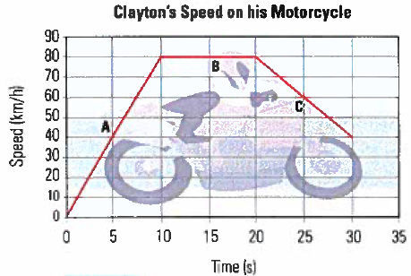
  - Calculate the accelerations during each of the time intervals, A, B, and C. (6 marks)

  - Without calculating, list the time intervals during which the distances travelled are, in order, from largest to smallest. (3 marks)

Miss Foley
Sci10: MW3 Speed, Time & Acceleration Acceleration

Acceleration: Check for Understanding
- Describe the motion involved by the object that left the following ticker tape pattern.
(3 marks)

- Draw a diagram of what the ticker tape might look like for the following example. (3 marks)

A driver on a two-lane highway is traveling the speed limit when it comes up behind a tractor pulling a large load of hay bales. If follows the tractor for a short distance until on-coming traffic has dissipated, then it pulls out and passes it. After it has passed the tractor it resumes traveling at the speed limit.

- Describe the following v-t graphs. (4 marks)

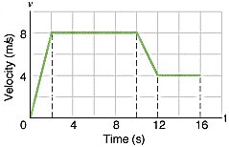

- Calculate each unknown quantity. (3 marks)

  - t_{i} = 5.0 s t_{f} = 12.0 s ∆t = ?

  - t₁ = 6.2 s t₂ = ? ∆t = 4.1 s

  - v_{i} = 4.1 m/s v_{f} = 9.5 m/s ∆v = ?

Miss Foley
Sci10: MW3 Speed, Time & Acceleration Acceleration

- Use the following graph to answer the following questions. Show your Work.

  - Find the distance the runner above covered from 2s to 10 s. (3 marks)

  - Find the average acceleration of the runner above from t = 2s to t = 14s. (3 marks)

Calculation Problems Criteria: (5 marks a piece = 15 marks)
1 mark – Did you identify info given in the question correctly in order to know what you
are trying to find?
1 mark – Did you show that you are using the correct formula?
1 mark – Did you substitute the correct info into the correct spot in the equation?
1 mark – Did you do the math correctly?
1 mark – Did you get the correct answer including using the correct units?

- Find the acceleration of a runner who starts from rest and reaches a velocity of 8.41m/s to in 6.2s.

- Find the velocity of an object that is accelerating at 18km/h² after starting at a time of 1:00 and ending at 6:00.

- Find the acceleration of a train that is travelling at 145m/s. It slows to 112m/s in 3.3 minutes.

Miss Foley
Sci10: MW4 Laws of Motion Newton’s Laws
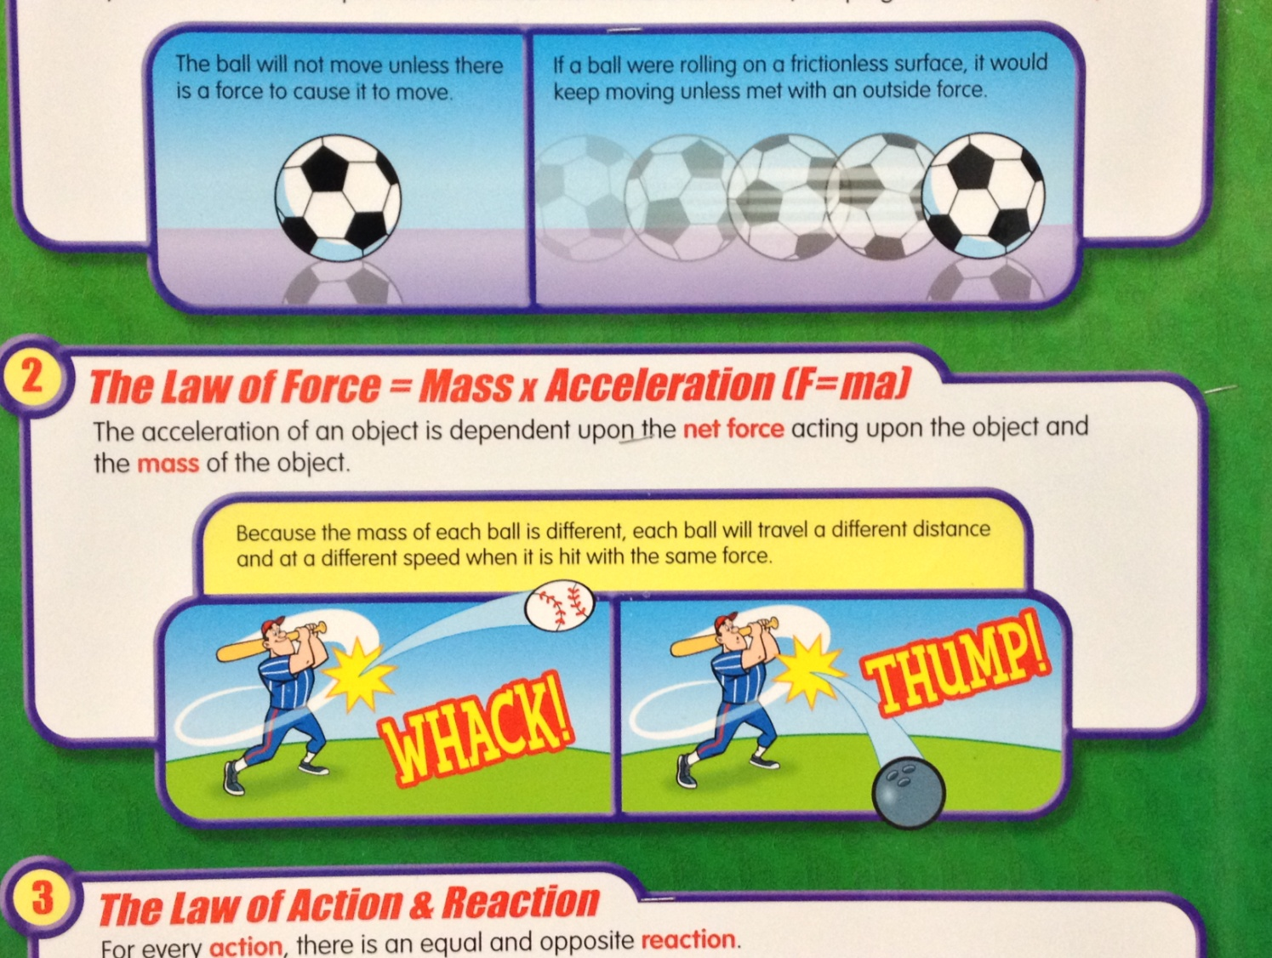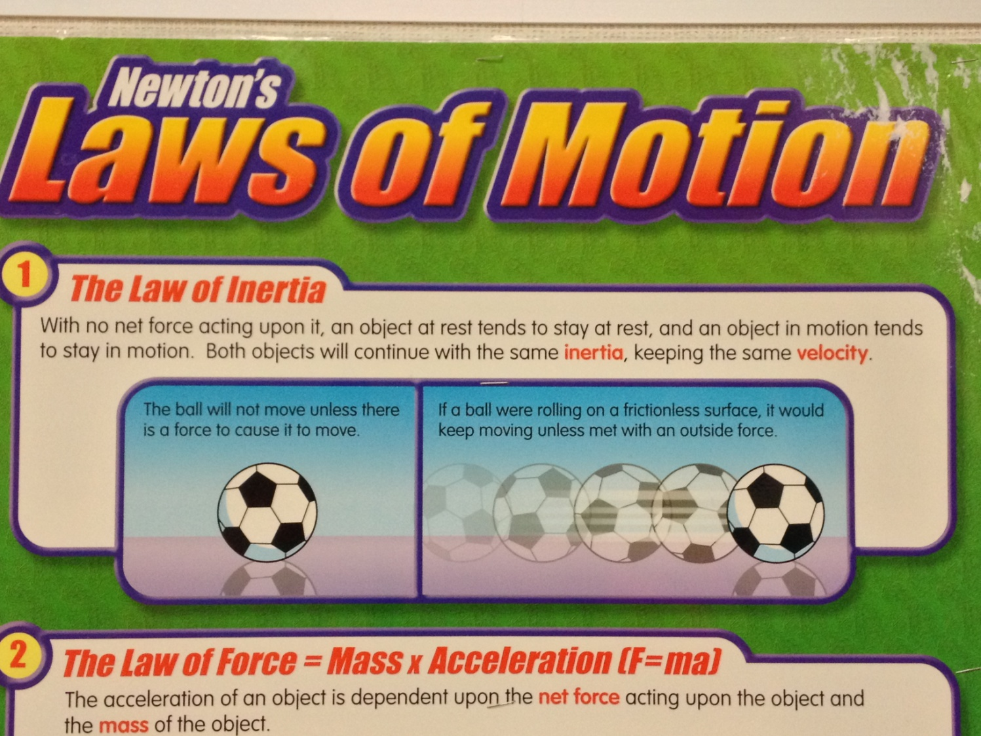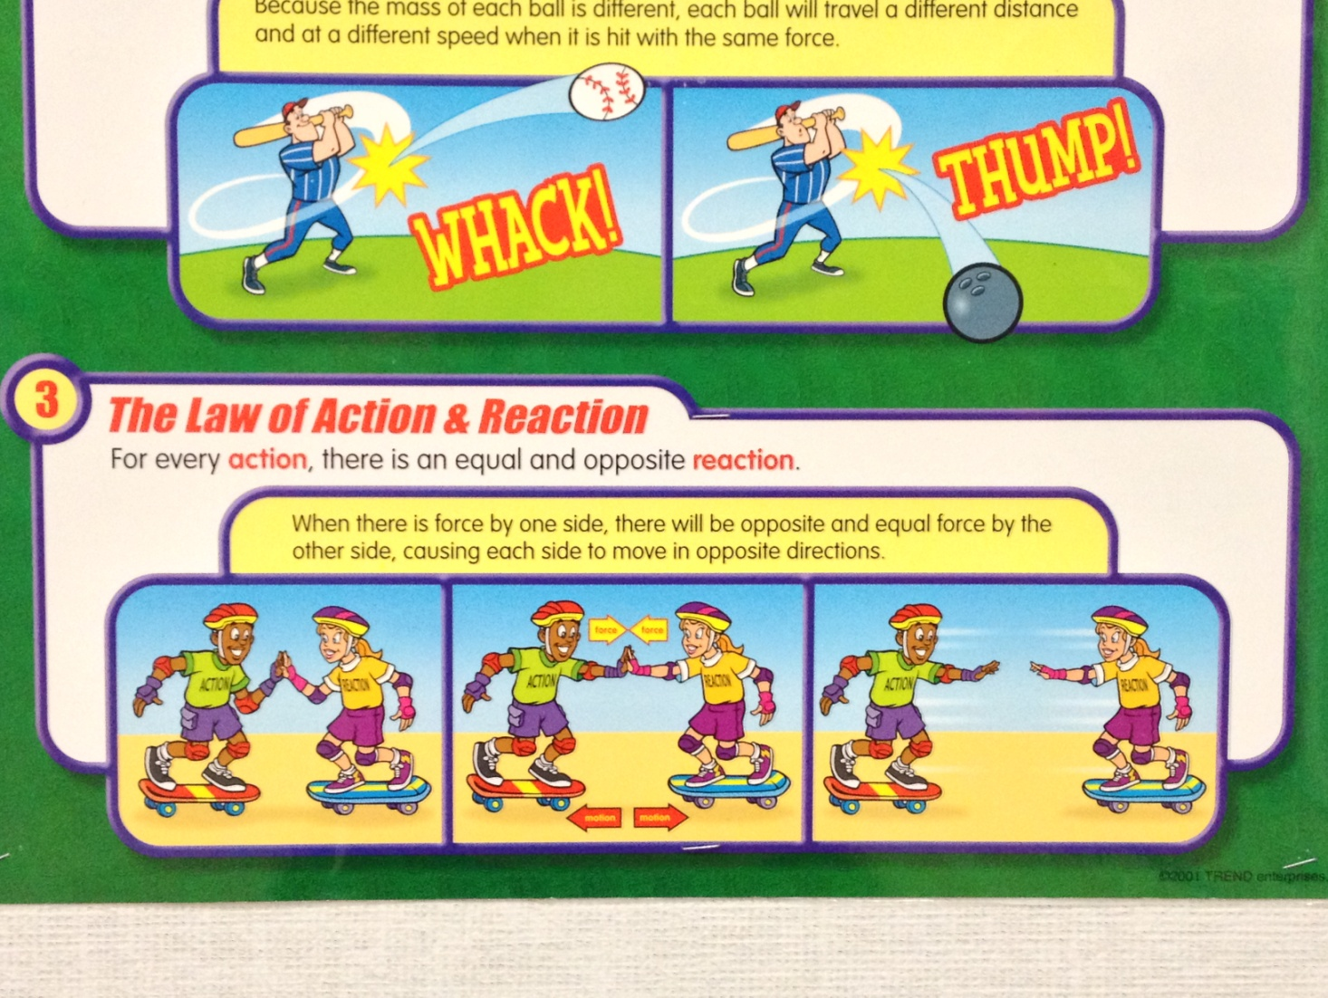

Name: ____________________ Date: _________
Sci10: MW4 Laws of Motion Balloon Car

Lab Report Requirements
p. 360 Nelson Frog Textbook
Question: Copy provided question.
Design: Complete (a) to record your data.
Materials: Copy materials – remembering that you must build your own base to your car and CAN NOT just reuse an already built toy car version for your wheel base.
Procedure: Feel free to write in “See p. 361 in textbook”.
Analysis & Evaluation: Complete & answer (b) and (c)…(d) will be completed on race day!
Understanding Concepts: Complete #’s 1-4.

RACE DAY: __________________________

Miss Foley
Sci10: Force & Motion Study Guide

Force & Motion Unit Exam Study Guide
- Define all italicized definitions found on Key Concepts Notes.
- Describe motion using definition words.
- Analyze and draw Ticker Tape patterns.
- Construct Distance-Time (velocity) graphs and Velocity-Time (acceleration) graphs.
  - Be sure to label correctly including all units
  - Be able to fill in a table based on a given graph
- Describe motion in Distance-Time (velocity) graphs and Velocity-Time (acceleration) graphs.
- Calculate Slope in both types of graphs (rise/run)
  - Slope of d-t graph = velocity
  - Slope of v-t graph = acceleration
- Calculate instantaneous and average velocity on a d-t graph
  - Remember tangent is used for instantaneous and use the points provided for average
- Calculate instantaneous and average acceleration on a v-t graph
- Calculate distance of a v-t graph by calculating area under a graph
- Calculate velocity, distance and time using v=d/t
- Calculate acceleration, velocity and time using a=v/t
- Units may have to be converted. Ex. seconds to hours, km to m and vice versa

Remember to Show your Work:
1 mark Did you identify info given in the question correctly in order to know
what you are trying to find?
1 mark Did you show that you are using the correct formula?
1 mark Did you substitute the correct info into the correct spot in the equation?
1 mark Did you do the math correctly?
1 mark Did you use the correct answer including correct units/significant digits?

Miss Foley
Sci10: Force & Motion

Miss Foley
Sci10: Climate & Ecosystem Outcomes & Indicators

Climate and Ecosystem Dynamics (CD)

CD1: Assess the implications of human actions on the local and global climate and the sustainability of ecosystems.
- Pose questions or problems relating to the effects of human actions on global climate change and the sustainability of ecosystems that arise from personal research.
- Reflect upon your personal view of humanity’s relationship with the environment.
- Research how people from Aboriginal and other cultures view relationships between living organisms and their ecosystems, and the role of humans in those relationships.
- Examine the positions of First Nations and government agencies responsible for the stewardship and management of resources, including the duty to consult. Evaluate changes in the scientific worldview of sustainability and human’s responsibility to protect ecosystems, considering key milestones and publications such as Our Common Future, Rio Declaration on Environment and Development, Agenda 21, Convention on Biological Diversity and the Bonn Declaration.
- Discuss why it is important to consider economic, social justice and environmental perspectives when examining sustainability.
- Select, integrate and analyze the validity of information from various human, print and electronic sources (e.g., government publications, community resources and personally collected data), with respect to sustainability, sustainable development and education for sustainable development.
- Provide examples of human actions that have contributed to the anthropogenic greenhouse effect.
- Research how scientists examine changes to the key indicators of climate change (e.g., CO₂ concentration, global surface temperature, Arctic sea ice area, land ice mass and sea level) to support the scientific understanding of climate change.
- Reflect upon individual and societal behavioural and lifestyle choices that can help to minimize anthropogenic sources of global climate change.
- Develop, present and defend a position or course of action based on personal research related to mitigating the effects of global or local climate change or to enhancing the sustainability of an ecosystem, taking into account human and environmental needs.
- Assess the current and potential future effects of ongoing changes to Earth’s climate systems on the people and the environment in Saskatchewan and Canada’s Arctic region.
CD2: Investigate factors that influence Earth’s climate system, including the role of the natural greenhouse effect.
- Differentiate between weather and climate, and the impacts of each on daily life.
- Understand that Earth’s climate system results from the exchange of thermal energy and moisture between the sun, ice sheets, oceans, solid earth and the biosphere over a range of timescales.
- Investigate how Earth’s axial tilt, rotation and revolution around the sun cause uneven heating of Earth’s surface, resulting in global convection currents, the Coriolis effect, jet streams, thermohaline circulation of the oceans and climate zones.
- Hypothesize how energy transfer, weather and climate might be different if Earth had a different axial tilt, diameter, period of rotation and/or period of revolution. Explain how greenhouse gases (e.g., water vapour, carbon dioxide, methane, nitrous oxide, (cont’d)
Miss Foley
Sci10: Climate & Ecosystem Outcomes & Indicators

(CD2 cont’d)
sulfur dioxide and ozone), particles, clouds and surface albedo affect the amount of solar energy absorbed and re-radiated at various locations on Earth.
- Explain the role of natural sources (e.g., volcanoes, fire, evaporation and living organisms) of the primary greenhouse gases in Earth’s atmosphere and how they contribute to the natural greenhouse effect.
- Design, construct and evaluate the effectiveness of a model used to illustrate the natural greenhouse effect, the reflectivity of Earth’s surface or the relationship between Earth’s axial tilt and the seasons.
- Investigate, through laboratory activities or simulations, heat transfer in air and water, including heat involved in phase changes.
- Examine how interactions between heat, pressure and the Coriolis Effect result in global wind patterns, ocean currents, jet streams and severe weather (e.g., hurricanes, tornadoes, blizzards and thunderstorms).
- Analyze weather and atmospheric data to identify patterns in temperature and atmospheric pressure, and changes in those patterns locally, regionally and globally.
- Provide examples of positive and negative feedback mechanisms in Earth’s climate system.
- Provide examples to show how scientific understanding may be refined in light of new evidence.

CD3: Examine biodiversity through the analysis of interactions among populations within communities.
- Discuss the importance of biodiversity and maintaining biodiversity.
- Understand that scientists describe biomes as resulting from the interaction of biotic and abiotic factors such as temperature, precipitation, insolation, latitude, altitude and geography.
- Compare the biodiversity and climatic characteristics of several of Earth’s major biomes.
- Estimate the abundance of organisms in a local ecosystem using random (e.g., quadrat), systematic (e.g., line transect and belt transect) and/or stratified sampling techniques.
- Determine the population density, percentage frequency and/or percentage cover of one or more organisms in an ecosystem using primary or secondary population data.
- Discuss ethical and cultural perspectives related to studying biotic components of ecosystems, including the potential benefits and consequences of technologies (e.g., radio collar) and techniques (e.g., mark and recapture) used to collect data. Examine ways in which scientists collaborate with Elders, knowledge keepers and other community members to gather and interpret data related to biotic components of ecosystems.
- Construct and/or interpret graphs of population dynamics of humans and other species to determine population trends within an ecosystem.
- Investigate various ways in which natural populations attempt to maintain equilibrium, and relate this equilibrium to the resource limits of an ecosystem with reference to concepts such as carrying capacity, natality, mortality, immigration and emigration.
- Examine the relationship between the biodiversity of an ecosystem, its primary productivity and ecological resilience.
- Examine how factors such as invasive species, habitat loss and climate change affect biodiversity within an ecosystem, and can result in species becoming at-risk (i.e., vulnerable, threatened and extirpated).
- Analyze how the bioaccumulation and bio-magnification of human-made substances can affect the viability and biodiversity of organisms and populations in an ecosystem.
Miss Foley
Sci10: Climate & Ecosystem Outcomes & Indicators

CD4: Investigate the role of feedback mechanisms in biogeochemical cycles and in maintaining stability in ecosystems.
- Explain systems in terms of their type (e.g., open, closed and isolated), equilibrium (e.g., dynamic, static, stable and unstable) and their associated feedbacks (e.g., positive and negative).
- Create a representation of a feedback mechanism that is relevant to a specific biogeochemical (e.g., carbon, nitrogen, phosphorus and water) cycle.
- Explore Indigenous ways of understanding the role of matter and energy in the environment.
- Describe how human actions can affect the cycling of matter and flow of energy through ecosystems.
- Examine the role of photosynthesis, respiration and sinks in the cycling of carbon through the environment.
- Design and carry out an investigation to determine the effect of carbon dioxide levels on photosynthesis and/or to determine the effect of nitrogenous-based fertilizer on plant or algal growth.
- Compare the processes of nitrification and de-nitrification in terrestrial and aquatic ecosystems.
- Research the short-term and long-term effects of small-scale and large-scale agricultural practices on the cycling of phosphorus, nitrogen and other nutrients in an ecosystem.
- Analyze the interdependence between the water cycle and other biogeochemical cycles.

Miss Foley
Sci10: Climate & Ecosystem Outcomes & Indicators

Miss Foley
Sci10: Climate & Ecosystem Dynamics OLD Key Concepts

* Definition words are bolded.
CD 1: Assess the implications of human actions on the local and global

climate and the sustainability of ecosystems.
- Scientific and technological developments impact every person's life. Some effects are desirable; some are not.
- Applications of scientific knowledge and technological products and practices are ultimately determined by society. Scientists and technologists have a responsibility to inform the public of the possible consequences of such applications.
- The selection of problems investigated by scientific and technological research is influenced by the needs, interests, and financial support of society.
- Human impact is the impact on the environment from human lifestyle, scientific discoveries and technological developments.

CD 2: Investigate factors that influence Earth’s climate system,

including the role of the natural greenhouse effect.

CE3: Examine biodiversity through the analysis of interactions among

populations within communities.
- A set of interrelated components forms a system.
- The living and non-living components of a biological community and their interrelationships form an ecosystem.
- Non-living components (sunlight, temperature, wind, water, and rock) of an ecosystem are abiotic.
- Living components (animals and plants) of an ecosystem are biotic.
- Biodiversity is a measure of the number and variety of species in an ecosystem.
- An organism is a living thing or something recently living.
- Organisms may be classified as producers or consumers depending on their relation to energy flow through an ecosystem. A producer is a type of organism that can make its’ own food whereas a consumer is a type of organism that can’t make its’ own food.
- The trophic level of an organism identifies its position in the energy flow pyramid of an ecosystem.
- A food chain shows the movement of energy through a system by indicating the path of food from a producer to a final consumer.
- A food web is a pictorial representation of the feeding relationships between organisms in an ecosystem and consists of interlocking food chains.
- Biomass is a measure of the mass of the dry matter contained in a group of living things.
- A pyramid of energy is a graphical model that shows the amount of energy available at each trophic level of an ecosystem.
- A pyramid of numbers is a graphical model that shows the numbers of organisms that exist at trophic levels in an ecosystem.
- A pyramid of biomass is a graphical model that shows the dry mass of organisms at each trophic level of an ecosystem.
- Biological accumulation (also called bioaccumulation) is the increase in concentration of a pollutant from the environment to the first organism in a food chain.
Miss Foley
Sci10: Climate & Ecosystem Dynamics OLD Key Concepts

- Biological magnification (also called biomagnification or bioamplification ) is the tendency of pollutants to become concentrated in successive trophic levels.
- Interpreting data means to find patterns in data collections that can lead to generalizations about the data.
- Scientists use models to represent objects, events, or processes.
- Ecologists use systematic and random (but not arbitrary) sampling techniques to examine representative portions of an ecosystem.
- A population is all the members of a species that are living in the same habitat at a particular time.
- A community is all of the organisms in an ecosystem.
- Biotic potential is the maximum number of offspring that a species could produce if resources were unlimited.
- Carrying capacity is the maximum number of individuals of a species that an ecosystem can support.
- Natality is the birth rate in a population.
- Mortality is the death rate in a population.
- Immigration is the movement of members into a population.
- Emigration is the movement of members from a population.
- A closed system is one in which substances do not enter or leave.
- Scientists classify limiting factors that regulate populations using multiple criteria: intrinsic or extrinsic, biotic or abiotic, or density-dependent or density-independent.
- The effects of density-dependent factors increase in significance as a population grows (e.g., disease due to overcrowding).
- The effect of density-independent factors does not depend on the population size (e.g., fire).
- Science searches for cause-effect relationships that enable predictions to be made.

CE 4: Investigate the role of feedback mechanisms in biogeochemical

cycles and in maintaining stability in ecosystems.
- A nutrient is any substance needed by an organism for proper growth, repair, and function such as nitrogen, oxygen, carbon, water, phosphorus, sulphur, hydrogen.
- A biogeochemical cycle or nutrient cycle is the path of a nutrient through an ecosystem.
- Cellular respiration is the process by which most living things generate useful energy by combining oxygen and sugars to produce carbon dioxide and water.
- Photosynthesis is the process by which green plants and other producers use energy from the sun, and carbon dioxide and water to produce sugars and oxygen.
- Nitrogen fixation is the conversion of atmospheric nitrogen gas into compounds that are usable by plants, typically nitrate ions or ammonia.

Name: ____________________ Date: _________
Sci10: CD1 Human Impact Planet in Peril

Planet in Peril Reflection Questions
- What struck you the most about the documentary series? Explain why.

- What did you agree with strongly? Explain why.

- What did you disagree with strongly? Explain why.

- HOW can YOU personally influence the human impact on your planet?

Miss Foley
Sci10: CD1 Human Impact

Miss Foley
Sci10: CD1 Human Impact Sustainability

Household Online Calculators Homework

Feel free to use estimates as needed and know that this information is for your private use for class purposes only

Km travelled weekly:
Hours flying weekly:
Km on each vehicle (estimated) annually:
Km travelled (estimated) on public transportation annually:
Average fuel economy of each vehicle:
Gross Annual Income:
Square footage of your home:

Type of Home:
Freestanding, no running water
Freestanding, running water
Multi-storey apartment
Duplex, row house or building with 2-4 housing units
Luxury condominium
Materials your home is constructed with:
Straw/bamboo
Wood
Brick/concrete
Adobe
Steel/other
How do you heat your home:
Gas
Oil
Electricity
Wood
How warm you regularly keep your home:
$ spent on power annually:
$ spent on natural gas annually:
$ spent on heating oil annually:
% of homes energy coming from green energy:
Square ft. of living space:
$ spent on water usage:
Miss Foley
Sci10: CD1 Human Impact Sustainability

How many calories/person of the following are consumed daily:
Meat, fish, eggs
Grains & baked goods
Dairy
Fruits & vegetables
Snacks, drinks, etc...
% of your food unprocessed, unpacked or locally grown:
$ spent on Goods annually:

Furniture & appliances
Clothing
Entertainment
Paper, office, & reading
Personal care & cleaning
Auto parts
Medical
Pets/Pet Food

$ spent on monthly new clothing, footwear and/or sporting goods purchases:
How often do you purchase new:
Household appliances
Electronic gadgets
Books, newspapers, magazines
$ spent on Services annually:

Health Care
Information & Communication
Medical
Vehicle services
Personal business & finance
Household maintenance & repair
Organizations & Charity
Other services

Which of these do you recycle: How often?
Food
Paper
Tin cans
Plastic
Glass
Energy Efficient Strategies used in your home:

Energy saving light bulbs
Energy efficient appliances
Passive heating/cooling
Grey water systems
Advanced temperature control
Advanced ventilation
Low electricity use
Loft insulation
Cavity or solid wall insulation
Condensing boiler
Double glazing
Low flow fittings to taps and showers
Solar panels
Solar water heater

Name: ____________________ Date: _________
Sci10: CD1 Human Impact Sustainability

Sustainability: Online Footprint Calculators
1 acre = 4047m² 2.47 acres = 1 hectare = 10,000m²
1 euro = $1.50 CDN 1 pound = $2 CDN

Saskatchewan Royal Museum of Natural History
http://www.royalsaskmuseum.ca/exhibits/life-sciences-gallery/the-human-factor

The Nature Conservatory
http://www.nature.org/greenliving/carboncalculator

Earth Day Network
http://www.earthday.org/footprint-calculator

World Wildlife Federation
http://footprint.wwf.org.uk

Ecology Fund
http://www.ecologyfund.com/ecology/res_bestfoot.html

Complete at least 3 of the above online footprint calculators and answer the following:

Organization | About | Calculator Results
Saskatchewan Royal Museum of Natural History
The Nature Conservatory

Name: ____________________ Date: _________
Sci10: CD1 Human Impact Sustainability

Earth Day Network
World Wildlife Federation
Ecology Fund

Which was the most user-friendly to use? Least user-friendly? Explain why.

Which do you think was most accurate? Explain why.

Which would you recommend based on your experience and who they are as an organization? Explain why.

Miss Foley
Sci10: CD1 Human Impact Sustainability

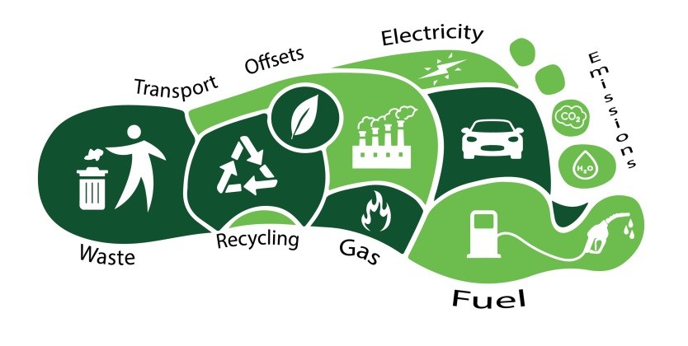
Reduce Your Footprint
There are many simple ways to reduce the footprint you leave on the planet. Learn how to reduce your footprint in each consumption category-carbon, food, housing, and goods and services-but don't stop there. Amplify your impact by encouraging others to follow your lead. Engage your friends and community with local and global movements for social change, or start your own movement!
Reduce Your Carbon Footprint
Use cleaner transport
- Walk, bike, or take public transit whenever possible.
- Avoid allowing your car to idle. If you'll be waiting for more than 30 seconds, turn off the engine (except in traffic). And don't take the drive-through-park the car and walk inside instead.
- Have your vehicle serviced regularly to keep the emission control systems operating at peak efficiency. Check your car's air filter monthly, and keep the tires adequately inflated to maximize gas mileage.
- Avoid short airplane trips-take a bus or train instead.
Add energy-saving features to your home
- Install compact fluorescent bulbs in all your home light fixtures-but remember, compact fluorescents contain mercury, so look for low-mercury models and be sure to dispose of old bulbs safely through your local hazardous waste program.
- Weatherproof your home. Make sure your walls and ceilings are insulated, and consider double-pane windows. Eliminate drafts with caulking, weather strips, and storm windows and doors.
- Insulate your water heater. Even better, switch to a tank-less water heater, so your water will be heated only as you use it.
- Choose energy efficient appliances.
Adopt energy-saving habits
- Keep thermostat relatively low in winter and ease up on the air conditioning in summer. Clean or replace dirty air conditioner filters as recommended to keep the A/C operating at peak efficiency.
- Unplug your electronics when not in use. To make it easier, use a power strip. Even when turned off, items like your television, computer, and cellphone charger still sip power.
- Dry your clothes outside whenever possible.
- Make minimal use of power equipment when landscaping.
- Defrost your refrigerator and freezer regularly.
- Choose green electricity. Many utilities give you the option to purchase electricity generated by wind and solar power for a small rate surcharge.
- Purchase carbon offsets to make up for the energy use you can't eliminate.
Miss Foley
Sci10: CD1 Human Impact Sustainability

Reduce Your Food Footprint
- Eat more local, organic, in-season foods.
- Plant a garden-it doesn't get more local than that.
- Shop at your local farmer's market or natural foods store. Look for local, in-season foods that haven't traveled long distances to reach you.
- Choose foods with less packaging to reduce waste.
- Eat lower on the food chain-going meatless for just one meal a week can make a difference. Globally, it has been estimated that 18% of all greenhouse gas emissions are associated with meat consumption.
Reduce Your Housing Footprint
Choose sustainable building materials, furnishings, and cleaning products.
- Explore green design features for your building, like passive solar heating, a rainwater catchment or grey water recycling system, and recycled materials.
- Choose efficient appliances, including low flow shower heads, faucets, and toilets.
- Choose furnishings that are second-hand, recycled, or sustainably produced.
- Plant drought tolerant plants in your garden and yard.
- Use biodegradable, non-toxic cleaning products.
Adopt water-saving habits
- Take shorter, less frequent showers-this not only saves water, but the energy necessary to heat it.
- Don't use the garbage disposal. Compost instead.
- Run the dishwasher and the laundry machine only when full.
- Wash cars rarely, or better yet, take them to a carwash. Commercial carwashes use less water per wash than home washers, and they are also required to drain used water into the sewage system, rather than storm drains, which protects aquatic life.
- Avoid hosing down or power-washing your deck, walkways, or driveway.
- Regularly look for and fix leaks.
Reduce your Goods and Services Footprint
- Buy less! Replace items only when you really need to.
- Recycle all your paper, glass, aluminum, and plastic. Don't forget electronics!
- Compost food waste for the garden. Garbage that is not contaminated with degradable (biological) waste can be more easily recycled and sorted, and doesn't produce methane gases (a significant greenhouse gas contributor) when stored in a landfill.
- Buy recycled products, particularly those labeled "post-consumer waste."

Miss Foley
Sci10: CD3 Biodiversity Ecosystems Defined

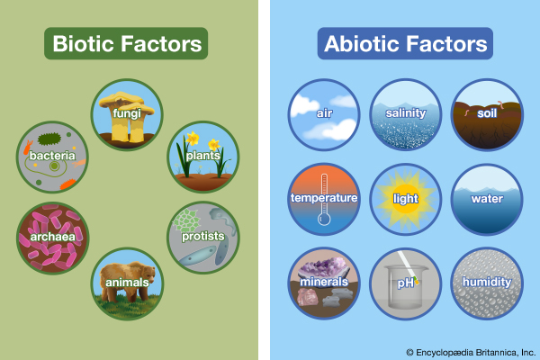
Ecology = the study of ecosystems
Ecosystem =
An interacting
system of biotic
(groups of organisms)
and abiotic
(physical environment)
factors
Biotic = meaning life, are living factors. Plants, animals, fungi, protest and bacteria are all biotic or living factors.
Abiotic = meaning not life, are non-living factors that affect living organisms. Environmental factors such as habitat (rock, soil, water) or weather such as temperature, cloud cover, rain, snow, hurricanes, etc. are abiotic factors.

The Impact of Changing Factors
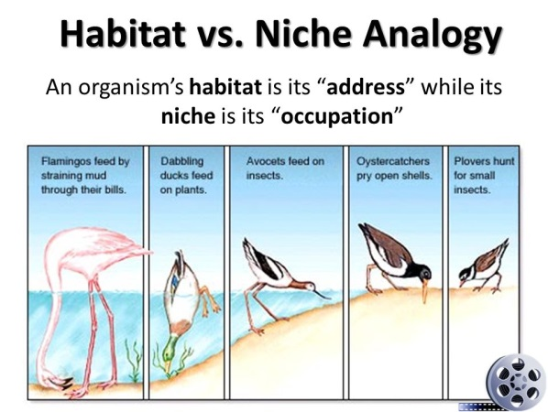
Biotic and abiotic factors are interrelated. Imagine someone pulling on a string from a ball of yarn. Each attempt to pull at a strand of yarn puts tension on the rest of the ball of yarn. If one factor is changed or removed, it impacts the availability of other resources within the system. If a single factor is changed, perhaps by pollution or natural phenomenon, the whole system can be altered. For example, humans can alter environments through farming, irrigation, and urbanization. While we usually cannot see what we are doing to various ecosystems, the impact is being felt all over. For example, acid rain in certain regions has resulted in the decline of fish populations.

Habitat = Home vs Niche = Job
The habitat of an organism is the place where it lives. An ecosystem, such as a woodlot, has many habitats. For example, the habitat of an earthworm is the rich woodlot soil. The habitat of a land snail is the moist leaf litter. The habitat of a porcupine is a hollow tree. The habitat of a blue jay if the branched of the trees. Habitats may overlap. For example, the porcupine may seek out a meal of bark on the branches that are also the habitat of the blue jay. However, since these animals do not eat the same food, no problems result from the overlap of their habitats.
The niche of an organism is its role or job in the community. For example the niche of a deer is to feed on grass and other plants, to become food for wolves, to provide blood for blackflies and mosquitoes, to fertilize the soil with nutrients, and so on. The niche of a frog in a pond is to feed on insects, to become food for snakes and other animals, and many other things.
If two species have the same habitat and similar niches, they will compete with one another. For example, mule deer and elk often live in the same mountain valley. That is, they have the same habitat. Both species eat grass and other plants. Both are preyed upon by wolves and are attacked by many of the same parasites. That is, they have similar niches. Clearly they will compete for available space and food in the valley.
Miss Foley
Sci10: CD3 Biodiversity Ecosystems Defined

Levels of Ecological Organization:
Individuals to Biosphere
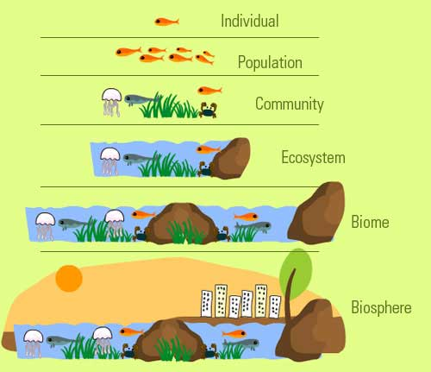
Organism – any living thing.
Individual – one living member of a population.
Population – a group of individuals of the same species living together in the same area. For example, the pond with geese on it also has bullfrog, water lily, and perch populations.
Community – is all the living things in an area. A community consists of several populations. The pond community is made up of goose population, a duck population, a water lily population, and many others that you can’t see.
Biome – a large area with a characteristic climate, vegetation & animal life. Canada only has five main biomes. This climate dictates each biome’s characteristic vegetation while the vegetation dictates each biome’s characteristic animals. A biome consists of several communities. For example, the coniferous forest has lake communities, pond communities, bog communities, and many others.
Biosphere - the region on earth where life exists. The only example is planet Earth. Organisms live in the lower parts of the atmosphere. They also live in almost all bodies of water on earth. They live on the soil, and in the first meter or two of soil. This thin layer from the lower atmosphere to the bottom of oceans makes up the biosphere. The biosphere is made up of many biomes. Among them are desert biomes, coniferous forest biomes, grassland biomes, tundra biomes, marine biomes, and others.
Miss Foley
Sci10: CD3 Biodiversity Species At Risk

Biodiversity = a measure of the number and variety of species in an ecosystem
It involves the dynamic abilities of species to adapt to and survive in an ever changing world. There are presently over 10 million different species on Earth.
Each member of an ecosystem is a valuable participant in the stability of that area. All organisms have a niche, or role to play within that ecosystem. Whether they are predators, prey, producers or decomposers, their position is valuable to the sustainability of the region. If any species became extinct because of environmental contaminants, natural disasters or human impact, the short and long term effects could be devastating. Even now, biodiversity is disappearing at an alarming rate. It has been estimated that nearly 50% of all mammals and birds could become extinct within the next century.
Human intervention has had a range of effects on natural biodiversity. Agriculture has expanded into environmentally sensitive regions. In its natural state, an area of land that has shrubs and grasses on it has an inherent tolerance against flooding, drought and insect infestation. Because of expanding lands for agriculture and diversification of crops such as growing corn, some ecosystems have become more vulnerable.

Carrying Capacity = the # of individuals an area can support based on the available resources

Density Independent Limiting Factors are environmental stresses that limit the growth of the population regardless of the density or numbers of the population. These elements of the environment include things such as natural disasters (forest fires caused by lightening, tornadoes, floods or drought), or changes in temperature, the amount of sunlight, or human interference. Changes in temperature can cause changes in a species' behaviour and growth. It may even cause a species to migrate to a more favourable location to survive. In aquatic environments, temperature changes are not as dramatic, however, the temperature does affect the oxygen release rate in the water, and a decrease in oxygen will cause decrease activity of aquatic species. Plants are dependent on sunlight to carry on photosynthesis. If a change in the environment causes a disruption of the amount of sunlight available, these plants species would suffer. This could cause a disappearance of the species and even adversely affect the entire ecosystem. Human interference includes clear cutting forests, building dams on rivers, the use of pesticides and herbicides. The physical characteristics of some species allow them to cope with environmental changes. The ability to grow fur when colder weather comes, the ability to adapt to new environmental pressures are all helpful in allowing the survival and prosperity of a population.

Density Dependent Limiting Factors inhibit the overgrowth of a population when the numbers of that population are large. These are things such as food, space, shelter, predation and disease. If different species of animals compete for the same food, and one of the species grows in population, the availability of the food source will decrease dramatically. If the population of predators increases suddenly, the population of the prey will decrease dramatically. In time, the predator population will decrease because of the decrease in the food source. Disease and parasitism is more devastating to a population when its numbers are high.
Miss Foley
Sci10: CD3 Biodiversity

Miss Foley
Sci10: CD3 Biodiversity Relationships

Community Relationships
Predation = one organism (predator benefits) eats another
organism (prey is harmed)
Some examples of predator and prey are lion and zebra, bear and fish, and fox and rabbit. The words "predator" and "prey" are almost always used to mean only animals that eat animals, but the same concept also applies to plants: Bear and berry, rabbit and lettuce, grasshopper and leaf.
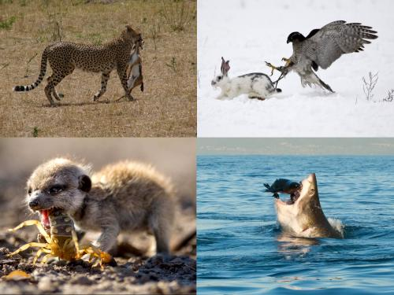
Predator and prey evolve together. The prey is part of the predator's environment, and the predator dies if it does not get food, so it evolves whatever is necessary in order to eat the prey: speed, stealth, camouflage (to hide while approaching the prey), a good sense of smell, sight, or hearing (to find the prey), immunity to the prey's poison, poison (to kill the prey) the right kind of mouth parts or digestive system, etc. Likewise, the predator is part of the prey's environment, and the prey dies if it is eaten by the predator, so it evolves whatever is necessary to avoid being eaten: speed, camouflage (to hide from the predator), a good sense of smell, sight, or hearing (to detect the predator), thorns, poison (to spray when approached or bitten), etc.
Another example of predator-prey evolution is that of the Galapagos tortoise. Galapagos tortoises eat the branches of the cactus plants that grow on the Galapagos islands. On one of the islands, where long-necked tortoises live, the branches are higher off the ground. On another island, where short-necked tortoises live, the branches are lower down. The cactuses, the prey, may have evolved high branches so that the tortoises, the predators, can't reach them.
Symbiosis = close, long-term interaction between two species
There are three different types of symbiotic relationships: mutualism, commensalism, and parasitism:
Mutualism - both partners benefit. An example of mutualism is the relationship between the Egyptian plover and the crocodile. In the tropical regions of Africa, the crocodile lies with its mouth open. The plover flies into its mouth and feeds on bits of decaying meat stuck in the crocodile’s teeth. The crocodile does not eat the plover. Instead, he appreciates the dental work. The plover eats a meal and the crocodile gets his teeth cleaned. Coincidentally, the Egyptian plover is also known as the crocodile bird.
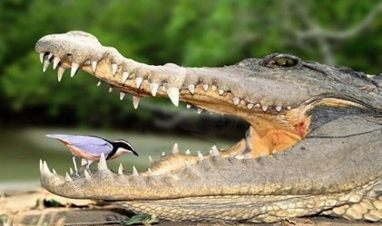
An astounding number of mutualistic relationships occur between multicellular organisms and microorganisms. Termites are only able to eat wood because they have mutualistic protozoans and bacteria in their gut that helps them digest cellulose. Inside our own bodies, there are hundreds of different types of bacteria that live just in our large intestine. Most of these are uncharacterized, but we do know a lot about E. coli, which is one of the normal bacteria found in all human large intestines. Humans provide E. coli with food and a place to live. In return, the E. coli produce vitamin K and make it harder for pathogenic bacteria to establish themselves in our large intestine. Whether or not most of the other species of bacteria found in our digestive tract aid in digestion, absorption, or vitamin production isn't completely known, but they all make it harder for invasive pathogens to establish a foothold inside us and cause disease.
Miss Foley
Sci10: CD3 Biodiversity Relationships

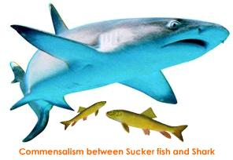
Commensalism - only one species benefits while the other is neither helped nor harmed. For example, remora fish are very bony and have a dorsal fin (the fin on the back of fish) that acts like a suction cup. Remora fish use this fin to attach themselves to whales, sharks, or rays and eat the scraps their hosts leave behind. The remora fish gets a meal, while its host gets nothing. Selfish, sure, but neither gets hurt. The cattle egret follows cattle, water buffalo, and other large herbivores as they graze. The herbivores flush insects from the vegetation as they move, and the egrets catch and eat the insects when they leave the safety of the vegetation. In this relationship the egret benefits greatly, but there is no apparent effect on the herbivore.
Some biologists maintain that algae and barnacles growing on turtles and whales have a commensalistic relationship with their hosts. Others maintain that the presence of hitchhikers causes drag on the host as it moves through the water and therefore the host is being harmed, albeit slightly. In either case, it is unlikely that the fitness of the host is really affected by the hitchhikers, so commensalism is probably the best way to describe these relationships as well.
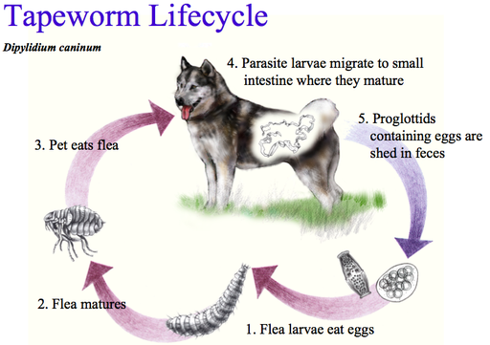
Parasitism - One organism (parasite) gains, while the other (host) suffers. The deer tick is a parasite. It attaches to a warm-blooded animal and feeds on its blood. Ticks need blood at every stage of their life cycle. They also carry Lyme disease, an illness that can cause joint damage, heart complications, and kidney problems. The tick benefits from eating the animal's blood. Unfortunately, the animal suffers from the loss of blood and nutrients and may get sick. Not all parasites have to cause disease. Lice, ticks, fleas, and leeches are all examples of parasites that don't usually cause disease directly, but they do suck blood from their host, and that is causing some harm, not to mention discomfort to their host.
Parasites can also act as organisms that transmit disease-causing pathogens to other species of animals. The bacteria that cause the bubonic plague are carried by rodents, such as rats. The plague bacteria then infect fleas that bite the rats. Infected fleas transmit the bacteria to other animals they bite, including humans. In this case, both the flea and the bacteria are parasites, and the flea is also a vector that transmits the disease-causing bacteria from the rat to the person.
Competition = individuals or species compete for the same
resources (both harmed).
When organisms compete for a resource (such as food or building materials) it is called consumptive or exploitative competition. When they compete for territory, it is called interference competition. When they compete for new territory by arriving there first, it is called preemptive competition. An example is lions and hyenas that compete for prey.
Miss Foley
Sci10: CD3 Biodiversity Energy Flow

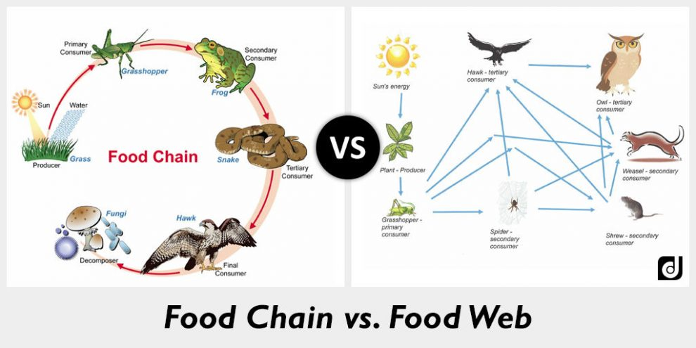
A food chain is a linear relationship showing how energy is transferred between organisms.
A food web is a pictorial representation of the feeding relationships between organisms in an ecosystem; consists of many inter-locking food chains.
Arrows are used on food chains and food webs to represent where the energy is flowing, otherwise known as who is receiving the energy.
The energy comes as solar energy that plants use to convert into chemical energy (photosynthesis). The herbivores eat the plants, taking some of the energy and then they are prey and the remaining energy is transferred to the predator.
But some of this energy is lost at each stage (or trophic level). In the above example, the grass loses some energy by respiration. And then the rabbit loses energy by heat and waste. And so by the time it gets to the fox a fraction of the original energy gets to it.
Energy Transfer
In an ecosystem there is energy, and this is what allows the organisms to live. This energy mainly comes from one original source: photosynthesis. The plants use this solar energy to produce carbohydrates which are then consumed by other organisms: transferring the energy.
At each level of the food chain energy is lost because it is used by the organism itself for respiration. This limits the number of steps there can be on a food chain.
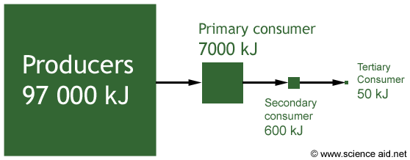
The diagram above represents quantitatively the efficiency of energy transfer in a food chain. Notice how only about 8% of the energy is transferred from one stage to the next.
Miss Foley
Sci10: CD3 Biodiversity Energy Flow

Ecological Pyramids
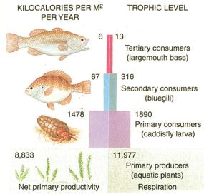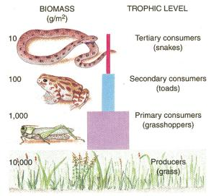A food chain can be represented with numbers in the form of a pyramid of numbers.
An ecological pyramid shows the relative sizes of different components at the various trophic levels of a food chain. A trophic level refers to each stage (shown as a horizontal bar on ecological pyramids).
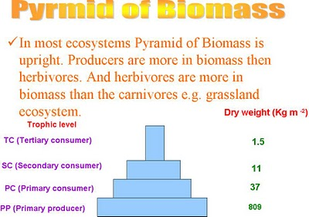
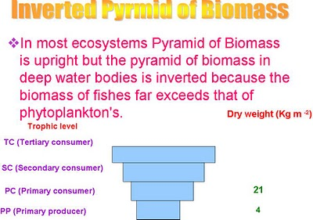

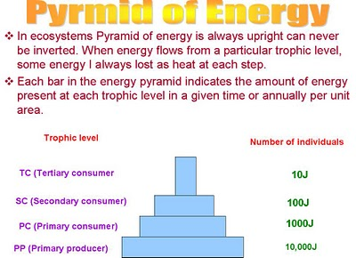
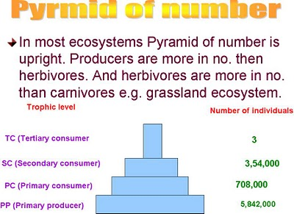
Miss Foley
Sci10: CD4 Cycles & Stability Cycles

Biogeochemical Cycle =
How an element/compound moves between various living/nonliving forms & locations in the biosphere

Energy flows directionally through Earth’s ecosystems, typically entering in the form of sunlight and exiting in the form of heat. However, the chemical components that make up living organisms are different: they get recycled.
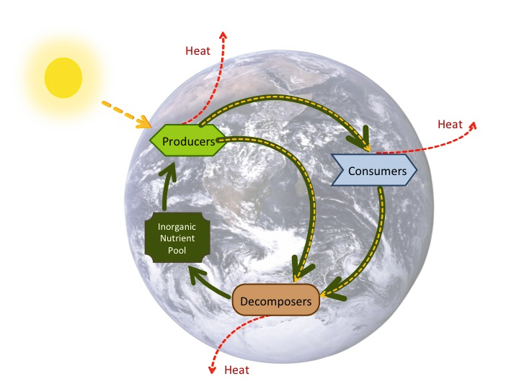The atoms in your body are not brand new. Instead, they've been cycling through the biosphere for a long, long time, and they've been part of many organisms and nonliving compounds along the way.
Figure 1 Image credit:
Eva Horne and Robert A. Bear
In this image, the flow of energy is shown with yellow and red arrows. Yellow indicates usable energy and red indicates energy lost in the unusable form of heat. Green arrows show the continual recycling of chemical nutrients.
The six most common elements in organic molecules — carbon, nitrogen, hydrogen, oxygen, phosphorus, and sulfur — take a variety of chemical forms. They may be stored for long or short periods in the atmosphere, on land, in water, or beneath the Earth’s surface, as well as in the bodies of living organisms. Geologic processes - such as weathering of rocks, erosion, water drainage, and the subduction of continental plates - all play a role in this recycling of materials, as do interactions among organisms.
Water, which contains hydrogen and oxygen, is essential for living organisms. That places the water cycle pretty high on the list of cycles we care about!
Water makes up more than half of our bodies, but humans cannot live by water alone. Instead, there are some other key elements that keep our bodies running and are part of biogeochemical cycles:
- Carbon is found in all organic macromolecules and is also a key component of fossil fuels.
- Nitrogen is needed for our DNA, RNA and proteins and is critical to human agriculture.
- Phosphorus is a key component of DNA and RNA and is one of the main ingredients—along with nitrogen—in artificial fertilizers used in agriculture.
- Sulfur is key to protein structure and is released to the atmosphere by the burning of fossil fuels.
These cycles don't happen in isolation, and the water cycle is a particularly important driver of other biogeochemical cycles. For example, the movement of water is critical for the leaching of nitrogen and phosphate into rivers, lakes, and oceans. The ocean is also a major reservoir—holding tank—for carbon.
Bioaccumulation = the increase in concentration of a pollutant
from the environment to the first organism in a food chain.
Biomagnification = the tendency of pollutants to become
more concentrated as they travel up trophic levels.
Miss Foley
Sci10: CD4 Cycles & Stability Cycles

The Water Cycle
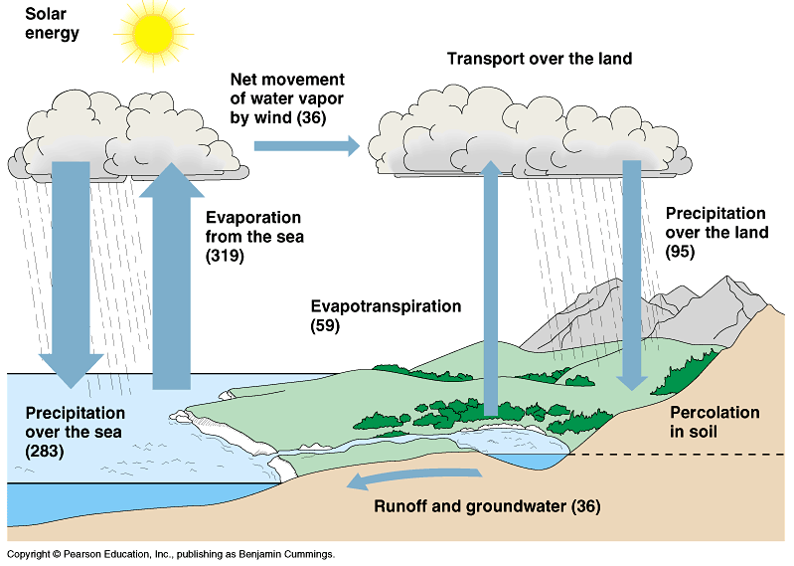
The Phosphorous Cycle
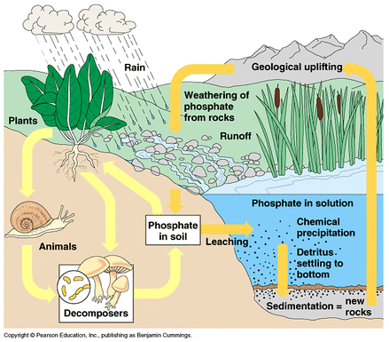

Miss Foley
Sci10: CD4 Cycles & Stability Cycles

The Carbon Cycle
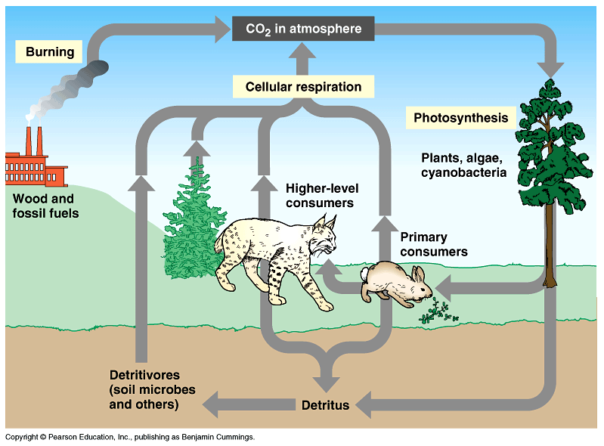
The Nitrogen Cycle
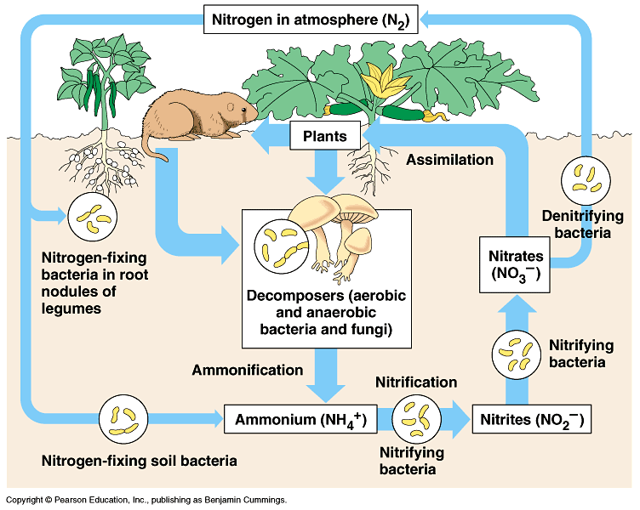
Miss Foley
Sci10: Climate & Ecosystem Dynamics Study Guide

Ecosystem Unit Exam:
Jan 2019
- Define all italicized definitions found on Key Concepts Notes.
- Discuss how society's needs and functions, as well as the global economy, affect one's community.
- Identify biotic and abiotic components of an ecosystem.
- Explain how biodiversity of an ecosystem contributes to its sustainability.
- Identify how relationships between organisms (symbiotic, mutualism, predation, parasitism, commensalism) contribute to its sustainability.
- Identify energy flow in ecosystems using the concept of the pyramid of energy, numbers, or biomass.
- Describe the mechanisms of bioaccumulation and biomagnifications and their impact on consumers at all trophic levels.
- Explain the impact of invasive species on an ecosystem.
- Identify factors that result in species becoming at-risk in Saskatchewan , the Prairies, and Canada.
- Explain various ways in which natural populations maintain equilibrium and relating this equilibrium to carrying capacity and limiting factors of populations.
- Interpret graphs of population dynamics.
- Discuss the cycling of nutrients and matter through an ecosystem by tracking carbon, nitrogen, water and oxygen, along with human impact on these cycles.
- State a prediction and a hypothesis based on available evidence and background information.
- Predict the personal, social, and environmental consequences of a proposed action.
Miss Foley
Sci10: Career Investigation Outcomes & Indicators

CI1: Investigate career paths related to various branches and sub-branches of science.
- Create a representation that demonstrates interrelationships
between various branches and sub-branches of science.
- Explore the breadth of science-related work roles and who is engaged in those work roles in the community.
- Develop a profile of a specific individual involved in a science career, addressing factors such as their educational and personal background, what drew them to their career, the focus of their work and their advice for others who wish to pursue a similar career.
- Research the range of science-related programs offered by post-secondary institutions in Saskatchewan and across the country.
- Identify the ways in which professional societies and organizations provide support to those engaged in science-related careers in Saskatchewan.
- Research the educational qualifications of people engaged in science-related careers.
- Attend a science-related career fair and analyze career choices based on information gathered.
- Identify how personal activities and interests relate to topics in secondary science curricula.
- Represent the range of career options available related to a specific branch or sub-branch of science.

