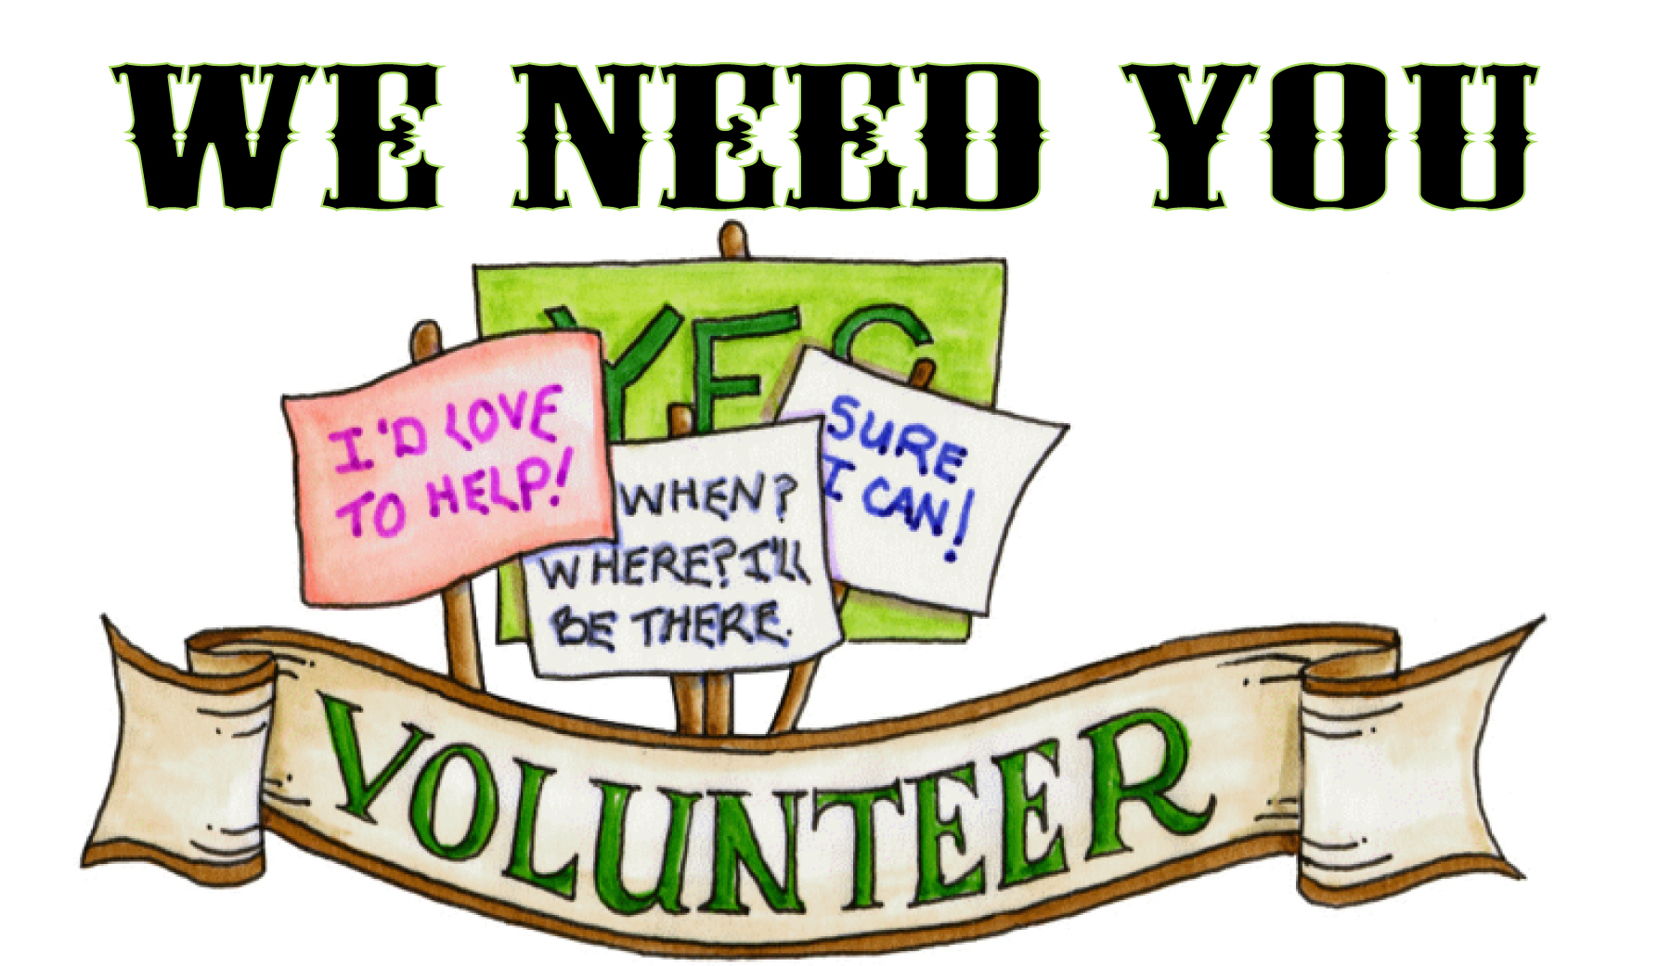Wellness 10:
Student Guide To Service Learning

Outcome W3: Verify how service learning enhances the well-being of the volunteer while providing a service to the individual or organization/community.
- Reflect on what is known about volunteering and service learning (e.g., what volunteers do, where volunteering occurs, value of volunteering).
- Communicate with a volunteer agency/organization to discuss volunteering on the community.
- Consider and conclude why various community members volunteer.
- Discuss what volunteers do.
- Determine community agencies and organizations that benefit from the services of volunteers (e.g. , Sexual health centers, senior centers, Canvasser, Special Olympics, Kidsport, Right to Play, minor sports, after school programs for children).
- Investigate historical, contemporary, and evolving needs and opportunities (i.e., time, situations, programs, and/or environments) in the community which might benefit from acts of service .
- Propose additional community service opportunities that would benefit one’s community.
- Investigate potential impact of service learning upon a volunteer’s overall well-being.
- Analyze the value that young adults can play in service to their community.
- 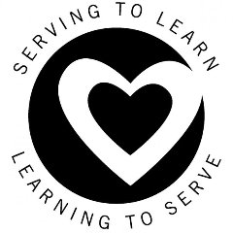Assess personal skills and aptitudes to find the ‘best’ community service opportunity for self.
- Set personal goals of what individuals want to accomplish from service learning.
- Evaluate and revise your personal Wellness plan to be involved in at least 12 hours of service learning in the community (i.e., local community, global community), using criteria such as mutuality, empowerment, and respect for the capabilities of others, that purposefully enhances the well-being of self and others.

Background Information
Volunteers and volunteer groups make up what is known as the volunteer or voluntary sector. Volunteer groups are referred to as: non-profits, non-governmental organizations (NGOs), or community-based organizations (CBOs). Today there are at least 8,000 such organizations in the province and they include a diversity of organizations such as historical and heritage associations, day care centres, sports and recreation clubs, art and culture organizations, social clubs, universities, hospitals, food banks and hot meal programs, environmental groups, trade associations, places of worship, advocates for social justice, and groups that raise funds to cure diseases.

Volunteers become involved in many activities within a community: hospitals, health centres, churches, libraries, community halls, museums, schools, women's centres, environmental groups, help lines, seniors' residences, arenas, literacy programs, immigrant agencies, youth groups, camps, cultural groups, fire halls, and many other organizations and agencies. They also help elders, people who are sick at home, and others in the community who are in need.
Service learning is a method of teaching, learning, and reflecting through service in the community. More specifically, it integrates meaningful community service with instruction and reflection to enrich the learning experience, teach and encourage social responsibility, encourage lifelong learning, and strengthen communities for the common good.
In Wellness 10, the expectation is that students will be involved in a minimum of 12 hours of service in the community that purposefully enhances the well-being of self and others. This involvement will be identified in their Personal Plans for Wellness (PPW). The intention is for students to evaluate how service learning experiences enhance the well-being of the volunteer while providing meaning services to the individual or organization.

Depending on the type of volunteering, students may be asked to do one or more of the following:
- Fill out an application form.
- Provide a resumé and/or criminal record check.
- Provide references. (Have them ask a teacher, community leader, employer, coach, or other trusted adult. Remind students to never give a name or phone number without first asking permission.)
- Participate in an interview. Provide them with practice opportunities.
Students are required to do a minimum of 12 hours of community service - work not done for family for which they receive no money or other planned benefits.

Student Planning Steps

- As a class, brainstorm volunteering opportunities early in the semester/year. These opportunities should align with wellness needs in the community as well as opportunities to enhance/balance dimensions(s) of personal wellness.

- Let your parents/guardians & families know of the service learning expectations.

- Start with a class volunteering experience and use this common experience when outlining a few of the expectations involved. Numerous experiences can make up the minimum of 12 hours of service learning.

- Discuss safety and precautions and be sure that you ask these kinds of questions in your interviews (e.g., fire alarms, extinguishers, exits, emergency procedures).

- Interview one of the people/organizations you would like to volunteer for during the semester. During the interview you will need to gather contact information, description of services offered, safety concerns, opportunities to enhance the wellness of the community, etc. Have them complete the Wellness 10: Service Learning Assessment form before handing in. This feedback will be included in your evaluation.

- Complete the Wellness 10 Self-Assessment: Preparing & Conducting A Service Learning Interview (face-to-face when appropriate) and hand in the information you gather from your interview after PRIOR to choosing & beginning their volunteer experience.

- Decide when & where you will be volunteering letting your Wellness teacher know the details of your current plan.

- Document both the hours volunteered and personal reflections as you respond to the majority of guiding questions for self-reflection provided with this package. Documentation will be handed in for assessment & evaluation.

- Conclude with thank-you letters/emails.

Dear ______________________,

Thank you for allowing the opportunity for me to spend time with you helping __________________. The purpose of my volunteering was to experience and develop an understanding of how service learning enhances the well-being of the volunteering while providing a service to the individual or organization/community. This purpose was achieved as I had the opportunities to ______________________and ________________________.
I learned many things about myself, including ___________________________________. I also learned that the wellness of the community _________________________________.

On behalf of my school and myself, ___________________________________________.

Sincerely,
Your Name
On-Going Personal Reflection

You will be required to reflect about your knowledge and beliefs about volunteering, to discuss what you know and how you have come to know ‘it’, as well as how you think this knowledge may have affected your volunteering during this course. What compelling questions could you ask that could lead to a deeper understanding of volunteerism and the impact on the wellness of self and community?

Examples of questions include:
- What is a volunteer?
- Why do people volunteer?
- How does volunteering make a community stronger?
- How does volunteering contribute to one’s personal wellness?
- How can volunteering help you define and achieve personal goals?

Service Learning Student Reflections
- How do I/did I choose the service learning opportunity that's right for me?
- What is really important to me?
- What wellness issue(s) do I feel passionate about?
- What situations or activities inspire or motivate me the most? What situations or activities do I enjoy the most?
- If I had unlimited time and resources, what problem would I solve? What would I change/create?
- What wellness challenges/concerns in my community keep catching my attention?
- What places, activities, services, people, and things in my community do I especially value? Are any of these dependent on volunteers? How would I feel if they were no longer available?
- What type of work, training, or education do I want to pursue?
- Who do I enjoy working with (e.g., young children, elders, people my own age, people in need, people who are ill, active people)?
- What did I learn about myself (as a result of these experiences) that I did not know before?
- What would I do differently if I was to participate in the same service learning opportunities again?
- What unexpected challenges presented themselves? How did I/we address these challenges?
- How did you benefit from your service learning experience?
- How did others benefit from your volunteering?
- Did the actual experience differ from your expectations? If so, how?
- What was your most rewarding experience?
- What is the most important thing you learned about volunteering?
- What did you discover about yourself that you didn't know before?
- What did you learn that will help you choose and take advantage of wellness opportunities?
- What challenges do you think the voluntary sector is faced with?

Wellness 10 Volunteering Information Collected:

- Name of Individual/Organization/Agency:

- Mailing Address:

- Contact name:

- Phone Number:

- Email Address:

- Website Address:

- How I found out about this position …

Description of Position: responsibilities, activities, safety discussions, special requirements...

Wellness 10 Student Self-Assessment:
Preparing and Conducting A Service Learning Interview
Student Name: ___________________________________________________
Interviewee Name(s):_______________________________________________
Date: _______________________
Criteria | Date of Completion | Notes
Did you prepare a list of questions in advance? Give an example of two questions you asked.
Who reviewed/discussed your questions with you prior to the interview?
Did you make revisions (if required) to your questions? Describe one change/addition.
When did you contact the interviewee?
What key message(s) did you include in your conversation about the purpose of the interview?
What did you tell your contact person about how and/or when the interview information will be used?
What interview techniques did you use?
Do you have a summary of your findings? What is one new thing you have learned as a result of the interview?
How will you communicate with others (and your teacher) what you learned from the interview?
Did you follow up with a written thank-you email/letter?
When is your first appointment/volunteer opportunity?
Other:

Wellness 10: Service Learning Interview Assessment
Name of Individual/Organization/Agency: ____________________________________

Criteria | Notes
When and how were you contacted by the student?
Did the student introduce himself/herself prior to beginning the interview?
Did the student come prepared?
What key message(s) did the student include in his/her discussion about the purpose of the interview?
Give an example of two questions you were asked. Did the student ask you to review the health and safety procedures for the location?
What did you learn about how and/or when the interview information will be used?
If applicable, what dates and times did the student arrange to volunteer?

Signature: __________________________________ Date: _________________

