Miss Foley
SS Life Trans: Intro Welcome To Me

3 Things I Offer This World…
- _______________________________________________________________________
- _______________________________________________________________________
- _______________________________________________________________________
5 Things To Do Before I Die…
Assume that you will live until you are 90+ years old.
Create a list of 5 Things you want to do before you die.

- _______________________________________________________________________
- _______________________________________________________________________
- _______________________________________________________________________
- _______________________________________________________________________
- _______________________________________________________________________
What Have I Accomplished Recently?
_____________________________________________________________________________________________
_____________________________________________________________________________________________
_____________________________________________________________________________________________
_____________________________________________________________________________________________
What Brings Me Joy or Makes Me Happy?
_____________________________________________________________________________________________
_____________________________________________________________________________________________
_____________________________________________________________________________________________
_____________________________________________________________________________________________

Miss Foley
SS Life Trans: Intro Welcome To Me

​Who Am I Outside Of School or How Do I Spend My Spare Time?
_____________________________________________________________________________________________
_____________________________________________________________________________________________
_____________________________________________________________________________________________
_____________________________________________________________________________________________
What Am I Good At Outside Of Academics?
_____________________________________________________________________________________________
_____________________________________________________________________________________________
_____________________________________________________________________________________________
_____________________________________________________________________________________________
What Do I Want To Accomplish In Life?
_____________________________________________________________________________________________
_____________________________________________________________________________________________
_____________________________________________________________________________________________
_____________________________________________________________________________________________
Who Do I Want To Be or What Characteristics Do I Want To Have As A Person?​
_____________________________________________________________________________________________
_____________________________________________________________________________________________
_____________________________________________________________________________________________
_____________________________________________________________________________________________
Complete & submit the following
Hopes & Dreams Survey online:
https://goo.gl/forms/VC0xIXHRsPQVu6nt2

Miss Foley
SS Life Trans: Sex & Sexuality Sexuality Defined

​Sexuality =
- Ability to experience sexual feelings and intimacy
- A person's sexual orientation or preference
- Sexual activity
Sexuality is a personal and natural expression of a person’s identity beginning at birth continuing until death. The meaning of sex and sexuality are a bit like a views through a kaleidoscope – a constantly changing set of colors with every new life experience we have. It encompasses nearly every aspect of our being from attitudes and values to feelings and experiences. It is influenced by the individual, family, culture, religion/spirituality, laws, professions, institutions, science and politics.
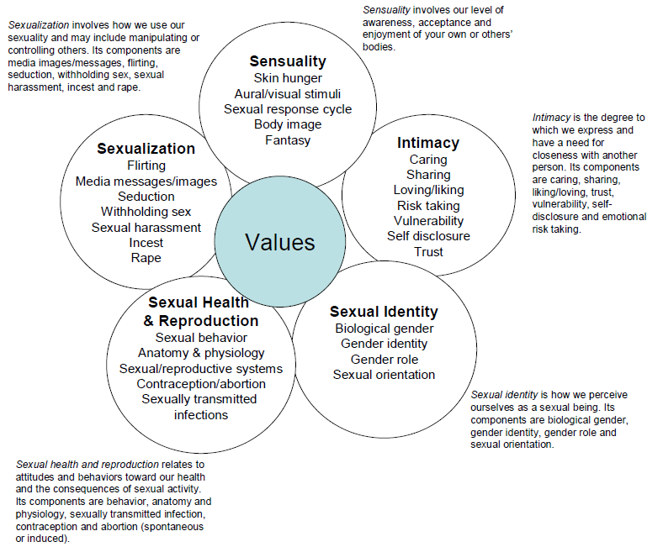
The Circles of Sexuality

Miss Foley
SS Life Trans: Sex & Sexuality Sexuality Defined
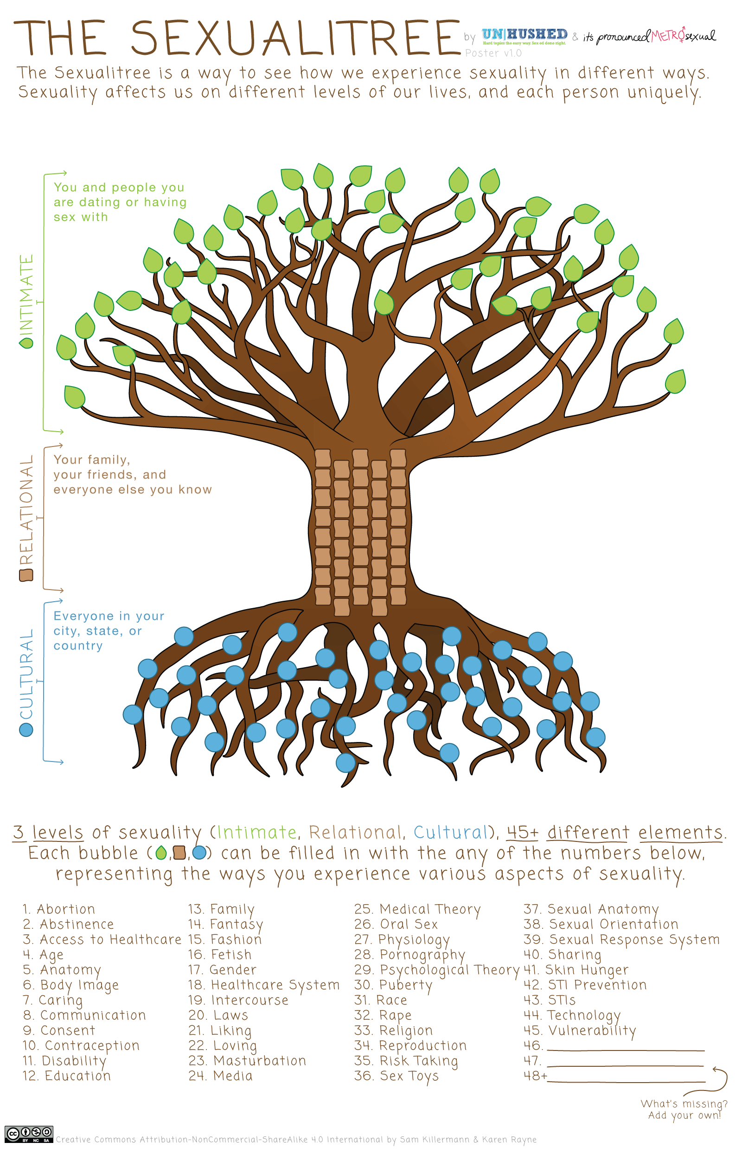

​Miss Foley
SS Life Trans: Sex & Sexuality Myths

​Myths & Misunderstandings

Miss Foley
SS Life Trans: Sex & Sexuality Myths

​

