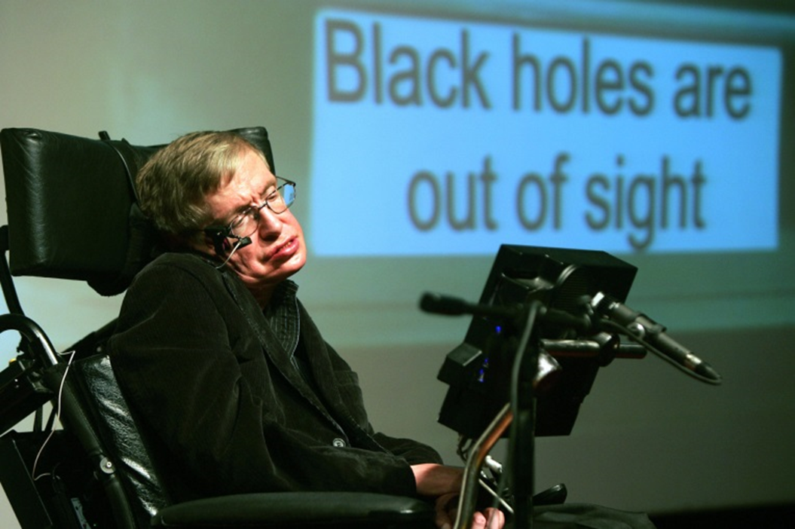
Stephen Hawking
(Jan 8, 1942 –
Mar 14, 2018)
British physicist Stephen Hawking was probably the most recognizable and admired scientist alive until his death. After being born on the 300th anniversary of the death of famed astronomer Galileo, Stephen died on National Pi (3.14) day which also coincides with Albert Einstein’s birthday. Diagnosed at 21 yrs - with a 2 year life expectancy- with amyotrophic lateral sclerosis (ALS), a form of motor neurone disease, he overcame debilitating illness to produce some of the most groundbreaking scientific theories in the last few centuries. Hawking’s goal has been no less than to understand the workings of the universe, devoting his life to uncovering “The Theory of Everything” — the fitting title of the 2014 Oscar-winning portrayal of his life. Stephen Hawking might be disabled in body, but certainly not in his ambitions. Stephen Hawking is hands down one of the most inspiring and ​transformative figures of the last century.
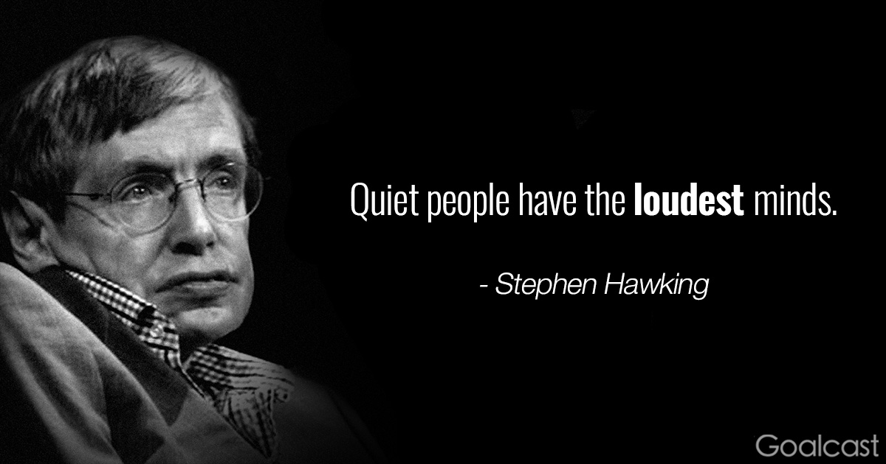
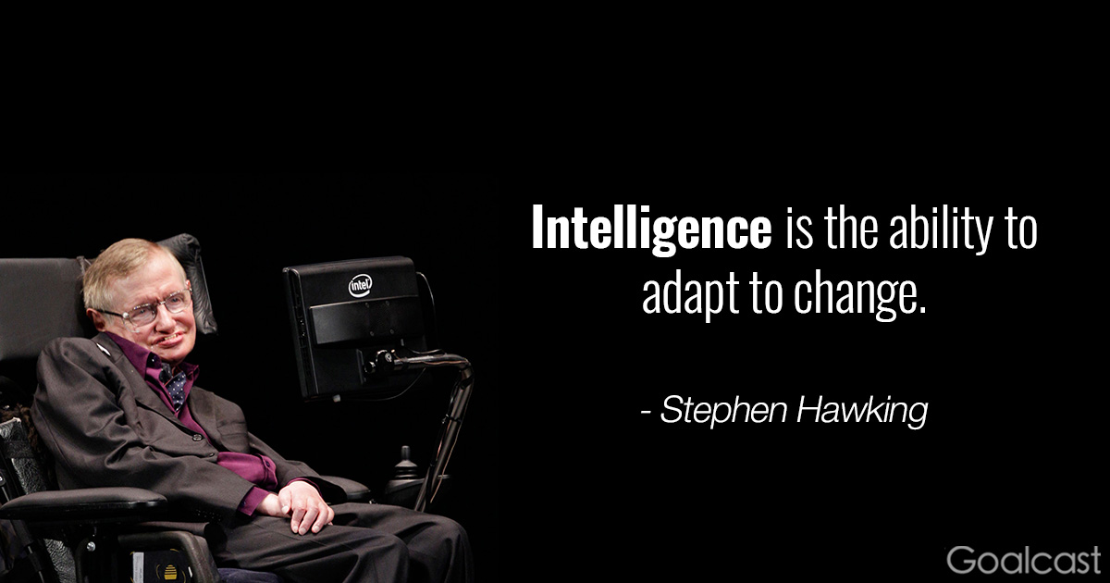
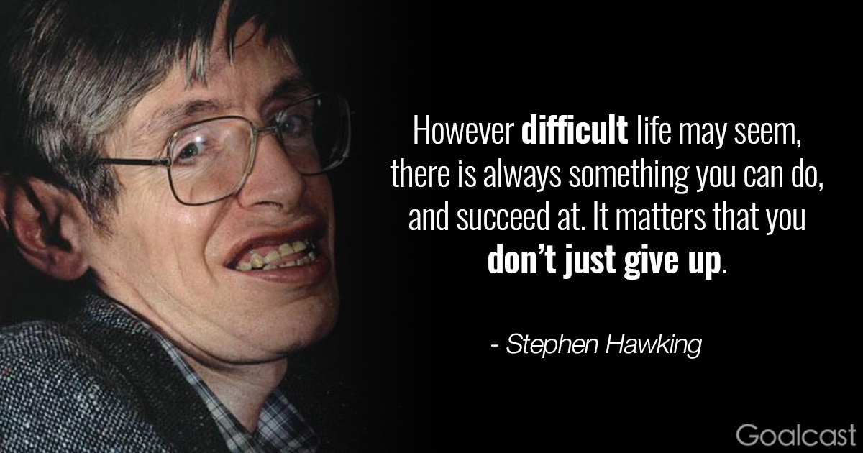
“My advice to other disabled people would be, concentrate on things your disability doesn’t prevent you doing well, and don’t regret the things it interferes with. Don’t be disabled in spirit,
as well as physically.”
~ Stephen Hawking ~
“It is no good getting furious if you get stuck. What I do is keep thinking about the problem but work on something else. Sometimes it is years before I see the way forward. In the case of information loss and black holes, it was 29 years.”
~ Stephen Hawking ~
I have noticed that even people who claim everything is predetermined and that we can do nothing to change it, look before they cross the road.”
~ Stephen Hawking ~
“We are all different, but we share the same human spirit. Perhaps it’s human nature that we adapt and survive.”
~ Stephen Hawking ~
“So next time someone complains that you have made a mistake, tell him that may be a good thing. Because without imperfection, neither you nor I would exist.”
~ Stephen Hawking ~

“Try to make sense of what you see and wonder about what makes the universe exist. Be curious, and however difficult life may seem, there is always something you can do, and succeed at. It matters that you don’t just give up.”
~ Stephen Hawking ~

“One, remember to look up at the stars and not down at your feet. Two, never give up work. Work gives you meaning and purpose, and life is empty without it. Three, if you are lucky enough to find love, remember it is there and don’t throw it away.”
~ Stephen Hawking ~
“I am just a child who has never grown up. I still keep asking these ‘how’ and ‘why’ questions. Occasionally, I find an answer.”
~ Stephen Hawking ~
“Keeping an active mind has been vital
to my survival, as has been maintaining
a sense of humor.”
~ Stephen Hawking ~

“Some people would claim that things like love, joy and beauty belong to a different category from science and can’t be described in scientific terms, but I think they can now be explained by the theory of evolution.”
~ Stephen Hawking ~

“It is a waste of time to be angry about my disability. One has to get on with life and I haven’t done badly. People won’t have time for you if you are always angry or complaining.”
~ Stephen Hawking ~
“I have no idea [what my IQ is].
People who boast about their I.Q. are losers.”
~ Stephen Hawking ~

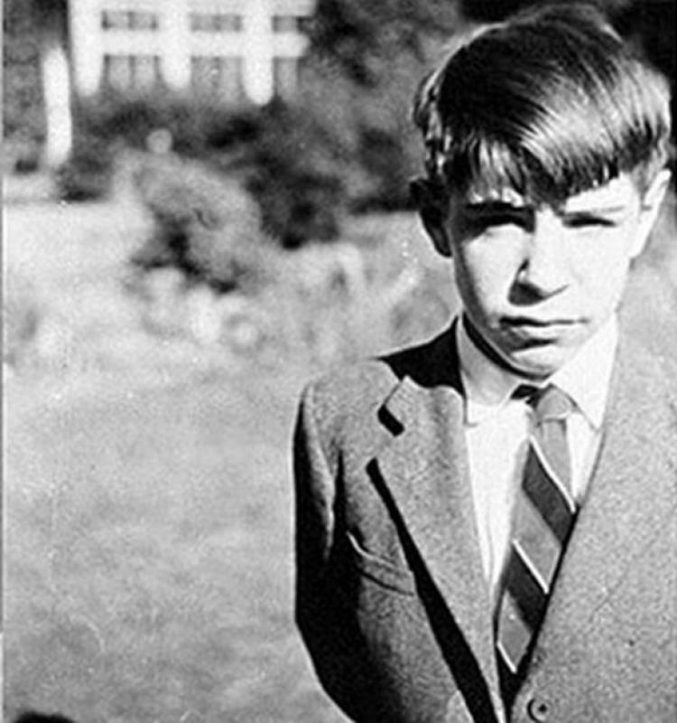
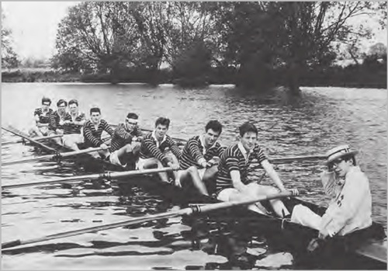
Stephen directs his rowing team at Oxford.

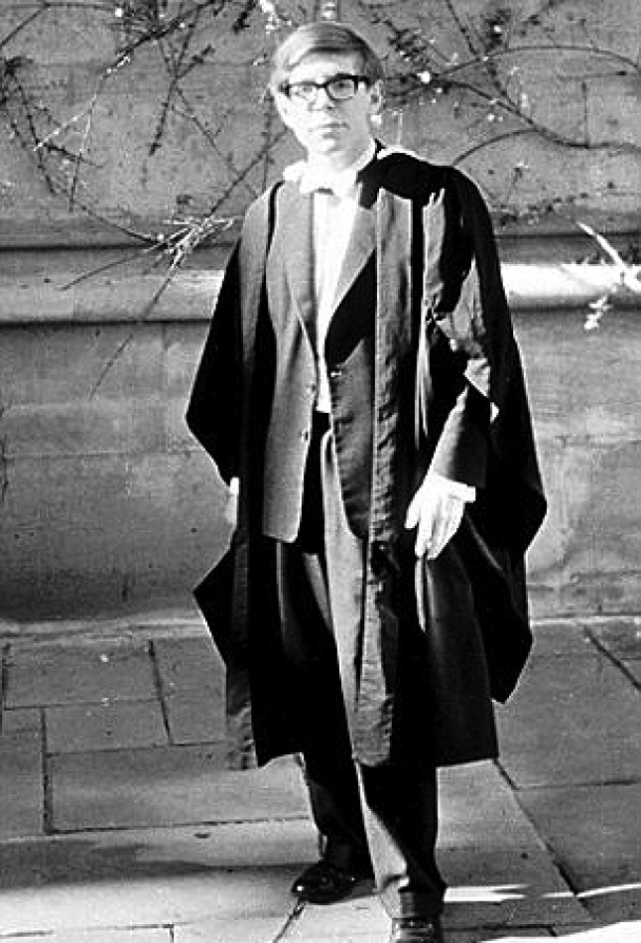
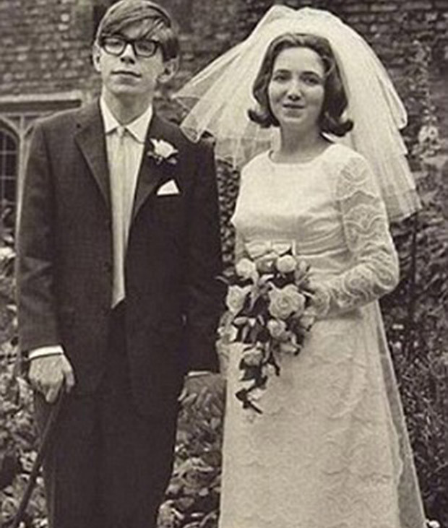
Stephen & Jane Wilde get married 1965.
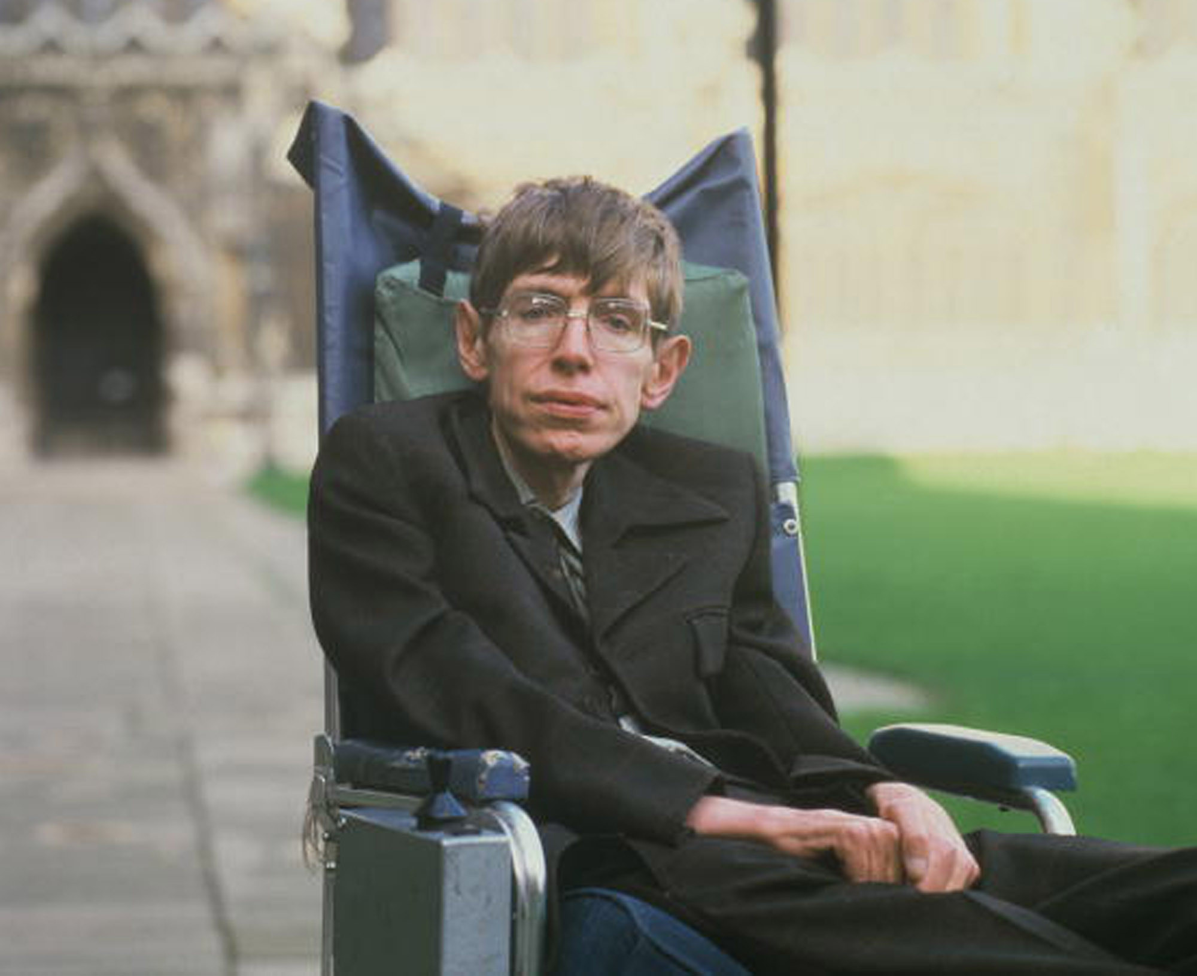
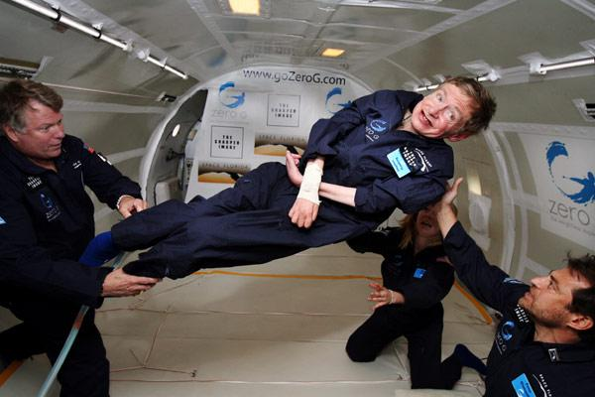
Stephen suspended in a Zero Gravity Flight

