The Heart of A Blue Whale
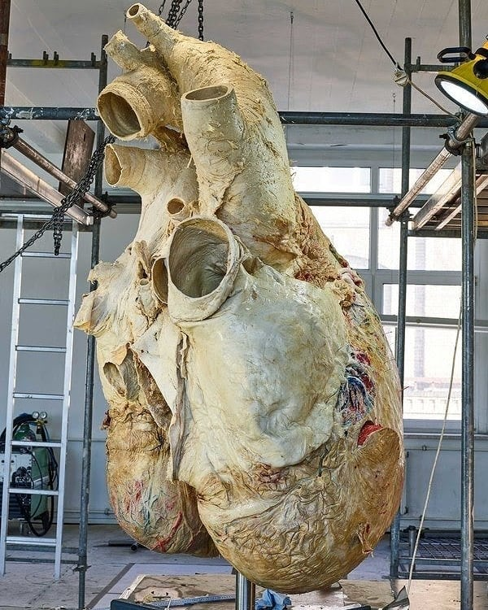

- The heart of a blue whale, which can weigh in excess of 1,300 lbs and is the size of a small car.
- The gigantic heart beats 8 to 10 times per minute and each heartbeat can be heard from over 2 miles away. Their arteries are so large that a full adult size human can swim through them.
- At birth, a baby blue whale is already 25 ft long (the size of an adult killer whale) and can drink up to 150 gallons of milk a day and gain as much as 200 lbs per day in its first year.
- They feed almost exclusively on krill, which are small, shrimp like invertebrates that are on average 1 or 2 centimeters long. They eat 4 to 6 tons of krill a day.
- As an adult, they can grow up to a 110 ft (33 m) and weigh up to 180 tons. Blue whales are the largest animals to have ever existed.

