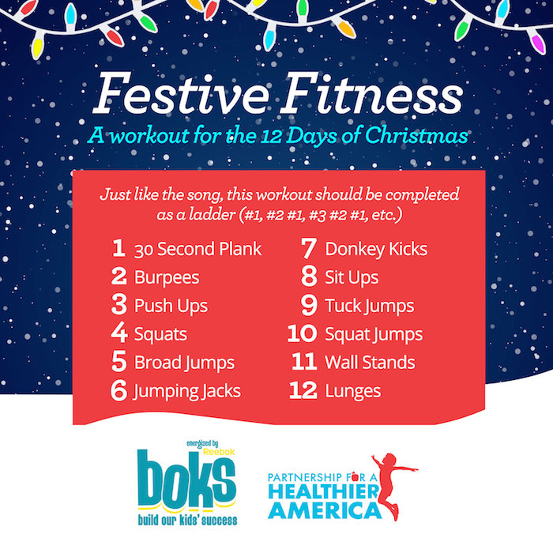
Plank: Get into a pushup position with your elbows bent 90 degrees so that you can place your weight on your forearms. Make sure your elbows are directly beneath your shoulders and your body is in a straight line from your head to your feet. Hold the position for 30 seconds.
Burpees: Begin in a standing position. Drop your hands to the floor right in front of your feet and then jump your feet backwards so that you’re in a plank position. Do a push up. Jump your feet back to your hands and from this crouched position, jump up as high as you can.
Push Ups: Lie prone on floor with hands palms down under your shoulders and the balls of your feet on the ground. Keeping your back straight slowly push your self up and down by straightening and then bending your arms.
Squats: Start standing with your feet shoulder-width apart and extend your hands straight out in front of you to help you keep your balance. Sit back and down until your thighs are as parallel to the floor as possible. Pushing through your heels, bring yourself back up to a standing position.
Broad Jumps: Stand with your feet hips-width apart. Squat down and while swinging your arms forward explode up and jump as far forward as you can. Land softly and return to your original position.
Jumping Jacks: This one should bring back memories of gym class, but just in case, you’ll want to stand with your legs together and arms at your sides. Then jump so that your legs are spread to the sides and your arms are over your head.
Donkey Kicks: Get down on all fours with knees below your hips and hands below your shoulders. With your core engaged, right leg bent and right foot flexed, lift your right leg so that your thigh is parallel with the floor. Then slowly lower to starting position. Make sure to alternate legs for each set of seven reps.
Sit Ups: Lie on your back with your legs bent, feet flat on the floor and your hands resting behind your ears. Raise your torso until you are in a sitting position and then slowly return to your original position.
Tuck Jump: Begin in a standing position with knees slightly bent. Jump straight up and swing your arms slightly. Before you reach the highest point of your jump, bring your knees to your chest and touch your shins with both hands. You will then land and return to the original standing position.
Squat Jump: Stand with your feet shoulder-width apart and start by doing a regular squat. Engage your core to jump up explosively and when you land, return to a squat position.
Wall Stand: Start with your back to the wall. Put your hands down on the floor in front of you and walk your feet up the wall. Now walk your feet back down until your feet are on the ground.
Lunges: Step forward with one leg so that your front knee is aligned with your foot. Lower your back knee towards the floor and then push back up to the starting position. Repeat with opposite leg.

