Miss Foley
Health 8: USC2 Families Prejudice Ladder

"Never doubt that a small group of thoughtful, committed citizens
can change the world; indeed, it is the only thing that ever has."
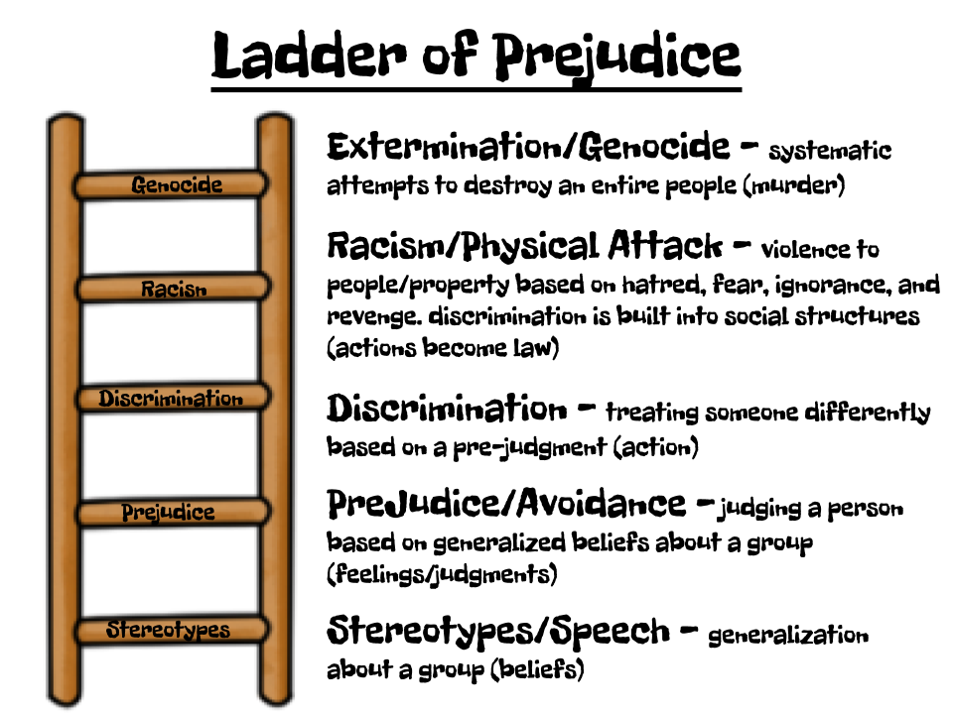
~ Margaret Mead ~
Post-It-Note “Park It” Activity:
Write something that has happened in the school or community that could be placed somewhere on the ladder. Park it on the correct ladder rung. Discuss how stereotypes and prejudices are learned attitudes & behaviours.
The Million Dollar Question:
What keeps individuals and communities from reaching extermination/genocide level?
First Rung: Stereotypes/Spoken Abuse - This often takes the form of talking or joking about a group as if all members of that group were one personality or had one set of features. Spoken abuse includes all of the following:

• Degrading names
• Verbal attack
• Stereotyping
• Music/songs that are degrading
• Jokes
• Rumors
• Ascribing evil motives and behaviors to a whole group/class of people

Miss Foley
Health 8: USC2 Families Prejudice Ladder

Second Rung: Prejudice/Avoidance - people seek to avoid the group which has been stereotyped. Like speech, this seems harmless in the beginning. One has the right to choose one’s friends, and choosing not to be friends with a particular group of people does not seem so awful. The trouble is that lack of contact and friendship with a group breeds fear and increases negative feelings leading to ignorance about them. Ignorance, in turn, leads to stereotyping, fear, and prejudice. Avoidance includes:
- Avoiding homes, schools, and churches
- Avoiding businesses and recreation areas/activities
- Boycotting - a group refusal to have dealings with a certain person, store, organization, race, etc. in order to express disapproval or to force acceptance of certain conditions.
Third Rung: Discrimination - the unwanted group is now kept out of some neighborhoods, shopping areas, social clubs, schools, churches, gathering places, and public centers. Laws are enacted to sometimes enforce this discrimination making it legal for society to discriminate. Institutional Racism is legalizing prejudice, which includes the following:
- Treating others as legally inferior
- Segregation laws
- All types of institutional racism, sexism, age-ism, etc.
- Making legal distinctions that deny rights to others
Fourth Rung: Racism/Physical Attack - may be a mob’s expression of anger or resentment. It may take the form of gang warfare resulting from prejudice, or it may take the form of defacing buildings or places of worship. Physical attack includes all violence to people or property based on hatred, fear, ignorance, and revenge.
• Such groups as the KKK and the neo-Nazis use forms of physical attack to frighten and intimidate their victims, such as burning crosses, painting swastikas on synagogues, inciting riots, gay bashing, etc.
• On the ladder of prejudice, the steps may be short between speaking against a group and attacking it physically.
Rung Five: Extermination/Genocide - the final step escalates from murder to genocide and includes lynching, massacre, mass murder, and attempting to annihilate members of an unwanted group. Genocide is the systematic attempt to destroy an entire people. Examples of genocide in history include the following:
• The Nazi extermination of the Jews and other enemies of the state (11 million)
• Cambodia in the late 1970s—the Khmer Rouge under the leadership of Pol Pot murdered 3 million people (one-third of the population)
• White settlers/Native Americans
• KKK & white supremacists/ non-whites
• Ethnic cleansing in Y ugoslavia
• The anarchy and violence in Rwanda and Somalia

Miss Foley
Health 8: USC2 Families Pyramid of Hate

Pyramid of Hate Anti-Defamation League (2005)
Similarities and/or differences between the
Ladder of Prejudice and the Pyramid of Hate?
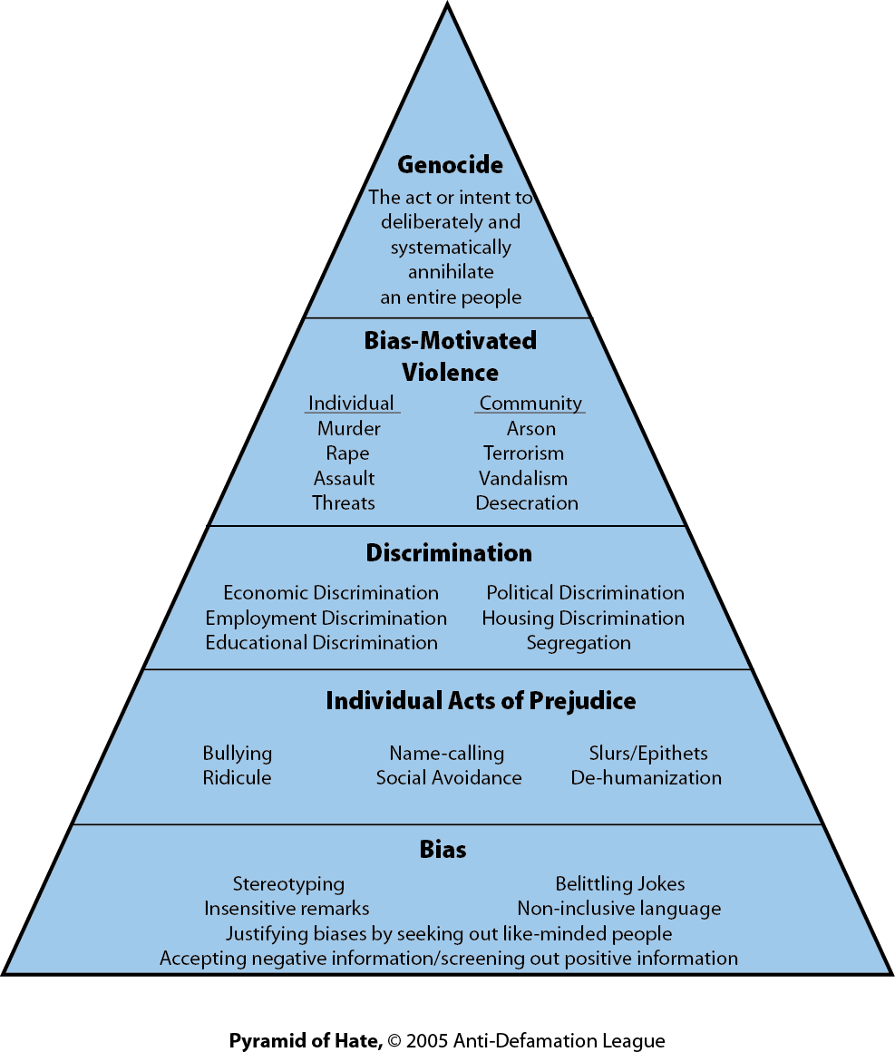

Comparisons/Similarities –

Contrasts/Differences -

Miss Foley
Health 8: USC2 Families Prejudice Ladder

"Never doubt that a small group of thoughtful, committed citizens
can change the world; indeed, it is the only thing that ever has."
~ Margaret Mead ~
Post-It-Note “Park It” Activity:
Write something that has happened in the school or community that could be placed somewhere on the ladder. Park it on the correct ladder rung. Discuss how stereotypes and prejudices are learned attitudes & behaviours.
The Million Dollar Question:
What keeps individuals and communities from reaching extermination/genocide level?
First Rung: Stereotypes/Spoken Abuse - This often takes the form of talking or joking about a group as if all members of that group were one personality or had one set of features. Spoken abuse includes all of the following:

•
•
•
•
•
•
•

Miss Foley
Health 8: USC2 Families Prejudice Ladder

Second Rung: Prejudice/Avoidance - people seek to avoid the group which has been stereotyped. Like speech, this seems harmless in the beginning. One has the right to choose one’s friends, and choosing not to be friends with a particular group of people does not seem so awful. The trouble is that lack of contact and friendship with a group breeds fear and increases negative feelings leading to ignorance about them. Ignorance, in turn, leads to stereotyping, fear, and prejudice. Avoidance includes:

Third Rung: Discrimination - the unwanted group is now kept out of some neighborhoods, shopping areas, social clubs, schools, churches, gathering places, and public centers. Laws are enacted to sometimes enforce this discrimination making it legal for society to discriminate. Institutional Racism is legalizing prejudice, which includes the following:

Fourth Rung: Racism/Physical Attack - may be a mob’s expression of anger or resentment. It may take the form of gang warfare resulting from prejudice, or it may take the form of defacing buildings or places of worship. Physical attack includes all violence to people or property based on hatred, fear, ignorance, and revenge.
•

•

Rung Five: Extermination/Genocide - the final step escalates from murder to genocide and includes lynching, massacre, mass murder, and attempting to annihilate members of an unwanted group. Genocide is the systematic attempt to destroy an entire people. Examples of genocide in history include the following:
•
•

•
•
•
•

Miss Foley
Health 8: USC2 Families Prejudice Ladder

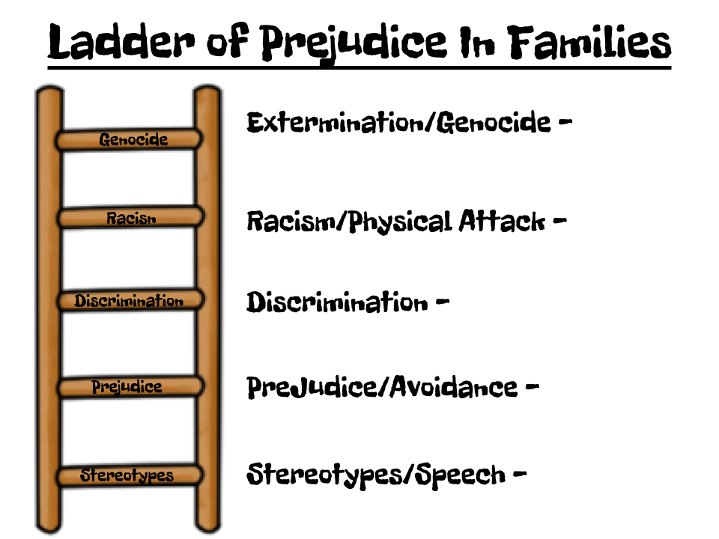
Post-It-Note “Park It” Activity:
Write things or situations related to family identities (FI), structure (FS), roles (R) & responsibilities(RES) that happen in families. Categorize them using the codes above. “Park It” under the correct ladder rung.
- How do stereotyping and social constructs (e.g. gender, “poor bashing”, white privilege) affect the well-being of:
Self –

Family –

Community –

Miss Foley
Health 8: USC2 Families Prejudice Ladder

- Without using real names, list examples of injustice towards families on own community.

- Reflect on your own personal prejudices and their influences on assumptions about families as you answer the following:

  - Give one (1) example of your own personal prejudice regarding families (e.g. identities, structures, roles or responsibilities).

  - How did this prejudice belief develop or where do you think this prejudice belief comes from?

  - How is this prejudice damaging or hurtful to families?

  - How are you able to change this prejudice in the future?

