Miss Foley
Health 8: USC5 Body Image Body Types

Somatotypes (Body Types):
Ectomorph, Mesomorph & Endomorph
Many people think that “body type” just describes the way a person looks, but your body type can also provide information about how you respond to food intake and your hormonal and sympathetic nervous system characteristics. These factors can be linked to metabolic differences between individuals, and influence how you respond to diet and training. Understanding your body type will help you to strategically & successfully plan your strength training and diet regiment, and once you establish your body type, you can maximize health related goals.
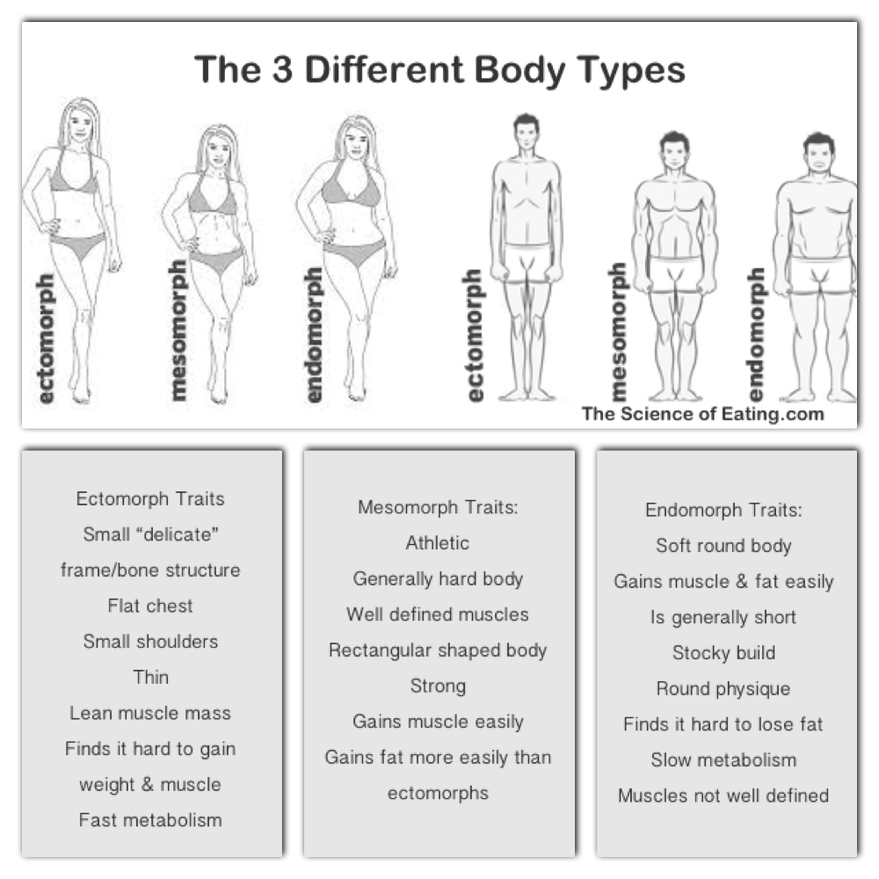

Miss Foley
Health 8: USC5 Body Image Body Types

Ectomorphs are skinny with a small frame, light build, small joints and lean muscle. Usually they have long thin limbs with stringy muscles, narrow shoulders with a fast metabolism making this body type the most resistant to weight gain. Ectomorph traits include:
- Small “delicate” frame and bone structure
- Classic “hard-gainer”
- Flat chest
- Small shoulders
- Thin
- Lean muscle mass
- Finds it hard to gain weight
- Fast metabolism
Mesomorphs have a medium sized bone structure, athletic body, and they typically have a considerable amount of lean mass. Mesomorphs tend to be testosterone and growth hormone dominant, which leads to a predisposition for muscle gain and the maintenance of a lower body fat. The Mesomorph form is the best body type for bodybuilding, and responds the best to weight training, and gains are usually seen very quickly, even for beginners. The downside to mesomorphs is they gain fat more easily than ectomorphs, so they must watch their calorie intake more closely. Because of this, it helps to use combination of weight training and cardio during workout routines. Mesomorph traits include:
- Athletic
- Generally hard body
- Well defined muscles
- Rectangular shaped body
- Strong
- Gains muscle easily
- Gains fat more easily than ectomorphs
Endomorphs have a larger bone structure with higher amounts of total body mass and fat mass, and this extra fat seems to resist most efforts to get rid of it. The endomorph body type is solid and generally soft, and gains fat very easily. Endo’s are usually a shorter build with thick arms & legs. Their muscles are strong, especially the upper legs, and are naturally strong in leg exercises like squatting. Football lineman and power lifters are frequently classified as endomorphs. They also tend to be insulin dominant, leading to a greater propensity for energy storage, including both lean mass and fat mass, and also mean a lower carbohydrate tolerance. As an endomorph, you may feel as though you are destined to be overweight or even obese. NOT TRUE! You just have to make a conscious, concerted effort to do the things your body should be doing for you automatically. If your body isn’t instinctively telling you to get moving, you have to make sure that exercise is part of your daily routine. If your metabolism is sluggish, you need to eat the right foods that will fire up your metabolism. Endomorph traits include:
      - Soft and round body
      - Gains muscle and fat very easily
      - Is generally short
      - "Stocky" build
      - Round physique
      - Finds it hard to lose fat
      - Slow metabolism
      - Muscles not so well defined

Miss Foley
Health 8: USC5 Body Image Body Types

Barbie Redesigned:
Includes More Body Types & Skin Tones
(Feb 2016)
The iconic Barbie doll is now available in several different body types, including a more full-figured version for the first time.
Produced by the American toy maker Mattel, the 2016 line of Barbies comes in four body types: original, tall, petite, and curvy.
The "curvy" doll is meant to reflect a more realistic idea body image for young people.
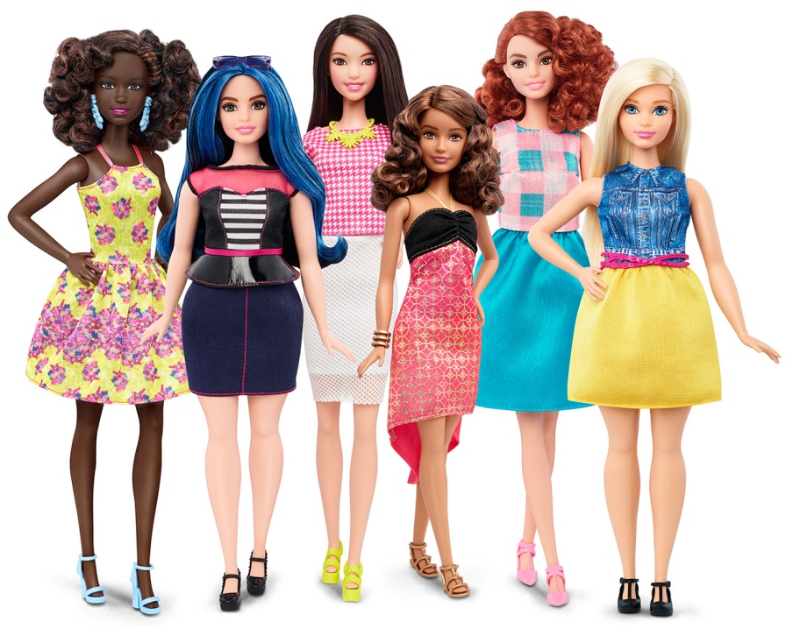
The company's new campaign slogan is: "Imagination comes in all shapes and sizes. That's why the world of Barbie is evolving."
The brand has long faced criticism that its stick-thin female dolls promoted unhealthy body ideals, especially for girls. Barbie's male companion, Ken, has an athletic body.
In addition to the three new body types, the 2016 Barbie Fashionista line includes seven skin tones, 22 eye colours, 24 hairstyles and "countless on-trend fashions and accessories".
"We are excited to literally be changing the face of the brand – these new dolls represent a line that is more reflective of the world girls see around them – the variety in body type, skin tones and style allows girls to find a doll that speaks to them," said Mattel senior vice president Evelyn Mazzocco.
Hairstyles include mohawks, afros, braids, curly and straight bobs, and some with unusual hair colours like blue and purple.
"With added diversity and more variety in styles, fashions, shoes, and accessories, girls everywhere will have infinitely more ways to spark their imagination and play out their stories," the brand added.
Mattel also owns iconic toy brands American Girl, Hot Wheels and Fisher-Price, among others.
Barbie has received a number of makeovers since she debuted in 1959. In the past few years, fashion designer Rei Kawakubo of Comme des Garçons created a new look for the doll and Roksanda Ilincic produced a Brutalist dystopian "dream house" for her.
Source: https://www.dezeen.com/2016/02/01/barbie-dolls-fashionista-collection-mattel-new-body-types

Miss Foley
Health 8: USC5 Body Image Body Types

TIME Health:
Why Men Have More Body Image Issues Than Ever
(Jan 2017)
Superheroes today are a lot more shredded than they used to be. The original Superman and Batman look almost willowy compared to our muscle-bursting modern-day versions.
That’s no coincidence. America is in the midst of a cultural shift in terms of the ideal male body image, and as the ideal man grows more muscular, men stuck in the real world with real bodies are growing less satisfied with theirs—with potentially dangerous medical consequences.
“If you think about the changes over the last 30 to 45 years in how men are depicted in Hollywood, cartoons, magazines and action toys, you’ll see that men’s bodies [today] appear much more muscular,” says Dr. Harrison Pope, director of the Biological Psychiatry Laboratory at McLean Hospital in Massachusetts. These unrealistic media images have contributed to low body image satisfaction among men—usually just considered a problem for women. A study last year found that American men are just as likely as women to feel unsatisfied with their physiques, while another study found adolescent boys who are dissatisfied with their body shape may be more likely than girls to self-criticize and feel distress. Studies have even shown that men feel worse about their bodies after playing video games with ripped characters.
“There’s this drumbeat that muscularity equals masculinity, and so we’re seeing more and more young men with muscle dysmorphia,” says Pope. The consequences of this kind of thinking can be dangerous. As more and more men hit the gym in the hopes of transforming themselves into the Rock, many are also turning to anabolic steroids to achieve the muscle mass they associate with masculinity. Up to 4 million Americans—nearly all of them male—have tried steroids at some point, according to Pope’s recent research.
“There’s a widespread misperception that anabolic steroid use is an issue of cheating in sports, but the vast majority of anabolic steroid users in this country are not athletes,” says Shalender Bhasin, a men’s health researcher at Brigham and Women’s Hospital and Pope’s co-author on a new article in the Journal of the American Medical Association. “Most young men using these drugs are doing it to improve their appearance.”
The potential side effects of anabolic steroids include premature death and neurobehavioral disturbances, like problems with thinking and attention. But Pope says the links to heart problems are the most worrying. “There’s a growing body of

Miss Foley
Health 8: USC5 Body Image Body Types

literature that suggests long-term steroid use can cause cardio myopathy, where the heart doesn’t pump or fill with blood efficiently.” That could lead to heart attack or stroke, he says.
It’s not yet clear just how significant these heart risks are, because steroid use is a relatively new phenomenon. Pope says few men used them before the 1980s, and those early adopters are just now hitting their 50s and 60s—ages when heart problems take their toll.
Another big risk of steroid use is hormone dysfunction. “If you’re taking steroids, your body sees all this testosterone coming in from the outside, and so it stops producing it,” Pope explains. Bhasin says that can lead to psychiatric problems, from “roid rage” to suicidal thoughts.
Also, when men stop using steroids, their bodies’ testosterone production often struggles to ramp back up. The resulting lack of the sex hormone can lead to depression, irritability, erectile dysfunction, low sex drive and more, Pope explains.
Few doctors or psychologists realize how common steroid use and abuse has become, say Pope and Bhasin, and almost none are trained to treat steroid addiction or dependence. Men taking steroids who want to quit therefore have few professional resources, which may lead many to go back on steroids or try other substances—like cocaine or opioids—in order to feel better, Bhasin says.
“Until we see greater awareness of this problem and more attention paid to treating it,” Pope says, “most of these men are on their own.”

Source: http://time.com/4622653/men-body-image-muscle-steroids

Miss Foley
Health 8: USC5 Body Image Body Types

Olympians vs Citizens:
Comparing Heights, Weights, and BMI’s of 10,000 Olympic
Athletes with the Average American Man and Woman
Since the first modern Olympic Games in 1896, nearly 110,000 athletes have used their bodies² – shaped by genetics and honed by rigorous training – to excel in their chosen sporting disciplines. Every four years since then, records have been broken, and medal winners have edged closer to achieving the maximum potential of the human body – whether it's hurling a 16-pound shot put ball as far as possible or sprinting 100 meters in the fastest time. We've analyzed the heights, weights, and BMIs of 10,000 Olympians to see how their bodies compare to the average American citizen from 1960 to today.
An Olympian's body shape and size directly relate to the sport in which he or she participates, and certain events demand extreme proportions to compete at the highest level. The image below shows how Olympic athletes across 30 events vary in height and weight, based on nearly 6,000 men and women who competed in the last Summer Olympics in London.

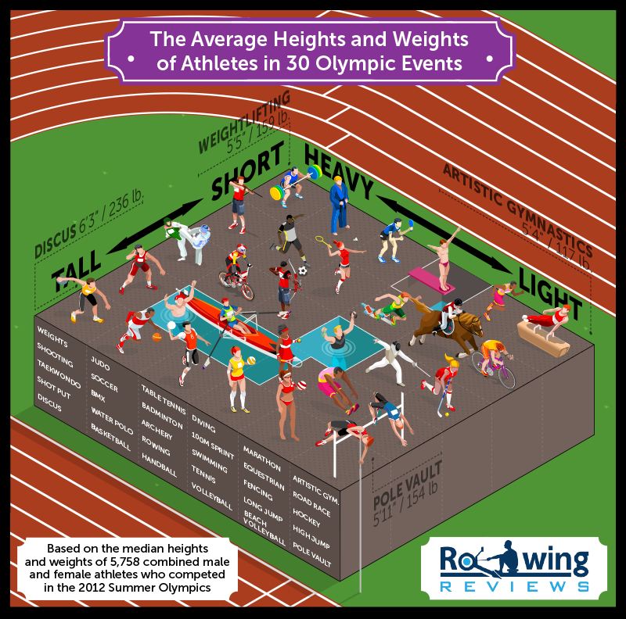

Miss Foley
Health 8: USC5 Body Image Body Types

The extremes of Olympic body types range from heavy and tall to short and light, with many athletes in between. For example, shot put competitors are among the tallest and heaviest at 6 feet 3 inches and 236 pounds (that's men and women combined). Pole-vaulters are also among the tallest, at 5 feet 11 inches, but are much lighter, at 154 pounds. The shortest and lightest athletes are found among marathon runners, who are 5 feet 6 inches and 121 pounds, and artistic gymnasts, who are 5 feet 4 inches and 117 pounds.
Those athletes with extreme body size and shape are those whose heights and weights directly affect their performance. For instance, gymnasts require a very high strength-to-weight ratio, which is why they tend to be short and muscular, with no superfluous fat. Distance runners also carry no extra weight, either in muscle or fat, and instead rely on their smaller frames to stay light on their feet. By contrast, weightlifters need a lot of muscle to attain the explosive power demanded by their lifts. Having relatively short arms and legs is also crucial, allowing weightlifters to save energy when lifting barbells.
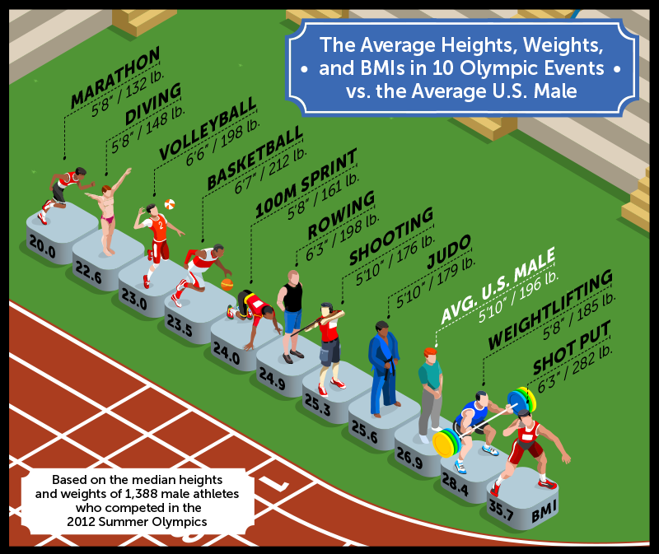
In the image above, we've selected 10 Olympic events and lined up the average athlete for each event based on the 2012 London Olympic Games. Among them is the average American man, who stands 5 feet 10 inches tall and weighs 196 pounds. His Body Mass Index (BMI) is 26.9, which means he's considered overweight (a person's BMI is calculated by dividing his or her body mass by the square root of their height).
For the average person, BMI is used to categorize whether someone is underweight, normal weight, overweight, or obese, on the assumption that extra weight usually equals extra fat, and is bad. The average American male is categorized as overweight because roughly 28% of his body weight is comprised of fat.⁷Olympic weightlifters and shot putters are also considered overweight according to their BMIs, although much more of their body mass is comprised of muscle than the average man.

Miss Foley
Health 8: USC5 Body Image Body Types

To compare which Olympic athlete's physique is most like the average American male, we need to look at sports that are predominantly skill-based, like shooting and badminton. The average male Olympic shooting competitor is the same height as the typical American man but 20 pounds lighter. The average judo competitor is also the same height but 17 pounds lighter. Still, the average American male hasn't always weighed 196 pounds.
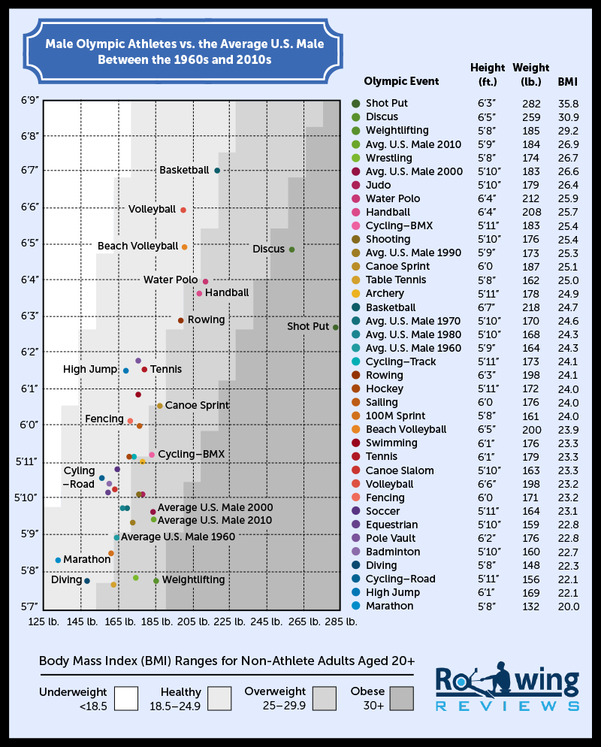

Miss Foley
Health 8: USC5 Body Image Body Types

The graphic above provides a more detailed overview of the average heights, weights, and BMIs of male Olympic athletes, this time across 32 sports and events. We've also included stats for the average American male aged 20 to 29 (to more closely match the age of Olympians) from 1960 to 2010, according to the Centers for Disease Control and Prevention.³
The majority of male athletes fall within the healthy BMI category, but the same cannot be said for the average American man, who has consistently been at the top end of the healthy weight category, if not squarely within overweight, since 1960. In fact, in 1960, the average American man was almost the same height and weight as the average Olympic table tennis player was in 2012. In 1970, however, he had gained six pounds and was closer to today's average hockey player. Today, the typical man is closest in height and weight to an Olympic weightlifter, although, as we mentioned earlier, their respective fat-to-muscle ratios are very different.
Unsurprisingly, basketball players are the tallest athletes in the Olympics, at 6 feet 7 inches on average (the tallest in 2012 was China's Zhaoxu Zhang, at 7 feet 3 inches, and the shortest – Tunisia's Marouan Kechrid – was about the same as the average man, at 5 feet 9 inches). The lightest male competitor in any sport was 21-year-old Tuvaluan weightlifter Tuau Lapua Lapua, who, at 4 feet 7 inches and 137 pounds, was able to lift a 300-pound barbell above his head.⁴ Male Olympic divers are also much lighter than average, at 148 pounds and 5 feet 8 inches, which is the same as a typical 14-year-old boy.⁶
Let's see if female athletes and the average woman over the last 40 years follow similar patterns.
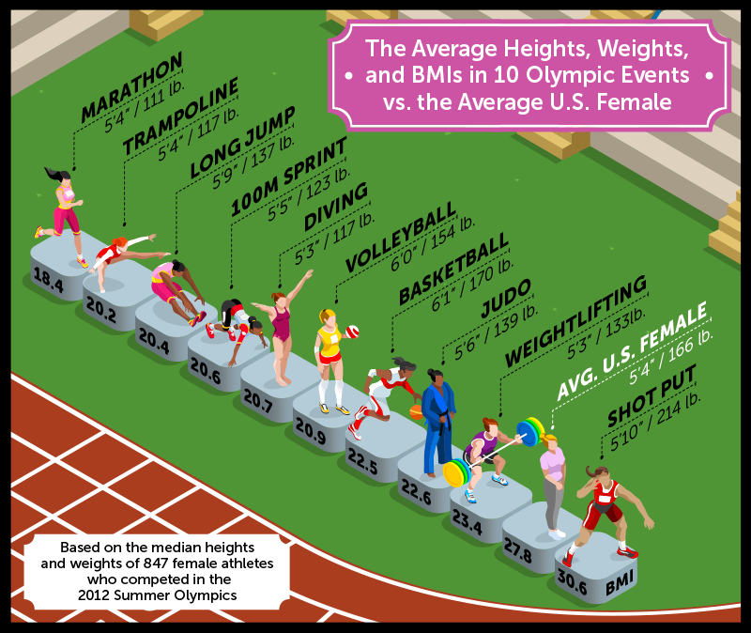

Miss Foley
Health 8: USC5 Body Image Body Types

While the average heights and weights of female athletes differ from their male counterparts, their BMIs are very similar. Female shot putters are highest, at 30.6, followed by weightlifters at 23.4. In between those two sports is the average American woman, who stands 5 feet 4 inches tall and weighs 166 pounds. Her BMI is 27.8, which places her in the overweight category, just like the average man. Again, though, she hasn't always weighed that much.
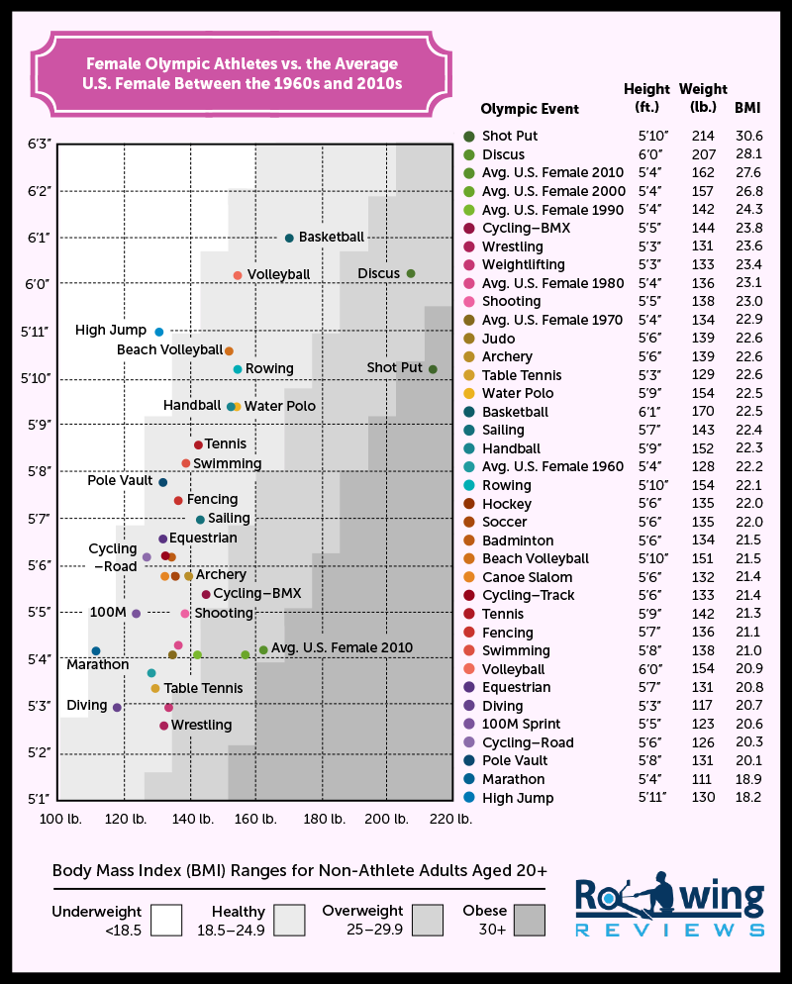

Miss Foley
Health 8: USC5 Body Image Body Types

The tallest female competitor in the 2012 Summer Olympics was 22-year-old Chinese basketball player Wei Wei, who at 6 feet 9 inches was taller than 76% of the male basketballers. The shortest was surprisingly not a gymnast or diver, but actually 200m runner Nercely Soto from Venezuela, who stood 4 feet 4 inches tall.
It's difficult to find an Olympic sport in which female athletes have an average height and weight that is similar to the typical American woman. Using CDC data and the Olympic athletes' heights and weights, we can deduce that the average woman is the same height as a female marathon runner and eight pounds lighter than the average female basketball player (despite being nine inches shorter). In 1960, the comparison was a little different. The average woman was 5 feet 4 inches and 128 pounds – almost the same as a typical Olympic table tennis player today.
In 1970, the average woman was 134 pounds – about the same as a weightlifter today. In 1980, she was still 5 feet 4 inches, but 136 pounds, which is the same weight (but three inches shorter) than the average fencing competitor today. By 1990, the average woman was the same weight as the typical Olympic tennis player is today, albeit five inches shorter.
Over the last 40 years, Olympic athletes' bodies have become increasingly specialized. Sprinters are more "slender" (which has raised their center of mass, allowing them to “fall forward” faster), marathon runners are thinner and shorter (which helps dissipate body heat as they run), and rowers are taller (which increases power and stroke length).⁵
In contrast, the average American man and woman have increased a bit in height and a lot in weight. While it is unrealistic to compare their physiques to those of elite athletes, their increases in weight over the last four decades have been significant enough to raise an eyebrow: 20 pounds for men and 34 pounds for women.
There isn't much someone can do to change their height – which means becoming a basketball player or high jumper isn't going to happen for the average person – but, with the right nutrition, exercise, and attitude, shifting one's weight from that of the average shot putter to the typical swimmer (or rower!) is more realistic.

Sources:
London 2012 competitor data released by the IOC. Available here:
https://docs.google.com/spreadsheets/d/1Y4xQqDuOVbn4mkEFUhW_xE5bgAy51raR1vlNZeXyl3Y/edit#gid=0
- https://www.rio2016.com/en/athletes
- http://www.sports-reference.com/olympics/summer/
- CDC/NCHS, National Health and Nutrition Examination Survey.
- http://www.foxsportspulse.com/assoc_page.cgi?client=0-3862-0-0-0&sID=254093&&news_task=DETAIL&articleID=20104566
- http://www.npr.org/2012/08/09/158455089/olympics-physics
- Fryar CD, Gu Q, Ogden CL. Anthropometric reference data for children and adults: United States, 2007–2010. National Center for Health Statistics. Vital Health Stat 11(252). 2012
- St-Onge M-P. Are Normal-Weight Americans Over-Fat? Obesity (Silver Spring, Md). 2010;18(11):10.1038/oby.2010.103. doi:10.1038/oby.2010.103.

