Miss Foley
Health 9: USC1 Health Promotion Determiners of Health

Population Health Model
We DO NOT have control over Genetics and Biology. However, we DO have control over Income, Social Status, Education, Working Conditions, Physical Environment, Personal Health Practices & Coping Skills, Healthy Child Development & Health Services!
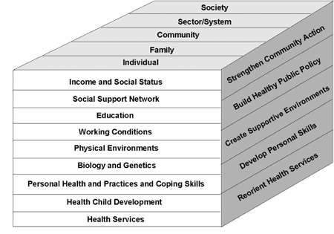
Populations
Determiners of Health
Health Promotion Strategies

Miss Foley
Health 9: USC1 Health Promotion Determiners of Health

Examples of Health Determiners
- Education
Example:

- Income
Example:

- Social Status
Example:

- Physical Environment
Example:

- Biology
Example:

- Genetics
Example:

We DO NOT have control over Genetics & Biology. However we DO have control over ALL of the other Determinants of Health.

Miss Foley
Health 9: USC1 Health Promotion Health Promotion

Ways To Promote Health Examples
- Develop Personal Skills
Example:

- Strengthen Community Action
Example:

- Create Supportive Environments
Example:

- Re-orient Health Services
Example:

- Build Healthy Public Policy
Example:

Miss Foley
Health 9: USC1 Health Promotion Health Promotion

How Does Health Promotion Affect Decision Making & Levels Of Health?

- My Health
Example:

- Family Health
Example:

- Community Health
Example:

- Environment Health
Example:

