W11 – Healthy Eating
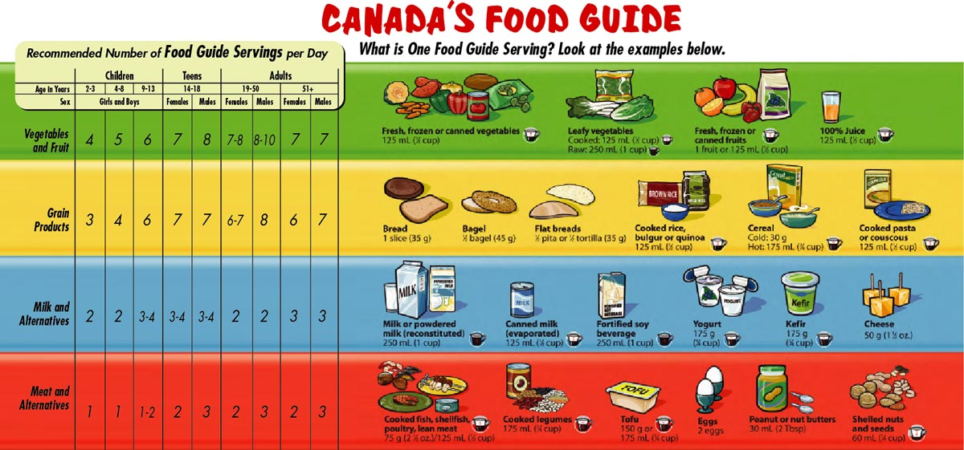
Canada’s Food Guide “Build It” Relay Race

Prep: Cut Canada’s Food Guide into corresponding parts & laminate onto cardstock for future durability. Get your copy of Canada's Food Guide here!
Relay Race: Run a relay race (obstacle course or not...completely up to you) to find “puzzle pieces” to rebuild Canada’s Food Guide as a team in order to be able to answer the following questions in no particular order.
Uses: Could be used as pre-assessment, to create personal Canada Food Guide notes, or as formative assessment.

W11 – Healthy Eating
Canada’s Food Guide “Build It” Relay Race
Complete the following information after gathering your “puzzle pieces” from the relay race to rebuild Canada’s Food Guide:
- Recommended Number of Servings of Fruits & vegetables for a teenager

- Recommended Number of Servings of Grain Products for a teenager

- Recommended Number of Servings of Milk & Alternatives for a teenager

- Recommended Number of Servings of Meat & Alternatives for a teenager

- Five (5) examples of a Meat Alternative

- Four (4) examples of a Milk Alternative

- Two (2) recommended Serving Sizes for Fruits & Vegetables

- Five (5) recommended Serving Sizes for Grain Products

- Four (4) recommended Serving Sizes for Milk & Alternatives

- Five (5) recommended Serving Sizes for Meat & Alternatives

- Water recommendation

- Oils & Fats recommendation

- Three (3) Fruits & Vegetable recommendations

- Two (2) Grain Products recommendations

- Two (2) Milk & Milk Alternatives recommendations

- Three (3) Meat & Meat Alternatives recommendations

- Recommendations for Children

- Recommendations for Women of Childbearing Age

- Recommendation for Men & Women over 50yrs

- List six (6) benefits of eating well & being physically active

- Physical Activity recommendation for children and youth

- Trans fat recommendation

