Nutrition Labels: Things To Consider
Free. This claim means that a food contains no amount (or a very small amount) of these nutrients: fat, saturated fat, cholesterol, sodium, sugar, and calories.
• "Calorie-free" means fewer than 5 calories per serving. • "Fat-free" means less than 0.5 grams of fat per serving.
Low. This claim can be used on all foods that can be eaten often without going over the limit for one or more of these nutrients: saturated fat, cholesterol, fat, sodium, and calories.
• "Low-saturated fat": 1 gram or less per serving. • "Low-fat": 3 grams or less per serving.
• "Low-sodium": 140 milligrams or less per serving. • "Low calorie": 40 calories or less per serving.
• "Low-cholesterol": 20 milligrams or less and 2 grams or less saturated fat per serving.
Other words that mean "low," include: "little," "few," and "low source of."
Lean and extra lean. These claims can be used to describe the saturated fat and fat content of meat, poultry, seafood and game meats.
• "Lean": less than 10 grams of fat and 4.5 grams or less of saturated fat, and less than 95 mg of cholesterol per serving.
• "Extra lean": less than 5 grams of fat, less than 2 grams saturated fat, and less than 95 mg of cholesterol per serving.
Watching your serving size is still important. Just because something is "reduced fat" or "lighter" in calories, does not mean that you can eat more of it. Choosing foods lower in saturated fat and cholesterol will help you to lower your blood
cholesterol. By eating a larger portion of a food low in saturated fat, you may eat more or just as much saturated fat and fat as the regular variety.
Check Serving Size - The only way to know how much fat, sugar, sodium or fibre you're consuming is to compare the serving size listed on the label with the amount you actually eat. Don't assume that one package of food - a bottle of fruit juice, a frozen dinner, a frozen pizza, or even a bagel - is one serving. Figure out how much you eat and then do the math.
Use Daily Values - These percentages - based on average recommended intakes - are listed for fat, saturated and trans fat, sodium, carbohydrate, fibre, vitamins A and C, calcium and iron. Instead of trying to remember the amount each DV is based on, follow the "five and 25 rule."
If a label says one serving supplies 5% or less of the daily value, that's a good thing for nutrients you want to avoid such as saturated and trans fat, added sugars and sodium. But it's not ideal for fibre, vitamins and minerals, nutrients you might want to consume more of. If one serving of a food supplies 25% or more for vitamins A and C, calcium, iron, or fibre, it's an excellent source of these nutrients.
For saturated and trans fats, the daily value is set at 20 grams. Foods low in these fats will have a daily value of 10 per cent or less.
For sodium, the DV is set at 2,400 milligrams or 1 tsp, an amount that is actually higher than your daily sodium requirement. Foods with a DV of 5% or less will be low in sodium.
Watch sugar numbers - Keep in mind that grams of sugars include ADDED refined sugars added during processing and naturally occurring sugars in milk and fruit. A whole-grain breakfast cereal with dried fruit will have more sugar than one without, but that's not necessarily a bad thing.
Don't focus on total fat - For most foods, total fat per serving is not that important. Some fats, such as omega-3 fats and monounsaturated fat, have health benefits. Instead, focus on saturated and trans fats, the two fats that can raise LDL cholesterol...the lower the better. There are no safe levels of trans fats. You are urged to limit processed trans fats to as little as 5% Daily Value of your total daily fat intake, or try to avoid it altogether if possible.
Don't get psyched out - Avoid trying to decipher too many numbers Think about who in your family is going to eat the food. Someone with high blood pressure? High cholesterol? If so, sodium and saturated and trans fats are important. Consider how often you eat the food in question - every day or once in a while? The answer will determine your focus of attention.
Get the whole picture - Just because a food carries a "trans fat-free" or "calorie-reduced" claim doesn't mean it is nutritious. These foods may deliver a hefty dose of sodium or sugar and may be lacking whole grains. You need to read the entire label - including the ingredient list - to know what you're eating.
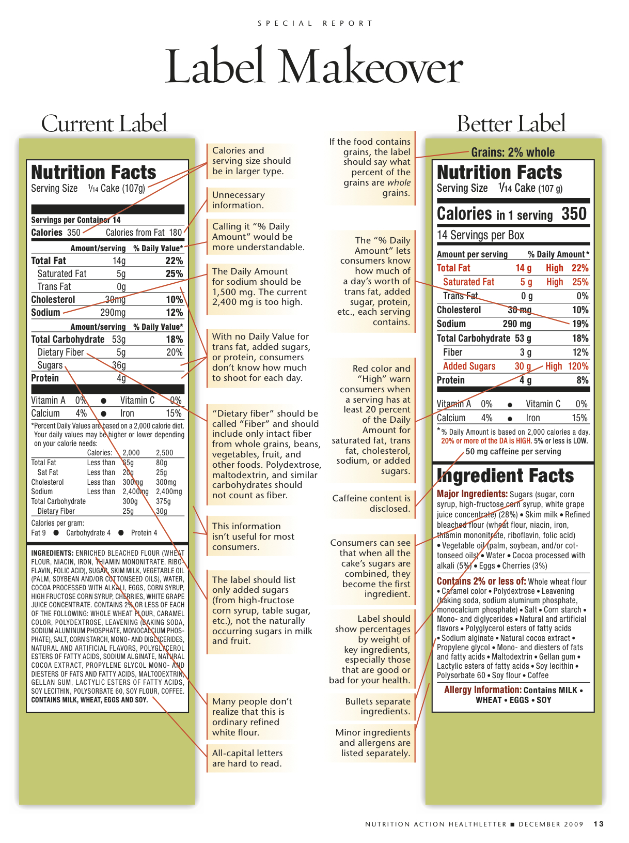
Which label do you like better?
Top 5 Favorite Foods Compared
Product Name
Serving Size
Calories
“Reality” Serving Size
Be sure to check notes for definitions of “Better & Worse” for each level of criteria…know your “5 & 25 Rule”!
Criteria | Better - - - - - - - - - - - - Worst
Total Fat
Saturated Fat
Trans Fat
Cholesterol
Sodium
Carbohydrates
Fiber
Sugar (Added)
Protein
Vitamin A
Vitamin C
Calcium
Iron
Best Nutritional Choice of My Top 5: ________________________________

