Wellness Inventory

Each statement in the inventory is an indicator of wellness. By completing the inventory and the wellness wheel, you should begin to determine the kind of balance you have in your life and be better prepared to design your own Personal Plan for Wellness (PPW).

Write the number that identifies your response in the columns to the left of each statement as indicated on the sample chart below.

5 – Yes, always (95% or more of the time)
4 - Very often, usually (approximately 75% (3/4) of the time)
3 - Often (approximately 50% (1/2) of the time)
2 - Sometimes, maybe (approximately 25% (1/4) of the time)
1 - Almost never, rarely (less than 10% of the time)
0 - No, never

Example
5 | 4 | 3 | 2 | 1 | 0 | Sample Statements (Physical Activity)
x |  |  |  |  |  | When participating in physical activities, I include stretching and flexibility exercises.
 | x |  |  |  |  | I run at least one mile three times a week (or equivalent aerobic exercise).
 | x |  |  |  |  | I am aware of the calories expended in my activities.
 |  |  |  | x |  | I walk, run, or ride my bicycle instead of drive/ride in a vehicle whenever feasible.
 |  | x |  |  |  | I maintain a healthy weight.
5 | 8 | 3 |  | 1 |  | Total points = 17

After you have responded to all the statements in the inventory, calculate your average points for each section and transfer it to the corresponding “wedge” around the Wellness Inventory Wheel.

5 + 8 + 3 + 1 = 17 (Total points for the Physical Activity section)

17/5 (Number of statements answered) = 3.4 (Average points for this section)

Physical Dimension of Wellness

5 | 4 | 3 | 2 | 1 | 0 | Section: Physical Activity
 |  |  |  |  |  | - I engage in strength-building exercises/activities at least two times per week.
 |  |  |  |  |  | - I engage in moderate to vigorous movement activities for at least 60 minutes per day.
 |  |  |  |  |  | - I keep track of my fitness/exercise (e.g., in a journal, notebook, using technology) and I share my fitness achievements with my family and friends.
 |  |  |  |  |  | - I stretch for several minutes each day to keep my body flexible.
 |  |  |  |  |  | - I use active transportation (e.g., walk, run, skateboard, ride bicycle) whenever possible.
 |  |  |  |  |  | - I am aware of the calories expended in my movement activities.
 |  |  |  |  |  | - I participate in movement activities that provide relief from stress.
 |  |  |  |  |  | - I maintain realistic and healthy personal fitness expectations.
 |  |  |  |  |  | - I have energy at the end of the day.
 |  |  |  |  |  | - I have developed appropriate complex skills (e.g., passing to avoid a defender, hitting a ball) to participate confidently in a variety of movement activities.
 |  |  |  |  |  | - I look for opportunities to enhance my physical fitness in my daily routines (e.g., take the stairs, walk to friend’s house).
 |  |  |  |  |  | Total points =
 |  |  |  |  |  | Average points (total points /11) =

5 | 4 | 3 | 2 | 1 | 0 | Section: Healthy Eating
 |  |  |  |  |  | - I eat at least five servings of fruits and vegetables each day.
 |  |  |  |  |  | - I make a conscious effort to choose/make foods, when possible, that are low in sugar, sodium, and saturated fat.
 |  |  |  |  |  | - I drink fewer than two soft drinks (including diet drinks, energy drinks) per week.
 |  |  |  |  |  | - I eat at restaurants no more than once per week.
 |  |  |  |  |  | - I intentionally include foods high in fibre in my diet on a daily basis (e.g., whole grain breads and cereals, beans).
 |  |  |  |  |  | - I drink enough water (i.e., six-eight glasses per day) to keep my urine light yellow.
 |  |  |  |  |  | - I read the nutrition labels when selecting and purchasing food and beverages.
 |  |  |  |  |  | - I avoid “fad” dieting but rather make healthy lifestyle changes that can be maintained.
 |  |  |  |  |  | - I avoid caffeine.
 |  |  |  |  |  | - I avoid consuming alcohol.
 |  |  |  |  |  | Total points =
 |  |  |  |  |  | Average points (total points /10) =

5 | 4 | 3 | 2 | 1 | 0 | Section: Physical Self-Care
 |  |  |  |  |  | - I have routine yearly health checkups rather than only seeking medical attention when I have concerns/symptoms.
 |  |  |  |  |  | 2. I complete regular/monthly personal breast/testicular exams.
 |  |  |  |  |  | 3. I complete a regular skin check for signs of skin cancer.
 |  |  |  |  |  | 4. I take vitamins on a regular basis.
 |  |  |  |  |  | 5. I brush my teeth after meals and floss once/day.
6. I take care of personal injuries so I can participate, in a timely and realistic manner,
in movement activities.
 |  |  |  |  |  | 7. I get at least seven hours of uninterrupted sleep/night.
 |  |  |  |  |  | 8. I regularly wash my hands (e.g., after using bathroom, before eating)
 |  |  |  |  |  | 9. I always check with my medical practitioner before taking supplements.
 |  |  |  |  |  | Total points =
 |  |  |  |  |  | Average points (total points /9) =

5 | 4 | 3 | 2 | 1 | 0 | Section: Safety
 |  |  |  |  |  | - I wear a seat belt while riding in and driving any motorized vehicle.
 |  |  |  |  |  | - I use sunscreen or take other precautions to prevent overexposure to the sun.
 |  |  |  |  |  | - I advocate that non smokers should not have to breathe tobacco smoke in public places.
 |  |  |  |  |  | - I always wear a helmet when I ride a motorcycle, bicycle, skate board, all-terrain vehicle, etc.
 |  |  |  |  |  | - I avoid extremely noisy areas or wear protective ear covers.
 |  |  |  |  |  | - I identify and attend to safety and risk factors involved in movement activities.
 |  |  |  |  |  | - Injury prevention is a focus in all that I do.
 |  |  |  |  |  | - I never drive while under the influence of substances (or ride with someone under the influence).
 |  |  |  |  |  | - I do not use tobacco products and avoid second-hand smoke.
 |  |  |  |  |  | - I use prescription drugs only as intended.
 |  |  |  |  |  | - I know where to seek help if I feel unsafe and/or if I am injured.
 |  |  |  |  |  | Total points =
 |  |  |  |  |  | Average points (total points /11) =

Social Dimension of Wellness

5 | 4 | 3 | 2 | 1 | 0 | Section: Intrapersonal Relationships
 |  |  |  |  |  | - I try to live in a way that causes as little personal damage and suffering as possible.
 |  |  |  |  |  | - I value spending time alone, not “plugged in” to the outside world.
 |  |  |  |  |  | - I regularly reflect on who I am and what I value.
 |  |  |  |  |  | - My wellness is a priority to me and I schedule my days accordingly.
 |  |  |  |  |  | - I am aware of my strengths and weaknesses as they relate to personal well-being.
 |  |  |  |  |  | - My self-talk has a positive influence on my personal well-being.
 |  |  |  |  |  | Total points =
 |  |  |  |  |  | Average points (total points /6) =

5 | 4 | 3 | 2 | 1 | 0 | Section: Interpersonal Relationships
 |  |  |  |  |  | - I try to live in a way that causes as little damage and suffering as possible to others.
 |  |  |  |  |  | - I am able to communicate with and get along with a wide variety of people.
 |  |  |  |  |  | - I have at least one person in whom I can confide.
 |  |  |  |  |  | - I am involved in social activities at school and/or in my community.
 |  |  |  |  |  | - I get along well with the members of my family.
 |  |  |  |  |  | - I consider the feelings of others and do not act in hurtful/selfish ways.
 |  |  |  |  |  | - When I make mistakes, I apologise (if appropriate) and do not try to cover them up.
 |  |  |  |  |  | - I am able to listen to people without interrupting them or finishing their sentences for them.
 |  |  |  |  |  | - I am accepting of others who have differing sexual orientations, abilities, and religious beliefs (not meaning I have to agree with their beliefs).
 |  |  |  |  |  | - I feel like I belong at school.
 |  |  |  |  |  | - I assertively address conflict with others in “face to face” conversations (i.e., do not avoid it or use social network).
 |  |  |  |  |  | - I seek and accept constructive criticism.
 |  |  |  |  |  | Total points =
 |  |  |  |  |  | Average points (total points /12) =

Psychological Dimension of Wellness

5 | 4 | 3 | 2 | 1 | 0 | Section: Mental
 |  |  |  |  |  | - I develop and assess personal goals on an ongoing basis.
 |  |  |  |  |  | - I achieve goals I set for myself.
 |  |  |  |  |  | - I am looking forward to the future as an opportunity for further personal growth.
 |  |  |  |  |  | - I enjoy expressing myself through art, dance, music, drama, movement, etc., and make time to do so.
 |  |  |  |  |  | - I schedule enough time to accomplish what I need to do.
 |  |  |  |  |  | - I avoid putting off important tasks (i.e., procrastination).
 |  |  |  |  |  | - I have at least one activity (e.g., hobby, sport) that I regularly do/enjoy.
 |  |  |  |  |  | - I often reflect on my attitudes and biases towards mental health and mental illness.
 |  |  |  |  |  | - I promote a realistic and positive understanding of mental illness.
 |  |  |  |  |  | - I have the self-awareness to know when to seek help for personal mental health challenges.
 |  |  |  |  |  | - I know how to keep myself mentally healthy.
 |  |  |  |  |  | - I practise mental fitness (e.g., place things in perspective, use stress management techniques).
 |  |  |  |  |  | Total points =
 |  |  |  |  |  | Average points (total points /12) =

5 | 4 | 3 | 2 | 1 | 0 | Section: Emotional
 |  |  |  |  |  | - I am able to develop and maintain close relationships.
 |  |  |  |  |  | - I feel positive about myself and my life.
 |  |  |  |  |  | - I avoid blaming others for my failures or problems.
 |  |  |  |  |  | - I easily fall asleep and stay asleep at night.
 |  |  |  |  |  | - I try to associate with people who have a positive attitude.
 |  |  |  |  |  | - I avoid people who are “down” all the time and bring down those around them.
 |  |  |  |  |  | - I express my feelings or anger in ways that are not harmful to self and/or others.
 |  |  |  |  |  | - I include relaxation as part of my daily routine.
 |  |  |  |  |  | - When I make mistakes, I take responsibility and I try to learn from them.
 |  |  |  |  |  | - I avoid giving mixed signals.
 |  |  |  |  |  | - I know who and what pushes my buttons.
 |  |  |  |  |  | - I can accurately identify and appropriately respond to the emotions of others.
 |  |  |  |  |  | Total points =
 |  |  |  |  |  | Average points (total points /12) =

5 | 4 | 3 | 2 | 1 | 0 | Section: Intellectual
 |  |  |  |  |  | - I keep abreast of current affairs – locally, nationally, and internationally.
 |  |  |  |  |  | - I am interested in learning new things and in deepening my learning of what I know.
 |  |  |  |  |  | - I am happy with the amount and the variety that I read.
 |  |  |  |  |  | - When seeking medical care, I plan ahead regarding how to describe my problem and what questions I should ask.
 |  |  |  |  |  | - I am able to see more than one side of an issue.
 |  |  |  |  |  | - I learn from my mistakes and plan to act different the next time.
 |  |  |  |  |  | - I consider various alternatives before making decisions.
 |  |  |  |  |  | - I am interested in continuing to learn beyond grade 12.
 |  |  |  |  |  | - I look for ways to use my creativity.
 |  |  |  |  |  | - I know the “way” I learn best and advocate to learn this way when necessary.
 |  |  |  |  |  | Total points =
 |  |  |  |  |  | Average points (total points /10) =

Spiritual Dimension of Wellness

5 | 4 | 3 | 2 | 1 | 0 | Section: Sense of Identity
 |  |  |  |  |  | - I am committed to following what I believe.
 |  |  |  |  |  | - I take time alone to think about what’s important in life - who I am, what I value, etc.
 |  |  |  |  |  | - I turn inward for a sense of strength in difficult situations.
 |  |  |  |  |  | - I am mainly guided by my “inner self” rather than the expectations of others.
 |  |  |  |  |  | - I treat all things with respect.
 |  |  |  |  |  | - I value my uniqueness (e.g., abilities, heritage, experiences)
 |  |  |  |  |  | Total points =
 |  |  |  |  |  | Average points (total points /6) =

5 | 4 | 3 | 2 | 1 | 0 | Section: Sense of Meaning and Purpose
 |  |  |  |  |  | - I try to relate to myself, to my community, and to my planet in a non-harming way.
 |  |  |  |  |  | - I spend a portion of every day praying, meditating, smudging, etc.
 |  |  |  |  |  | - I take time alone to think about what’s important in life - where I fit in and where I’m going, etc.
 |  |  |  |  |  | - I take time to enjoy nature and I feel connected to the earth.
 |  |  |  |  |  | - I am mainly guided by my “inner self” rather than the expectations of others.
 |  |  |  |  |  | - I believe that there is a bigger “purpose” in life.
 |  |  |  |  |  | - I understand that true happiness is about more that accumulating wealth or “stuff”.
 |  |  |  |  |  | - I reach out to comfort or help others.
 |  |  |  |  |  | - I volunteer my time at least once per week.
 |  |  |  |  |  | Total points =
 |  |  |  |  |  | Average points (total points /9) =

Environmental Dimension of Wellness

5 | 4 | 3 | 2 | 1 | 0 | Section: Environmental Footprint
 |  |  |  |  |  | - I try to live in a way that causes as little damage and suffering as possible to my environment.
 |  |  |  |  |  | - I use active transportation (e.g., ride a bicycle, walk) to conserve fuel energy and to lessen the pollution in the atmosphere.
 |  |  |  |  |  | - I do not litter.
 |  |  |  |  |  | - I advise others on the importance of maintaining a healthy environment.
 |  |  |  |  |  | - I try to conserve energy by turning off lights and electrical appliances when they are not being used.
 |  |  |  |  |  | - I look for recycled materials when purchasing products.
 |  |  |  |  |  | - I try to not leave the tap running too long when I brush my teeth, shave, or bathe.
 |  |  |  |  |  | - I network with people/organizations who advocate for the environment (e.g., social media, online publications).
 |  |  |  |  |  | - I support efforts in my community to reduce environmental pollution.
 |  |  |  |  |  | - I know where my food comes from and its journey from “seed to plate”.
 |  |  |  |  |  | - My decisions are informed by the impact of consumerism on the environment.
 |  |  |  |  |  | - I use reusable shopping bags.
 |  |  |  |  |  | Total points =
 |  |  |  |  |  | Average points (total points /12) =

5 | 4 | 3 | 2 | 1 | 0 | Section: Social Justice
 |  |  |  |  |  | - I support local businesses and their products.
 |  |  |  |  |  | - I recognize that certain groups of people have privileges (e.g., white, male, educated, Christian, socio-economics, abilities, appearances, culture).
 |  |  |  |  |  | - I advocate for equal opportunity (e.g., access to healthy foods, clean water, housing, physical activity).
 |  |  |  |  |  | - I feel empowered to contribute to the greater good of my community.
 |  |  |  |  |  | - I recognize, name, and challenge instances of inequality, bias, and intolerance.
 |  |  |  |  |  | - I resist negative media portrayals and other imposed images.
 |  |  |  |  |  | Total points =
 |  |  |  |  |  | Average points (total points /6) =

Physical Dimension | Score | Psychological Dimension | Score
1. Physical Activity  2. Healthy Eating  3. Physical Self-Care  4. Safety | _____  _____  _____  _____ | 1. Mental  2. Emotional  3. Intellectual | _____  _____  _____
Social Dimension | Score | Spiritual Dimension | Score
1. Intrapersonal Relationships  2. Interpersonal Relationships | _____  _____ | 1. Sense of Identity  2. Sense of Meaning and Purpose | _____  _____
Environmental Dimension | Score
1. Environmental Footprint  2. Social Justice | _____  _____

Transfer your average points from each section of the inventory to the corresponding wedge in the Wellness Wheel below. Then, draw a curved line between the “spokes” of the wheel – the lines that define each wedge. Finally, fill in the portion of each wedge between the centre of the wheel and the curved line using different colours. For example:
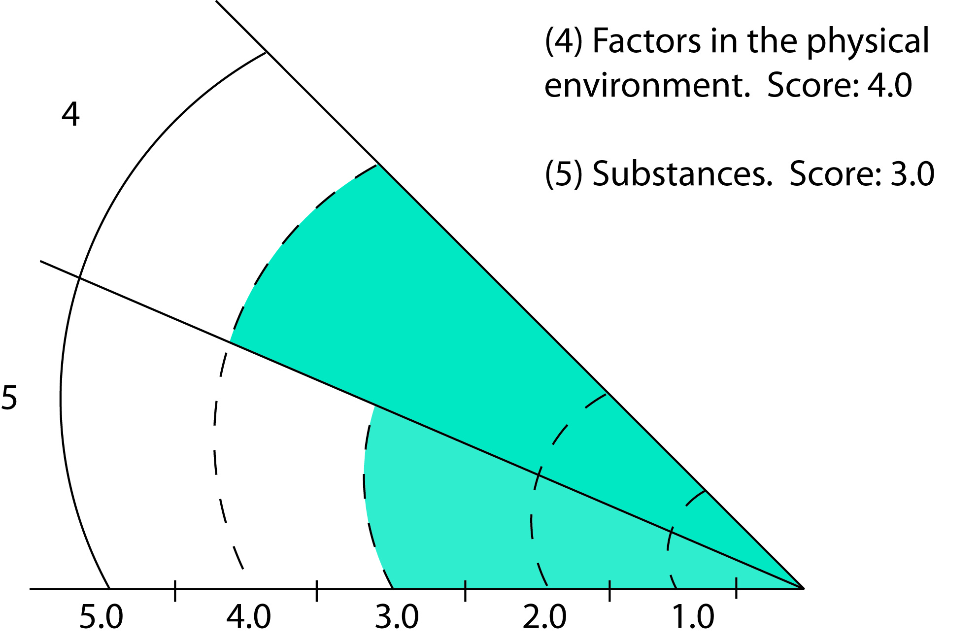

When you have completed your Wellness Wheel, study its shape, its balance, and reflect on the following questions:
- How smoothly would it roll?
- How do you feel about its shape and size?
- What improvements would you like to see in your wheel?
- In which areas of your life are you most/least well?
- What do you need to learn more about and why?

Name: ____________________________ Date: ______________
When you have completed your Wellness Wheel, study its shape, its balance, and reflect on the following questions:
• How smoothly would it roll?

• How do you feel about its shape and size?

• What improvements would you like to see in your wheel?

• In which areas of your life are you most/least well?

• What do you need to learn more about and why?

