My Wellness Wheel

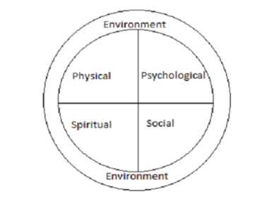
The wellness wheel provides a visual representation of the concept of wellness that demonstrates the need for “positive tension” or “well-rounded” lives. To attain and maintain harmony and balance in our lives, we must pay attention to each of the four dimensions of wellness. To neglect or over-emphasize any of the four dimensions will result in an out-of-balance (out-of-round) wellness wheel. These ideas are represented visually through the three following graphics:
Rounded Wellness Wheel
This Wellness Wheel belongs to a person who takes responsibility for achieving balance in his/her life. As a result, this person is rolling along smoothly through life – for whom everything is going “just right”.

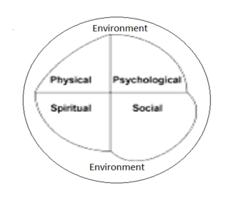
Out of Balance Wheel #1
This wheel could represent a person who is overly concerned with having fun and socializing (social dimension), and neglects the physical dimension (e.g., has a low level of physical fitness, and/or is overweight, and/or does not have a healthy diet, etc.).

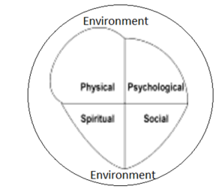
Out of Balance Wheel #2
This wellness wheel is that of a person who is obsessed with the physical dimension of wellness. He or she engages in physical activity for so many hours each day that there is no time for attending to elements of wellness in the other dimensions (e.g., meaningful relationships, reading).

Aboriginal Medicine Wheel
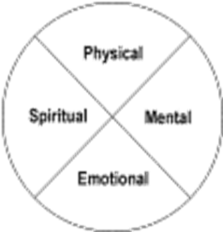
The Medicine Wheel is an ancient holistic approach to healing ailments of the mind, body, and spirit that explains illness as springing from an imbalance of being. The Medicine Wheel is a complex network of ideas, symbols, and philosophies depicted within a metaphorical circle. The Wheel is divided into north, south, east, and west doors, each associated with thoughts, feelings, time periods, and sacred elements.
A holistic approach to life where all things are connected is central to the Aboriginal world view. Illness is explained as an imbalance in life and restoring balance and harmony is achieved by examining the elements of one’s life represented by the Medicine Wheel.

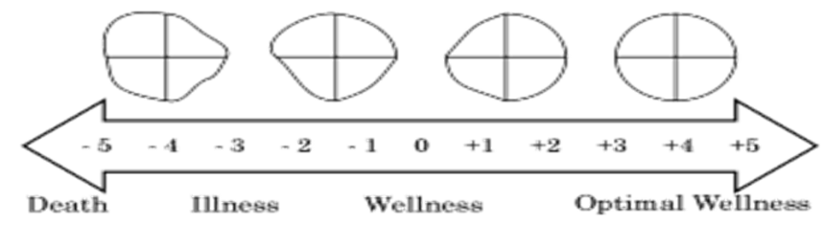
Illness-Wellness Continuum
Wellness is not merely the absence of illness. The Illness-Wellness Continuum illustrates that there are many degrees of wellness, just as there are many degrees of illness. Moving from the centre of the continuum to the left shows a progressively worsening state of health. It depicts a wellness wheel that is becoming less balanced (less round). Moving to the right of the centre of the continuum indicates an increasing level of wellness. It shows a wellness wheel that is becoming more balanced (round).
Wellness Inventory

By completing the inventory and the Wellness Wheel, you should begin to determine the kind of balance you have in your life and be better prepared to design your own Personal Plan for Wellness.

This inventory will help determine the dimension in your life that requires the most re-balancing. This dimension will be a main focus over the course of the semester. With each outcome that is covered in Wellness 10, students will concentrate on re-balancing their dimension of wellness that is currently lacking.

Inventory Reflection

When you have completed your Wellness Wheel, study its shape and balance and discuss the answers to the following questions:

- How smoothly would it roll?

- How do you feel about its shape and size?

- In which areas are you least well?

- What don’t you like about it?

- What do you like about it?

- What improvements would you like to see in your wheel?

